Monitoring Plan:
Black Warrior Solid Waste Facility
Reporting Period: 1/1/2024 – 12/31/2024
december 10, 2025

Contents
1 Introduction 3
1.1 Project Overview 3
1.2 Project Changes During the Reporting Period (1/1/2024 – 12/31/2024) 3
2 Project Description 3
2.1 Project Participants 3
2.1.1 Anew Environmental Project Personnel 3
2.1.2 BWSWA County Landfill/Waste Connections Project Personnel 4
2.1.3 SCS Engineers Project Personnel 4
2.2 Project Scope 4
2.3 Project Location 4
2.3.1 Site Description 5
2.3.2 Landfill Gas Collection System 5
2.3.3 Regulatory Compliance QA/QC 6
2.3.4 Project Diagram 6
3 Project Monitoring 7
3.1 Data Monitoring 7
3.1.1 Landfill Gas Flow 7
3.1.2 Methane Content 7
3.1.3 Project Emissions 7
3.1.4 Landfill Regulations 7
3.2 Data Management 8
3.2.1 BWSWA County Landfill Data Management 8
3.2.2 Redundant Offsite Data Storage 8
3.2.3 Summary of Data Monitoring and Data Management Equipment 8
3.3 Monitoring & Reporting Procedures 8
3.3.1 Monitoring & Reporting 8
3.3.2 Calibration Reporting 9
3.3.3 Environmental Violation Reporting 9
3.3.4 Unscheduled Outage Reporting 9
3.3.5 Record Keeping 9
3.4 Monitoring & Reporting QA/QC 11
3.4.1 Data QA/QC 11
3.4.2 Flow Meter Calibration QA/QC 11
3.4.3 Methane Analyzers Calibration QA/QC 12
3.4.4 Emission Reduction Quantification QA/QC 12
3.5 Data Substitution Guidelines 13
4 References 13

Introduction

Project Overview
The Black Warrior Solid Waste Facility is an active municipal landfill located at 3301 Landfill Drive in Coker, Alabama. The site originally opened in 1978 and was operated by a solid waste authority chartered by the City of Tuscaloosa. The entity was dissolved in 1994, and the Black Warrior Solid Waste Disposal Authority (BWSWA) was established to upgrade environmental controls and operate the landfill. The site began accepting waste as a Subtitle D landfill in January 1994 and currently consists of Cells 1 through 8A. The project collects and combusts landfill gas (LFG) in an open flare. No combustion devices existed on site prior to the initiation of the project activity. The baseline scenario is defined as the total release of LFG to the atmosphere.
A landfill gas collection and control system (GCCS) was voluntarily installed in 2009. The project commencement date is January 14, 2009. The project activity consists of an active LFG collection system with an open flare at the landfill. The landfill is not a bioreactor.
On June 7, 2021, BWSWA and Anew Environmental (“Anew”) entered an agreement to develop and monetize carbon credits from the destruction of methane from LFG. The Project Developer is Anew and the landfill owner is BWSWA. The Project Developer owns the rights to all the greenhouse gas (GHG) credits that result from the project.
The present Monitoring Plan was developed by Anew in accordance with the Climate Action Reserve (CAR) guidelines and complies with Version 6.0 of the U.S. Landfill Protocol (“Protocol”).

Project Changes During the Reporting Period (1/1/2024 – 12/31/2024)
In August 2024, a flare skid swap was performed, which included the replacement of the flow meter and gas analyzer used in the last reporting period with a new flow meter and gas analyzer.

Project Description

Project Participants
Table 1. Project participants
Project Developer | Anew Environmental, LLC
Landfill Owner/Operator | Black Warrior Solid Waste Disposal Authority
Gas Collection & Control System Owner | Black Warrior Solid Waste Disposal Authority
Carbon Credit Manager | Anew Environmental, LLC
Project O&M Provider | SCS Engineers

Anew Environmental Project Personnel
John McDougal – Senior Vice President of Environmental Products
- Manages the carbon credit marketing and trading activities

Antonio Juan Ding – Project Lead
- Manages Anew’s CAR account
- Manages communications between Anew and CAR staff
- Performs emission reduction calculations
- Prepares project documentation, verification, and registration
- Collects and organizes information
- Manages continued GCCS data acquisition
- Maintains Anew’s databases of digitally recorded data from landfill operations

BWSWA County Landfill/Waste Connections Project Personnel
Fred Rogers – Executive Director
- Primary contact for LFG system
- Conducts routine operation and maintenance of LFG system
- Coordinates maintenance and repairs with contractors

Daniel Swartz – Engineer

SCS Engineers Project Personnel
Joshua Williams – Project Manager
- Routine testing, monitoring, maintenance, and repair of LFG collection headers, extraction wells, and installation and start-up of blower/flare systems

Project Scope
The project consists of the voluntary collection and destruction of LFG and the necessary monitoring and data recording for the purpose of verifying Climate Reserve Tonnes (CRTs). These emission reductions are generated in accordance with Version 6.0 of the U.S. Landfill Protocol developed by CAR.

Project Location
Figure 1 shows the location of the Black Warrior Solid Waste Facility in Coker, Alabama.
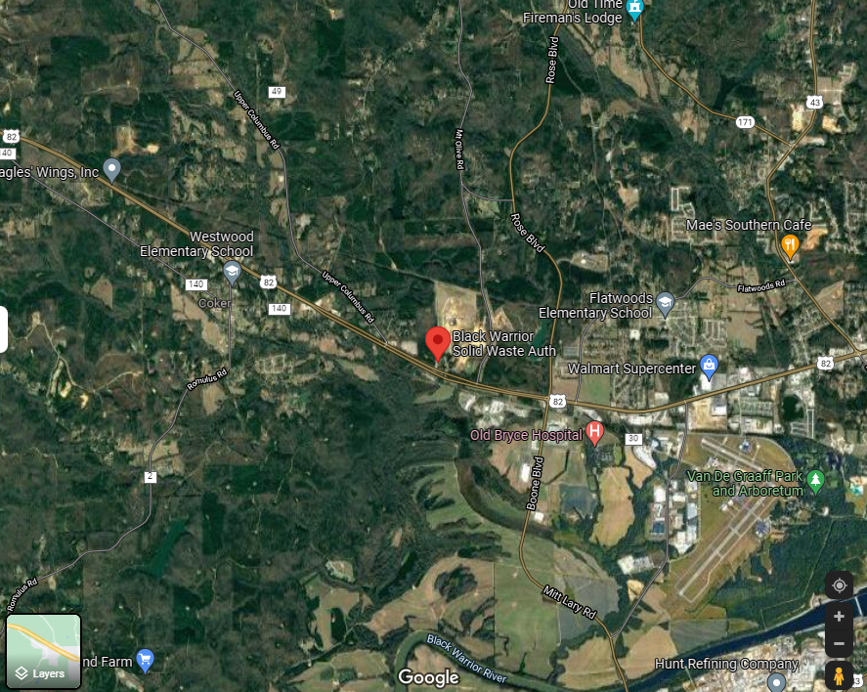
Figure 1. Aerial map of Black Warrior Solid Waste Facility

Site Description
The project activity at the Black Warrior Solid Waste Facility consists of an active LFG collection and destruction system. The design capacity of the landfill is 8,915,000 tonnes.
The landfill has submitted the required initial design capacity and non-methane organic compound (NMOC) emission rate reports due to the applicability of New Source Performance Standards (NSPS) Subpart XXX. The NMOC emission rate report showed that NMOC emissions do not exceed the 34 Mg per year threshold for which a GCCS is required to be installed and operated. The landfill conducts Tier 2 testing to determine a site-specific NMOC concentration for the purposes of showing that NMOC emissions are below the threshold. Previous Tier 2 samples conducted for compliance with NSPS Subpart WWW showed the landfill’s NMOC emissions to not exceed 34 Mg per year.

Landfill Gas Collection System
The Black Warrior Solid Waste Facility is an active municipal landfill located at 3301 Landfill Drive in Coker, Alabama. The site originally opened in 1978 and was operated by a solid waste authority chartered by the City of Tuscaloosa. The entity was dissolved in 1994 and the BWSWA was established to upgrade environmental controls and operate the landfill. The site began accepting waste as a Subtitle D landfill in January 1994 and currently consists of Cells 1 through 8A.
The project collects and combusts landfill gas in an open flare. No combustion devices existed on site prior to the initiation of the project activity. The baseline scenario is defined as the total release of LFG to the atmosphere.

Regulatory Compliance QA/QC
The Black Warrior Solid Waste Facility maintains regulatory and environmental compliance through the guidance detailed in their operating permits required under federal, state, and local environmental regulations. The permits include inspection frequencies, sampling frequencies, and reporting requirements. These permits are included in the documentation provided for verification.

Project Diagram
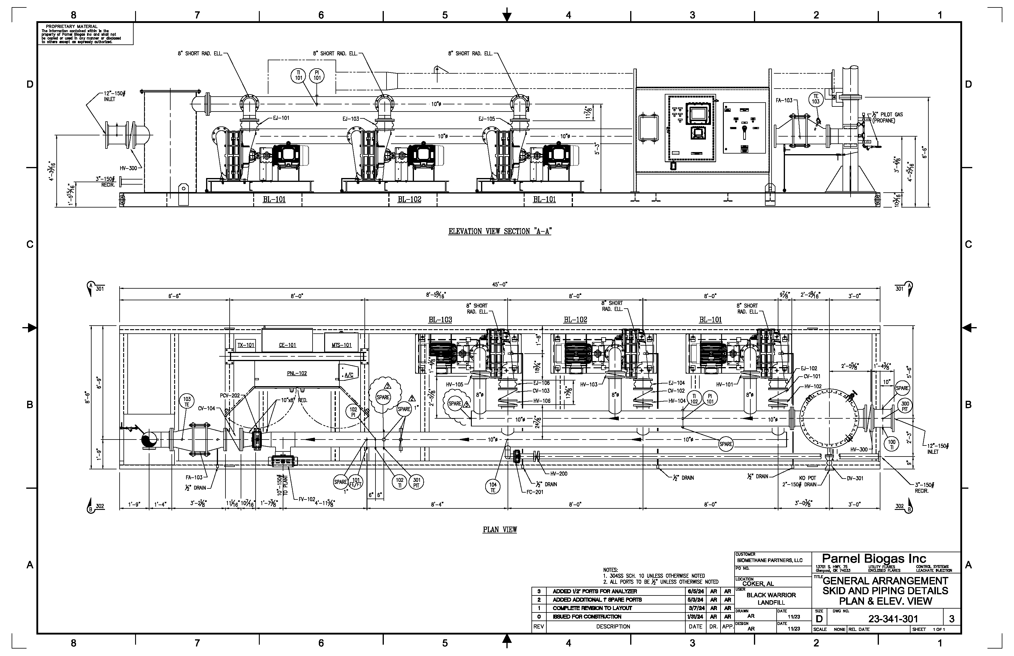
Figure 2. BWSWA project diagram

Project Monitoring

Data Monitoring

Landfill Gas Flow
According to the Protocol, the flow of LFG delivered to the destruction device must be measured continuously and recorded at least once every fifteen minutes, and all flow data collected must be corrected for temperature and pressure at standard conditions of 60 °F and 1 atm.
At the Black Warrior Solid Waste Facility, LFG flow was measured continuously using Thermal Instrument Company mass flow meters (SN: 2008455, 2024067, and 2024208). The flow meters are configured to standard conditions of 60 °F and 1 atm. Data were recorded approximately every minute between January and August prior to the flare swap and approximately every ten minutes between August and December following the flare swap.
The periods in the reporting period during which each flow meter was used are summarized in Table 2.

Methane Content
According to the Protocol, the fraction of methane in the LFG can be measured continuously or weekly using a calibrated portable gas analyzer.
At the Black Warrior Solid Waste Facility, methane content was measured using an ECOTEC continuous gas analyzer (SN: 1211). Data from the ECOTEC gas analyzer were recorded approximately every minute between January and August prior to the flare swap and approximately every ten minutes between August and December following the flare swap.

Project Emissions
Version 6.0 of the Protocol requires that all project emissions be accounted for in the emission reductions calculations. Utility bills have been provided by BWSWA to show purchased electricity and propane.

Landfill Regulations
The landfill monitors all applicable local, state, and national regulations and permit requirements for BWSWA on an ongoing basis. These actions help ensure ongoing project eligibility. If any potential issue arises around legal requirements or project eligibility for the landfill, Anew is notified and the issue is discussed. Regulations that are monitored include:
- NSPS regulations
  - Requirements around Tier 2 reporting are checked on an annual basis to ensure that the report is up to date and that a new report is not required. TTL and Anew also check the predicted NMOC levels in the Tier 2 report to determine if the landfill is expected to exceed the 34 Mg per year threshold.
- State regulations
- Potential future federal regulations

Data Management

BWSWA County Landfill Data Management
Data from the flow meter, thermocouple, and continuous gas analyzer were digitally recorded using a Yokogawa data logger and uploaded automatically into an Automated Equipment Monitoring System (AEMS) and/or web portal. Anew can directly download the data as needed.

Redundant Offsite Data Storage
In addition to Anew’s servers located in Houston, Texas, Anew provides redundant offsite storage of all servers on a separate system in Austin, Texas. The system performs a complete backup of all company servers each night. Even in the event of catastrophic damage to the building or power failure, Anew would still be able to recover all project data.

Summary of Data Monitoring and Data Management Equipment
Table 2. Data monitoring and data management equipment used in the 1/1/2024 – 31/12/2024 reporting period
Project Activity | Monitoring Equipment | Make/Model | Serial Number | Dates of Service During Reporting Period
LFG flow | Thermal Instrument Company flow meter | 62-9/9500I | 2008455 | January to August
LFG flow | Thermal Instrument Company flow meter | 62-9TEF/9500PI | 2024067 | August 28
LFG flow | Thermal Instrument Company flow meter | 62-9TEF/9500P | 2024208 | August 29 to December
Flare temperature | Thermocouple | N/A | N/A | Full reporting period
Methane content | ECOTEC continuous gas analyzer | FAU-TDL | 1211 | January to August
Methane content | ECOTEC continuous gas analyzer | FAU-TDL | 1316 | August to December
Data recording | AEMS | N/A | N/A | January to August
Data recording | FleetZOOM | N/A | N/A | August to December

Monitoring & Reporting Procedures

Monitoring & Reporting
Flow rate, flare temperature, and methane concentration are monitored remotely using a telemetry system, which gives all relevant parties access to view the operation of the flare skid in real-time. Daily remote monitoring of the system by Anew personnel assures that, should any problems arise, they are detected and resolved in a timely manner. LFG flow rate is also monitored and reviewed monthly by Anew personnel to track BSWSA’s carbon credit production.

Calibration Reporting
Calibration records are provided, as available, for all project equipment requiring calibration checks, which include the TI flow meters, and the ECOTEC continuous gas analyzers. Information includes the date, time, and results of the last calibration check.

Environmental Violation Reporting
As the landfill operator, BWSWA has well-defined environmental tracking and reporting procedures as well as procedures for corrective action.
As part of the monitoring plan, BWSWA notifies Anew of any notice of violation, potential violation, or violations of any environmental laws whether caused by or relating to the project facilities, and the corrective action taken to mitigate the risk.

Unscheduled Outage Reporting
BWSWA provides notice of any major event, including unscheduled outage of the project facilities and equipment failure or any portions thereof, which could affect the production and verification of GHG emission reduction credits. Any necessary corrective action is performed, recorded, and reported.

Record Keeping
In accordance with the Protocol, BWSWA and Anew will keep all required information for a period of 10 years after the information is generated or 7 years after the last verification. The following system information will be retained for the given time:
- All data inputs for the calculation of the project emission reductions
- Copies of all solid waste, air, water, and land use permits, Notices of Violations (NOVs), and any administrative or legal consent orders dating back at least 3 years prior to the project start date, and for each subsequent year of project operation
- Project developer Attestation of Compliance with regulatory requirements relating to the LFG project
- Project developer Attestation of Voluntary Implementation of the project
- Collection and control device information (installation dates, equipment list, etc.)
- LFG flow meter information (model number, serial number, calibration procedures)
- Methane monitor information (model number, serial number, calibration procedures)
- Destruction device monitor information (model number, serial number, calibration procedures)
- LFG flow data (for each flow meter)
- LFG flow meter calibration data (for each flow meter)
- Methane monitoring data (for each gas analyzer)
- Methane analyzer calibration data (for each gas analyzer)
- Destruction device monitoring data (for each destruction device)
- Destruction device calibration data (for each destruction device)
- CO₂e monthly and annual tonnage calculations
- Copies of the results of the NSPS and Emission Guidelines (EG) Tier 1 and/or Tier 2 NMOC emission rate estimates and the projected date when system start-up will be required by NSPS
- Initial and annual verification records and results
- All maintenance records relevant to the LFG control system, monitoring equipment, and destruction devices
- Operational records of the landfill relating to the amount of waste placed onsite (scalehouse records, etc.) or most recent documented waste-in-place (WIP) report accepted by a regulatory agency
- Calibrated portable gas analyzer information that the project developer should retain includes:
  - Date, time, and location of methane measurement
  - Methane content of LFG (% by volume) for each measurement
  - Methane measurement instrument type and serial number
  - Date, time, and results of instrument calibration
  - Corrective measures taken if instrument does not meet performance specifications
In addition to the above files provided to Anew, Anew will also store information specifically related to the offset project and project verification in electronic form. All files and documents will be provided electronically and/or in hard copy form to BWSWA once verifications are completed to ensure duplicative record storage. Information stored includes:
- All CAR attestations
- Verification reports
- Verification opinions
- Emission reductions calculations
- Project monitoring plans

Monitoring & Reporting QA/QC

Data QA/QC

Data Acquisition
The BWSWA project data are monitored at least monthly. Data are reviewed for accuracy, completion, and abnormalities. Data are also compared to previous data for quality assurance purposes. The review helps ensure that the appropriate data have been sent, any gaps in data are understood, no erroneous information is utilized, and that all systems are running as expected. Monthly monitoring and inspection are conducted by SCS Engineers to ensure that all systems are running well.

Thermocouple Temperature Data
The Protocol requires the thermocouple temperature measurement to be greater than 500 °F to prove methane destruction. A temperature probe is positioned near the flame to continuously measure the temperature of the flame. For timestamps when the thermocouple data are less than 500 °F, the data are not included in the emission reduction calculations.

Flow Meter Calibration QA/QC
The Protocol requires that all gas flow meters are cleaned and inspected on a regular basis and field checked for calibration accuracy by a third-party technician at the end of – but no more than two months prior to or after – the end date of the reporting period. In addition, flow meters must be calibrated by the manufacturer per manufacturer guidelines.
The Thermal Instrument Company flow meters were calibrated to meet the manufacturer’s recommended calibration frequency of 12-18 months. Dates for the most recent calibrations of the flow meter are listed in Table 3.
The most recent calibration of the flow meter TI 2024208 is used for meeting the Protocol requirement for a field check for calibration accuracy within two months prior to or after the end date of the reporting period.
Table 3. Flow meter calibration summary
Date | Performed By | Serial Number | % Drift
11/29/2023 | Thermal Instrument Company | 2008455 | < 5%
02/28/2025 | Thermal Instrument Company | 2008455 | < 5%
03/12/2024 | Thermal Instrument Company | 2024067 | < 5%
06/17/2024 | Thermal Instrument Company | 2024208 | < 5%
02/25/2025 | Thermal Instrument Company | 2024208 | < 5%

The flow meter in service for the Project is routinely inspected during daily checks of the flare by site personnel. Activities and results from the inspection are documented in a log.

Methane Analyzers Calibration QA/QC
The ECOTEC continuous gas analyzers were calibrated to meet the manufacturer’s recommended calibration frequency of 2 years after installation and every 3 years afterwards. Dates for the most recent calibrations of the gas analyzers are listed in Table 4.
Table 4. Methane analyzer calibration summary
Date | Performed By | Serial Number | % Drift
3/2/2023 | ECOTEC | 1211 | < 5%
2/7/2024 | ECOTEC | 1211 | < 5%
7/24/2024 | ECOTEC | 1316 | < 5%
11/5/2024 | ECOTEC | 1316 | < 5%
1/28/2025 | ECOTEC | 1316 | < 5%

The most recent calibration of the gas analyzer ECOTEC 1316 is used for meeting the Protocol requirement for a field check for calibration accuracy within two months prior to or after the end date of the reporting period.
The gas analyzer in service for the Project is routinely inspected during daily checks of the flare by site personnel. Activities and results from the inspection are documented in a log.

Emission Reduction Quantification QA/QC
The initial emission reduction calculations are completed by the Project Lead. Anew has internal procedures in place to check the accuracy of the calculations with additional Anew staff reviewing all aspects of the calculations, including reviewing raw data from Anew’s internal database, methane readings, Excel formulas/functions and electricity/propane use. After review by Anew staff, any errors or changes are noted, and the calculations are then reviewed again for the final time by the Project Lead.

Data Substitution Guidelines
The Protocol references data substitution guidelines that are permissible for methane concentration and flow metering parameters but not for destruction monitoring devices. Substitution may only occur when two monitored parameters corroborate proper functioning of the destruction device and system operation within normal ranges. The substitution methodology is as indicated in Table 5.
Table 5. Data substitution methodology
Duration of Missing Data | Substitution Methodology
Less than six hours | Use the average of the four hours immediately before and following the outage
Six to 24 hours | Use the 90% lower or upper confidence limit of the 24 hours prior to and after the outage, whichever results in greater conservativeness
One to seven days | Use the 95% lower or upper confidence limit of the 72 hours prior to and after the outage, whichever results in greater conservativeness
Greater than one week* | No data may be substituted, and no credits may be generated

*For weekly measured methane concentration, the lower of the measurement before and the measurement after must be used and only one missing weekly measurement can be substituted.
The lower confidence limit should be used for both methane concentration and flow readings for landfill projects.
    - Flow Data
No flow rate data were substituted during the reporting period.
    - Methane Concentration
No methane concentration data were substituted during the reporting period.

References
Climate Action Reserve. U.S. Landfill Protocol, Version 6.0, June 8, 2022.

Climate Action Reserve. Reserve Offset Program Manual, Version 9.2, April 2024.

