LANDFILL GAS PROJECT VERIFICATION REPORT
  - Verification under the Climate Action Reserve (CAR)

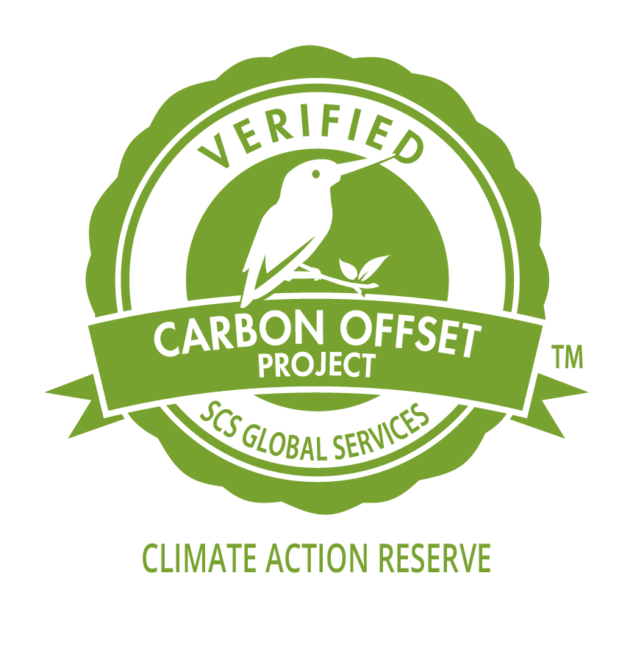
  - Moccasin Mike Landfill Gas Project CAR#406

Reporting Period:
1 January 2016 to 31 December 2016

Prepared for:
The City of Superior, Wisconsin
7 October 2017

Table of Contents
LANDFILL GAS PROJECT VERIFICATION REPORT 1
Verification under the Climate Action Reserve (CAR) 1
Moccasin Mike Landfill Gas Project CAR#406 1
Table of Contents i
Summary 2
Introduction 3
Verification Details 3
Verification Objectives 3
Verification Scope and Criteria 3
Level of Assurance 4
Treatment of Materiality 4
Verification Process 4
Verification Summary 4
Verification Team 6
CAR Landfill Project Requirements 6
Project Description 6
Project Eligibility 7
Location 7
The GHG Assessment Boundary 10
Review of Project GHG Management Systems 10
Quantitative Review of Carbon Reductions and Removals 12
Verification Results 14
Recommendation 15
Appendix A: SCS Certification Mark 16

Summary
This report presents the findings of the verification assessment of the Moccasin Mike Landfill Gas Project (“the Project”) developed by The City of Superior, Wisconsin (“the Project Proponent”). This assessment covers the Moccasin Mike Landfill Gas Project’s greenhouse gas emission reductions reported to the Climate Action Reserve (the Reserve or CAR) for the monitoring period of 1 January 2016 to 31 December 2016. The verification was undertaken to evaluate the Monitoring Report and assess whether the compiled data conforms to the verification criteria.

The evaluation was undertaken using the Climate Action Reserve Verification Program Manual, February 2017 as well as the verification methodology developed by SCS for carbon offset projects submitted to the Reserve.

In the course of the verification assessment, the SCS verifiers developed findings which included New Information Requests (NIRs) and Non-Conformity Reports (NCRs). All New Information Requests and Non-Conformity Reports have been adequately responded to, resulting in their closure.

On the basis of the information provided and the analyses completed, SCS was able to reach a decision on the emissions reduction reported by the Project Proponent to the Climate Action Reserve. SCS verified the adequacy of the information provided in the Monitoring Report, confirming that this document meets the requirements of the Climate Action Reserve standards. Further, SCS was able to reach a positive opinion on the claimed emission reductions and removals presented in the Monitoring Report and on the Reserve website by The City of Superior, Wisconsin. Thus, SCS has verified 36,593 metric tonnes of CO₂e reductions and removals from the Moccasin Mike Landfill Gas Project for the reporting period of 1 January 2016 to 31 December 2016.

Introduction
SCS Global Services (SCS) is a global leader in third-party certification, auditing, testing services, and standards. Established as an independent third-party certification firm in 1984, our goal is to recognize the highest levels of performance in environmental protection and social responsibility in the private and public sectors, and to stimulate continuous improvement in sustainable development. In 2012, Scientific Certification Systems, Inc. began doing business as SCS Global Services, communicating its global position with offices and representatives in over 20 countries. SCS is currently accredited to ISO 14065 for GHG Validation and Verification by the American National Standards Institute (ANSI) and offers carbon offset validation and verification under the Verified Carbon Standard (VCS) and the American Carbon Registry (ACR). SCS also offers carbon offset verification under the Climate Action Reserve (CAR). SCS also offers verification services for the American Carbon Registry (ACR) and the Climate, Community and Biodiversity (CCB) standards.
SCS was commissioned by Element Markets (a contractor to the City of Superior) to undertake an annual project verification of the Moccasin Mike Landfill Gas Project. The project consists of the collection of landfill gas (LFG) from the Moccasin Mike Landfill at 15 Moccasin Mike Road, Superior, Wisconsin, USA, and the subsequent destruction through combustion in an open flare. This report covers the monitoring period of 1 January 2016 to 31 December 2016 as a project deliverable into the Climate Action Reserve.

Verification Details

Verification Objectives
The objective of the verification is to:
- Evaluate conformance with the Landfill project as defined in the criteria stated below.
- Determine with a reasonable level of assurance whether the Project has resulted in the GHG emissions reductions and/or removals as stated in the project documents.
- Evaluate the project planning information and documentation including the determination of project eligibility, project design, baseline and project emissions determination, management systems supporting the project, and methodologies employed for the calculation of GHG emission reductions.

Verification Scope and Criteria
The scope of the verification is defined as an independent and objective review of the project description document, the project’s baseline study, monitoring plan and emissions reductions calculations. The information in these documents is reviewed against the following criteria:
- CAR Landfill Project Protocol Version 3.0, December 2, 2009
- Errata and Clarification LPP Version 3.0, June 18, 2015
- CAR Verification Program Manual, February 8, 2017
- CAR Program Manual, September 1, 2015
- All Verification activities carried out by SCS will follow the requirements of ISO 14064-3:2006 – Specification with guidance for the validation and verification of GHG assertions

Level of Assurance
The level of assurance applied to this verification assessment is Reasonable Assurance as required by the Climate Action Reserve.

Treatment of Materiality
In consideration of the required level of assurance, the needs of the intended user and the requirements of the Climate Action Reserve Program, SCS applied a materiality threshold of 3%. The data reviewed was considered to meet the principles of accuracy, completeness, transparency and is free of material error or omission.

Verification Process

Verification Summary
The verification process consisted of the following:
- Project listed with the Climate Action Reserve:
The Moccasin Mike Landfill Gas Project is listed on the Climate Action Reserve (CAR) website. The City of Superior selected SCS as their verification body.
- Conflict of Interest Review.
A Notification of Verification Activities/ Conflict of Interest (NOVA/COI) form was submitted to CAR. The COI assessment was conducted to identify any potential conflicts interests with the verification/project. No conflicts were identified and a determination of low potential for conflict of interest was received from the Climate Action Reserve prior to the commencement of verification activities in a determination letter dated 25 January 2017.
- Introductory Meeting:
A kick-off meeting was conducted between the verification team and Darienne McNamara and
Catherine Folman of The City of Superior on 03 February 2017. The purpose of the kick-off meeting was to review the timeline of audit; confirm verification criteria; determine any changes in the site, sources, GHG management systems or personnel, and to begin gathering information.
- Desk Review
SCS received and reviewed the Monitoring Report, CAR submittals, and supporting documentation to assess initial conformance with the data requirements of the CAR Landfill Project Protocol. A risk assessment was conducted to identify key factors that impact the reported emission reductions and removals. A Verification Plan was created to focus on the critical elements presenting potential risk for errors with the project.
- Site Visit
Following the desk review, the audit team conducted an on-site audit of the project area on 16 March 2017. The purpose of the site visit was to verify the project equipment, location and eligibility, to review and evaluate the project GHG management systems, data collection and handling, and emission reduction calculations and procedures in place, and to finalize the risk assessment and sampling plan.
- Quantitative Review
An assessment of the emission reduction calculation inputs and procedures was performed to review the quantitative analyses undertaken by the Project Proponent to convert the raw inventory data into emission reduction estimates.
- Findings
Throughout the verification, there is an iterative exchange between SCS and the Project Proponent to gather additional information for review and examination. This exchange includes Findings—New Information Requests (NIR) and Non-Conformity Reports (NCR) —that are issued by SCS to the Project Proponent. The Project Proponent must respond to NIRs and NCRs in order for SCS to render a verification opinion. At this time all Findings have been appropriately addressed by The City of Superior and subsequently closed by SCS.
- Draft Report and Statement
This step in the verification process includes a final review of the submitted data, completion of the Verification Report, and drafting of the Verification Statement. A draft Verification Report and Statement are completed based on the results of the verification assessment.
- Technical Review
The draft report was presented to an SCS lead verifier, independent of the verification, who determined the Verification Statement to be justified given the evidence presented. The Verification Report and Verification Statement were then presented to The City of Superior for review and comment.
- Final Report and Statement
Once The City of Superior approved these documents, SCS uploaded them to the Reserve website for administrative review by CAR. Given a positive review, CAR will register the emissions reductions for the landfill gas project and issue Climate Reserve Tonnes (CRT’s) for a reporting period of 1 January 2016 to 31 December 2016.
- Exit meeting with client:
The exit meeting entails a review of the verification process, summary of the verification findings and to initiate scheduling for the next verification period.

Verification Team
The verification was undertaken by Mark Lutz, contracted Lead Verifier, and the Technical Review was performed by Blake Troxel, Lead Verifier, of SCS.

CAR Landfill Project Requirements
SCS verified the Moccasin Mike Landfill Gas Project against the requirements of the Climate Action Reserve Landfill Project Protocols. The following sections detail the most essential aspects of the verification of the Moccasin Mike Landfill Gas Project.

Project Description
Moccasin Mike is a municipal solid waste landfill with estimated closure of the current design capacity approximately by 2022. Historically, the landfill utilized passive wells and vents that discharged landfill gas (LFG) to the atmosphere. The Moccasin Mike Landfill accepts approximately 128,000 tons of municipal solid waste per year and operates under the State of Wisconsin Department of Natural Resources Solid Waste Facility Operation License #2627. There was approximately 1,944,923 Mg of waste in place as of the end of 2016.

The landfill gas collection and destructive flare system was installed in 2008 and 2009 by the
City of Superior as part of a larger planned landfill capping project. The Moccasin Mike Landfill Gas Project was initiated on April 28, 2009 when the landfill gas collection system and flare began operation and destroying landfill gas. The project started post January 1, 2001, thus meeting the Project Start Date eligibility criteria. At that time, seven gas wells were installed at the facility, expanding the number of gas wells present on-site to twelve.

Just prior to the start-up process, the City realized that the monitoring equipment provided with the flare would not meet the requirements of the CAR program and new equipment would be required. This new equipment, consisting of a continuously reading gas analyzer and flow meter was then ordered and not installed until September 2009. During this interim period, the flare operated on a voluntary basis. On September 10, 2009 the required monitoring equipment was installed and became operational.

Superior does not utilize cellular telemetry to remotely monitor the operation of the system. To transfer data from the data transmitter, an SD card is switched out of the panel each week and data is uploaded onto the City’s electronic file network. The card is switched out by the landfill foreman, who gives it to the office assistant to upload the data. The project uses a secure and reliable process to retrieve the digitally recorded data (flow, methane content, thermocouple temperature) from the data recorder at the flare station.

In addition to Element Markets servers, located in Houston, Texas, Element Markets stores all databases on a separate system in Austin, Texas. The system performs a complete backup of all company databases each night. In the event of catastrophic damage to the building or power failure, Element Markets will still be able to recover all project data.

The project was listed with the Climate Action Reserve under the ID: CAR406. The baseline and monitoring methodology for this project is the CAR Landfill Project Protocol, Version 3.0 (December 2009). The verification team confirmed, during the site visit, that this project is not a bioreactor.

Project Eligibility
There are eligibility rules the Project must meet in order to register reductions with the Climate Action Reserve.

Location
The project is a U.S. based landfill located in the town of Superior, Wisconsin, USA and therefore meets this eligibility requirement.

Project Start Date
As stated in the Landfill Gas Reporting Protocol, pre-existing projects must have a start date on or after 1 January 2001 and must be listed with the Reserve twelve months from the effective date of the protocol (Landfill Project Protocol Version 3.0, December 2009). The start date is defined as the date at which a qualifying destruction device becomes operational.

The Project’s listing on the Climate Action Reserve website indicated the Project Proponent began installation of the landfill gas collection and conveyance system (GCCS) and began continuously flaring gas on 28 April, 2009. The project start date was corroborated by the audit team by reviewing (1) A letter from S.E.H. (31 April 2010) regarding construction completion and startup on 4/28/2009; ("This flare system went through start-up in mid-April….”) and (2) A letter from the State of Wisconsin Department of Natural Resources Compliance Letter of the project May 13, 2009 indicating a startup date of 28 April 2009. This date complies with the protocol definition of “start date” which is the date that methane gas was first continuously destroyed in a qualifying destruction device.

Additionality
Project Proponents must indicate that reductions are above and beyond business as usual. In order to do so, the Project must pass a Performance Standard test and the Legal Requirement test.

Performance Standard
For the Performance Standard test, a project developer may meet eligibility under three possible performance threshold scenarios. The following scenario applies to the Moccasin Mike Landfill Gas Project: “The installation of a landfill gas collection system and a new qualifying destruction device at an eligible landfill where landfill gas has never been collected and destroyed prior to the project start date”.
Review of a 2008 drawing of the landfill and a 2008 Air Permit from the State of Wisconsin Department of Natural Resources (granting approval from the state to operate the flare) both showed no prior installation of any other flares. This drawing along with the Air Permit leads the audit team to reasonably conclude that there was no landfill gas collection system in place prior to the start date of the current offset project.

Legal Requirements
For the Legal Requirements Test, Project Proponents must ensure that emission reductions achieved by the Project would not have occurred in the baseline case due to federal, state, or local regulations.

A review of legal requirements of the Project and the landfill were conducted by the audit team. The results of this review indicated there are no laws, statutes, regulations, court orders, environmental mitigation agreements, permitting conditions, or other legally binding mandates requiring the destruction of landfill gas.

This landfill is subject to NSPS regulations because waste design capacity is greater than 2.5 million mg. NMOC emission rate for 2016 was estimated 12.56 Mg/year. The 2015 NMOC rate was 11.88 Mg/yr. The 2016 emission rate is below the 50 Mg/yr threshold and therefore the landfill was not required to install a gas collection and conveyance system during the reporting period.

Also, The Wisconsin Department of Natural Resources has rules governing the emissions from this facility. The LFG extraction system air pollution control operation permit issued by the DNR (permit #816041600-P01) condition I.A.2, stipulates that the landfill does not require landfill gas emission control since the hazardous air pollutant (HAP) evaluation submitted in December 2013 indicated that the uncontrolled emissions were below applicable thresholds and was not required to install a gas collection and conveyance system.

Lastly, SCS reviewed the Attestation of Voluntary Implementation, signed by the City of Superior Director of Public Works, March 17, 2017. The City of Superior has affirmed that the Project was established and implemented voluntarily and continues to operate as such. Based on this evidence, SCS concludes the Project passes the legal requirements test.

Regulatory Compliance
The audit team reviewed the landfill’s 2016-2017 Solid Waste Facility License, the 2016 Industrial Storm Water Permit and the 2015-2016 Air Permit. Moccasin Mike Landfill is subject to periodic site visits from its permitting agencies for these and other permits

Per site interviews and records provided, there was one instance of non-compliance connected to insufficient cover on part of the landfill (issued by the State of Wisconsin Department of Natural Resources on October 20, 2016.) Noted that that this was not a recurrent non-compliance or non-compliance as a result of negligence or intent and was minor in nature. The verification team confirmed that it did not affect project activities and emission reductions. A letter from the State of Wisconsin Department of Natural Resources (10 February 2017) confirmed that the nonconformance had been addressed and the issue was closed.

SCS reviewed the Attestation of Regulatory Compliance submitted by signed by the City of Superior Director of Public Works, dated March 17, 2017 affirming the Project’s compliance status throughout the project reporting period. In addition, the audit team reviewed the national “ECHO” database’s “Detailed Facility Report” and found no other instances of noncompliance during the reporting period.

As a result of the above, SCS was able to confirm to a reasonable level of assurance that the Project is in compliance with local, state and Federal regulations and had no material regulatory non-conformance events.

Ownership
The City of Superior is the owner of the Moccasin Mike Landfill. Ownership was confirmed through review of various regulatory permits issued from the State of Wisconsin Department of Natural Resources as well as a review of the legal property descriptions. Both the landfill and gas collection system is owned and operated by the City of Superior. The audit team also confirmed The City of Superior retains full, legal, and beneficial title to the carbon offset credits being issued as a result of the collection and combustion of methane at the landfill facility. The audit team reviewed an agreement between the City and Element Markets that explicitly identifies Element Markets as the sole agent for the registration, verification and administrative processing of the project’s CRT’s and the City as the seller of the emission reduction credits.

Lastly, SCS reviewed the Attestation of Title signed and submitted by the City of Superior Director of Public Works, March 17, 2017 - a lawful representative of the City of Superior. This document asserts that the project applicant has legal rights to any emission reduction credits to be issued by the Climate Action Reserve (i.e. Climate Reserve Tonnes). From this evidence, SCS has concluded that the project developer, The City of Superior, is entitled to receive the emission reduction credits that may be issued by the Climate Action Reserve for methane destroyed during this project period.

The GHG Assessment Boundary
The Project includes all emission sources from the operation of the landfill gas collection system to the ultimate destruction of the landfill gas. The sources of GHG emissions reviewed include:

The GHG sources, sinks, and reservoirs associated with the baseline scenario are:
- CH₄ vented to the atmosphere.
- CO₂ from the oxidation of CH₄ by soil bacteria. As the landfills are not covered with a synthetic liner, the CAR Landfill Project Reporting Protocol assumption that 10 percent of the methane produced would be naturally oxidized by soil bacteria has been applied.
The GHG sources, sinks, and reservoirs associated with the project are:
- Un-combusted CH₄ from Landfill gas in the enclosed flare.
- CO₂ from the combustion of fossil fuels used during operation and maintenance activities for the project activity.
- CO₂ resulting from the consumption of imported electricity.
The gases reviewed include CO₂ and CH₄. All gases are converted to CO₂ equivalents.

Review of Project GHG Management Systems
During the site visit, a review of the Project’s greenhouse gas management systems was detailed with the Project Proponent. This review included a detailed look at the Project’s data handling and processing procedures, recordkeeping and data storage and the quality control and assurance procedures. The following is the result of this review:

The primary data gathered for the Project is landfill gas flow, pressure, temperature and methane content of the landfill gas. A Rosemount Mass Flow Transmitter, Model 3051MFA (Sn: 434191) continuously monitors flow after the blower and a knockout prior to combustion in to the destruction device. The position of the flow meter is adequate to ensure laminar flow. This meter was factory calibrated prior to installation with the last calibration completed by an authorized representative on 24 August 2016. Prior to this calibration, the standard condition was set to 60 degrees and 1 atm. After the 24 August 2016 calibration, the standard condition set to 85 degrees F and 1 atm. This was due to a known problem with this flow meter set at 60 degrees, but corrected if set at 85 degrees F. The audit team reviewed the data after the 24 August 2016 calibration and verified that the data set for this period was corrected to the standard 60 degrees required by the protocol.

It was also noted that the project follows the recommended factory calibration recommendations of 3 years with the last factory calibration on 12 December 2013. The calibration certificates were reviewed by the project team and indicate that the instrument is reporting accurate data.

The instrument is field cleaned and inspected on a quarterly basis by Aspect Electrical Engineering and Services, LLC and a quarterly monitoring and maintenance report is created for each inspection. This report includes as found/as left conditions of the flow meter, destruction device, and associated equipment. This report includes as found/as left condition of the flow meter with % drift noted. The audit team reviewed the reports to ensure that the quarterly cleaning and inspection was carried about according to the protocol’s requirements. In addition, the audit team verified that all quarterly checks showed a drift of less than 5% with the last check being within 2 months of the end of the reporting period.

The project monitors methane gas using an in-line Siemens Ultramat 23 Continuous Gas Analyzer (Sn: X4-442.) The methane concentration readings are monitored at 1-minute intervals and recorded at 8-minute intervals, along the the flowmeter and flare temperature.

Siemens, the manufacturer of Ultramat 23, recommends calibration of the gas analyzer with calibration gas on an annual basis and factory re-calibration every five years. The audit team noted that the last factory calibration was 29 July 2015 with the previous factory calibration on 31 August 2010. This frequency meets both Sieman's factory calibration recommendations and protocol requirements.

As with the flow meter, the analyzer is field cleaned and inspected on a quarterly basis by Aspect Electrical Engineering and Services, LLC and a quarterly monitoring and maintenance report is created for each inspection. This report includes as found/as left condition of the analyzer with % drift noted. The audit team reviewed the reports to ensure that the quarterly cleaning and inspection was carried about according to the protocol’s requirements. In addition, the audit team verified that all quarterly checks showed a drift of less than 5% with the last check being within 2 months of the end of the reporting period.

There were several instances during the current reporting period in which , due to problems, that either the flowmeter (shorting out) or the analyzer (stuck solenoid) were not working properly. The audit team confirmed that the Project Proponent did not use data substitution methods for these periods. In addition, the audit team reviewed the raw data and verified that no credits were claimed for these periods.

The LFG Shaw Model PCFT62216 Landfill Gas Flare maintains normal operation between 1,400 – 1,600 degrees. The performance of the thermocouple is monitored and in the event of error in the units, maintenance is performed. The flare will automatically shut off in the event of low flare temperature and poor gas quality. For the current reporting period, any interval of time in which the temperature fell below 500 degrees the project reported zero credits as directed in the protocol.

All of the flow, analyzer and temperature data for the reporting period was monitored and recorded. Superior does not utilize cellular telemetry to remotely monitor the operation of the system. To transfer data from the data transmitter, an SD card is switched out of the panel each week and data is uploaded onto the City’s electronic file network. The card is switched out by the landfill foreman, who gives it to the office assistant to upload the data. A document retention system is in place at Superior, described in the Monitoring Plan. Many records are redundant and stored in multiple locations (City of Superior and Element Markets with backups on both)

A project design document and monitoring plan have been created for the Project. The contents of the monitoring plan were thoroughly reviewed and observed to meet the requirements of the Landfill Gas Project Protocol.

Quantitative Review of Carbon Reductions and Removals
SCS devoted a portion of the verification assessment to the review of the manner and propriety by which The City of Superior quantified their net GHG reductions and removals. This assessment included a review of the baseline determination, review of project assumptions, raw data inputs and accuracy of calculations. The formulas and raw data inputs used to determine emission reduction calculations as described in the Project Design Document and the calculation spreadsheets were first reviewed for compliance with the Landfill Project Reporting Protocol. The main parameters of Equation 5.1 were verified as follows:

Total Annual Methane Emissions Destroyed By The Project Landfill Gas Collection And Destruction System (CH4 Dest_{PR})

The amount of methane destroyed is calculated from the continuously metered landfill gas flow data.
For the verification period, data was electronically aggregated on a one minute interval for the flare.
The main monitored parameters needed to calculate the amount of methane destroyed are:

LFG _{I,t} = total quantity of landfill gas fed to the destruction device and
PR_{CH4} _{i,t} = the average methane fraction of the landfill gas in time interval t as measured

Flare flow is first adjusted for low temperature by manually voiding the flow for any period when the flare temperature is below the threshold of 500 degrees F. Incremental flow is then calculated by summing the flare flow for each interval period to produce an increment total. The incremental methane destroyed is calculated based on weekly measured methane concentration with temperature and pressure taken into consideration. Total daily destroyed methane is carried forward into further calculations for the flare to determine emission reductions for the project.

Adjustment For Landfill Gas Flow Metering Equipment For Temperature And Pressure
The project flow meter automatically corrected for the temperature and pressure of the landfill gas and no additional calculations were necessary because the flow meter was originally set at 60 degrees F and 1 ATM. Noted that, after 24 August 2016, that due to technical problems with the flow meter, the setting was changed to 85 degrees F and 1 ATM. This necessitated an adjustment in the calculations during this time period to reflect the protocol requirements for flow volume to be the standard 60 degrees F and 1 ATM.

Default Methane Destruction Efficiency For Device (Dei)
The value applied was 0.96 for an open flare as prescribed by the protocol. The Project Developer applied the protocol default guidance of a 500 degree F temperature minimum to emission reduction calculations to ensure 96% destruction efficiency of the flare.

Factor For The Oxidation Of Methane By Soil Bacteria (OX)
The project does not incorporate a synthetic liner in its cover system; therefore a 10% methane soil oxidation factor was applied to the baseline scenario.

Discount Factor To Account For Uncertainties Associated With The Project Monitoring Equipment (DF)
As per the methodology, DF equals to zero if using continuous methane monitor with no missing data and all calibration tests are within a 5% margin of error. It was verified that measurement readings were taken with a continuous analyzer and that calibration certificates indicated that instruments were within the thresholds for permissible error. Therefore, the project did not apply a discount factor because of the use of continuous methane concentration readings.

Adjustment To Account For Pre-Project LFG Destruction Device (PRE_{discount})
An adjustment to the project baseline was not necessary because there was no installation of a pre-project destruction device.

Total Annual Indirect Carbon Dioxide Emissions From The Consumption Of Electricity From The Grid (EL_{CO2}) and Total Annual Carbon Dioxide Emissions From The Destruction Of Fossil Fuel (FF_{CO2})
CO2 emissions result from consumption of electricity to power project equipment and activity data for this source was tracked by reviewing utility invoices from the power supplier. Direct CO2 emissions result from propane used to assist the ignition of the flare. This activity data is taken from purchase invoice monthly totals and estimates from propane used. The emission factors for electricity and propane were verified and no material errors were found.

Project emissions consisting of indirect emissions from electricity and direct emissions from propane use are subtracted from the total amount of methane destroyed. The values are presented in the final calculation spreadsheets for the verification period.

Missing Data Procedures
Missing Data calculation procedures were reviewed for consistency with the Landfill Gas Protocol requirements as part of this verification. Missing Data procedures were not applied to the data in this verification period.

Verification Results
The verification of Moccasin Mike Landfill Gas Project focused on the accurate collection of data and quantification of emission reductions as implemented by The City of Superior in accordance to with the Landfill Project Protocol. A sample set of raw flow data (consisting of landfill gas flow, and temperature) and methane concentration was selected and reviewed in order to identify material misstatements due to transcription mistakes, mathematical errors or malfunction of instrumentation. The emission reduction calculations were recalculated by the audit team and found to be conformance with the Landfill Project Protocol.

The following provides a summary of the verification results in metric tons of carbon dioxide equivalent (tCO₂e):

Emissions Verified (t CO₂e) | 1 January 2016– 31 December 2016
Baseline Emissions | 36,644
Project Emissions | 51
Pre-Discount | 0
Total Emissions Reductions | 36,593
Throughout the verification process, SCS made several supplemental documentation requests in the form of New Information Requests and Non Conformances. These requests provided clarification regarding the project. The Findings from the verification of the Moccasin Mike Landfill Gas Project are compiled in a separate “List of Findings” and are available under separate cover. The List of Findings is only shared between the Project Proponent and verifier and is not publicly available.

Recommendation
The Lead Verifier recommends that SCS Global Services issue a positive verification opinion for the following:
Name & Address | Darienne McNamara  Environmental Regulatory Manager  1316 North 14th Street, #200  Superior WI 54880
Scope of Verification | Emission reductions arising from the capture and destruction of Landfill Gas Methane from :  Moccasin Mike Landfill
Reporting Period | 1 January 2016 to 31 December 2016
Total GHG Emission Reductions Verified | 36,593 metric tonnes CO₂e
GHG Protocol(s) Used for Verification | - CAR Landfill Project Reporting Protocol Version 3.0, 2 December 2009  - Errata and Clarification LPP Version 3.0, 18 June 2015  - CAR Verification Program Manual, 8 February 2017  - CAR Program Manual, 1 September 2015  - All Verification activities carried out by SCS will follow the requirements of ISO 14064-3:2006 (Specification with guidance for the validation and verification of GHG assertions)
Lead Verifier’s Approval | 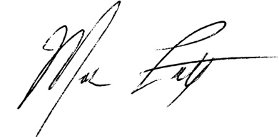  Mark Lutz, 07 October 2017
Technical Reviewer’s Approval | 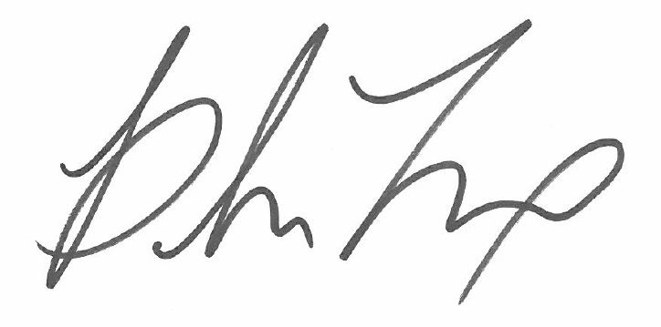  Blake Troxel, 31 October 2017
Date of Verification | 16 March 2017

Appendix A: SCS Certification Mark
Congratulations on receiving a positive verification for Moccasin Mike Landfill Gas Project. Your project is now eligible to use the SCS Kingfisher Certification Mark B for Carbon Offset Project Verification, as represented on the cover page of this verification report. The SCS Kingfisher Certification Mark increases the recognition of your achievements with your verification carbon offset project.
Please refer to the SCS Kingfisher Certification Mark Labeling and Language Guide: Mark B provided to you by the GHG Verification Program staff for more information about your Mark and usage. Should you have any additional questions regarding your Mark, use, messaging, or other marketing opportunities, please contact the GHG Verification Team or SCS Marketing Staff at NRmarcom@scsglobalservices.com.

