Monitoring Report

PUBLICATION DATE 14.10.2020
VERSION v. 1.1
RELATED SUPPORT – TEMPLATE GUIDE Monitoring Report v. 1.1

This document contains the following Sections
Key Project Information
SECTION A - Description of project
SECTION B - Implementation of project
SECTION C - Description of monitoring system applied by the project
SECTION D - Data and parameters
SECTION E - Calculation of SDG Impacts
SECTION F - Safeguards Reporting
SECTION G - Stakeholder inputs and legal disputes

KEY PROJECT INFORMATION
GS ID (s) of Project (s) | GS11207
Title of the project (s) covered by monitoring report | Multi-Layer Household Water Filtration System in Kenya
Version number of the PDD/VPA-DD (s) applicable to this monitoring report | 06
Version number of the monitoring report | 03
Completion date of the monitoring report | 04/04/2023
Date of project design certification | 17/11/2021
Date of Last Annual Report | N/A
Monitoring period number | 2nd
Duration of this monitoring period | The 2nd monitoring period, first and last days included (01/08/2021 to 31/07/2022)
Project Representative | The official focal point and developer:  Profit Carbon Environmental Energy Technology (Shanghai) Co., Ltd.  Project owner:  Climate Neutral Kenya Limited
Host Country | Republic of Kenya
Activity Requirements applied | Community Services Activities  Renewable Energy Activities  Land Use and Forestry Activities/Risks & Capacities  N/A
Methodology (ies) applied and version number | Methodology for Emission Reductions from Safe Drinking Water Supply (Version 1.0)
Product Requirements applied | GHG Emissions Reduction & Sequestration  Renewable Energy Label  N/A

Table 1 - Sustainable Development Contributions Achieved
Sustainable Development Goals Targeted | SDG Impact | Amount Achieved | Units/ Products
SDG13 Climate Action (mandatory) | Emissions Reductions | 377,528 | VERs
SDG6 Clean Water and Sanitation | Total number of person.days served with satisfactory level of safe water | 587,942,956 | Person.days
SDG7 Affordable and Clean Energy | Number of water purifiers sold each year | 0. | Units
SDG8 Decent Work and Economic Growth | Number of males and females employed by the project | 12 jobs created including 6 males and 6 females | Numbers
SDG8 Decent Work and Economic Growth | Percentage of employees with salaries paid at par with the average wage of Kenya. | 100 | %

Table 2 – Product Vintages
SDG13 |  | Amount Achieved
Start Dates | End Dates | VERs(tCO₂e)
01/08/2021 | 31/12/2021 | 159,293
01/01/2022 | 31/07/2022 | 218,235

SDG7 |  | Amount Achieved
Start Dates | End Dates | Number of water purifiers sold (Units)
01/08/2021 | 31/12/2021 | 0
01/01/2022 | 31/07/2022 | 0

SDG6 |  | Amount Achieved
Start Dates | End Dates | Total number of person.days served with satisfactory level of safe water(person.days)
01/08/2021 | 31/12/2021 | 248,071,737
01/01/2022 | 31/07/2022 | 339,871,219

SDG8 |  | Amount Achieved
Start Dates | End Dates | Number of males and females employed by the project
01/08/2021 | 31/12/2021 | 12 jobs created including 6 males and 6 females
01/01/2022 | 31/07/2022 | 12 jobs created including 6 males and 6 females

SDG8 |  | Amount Achieved
Start Dates | End Dates | Percentage of employees with salaries paid at par with the average wage of Kenya
01/08/2021 | 31/12/2021 | 100%
01/01/2022 | 31/07/2022 | 100%

- DESCRIPTION OF PROJECT
  - General description of project
>>
The Multi-Layer Household Water Filtration System in Kenya (hereinafter referred to as “the project”) is implement in Republic of Kenya. The project will be sold 644,850 water purifiers to residents in Makueni County, Trans Nzoia County, Kirinyaga County, Bungoma County and Nakuru County of Kenya. The water purifiers of the project will offer an affordable, long-term and zero emission solution for households that generally consume unsafe drinking water. It will not only dramatically increase access to safe drinking water but also reduce consumption for woody fuels previously required to treat drinking water, which will decrease environmental degradation and greenhouse gas emissions.

It is estimated that about 644,850 water purifiers will be sold and about 2.5149 million people would have access to clean water during the first crediting period. 459,638 tCO₂e emission reductions will be produced annually and the total emission reductions during the first crediting period is 2,298,193 tCO₂e.

The first monitoring period of this project is from 10/10/2020 to 31/07/2021. During the first monitoring period, total 467,123 sets project water purifier were sold. This monitoring period is the second monitoring period which is from 01/08/2021 to 31/07/2022, according to the sales plan, total 190,082 units water purifier should have been sold. Influenced by international environment and regional market saturation and as per prediction on future water purifier market, the project owner adjusted the corresponding business plan in December 2020 and decided to suspend the sales work in project area, and expand to other regions of Kenya as well as other countries of Africa, so, no water purifiers were sold during this monitoring period, so the water purifier operated in this monitoring period are still those sold in the first monitoring period, and the total emission reductions achieved in this monitoring period is 377,528 tCO₂e.

  - Location of project
>>
The project crosses five counties of Kenya (Kenya has a latitude of 0.0236°S, and longitude of 37.9062° E), including Makueni County (1°48′S and 37°37′E), Trans Nzoia County (1°6'N and 34°57'E), Kirinyaga County (0°30′S and 37°17′E), Bungoma County (0°34′S and 34°34′E) and Nakuru County (0°18′S and 36°4′E). The location of the project is illustrated in Figure 1.
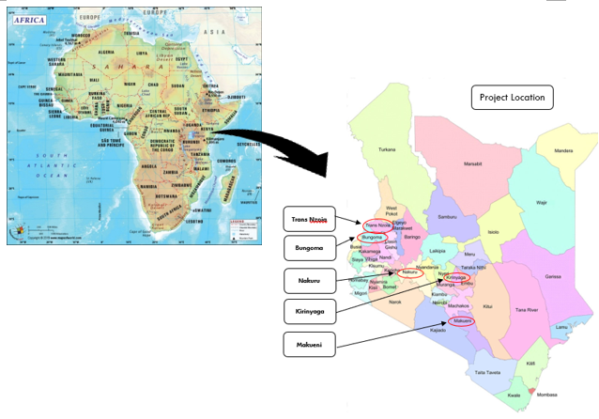
Figure 1 The Geographic Location of the project
  - Reference of applied methodology
>>
Methodology for Emission Reductions from Safe Drinking Water Supply (Version 1.0) is applicable to the project. The methodology can be obtained from the following URL:
https://globalgoals.goldstandard.org/429-ee-sws-emission-reductions-from-safe-drinking-water-supply/
  - Crediting period of project
>>
Start date of crediting period: 10/10/2020
End date of crediting period: 09/10/2025
Total length of crediting period: 5 years renewable (two renewal cycles and in total 15 years).
Expected operational lifetime of the project: 15 years.
- IMPLEMENTATION OF PROJECT
  - Description of implemented project
>>
The project owner (Climate Neutral Kenya Limited) invested in purchasing the Multi-Layer water purifiers produced by Zhejiang Duanqi Renewable Energy Co., Ltd., and sold the Multi-Layer water purifiers in Makueni County, Trans Nzoia County, Kirinyaga County, Bungoma County and Nakuru County of Kenya. For this project, the sold of water purifiers started on 09/10/2020 which is the date of Sales contract signed between the project and the End-user and the date of implementation of the first water purifiers. The current monitoring period is the second monitoring period. In the first monitoring period (10/10/2020-31/07/2021), total 467,123 sets project water purifier were sold, in this monitoring period, no water purifiers were sold. So, all water purifiers operated in this monitoring period is the 467,123 sets water purifier sold in the last monitoring period, thus, all the water purifier operated in this monitoring period have the same age.

The main action made for the project implementation during this motoring period are generalized in the following:
Table 1 The main action made for the project implementation
Time | Milestone
07/08/2020 | Completion of the project proposal (Including sales plan for the water purifiers and prior consideration of carbon revenue).
25/08/2020 | Conducted business management meeting determining to apply for Gold Standard certification of this project.
09/10/2020 | Start date of the project (first purchase receipt for the water purifier sold to an end-user).
10/10/2020 | Start date of the crediting period
01/12/2020 | All water purifiers put into operation
17/11/2021 | The date of project complete design certificated
02/03/2022 | The Monitor staff training time
16/03/2022-17/03/2022 | Usage rate survey
12/04/2022-13/04/2022 | Project survey
17/05/2022-19/05/2022 | Water hygiene education campaigns and water quality test sampling
01/05/2022-29/07/2022 | Water purifier filter replacement

The proposed project involves in sold Multi-Layer water purifiers in Makueni County, Trans Nzoia County, Kirinyaga County, Bungoma County and Nakuru County of Kenya. The Multi-Layer water purifiers will displace the use of woody fuels traditionally used to treat drinking water. The water filtration system requires no energy input or consumables, so, the Multi-Layer water purifiers is not only dramatically increase access to safe drinking water but also reduce consumption for woody fuels previously required to treat drinking water, which will decrease environmental degradation and greenhouse gas emissions. For this project, the sold of Multi-Layer water purifiers started on 09/10/2020 and total 467,123 water purifier were sold in the first monitoring period, no water purifier was sold in this monitoring period. So all Multi-Layer water purifiers operated in this monitoring periods have the same age.

The Multi-Layer water purifiers involve in this project consist of 8 step filtration system and can purify water 3 liter/hour. The lifespan of the water purifiers are over 15 years and the dome ceramic, carbon cartridge and mineral stone should be changed when purify every 10,000 L water. A whole set of the alternative dome ceramic, carbon cartridge and mineral stone will be supplied to the end-users together with the water purifiers. All the alternative filtration system can be changed easily and will not affect the usage of the water purifiers on that day. Considering carbon revenue of the project, some alternative materials needed will be provided by the project owner for free, such as Dome ceramic filter, Mineral stone, Granular activated carbon, Silica sand, Zeolite, Magnetic Water Tap.
The Step Filtration System in the project are listed below:
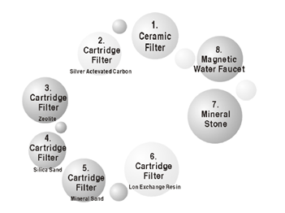
Figure 2 Step Filtration System
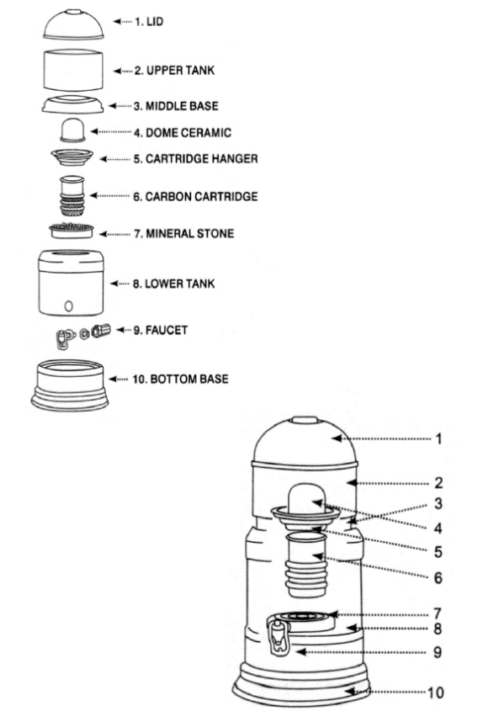
Figure 3 Components of the Water Purifier

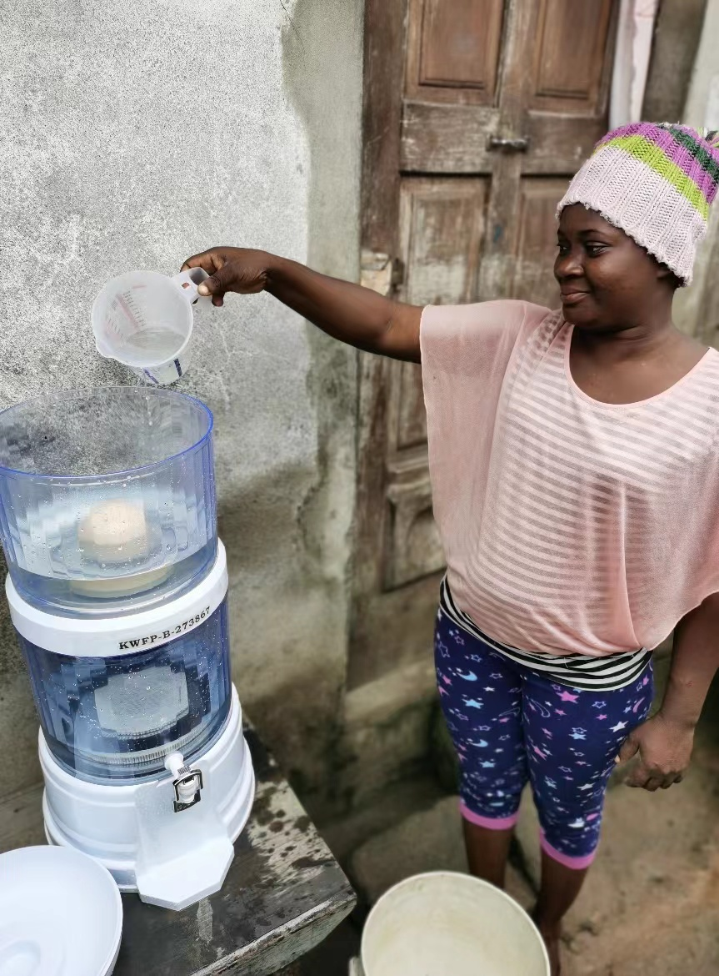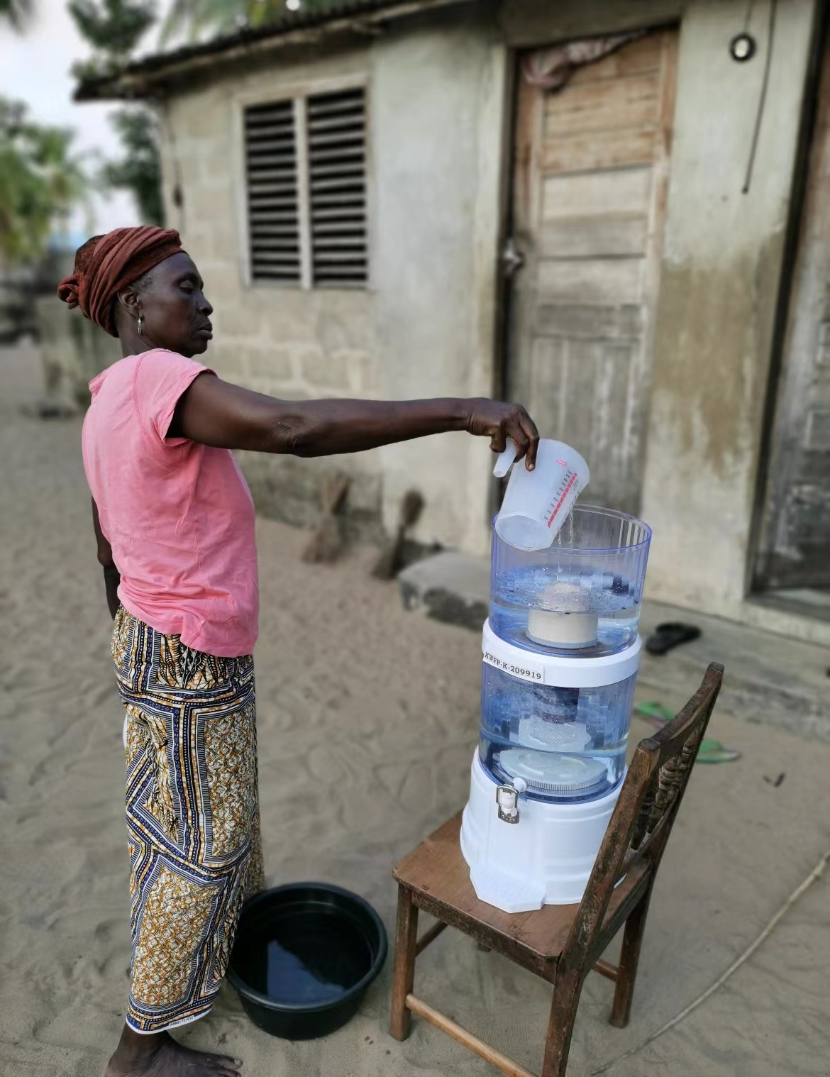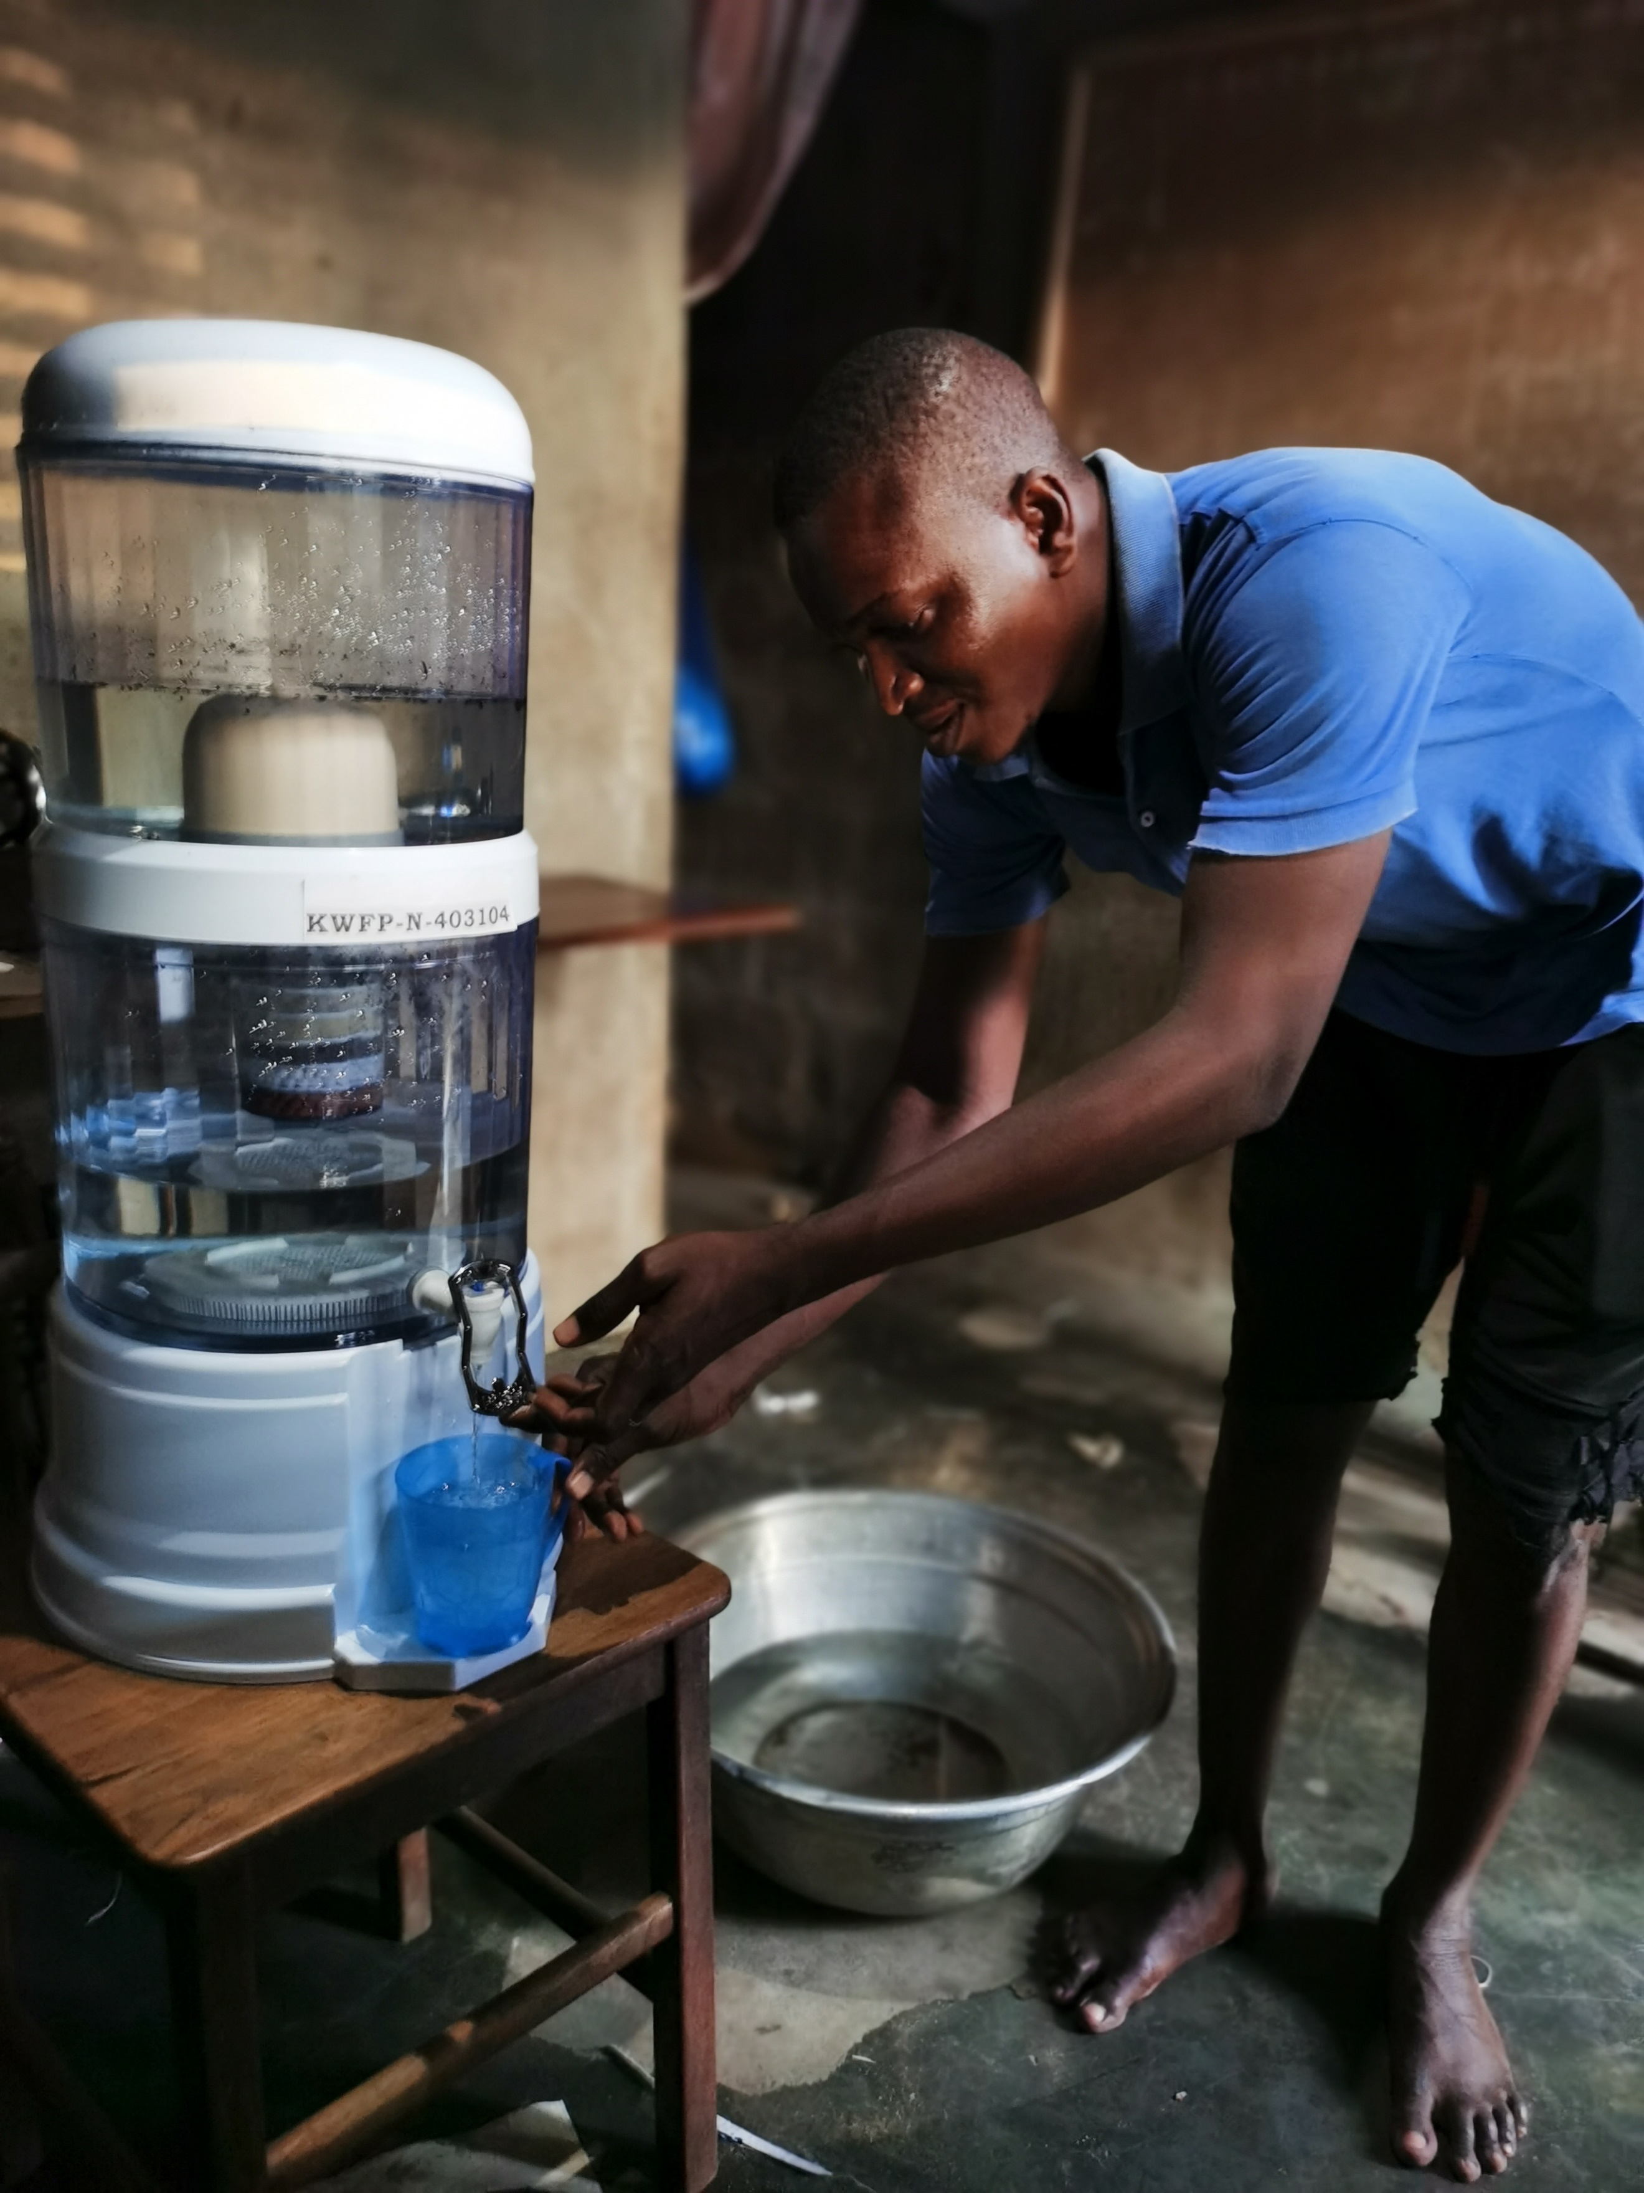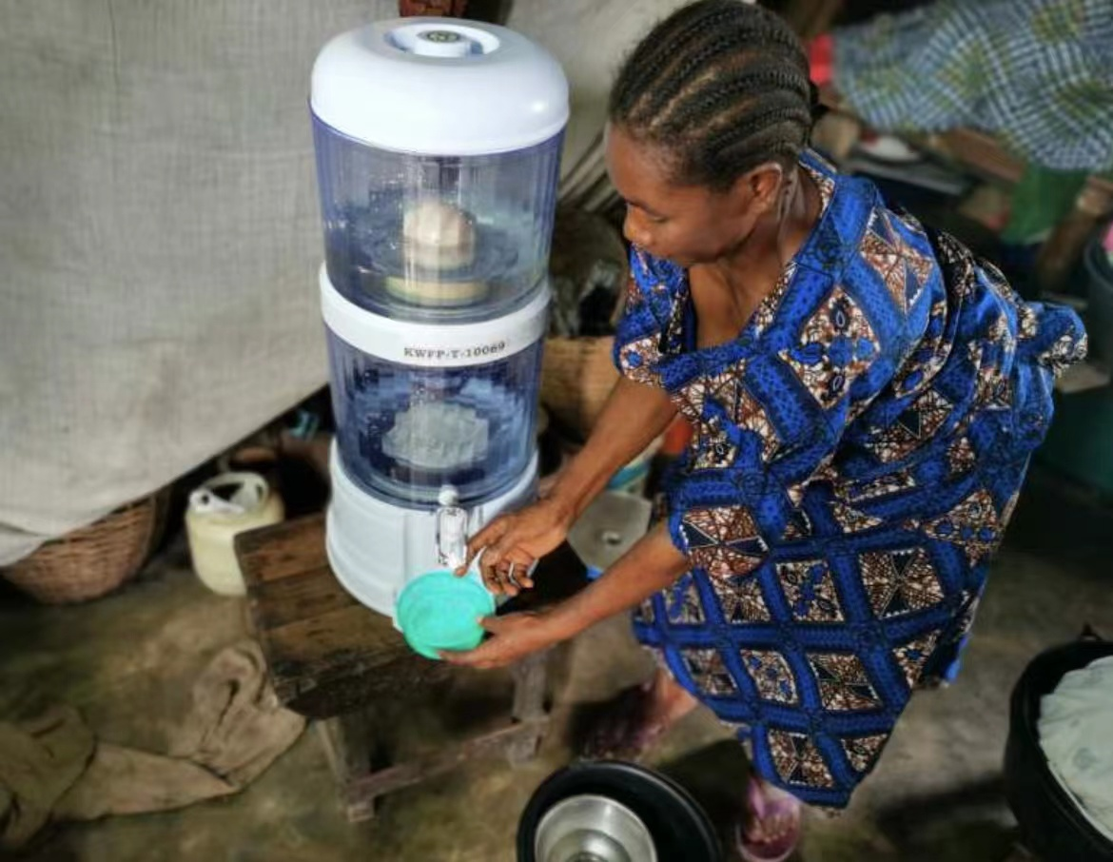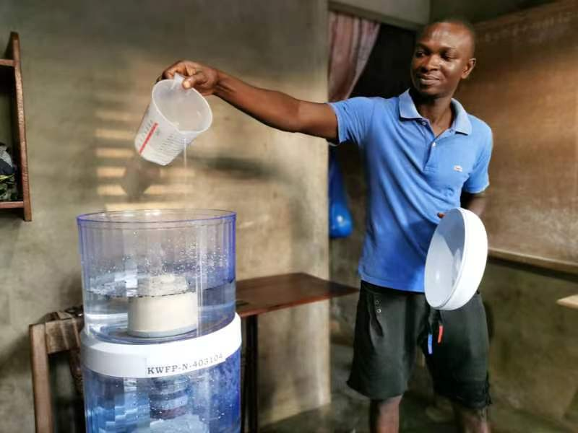
Figure 4 Examples of the Water Purifier engaged in the project
The water purifier sold in this project has a unique number, and during use, due to the quality of the water purifier itself, the project owner is responsible for the replacement of parts and other alternative materials to maintain the normal use of the water purifier. The maintenance situation in this monitoring period such as parts replacement were carried out smoothly, without affecting the normal use of the water purifier. The actual operation situation of this monitoring period has no change comparing with the PDD.

    - Forward Action Requests
>>
As this monitoring period is the 2nd monitoring period, so this part should describe the “Declare any Forward Action Requests from the performance certification no.1, design certification and validation”.
For design certification, there are three FARs need to be clarify, the first two FARs have been addressed during the design review and performance review no.1, now, only FAR#3 needs to be addressed.
For performance certification no.1, there are two FARs need to be clarify, the second FAR is consistent with the FAR#3 in design review. The first FAR is address as follows.
For FARs from project validation, there are three FARs to be clarify, among them, the FAR#03 is consistent with the FAR#3 from design certification stage.

The specific description is as follows:
FAR#01 from design review and project validation: During verification, the PP must demonstrate that the project area does not overlap with that of another Gold Standard or other voluntary or compliance standard programme of a similar nature. E.g., if the household use water from boreholes which the clean water is claimed by existing carbon project, that same amount of water will be double counted under this project activity.
Reply: In order to avoid the double counting and the overlap with that of another Gold Standard or other voluntary or compliance standard programme of a similar nature. When the water purifier was sold, the user's related information (include the date of sale, Geographic area of sale, Model/type of project technology sold and unique water purifier serial number, Mode of use: commercial, institutional, domestic and other, Number of water purifiers sold, Name, telephone number and address) will be recorded. For the water purifiers sold by the project, the cross-serial number is not allowed between different projects and each project has a unique serial number naming rule. Furthermore, each water purifier also has its unique serial number, if there are other water purifier that don’t belong to the proposed project was used within the project boundary, these water purifiers will not have the unique serial number and will not be taken into account.
Also, from the project survey, the end users are Investigated whether to participant in another Gold Standard or other voluntary or compliance standard programme of a similar nature and the source of drinking water that is usually collected. The results showed that project users did not participate in another Gold Standard or other voluntary or compliance standard programme of a similar nature, and the water source is a nearby river, so the end users involved in this project will not overlap with that of another Gold Standard or other voluntary or compliance standard programme of a similar nature.

FAR#02 from design review and project validation: The VVB shall verify the replacement for the core filters after their lifetime and the availability of the spare filter at user premises.
Reply: The full original version of technical manual of water filter manufacturer has been provided to VVB, and from this document, it can be confirmed that the technology of the water
purifier involved in this project is over 15 years. In addition, when the water purifier has been used for less than 22 months, if the user needs to replace the filter element, a request can be sent to the project owner, and the user can use a spare filter element during the time period when the project owner comes to replace it. Of course, after receiving the request, the project owner will immediately go to the user’s home to replace the core filter. When the water purifier has been used for 22 months, the project owner will replace the alternative materials of all the water purifier sold. This monitoring period ends on 31/07/2022, its exactly 22 months, all of the project core filter have been replaced during this monitoring period, the replacement of filter element has been recorded in the " replacement and maintenance record", which can be verified by VVB on site.
The water purifier is also presented with a filter element as a spare when it is sold, during the on-site audit of VVB, the availability of spare filter element can be shown to VVB for verification.

FAR#3 from design certification stage and project validation: The VVB shall randomly visit and interview the retailers from the list of retailers that provided by PP during Design Certification to verify the date, number of sales, procedure of recording the sales to PP's database.
Reply: For this project, Climate Neutral Kenya Limited took advantage of the sales network that TRIOPT AFRICA LIMITED had built and delegated the sales work to TRIOPT AFRICA LIMITED, with their help, achieved gratifying sales performance. The specific sales model of this project is as follows: In areas with relatively prosperous economy, such as main urban areas and counties,
TRIOPT has set up special sales points to sell products directly. In relatively remote townships and rural areas where the economy is slightly underdeveloped, the sales work was conducted by using the distribution network (for example, township convenient stores, rural shops) established by TRIOPT, i.e., using the local resellers developed by TRIOPT to sell the water purifiers. There are 224 sales points in this project (including the project owner's own direct special sales points and the local resellers it develops).
At the same time, each county will establish a sales management center to be responsible for statistics and analysis of sales in each county, and to solve various problems from the sales process. For the specific assignments, TRIOPT designated its five staff with professional sales experience as sales management center manager to respectively take charge of the sales of water purifiers in above five counties by means of the distribution network and connections established and obtained by TRIOPT in telecom industries over the years.
No matter what kind of sales model, at a time of water purifier pick up, the salesperson in special sales points and the local resellers will record the buyer's information (such as name, gender, age, address etc.) and the water purifier serial number. And the end user signs a sales contract with the project owner to give up carbon emission ownership and get a receipt issued by the seller. The sales management center picks up the sales contract and the copy of this receipt weekly and summarizes the information of end users on the contracts weekly, and then forwarding the sales contract and the copy of this receipt to project owners, the contract and a copy of this receipt are kept by project owner.
The retailer instructions and the reseller list has been provided to VVB and all the information can be verified by the VVB and VVB can interview the retailers for on-site visit during this monitoring period.

FAR#1 from performance review: To ensure transparency of sampling process, the PP shall use the online number generator and keep the screenshot of generated result.
Reply: The sampling process of this project in this monitoring period was implemented by online number generator (https://www.randomizer.org/), and the screenshot of generated result have been provided to VVB for verification.
  - Post-Design Certification changes
>>
    - Temporary deviations from the approved Monitoring & Reporting Plan, methodology or standardized baseline
>>
None.
    - Corrections
>>
None.
    - Changes to start date of crediting period
>>
None.
    - Permanent changes from the Design Certified monitoring plan, applied methodology or applied standardized baseline
>>
None.
    - Changes to project design of approved project
>>
None.

- DESCRIPTION OF MONITORING SYSTEM APPLIED BY THE PROJECT
>>
According to section B.7.1 of the PDD, there are fourteen parameters to be monitored:
(1) Water hygiene education campaigns.
(2) Number of water purifiers sold in year y.
(3) Ongoing water quality indicated as the fraction of the samples that pass microbial quality standard requirements specified in relevant microbial quality standard for drinking water of the host country (KS EAS 153: 2018 East African Standard Specification for Packaged Drinking Water), M_{q,y};
(4) Number of individuals per premises type p in the project boundary in year y, HN_{p,y};
(5) Accumulated number of premises type p with at least one individual project technology in year y, N_{p,y}.
(6) Average days the project technology is present for end-users in the premises p in year y, DP_{p,y}.
(7) Usage rate of the project technology by premises type p during year y, U_{p,y}.
(8) Volume of drinking water per person per day for premises type p, QPW_{p}.
(9) Average number of individual project technologies in each project premises type p in year y, DN_{p,y}.
(10) Usage time of the project technology by premises type p in year y, t_{p,y}.
(11) Proportion of project households that boil safe (treated, or from safe supply) water after installation of project technology in year y, X_{cleanboil,y}.
(12) Leakage emissions during year y, LE_{y}.
(13) Number of males and females employed.
(14) Percentage of employees with salaries paid at par with the average wage of Kenya.

For parameter 2 and parameter 5: Number of water purifiers sold in year y and Accumulated number of premises type p with at least one individual project technology in year y. According to sales database, PP can obtain those two parameters.

For parameter 6: Average days the project technology is present for end-users in the premises p in year y. According to sales database, PP can know the sales date of the water purifier equipment, and then get the actual operating days of every equipment during the monitoring period. The average days the project technology is present for end-users can be calculated by the sum of the actual operating days of each water purifier divided by the total number of water purifiers. As no water purifier sold in this monitoring period, so the water purifier operated in this monitoring period is the 467,123 sets water purifiers sold in last monitoring period, so the DP_{p,y} used in the emission reduction calclations for this monitoring period is the number of days in this monitoring period.

For parameter 9: Average number of individual project technologies in each project premises type p in year y. As description in PDD, to cover more households with high-quality water purifiers at a lower price, it is restricted in the project that each household can only buy one set of water purifier. Also, according to sales database, Average number of individual project technologies in each project premises is 1.

For parameter 10: Usage time of the project technology by premises type p in year y, according to applied methodology and PDD, value(s) applied of this parameter is default of 5 hours.

For parameter 12: Leakage emissions during year y, according to the applied methodology, If the ex-ante evaluation shows that leakage emissions are less than 5% of total emission reductions, then no monitoring is needed, and emission reductions simply shall be adjusted 5% down. In the PDD, the leakage emissions are less than 5% of total emission reductions, so, the leakage emissions in this monitoring period are 5% of the total emission reduction.

For parameter 13: the number of males and females employed by this project can be obtained from employment records and cross-checked with labor contract, 12 jobs (including 6 females and 6 males) for local people were created in the 2nd monitoring period.

For parameter 14: the percentage of employees with salaries paid at par with the average wage of Kenya, according to the employment records or Payroll, the salary of all employees is higher than or equal to the Kenyan average salary.

Above all, the monitoring system only need to address the monitoring of Water hygiene education campaigns, M_{q,y}, HN_{p,y}, U_{p,y}, QPW_{p} and X_{cleanboil,y}. Below is the organization structure of the monitoring system for the related parameters.
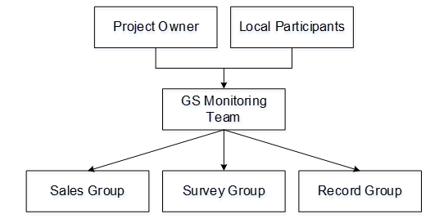
Figure 5 The organization of the project monitoring
Responsibility of each group are summarized as follows:
Local participants: For this project, the local participant is-TRIOPT AFRICA LIMITED, which is a subsidiary of TAL HOLDING LIMITED (one of the funders of the project owner CNKL). Based on the trend of common interests and trust, a better internal communication mechanism will be more conducive to the development of sales and develop the project as an emission reduction project under the GS mechanism.

TRIOPT AFRICA LIMITEDTAL is a subsidiary under TAL HOLDING LIMITED, which is an independent, ambitious and fast growing in African telecom sector. It has years of professional distribution experiences in telecom industry within East Africa across Kenya, Tanzania, Uganda, Rwanda and Mozambique. TAL HOLDING LIMITED had cooperated with ROTOR ENERGY TECHNOLOGY CORPORATION LIMITED to carry out Akon Lighting Africa Initiative, which covered 25 African counties, provided solutions to the energy poverty in rural areas in Africa through innovative, clean and accessible solar solutions. The shareholding structure is as follows:
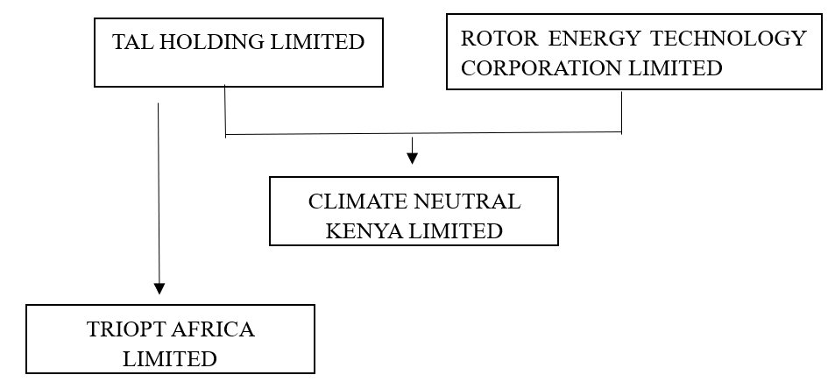
Figure 6 The shareholding structure of the project owner and local participant

For this project, Climate Neutral Kenya Limited took advantage of the sales network that TRIOPT AFRICA LIMITED had built and delegated the sales work to TRIOPT AFRICA LIMITED, with their help, achieved gratifying sales performance. The specific sales model of this project is as follows: In areas with relatively prosperous economy, such as main urban areas and counties, TRIOPT has set up special sales points to sell products directly. In relatively remote townships and rural areas where the economy is slightly underdeveloped, the sales work was conducted by using the distribution network (for example, township convenient stores, rural shops) established by TRIOPT, i.e., using the local resellers developed by TRIOPT to sell the water purifiers. There are 224 sales points in this project (including the project owner's own direct special sales points and the local resellers it develops).
At the same time, each county will establish a sales management center to be responsible for statistics and analysis of sales in each county, and to solve various problems from the sales process. For the specific assignments, TRIOPT designated its five staff with professional sales experience as sales management center manager to respectively take charge of the sales of water purifiers in above five counties by means of the distribution network and connections established and obtained by TRIOPT in telecom industries over the years. No matter what kind of sales model, at a time of water purifier pick up, the end user signs a sales contract with the project owner to give up carbon emission ownership and get a receipt issued by the seller. The sales management center picks up the sales contract and the copy of this receipt weekly and summarizes the information of end users on the contracts weekly, and than forwarding the sales contract and the copy of this receipt to project owners, the contract and a copy of this receipt are kept by project owner.
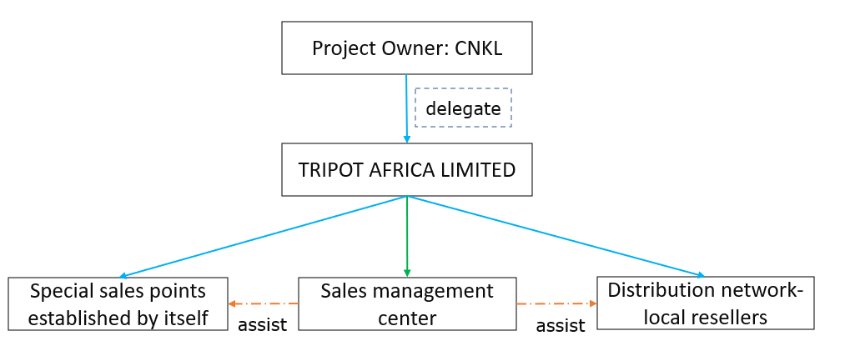
Figure 7 The Sales Network Diagram
In addition, when the product is sold, the salesperson in special sales points and the local resellers will record the buyer's information (such as name, gender, age, address etc.) and the water purifier serial number. The project record adopts a sales management system, which can perform real-time numbering according to the order of sales of water purifiers and can generate the excel sheet of Sales Record Database.

Sales group: Maintain and updated the sales database in a timely manner. The project proponent must maintain an accurate and complete electronic database for enabling the unique identification of the project water purifiers. It is envisaged that the database will include at least the following information:
- Date of sale
- Geographic area of sale
- Model/type of project technology sold and unique water purifier serial number
- Mode of use: commercial, institutional, domestic and other
- Number of water purifiers sold
- Name, telephone number and address.

Survey group: To carry out project survey, usage survey, water quality survey test and hygiene practices assessment.

Record group: Data verification and filing and managing the project documents.

Specifically, there were monitoring teams for the monitoring of Water hygiene education campaigns, M_{q,y}, HN_{p,y}, U_{p,y}, QPW_{p} and X_{cleanboil,y}. For the details monitoring process implemented of the monitoring parameters please refer to the table below.

Table 2 The details Monitoring Process of the monitoring parameters engaged in the project
Monitoring Plan in PDD | Monitoring Process Implemented
For water hygiene education campaigns:  B.7.3.4 of PDD:  The drinking water and hygiene practices will be assessed using the WHO/UNICEF Joint Monitoring Programme guidelines (JMP 2018). In-person or telephone or by messaging based survey including all the JMP core questions for drinking water and core questions for hygiene will be conducted.  B.7.2.5 of PDD:  This parameter can be conducted with water Quality Testing using the same sample and the calculation of the sample size for the monitoring shall be based upon a 0.6 Coefficient of Variation (COV) under a 90/10 approach as provided in Table 3 of Annex 4 of TPDDTEC (Version 3.1). | For water hygiene education campaigns:  As this monitoring period covers 2021 and 2022 years, for year 2021, the water hygiene education campaigns has been conducted on 02/06/2021-11/06/2021 (last monitoring period). So, there is also need to implement the water hygiene education campaigns in 2022.  The specific process of water hygiene education campaigns conducted in 2022 is as follows:  A serial number was put on each of Multi-Layer water purifiers sold to the users. A list of all the users and the corresponding serial numbers of their Multi-Layer water purifiers was kept.  The sold of Multi-Layer water purifiers started on 09/10/2020 and total 467,123 sets water purifier were sold in the first monitoring period (10/10/2020-31/07/2021), no water purifier sold in this monitoring period. So, all water purifiers operated in this monitoring period have the same age. As per the calculation of the sample size in PDD, the sample size for water hygiene education campaigns is 101. 101 samples were randomly selected from 467,123 water purifiers users using online number generator by the Survey Group at the beginning of 2022 .  The monitoring of this parameter was conducted by GS monitoring team, which consisted of sales group, survey group and record group. For this monitoring period, all the team members were properly trained on 02/03/2022, so that they were fully aware of the monitoring procedures and the conservative principle.  The water hygiene education campaigns, and water Quality Testing have been conducted together on 17/05/2022-19/05/2022 during the monitoring team member visiting to end-user’ homes to take water quality samples for water Quality Testing. The monitoring team member conducted in-person survey including all the JMP core questions for drinking water and core questions for hygiene and ask them to fill the questionnaires.  Samples of survey questionnaires, photos of in-person survey and hygiene education campaigns have been taken as evidence.  The result of the water hygiene education campaigns conducted on 02/06/2021-11/06/2021 is: the fraction of the households where safe water is found to fulfill "safely managed" is 100%, i.e., All the project users have access to safe water because they have water purifiers; The fraction of the households where Hygiene practices are found to fulfll basic requirements is 7.92%, i.e., Among the 101 sample users surveyed, 8 users can get soap when washing their hands at home.  The result of the water hygiene education campaigns conducted on 17/05/2022-19/05/2022 is: the fraction of the households where safe water is found to fulfill "safely managed" is 100%, i.e., All the project users have access to safe water because they have water purifiers; The fraction of the households where Hygiene practices are found to fulfll basic requirements is 9.90%, i.e., Among the 101 sample users surveyed, 10 users can get soap when washing their hands at home.
For ongoing water quality indicated as the fraction of the samples that pass microbial quality standard requirements specified in relevant microbial quality standard for drinking water of the host country (KS EAS 153: 2018 East African Standard Specification for Packaged Drinking Water), M_{q,y}:  B.7.3.4 of PDD:  The quality of the treated water will be assessed to ensure that it is fit for human consumption. Water quality test will be conducted based on section E of Annex 3 of TPDDTEC (Version 3.1). Accredited laboratory will be used to conduct the water quality test based on WHO standard of less than 1 Colony Forming Unit (CFU) of E.Coli/100 ml and the Quality Standards for Sources of Domestic Water of The Environmental Management And Co-Ordination (Water Quality) Regulations, 2006 .  The laboratory used must demonstrate that it has an adequate quality management plan in place which addresses both quality assurance and quality control test procedures. Field testing kits also are eligible, e.g., based on Colony Forming Unit method or Most Probable Number method. To use the field testing kits the project shall meet the following requirements: Testing kits must be approved by national agency or meet standards set by relevant international organization e.g., US-EPA, or testing kits shall be tested for its accuracy and robustness prior to application for project level monitoring. Local or accredited laboratory shall conduct water quality tests using testing kits and a relevant ISO standard or an equivalent standard, in parallel with field testing kits. The water test results will be compared against values provided for different parameters under the manufacturer’s specifications of the project technologies.  The water quality must be tested annually, and the first round of testing shall be conducted at least after six months from the start date. The monitoring report may include:  -A full description of the water quality process which may be conducted either in the field or by transportation to laboratories.  -Endorsement by third parties of the testing.  -Justification of the appropriateness of the testing approach.  B.7.2.4 of PDD:  The sample size is following 90/10 precision rule and the water sample is taken at water outlet randomly from project database. The calculation of the sample size for the test shall be based upon a 0.6 Coefficient of Variation (COV) under a 90/10 approach as provided in Table 3 of Annex 4 of TPDDTEC (Version 3.1). | For ongoing water quality indicated as the fraction of the samples that pass microbial quality standard requirements specified in relevant microbial quality standard for drinking water of the host country (KS EAS 153: 2018 East African Standard Specification for Packaged Drinking Water), M_{q,y}:  As this monitoring period covers 2021 and 2022 years, the M_{q,y} used in emission reduction calculations in 2021 has been determined in the water quality test conducted on 02/06/2021-11/06/2021 (conducted in last monitoring period), the result is 100%. So it is only necessary to determine the M_{q,y} used in emission reduction calculations in 2022.  For M_{q,y} used in emission reduction calculations in 2022 was determined in water quality test conducted on 17/05/2022-19/05/2022, The specific process are as follows:  A serial number was put on each of Multi-Layer water purifiers sold to the users. A list of all the users and the corresponding serial numbers of their Multi-Layer water purifiers was kept.  The sold of Multi-Layer water purifiers started on 09/10/2020 and total 467,123 sets water purifier were sold in the first monitoring period (10/10/2020-31/07/2021), no water purifier sold in this monitoring period. So, all water purifiers operated in this monitoring period have the same age. As per the calculation of the sample size in PDD. The sample size for water quality testing is 101. 101 samples were randomly selected from 467,123 water purifiers users using online number generator by the Survey Group at the beginning of 2022.  The monitoring of this parameter was conducted by GS monitoring team, which consisted of sales group, survey group and record group. All the team members were properly trained on 02/03/2022, so that they were fully aware of the monitoring procedures and the conservative principle.  The water Quality Testing have been conducted on 17/05/2022-19/05/2022 by the monitoring team member with Water sampler visiting to end-user’ homes to take water quality samples for water Quality Testing.  The specific sampling process are:  Fill a numbered (which can identify the source of the sample) sterilized sampling bottle with water from outlet of the water purifier. Avoid contamination of the mouth with fingers and other objects during sampling. After sampling, the samples were stored at low temperature (0~4℃) and protected from light. Water quality samples have been sent to the laboratory for water quality monitoring and analysis immediately after the completion of water quality collection.  Entrust a qualified third-party testing agency-a microbiology laboratory affiliated with the Kenya Bureau of Standards (KEBS) to test the water quality, which is official organization with the ability to issue qualifications to other institution. so, the KEBS has the undoubted accreditation.  Sampling photos and test results report heve been taken as evidence.  From the results of water quality testing , the M_{q,y} used in emission reduction calculations claimed in this monitoring period is 100%.
For number of individuals per premises type p in the project boundary in year y, HN_{p,y}:  B.7.1 of PDD:  The source of this parameter is project survey. So, the monitoring method of this parameter is consistent with project survey.  B7.2.1 of PDD:  The safe water project survey is conducted with end user’s representative of the project scenario target population and currently using the safe water project technology. The project survey will be carried out using representative and random sampling following the GS guidelines for minimum sample size:  Group size <300: Minimum sample size 30  Group 300 to minimum to 1,000: Minimum sample size 10% of group size  Group size >1,000: Minimum sample size 100  The project survey will likely have a minimum sample size of 100 as the number of water purifier sold is estimated to be greater than 1,000.  End users for the project survey will be selected using representative sampling techniques to ensure adequate representation of users with technologies of different ages. Common sampling approach such as clustered random sampling is allowed, and geographic distribution will be factored into selection criteria. End users can be surveyed at any time throughout the year with care taken to collect information pertaining to seasonal variations in technology and fuel use patterns.  B.7.3.2 of PDD:  The project survey provides critical information on year-to-year trends in end user characteristics such as technology use, fuel consumption and seasonal variations. Questionnaire which is similar to the baseline survey (Refer to Table B4.1 of PDD for sample questionnaire) will be adapted. It will be conducted with end-user’s representative of the project scenario target population and currently using the safe water project technology. Related data and information will be collected through in-person paper surveys, which will be then entered into an excel file to be used to analyze the data.  In the guidance on data collected, questions about end user characteristics and baseline technology and fuels should be treated as specific to safe water supply and boiling. These questions should be asked twice, first in regard to the baseline scenario water supply and water treatment, including boiling technologies, and second in regard to the project scenario clean water supply, including treatment and boiling technologies.  The Project Survey and the WCFT can be conducted concurrently using the same sample. | For number of individuals per premises type p in the project boundary in year y, HN_{p,y}:  As this monitoring period covers 2021 and 2022 years, the HN_{p,y} used in emission reduction calculations in 2021 has been determined in the project survey conducted in 18/01/2021-28/01/2021 (conducted in last monitoring period), which is 3.94 (398/101) number. So it is only necessary to determine the HN_{p,y} used in emission reduction calculations in 2022.  For HN_{p,y} used in emission reduction calculations in 2022 was determined in project survey conducted in 12/04/2022-13/04/2022 (in this monitoring period). The specific survey process is as follows:  A serial number was put on each of Multi-Layer water purifiers sold to the users. A list of all the users and the corresponding serial numbers of their Multi-Layer water purifiers was kept.  The sold of Multi-Layer water purifiers started on 09/10/2020 and total 467,123 sets water purifier were sold in the first monitoring period (10/10/2020-31/07/2021), no water purifier sold in this monitoring period. So, all water purifiers operated in this monitoring period have the same age.  As the Project Survey and the WCFT can be conducted concurrently using the same sample, As per the description of the sample size in PDD. For project survey, the minimum sample size is 100, for WCFT, the sample size is 101. So, the final sample size is 101, 101 samples were randomly selected from 467,123 water purifiers users using online number generator by the Survey Group at the beginning of 2022.  The project survey was conducted by GS monitoring team, which consisted of sales group, survey group and record group. All the team members were properly trained on 02/03/2022, so that they were fully aware of the monitoring procedures and the conservative principle.  The monitoring team member conducted the in-person paper survey on 12/04/2022-13/04/2022. During the project survey, the monitoring team member ask the End-user to fill the questionnaire, the questionnaire which is similar to the baseline survey (Refer to Table B4.1 of PDD for sample questionnaire) was adapted. The critical information including end user basic characteristics, family size, technology use, fuel consumption and seasonal variations, etc.  After the project survey, the questionnaires were collected, and the results were summarized.  Samples of project survey questionnaires, project survey summary table and photos can be been taken as evidence.  From the project survey questionnaires, the average number of individuals per premises in 2021 and 2022 are 3.94 and 3.91 number, respectively.  The value applied shall be cross-checked against at least one other source on the list. As per 2019 Kenya Population and Housing Census Volume I: Population by County and Sub- County , there are 1,647,507 households and 6,421,177 people in Makueni County, Trans Nzoia County, Kirinyaga County, Bungoma County and Nakuru County of Kenya. Number of individuals per household can be calculated as 6,421,177/1,647,507=3.9.  In summary , the HN_{p,y} used in emission reduction calculations claimed in this monitoring period is 3.9 number.
For proportion of project households that boil safe (treated, or from safe supply) water after installation of project technology in year y, X_{cleanboil,y}:  B.7.1 of PDD:  The source of this parameter is project survey. So, the monitoring method of this parameter is consistent with project survey.  B7.2.1 of PDD:  The safe water project survey is conducted with end user’s representative of the project scenario target population and currently using the safe water project technology. The project survey will be carried out using representative and random sampling following the GS guidelines for minimum sample size:  Group size <300: Minimum sample size 30  Group 300 to minimum to 1,000: Minimum sample size 10% of group size  Group size >1,000: Minimum sample size 100  The project survey will likely have a minimum sample size of 100 as the number of water purifier sold is estimated to be greater than 1,000.  End users for the project survey will be selected using representative sampling techniques to ensure adequate representation of users with technologies of different ages. Common sampling approach such as clustered random sampling is allowed, and geographic distribution will be factored into selection criteria. End users can be surveyed at any time throughout the year with care taken to collect information pertaining to seasonal variations in technology and fuel use patterns.  B.7.3.2 of PDD:  The project survey provides critical information on year-to-year trends in end user characteristics such as technology use, fuel consumption and seasonal variations. Questionnaire which is similar to the baseline survey (Refer to Table B4.1 of PDD for sample questionnaire) will be adapted. It will be conducted with end-user’s representative of the project scenario target population and currently using the safe water project technology. Related data and information will be collected through in-person paper surveys, which will be then entered into an excel file to be used to analyze the data.  In the guidance on data collected, questions about end user characteristics and baseline technology and fuels should be treated as specific to safe water supply and boiling. These questions should be asked twice, first in regard to the baseline scenario water supply and water treatment, including boiling technologies, and second in regard to the project scenario clean water supply, including treatment and boiling technologies.  The Project Survey and the WCFT can be conducted concurrently using the same sample. | For proportion of project households that boil safe (treated, or from safe supply) water after installation of project technology in year y, X_{cleanboil,y}:  As this monitoring period covers 2021 and 2022 years, the X_{cleanboil,y} used in emission reduction calculations in 2021 has been determined in the project survey conducted in 18/01/2021-28/01/2021 (conducted in last monitoring period), which is 0%. So it is only necessary to determine the X_{cleanboil,y} used in emission reduction calculations in 2022.  For X_{cleanboil,y} used in emission reduction calculations in 2022 was determined in project survey conducted in 12/04/2022-13/04/2022 (in this monitoring period). The specific survey process is as follows:  A serial number was put on each of Multi-Layer water purifiers sold to the users. A list of all the users and the corresponding serial numbers of their Multi-Layer water purifiers was kept.  The sold of Multi-Layer water purifiers started on 09/10/2020 and total 467,123 sets water purifier were sold in the first monitoring period (10/10/2020-31/07/2021), no water purifier sold in this monitoring period. So, all water purifiers operated in this monitoring period have the same age.  As the Project Survey and the WCFT can be conducted concurrently using the same sample, As the description of the sample size in PDD. For project survey, the minimum sample size is 100, for WCFT, the sample size is 101. So, the final sample size is 101, 101 samples were randomly selected from 467,123 water purifiers users using online number generatore by the Survey Group at the beginning of 2022.  The project survey was conducted by GS monitoring team, which consisted of sales group, survey group and record group. All the team members were properly trained on 02/03/2022, so that they were fully aware of the monitoring procedures and the conservative principle.  The monitoring team member conducted the in-person paper survey on 12/04/2022-13/04/2022. During the project survey, the monitoring team member ask the End-user to fill the questionnaire, the questionnaire which is similar to the baseline survey (Refer to Table B4.1 of PDD for sample questionnaire) was adapted. The critical information including end user basic characteristics, family size, technology use, fuel consumption, do you boil safe water and seasonal variations, etc.  After the project survey, the questionnaires were collected, and the results were summarized.  Samples of project survey questionnaires, project survey summary table and photos have been taken as evidence.  From project survey questionnaires, the proportion of project households that boil safe (treated, or from safe supply) water after installation of project technology in 2022 is 0%.  In summary , the X_{cleanboil,y} used in emission reduction calculations in this monitoring period is 0%.
Volume of drinking water per person per day for premises type p, QPW_{p}:  B.7.2.2 of PDD:  For WCFT statistical analysis, 90/10 precision level will be selected. The survey will be a single sample for establishing project scenario water consumption. The calculation of the sample size for the survey shall be based upon a 0.6 Coefficient of Variation (COV) under a 90/10 approach as provided in Table 3 of Annex 4 of TPDDTEC (Version 3.1).  B.7.3.3 of PDD  The water consumption field test (WCFT) measures project-supplied clean water consumption volumes. The WCFT is conducted with end user’s representative of the project scenario target population and currently using the project technology. The WCFT must be designed to ensure that monitoring is representative of typical technology use practices and that:  - it is transparent and can easily be replicated,  - it is evidently conservative,  - the sample is randomly selected so as to not introduce a material bias, and  - the impact of daily and seasonal variations on the expected average water consumption is accounted for.  The WCFT must be conducted over 3 days, not including weekends, and averaged value (L/person/day) value should be determined after excluding outliers. It must be made explicit to the households/institutions that they must behave and consume water normally, reflecting typical daily water consumption pattern. WCFT protocol are designed for the project based on the Kitchen Project Test (KPT) guidelines in Annex 4 of TPDDTEC (Version 3.1). The protocol will be executed over a four-day period with the first day targeted at questionnaires and surveys with the remaining three left dedicated to WCFT exercises. The four-day period shall not be carried out over a holiday period to ensure conservative quantification of water consumption per end user.  Day 0: Training of field enumerators  The PP will carry out training exercise with the enumerators who would then proceed to carry out the WCFT. The PP will go over the survey questions to be asked during WCFT exercise as well as did mock examples of real WCFT with the enumerators to ensure they understood what would take place in a real-world situation in the field. Calibrated buckets are issued to each of the enumerators which they would use in the field in measuring the water volume consumed in a day per household. Enumerators are expressly told to ensure maximum accuracy in measuring water using the buckets.  Day 1: Surveys and Introduction  The project proponent will inform the end-users of the 3-day WCFT exercise that them that they should treat water as usual. Households will report on the times at which they treat water every day. The times reported shall be recorded to allow enumerators to go to the end-user’s residence the following day before raw water is treated. Distribute calibration flasks for measurement to users.  Day 2 – 4: WCFT exercise  Distribute a Water consumption survey record form to users every morning before the user’s beginning to use water. When users want to use water, use a volumetric flask to collect water from the water purifier and record the amount of water received. Daily Water consumption by the end users will be measured in these flasks filtered through the water filter. In every evening the Water consumption survey record form will be collected.  The mean value of the total water consumption (the total water consumption per day aggregated over a three-day period) will establish the value QPW_{p} per end user. Which will then be aggregated (after elimination of outliers) to determine the value used to calculate Emission Reductions for the whole project per technology.  The end user will then be asked if at all they boil any of the clean water or if they consume any raw water without boiling.  Water consumption for the water filter will be capped at 5.5 litres per person per day in accordance with the applied GS methodology. | Volume of drinking water per person per day for premises type p, QPW_{p}:  As per the applied mmethodoloy, the monitoring frequency of this parameter is every two years. The water consumption field test have been conducted on 18/01/2021 to 21/01/2021 and 25/01/2021 to 28/01/2021. This monitoring period is from 01/08/2021-31/07/2022, which is within 2 years of the water consumption field test date. So there is no need to conduct the water consumption field test during this monitoring period.  The value of this parameter used in the emission reduction calculations in this monitoring period has been determined in the water consumption field test have been conducted on 18/01/2021 to 21/01/2021 and 25/01/2021 to 28/01/2021, the value is 3.78 L/person/day.
For usage rate of the project technology by premises type p during year y, U_{p,y} :  As B.7.3.4 of PDD, the monitoring of the parameter is according to Annex 1 of applied methodology. The guidelines outline six topics which must be successfully completed for the survey respondent to be classed as a user. Additionally, other topics relevant to specific technology types and project conditions are required to provide accurate estimates of the usage of the water purifiers. If all six topics outlined are successfully completed the survey respondent can be classed as a user. If failure occurs in one or more of the topics, then the respondent is classed as a non-user. The project proponent needs to clearly define what is deemed a success or a failure for each topic area as part of its usage plan.  It is required that sufficient precautions are taken by enumerators to ensure that there is no bias while conducting the usage surveys. For example:  - The survey should not be conducted immediately after capacity building/awareness programs in the target households.  - Surveyors should not wear clothes with logos of their employers, etc.  B.7.2.3 of PDD:  The minimum total sample size for Usage Survey is 100, with at least 30 samples for project technologies of each age being credited. The majority of interviews in a usage survey must be conducted in person. Thus, if technologies of age 1-5 are credited, the usage survey must include 30 representative samples from each age for total of 150 samples. The resulting usage parameter should be weighted based on the proportion of technologies in the borehole database of each age.  In line with the applied GS methodology, any sampling methods can be used, provided that the sample is selected randomly. If sampling approach other than simple random sampling is applied, CDM Guideline: Sampling and surveys for CDM project activities and programmes of activities (Version 04.0) must be followed. | For usage rate of the project technology by premises type p during year y, U_{p,y}:  As this monitoring period covers 2021 and 2022 years, the U_{p,y} used in emission reduction calculations in 2021 has been determined in the usage rate survey conducted in 01/02/2021 (conducted in last monitoring period), which is 89%. So it is only necessary to determine the U_{p,y} used in emission reduction calculations in 2022.  For U_{p,y} used in emission reduction calculations in 2022 was determined in usage rate survey conducted in 16/03/2022-17/03/2022 (in this monitoring period). The specific survey process is as follows:  A serial number was put on each of Multi-Layer water purifiers sold to the users. A list of all the users and the corresponding serial numbers of their Multi-Layer water purifiers was kept.  The sold of Multi-Layer water purifiers started on 09/10/2020 and total 467,123 sets water purifier were sold in the first monitoring period (10/10/2020-31/07/2021), no water purifier sold in this monitoring period. So, all water purifiers operated in this monitoring period have the same age. As the description of the sample size in PDD, the sample size for usage rate survey is 100. 100 samples were randomly selected from 467,123 water purifiers users using inline number generator at the beginning of 2022.  The Usage rate survey was conducted by GS monitoring team, which consisted of sales group, survey group and record group. All the team members were properly trained on 02/03/2022, so that they were fully aware of the monitoring procedures and the conservative principle. The monitoring activity of this parameter was completed successively on 16/03/2022-17/03/2022.  According to Annex 1 of applied methodology. The guidelines outline six topics which must be successfully completed for the survey respondent to be classed as a user. Additionally, other topics relevant to specific technology types and project conditions are required to provide accurate estimates of the usage of the water purifiers.  During the usage rate survey, End users were invited to fill out the questionnaire. The questionnaire contains the following six topics according to Annex 1 of applied methodology:  Topic 1: Introductory question and water treatment.  Q1: Are you the main user /operator of the water purifier in the household?  Q2: Did you do anything to make your water safer to drink?  Q3: How did you make this water safer to drink?  The first question can confirm that all respondents were the main user /operator of the water purifier in their households.  Topic 2: Rate of usage.  Q1: How often do you filter water?  Q2: When was the last time you filtered water using the project water purifier?  Q3: Have you used the project water purifier in the last two days?  As description in PDD, the households that show at least once-in-two-days use may be counted as users.  Topic 3: Water storage  Q1. Is there a safe storage container that contains filtered water in it?  Q2: If ‘no’, when was the last time there was filtered water in it?  Topic 4: Physical signs of usage  Q1: Observe to see if the project water purifier shows signs of usage?  Topic 5: Demonstration & knowledge  Q1: Can you please show us how you filter water?  Q2: Can you please give us a cup of drinking water?  Topic 6: Functionality  Q1: Observe whether the HWT unit is currently functional.  After the Usage rate survey, the questionnaires were collected, and the results were summarized.  Samples of Usage survey questionnaires, Usage survey summary table and photos have been taken as evidence.  From the completion of six topics questionnaires and the survey of Topic 2, the usage rate of the water purifier in this monitoring period is 88% (88/100*100%).  In summary , the U_{p,y} used in emission reduction calculations claimed in 2021 and 2022 are 89% and 88%, respectively.

Due to the non-industrial nature of the project, emergency procedures are not applicable to the project. For QA/QC procedure, please refer to QA/QC procedures in section D.2.

Avoiding Double Counting

The Avoiding Double Counting of this project is detailed below:

The project owner is the overall data management department and all the data collected should be submitted to the project owner for the purpose of effective management. To avoiding double counting, the following measures will be taken:

(i) In order to cover more households with high-quality water purifiers at a lower price, it is restricted in the project that each household can only buy one set of water purifier. After the project put into operation, the project owner will arrange for relevant personnel to conduct irregular surveys on the use of the water purifier, the survey member inform the End-user that if the water purifier is damaged or parts need to be replaced, the project owner can be notified in time, and the project owner will repair and replace parts free of charge in time to ensure the water purifier in normal use. Also, each water purifier sold has a unique number with a unique naming rule. If the project owner uses other types of water purifiers that are not within the project boundary, these water purifiers will not have a unique serial number that complies with this naming rule and will not be included in the calculation of emission reductions.

Therefore, only one water purifier per household is considered in the emission reduction calculation and only calculated once.

(ii) Declaration of No Double Counting by the project owner was signed by project owner.

- DATA AND PARAMETERS
  - Data and parameters fixed ex ante or at renewal of crediting period
>>
Related to water quality
Parameter ID | SDWS 2
Data/parameter | Project technology description
Unit | N/A
Description | The Multi-Layer water purifiers are produced by Zhejiang Duanqi Renewable Energy Co., Ltd., which consist of 8 step filtration system and can purify water 3 liter/hour. The lifespan of the water purifiers are over 15 years and the dome ceramic, carbon cartridge and mineral stone should be changed when purify every 10,000 L water. The project equipment provides safe drinking water that are free from pathogens and elevated levels of toxic substances.  In addition, the water purifier involved in this project obtain the pre-export verification of conformity by KEBS (Kenya bureau of standards). Moreover, according to the water quality test report by the KEBS, the purified water quality of the product meets the standards of KS EAS 153: 2018 East African Standard Specification for Packaged Drinking Water.
Source of data | Manufacturer specifications and the pre-export verification of conformity.
Value(s) applied | N/A
Choice of data or Measurement methods and procedures | The manufacturer specifications, the pre-export verification of conformity and the water quality test report provide an accurate evidence of compliance with relevant standards. It also can be known from the sales contract that the water purifier is also presented with a filter element as a spare when it is sold. When the water purifier has been used for less than 22 months, if the user needs to replace the filter element, a request can be sent to the project owner, and the user can use a spare filter element during the time period when the project owner comes to replace it. Of course, after receiving the request, the project owner will immediately go to the user’s home to replace the core filter. When the water purifier has been used for 22 months, the project owner will replace the alternative materials of all the water purifier sold. This monitoring period is from 10/10/2020 to 31/07/2022, from the date to start using the water purifier to 31/07/2022, its exactly 22 months, all of the project core filters have been replaced during this monitoring period.
Purpose of data | The Project technology of the water purifier involved in this project meet the relevant standard and the product is eligible products.
Additional comment | N/A

Parameter ID | SDWS 4
Data/parameter | Regulatory framework for safe water supply
Unit | N/A
Description | Water scarcity in various regions of Kenya has been an issue for decades. The government has issued some water resources related policies and regulations. The Water Act 2016 provides for the regulation, management and development of water resources and water and sewerage services in line with the Constitution. The National Water Quality Management Strategy (NWQMS) issued by the Ministry of Water and Irrigation to improve water quality. The Kenya National Water Master Plan 2030 developed by Ministry of Environment, Water and Natural Resources recognizes water as an enabler in socio-economic development and aims to improve water and sanitation availability and access to all by 2030. The implementation of the project is fully in line with the relevant water resources policies of Kenya.
Source of data | National authorities
Value(s) applied | N/A
Choice of data or Measurement methods and procedures | National authorities provide the powerful regulatory framework for safe water supply
Purpose of data | The Kenyan government attaches great importance to the issue of water resources. This project could bring water benefits to the Kenyan people. So, the implementation of the project is fully in line with the relevant water resources policies of Kenya.
Additional comment | N/A

Parameter ID | SDWS 5
Data/parameter | Water sources in the project boundary
Unit | N/A
Description | The water source in the project boundary and whether they are used for drinking water, and for all that are used for drinking water, classify them as improved and unimproved water source.
Source of data | Baseline study conducted from 10/10/2020 to 20/12/2020.
Value(s) applied | 0.59% (3HH/505HH) of the households are available of piped water. 6.7% (34HH/505HH) of the households take water from boreholes or protected wells. As per Annex 2 of the applied GS methodology, piped water and water from boreholes or protected wells belong to improved sources of drinking water. For the rest of 92.7% (468HH/505HH) households, the most common sources of water are from unprotected well, unprotected spring and surface water, which belong to unimproved sources of drinking water.
Choice of data or Measurement methods and procedures | The baseline study conducted from 10/10/2020 to 20/12/2020 provided the water source in project boundary.
Purpose of data | From the baseline survey, the most people in Kenya can’t obtained the safety water from improved water source, so the implementation of this project is important for the safety of drinking water for Kenyans. Demonstrated the reasonableness of project implementation.
Additional comment | N/A

SDG13
Parameter ID | SDWS 6
Data/parameter | Stove technologies used in the project boundary
Unit | N/A
Description | The proportion of different stove types used in premises in the  geographical area of the project.
Source of data | Baseline survey conducted from 10/10/2020 to 20/12/2020.
Value(s) applied | The stove used to boil water in baseline scenario is three-stone stoves (67.2%, 223HH/332HH), Conventional stoves (19.3%, 64HH/332HH), improved stoves (6.3%, 21HH/332HH) and LPG stoves (7.2%, 24HH/332HH). The project is implemented in Makueni, Trans Nzoia, Kirinyaga, Bungoma and Nakuru Counties of Kenya, the proportion of different stove types are defined for each county. Refer to section B.4.1 of the PDD for more details.
Choice of data or Measurement methods and procedures | The baseline study conducted from 10/10/2020 to 20/12/2020 provided the proportion of different stove types used in premises in the geographical area of the project.
Purpose of data | To calculate the baseline emissions.
Additional comment | N/A

Parameter ID | SDWS 7
Data/parameter | Expected technical life of project technology
Unit | Operational lifespan of the water purifiers are more than 15 years
Description | As per manufacturer specifications of the water purifiers, the dome ceramic should be cleaned every 7 days with toothbrush, the outside of carbon cartridge should be cleaned every 10 days and the dome ceramic, carbon cartridge and mineral stone should be changed when purify every 10,000 L water (about 22 months).
Source of data | Manufacturer specifications
Value(s) applied | More than 15 years
Choice of data or Measurement methods and procedures | The manufacturer specifications provided the accuracy information of expected technical life of an individual project technology and the details include both technology/device life and filter life.  Consider conservatively, it is believed that the water purifier Involved in this project began to use on 10/10/2020. As per the technical manual of the water purifier, the frequency of replacement is every 10,000 L water (about 22 months). This monitoring period is from 01/08/2021-31/07/2022, so, from the date of start to use of the water purifier to 31/07/2022, which is exactly 22 months. During this monitoring period, all of the water purifier core filters have been replaced.
Purpose of data | The expected technical life of project technology meets the total length of crediting period.
Additional comment | N/A

Parameter ID | SDWS 8
Data/parameter | x_{firewood}/x_{charcoal}/x_{LPG}
Unit | Percentage of firewood, charcoal and LPG
Description | The proportion of each different household cooking fuel (firewood, charcoal and LPG) used in the project boundary
Source of data | Baseline survey conducted from 10/10/2020-20/12/2020.
Value(s) applied
  County | x_{firewood} | x_{charcoal} | x_{LPG}
  Makueni | 81.3 | 18.8 | 0
  Trans Nzoia | 78.3 | 19.6 | 2.2
  Kirinyaga | 93.1 | 6.9 | 0
  Bungoma | 79.7 | 17.4 | 2.9
  Nakuru | 56.7 | 21.6 | 21.6
  Total | 75.9 | 16.9 | 7.2
Choice of data or Measurement methods and procedures | 505 households participated the baseline survey (101 households for each County). 332 households (Makueni 48, Trans Nzoia 46, Kirinyaga 72, Bungoma 69 and Nakuru 97) treat unsafe drinking water by boiling. The questionnaire shown in Table B4.1 of PDD are adapted to capture the information of fuel types and stove types used to boil water. The data was collected through paper surveys, which were then entered into an excel file to be used to analyze the data. Refer to section B4.1 of PDD for more details.
Purpose of data | To demonstrate contribution to SDG 13.
Additional comment | The proportion of different fuel types are defined for each County. According to applied methodology, the percentages applied shall be cross-checked against at least one other source on the list. For cross-check purposes, sources applied may be up to 5 years old. In this project the cross-check document is Water Survey Report approved by National Environment Management Authority, which belongs to credible published literature for project region. According to Water Survey Report approved by National Environment Management Authority, in Turkana, Makueni, Kirinyaga, Mandera, Tran Nzoia, Bungoma and Nakuru County, the main fuel used for boiling water were firewood and products of wood 77.1%, charcoal 17.1% and LPG 5.8%. So, consider conservative principles, the percentage of firewood, charcoal and LPG is 75.9%, 16.9% and 7.2% in the calculation of baseline emissions.

Parameter ID | SDWS 9
Data/parameter | EF_{b,firewood,CO2}
Unit | tCO₂/TJ
Description | CO₂ emissions factor of the fuel (firewood) that it substituted or reduced
Source of data | IPCC default value. As per applied methodology “Methodology for Emission reductions from safe drinking water supply (Version 1.0)”, this parameter should sourced from IPCC default and the value is 112 tCO₂/TJ.
Value(s) applied | 112
Choice of data or Measurement methods and procedures | IPCC default values provide an accurate and conservative estimate of emissions reduction from various fuel sources.
Purpose of data | To demonstrate contribution to SDG 13.
Additional comment | N/A

Parameter ID | SDWS 9
Data/parameter | EF_{b,charcoal,CO2}
Unit | tCO₂/TJ
Description | CO₂ emissions factor of the fuel (charcoal) that it substituted or reduced
Source of data | Methodology for Emission reductions from safe drinking water supply (Version 1.0)
Value(s) applied | 165.22 (includes charcoal production emissions)
Choice of data or Measurement methods and procedures | IPCC default values provide an accurate and conservative estimate of emissions reduction from various fuel sources.
Purpose of data | To demonstrate contribution to SDG 13.
Additional comment | N/A

Parameter ID | SDWS 9
Data/parameter | EF_{b,LPG,CO2}
Unit | tCO₂/TJ
Description | CO₂ emissions factor of the fuel (LPG) that it substituted or reduced
Source of data | IPCC 2006 default value (Table 2.4 of Chapter 2)
Value(s) applied | 63.1
Choice of data or Measurement methods and procedures | IPCC default values provide an accurate and conservative estimate of emissions reduction from various fuel sources.
Purpose of data | To demonstrate contribution to SDG 13.
Additional comment | N/A

Parameter ID | SDWS 10
Data/parameter | EF_{b,firewood,nonCO2}
Unit | t/TJ
Description | Non CO₂ emissions factor of the firewood that is substituted or reduced
Source of data | Table 2.5 of Chapter 2 Stationary Combustion (IPCC 2006) and Table 8.7 of 2013 Climate Change 2013 The Physical Science Basis. Contribution of Working Group I to the Fifth Assessment Report of the Intergovernmental Panel on Climate Change (IPCC).
Value(s) applied | 9.46 (0.3t/TJ*28+ 0.004t/TJ*265)
Choice of data or Measurement methods and procedures | Determined as per IPCC default figures.
Purpose of data | To demonstrate contribution to SDG 13.
Additional comment | N/A

Parameter ID | SDWS 10
Data/parameter | EF_{b,charcoal,nonCO2}
Unit | t/TJ
Description | Non CO₂ emissions factor of the firewood that is substituted or reduced
Source of data | Methodology for Emission reductions from safe drinking water supply (Version 1.0)
Value(s) applied | 44.83 (includes production emissions of CH₄ and N₂O)
Choice of data or Measurement methods and procedures | Determined as per IPCC default figures.
Purpose of data | To demonstrate contribution to SDG 13.
Additional comment | N/A

Parameter ID | SDWS 10
Data/parameter | EF_{b,LPG,nonCO2}
Unit | t/TJ
Description | Non CO₂ emissions factor of the LPG that is substituted or reduced
Source of data | Table 2.5 of Chapter 2 Stationary Combustion (IPCC 2006) and Table 8.7 of 2013 Climate Change 2013 The Physical Science Basis. Contribution of Working Group I to the Fifth Assessment Report of the Intergovernmental Panel on Climate Change (IPCC).
Value(s) applied | 0.1665 (0.005t/TJ*28+ 0.0001t/TJ*265)
Choice of data or Measurement methods and procedures | Determined as per IPCC default figures.
Purpose of data | To demonstrate contribution to SDG 13.
Additional comment | N/A

Parameter ID | SDWS 11
Data/parameter | $$η_{wb}$$
Unit | %
Description | Weighted average efficiency of the baseline water boiling. Calculate the weighted average of the water boiling efficiency in the project boundary using the proportion of different stove types used and the stove efficiencies.
Source of data | Baseline Survey conducted from 10/10/2020-20/12/2020.
Value(s) applied
  County | $η_{wb}$(%)
  Makueni | 12.9
  Trans Nzoia | 14.8
  Kirinyaga | 11.3
  Bungoma | 14.6
  Nakuru | 22.9
Choice of data or Measurement methods and procedures | 505 households participated the baseline survey (101 households for each County). 332 households (Makueni 48, Trans Nzoia 46, Kirinyaga 32, Bungoma 69 and Nakuru 137) treat unsafe drinking water by boiling. The questionnaire shown in Table B4.1 of PDD are adapted to capture the information of fuel types and stove types used to boil water. The data was collected through paper surveys, which were then entered into an excel file to be used to analyze the data. Refer to section B4.1 of this PDD for more details.  Default efficiency values for different type of stoves: three-stone stoves 10%, conventional stoves 20%, improved stoves 30%. As per manufacturer specifications of the baseline LPG stoves, the highest efficiency is 50%.
Purpose of data | To demonstrate contribution to SDG 13.
Additional comment | N/A

Parameter ID | SDWS 12
Data/parameter | C_{b}
Unit | %
Description | Proportion of project households who in the baseline were already using a safe water supply that did not require boiling.
Source of data | Baseline Survey conducted from 10/10/2020-20/12/2020.
Value(s) applied | 20.0
Choice of data or Measurement methods and procedures | The percentage of households who are available of safe drinking water before project activity is 7.3% (37HH/505HH). 78.4% (396HH/505HH) treat unsafe water before drinking and 14.3% (72HH/505HH) drink unsafe water directly without any treatment. Data and information collected from the questionnaires show that all the households surveyed are involved in water treatment for domestic consumption. Among those who treat water, 83.8% (332HH/396HH) of them boil water before drinking and 16.2% (64HH/396HH) use gravity household water filters, ultraviolet radiation treatment, reverse osmosis, chlorine tablets and other technologies. Therefore, C_{b} can be calculated as 7.3%+78.4%*16.2%=20.0%.
Purpose of data | To demonstrate contribution to SDG 13.
Additional comment | According to applied methodology, the percentages applied shall be cross-checked against at least one other source on the list. For cross-check purposes, sources applied may be up to 5 years old. In this project the cross-check document is Water Survey Report approved by National Environment Management Authority , which belongs to Credible published literature for project region. According to Water Survey Report approved by National Environment Management Authority, in Turkana, Makueni, Kirinyaga, Mandera, Tran Nzoia, Bungoma and Nakuru County, 0.43% (2HH/462HH) of the households were available of piped water or bottled water. 5.8% (27HH/462HH) of the households got water from boreholes or protected wells. Piped water, bottled water and water from boreholes or protected wells were improved sources for drinking (6.3%, 29HH/462HH). Among those who were not available of safe water (93.7%, 433HH/462HH), 12.9% (56HH/433HH) will treat unsafe water before drinking by chlorine tablets, water filters or similar technologies, 75.5% (327HH/433HH) will drink boiled water and the rest of them (18.2%, 79HH/433HH) will drink unsafe water directly. Therefore, the proportion of households who were already using a safe water supply that did not require boiling it can be calculated as 6.3%+12.9%*93.7%=18.4%, which is less than 20.0%.

Parameter ID | SDWS 13
Data/parameter | q_{i}
Unit | Liters per hour
Description | Capacity of the household water treatment technology
Source of data | Manufacturer specifications
Value(s) applied | 3
Choice of data or Measurement methods and procedures | Manufacturer specifications provides the capacity, lifetime and water quality of the household water treatment technology.
Purpose of data | To demonstrate contribution to SDG 13.
Additional comment | N/A

Parameter ID | SDWS 21
Data/parameter | f_{NRB,f,y}
Unit | %
Description | Fractional non-renewability status of woody biomass fuel during year y, in case the baseline fuel is biomass or charcoal
Source of data | Determined by CDM Tool 30 Calculation of the fraction of non-renewable biomass (Version 03.0)
Value(s) applied | 66.4
Choice of data or Measurement methods and procedures | Since it is difficult to estimate the locations and extent of areas from which woody biomass fuel used by the project is collected, the project proponent aggregates all reachable woody biomass fuel collection areas within Kenya and apply a single fraction derived from all collection areas in the country. According to East African Civil Society for Sustainable Energy and Climate Action (EASE & CA) published on August 2020, biomass fuels consumption in Kenya in 2017 was 724 PJ, in which sustainable potential of solid biomass was 243 PJ. Therefore, RB is 243 PJ, NRB equals to 724-243=481 PJ.  f_{NRB}=481/(481+243)=66.4%  The f_{NRB} of 66.4% is fixed based on the results of the NRB assessment for the first crediting period.
Purpose of data | To demonstrate contribution to SDG 13.
Additional comment | N/A

  - Data and parameters monitored
>>
Related to water quality
Parameter ID | SDWS 20
Data / Parameter | Water hygiene education campaigns
Unit | N/A
Description | Hygiene campaigns carried out among project technology users. The drinking water and hygiene practices will be assessed using the WHO/UNICEF Joint Monitoring Programme guidelines (JMP 2018). In-person or telephone or by messaging based survey will be conducted including all the JMP core questions for drinking water and core questions for hygiene. Refer to section B.7.3 of the PDD for more details.
Source of data | Hygiene practices assessment
Value(s) applied | In 2021, the Water hygiene education campaigns was conducted on 02/06/2021-11/06/2021 and the result is as follows: the fraction of the households where safe water are found to fulfill "safely managed" is 100%,i.e., All the project users have access to safe water because they have water purifiers. The fraction of the households where Hygiene practices are found to fulfll basic requirements is 7.92%, i.e., Among the 101 sample users surveyed, 8 users can get soap when washing their hands at home.  In 2022, the Water hygiene education campaigns was conducted on 17/05/2022-19/05/2022 and the result is as follows: the fraction of the households where safe water are found to fulfill "safely managed" is 100%,i.e., All the project users have access to safe water because they have water purifiers. The fraction of the households where Hygiene practices are found to fulfll basic requirements is 9.90%, i.e., Among the 101 sample users surveyed, 10 users can get soap when washing their hands at home.  Therefore, the implementation of the Water hygiene education campaigns contributes to an increasing of the fraction of the households where safe water and hygiene practices are found to fulfill “safely managed” or “basic” requirements over time.
  Period | Parameter | Actual result
  01/08/2021-31/12/2021 | The fraction of the households where safe water is found to fulfill "safely managed" | 100%
  01/08/2021-31/12/2021 | The fraction of the households where Hygiene practices are found to fulfll basic requirements | 7.92%
  01/01/2022-31/07/2022 | The fraction of the households where safe water is found to fulfill "safely managed" | 100%
  01/01/2022-31/07/2022 | The fraction of the households where Hygiene practices are found to fulfll basic requirements | 9.9%
Measurement methods and procedures | Although this monitoring period covers 2021 and 2022 years, for year 2021, the water hygiene education campaigns has been conducted on 02/06/2021-11/06/2021 (last monitoring period), the specific process have been described in MR of last monitoring period. Therefore, only once water hygiene education campaigns should be conducted during this monitoring period, which was conducted on 17/05/2022-19/05/2022. The specific process has been described in section C of this MR.  According to section 7.2 sample plan in PDD, 101 samples is sufficient to represent the entire population of 467,123 and the 101 samples were randomly selected from 467,123 water purifiers users using online number generator by the Survey Group at the beginning of 2022. So, there are 101 samples in 2022 for monitoring this parameter.  The hygiene education campaigns have been conducted together on 17/05/2022-19/05/2022 during the monitoring team member visiting to end-user’ homes and the monitoring team member conducted in-person survey including all the JMP core questions for drinking water and core questions for hygiene and ask them to fill the questionnaires.
Monitoring frequency | Annually
QA/QC procedures | The fraction of the households where Safe water and Hygiene practices are found to fulfill “safely managed” or “basic” requirements is expected to increase over time as a result of the hygiene campaigns.
Purpose of data | N/A
Additional comment | N/A

SDG 7
Parameter ID | SDWS 19
Data / Parameter | Number of water purifiers sold in year y
Unit | Sets
Description | Number of water purifiers sold in year y
Source of data | Sales database
Value(s) applied | According to the sales database in this monitoring period, no water purifiers sold in this monitoring period.
Measurement methods and procedures | Influenced by international environment and regional market saturation and as per prediction on future water purifier market, the project owner adjusted the corresponding business plan. It decided to suspend the sales work in project area, and expand to other regions of Kenya as well as other countries of Africa, so, no water purifiers were sold during this monitoring period, so the actual number of water purifiers in normal operation in this monitoring period is still the 467,123 water purifiers sold in the first monitoring period.  The water purifiers involved in the project are sold at the sales point in each region. For each water purifier sold, the sales personnel signed a sales contract with the buyer and filled the buyer's name, gender, water purifier number, sales time, sold region and other information in the sales record system. GS monitoring team exported the sales information in the system and summarized the sales record table into excel.
Monitoring frequency | Yearly
QA/QC procedures | The number of water purifiers sold was based on the sale database and cross checked by the purchase receipt. After verification, the value in the sale database and purchase receipt are consistent.
Purpose of data | To demonstrate contribution to SDG 7.
Additional comment | N/A

SDG 6/SDG 13
Parameter ID | SDWS 18
Data / Parameter | M_{q,y}
Unit | %
Description | Ongoing water quality indicated as the fraction of the samples that pass microbial quality standard requirements specified in relevant microbial quality standard for drinking water of the host country (KS EAS 153: 2018 East African Standard Specification for Packaged Drinking Water).
Source of data | Testing of the water that exits the treatment technology.
Value(s) applied | From the summary table of WQT in 2021 and 2022, the quality of all the filtered water samples meets the standards of "KS EAS 153: 2018 East African Standard Specification for Packaged Drinking Water", so the modifier for the water quality used to calculate emission reductions is:
  Period | M_{q,y}
  01/08/2021-31/12/2021 | 100%
  01/01/2022-31/07/2022 | 100%
Measurement methods and procedures | Although this monitoring period covers 2021 and 2022 years, for year 2021, the water quality testing has been conducted on 02/06/2021-11/06/2021 (last monitoring period), the specific process have been described in MR of last monitoring period. Therefore, only once water quality testing should be conducted during this monitoring period, which is conducted on 17/05/2022-19/05/2022. The specific process has been described in section C of this MR.  The water quality test applied the bacterial quality standard <1 cfu/100ml, and the sampling determines the proportion of pass and fail results. The sample size is following 90/10 precision rule and a minimum sample size of 30 must be selected. The calculation of the sample size for the test was based upon a 0.6 Coefficient of Variation (COV) under a 90/10 approach as provided in Table 3 of Annex 4 of TPDDTEC (Version 3.1). So, the sample size is 101 and 101 samples were selected from 467,123 water purifier at the beginning of 2022 using online number generator in this monitoring period.  The water sample is taken at water outlet of the project water purifiers from the 101 samples and project owner Entrust a third-party testing agency - a microbiology laboratory affiliated with the Kenya Bureau of Standards (KEBS) to test the water quality. Refer to Section C for the specific execution process.  From the laboratory test report, the monitoring parameters, monitoring methods and the monitoring result of each parameter are shown in the following table:
  Parameters | Test Method No. | Result
  E.Coli | TES/MIC/TM/14 | Not detected
  Pseudomonas aeruginosa fluorescence | TES/MIC/TM/12B | Not detected
  Salmonella | TES/MIC/TM/15 | Not detected
  Staphylococcus aureus | TES/MIC/TM/27* | Not detected
  Streptococcus Faecalis | TES/MIC/TM/21B | Not detected
Monitoring frequency | Annual sampling, and the first round of testing shall be conducted at least after six months from the start date.  For this project, the start date is 09/10/2020, the first round of testing conducted on 02/06/2021-11/06/2021, therefore, the date of first round of testing meets the requirements of at least after six months from the start date. The water quality testing conducted in this monitoring period was the second round of testing.
QA/QC procedures | - Laboratories used for water quality testing must be approved by local health authorities and/or have quality accreditation;  The organization that carries out the water quality testing in this monitoring period is KEBS (Kenya Bureau of Standards), which is an official organization with the ability to issue qualifications to other institution. So, the KEBS has the undoubted accreditation.  - The laboratory used must demonstrate that it has an adequate quality management plan in place which addresses both quality assurance and quality control test procedures.  In order to ensure that the testing activities meet the requirements, in addition to obtaining ISO/IEC 17025 accreditation, the laboratory has formulated a strict quality management plan, the specific content of which can be found in the link:  https://www.kebs.org/index.php?option=com_content&view=article&id=89&Itemid=353  - Field testing kits also are eligible, e.g., based on Colony Forming Unit method or Most Probable Number method. To use the field testing kits the project shall meet the following requirements:  a. Testing kits must be approved by national agency or meet standards set by relevant international organization e.g., US-EPA, and  b. Testing kits shall be tested for its accuracy and robustness prior to application for project level monitoring, whereby local or accredited laboratory shall conduct water quality tests using testing kits and a relevant ISO standard or an equivalent standard, in parallel with field testing kits.  After the sampler collects the water quality sample from the user's home on site, the water sample were brought to laboratory for analysis, so field testing is not involved, and this article does not application.
Purpose of data | To demonstrate contribution to SDG 6 and SDG 13.
Additional comment | If the proportion of samples not meeting Safe Drinking Water Quality Standards exceeds a threshold, no emission reductions can be claimed for the corresponding monitoring period.  Thresholds:  - Project or VPA year 1: 20%  - Project or VPA year 2: 15%  - Project or VPA year 3 or above: 10%  When the crediting period is renewed, the year number count continues, i.e., the second crediting period would encompass year 6, year 7, year 8, etc.  Additionally, when the threshold is exceeded, the project shall provide an explanation for why this occurred and provide a remediation plan.

Parameter ID | SDWS 25
Data/parameter | HN_{p,y}
Unit | Number
Description | Number of individuals per premises type p in the project boundary in year y
Source of data | Project Survey
Value(s) applied
  Period | Value used in ER calculation
  01/08/2021-31/12/2021 | 3.9
  01/01/2022-31/07/2022 | 3.9
Measurement methods and procedures | Although this monitoring period covers 2021 and 2022 years, for year 2021, the project survey has been conducted on 18/01/2021-28/01/2021 (last monitoring period), the specific process have been described in MR of last monitoring period. Therefore, only once project survey should be conducted during this monitoring period, which is conducted on 12/04/2022-13/04/2022, the specific survey process has been described in section C of this MR.  The project survey can be conducted carried out together with WCFT. 101 samples are sufficient to represent the entire end-user of 467,123 and 101 samples were selected from 467,123 End-user by stratified sampling method.  During this monitoring period, the project was conducted on 12/04/2022-13/04/2022 and the project questionnaires were filled by the 101 samples, and then summarize the survey results into an Excel table.  Project survey conducted in 2021 contained 101 sample users, including 398 individuals. So, HN_{p,y} can be calculated as 398/101=3.94.  Project survey conducted in 2022 contained 101 sample users, including 395 individuals. So, HN_{p,y} can be calculated as 395/101=3.91.
  Period | Actual monitoring result of HN_{p,y}
  01/08/2021-31/12/2021 | 3.94
  01/01/2022-31/07/2022 | 3.91
Monitoring frequency | Annually
QA/QC procedures | The value applied shall be cross-checked against at least one other source on the list. For cross-check purposes, sources applied may be up to 5 years old. Further, cross-check with older sources may be used provided they provide conservative results.
Purpose of data | To demonstrate contribution to SDG 13.
Additional comment | As per 2019 Kenya Population and Housing Census Volume I: Population by County and Sub-county, there are 1,647,507 households and 6,421,177 people in Makueni County, Trans Nzoia County, Kirinyaga County, Bungoma County and Nakuru County of Kenya. Number of individuals per household can be calculated as 6,421,177/1,647,507=3.9. To be conservative principle, the value of this parameter used in the emission reduction calculations in this monitoring period is 3.9.

Parameter ID | SDWS 28
Data / Parameter | N_{p,y}
Unit | Number
Description | Accumulated number of premises type p with at least one individual project technology in year y
Source of data | Sales database
Value(s) applied | Total 467,123 sets water purifier sold in the last monitoring period, Influenced by international environment and regional market saturation and as per prediction on future water purifier maket, the project owner adjusted the corresponding business plan. It decided to suspend the sales work in project area, and expand to other regions of Kenya as well as other countries of Africa, so, no water purifiers were sold during this monitoring period, so the actual number of water purifiers in normal operation in this monitoring period is still the 467,123 water purifiers sold in the first monitoring period.
  Year | N_{p,y} (Sets)
  01/08/2021-31/12/2021 | 467,123
  01/01/2022-31/07/2022 | 467,123
Measurement methods and procedures | Sale database was recorded and maintained according to the monitoring plan. From the sale database, the follow contents can be obtained:  i. Date of sale  ii. Gepgraphic area of sale  iii. Model/type of project technology sola  iV. Quantity of project technology sola  V. Name and telephone number.
Monitoring frequency | Annually
QA/QC procedures | The number of water purifiers sold was cross checked by the purchase receipt. After Verification, the parameter’s value in sale database and purchase receipt are consistent. The accumulated number of water purifiers operated in this monitoring period were sold in last monitoring period and all the water purifiers operation in this monitoring period are within the normal technical lifetime (the technical lifetime of the equipment shall not be less than 15 years), so the 467,123 water purifiers were counted in N_{p,y}.
Purpose of data | To demonstrate contribution to SDG 6 and SDG 13.
Additional comment | Units shall not be counted in N_{d,y} after the end of their technical life, unless this is addressed by the measures to manage the cases where the expected technical life of the project technology is shorter than the crediting period.

Parameter ID | SDWS 31
Data / Parameter | DP_{p,y}
Unit | Days
Description | Average days the project technology is present for end-users in the premises p in year y
Source of data | Sales database
Value(s) applied
  Year | Average days the project technology is present for end-users in the premises
  01/08/2021-31/08/2021 | 31
  01/09/2021-30/09/2021 | 30
  01/10/2021-31/10/2021 | 31
  01/11/2021-30/11/2021 | 30
  01/12/2021-31/12/2021 | 31
  01/01/2022-31/01/2022 | 31
  01/02/2022-28/02/2022 | 28
  01/03/2022-31/03/2022 | 31
  01/04/2022-30/04/2022 | 30
  01/05/2022-31/05/2022 | 31
  01/06/2022-30/06/2022 | 30
  01/07/2022-31/07/2022 | 31
Measurement methods and procedures | Based on the sale database, no water purifier sold in this monitoring period, the number of water purifier operated in this monitoring period was sold in last monitoring period, so the water purfier operated in this monitoring period is within the normal technical lifetime (the technical lifetime of the equipment shall not be less than 15 years), so the DP_{p,y} used in the emission reduction calclations for this monitoring period is the number of days in this monitoring period.
Monitoring frequency | Annually
QA/QC procedures | N/A
Purpose of data | To demonstrate contribution to SDG 6 and SDG 13.
Additional comment | N/A

Parameter ID | SDWS 29
Data / Parameter | U_{p,y}
Unit | %
Description | Usage rate of the project technology by premises type p during year y
Source of data | Annex 1: Usage Surveys Guidelines – HWT Technologies. For this monitoring period, this parameter was from the Usage rate survey.
Value(s) applied
  Year | U_{p,y}
  01/08/2021-31/12/2021 | 89%
  01/01/2022-31/07/2022 | 88%
Measurement methods and procedures | In-person survey of project households following Annex 1 of the applied GS methodology. Households that show at least once-in-two-days use may be counted as users. The resulting fraction is multiplied by 100% to get U_{p,y}. The minimum total sample size is 100, with at least 30 samples for project technologies of each age being credited.  As this monitoring period covers 2021 and 2022 years, the U_{p,y} used in emission reduction calculations in 2021 has been determined in the usage rate survey conducted in 01/02/2021 (conducted in last monitoring period), which is 89%. So it is only necessary to determine the U_{p,y} used in emission reduction calculations in 2022.  The sold of Multi-Layer water purifiers started on 09/10/2020 and total 467,123 sets water purifier were sold in the first monitoring period (10/10/2020-31/07/2021), no water purifier sold in this monitoring period. So, all water purifiers operated in this monitoring period have the same age. 100 samples were selected from the 467,123 End-users by random survey method using MS Microsoft Excel at the beginning of 2022. The monitoring activities has been conducted on 16/03/2022-17/03/2022. The specific survey process has been described in section C of MR.  Also, in line with the usage survey guideline of Annex 1 of the applied GS methodology, the usage rate monitoring cover six topics: Introductory question and water treatment, Rate of usage, Water storage, Physical signs of usage, Demonstration & knowledge and Functionality.
Monitoring frequency | Annually
QA/QC procedures | Water Consumption Field Test (WCFT) may be used to cross check the usage percentage. The results of WCFT show that users consumed the filtered water from the water purifier every day. Therefore, from the perspective of WCFT, the usage rate of the water purifier is 100%. However, we also conducted a usage survey and defined that the households at least once-in-two-days use may be counted as users. The usage survey results show that the usage rate of the project in 2021 and 2022 are 89% and 88%, respectively. Considering the conservative principle, the usage rate used to calculate emission reductions in 2021 and 2022 are 89% and 88%, respectively.
Purpose of data | To demonstrate contribution to SDG 6 and SDG 13.
Additional comment | The usage survey provides a single usage parameter that is representative for project technologies in the total sales record.
SDG 13
Parameter ID | SDWS 24
Data / Parameter | QPW_{p}
Unit | Liters/person/day
Description | Volume of drinking water per person per day for premises type p
Source of data | Water Consumption Field Test (WCFT)
Value(s) applied | For this monitoring period, the result of 3.78 L/person/day from WCFT conducted on 18/01/2021-28/01/2021 was still can be used which meet the requirement of methodology- capped at 5.5L per person per day.
Measurement methods and procedures | The WCFT has been conducted with end user’s representative of the project scenario target population and currently using the project technology. The WCFT must be designed to ensure that monitoring is representative of typical technology use practices and that:  - it is transparent and can easily be replicated,  - it is evidently conservative,  - the sample is randomly selected so as to not introduce a material bias, and  - the impact of daily and seasonal variations on the expected average water consumption is accounted for  The WCFT must be conducted over 3 days, not including weekends, and averaged value (L/person/day) value should be determined after excluding outliers.  It must be made explicit to the households that they must behave and consume water normally, reflecting typical daily water consumption pattern. Minimum sample size is 30. Any sampling methods can be used, provided that the sample is selected randomly.  The monitoring activities has been conducted on 18/01/2021 to 21/01/2021 (four days) and 25/01/2021 to 28/01/2021(four days), which is not the weekends and holidays. The daily water consumption survey record forms have been filled by end-user. Sum each water consumption record can get the daily water consumption.  The mean value of the total water consumption (the total water filtered per day aggregated over a three-day period) was the final value QPW_{p} per end user.  The volume of drinking water per person per day of this monitoring period is 3.78 L/person/day.
Monitoring frequency | Every two years
QA/QC procedures | As the monitoring frequency of this parameter is every two years. The water consumption field test have been conducted on 18/01/2021 to 21/01/2021 and 25/01/2021 to 28/01/2021. This monitoring period is from 01/08/2021-31/07/2022, which is within 2 years of the water consumption field test date. So there is no need to conduct the water consumption field test during this monitoring period.  The value of this parameter used in the emission reduction calculations in this monitoring period has been determined in the water consumption field test have been conducted on 18/01/2021 to 21/01/2021 and 25/01/2021 to 28/01/2021,which is 3.78 L/person/day.
Purpose of data | To demonstrate contribution to SDG 13.
Additional comment | The value is capped at 5.5 L/person/day, which is determined based on WHO recommendations (Domestic Water Quantity, Service Level and Health, Table 2: Volumes of water required for hydration, WHO 2003). https://www.who.int/water_sanitation_health/diseases/WSH03.02.pdf.

Parameter ID | SDWS 32
Data / Parameter | DN_{p,y}
Unit | Number
Description | Average number of individual project technologies in each project premises type p in year y
Source of data | Sales database
Value(s) applied | In order to cover more households with high-quality water purifiers at a lower price, it is restricted in the project that each household can only buy one set of water purifier.
  Period | DN_{p,y}
  01/08/2021-31/12/2021 | 1
  01/01/2022-31/07/2022 | 1
Measurement methods and procedures | Based on the sales records of “Quantity of project technologies sold” and identifying information of buyer/recipient, calculate the average number of project devices per household.
Monitoring frequency | Annually
QA/QC procedures | -
Purpose of data | To demonstrate contribution to SDG 13.
Additional comment | N/A

Parameter ID | SDWS 30
Data / Parameter | t_{p,y}
Unit | Hours per day
Description | Usage time of the project technology by premises type p in year y
Source of data | Methodology for Emission Reductions from Safe Drinking Water Supply (Version 1.0)
Value(s) applied | 5 hours.
Measurement methods and procedures | Option 3. Default of 5 hours.
Monitoring frequency | Annually
QA/QC procedures | -
Purpose of data | To demonstrate contribution to SDG 13.
Additional comment | N/A

Parameter ID | SDWS 22
Data / Parameter | X_{cleanboil,y}
Unit | %
Description | Proportion of project households that boil safe (treated, or from safe supply) water after installation of project technology in year y
Source of data | Project survey
Value(s) applied
  Period | X_{cleanboil,y}
  01/08/2021-31/12/2021 | 0%
  01/01/2022-31/07/2022 | 0%
Measurement methods and procedures | Although this monitoring period covers 2021 and 2022 years, for year 2021, the project survey has been conducted on 18/01/2021-28/01/2021 (last monitoring period), the specific process have been described in MR of last monitoring period. Therefore, only once project survey should be conducted during this monitoring period, which is conducted on 12/04/2022-13/04/2022, the specific survey process has been described in section C of this MR.  The project survey can be conducted carried out together with WCFT. 101 samples are sufficient to represent the entire end-user of 467,123 in this monitoring period and 101 samples were selected from 467,123 End-user by stratified sampling method.  The project was conducted on 12/04/2022-13/04/2022 and the project questionnaires were filled by the 101 samples, and then summarize the survey results into an Excel table.
Monitoring frequency | Annually
QA/QC procedures | -
Purpose of data | To demonstrate contribution to SDG 13.
Additional comment | N/A

Parameter ID | SDWS 35
Data / Parameter | LE_{y}
Unit | tCO₂e per year
Description | Leakage emissions during year y
Source of data | Sources established by following Leakage emissions section
Value(s) applied | The leakage emissions for this monitoring period as shown in the table below:
  Time | Leakage emissions (tCO₂e)
  01/08/2021-31/08/2021 | 1,614
  01/09/2021-30/09/2021 | 1,562
  01/10/2021-31/10/2021 | 1,614
  01/11/2021-30/11/2021 | 1,562
  01/12/2021-31/12/2021 | 1,614
  01/01/2022-31/01/2022 | 1,596
  01/02/2022-28/02/2022 | 1,442
  01/03/2022-31/03/2022 | 1,596
  01/04/2022-30/04/2022 | 1,545
  01/05/2022-31/05/2022 | 1,596
  01/06/2022-30/06/2022 | 1,545
  01/07/2022-31/07/2022 | 1,596
  total | 18,882
Measurement methods and procedures | As the monitoring frequency of this parameter is every two years. The leakage emission has been assessed in approved PDD. This monitoring period is from 01/08/2021-31/07/2022 within 2 years of the design certification date of 17/11/2021. So no leakage emission assessment is required for this monitoring period.  As per section 3.8 of the applied GS methodology: If the ex-ante evaluation shows that leakage emissions are less than 5% of total emission reductions, then no monitoring is needed, and emission reductions simply shall be adjusted 5% down of the total emission reductions.  According to PDD, the leakage emissions in ex-ante evaluation are less than 5% of total emission reductions, so, the leakage emissions for this monitoring period is 5% of the total emission reductions.
Monitoring frequency | Every two years.
QA/QC procedures | Compliance with the general requirements for sampling and general requirements for data and information sources
Purpose of data | To demonstrate contribution to SDG 13.
Additional comment | N/A

SDG 8
Parameter ID | SDWS 19
Data / Parameter | Number of males and females employed
Unit | Number
Description | Jobs created for both men and women.
Source of data | Employment records
Value(s) applied
  Period | Actual result
  01/08/2021-31/12/2021 | 12 jobs are created including 6 males and 6 females.
  01/01/2022-31/07/2022 | 12 jobs are created including 6 males and 6 females.
Measurement methods and procedures | The number of persons employed was obtained based on the employment records and cross checked by the labor contracts. After cross-check, total 12 jobs was created including 6 males and 6 females, which is consistent in employment record and labour contract.
Monitoring frequency | Once for each monitoring period.
QA/QC procedures | Data was collected using the standard procedures and was stored for the crediting period and an additional two years after the end of the crediting period or the last issuance of GS VERs for this project activity, whichever occurs later.
Purpose of data | To demonstrate contribution to SDG 8.
Additional comment | N/A

Parameter ID | SDWS 19
Data / Parameter | Percentage of employees with salaries paid at par with the average wage of Kenya.
Unit | %
Description | This parameter will be collected to indicate the project provides decent work for both men and women.
Source of data | Employment Payroll and average wages in Kenya based on most recent information available.
Value(s) applied | Kenya’s monthly Wage Earnings data was reported range from 27,704 KES to 126,949 KES, and the average salary in 2022 was $330 (41,613KES). The actual average monthly wage of the employees for this project was 235,000KES which higher than that of Kenya. Therefore, 100% is taken.
Measurement methods and procedures | The number of employees that are paid at par with the average wage of Kenya/The number of jobs created*100%.
Monitoring frequency | Once for each monitoring period.
QA/QC procedures | Data was collected using the standard procedures and was stored for the crediting period and an additional two years after the end of the crediting period or the last issuance of GS VERs for this project activity, whichever occurs later.
Purpose of data | To demonstrate contribution to SDG 8.
Additional comment | N/A

  - Comparison of monitored parameters with last monitoring period
There are fourteen parameters that need to be monitored, the monitoring results in this monitoring period and last monitoring period are as follows:
Monitoring parameter | Monitoring indicators | Value obtained in this monitoring period | Value obtained in last monitoring period
Water hygiene education campaigns | The fraction of the households where safe water is found to fulfill "safely managed", i.e., The fraction of the households involved in this project who can obtain safe water | 100% | 100%
Water hygiene education campaigns | The fraction of the households where Hygiene practices are found to fulfill “basic” requirements, i.e., the fraction of the soap availability for handwashing | 9.90% | 7.92%
Number of water purifiers sold in year y |  | 0 | 467,123
Ongoing water quality indicated as the fraction of the samples that pass microbial quality standard requirements specified in relevant microbial quality standard for drinking water of the host country (KS EAS 153: 2018 East African Standard Specification for Packaged Drinking Water), M_{q,y} |  | 100% | 100%
Number of individuals per premises type p in the project boundary in year y, HN_{p,y} |  | 3.91 | 3.94
Accumulated number of premises type p with at least one individual project technology in year y, N_{p,y}
  Month | N_{p,y}
  01/08/2021-31/08/2021 | 467,123
  01/09/2021-30/09/2021 | 467,123
  01/10/2021-31/10/2021 | 467,123
  01/11/2021-30/11/2021 | 467,123
  01/12/2021-31/12/2021 | 467,123
  01/01/2022-31/01/2022 | 467,123
  01/02/2022-28/02/2022 | 467,123
  01/03/2022-31/03/2022 | 467,123
  01/04/2022-30/04/2022 | 467,123
  01/05/2022-31/05/2022 | 467,123
  01/06/2022-30/06/2022 | 467,123
  01/07/2022-31/07/2022 | 467,123
  Month | N_{p,y}
  10/10/2020-31/10/2020 | 215,237
  01/11/2020-30/11/2020 | 467,123
  01/12/2020-31/12/2020 | 467,123
  01/01/2021-31/01/2021 | 467,123
  01/02/2021-28/02/2021 | 467,123
  01/03/2021-31/03/2021 | 467,123
  01/04/2021-30/04/2021 | 467,123
  01/05/2021-31/05/2021 | 467,123
  01/06/2021-30/06/2021 | 467,123
  01/07/2021-31/07/2021 | 467,123
Average days the project technology is present for end-users in the premises p in year y, DP_{p,y}
  Month | DP_{p,y}
  01/08/2021-31/08/2021 | 31
  01/09/2021-30/09/2021 | 30
  01/10/2021-31/10/2021 | 31
  01/11/2021-30/11/2021 | 30
  01/12/2021-31/12/2021 | 31
  01/01/2022-31/01/2022 | 31
  01/02/2022-28/02/2022 | 28
  01/03/2022-31/03/2022 | 31
  01/04/2022-30/04/2022 | 30
  01/05/2022-31/05/2022 | 31
  01/06/2022-30/06/2022 | 30
  01/07/2022-31/07/2022 | 31
  Month | DP_{p,y}
  10/10/2020-31/10/2020 | 10
  01/11/2020-30/11/2020 | 21
  01/12/2020-31/12/2020 | 31
  01/01/2021-31/01/2021 | 31
  01/02/2021-28/02/2021 | 28
  01/03/2021-31/03/2021 | 31
  01/04/2021-30/04/2021 | 30
  01/05/2021-31/05/2021 | 31
  01/06/2021-30/06/2021 | 30
  01/07/2021-31/07/2021 | 31
Usage rate of the project technology by premises type p during year y, U_{p,y} |  | 88% | 89%
Volume of drinking water per person per day for premises type p, QPW_{p} (Liters/person/day) |  | 3.78 | 3.78
Average number of individual project technologies in each project premises type p in year y, DN_{p,y} |  | 1 | 1
Usage time of the project technology by premises type p in year y, t_{p,y} (hours) |  | 5 | 5
Proportion of project households that boil safe (treated, or from safe supply) water after installation of project technology in year y, X_{cleanboil,y} |  | 0% | 0%
Leakage emissions during year y, LE_{y}
  Month | LE_{y} (tCO₂e)
  01/08/2021-31/08/2021 | 1,614
  01/09/2021-30/09/2021 | 1,562
  01/10/2021-31/10/2021 | 1,614
  01/11/2021-30/11/2021 | 1,562
  01/12/2021-31/12/2021 | 1,614
  01/01/2022-31/01/2022 | 1,596
  01/02/2022-28/02/2022 | 1,442
  01/03/2022-31/03/2022 | 1,596
  01/04/2022-30/04/2022 | 1,545
  01/05/2022-31/05/2022 | 1,596
  01/06/2022-30/06/2022 | 1,545
  01/07/2022-31/07/2022 | 1,596
  total | 18,882
  Month | LE_{y} (tCO₂e)
  10/10/2020-31/10/2020 | 245
  01/11/2020-30/11/2020 | 1,105
  01/12/2020-31/12/2020 | 1,631
  01/01/2021-31/01/2021 | 1,631
  01/02/2021-28/02/2021 | 1,473
  01/03/2021-31/03/2021 | 1,631
  01/04/2021-30/04/2021 | 1,578
  01/05/2021-31/05/2021 | 1,631
  01/06/2021-30/06/2021 | 1,578
  01/07/2021-31/07/2021 | 1,631
  total | 14,134
Number of males and females employed |  | 12 jobs are created including 6 males and 6 females. | 12 jobs are created including 6 males and 6 females.
Percentage of employees with salaries paid at par with the average wage of Kenya. |  | 100% | 100%

For Water hygiene education campaigns, the monitoring indicators are: The fraction of the households where safe water is found to fulfill "safely managed", i.e., The fraction of the households involved in this project who can obtain safe water. And the fraction of the households where Hygiene practices are found to fulfill “basic” requirements, i.e., the fraction of the soap availability for handwashing. The fraction of the households involved in this project who can obtain safe water in this monitoring period is 100% which is as the same as the value in last monitoring period. The fraction of the soap availability for handwashing in this monitoring period is 9.9%, which is higher than the 7.92% in the last monitoring period. this parameter was sourced from water hygiene education campaigns conducted once per year by project owner and the result are related to the education level, family economic conditions of sample users, etc.

The number of water purifiers sold is mainly influenced by international environment and regional market saturation. Although the number of water purifiers sold in this monitoring period is 0, total 467,123 units water purifiers operation in this monitoring period, so, total 467,123 households can access to Affordable and Clean Energy.

The fraction of the samples that pass microbial quality standard requirements specified in relevant microbial quality standard for drinking water of the host country (M_{q,y}) in this monitoring period is as the same as the fraction in last monitoring period, both are 100%. This parameter sourced from the water quality test conducted once per year, and which is mainly related to the performance of water purifier.

The number of individuals per premises type p in the project boundary in this monitoring period is 3.91, which is lower than the 3.94 in last monitoring period. this project was sourced from project survey conducted once per year, Therefore, this parameter is influenced by the sample users.

Accumulated number of premises type p with at least one individual project technology in this monitoring period is 467,123, all of which were sold in the last monitoring period.

The total average days the project technology is present for end-users (DP_{p,y}) in this monitoring period is 365 days which is more than the 274 days of the last monitoring period. This is mainly related to the accumulative number of water purifiers and the number of days covered by the monitoring period.

The Usage rate in this monitoring period is 88% which is lower than 89% in the last monitoring period, this parameter was sourced from Usage rate survey conducted once per year, and is mainly related to the family size and people's drinking habits.

As the monitoring frequency of Volume of drinking water per person per day for premises type p(QPW_{p}) is Every two years. The water consumption field test has been conducted on 18/01/2021 to 21/01/2021 and 25/01/2021 to 28/01/2021. This monitoring period is from 01/08/2021-31/07/2022, which is within 2 years of the water consumption field test date, so the value in this monitoring period is as the same as the value in last monitoring period, both are 3.78 Liters/person/day.

Since order to cover more households with high-quality water purifiers at a lower price, it is restricted in the project that each household can only buy one set of water purifier, so the average number of individual project technologies in each project premises type p (DN_{p,y}) in this monitoring period is consistent with the last monitoring period, both are 1 unit.

As the usage time of the project technology by premises type p in year y, i.e., t_{p,y} (hours) is a default value which is sourced from applied methodology, so the value in this monitoring period is consistent with the last monitoring period, both are 5 hours.

The proportion of project households that boil safe (treated, or from safe supply) water after installation of project technology in this monitoring period is 0% which is as the same as the value in the last monitoring.

Leakage emissions in this monitoring period is 18,882 tCO₂e, which is higher than the leakage emission in the last monitoring period (14,134 tCO₂e), this is because there are 365 days in this monitoring period, and only 295 days in the last monitoring period. Also, this parameter is also affected by the accumulative number of water purifiers (N_{p,y}), Days the project technology is present(D_{p,y}), Usage rate(U_{p,y}), Number of individuals per premises(HN_{p,y}) and Volume of drinking water per person per day(QPW_{p}).

12 jobs are created including 6 males and 6 females in this monitoring period, which is as the same as the last monitoring period. the salary in this monitoring period is also 235000 KES/month which is as the same as the salary in last monitoring period and the salary in the two monitoring period are higher than the average wage of Kenya.

  - Implementation of sampling plan
>>
The sampling approach is to be used for following surveys and tests as summarized below:
    - Project Survey and WCFT

According to PDD, the project survey and WCFT can be conducted together. For project survey, as the number of water purifier End-user is greater than 1000, so the minimum sample size for project survey is 100. For WCFT statistical analysis, 90/10 precision level was selected and the calculation of the sample size for the survey was based upon a 0.6 Coefficient of Variation (COV) under a 90/10 approach as provided in Table 3 of Annex 4 of TPDDTEC (Version 3.1), i.e., the sample size for WCFT is 101. So, the sample size for project survey and WCFT is 101.

As per the applied methodology, the Monitoring frequency of this parameter is every two years. The water consumption field test have been conducted on 18/01/2021 to 21/01/2021 and 25/01/2021 to 28/01/2021. This monitoring period is from 01/08/2021-31/07/2022, which is within 2 years of the water consumption field test date. So there is no need to conduct the water consumption field test during this monitoring period.

The sampling process started as soon as the target population is determined and finished before the beginning of monitoring activities. 101 sample users were selected from the 467,123 End-user at the beginning of 2022 according to the random sampling method for project survey.

The monitoring team implemented the sampling investigation strictly follow the monitoring plan. The project survey questionnaires were collected.

    - Usage Survey

According to PDD, the minimum total sample size for Usage Survey is 100, with at least 30 samples for project technologies of each age being credited. The majority of interviews in a usage survey must be conducted in person. Thus, if technologies of age 1-5 are credited, the usage survey must include 30 representative samples from each age for total of 150 samples. The resulting usage parameter should be weighted based on the proportion of technologies in the borehole database of each age. As the Multi-Layer water purifiers operating in this monitoring were sold in the same year. So, all water purifiers involved in this monitoring period have the same age, so the sample size is 100 for this monitoring period.

The sampling process started as soon as the target population is determined and finished before the beginning of monitoring activities. 100 sample users were selected from the 467,123 End-user at the beginning of 2022 according to the random sampling method by Microsoft Excel. The data was stored in the Excel database.

    - Water Quality Testing and Water Hygiene Education Campaigns

According to PDD, the water quality testing and water hygiene education campaigns can be conducted together. 90/10 precision rule was selected and the calculation of the sample size for water quality testing and water hygiene education campaigns was based upon a 0.6 Coefficient of Variation (COV) under a 90/10 approach as provided in Table 3 of Annex 4 of TPDDTEC (Version 3.1), i.e., the sample size for water quality testing and water hygiene education campaigns is 101.

The sampling process started as soon as the target population is determined and finished before the beginning of monitoring activities. 101 sample users were selected from the 467,123 End-user at the beginning of 2022 according to the random sampling method for water quality testing and water hygiene education campaigns.
- CALCULATION OF SDG IMPACTS
  - Calculation of baseline value or estimation of baseline situation of each SDG Impact
>>
Baseline impact of SDG 13 Climate Action

As per section 3.6 of the applied GS methodology, baseline emissions can be calculated as follows:

${EF}_{b}={SE}_{w,b,y}*\sum_{f}{\left({x_{f}*(EF}_{b,f,CO2}*f_{NRB,f,y}+{EF}_{b,f,nonCO2})\right)}÷{10}^{9}$ (2)

As per results of baseline survey, among those who treat drinking water by boiling, the main fuel used are non-renewable biomass of firewood, charcoal and LPG. EF_{b} can be calculated as the following equation.

${EF}_{b}={SE}_{w,b,y}*\left({x_{firewood}*(EF}_{b,firewood,CO2}*f_{NRB}+{EF}_{b,firewood,nonCO2})+{x_{charcoal}*(EF}_{b,charcoal,CO2}*f_{NRB}+{EF}_{b,firewood,nonCO2})+{x_{LPG}*({EF}_{b,LPG,CO2}+EF}_{b,LPG,nonCO2})\right)÷{10}^{9}$ (3)

Where:
Parameters | Description | Source/value
$${EF}_{b}$$ | Emission factor for the use of fuel to obtain safe water in the baseline (tCO₂e/L) | Calculated as Equation (3), Makueni (2.713*10⁻⁴), Trans Nzoia (2.374*10⁻⁴), Kirinyaga (2.848*10⁻⁴). Bungoma (2.356*10⁻⁴) and Nakuru (1.493*10⁻⁴)
$${SE}_{w,b,y}$$ | Specific energy required to boil water (kJ/L) | Calculated as Equation (4), Makueni (2,793.52), Trans Nzoia (2,440.91), Kirinyaga (3,207.38). Bungoma (2,465.08) and Nakuru (1,576.60)
$$x_{firewood}$$ | Proportion of firewood used in the baseline (fraction) | Baseline survey, Makueni (81.3%), Trans Nzoia (78.3%), Kirinyaga (93.1%). Bungoma (79.7%) and Nakuru (56.7%)
$$x_{charcoal}$$ | Proportion of charcoal used in the baseline (fraction) | Baseline survey, Makueni (18.8%), Trans Nzoia (19.6%), Kirinyaga (6.9%). Bungoma (17.4%) and Nakuru (21.6%)
$$x_{LPG}$$ | Proportion of LPG used in the baseline (fraction) | Baseline survey, Makueni (0%), Trans Nzoia (2.2%), Kirinyaga (0%). Bungoma (2.9%) and Nakuru (21.6%)
$${EF}_{b,firewood,CO2}$$ | CO₂ emission factor from use of firewood (tCO₂/TJ) | IPCC 2006 default value for wood (Table 1.4 of Chapter 1 Introduction), 112 tCO₂/TJ
$${EF}_{b,firewood,nonCO2}$$ | Non-CO₂ emission factor arising from use of firewood (tCO₂e/TJ) | Methodology for Emission Reductions from Safe Drinking Water Supply (Version 1.0), 9.46t/TJ
$${EF}_{b,charcoal,CO2}$$ | CO₂ emission factor from use of charcoal (tCO₂/TJ) | Methodology for Emission Reductions from Safe Drinking Water Supply (Version 1.0), 165.22 tCO₂/TJ (includes charcoal production emissions)
$${EF}_{b,charcoal,nonCO2}$$ | Non-CO₂ emission factor arising from use of charcoal (tCO₂e/TJ) | Methodology for Emission Reductions from Safe Drinking Water Supply (Version 1.0), 44.83t/TJ (includes production emissions of CH₄ and N₂O)
$${EF}_{b,LPG,CO2}$$ | CO₂ emission factor from use of LPG (tCO₂/TJ) | IPCC 2006 default value for wood (Table 1.4 of Chapter 1 Introduction), 63.1 tCO₂/TJ
$${EF}_{b,LPG,nonCO2}$$ | Non-CO₂ emission factor arising from use of LPG (tCO₂e/TJ) | Calculated as Equation (5), 0.1665t/TJ
$$f_{NRB,f,y}$$ | Fractional non-renewability status of woody biomass fuel during year y, in case the baseline fuel is biomass or charcoal | Baseline survey, 66.4% and fixed for the first crediting period.
f | Index for baseline fuel types | Baseline survey, the baseline fuel types are firewood, charcoal and LPG.

The specific energy required to boil water using the baseline technology (${SE}_{w,b,y}$) is determined as follows, by calculating the energy input required to obtain 1 L of boiling water, including boiling and vaporization losses.

${SE}_{w,b,y}=360.83/η_{wb}$ (4)

Where:
360.83 | Default amount of energy required to boil 1 L of water from a first principles approach
$$η_{wb}$$ | Efficiency of the baseline water boiling (%). Weighted average of baseline stove types. Default efficiency: 10% for three-stone stove, 20% for conventional stove, 30% for improved stove. 50% for LPG stove based on manufacturer specification. Based on the results of baseline survey, $η_{wb}$ of each County: Makueni (12.9%), Trans Nzoia (14.8%), Kirinyaga (11.3%). Bungoma (14.6%) and Nakuru (22.9%)

EF_{b,LPG,nonCO2}=LPG Emission CH₄ Conversion Factor* GWP_{CH4}+ LPG Emission N₂O Conversion Factor*GWP_{N2O} (5)

As per Table 2.5 of Chapter 2 Stationary Combustion of IPCC 2006, LPG Emission CH₄ Conversion Factor is 0.005t/TJ, LPG Emission N₂O Conversion Factor is 0.0001t/TJ.

As per Table 8.7 of 2013 Climate Change 2013 The Physical Science Basis. Contribution of Working Group I to the Fifth Assessment Report of the Intergovernmental Panel on Climate Change (IPCC), GWP₁₀₀ of CH₄ is 28 (no climate-carbon feedbacks, cc fb) and GWP₁₀₀ of N₂O is 265 (no climate-carbon feedbacks, cc fb).

Based on Equation (5), EF_{b,LPG,nonCO2}=0.005t/TJ*28+ 0.0001t/TJ*265=0.1665t/TJ

Next, calculate the baseline emissions.

${BE}_{y}={EF}_{b}*\left(1-C_{b}-X_{cleanboil,y}\right)*Q_{y}*M_{q,y}$ (6)

Where:
Parameters | Description | Source/value
$${BE}_{y}$$ | Baseline emissions from the use of fuel to obtain safe water in the baseline (tCO₂e) | Calculated as Equation (6)
$$C_{b}$$ | Proportion of project households who in the baseline were already using a safe water supply that did not require boiling it (%) | Baseline survey, 20.0%
$$X_{cleanboil,y}$$ | Proportion of project households that boil safe water in the project year y (%) | project survey, 0% applied for this monitoring period.
$$Q_{y}$$ | Quantity of safe drinking water provided by the project in year y (L) | Calculated based on Method 2 for household water treatment technologies, Calculated as Equation (7)
$$M_{q,y}$$ | Modifier for the water quality in year y | Based on water quality test conducted in 2021 and 2022, the actual value is 100%.

The quantity of safe drinking water provided by the project ($Q_{y}$) can be calculated using Method 2, which applies to projects using household water treatment technologies.

$Q_{y}=\sum_{p}{N_{p,y}*U_{p,y}*{QPW}_{hh,p,y}*{DP}_{p,y}}$ (7)

Where:
Parameters | Description | Source/value
$$N_{p,y}$$ | Number of premises type p with at least one project technology in year y | Sales database, in this monitoring period, this parameter is 467,123
$$U_{p,y}$$ | Usage rate of the project technology by premises type p during year y (%) | Usage rate survey. 89/100=89% is applied in ER calculations claimed in 2021. 88/100=88% is applied in ER calculations claimed in 2022
$${QPW}_{hh,p,y}$$ | Volume of drinking water per premises p per day in year y (L) | Calculated as Equation (8), 14.7L is applied.
$${DP}_{p,y}$$ | Days the project technology is present for end-users in the premises p in year y | The actual value was determined based on the sales database. 1 is applied.

The volume of drinking water per household per day is determined by considering whether the capacity of the project device is sufficient to provide at least the default amount of drinking water, as follows.

${QPW}_{hh,p,y}=\min_{}\left(\left(q_{i}*t_{p,y}*{DN}_{p,y}\right),\left({QPW}_{p}*{HN}_{p,y}\right)\right)$ (8)

Where:
Parameters | Description | Source/value
$$q_{i}$$ | Capacity of the household water treatment technology (L/h) | Manufacturer specifications, 3
t_{p,y} | Usage time of the project technology by premises type p in year y (h/day) | Option 3 Default value of 5 hours will be used.
$${DN}_{p,y}$$ | Average number of individual project technologies in each project premises type p in year y | The actual value was determined based on sales database in this monitoring period. 1 was applied.
$${HN}_{p,y}$$ | Number of individuals per premises type p in year y | The actual value was determined based on project survey. After cross-checked, the valuet of 3.9 number was used.
$${QPW}_{p}$$ | Volume of drinking water per person per day for premises type p (L) | The actual value was determined based on Water Consumption Field Tests. The result of 3.78 L/person/day was used.

The calculation of baseline emissions:
The result is summarized in the table below:
Table 4 The calculation results of baseline emission in this monitoring periods
Date | Proportion of project households who in the baseline were already using a safe water supply that did not require boiling it (%) | Proportion of project households that boil safe water in the project year y (%) | Days the project technology is present for end-users in the premises p in year y | The quantity of safe drinking water provided by the project | Modifier for the water quality | Baseline Emission in this month
Date | $$C_{b}$$ | $$X_{cleanboil,y}$$ | DP_{p,y} | $Q_{y}$(L) | $$M_{q,y}$$ | BE_{y} (tCO₂e)
01/08/2021-31/08/2021 | 20% | 0% | 31 | 189,993,769 | 100% | 33,889
01/09/2021-30/09/2021 | 20% | 0% | 30 | 183,864,938 | 100% | 32,796
01/10/2021-31/10/2021 | 20% | 0% | 31 | 189,993,769 | 100% | 33,889
01/11/2021-30/11/2021 | 20% | 0% | 30 | 183,864,938 | 100% | 32,796
01/12/2021-31/12/2021 | 20% | 0% | 31 | 189,993,769 | 100% | 33,889
01/08/2021- 31/12/2021 | 20% | 0% | 153 | 937,711,184 | 100% | 167,259
01/01/2022-31/01/2022 | 20% | 0% | 31 | 187,859,008 | 100% | 33,508
01/02/2022-28/02/2022 | 20% | 0% | 28 | 169,679,104 | 100% | 30,265
01/03/2022-31/03/2022 | 20% | 0% | 31 | 187,859,008 | 100% | 33,508
01/04/2022-30/04/2022 | 20% | 0% | 30 | 181,799,040 | 100% | 32,427
01/05/2022-31/05/2022 | 20% | 0% | 31 | 187,859,008 | 100% | 33,508
01/06/2022-30/06/2022 | 20% | 0% | 30 | 181,799,040 | 100% | 32,427
01/07/2022-31/07/2022 | 20% | 0% | 31 | 187,859,008 | 100% | 33,508
01/01/2022-31/07/2022 | 20% | 0% | 212 | 1,284,713,215 | 100% | 229,151
Total: 01/08/2021-31/07/2022 |  |  |  |  |  | 396,410

Total baseline impact of SDG13 in the 2nd monitoring period (01/08/2021-31/07/2022) is 396,410 tCO₂e.
Table 5 Baseline impact of SDG6, SDG7 and SDG8
Target | Baseline impact
SDG6 | In the absence of the project activity, no project water purifiers would be sold, so, the total number of person.days served with satisfactory level of safe water is 0,i.e., the baseline outcome benefit of SDG6 is 0.
SDG7 | In the absence of the project activity, no project water purifiers would be sold. Therefore, the baseline outcome benefit is 0.
SDG8 | In baseline scenario, this project did not exist, so the number of males and females employed by the project is 0, the Percentage of employees with salaries paid at par with the average wage of Kenya is 0. Therefore, the baseline outcome benefit is 0.

  - Calculation of project value or estimation of project situation of each SDG Impact
>>

SDG 6 Clean Water and Sanitation
Total number of person.days served with satisfactory level of safe water can be calculated as follows:
Project outcome of SDG6 =N_{p,y}*HN_{p,y}*DP_{p,y}*U_{p,y}*M_{q,y} (9)
Where,
Parameters | Description | Source/Value
N_{p,y} | Number of premises type p with at least one project technology in year y | Sales database
HN_{p,y} | Number of individuals per premises type p in year y | The actual value was determined based on project survey. After cross-checked, the valuet of 3.9 number was used.
DP_{p,y} | Days the project technology is present for end-users in the premises p in year y | The value of this parameter please refer to Table 4 above.
U_{p,y} | Usage rate of the project technology by premises type p during year y. | Usage rate survey. 89/100=89% is applied in ER calculations claimed in 2021. 88/100=88% is applied in ER calculations claimed in 2022
M_{q,y} | Ongoing water quality indicated as the fraction of the samples that pass microbial quality standard requirements specified in relevant microbial quality standard for drinking water of Kenya. | M_{q,y}=100% based on Water quality test conducted on 2021 and 2022

The calculation results are shown in the table below:
Table 6 Project outcome of SDG6
Date | Number of premises type p with at least one project technology | Number of individuals per premises type | Usage rate of the project technology by premises
Date | N_{p,y} (number) | HN_{p,y} | U_{p,y}
01/08/2021-31/08/2021 | 467,123 | 3.9 | 89%
01/09/2021-30/09/2021 | 467,123 | 3.9 | 89%
01/10/2021-31/10/2021 | 467,123 | 3.9 | 89%
01/11/2021-30/11/2021 | 467,123 | 3.9 | 89%
01/12/2021-31/12/2021 | 467,123 | 3.9 | 89%
01/01/2022-31/01/2022 | 467,123 | 3.9 | 88%
01/02/2022-28/02/2022 | 467,123 | 3.9 | 88%
01/03/2022-31/03/2022 | 467,123 | 3.9 | 88%
01/04/2022-30/04/2022 | 467,123 | 3.9 | 88%
01/05/2022-31/05/2022 | 467,123 | 3.9 | 88%
01/06/2022-30/06/2022 | 467,123 | 3.9 | 88%
01/07/2022-31/07/2022 | 467,123 | 3.9 | 88%

Date | Days the project technology is present for end-users | Modifier for the water quality | Total number of person.days served with satisfactory level of safe water
Date | DP_{p,y}(days) | M_{q,y} | Project outcome of SDG6
01/08/2021-31/08/2021 | 31 | 100% | 50,262,901
01/09/2021-30/09/2021 | 30 | 100% | 48,641,517
01/10/2021-31/10/2021 | 31 | 100% | 50,262,901
01/11/2021-30/11/2021 | 30 | 100% | 48,641,517
01/12/2021-31/12/2021 | 31 | 100% | 50,262,901
01/08/2021-31/12/2021 | 153 | 100% | 248,071,737
01/01/2022-31/01/2022 | 31 | 100% | 49,698,150
01/02/2022-28/02/2022 | 28 | 100% | 44,888,651
01/03/2022-31/03/2022 | 31 | 100% | 49,698,150
01/04/2022-30/04/2022 | 30 | 100% | 48,094,984
01/05/2022-31/05/2022 | 31 | 100% | 49,698,150
01/06/2022-30/06/2022 | 30 | 100% | 48,094,984
01/07/2022-31/07/2022 | 31 | 100% | 49,698,150
01/01/2022-31/07/2022 | 212 | 100% | 339,871,219
Total in this monitoring period | 365 | 100% | 587,942,956

Above all, from 01/08/2021 to 31/12/2021, the total number of person.days served with satisfactory level of safe water is 248,071,737 person.days. Form 01/01/2022 to 31/07/2022, the total number of person.days served with satisfactory level of safe water is 339,871,219 person.days.
For the 2nd monitoring period from 01/08/2021 to 31/07/2022, the total number of person.days served with satisfactory level of safe water is 587,942,956 person.days.

SDG 7 Affordable and Clean Energy
The number of water purifiers sold will be based on the sales database and cross checked by the purchase receipts. Influenced by international environment and regional market saturation and as per prediction on future water purifier maket, the project owner adjusted the corresponding business plan. It decided to suspend the sales work in project area, and expand to other regions of Kenya as well as other countries of Africa, so, no water purifiers were sold during this monitoring period. Although no new water purifier was sold in the project area by the project owner, 467,123 water purifiers were sold during the 1st monitoring period and in order to cover more households with high-quality water purifiers at a lower price, it is restricted in the project that each household can only buy one set of water purifier. Therefore, total 467,123 units water purifiers involved in this monitoring period which were sold in the last monitoring period; Therefore, 467,123 households can access to Affordable and Clean Energy (SDG7) in this monitoring period.

SDG 8 Decent Work and Economic Growth Project Impact

From 01/08/2021 to 31/12/2021, 12 jobs for local people created (including 6 females and 6 males), the percentage of employees with salaries paid at par with the average wage of Kenya is 100%.
From 01/01/2022 to 31/07/2022, 12 jobs for local people created (including 6 females and 6 males), the percentage of employees with salaries paid at par with the average wage of Kenya is 100%.
For the 2nd monitoring period from 01/08/2021 to 31/07/2022, 12 jobs for local people created (including 6 females and 6 males), the percentage of employees with salaries paid at par with the average wage of Kenya is 100%.

SDG 13 Climate Action Project Impact

As the section B.6.2 in PDD, the Multi-Layer water purifiers introduced by the project require no energy input or consumables, which will offer an affordable, long-term and zero emission solution for households that generally consume unsafe drinking water. No fossil fuel or electricity will be used in the project activity, project emissions (PE_{y}) is 0 tCO₂e.
  - Calculation of leakage
>>
As per section 3.8 of the applied GS methodology and the section B.6.1 in PDD of this project. The leakage emission is 5% of the total emission reductions, i.e., the leakage emission = 5%*total emission reductions=5%*(Baseline emission-leakage emission), so the leakage emission=5%*Baseline emission/ (1+5%). The calculation result of leakage emissions is shown in the table below:
Table 7 the calculation result of leakage emission

Date | Baseline Emission  (tCO₂e) | Leakage Emission  (tCO₂e)
01/08/2021-31/08/2021 | 33,889 | 1,614
01/09/2021-30/09/2021 | 32,796 | 1,562
01/10/2021-31/10/2021 | 33,889 | 1,614
01/11/2021-30/11/2021 | 32,796 | 1,562
01/12/2021-31/12/2021 | 33,889 | 1,614
01/08/2021-31/12/2021 | 167,259 | 7,966
01/01/2022-31/01/2022 | 33,508 | 1,596
01/02/2022-28/02/2022 | 30,265 | 1,442
01/03/2022-31/03/2022 | 33,508 | 1,596
01/04/2022-30/04/2022 | 32,427 | 1,545
01/05/2022-31/05/2022 | 33,508 | 1,596
01/06/2022-30/06/2022 | 32,427 | 1,545
01/07/2022-31/07/2022 | 33,508 | 1,596
01/01/2022-31/07/2022 | 229,151 | 10,916
Total in this monitoring period | 396,410 | 18,882

  - Calculation of net benefits or direct calculation for each SDG Impact
SDG | SDG Impact | Baseline  impact | Project  impact | Leakage emission | Net  benefit
13 | Emission Reductions | 01/08/2021-31/12/2021: 167,259 tCO₂e emission | 01/08/2021-31/12/2021: 0 tCO₂e emission | 01/08/2021-31/12/2021: 7,966 tCO₂e emission | 01/08/2021-31/12/2021: 159,293 tCO₂e emission reduction
13 | Emission Reductions | 01/01/2022-31/07/2022: 229,151 tCO₂e emission | 01/01/2022-31/07/2022:0 tCO₂e emission | 01/01/2022-31/07/2022:  10,916 tCO₂e emission | 01/01/2022-31/07/2022: 218,235 tCO₂e emission reduction
13 | Emission Reductions | Total:396,410 tCO₂e emission | Total: 0 tCO₂e emission | Total: 18,882 tCO₂e emission | Total: 377,528 tCO₂e emission reduction
6 | Total number of person.days served with satisfactory level of safe water. | 01/08/2021-31/12/2021:0 person.days | 01/08/2021-31/12/2021: 248,071,737 person.days |  | 01/08/2021-31/12/2021: 248,071,737 person.days
6 |  | 01/01/2022-31/07/2022: 0 person.days | 01/01/2022-31/07/2022: 339,871,219 person.days |  | 01/01/2022-31/07/2022: 339,871,219 person.days
6 |  | 2ndmonitoring period: 0 person.days | 2ndmonitoring period:: 587,942,956 person.days |  | 2ndmonitoring period: 587,942,956 person.days
7 | The Number of water purifiers sold | 01/08/2021-31/12/2021:0 | 01/08/2021-31/12/2021:0 |  | 01/08/2021-31/12/2021:0
7 | The Number of water purifiers sold | 01/01/2022-31/07/2022: 0 | 01/01/2022-31/07/2022: 0 |  | 01/01/2022-31/07/2022:0
7 | The Number of water purifiers sold | 2ndmonitoring period: 0 | 2ndmonitoring period: 0 |  | 2ndmonitoring period: 0
8 | 1) Number of males and females employed by the project. | 01/08/2021-31/12/2021:0 | 01/08/2021-31/12/2021: 12 jobs created (including 6 females and 6 males). |  | 01/08/2021-31/12/2021: 12 jobs created (including 6 females and 6 males).
8 | 1) Number of males and females employed by the project. | 01/01/2022-31/07/2022: 0 | 01/01/2022-31/07/2022: 12 jobs created (including 6 females and 6 males). |  | 01/01/2022-31/07/2022: 12 jobs created (including 6 females and 6 males).
8 | 1) Number of males and females employed by the project. | 2ndmonitoring period: 0 | 2ndmonitoring period: 12 jobs created (including 6 females and 6 males). |  | 2ndmonitoring period: 12 jobs created (including 6 females and 6 males).
8 | 2) Percentage of employees with salaries paid at par with the average wage of Kenya. | 01/08/2021-31/12/2021:0 | 01/08/2021-31/12/2021:100% |  | 01/08/2021-31/12/2021:100%
8 |  | 01/01/2022-31/07/2022: 0 | 01/01/2022-31/07/2022: 100% |  | 01/01/2022-31/07/2022: 100%
8 |  | 2ndmonitoring period:: 0 | 2ndmonitoring period: 100% |  | 2ndmonitoring period:: 100%

  - Comparison of actual SDG Impacts with estimates in approved PDD
SDG | Values estimated in ex ante calculation of approved PDD  for this monitoring period | Actual values achieved during this monitoring period
13 | 01/08/2021-31/12/2021: 192,670 tCO₂e | 01/08/2021-31/12/2021: 159,293 tCO₂e
13 | 01/01/2022-31/07/2022: 266,968 tCO₂e | 01/01/2022-31/07/2022: 218,235 tCO₂e
13 | Total: 459,638 tCO₂e | Total: 377,528 tCO₂e
6 | 01/08/2021-31/12/2021: Total number of person.days served with satisfactory level of safe water is 290,447,730. | 01/08/2021-31/12/2021: Total number of person.days served with satisfactory level of safe water is 248,071,737.
6 | 01/01/2022-31/07/2022: Total number of person.days served with satisfactory level of safe water is 402,450,449 | 01/01/2022-31/07/2022: Total number of person.days served with satisfactory level of safe water is 339,871,219.
6 | 2nd monitoring period: Total number of person.days served with satisfactory level of safe water is 692,898,179 | 2nd monitoring period: Total number of person.days served with satisfactory level of safe water is 587,942,956.
7 | 01/08/2021-31/12/2021: The Number of water purifiers sold is: 138,656 | 01/08/2021-31/12/2021: The Number of water purifiers sold is:0
7 | 01/01/2022-31/07/2022: The Number of water purifiers sold is: 71,150 | 01/01/2022-31/07/2022: The Number of water purifiers sold is: 0
7 | 2nd monitoring period: 209,806 water purifiers sold. | 2nd monitoring period: 0 water purifiers sold
8 | 01/08/2021-31/12/2021: 12 jobs for local people created (6 females and 6 males).  Percentage of employees with salaries paid at par with the average wage of Kenya:100%. | 01/08/2021-31/12/2021: 12 jobs for local people created (6 females and 6 males).  Percentage of employees with salaries paid at par with the average wage of Kenya:100%.
8 | 01/01/2022-31/07/2022: 12 jobs for local people created (6 females and 6 males).  Percentage of employees with salaries paid at par with the average wage of Kenya:100%. | 01/01/2022-31/07/2022: 12 jobs for local people created (6 females and 6 males).  Percentage of employees with salaries paid at par with the average wage of Kenya:100%.
8 | 2nd monitoring period: 12 jobs for local people created (6 females and 6 males).  Percentage of employees with salaries paid at par with the average wage of Kenya:100%. | 2nd monitoring period: 12 jobs for local people created (6 females and 6 males).  Percentage of employees with salaries paid at par with the average wage of Kenya:100%.

    - Explanation of calculation of value estimated ex ante calculation of approved PDD for this monitoring period
>>
The estimated outcomes of SDG 7 are 209,806 water purified sold in PDD. The calculation of value estimated of SDG 7 is according to the business plan.
The estimated outcomes of SDG 6 are 692,898,179 person.days served with satisfactory level of safe water is in PDD. The calculation of value estimated of SDG6 in PDD is obtained by using the following formula: Project outcome of SDG 6=N_{p,y}*HN_{p,y}*DP_{p,y}*U_{p,y}*M_{q,y}
Where,
Parameters | Description | Source/Value
N_{p,y} | Number of premises type p with at least one project technology in year y | Sales database
HN_{p,y} | Number of individuals per premises type p in year y | Project survey, for ex ante estimation, result of 3.9 from baseline survey shall be used.
DP_{p,y} | Days the project technology is present for end-users in the premises p in year y | To be monitored, for ex ante estimation, D_{p,y}=365
U_{p,y} | Usage rate of the project technology by premises type p during year y. | To be monitored, for ex ante estimation, U_{p,y}=80%
M_{q,y} | Ongoing water quality indicated as the fraction of the samples that pass microbial quality standard requirements specified in relevant microbial quality standard for drinking water of Kenya. | Water quality test, for ex ante estimation, M_{q,y}=100% based on the manufacturer’s specifications of the project technologies

The estimated value of the outcomes of SDG 13 for the first monitoring period is 459,638 tCO₂e, in PDD and the calculation method is based on methodology” Methodology for Emission Reductions from Safe Drinking Water Supply (Version 1.0)”. The actual value of SDG13 in this monitoring periods is also calculated based on methodology” Methodology for Emission Reductions from Safe Drinking Water Supply (Version 1.0)”, The methods of calculation are the same. The mainly difference between the estimated value and actual values is mainly due to the changes of the number of water purifier sold (N_{p,y}), the Days the project technology is present(DP_{p,y}), usage rate (U_{p,y}) , Proportion of project households that boil safe water(X_{clean,boil,y}), the Modifier for the water quality(M_{q,y}) and the Quantity of safe drinking water provided by the project (Q_{y}).

The estimated outcomes of SDG 8 are 12 jobs created (6 females and 6 males) and the Percentage of employees with salaries paid at par with the average wage of Kenya is 100% in PDD. It can be obtained from the employment records and labor contracts. The actual outcomes of SDG 8 are 12 jobs created (6 females and 6 males) and the Percentage of employees with salaries paid at par with the average wage of Kenya is 100%. It can also be obtained from employment records and labor contracts.
  - Remarks on increase in achieved SDG Impacts from estimated value in approved PDD
>>
The estimated value of the outcomes of SDG 6 for this monitoring period is 692,898,179 person.days served with satisfactory level of safe water and the actual value is 587,942,956 person.days served with satisfactory level of safe water, which is about 84.85% of the estimated value. That's because the number of water purifier sold (N_{p,y}), the Days the project technology is present (DP_{p,y}) and usage rate (U_{p,y}) will fluctuate according to the actual situation. The difference from the estimated value mainly due to the changes of the related three variables.

The outcomes of SDG7 are lower than the estimated value in the PDD. The estimated outcomes of SDG 7 are 209,806 water purifiers sold in this monitoring period in PDD and the actual value is lower than the estimated value. That's because the sufficient water purifiers have been sold in the last monitoring period and influenced by international environment and regional market saturation and as per prediction on future water purifier maket, the project owner adjusted the corresponding business plan. It decided to suspend the sales work in project area, and expand to other regions of Kenya as well as other countries of Africa, so, no water purifiers were sold during this monitoring period.

The estimated outcomes of SDG 8 are consistent with the actual value in this monitoring period, both are 12 jobs created (6 females and 6 males) and the Percentage of employees with salaries paid at par with the average wage of Kenya is 100%.

The estimated value of the outcomes of SDG 13 for this monitoring period is 459,638 tCO₂e, and the actual value is 377,528 tCO₂e, which is about 82.13% of the estimated value. That's because the number of water purifier sold (N_{p,y}), the Days the project technology is present (DP_{p,y}) and usage rate (U_{p,y}) will fluctuate according to the actual situation. The difference from the estimated value mainly due to the changes of the related three variables.

- SAFEGUARDS REPORTING
>>
According to the Section D.1 and Appendix 1 in PDD, there are two Safeguarding principles to be monitored, i.e., principles 3 and principles 7.1.

For Safeguarding principles 3, the Mitigation Measures added to the Monitoring Plan are: The project is expected to have a positive effect on community health and safety. As a mitigation measure, the parameter of Water Hygiene education campaigns, Ongoing water quality indicated as the fraction of the samples that pass the test of bacterial quality to a standard of <1cfu/100ml (M_{q,y}) will be monitored during the crediting period. so, the monitoring parameter are Water Hygiene education campaigns and the water quality. Please refer to Section C and Section D.2 in this monitoring report for the specific monitoring of water quality and Water Hygiene education campaigns.

The monitoring of those parameters was fully implemented in accordance with the monitoring plan in PDD and the monitoring activities was successful, so there is no need to update the mitigation measures.

For Safeguarding principles 3, the monitoring parameter is the water quality filtered by the water purifier and Water Hygiene education campaigns. From the Water Hygiene education campaigns questionnaires in 2021 and 2022, there is no deviation from the pre-set tolerances. From the water quality test report in 2021 and 2022, the fraction of the samples that pass the test of bacterial quality to a standard of <1cfu/100ml (M_{q,y}) is 100% and there is no deviation from the pre-set tolerances(100%).

For Safeguarding principles 7.1, the Mitigation Measures added to the Monitoring Plan are: Leakage emissions in project scenario were assessed and will be re-assessed every two years. So, the monitoring parameter are Leakage emissions. Please refer to Section B.6 of PDD and Section D.2 in this monitoring report for the specific monitoring of Leakage emissions.

As the Leakage emissions in project scenario need to be evaluated every two years. So, in this monitoring period, there is no need to re-assess. As applied methodology, If the ex-ante evaluation shows that leakage emissions are less than 5% of total emission reductions, then no monitoring is needed, and emission reductions simply shall be adjusted 5% down. In the PDD, the leakage emissions are less than 5% of total emission reductions, so, the leakage emissions in this monitoring period are 5% of the total emission reduction.

The monitoring of those parameters was fully implemented in accordance with the monitoring plan in PDD and the monitoring activities was successful, so there is no need to update the mitigation measures.

In addition, in this monitoring periods, there is no Information on any assessment questions answered ‘Potentially’.
- STAKEHOLDER INPUTS AND LEGAL DISPUTES
  - List all Inputs and Grievances which have been received via the Continuous Input and Grievance Mechanism together with their respective responses/mitigations.
>>
Method | Include all details of Chosen Method (s) so that they may be understood and, where relevant, used by readers.
Continuous Input / Grievance Expression Process Book (mandatory) | The grievance expression book is kept by the chief officer Environment, Energy & Natural Resources of Makueni County, Trans Nzoia County, Kirinyaga County, Bungoma County and Nakuru County. All stakeholders are allowed to record their grievances or comments in the book. The project owner will assign specific person in each sub county to deal with related issues. When assessing the relevance and appropriateness of the stakeholders’ comments, the project owner will apply a gender lens.
GS Contact (mandatory) | help@goldstandard.org
Other | Feedback can be made directly through visiting Climate Neutral Kenya Limited or through e-mail mosesatemba8810@gmail.com
No inputs/grievances received during this monitoring period through all the methods.
  - Report on any stakeholder mitigations that were agreed to be monitored.
>>
This is the 2nd monitoring period due to which there is no input/grievance to follow up action so there is no need to re-assessment the Safeguarding principles.
  - Provide details of any legal contest that has arisen with the project during the monitoring period
>>
No legal contest or dispute has been arisen with the project during the monitoring period.

Revision History

Version | Date | Remarks
1.1 | 14 October 2020 | Hyperlinked section summary to enable quick access to key sections  Improved clarity on Key Project Information  Section for POA monitoring  Forward action request section  Improved Clarity on SDG contribution/SDG Impact term used throughout  Clarity on safeguard reporting  Clarity on design changes  Leakage section added for VER/CER projects  Addition of Comparison of monitored parameters with last monitoring period  Provision of an accompanying Guide to help the user understand detailed rules and requirements
1.0 | 10 July 2017 | Initial adoption

Although 0 water purifiers sold in this monitoring period, total 467,123 units water purifiers involved in this monitoring period which were sold in the last monitoring period, so, total 467,123 households still can access to Affordable and Clean Energy (SDG7) in this monitoring period.
https://bdeex.com/kenya/.The average salary in kenya in 2022 is 330$ (41,613KES), the average salary of employee in proposed project is 235,000 KES which higher than 41,613KES, so the Percentage of employees with salaries paid at par with the average wage of Kenya is 100%.
From 01/08/2021 to 31/12/2021, although no water purifier was sold, total 467,123 units water purifiers operation, so, total 467,123 households can access to Affordable and Clean Energy in the period from 01/08/2021 to 31/12/2021.
From 01/01/2022 to 31/07/2022, although no water purifier was sold, total 467,123 units water purifiers operation, so, total 467,123 households can access to Affordable and Clean Energyin the period from 01/08/2021 to 31/12/2021.
This value is the estimated value of the project's business plan. The actual sales situation will be affected by the regional market and international environment, and will be monitored during each monitoring period.
Although, the water purifier involved in this project was sold start on 09/10/2020, While, based on conservative considerations, in the calculation of emission reductions, it is considered that the water purifiers are used on the second day of purchase, so the start date of credit period is 10/10/2020.
As per sales plan, total 480,000 water purifiers should have been sold in the first year (09/10/2020-08/10/2021), total 122,500 water purifiers should have been sold in the second year (09/10/2021-08/10/2022). This moniroeing period is from 01/08/2021 to 31/07/2022, so total 190,082 water purifiers (480,000/365 days*69 days +122,500/365days*296days) should be sold.
https://worldpopulationreview.com/country-locations/where-is-kenya
Although the project start date is 09/10/2020, which is the date of the first purchase receipt for the water purifier sold to an end-user, While, based on conservative considerations, in the calculation of emission reductions, it is considered that the water purifiers are used on the second day of purchase, so the start date of credit period is 10/10/2020.
According to the technical manual of the Water Purifier, the Technical life of equipment is no less than 15 years.
TRIOPT AFRICA LIMITED is a subsidiary of TAL HOLDING LIMITED, the project owner CNKL is established by TAL HOLDING LIMITED cooperated with ROTOR ENERGY TECHNOLOGY CORPORATION LIMITED, so the TRIOPT AFRICA LIMITED and the project owner CNKL has the same investor.
https://www.randomizer.org/
As the requirement of approved methodology, the first round of testing shall be conducted at least after six months from the start date. The start date of the project is 09/10/2020, and the first survey time is 02/06/2021-11/06/2021 which is meet methodological requirements, the water quality testing conducted on 17/05/2022-19/05/2022 was the second round of testing.
https://www.kebs.org/index.php?option=com_content&view=article&id=94:microbiology-laboratory&catid=30&Itemid=161
The monitoring team consists of 12 people, each of whom is responsible for the monitoring of 8-10 samples.
The name of water purifier consists of project name (KWFP), sales region (K, N, M, T, B) and sales serial number, such as KWFP-B-1 means the first water purifier sold in Bungoma county of this project.
During the 01/05/2022 to 29/07/2022, the project owner arranges replacement personnel to come to the door to replace the filter element for the user free of charge and record the replacement information in the “replacement and maintenance record”, the project owner aggregates the necessary replacement information into the sales database.
The lastest IPCC methodology report “2019 Refinement to the 2006 IPCC Guidelines for National Greenhouse Gas Inventories” did not revise this parameter, so this parameter is still souced from IPCC 2006 and the value is 63.1 tCO2/TJ.
The lastest IPCC methodology report “2019 Refinement to the 2006 IPCC Guidelines for National Greenhouse Gas Inventories” did not revise the relevant data for calculating this parameter, so the source is still IPCC 2006.
The lastest IPCC methodology report “2019 Refinement to the 2006 IPCC Guidelines for National Greenhouse Gas Inventories” did not revise the relevant data for calculating this parameter, so the source is still IPCC 2006.
https://www.inforse.org/africa/pdfs/Pub_100-Renewable-Energy-Plan-for-Kenya-by-2050-12-08-2020.pdf
1PJ=10¹⁵J.
https://washdata.org/report/jmp-2018-core-questions-household-surveys
This is the latest official data publicly available.
https://www.knbs.or.ke/?wpdmpro=2019-kenya-population-and-housing-census-volume-i-population-by-county-and-sub-county
This parameter is calculated by Sum up the present days for end user of each water purifier / the total number of water purifier. Since the water purifiers involved in this monitoring period is sold in the last monitoring, 467,123 water purifiers were involved during the monitoring period, this monitoring period is from 01/08/2021-31/07/2022 (total 365 days), so the DP_{p,y}= 467,123sets*365 days/467,123 sets=365 days.
The form contains the basic information of the sample users, the start time of water use, the end time of water use, the daily safe water volume in water purifier, the raw water volume in calibration bucket.
https://kenya.paylab.com/salaryinfo. The salary range for people working in Kenya is typically from 27,704 KES (minimum salary) to 126,949 KES27,704 KES (minimum salary) to 126,949 KES (highest average, actual maximum salary is higher), the average salary of employee in proposed project is 235,000 KES which higher than 126,949KES, so the Percentage of employees with salaries paid at par with the average wage of Kenya is 100%. https://bdeex.com/kenya/. The average salary in kenya in 2022 was $330 (41,613KES), the average salary of employee in proposed project is 235,000 KES which higher than 41,613KES, so the Percentage of employees with salaries paid at par with the average wage of Kenya is 100%.
Although the HN_{p,y} from the project survey in last monitoring period and this monitoring period are 3.94 and 3.91 respectively, while after cross-checked with the “2019 Kenya Population and Housing Census Volume I: Population by County and Sub-county” the value of HN_{p,y} used in emission reduction calculations claimed in 2021 and 2022 is 3.9 number.
Although this monitoring period covers 2021 and 2022 years, for year 2021, the project survey has been conducted on 18/01/2021-28/01/2021 (last monitoring period), the specific process have been described in MR of last monitoring period. Also, the monitoring frequency is annually, therefore, only once water quality testing should be conducted in 2022.
Although this monitoring period covers 2021 and 2022 years, for year 2021, the usage rate survey has been conducted on 01/02/2021 (last monitoring period), the specific process have been described in MR of last monitoring period. Also, the monitoring frequency is annually, therefore, only once water quality testing should be conducted in 2022.
Although this monitoring period covers 2021 and 2022 years, for year 2021, the water quality testing and water hygiene education campaigns has been conducted on 02/06/2021-11/06/2021 (last monitoring period), the specific process have been described in MR of last monitoring period. Also, the monitoring frequency is annually, therefore, only once water quality testing and water hygiene education campaigns should be conducted in 2022.
The lastest IPCC methodology report “2019 Refinement to the 2006 IPCC Guidelines for National Greenhouse Gas Inventories” did not revise those values, so the source is still IPCC 2006.
https://www.ipcc.ch/report/ar5/wg1/
Whenever emission reductions are capped, both the original and capped values used for calculations must be transparently reported. Use brackets to denote original values.
Yearly total amount estimated emission reduction in PDD is 459,638 tCO₂e, so the values estimated emission reduction from 01/08/2021-31/12/2021 is 459,638 tCO₂e/365d*153 d=192,670 tCO₂e.
Yearly total amount estimated emission reduction in PDD is 459,638 tCO₂e, so the values estimated emission reduction from 01/01/2022-31/07/2022 is 459,638 tCO₂e/365d*212 d=266,968 tCO₂e.
The values estimated emission reduction from 01/08/2021-31/07/2022 is 192,670 tCO₂e +266,967 tCO₂e =459,638 tCO₂e
According to PDD, the Yearly total number of person.days served with satisfactory level of safe water in first year is 692,898,179. So the number of person.days served with satisfactory level of safe water in 01/08/2021-31/12/2021 is 692,898,179/365*153=290,447,729.
According to PDD, the yearly total number of person.days served with satisfactory level of safe water in first year is 692,898,179. So the number of person.days served with satisfactory level of safe water in 01/01/2022-31/07/2022 is 692,898,179/365*212=402,450,449.
According to PDD, the number of first year sold is 480,000. So, the number of water purifier sold in 01/08/2021-08/10/2021 is 480,000 sets/365days*69days=110,465 sets. The number of second year sold is 122,500 sets, so the number of water purifier sold in 09/10/2021-31/12/2021 is 122,500 sets/365days*84days=28,191 sets. So the estimated number of water purifier sold in 01/08/2021-31/12/2021 is 138,656sets.
According to PDD, the number of second year sold is 122,500 sets. So, the number of water purifier sold in 01/01/2022-31/07/2022 is 122,500 sets/365 days*212 days=71,150 sets.
Total 467,123 units water purifiers operation in this monitoring period, so, total 467,123 households can access to Affordable and Clean Energy in this monitoring period.
Yearly total amount estimated emission reduction in PDD is 459,638 tCO₂e, so the values estimated emission reduction from 01/08/2021-31/07/2022 (one year) is 459,638 tCO₂e.

