Monitoring Report

PUBLICATION DATE 14.10.2020
VERSION v. 1.1
RELATED SUPPORT - TEMPLATE GUIDE Monitoring Report v. 1.1

This document contains the following Sections
Key Project Information
SECTION A - Description of project
SECTION B - Implementation of project
SECTION C - Description of monitoring system applied by the project
SECTION D - Data and parameters
SECTION E - Calculation of SDG Impacts
SECTION F - Safeguards Reporting
SECTION G - Stakeholder inputs and legal disputes

KEY PROJECT INFORMATION

Key Project Information
GS ID (s) of Project (s) | GS12062
Title of the project (s) covered by monitoring report | CTL Landfill Gas Project
Version number of the PDD/VPA-DD (s) applicable to this monitoring report | 5
Version number of the monitoring report | 5
Completion date of the monitoring report | 11/06/2024
Date of project design certification | 02/11/2023
Date of Last Annual Report | -
Monitoring period number | 9th Monitoring Period
Duration of this monitoring period | 20/01/2021 – 30/04/2023  (Both dates inclusive)
Project Representative | EcoUrbis Ambiental S.A
Host Country | Brazil
Activity Requirements applied | Community Services Activities  Renewable Energy Activities  Land Use and Forestry Activities/Risks & Capacities  N/A
Methodology (ies) applied and version number | ACM0001: Flaring or use of landfill gas (version 19.0)
Product Requirements applied | GHG Emissions Reduction & Sequestration  Renewable Energy Label  N/A

Table 1 - Sustainable Development Contributions Achieved
Sustainable Development Goals Targeted | SDG Impact | Amount Achieved |  | Units/ Products
13 Climate Action (mandatory) | Yearly emission reductions | 2021 | 957,858 | VERs
13 Climate Action (mandatory) | Yearly emission reductions | 2022 | 724,378 | VERs
13 Climate Action (mandatory) | Yearly emission reductions | 2023 | 227,374 | VERs
4 Quality Education | Based on Internal Reports of the company Education Program | 2021 | 395 | PARTICIPANTS
4 Quality Education | Based on Internal Reports of the company Education Program | 2022 | 4,351 | PARTICIPANTS
4 Quality Education | Based on Internal Reports of the company Education Program | 2023 | 2,301 | PARTICIPANTS
5 Gender Equality | Quantity of women in managerial positions | 2021 | 1 | Women
5 Gender Equality | Quantity of women in managerial positions | 2022 | 1 | Women
5 Gender Equality | Quantity of women in managerial positions | 2023 | 1 | Women
7 Affordable and Clean Energy | Amount of electricity generated using LFG by the project activity in year y | 2021 | 0 | MWh
7 Affordable and Clean Energy |  | 2022 | 0 | MWh
7 Affordable and Clean Energy |  | 2023 | 0 | MWh
7 Affordable and Clean Energy | Amount of methane selling to costumers through dedicated pipeline | 2021 | 34,537,415 | Nm³ methane
7 Affordable and Clean Energy |  | 2022 | 32,667,119 | Nm³ methane
7 Affordable and Clean Energy |  | 2023 | 9,894,389 | Nm³ methane
8 Decent Work and Economic Growth | Total jobs generated as a result of the project | 2021 | 34 | Jobs
8 Decent Work and Economic Growth | Total jobs generated as a result of the project | 2022 | 34 | Jobs
8 Decent Work and Economic Growth | Total jobs generated as a result of the project | 2023 | 36 | Jobs

Table 2 – Product Vintages
 |  | Amount Achieved
Start Dates | End Dates | GS VERs | Number of people from local community attending company's socioenvironmental activities events. | Quantity of women in managerial positions | Amount of methane selling to costumers through dedicated pipeline | Total jobs generated
20/01/2021 | 31/01/2021 | 957,858 | 395 | 1 | 34,537,415 | 34
01/01/2022 | 31/12/2022 | 724,378 | 4,351 | 1 | 32,667,119 | 34
01/01/2023 | 30/04/2023 | 227,374 | 2,301 | 1 | 9,894,389 | 36

SECTION A. DESCRIPTION OF PROJECT

A.1. General description of project
>>
The proposed project activity has the objective to capture and to flare/combustion the landfill gas produced in the new landfill called, “Central de Tratamento de Resíduos Leste – CTL” located in the city of São Paulo (in the state of São Paulo), Brazil.
The project activity results in greenhouse gas (GHG) emission reduction from the CTL landfill through the ways below:
- Burning CH4 in flares and/or group generators;
- Supply consumers through a dedicated pipeline;
- The amount of electricity generated in the project activity will be part used for self-consumption at CTL landfill facilities and the surplus part will be exported to the Brazilian national grid, avoiding the dispatch of an equal amount of energy produced by fossil-fuelled thermal plants to that grid. The initiative avoids CO2 emissions and contributes to the regional and national sustainable development.

Prior to the implementation of the project activity the landfill gas was released to atmosphere.

The project activity includes two phases: The first phase (2012) was to capture, flare and supply the landfill gas (LFG) to a costumer through a dedicated pipeline. The second phase (2016 to 2027) is the implementation of a power generation plant that will use LFG to generate electricity. The installed generation capacity will be expected to change during the lifetime of the project.

Phase 1 | LFG capture, flare and supply the landfill gas (LFG) to a costumer through a dedicated pipeline | Operational since 2012
Phase 2 | LFG used to power generation plant that will use LFG to generate electricity | Not Operational/  implemented yet

The first phase of the project was the construction an efficient capture, collection and flaring system to burn CH4 (a greenhouse gas) as well as supply the landfill gas (LFG) to a costumer through a dedicated pipeline. These actions reduces odours and adverse environmental impacts.
Ecourbis Ambiental S.A. injects part of its collected LFG (approximately 78%) to São João Energia thermoelectric plant (SJEA) and FSL/ZEG thermoelectric plant, combusted in LFG engine generator sets of high performance standards.

Apart from LFG supplying to costumers, during the second phase (2016 to 2027), the project will install generators that will combust the LFG to produce electricity, using the majority part of the electricity for self-consumption at CTL landfill facilities and the surplus part will be exported to the grid. The flares will be kept in operation due to LFG excess, periods when electricity will not be produced or other operational considerations. The LFG power plant will be expected to install approximately 4.278 MW upon project completion. However, the final equipment that will be chosen (as well as the final installed capacity) may vary depending on the availability of the generator equipment in the market at the time of actual implementation of the second phase.

The LFG capture and collection systems and flaring station are consisted on a LFG pipeline grid and a flaring station, equipped with flares, centrifugal blower(s), and all other supporting mechanical and electrical subsystems and appurtenances necessary to run the system. The supplying of LFG to the consumer is made using a dedicated pipeline connecting CTL LFG plant to SJEA and FSL/ZEG thermoelectric plants, guaranteeing the high efficiency combustion of the LFG for energy purposes and also honouring the LFG purchase agreement signed on 30th September 2013 between Ecourbis Ambiental S/A and São João Energia Ambiental S.A. and the agreement signed on 1st November 2016 between Ecourbis Ambiental S/A and FSL/ZEG Consultoria Empresarial EIRELI. It is important to highlight that in case any of the LFG consumers presents operational problems, the LFG flow to the dedicated pipelines is automatically closed and no LFG venting to atmosphere will occur.

The power generation facility will be comprised of LFG engine generator sets of high performance standards. The engine-generator sets will be the primary equipment to combust the collected LFG once they are installed. A fraction of the collected LFG will be diverted to flares, which will be used to combust any gas in excess of the fuel demand for the engines, as well as a contingency backup.

The landfill began its operation on 24 November 2010, receiving of household waste (Class II-A and II-B). The increased area of the landfill is 704,106 m² incorporated to the existent landfill area of 1,123,590 m². Thus, the total landfill area considering the increased area is 1,827,696 m². Currently, the landfill count on an updated operational license 30012899 issued on 09/04/2021 and valid until 09/04/2026. The landfill area was updated by the operational license mentioned above, totalizing 1,712,837 m². There is the possibility of increasing the waste disposal area, however this possibility will be analyzed in the future.
In order to guarantee an efficient LFG capture and maximum quality, compaction and sanitary coverage of waste are carried out daily as well as connection of vertical drains. When operationally feasible, LFG is captured from the drains near to the waste discharge front and the quality of LFG flow is monitored. Also, continuous adjustments are carried out for the collection drains and the field is monitoring by specialized consultants.

Please see below the project activity timeline of events:

- Beginning of the Special Purpose Entity (SPE): EcoUrbis Ambiental S/A won the concession to perform the collection, transport, treatment, and final disposal of solid household waste (HSW) and of Health Services in the Southeast Grouping of the Municipality of São Paulo, contract number 026/SSO/04 was signed on October 6th, 2004

- Environmental Licenses: CTL received Operating License no. 30006398, issued by CETESB - Environmental Company of the State of São Paulo, on 23/11/2010, having been replaced on 03/06/2011 by Operating License no. 30006740. On 21/10/2014, Operating License no. 30009404 was issued for phases 6 and 7 of the East Waste Treatment Plant - CTL.

The Biogas Burning Station - EQB received from CETESB the Operation License no. 30008288 on 27/03/2013, been renewed on 22/03/2018 by issuing the Operation License no. 30011270.

The Expansion of the East Waste Treatment Plant - CTL received Operation License no. 30010065 issued on 26/02/2016 by CETESB, for all the expansion phases of the landfill.

On 28/10/2016, the Renewal of the Operation License No. 30010470 referring to the first licensing of CTL was received.

On 09/04/2021, Operating License No. 30012899 was issued, currently in effect, as a result of the Application for Renewal of Operating Licenses Nos. 30010065 (CTL Expansion) and 30010470 (CTL). Operating License no. 30012899 encompasses all the support structures of the Waste Treatment Center East - CTL, including the EQB - Biogas Burning Station.

- LFG Capture and Flaring: The Biogas Burning Station - EQB at CTL was implemented with the objective of promoting the complete combustion of methane gas (CH4) produced in the decomposition of waste, transforming it into carbon dioxide (CO2) and water (H2O). EQB's Installation License No. 30004335 was issued by CETESB on May 25, 2012, and in July 2012, the process of capture and centralized burning of biogas produced at CTL was registered as a CDM (Clean Development Mechanism) project by the Executive Committee of the UNFCCC - United Nations Framework Convention on Climate Change. EQB received the Operation License No. 30008288 on 27/03/2013 and in April 2013, it started its operation from the centralized burning of biogas in the enclosed flares. It currently operates under LO no. 30012899.

- LFG supply to costumer SJEA: Since April 28, 2014
- LFG supply to costumer FSL/ZEG: Since March 1, 2019

- Gold Standard Stakeholder Consultation: The public consultation meeting was held on December 12, 2022, at CTL's Auditorium, attended by 45 participants from the community surrounding CTL, community leaders, government representatives, teachers from educational institutions, among other entities and stakeholders. The invitations were sent by e-mail to the participants 30 days in advance, and the invitation was published in the regional newspaper "O Estado de São Paulo" on 11/11/2022.

- Inclusion of the CTL Landfill Gas Project in the SustainCert pipeline: In January 2023, the submission of documents to SustainCERT to assess the project's eligibility for registration and issuance of VERs was initiated.

This project activity is not registered with any other voluntary or compliance schemes and will not claim credits in any other schemes. Also, the CDM project will remain active once met the Gold Standard registration.

EcoUrbis Ambiental S.A. is the company responsible for the implementation and operation of the CTL landfill and, also, it is responsible, since October/2004, for collection services and disposal of solid waste in region East and South of the city of São Paulo (covering around 6,000,000 of inhabitants) under a concession for twenty years, renewable for another twenty years.

EcoUrbis Ambiental S.A. also counts on a code of ethics an implemented compliance system and policies such as (instituted in 2016):
- Anti-Corruption Policy;
- Policy on Gifts and Entertainment;
- Supplier Hiring Policy;
- Donation and Sponsorship Policy;
- Partnership Policy.

Regarding Host Country’s legal, environmental, ecological and social regulations, the project activity is compliance since it was audited by DOE accredited in the UNFCCC during the years 2018, 2019 and 2020 and also for Carbon Credits selling to the World Bank, considering Environmental, Health and Safety (EHS) aspects, being the last EHS Report prepared in 2021.

CTL operates in compliance with the environmental legislation of the State of São Paulo, been granted the Preliminary, Installation and Operation Environmental Licenses by CETESB – São Paulo State Environmental Agency, which performs frequent inspections at CTL to monitor the operation with a view to the technical requirements and conditioning factors of the Environmental License issued, with the last inspection report dated November/2022.

Every week, São Paulo public services regulation agency inspects CTL to monitor the operational conditions of the landfill.

Total GHG emission reductions achieved in this monitoring report

The Certified Emission Reductions (CERs) volume claimed for the monitoring period extending from January 20, 2021 to April 30, 2023 is 1,909,610 tCO₂e.

A.2. Location of project
>>
Host Party:
Brazil

Region/State/Province etc:
São Paulo State

City/Town/Community etc:
São Paulo City

Physical/Geographical location:
CTL landfill is located at Av. Sapopemba, 22,254 – km 32, São Paulo (city), São Paulo (State), Brazil.

Geographical Coordinates: (Latitude: 23° 37’ 52.17” S and Longitude: 46° 25’ 30.29” W)

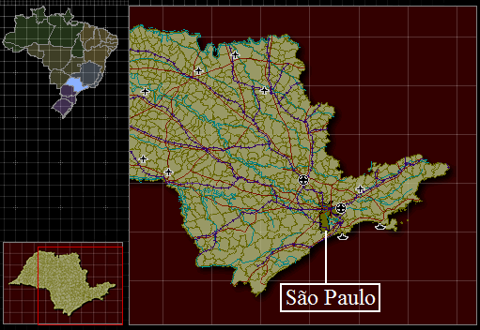
Figure 1 - Geographical position of São Paulo city, inside of São Paulo State
(Source: http://www.ibge.gov.br/cidadesat/default.php)

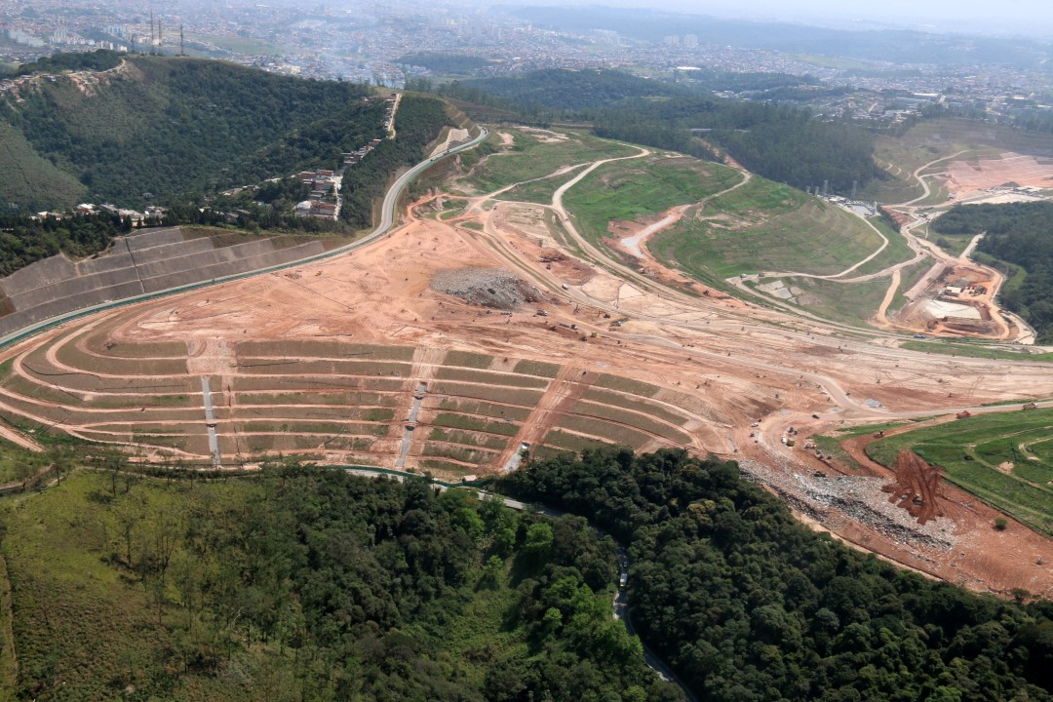
Figure 2 - Aerial view of CTL Landfill

A.3. Reference of applied methodology
>>
The following methodologies are applicable to this project activity:

- Large-scale Consolidated Methodology ACM0001: “Flaring or use of landfill gas” (Version 19.0);
- TOOL02 Methodological tool: “Combined tool to identify the baseline scenario and demonstrate additionality” (Version 07.0);
- TOOL04 Methodological tool: “Emissions from solid waste disposal sites” (Version 08.0);
- TOOL05 Methodological tool: “Baseline, project and/or leakage emissions from electricity consumption and monitoring of electricity generation” (Version 03.0);
- TOOL06 Methodological tool: “Project emissions from flaring” (Version 03.0);
- TOOL08 Methodological tool: “Tool to determine the mass flow of a greenhouse gas in a gaseous stream” (Version 03.0);
- TOOL09 Methodological tool: “Determining the baseline efficiency of thermal or electric energy generation systems” (Version 02.0);
- TOOL10 Methodological Tool: “Tool to determine the remaining lifetime of equipment” (Version 01);
- TOOL12 Methodological tool: “Project and leakage emissions from transportation of freight” (Version 01.1.0);
- TOOL07 Methodological tool: “Tool to calculate the emission factor for an electricity system” (Version 07.0);
- TOOL11 Methodological Tool: “Assessment of the validity of the original/current baseline and update of the baseline at the renewal of the crediting period” (Version 03.0.1);
- TOOL32 Methodological tool: “Positive lists of technologies” (Version 02.0)

A.4. Crediting period of project
>>
Under the original standard:

1st Crediting Period (expired): 01/04/2013 - 31/03/2020

Under GS4GG:
2nd Crediting Period (current): 01/04/2020 – 31/03/2025

SECTION B. IMPLEMENTATION OF PROJECT

B.1. Description of implemented project
>>
The implementation and operation of the CTL Landfill Gas Project consists concisely in:

LFG Capture and Collection Systems

The landfill gas capture and collection infrastructure of the landfill was designed with horizontal trenches and with the recovery of the vertical wells/drains. The horizontal trenches and vertical wells/drains are connected to the collection system known as well as transmission pipeline that accomplishes the transport of gas to the flaring station responsible for its treatment and destruction.

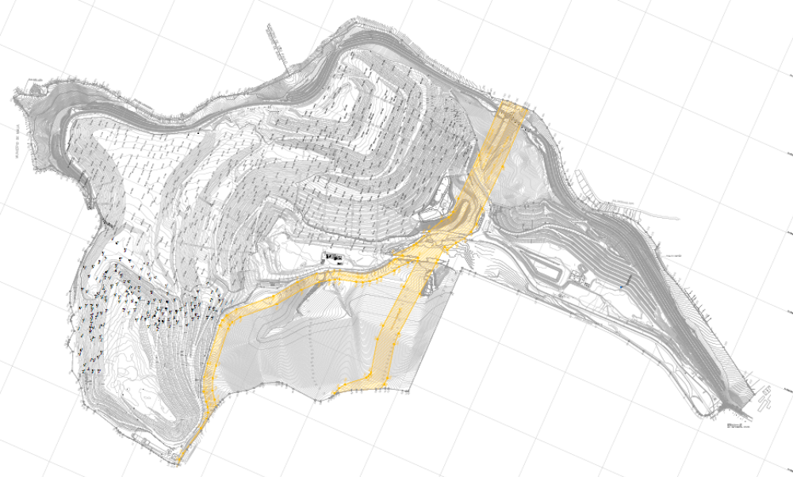
Figure 3 - General view of the LFG Capture and Collection Systems and Flaring Station.

- Capture System (Horizontal Trenches)

The capture system consists on a grid of horizontal trenches made of High Density Polyethylene (HDPE), due to the flexibility and the corrosion resistance. Each trench has an average length of 100 meters and is installed with approximately 15 meters away from each other. The capture system will continue to be installed throughout the lifetime of the CTL. Currently CTL landfill counts with approximately 596 drains, where 284 are connected to the biogas collection network and 181 under active collection, which means counting with adequate LFG quality and flow.

The figures below show an example of the installation of a horizontal trench.

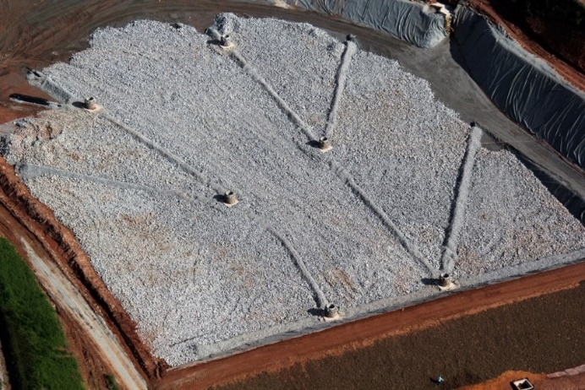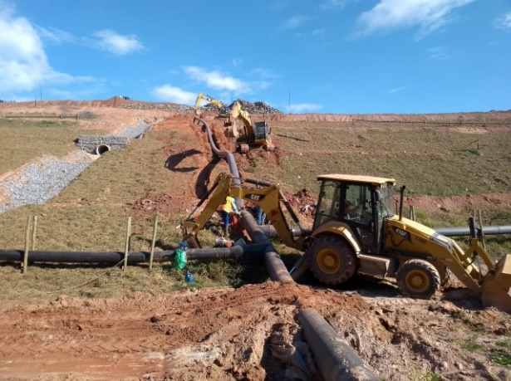

Figure 4 - LFG Drainage System.
(Source: EcoUrbis Ambiental S.A.)

All horizontal trenches (capture system) are connected to a collection system known as well as transmission pipeline that transports the landfill gas to the flaring station.

Each individual trench can regulate the concentrations of O₂ in the LFG collected. In case the concentrations are above a certain value, it means that maybe some air is infiltrating in the landfill and the valve corresponding to the trench is then closed. The periodic operation of the horizontal trenches will promote a systematic control and monitoring of the characteristics of the LFG extracted.

- Vertical Wells/Drains

In order to drain the leachate of the landfill, vertical wells/drains are progressively installed. In order to recover the LFG which is released through the wells/drains, the project aim to cap the vertical wells/drains and connect them to the collection system. The average distance is about 30 – 35 meters from each other. The top of the drains is equipped with LFG wellheads. This equipment connects the drain to the pipeline.

Also, CTL landfill counts with a proper leachate drainage system and periodic monitoring of the generated leachate quality. The leachate is sent for external treatment, and quality is monitored in order to meet the local established standards.

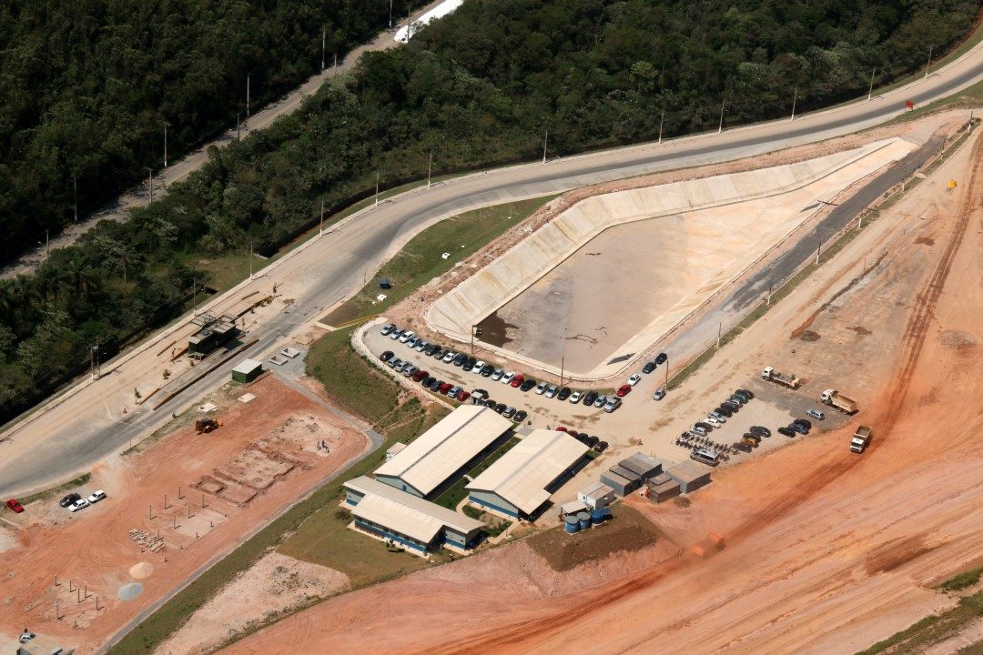
Figure 5 – Leachate drainage system
(Source: EcoUrbis Ambiental S.A.)

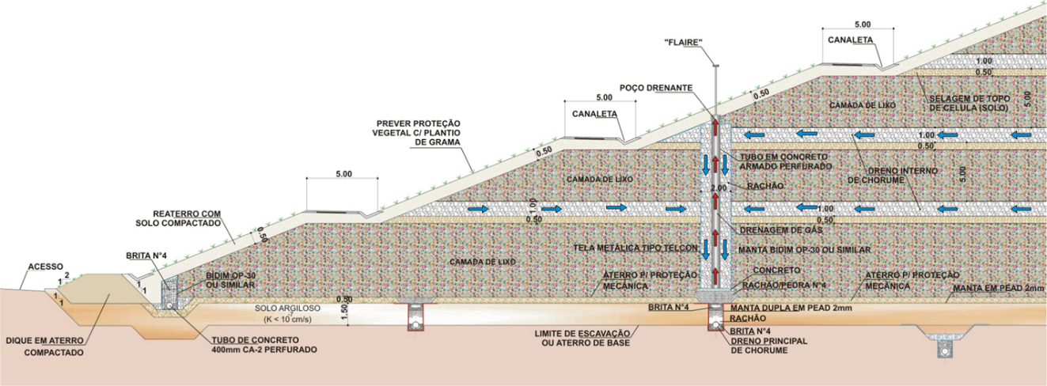
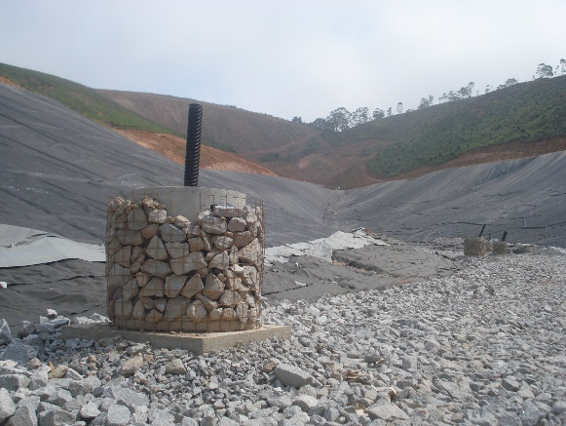 | 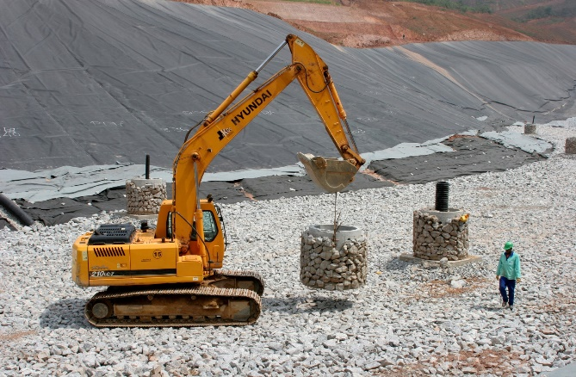
Figure 6 – Design of vertical wells/drains.
(Source: EcoUrbis Ambiental S.A.)

- Collection System (Transmission Pipeline)

The collection system, known as well as transmission pipeline, transports the collected LFG to the flaring station.

The collection system is usually built using High Density Polyethylene (HDPE), due to the flexibility and the corrosion resistance. The sizing of the piping is designed considering the maximum production of landfill gas. Intense welding activity is expected to connect each horizontal trench to the transmission pipeline.

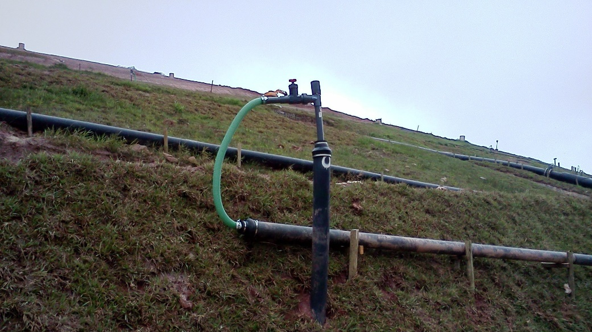
Figure 7 – Connected transmission pipelines
(Source: EcoUrbis Ambiental S.A.)
Flaring Station

The collection of LFG within the landfill is made by applying a pressure differential in each horizontal trench and or vertical well/drain. The depressurization system is composed of a group of centrifugal multi-stage blowers, connected in parallel with the main transmission pipeline. The depressurization of the system depends on the pressure of operation of flares. In addition, the Flaring Station usually has:

- Flares;
- Blowers;
- Safety valve on/off;
- Remover of condensate;
- Gas Analyzer;
- Meter for pressure;
- Meter for flow;
- Meter for temperature.

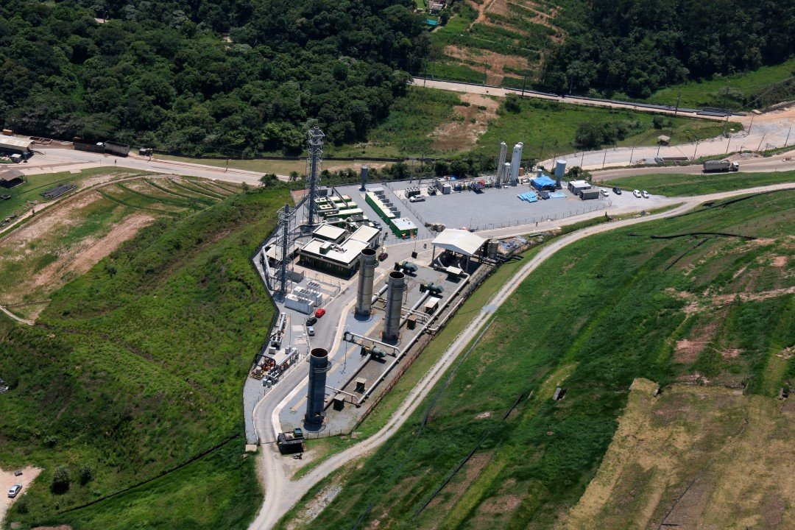
Figure 8 – Flaring station at CTL Landfill Gas Project
(Source: EcoUrbis Ambiental S.A.)

- The Blower System

The blower system is responsible to give negative pressure to the landfill, suctioning the gas to the pipeline. The dimensioning of the blower depends on the final use of the gas (flare, boiler, electricity).

In order to preserve the operation of the blowers, a dewatering system is installed to remove any condensate present in the LFG. This equipment is a single knock-out dewatering component.

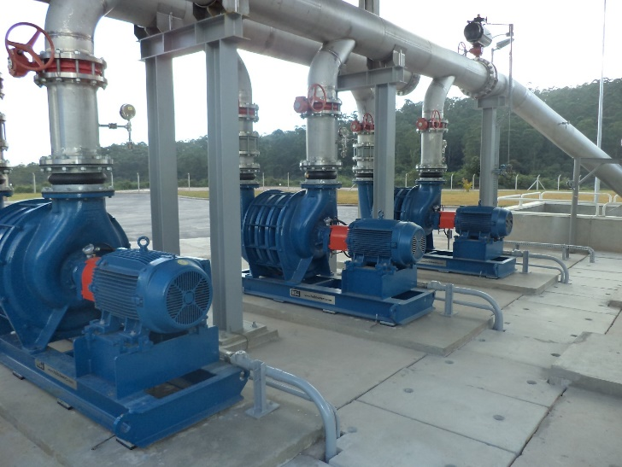
Figure 9 – Blower system at CTL Landfill Gas Project
(Source: EcoUrbis Ambiental S.A.)

- The Flare System

The destruction of the methane content in the LFG collected is made via an enclosed flare, in order to assure higher methane destruction (above 98%).

The flare efficiency is monitored according to Option B.1: Biannual measurement of the flare efficiency

The flaring station counts on a system of destruction of methane through flares. This system is composed by 3 enclosure flares and may have additional units installed, according to the LFG generation.

Basically, the flare is constructed using refractory material, a gas inlet, dampers to control the air inlet, an ignition spark, flame viewer and points to sample collection, as presented in the pictures below.

The flare is constructed in a vertical cylindrical combustion chamber, where the landfill gas is flared at a constant temperature (around 1,000º C), controlled by the admission of air, and with a retention time > 0.7 seconds.

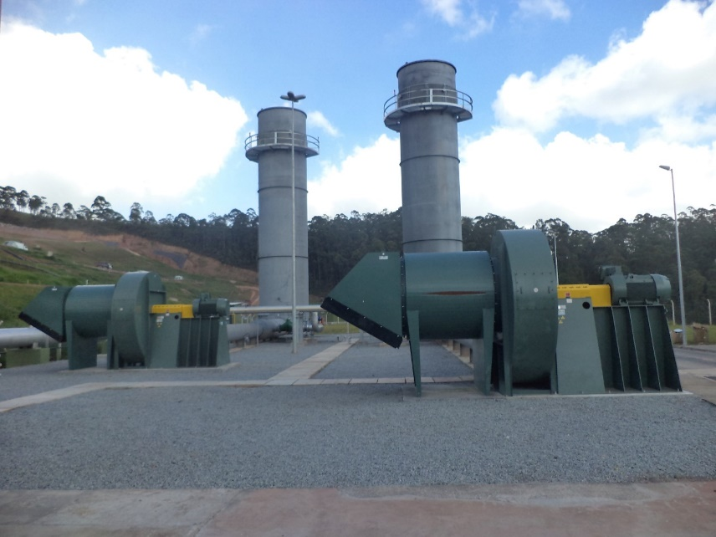
Figure 10 - Enclosed Flare system at CTL Landfill Gas Project
(Source: EcoUrbis Ambiental S.A.)

Power generation

The power generation system will be comprised of around 4.278 MW. The electricity generated by the Project will be used for self-consumption at CTL Landfill and eventually exported to the electricity grid. The configuration of the equipment will be chosen in accordance with the availability of the generation equipment on the market at the time of actual implementation of the second phase.

This kind of technology is still not widely applied in Brazil. Very few landfills have already installed equipment for the collection and flare of LFG.

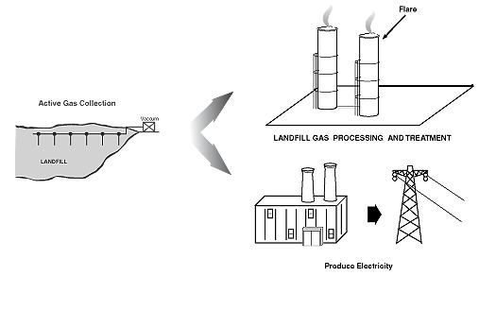
Figure 11 – Power generation diagram

The group generators to be installed will be as follows:

Manufacturer: GE Jenbacher
Model: JENBACHER J320 (TYPE 3)
Max. Electrical Efficiency: 41.4%
Net capacity for each generator: 1.426 MW
Plant Load Factor: 94.38%

The forecast installed capacity and electricity generated by the project activity are present below:
Net capacity  (MWe)¹ | Net electricity generated in the plant  (MWh)
4.278 | 35,369
[1] Definition of Net capacity: is the maximum capacity at the plant minus the amount of electricity that is consumed by the plant;
Note: As highlighted in Section A.2, the final equipment that will be chosen (as well as the final installed capacity) may vary depending on the availability of the generation equipment on the market at the time of actual implementation of the second phase.

Due to the already implemented LFG selling to consumers through dedicated pipelines and therefore, exporting of renewable energy, the LFG Electric Energy Generation plant implementation suffered considered delays, being forecasted to be installed by the year 2025.

The lifetime of the equipment is 25 years and it was based on manufacturer’s specifications.

B.1.1 Forward Action Requests
>>
Not applicable

B.2. Post-Design Certification changes
>>

B.2.1. Temporary deviations from the approved Monitoring & Reporting Plan, methodology or standardized baseline
>>
Deviation 1
Since the project participant, during the entire monitoring period from 20/01/2021 00:00 hs to 30/04/2023 23:59 hs, has temporarily not monitored the project emission parameter Quantity of electricity consumed from diesel generator by the project activity due to a failure in the implementation of electricity meters. According to the guidance of the “CDM project standard for project activities”, project participant estimated the parameter assuming that the source of the GHG emissions has been operated at maximum capacity for the periods when diesel generators were operational. It was also considered an addition of 10% to account for transmission and distribution losses.
The calculation of the conservative electricity consumption considered the maximum demand of the equipment consuming electricity at the landfill gas plant. The detailed calculation is presented below:
- Identification of LFG plant electricity consumption installed capacity:
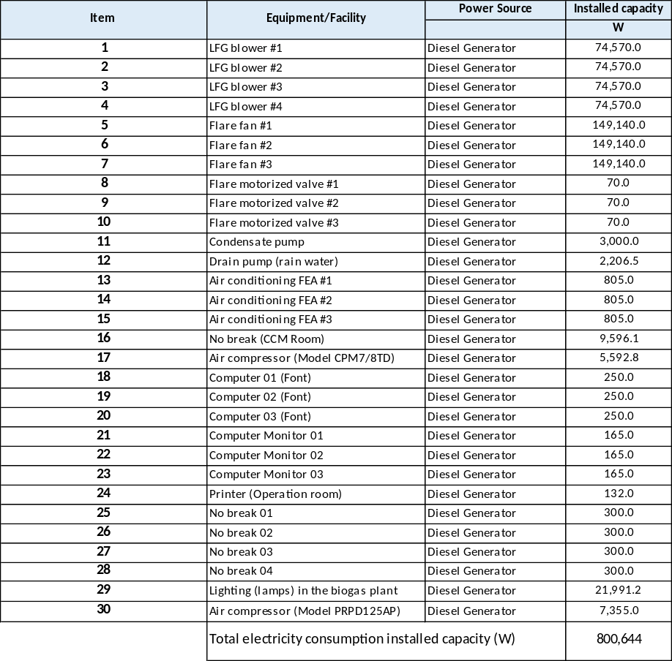

- Identification of total minutes of the Monitoring Period when diesel generator was ON:
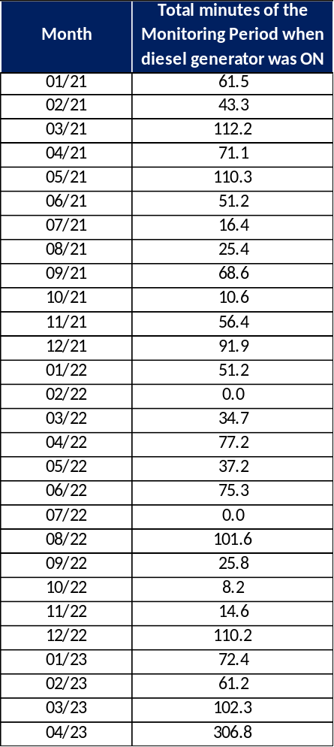

- Calculation of total electricity consumption (MWh) added 10% of conservativeness:
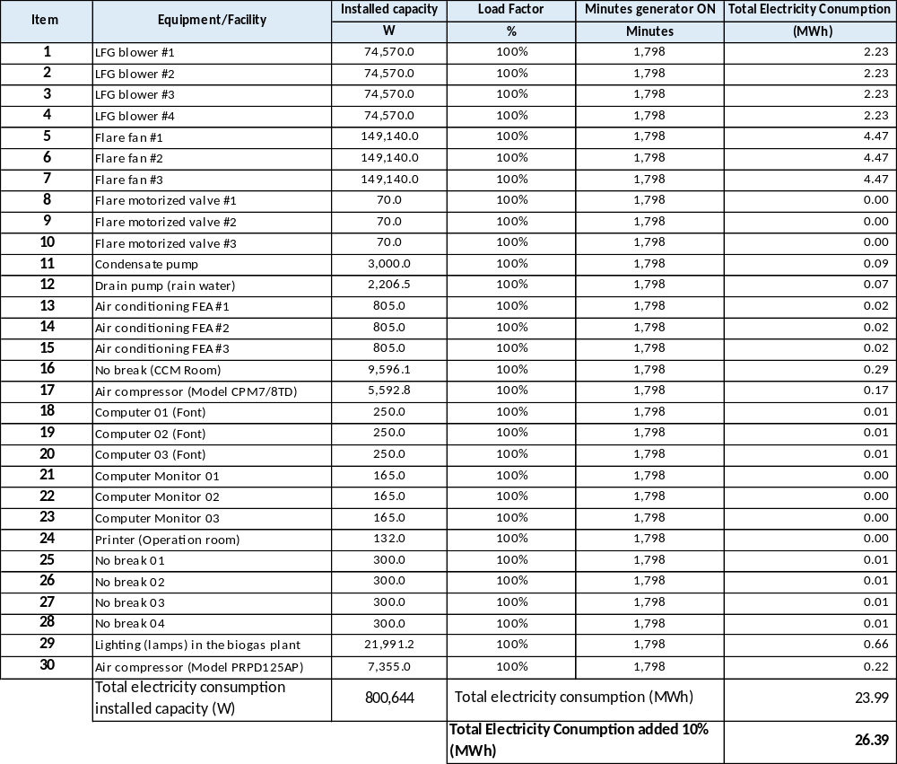

The Project Participant expects to correct such failure during the subsequent monitoring period.

B.2.2. Corrections
>>
Not applicable

B.2.3. Changes to start date of crediting period
>>
Not applicable

B.2.4. Permanent changes from the Design Certified monitoring plan, applied methodology or applied standardized baseline
>>
Not applicable

B.2.5. Changes to project design of approved project
>>
Not applicable

SECTION C. DESCRIPTION OF MONITORING SYSTEM APPLIED BY THE PROJECT
>>
The monitoring plan will be done according to the methodology ACM0001, the applicable tools, as well as per the paragraph 112 of the CDM project standard. Details are available in section B.7.1 above. The monitoring equipment locations are presented in the picture below:

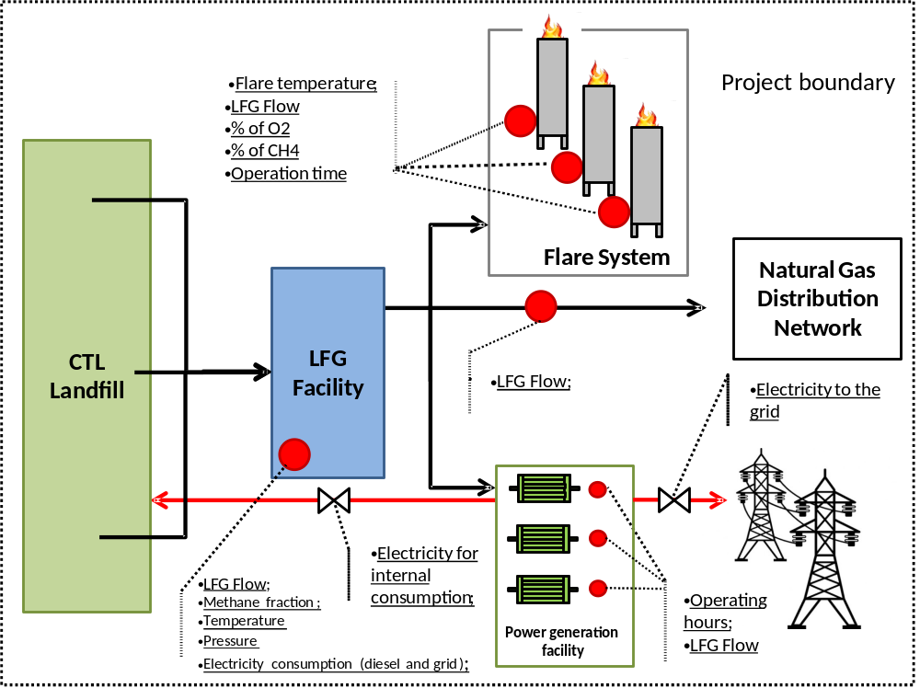
Figure 13 – Monitoring equipments locations

All continuously measured parameters (LFG flow, CH₄ concentration, flare temperature, flare operating hours, engine operating hours, and engine electrical output) will be recorded electronically via a datalogger, located within the Site boundary which will have the capability to aggregate and print the collected data at the frequencies as specified above. It will be the responsibility of the Site Operator to provide all requested data logs which will be stored over the duration of the reporting period at the Site office. The data logs will be summarized into emission reduction calculations prior to each verification. This task will be completed by EcoUrbis and reported directly to the DOE. These logs will be available at the request of the DOE in order to prove the operational integrity of the Project.

- Introduction and Objectives

The two primary purposes of the monitoring plan are:

- To collect the necessary system data required for the determination of emissions reductions; and
- To demonstrate successful compliance with established operating and performance criteria to verify the emission reductions and generate the respective CERs.

The operational data that is collected will be used to support the periodic verification report that will be required for CER auditing. The monitoring plan discussed herein is designed to meet or exceed the UNFCCC requirements (approved monitoring methodology ACM0001)

The routine system monitoring program required for the determination of the emission reductions is discussed in section 2 below, while the additional system data that is collected to ensure the safe, correct, and efficient operation of the LFG management system is discussed in section 3.

- Training of monitoring personnel

Before commencement of the O&M phase, EcoUrbis will conduct a training and quality control program to ensure that good management practices are carried out and implemented by all project operating personnel in terms of record-keeping, equipment calibration, overall maintenance, and procedures for corrective action. An operations manual will be developed for the operating personnel. The procedures for filing data and calculations to be performed by the LFG utilization operator will be included in a daily log to be placed in the main control room.

- Monitoring Work Program

The LFG monitoring program is a relatively simple, straight forward program designed to collect system operating data required to safely operate the system and for the verification of CERs. This data will be collected in real time, and will provide a continuous record that is easy to monitor, review, and validate.

The following sections will outline and discuss the following key elements of the monitoring program:

- Flow measurement;
- Gas quality measurements;
- Uncombusted methane;
- Electrical Consumption;
- Project electricity output;
- Regulatory requirements;
- Data records; and
- Data assessment and reporting.

  - Flow Measurement

According to ACM0001, one flow meter will be installed during Phase 1 (flaring) on the piping, straight before the flares.

During phase 2 (electricity generation) implementation, in order to follow ACM0001, two other flow meters are installed: one flow meter will be installed in the main piping straight after the blowers to measure the total LFG flow extracted from the landfill; and another flow meter is installed in the piping before the power plant to measure the LFG flow utilized for electricity generation.

Also, during phase 2 (LFG sent to consumer through dedicated pipeline) implementation, in order to follow ACM0001, other flow meters are also installed in the piping leading to a consumers through dedicated pipeline, being one flow meter for each LFG consumer.

The flow of LFG collected by the system and subsequently utilized, flared or sent to the consumers through dedicated pipelines are measured via individual flow measuring devices suitable for measuring the velocity and volumetric flow of a gas. One common example is an annubar. The flow measurements are taken within the piping itself, and the flow sensors are connected to transmitters that are capable of collecting and sending continuous data to a recording device such as a datalogger.

The flow sensors are calibrated according to a specified temperature and composition of the gas, thus the flow actually measured must be corrected to according to actual temperature, pressure, and composition, thus density, of the gas measured. The equipment selected will allow dynamic compensation for these parameters, normalized to a standard temperature, pressure, and gas composition. For reporting purposes, the flows are generally required to be normalized to 0°C and 1.01325 bar at standard gas composition of 50% methane and carbon dioxide each by volume.

The accuracy of a flow meter is dependent on the design of the equipment, and the specific type of sensor used, however equipment is available that will provide a minimum accuracy of +/- 2% by volume. The equipment selected for the site utilizes a continuous monitoring system as defined in ACM0001, which measures and aggregates flow data approximately once every two minutes.

  - Gas Quality

The two parameters that are most pertinent to the validation of CERs, as well as the safe and efficient operation of the system are the concentration of methane and oxygen in the gas stream delivered for utilization or diverted to flaring. These two parameters are measured via a common sample line that is ran to the main collection system piping, and measured in real time by two separate sensors, one for methane and the other for oxygen, installed as per ACM0001.

Regular calibration of the equipment is especially important, as the accuracy of the methane and oxygen sensors is greatest within the expected range of the gas stream to be measured. Equipment is readily available that will provide an accuracy of at least +/- 1% by volume. The equipment selected for the site aggregates gas compositions approximately once every 2 minutes as per the definition of a continuous monitoring system in ACM0001.

  - Uncombusted Methane

The efficiency of the enclosed flares will be measured per the methodological “Tool to determine project emissions from flaring gases containing methane”.

  - Electrical Consumption

The consumed electricity from the grid by the project activity is continuously measured by electricity meters for the grid and diesel generators. The respective data will be electronically recorded.
Monthly electrical bills charged to the project are monitored and considered as the actual energy consumption for the project.

  - Project Electricity Output

The generated electricity used for the landfill internal consumption (i.e. administration offices, truck garage, recycling plant, leachate pumps), excluding the LFG Facility electricity consumption by the project activity is continuously measured by an electricity meter and respective data is electronically recorded.

  - LPG purchased

The mass of LPG purchased by the project developer will be stated in the invoices issued by the LPG supplier. For ex-ante calculation, the value of LPG purchased was considered zero since there is no estimation from LPG consumption in pilot flames of flares and this emission source is very small.

  - Regulatory Requirements

Regulatory requirements relating to LFG projects will be evaluated annually by investigating municipal, state and national regulations pertaining to LFG. This will be done through consultation with the appropriate regulatory bodies, ongoing discussion with regulators, and monitoring of publications delineating upcoming legislative changes governing landfills and LFG.

- Data records and storage

Data collected from each of the parameter sensors is transmitted directly to an electronic database from which the CER volume calculations may be carried out, as described in section 2.1 above. A hard copy backup or reports of the data may be printed as required or recorded in Portable Document Format (PDF). Backup of the electronic data is conducted on a 2-3 minute intervals, as described above.

  - Data Assessment and Reporting

Assessment of the flow and composition data described above coupled with the operating hours of the engines/flare and engines/flare destruction efficiencies are used to determine the quantity of CERs to be generated. For electricity generation offsets, the appropriate emission factors will be applied.

The destruction efficiency of the flare is a function of the internal combustion temperature and resident holding time, which are generally measured by the flare system controller and recorded for auditing purposes. Extensive technical documentation is available that documents the destructive efficiency of the enclosed drum flares that will be used, subject to the flow rate and combustion temperature verification. Destruction efficiency will also be assessed periodically through measurement of ncombusted methane emissions.

As discussed in Section 2.1, flow data is normalized to standard temperature, pressure, and composition for reporting purposes. The data will be compiled and assessed to produce the required quantification and validation. The periodic monitoring report will contain the data required for the verification of the CERs, and additionally may contain operational data from the collection system and flaring system described below to illustrate that the system is well maintained and operating at peak efficiency. Records of regular maintenance performed will also be a component of the annual report.

- Related monitoring and project performance review

EcoUrbis will conduct an additional operational monitoring of the LFG collection system to check the project performance and ensure that the system is being operated both correctly and efficiently. Periodic adjustments to the horizontal trenches and to the extraction wells/drains will be required to optimize the capture and collection systems effectiveness. LFG collection field adjustments will be made based upon a review of the trench and well performance history considered within the context of the overall LFG collection field operation in order to maximize the collection of methane balanced against minimization of any oxygen in the system that could introduce unsafe operating conditions. Monitoring at each trench and extraction well will consist of the following parameters: valve position, individual well/trench flow, individual well/trench vacuum, and composition of the gas collected, i.e., methane, carbon dioxide, and oxygen, using a portable measuring device.

- Emergency procedures

As a precautionary measure, the Landtec® system is plugged to a battery-based uninterruptible power supply (UPS) to avoid data loss due to power failures. As a backup is produced and stored off-site from the main recording system, no more than 2 to 3 minutes of data at a time would ever be lost due to a system malfunction.

All data will be collected through a Landtec® Field Analytical Unit (FAU) and will be transmitted to a Landtec® Field Server Unit (FSU), which records the data on-site and automatically sends it via a “always-on” Internet connection to an off-site server for storage and off-site back-up. All collected data is available for viewing, report generation, and retrieval through a Web interface, the EnvironComp™ Reporting System (ECRS), which can be accessed from anywhere an Internet connection is available. The plant Manager will check daily the records. In addition, there will be developed an Emergency Plan including other types of emergencies such as fire and work accidents.

- Calibration

All the measurement instruments are subjected to regular calibration as per manufacturer’s specifications. The regular check and calibration are made by the operators. The plant Manager will be responsible for checking the equipment’s proper working order, as well as checking and storing up the calibration certificates and records. Calibration certificates will be kept for all the equipments during the crediting period and two years after.

- Date of completion of application of methodology and standardized baseline and contact information of responsible persons/ entities

The date of completion the application of the methodology to the project activity study is 22/04/2023.

The person/entity determining the baseline is as follows:
Beng Engenharia Ltda, São Paulo, Brazil
Contact person: Mr. João Sprovieri
Mr. Francisco Santo
Email: joao.sprovieri@beng.eng.br
francisco.santo@beng.eng.br

Beng Engenharia Ltda is not a Project Participant.

SECTION D. DATA AND PARAMETERS

D.1. Data and parameters fixed ex ante or at renewal of crediting period
>>
Relevant SDG Indicator | SDG 13.2.1  SDG 7
Data/parameter | EF_{grid,BM,2018}
Unit | tCO₂ /MWh
Description | Build margin emission factor of the Brazilian grid
Source of data | Calculations based on parameters described above.
Value(s) applied | 0.1370
Choice of data or Measurement methods and procedures | The build margin emission factor has been defined by the Brazilian DNA
Purpose of data | (b) Calculation of project emissions or actual net GHG removals by sinks;
Additional comment | All data and parameters to determine the grid electricity emission factor, as required by the “Tool to calculate the emission factor for an electricity system”, were included in the monitoring plan.  2018 Build Margin – According to STEP 5, option 2 of Tool to calculate the emission factor for an electricity system

Relevant SDG Indicator | SDG 13.2.1
Data/parameter | OX_{top_layer}
Unit | Dimensionless
Description | Fraction of methane that would be oxidized in the top layer of the SWDS in the baseline
Source of data | Consistent with how oxidation is accounted for in the methodological tool “Emissions from solid waste disposal sites”
Value(s) applied | 0.1
Choice of data or Measurement methods and procedures | Default value used, according to ACM0001
Purpose of data | Calculation of baseline emission
Additional comment | Applicable to Step A

Relevant SDG Indicator | SDG 13.2.1
Data/parameter | GWP_{CH4}
Unit | t CO₂e/t CH₄
Description | Global warming potential of CH₄
Source of data | IPCC
Value(s) applied | 28 updated as per Applicability of Global Warming Potential for Gold Standard for the Global Goals Projects available at https://globalgoals.goldstandard.org/standards/RU-2020-PR-V1.2-GWP-values.pdf .
Choice of data or Measurement methods and procedures | Default value used, according to IPCC Fourth Assessment Report: Climate Change 2007, item 2.10.2: Direct Global Warming Potentials, Table 2.14
Purpose of data | Calculation of baseline emission
Additional comment | Monitoring Period adopted value: 28 updated as per Applicability of Global Warming Potential for Gold Standard for the Global Goals Projects available at https://globalgoals.goldstandard.org/standards/RU-2020-PR-V1.2-GWP-values.pdf

Relevant SDG Indicator | SDG 13.2.1
Data/parameter | NCV_{fuel,y}
Unit | TJ/t CH₄
Description | Net calorific value of methane at reference conditions
Source of data | Technical literature
Value(s) applied | 0.0504
Choice of data or Measurement methods and procedures | -
Purpose of data | -
Additional comment | -

Relevant SDG Indicator | SDG 13.2.1
Data/parameter | R_{u}
Unit | Pa.m³/kmol.K
Description | Universal ideal gas constant
Source of data | Methodological tool “Project emissions from flaring”
Value(s) applied | 0.008314472
Choice of data or Measurement methods and procedures | Default value used, according to Methodological tool “Project emissions from flaring”, table 1: Constants used in equations
Purpose of data | Calculation of baseline emission
Additional comment | -

Relevant SDG Indicator | SDG 13.2.1
Data/parameter | Waste composition
Unit | %
Description | Waste composition
Source of data | landfill internal studies
Value(s) applied
  Composition of waste
  A) Wood and wood products | 2.21%
  B) Pulp, paper and cardboard (other than sludge) | 8.90%
  C) Food, food waste, beverages and tobacco (other than sludge) | 47.08%
  D) Textiles | 19.23%
  E) Garden, yard and park waste | 0.00%
  F) Glass, plastic, metal, other inert waste | 22.58%
  TOTAL | 100%
Choice of data or Measurement methods and procedures | Internal Report
Purpose of data | Calculation of baseline emission
Additional comment | Used for projection of methane avoidance

Relevant SDG Indicator | SDG 13.2.1
Data/parameter | SPEC_{flare}
Unit | Temperature - °C  Flow rate – Nm³/h  Maintenance schedule – number of days
Description | Manufacturer’s flare specifications for temperature, flow rate and  maintenance schedule
Source of data | Flare Manufacturer
Value(s) applied
  Flare model | 3000 HT  (ZULE® 13’ x 60’)
  Minimum flare temperature | 649 ºC
  Maximum flare temperature | 1093 ºC
  Minimum and maximum inlet flow rate | Minimum flow: 750 Nm³/h  ---  Maximum flow: 9,600 Nm³/h
  Maximum duration in days between maintenance events | N/A
Choice of data or Measurement methods and procedures | Calculation of project emissions
Purpose of data | -
Additional comment | SPEC_{flare}

Relevant SDG Indicator | SDG 13.2.1
Data/parameter | P_{ref}
Unit | Pa
Description | Atmospheric pressure at reference conditions
Source of data | Tool “Project emissions from flaring”
Value(s) applied | 101,325
Choice of data or Measurement methods and procedures | Default value extracted from Tool “Project emissions from flaring”
Purpose of data | Calculation of project emissions
Additional comment | -

Relevant SDG Indicator | SDG 13.2.1
Data/parameter | T_{ref}
Unit | K
Description | Temperature at reference conditions
Source of data | Tool “Project emissions from flaring”
Value(s) applied | 273.15
Choice of data or Measurement methods and procedures | Default value extracted from Tool “Project emissions from flaring”
Purpose of data | Calculation of project emissions
Additional comment | -

Relevant SDG Indicator | SDG 13.2.1
Data/parameter | η_{PJ}
Unit | Dimensionless
Description | Efficiency of the LFG capture system that is be installed in the project activity
Source of data | A Landfill Gat-to-Energy Project Development Handbook. USEPA 1996 Handbook EPA-LFG.
Value(s) applied | 85%
Choice of data or Measurement methods and procedures | Based on the active LFG capture system installed in the project activity.
Purpose of data | Calculation of baseline emission
Additional comment | -

Relevant SDG Indicator | SDG 13.2.1
Data/parameter | φ_{default}
Unit | -
Description | Default value for the model correction factor to account for model uncertainties
Source of data | Tool “Emissions from solid waste disposal sites”
Value(s) applied | 0.75
Choice of data or Measurement methods and procedures | According to “Emissions from solid waste disposal sites”, the Application A was used because the landfill is an existing solid waste disposal site and in the project activity the methane emissions are being mitigated by capturing and flaring the methane (ACM0001).
Purpose of data | Calculation of baseline emission
Additional comment | -

Relevant SDG Indicator | SDG 13.2.1
Data/parameter | OX
Unit | -
Description | Oxidation factor (reflecting the amount of methane from SWDS that is oxidized in the soil or other material covering the waste)
Source of data | Based on an extensive review of published literature on this subject, including the IPCC 2006 Guidelines for National Greenhouse Gas Inventories
Value(s) applied | 0.1
Choice of data or Measurement methods and procedures | Default value used according to “Emissions from solid waste disposal sites”
Purpose of data | Calculation of baseline emission
Additional comment | When methane passes through the top-layer, part of it is oxidized by methanotrophic bacteria to produce CO₂. The oxidation factor represents the proportion of methane that is oxidized to CO₂.This should be distinguished from the methane correction factor (MCF) which is to account for the situation that ambient air might intrude into the SWDS and prevent methane from being formed in the upper layer of SWDS.

Relevant SDG Indicator | SDG 13.2.1
Data/parameter | F
Unit | -
Description | Fraction of methane in the SWDS gas (volume fraction)
Source of data | IPCC 2006 Guidelines for National Greenhouse Gas Inventories
Value(s) applied | 0.5
Choice of data or Measurement methods and procedures | Default value used according to “Emissions from solid waste disposal sites”
Purpose of data | Calculation of baseline emission
Additional comment | Upon biodegradation, organic material is converted to a mixture of methane and carbon dioxide

Relevant SDG Indicator | SDG 13.2.1
Data/parameter | DOC_{f,default}
Unit | Weight fraction
Description | Default value for the fraction of degradable organic carbon (DOC) in MSW that decomposes in the SWDS
Source of data | IPCC 2006 Guidelines for National Greenhouse Gas Inventories
Value(s) applied | 0.5
Choice of data or Measurement methods and procedures | The default value was used for type Application A). according to “Emissions from solid waste disposal sites”
Purpose of data | Calculation of baseline emission
Additional comment | This factor reflects the fact that some degradable organic carbon does not degrade, or degrades very slowly, in the SWDS. This default value can be used for Application A.

Relevant SDG Indicator | SDG 13.2.1
Data/parameter | MCF_{default}
Unit | -
Description | Methane correction factor
Source of data | IPCC 2006 Guidelines for National Greenhouse Gas Inventories
Value(s) applied | 1.0
Choice of data or Measurement methods and procedures | The project activity is an anaerobic managed solid waste disposal site with controlled placement of waste (i.e. waste directed to specific deposition areas, a degree of control of scavenging and a degree of control of fires) and is include: (i) cover material; (ii) mechanical compacting and (iii) leveling of the waste;
Purpose of data | Calculation of baseline emission
Additional comment | -

Relevant SDG Indicator | SDG 13.2.1
Data/parameter | DOC_{j}
Unit | -
Description | Fraction of degradable organic carbon in the waste type j (weight fraction)
Source of data | IPCC 2006 Guidelines for National Greenhouse Gas Inventories (adapted from Volume 5, Tables 2.4 and 2.5)
Value(s) applied
  Waste type j | DOCj  (% wet waste)
  Wood and wood products | 43%
  Pulp, paper and cardboard (other than sludge) | 40%
  Food, food waste, beverages and tobacco (other than sludge) | 15%
  Textiles | 24%
  Garden, yard and park waste | 20%
  Glass, plastic, metal, other inert waste | 0%
Choice of data or Measurement methods and procedures | IPCC default value for municipal solid waste (MSW) disposal site is applied.
Purpose of data | Calculation of baseline emission
Additional comment | -

Relevant SDG Indicator | SDG 13.2.1
Data/parameter | k_{j}
Unit | -
Description | Decay rate for waste type j
Source of data | 2006 IPCC Guidelines for National Greenhouse Gas Inventories
Value(s) applied
  Waste type j |  | Tropical (MAT > 20 °C)
   |  | Wet (MAP > 1,000mm)
  Slowly degrading | Pulp, paper, cardboard (other than sludge), textiles | 0.07
  Slowly degrading | Wood, wood products and straw | 0.035
  Moderately degrading | Other (non-food) organic putrescible garden and park waste | 0.17
  Rapidly degrading | Food, food waste, sewage sludge, beverages and tobacco | 0.4
Choice of data or Measurement methods and procedures | IPCC default value for anaerobic managed solid waste disposal site is applied.
Purpose of data | Calculation of baseline emissions
Additional comment | Used for projection of methane avoidance. The climate data was provided to Rainfall index database from São Paulo city – Station: E3-243 (http://www.sigrh.sp.gov.br/cgi-bin/bdhm.exe/plu?qwe=qwe). And the temperature data was provided to CIIAGRO (http://www.ciiagro.sp.gov.br/ciiagroonline/Quadros/QtmedPeriodo.asp)

Relevant SDG Indicator | SDG 13.2.1
Data/parameter | MM_{i}
Unit | kg/kmol
Description | Molecular mass of greenhouse gas i
Source of data | Tool to determine the mass flow of a greenhouse gas in a gaseous stream
Value(s) applied
  Compound | Structure | Molecular mass (kg/kmol)
  Methane | CH₄ | 16.04
Choice of data or Measurement methods and procedures | According to “Tool to determine the mass flow of a greenhouse gas in a gaseous stream”
Purpose of data | Calculation of baseline emissions
Additional comment | -

Relevant SDG Indicator | SDG 13.2.1
Data/parameter | MM_{k}
Unit | kg/kmol
Description | Molecular mass of gas k
Source of data | Tool to determine the mass flow of a greenhouse gas in a gaseous stream
Value(s) applied
  Compound | Structure | Molecular mass (kg/kmol)
  Nitrogen | N₂ | 28.01
Choice of data or Measurement methods and procedures | According to “Tool to determine the mass flow of a greenhouse gas in a gaseous stream”
Purpose of data | Calculation of baseline emissions
Additional comment | -

Relevant SDG Indicator | SDG 13.2.1
Data/parameter | MM_{H2O}
Unit | kg/kmol
Description | Molecular mass of water
Source of data | Tool to determine the mass flow of a greenhouse gas in a gaseous stream
Value(s) applied | 18.0152
Choice of data or Measurement methods and procedures | According to “Tool to determine the mass flow of a greenhouse gas in a gaseous stream”
Purpose of data | Calculation of baseline emissions
Additional comment | -

Relevant SDG Indicator | SDG 13.2.1
Data/parameter | DEFT_{SP,y}
Unit | tCO₂/TJ
Description | Default emission factor from the supply of LFG to consumers through a dedicated pipeline
Source of data | This default value was based on Tool 15 – Upstream leakage emissions associated with fossil fuel use ,Appendix, Table 1, page 19 (Natural gas distribution).
Value(s) applied | 2.2
Choice of data or Measurement methods and procedures | -
Purpose of data | Calculation of project emissions
Additional comment | Conservatively, it was used the highest value from Table 4 to include as default emission factor.

D.2 Data and parameters monitored
>>
Relevant SDG Indicator | SDG 7.2.1  SDG 13.2.1
Data / Parameter | EF_{grid,CM,y}
Unit | tCO₂ /MWh
Description | CO₂ emission factor of the Brazilian grid electricity during the year y
Source of data | Brazilian DNA
Value(s) applied | 0.2524 (2021)  0.2045 (2022)  0.1912 (2023)
Measurement methods and procedures | Calculated as the weighted average of the dispatch data analysis OM (Operating Margin) and the BM (Build margin).
Monitoring frequency | Annual
QA/QC procedures | Value applicable is calculated by considering the applicable guidance of the “Tool to calculate the emission factor for an electricity system”. Apply procedures in the “Tool to calculate the emission factor for an electricity system”.
Purpose of data | (b) Calculation of project emissions or actual net GHG removals by sinks;
Additional comment | All data and parameters to determine the grid electricity emission factor, as required by the “Tool to calculate the emission factor for an electricity system”, were included in the monitoring plan.

Relevant SDG Indicator | SDG 7.2.1  SDG 13.2.1
Data / Parameter | EF_{grid,OM,y}
Unit | tCO₂ /MWh
Description | Operating margin emission factor of the Brazilian grid
Source of data | Brazilian DNA
Value(s) applied | 0.5985 (2021)  0.4068 (2022)  0.3539 (2023)
Measurement methods and procedures | Calculated (based on official monthly values as calculated and published by the DNA of Brazil).
Monitoring frequency | Annual
QA/QC procedures | Value applicable is calculated by considering the applicable guidance of the “Tool to calculate the emission factor for an electricity system”. Apply procedures in the “Tool to calculate the emission factor for an electricity system”.
Purpose of data | (b) Calculation of project emissions or actual net GHG removals by sinks;
Additional comment | All data and parameters to determine the grid electricity emission factor, as required by the “Tool to calculate the emission factor for an electricity system”, were included in the monitoring plan.  For more details, see Annex 3 in the PDD  For EF 2020, it was used OM data of 2020 since the dispatch data analysis OM is to use the year in which the project activity displaces grid electricity.

Relevant SDG Indicator | SDG 7.2.1  SDG 13.2.1
Data / Parameter | TDLy
Unit | -
Description | Average technical transmission and distribution losses in the grid in year y for the voltage level at which electricity is obtained from the grid at the project site.
Source of data | Brazilian Energy Balance 2022 – Síntese do Relatório Final (base year 2021)  and  Brazilian Energy Balance 2023 – Síntese do Relatório Final (base year 2022)
Value(s) applied | 23.2% (applied for 2021)  28.6% (applied for 2022)  28.6% (applied for 2023)
Measurement methods and procedures | https://www.epe.gov.br/pt/publicacoes-dados-abertos/publicacoes/balanco-energetico-nacional-2022  https://www.epe.gov.br/pt/publicacoes-dados-abertos/publicacoes/balanco-energetico-nacional-2023
Monitoring frequency | Annual
QA/QC procedures | -
Purpose of data | (b) Calculation of project emissions or actual net GHG removals by sinks
Additional comment | -

Relevant SDG Indicator | SDG 7.2.1  SDG 13.2.1
Data / Parameter | EC_{PJ1,y} = EG_{EC1,y}
Unit | MWh/y
Description | Quantity of electricity consumed from the grid by the project activity during the year y
Source of data | Measurement from Project participants.
Value(s) applied
  Month/Year | Electricity  (MWh)
  January/2021 | 73.9
  February/2021 | 140.1
  March/2021 | 150.3
  April/2021 | 169.0
  May/2021 | 133.3
  June/2021 | 161.3
  July/2021 | 163.2
  August/2021 | 120.5
  September/2021 | 116.0
  October/2021 | 97.0
  November/2021 | 114.4
  December/2021 | 123.8
  January/2022 | 116.0
  February/2022 | 126.4
  March/2022 | 103.6
  April/2022 | 112.2
  May/2022 | 108.8
  June/2022 | 90.4
  July/2022 | 99.3
  August/2022 | 73.7
  September/2022 | 56.8
  October/2022 | 62.1
  November/2022 | 75.4
  December/2022 | 88.3
  January/2023 | 98.6
  February/2023 | 115.4
  March/2023 | 82.4
  April/2023 | 90.2
  TOTAL | 3,062.7
 | The quantity of electricity consumed from the grid was monitored through the electricity invoices received from the ENEL (Power distributor company of metropolitan region of São Paulo city). The energy meters are installed by the power distribution company ENEL, which is also responsible for meters maintenance and calibrations.
Monitoring frequency | Continuously.
QA/QC procedures | The energy meters are installed by the power distribution company ENEL, which is also responsible for meters maintenance and calibrations.
Purpose of data | (b) Calculation of project emissions or actual net GHG removals by sinks
Additional comment | The data will be archived throughout the crediting period and two years thereafter

Relevant SDG Indicator | SDG 7.2.1  SDG 13.2.1
Data / Parameter | EC_{PJ2,y} = EG_{EC2,y}
Unit | MWh/y
Description | Quantity of electricity consumed from diesel generator by the project activity during the year y
Source of data | Measurement from Project participants.
Value(s) applied | 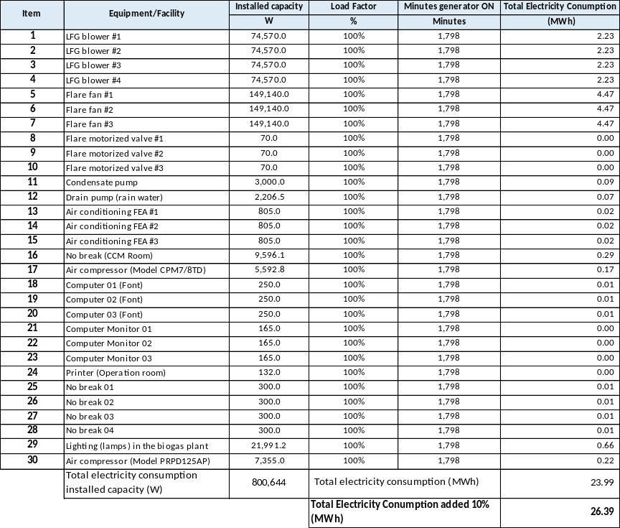
Measurement methods and procedures | Continuously measured by electricity meters for the diesel generators as per “Methodological tool: Baseline, project and/or leakage emissions from electricity consumption and monitoring of electricity generation” and ACM0001 methodology
Monitoring frequency | Continuously
QA/QC procedures | As per the “Methodological tool: Baseline, project and/or leakage emissions from electricity consumption and monitoring of electricity generation”  For the current monitoring period, the electricity meters measuring the amount of electricity consumed from the diesel generators do not enables calibration or calibration certificates, CDM Project Standard for project activities, has been used to determine project emissions due to electricity consumption; The conservative electricity consumption data was defined assuming that the source of the GHG emissions has been operated at maximum capacity for the periods when diesel generators was operational. It was also considered an addition of 10% to account for transmission and distribution losses.
Purpose of data | (b) Calculation of project emissions or actual net GHG removals by sinks
Additional comment | The data will be archived throughout the crediting period and two years thereafter.  Since the project participant, during the entire monitoring period from 20/01/2021 00:00 hs to 30/04/2023 23:59 hs, has temporarily not monitored the project emission parameter Quantity of electricity consumed from diesel generator by the project activity due to a failure in the implementation of electricity meters. According to the guidance of the “CDM project standard for project activities”, project participant estimated the parameter assuming that the source of the GHG emissions has been operated at maximum capacity for the periods when diesel generators were operational. It was also considered an addition of 10% to account for transmission and distribution losses.

ACM0001: Flaring or use of landfill gas --- Version 18.0
Relevant SDG Indicator | SDG 13.2.1
Data / Parameter | Management of SWDS
Unit | -
Description | Management of SWDS
Source of data | Use different sources of data:  - Original design of the landfill;  - Technical specifications for the management of the SWDS;  - Local or national regulations.
Value(s) applied | -
Measurement methods and procedures | Verification of all equipment according to the manufacturer.
Monitoring frequency | Annually
QA/QC procedures | -
Purpose of data | (a) Calculation of baseline emissions or baseline net GHG removals by sinks
Additional comment | The project is taking place at the current municipality discharge site thus no land change is involved.

Relevant SDG Indicator | SDG 7.2.1  SDG 13.2.1
Data / Parameter | EG_{PJ,y} = EC_{BL,k,y}
Unit | MWh
Description | Amount of electricity generated using LFG by the project activity in year y
Source of data | Electricity meter
Value(s) applied | Not applicable yet since there is no electricity generation at the project activity.
Measurement methods and procedures | Monitor net electricity generation by the project activity using LFG
Monitoring frequency | Continuous
QA/QC procedures | Electricity meter will be subject to regular (in accordance with stipulation of the meter supplier) maintenance and testing to ensure accuracy. The readings will be double checked by the electricity distribution company.
Purpose of data | b) Calculation of project emissions or actual net GHG removals by sinks
Additional comment | This parameter is required for calculating baseline emissions associated with electricity generation (BE_{EC,y}) using the “Methodological tool: Baseline, project and/or leakage emissions from electricity consumption and monitoring of electricity generation”.

Relevant SDG Indicator | SDG 7.2.1  SDG 13.2.1
Data / Parameter | O_{pj,h}
Unit | -
Description | Operation of the equipment that consumes the LFG
Source of data | Measurements by Project participant using a device integrated with the operational software at the landfill gas plant.
Value(s) applied | Data available in the CERs calculation spreadsheet
Measurement methods and procedures | For each equipment unit j using the LFG monitor that the plant is operating in hour h by the monitoring any one or more of the following three parameters:  (a) Temperature. Determine the location for temperature measurements and minimum operational temperature based on manufacturer’s specifications of the burning equipment. Document and justify the location and minimum threshold in the PDD;  (b) Flame. Flame detection system is used to ensure that the equipment is in operation;  I Products generated. Monitor the generation of steam for the case of boilers and air-heaters and glass for the case of glass melting furnances. This option is not applicable to brick kilns.  O_{pj,h} = 0 when:  (a) One of more temperature measurements are missing or below the minimum threshold in hour h (instantaneous measurements are made at least every minute);  (b) Flame is not detected continuously in hour h (instantaneous measurements are made at least every minute);  (c) No products are generated in the hour h.  Otherwise, O_{pj,h} = 1
Monitoring frequency | Once per minute
QA/QC procedures | The calibration of this equipment is not applicable since it is a device integrated with the operational software at the landfill gas plant.
Purpose of data | (a) Calculation of baseline emissions or baseline net GHG removals by sinks
Additional comment | -

Relevant SDG Indicator | SDG 13.2.1
Data / Parameter | F_{CH4,NGy}
Unit | tCH₄/yr
Description | Amount of methane in the LFG which is sent to the costumer through a dedicated pipeline in year y
Source of data | Measured by Project Participant
Value(s) applied | The CERs calculation spreadsheet includes all records of measurement data of this parameter during the considered monitoring period.
Measurement methods and procedures | 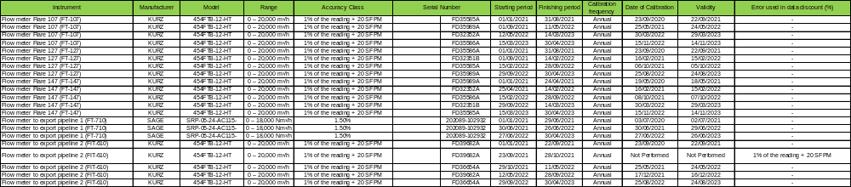
Monitoring frequency | Continuous and aggregated annually in case of natural gas distribution network and dedicated pipeline. Determined using the “Tool to determine the mass flow of a greenhouse gas in a gaseous stream”
QA/QC procedures | Not applicable
Purpose of data | (a) Calculation of baseline emissions or baseline net GHG removals by sinks; and  (b) Calculation of project emissions or actual net GHG removals by sinks;
Additional comment | -

Tool to determine the mass flow of a greenhouse gas in a gaseous stream
Relevant SDG Indicator | SDG 13.2.1
Data / Parameter | V_{t,db}
Unit | m³/h
Description | Volumetric flow of the gaseous stream in time interval t on a dry basis
Source of data | Measurements by Project participants using a flow meter(s)
Value(s) applied | Data available in the CERs calculation spreadsheet
Measurement methods and procedures
Monitoring frequency | Continuous recorded and hourly aggregated
QA/QC procedures | Periodic calibration against a primary device provided by an independent accredited laboratory is mandatory. The calibration frequency of this monitoring equipment should be in accordance with manufacturer’s specifications.
Purpose of data | (a) Calculation of baseline emissions or baseline net GHG removals by sinks
Additional comment | This parameter will be monitored only in case Option A of the “Tool to determine the mass flow of a greenhouse gas in a gaseous stream” is applied for the determination of F_{CH4,flared,y} and F_{CH4,EL,y}

Relevant SDG Indicator | SDG 13.2.1
Data / Parameter | v_{i,t,db}
Unit | m³ gas i/m³ dry gas
Description | Volumetric fraction of greenhouse gIs i in a time interval t on a dry basis
Source of data | Measurements by Project Participants using gas analyser (onsite measurements)
Value(s) applied | Data available in the CERs calculation spreadsheet
Measurement methods and procedures
Monitoring frequency | Continuous recorded and hourly aggregated
QA/QC procedures | Calibration should include zero verification with an inert gas (e.g. N₂) and at least one reading verification with a standard gas (single calibration gas or mixture calibration gas). All calibration gases must have a certificate provided by the manufacturer and must be under their validity period.
Purpose of data | (a) Calculation of baseline emissions or baseline net GHG removals by sinks
Additional comment | - This parameter will be monitored only in case Options B or C of the “Tool to determine the mass flow of a greenhouse gas in a gaseous stream” is applied for the determination of F_{CH4,flared,y} and F_{CH4,EL,y}

Relevant SDG Indicator | SDG 13.2.1
Data / Parameter | T_{t}
Unit | K
Description | Temperature of the gaseous stream in time interval t
Source of data | Measurements by Project participant using a temperature meter
Value(s) applied | Data available in the CERs calculation spreadsheet
Measurement methods and procedures
Monitoring frequency | Continuous
QA/QC procedures | Periodic calibration against a primary device provided by an independent accredited laboratory is mandatory. The calibration frequency of this monitoring equipment should be according to the manufacturer’s specifications
Purpose of data | (a) Calculation of baseline emissions or baseline net GHG removals by sinks
Additional comment | Provided all parameters are converted to normal conditions during the monitoring process, this parameter may not be needed except for moisture content determination and therefore it should be metered only when performing such measurements (with same frequency). However, if the applicability condition related to the gaseous stream flow temperature being below 60ºC is adopted, this parameter must be monitored continuously to assure the applicability condition is met.

Relevant SDG Indicator | SDG 13.2.1
Data / Parameter | P_{t}
Unit | Pa
Description | Pressure of the gaseous stream in time interval t
Source of data | Measurements by Project participant using a pressure meter
Value(s) applied | Data available in the CERs calculation spreadsheet
Measurement methods and procedures | 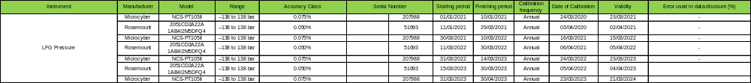
Monitoring frequency | Continuous
QA/QC procedures | Periodic calibration against a primary device must be performed periodically and records of calibration procedures must be kept available as well as the primary device and its calibration certificate. Pressure transducers (either capacitive or resistive) must be calibrated monthly. In case the pressure meter is not a capacitive or resistive pressure transducer, the calibration frequency of this monitoring equipment should be according to the manufacturer’s specifications.
Purpose of data | (a) Calculation of baseline emissions or baseline net GHG removals by sinks
Additional comment | Provided all parameters are converted to normal conditions during the monitoring process, this parameter may not be needed except for moisture content determination and therefore it should be metered only when performing such measurements (with same frequency)

Relevant SDG Indicator | SDG 13.2.1
Data / Parameter | Status of biogas destruction device
Unit | -
Description | Operational status of biogas destruction devices
Source of data | Provided by project participants
Value(s) applied | Data available in the CERs calculation spreadsheet
Measurement methods and procedures | Measurements by project participants using a continuous Ultra Violet flame detector.
Monitoring frequency | Continuous  Landtec System
QA/QC procedures | -
Purpose of data | (a) Calculation of baseline emissions or baseline net GHG removals by sinks
Additional comment | For flame detector devices refer to the methodological tool “Project emissions from flaring”

Relevant SDG Indicator | SDG 13.2.1
Data / Parameter | P_{H2O,t,Sat}
Unit | Pa
Description | Saturation pressure of H₂O at temperature T_{t} in time interval t
Source of data | Provided by project participants
Value(s) applied | 101,325 Pa
Measurement methods and procedures | This parameter is solely a function of the gaseous stream temperature Tt and can be found at reference [1] for a total pressure equal to 101,325 Pa
Monitoring frequency | -
QA/QC procedures | -
Purpose of data | (a) Calculation of baseline emissions or baseline net GHG removals by sinks
Additional comment | [1] Fundamentals of Classical Thermodynamics; Gordon J. Van Wylen, Richard E. Sonntag and Borgnakke; 4º Edition 1994, John Wiley & Sons, Inc.

Methodological tool “Project emissions from flaring”

Relevant SDG Indicator | SDG 13.2.1
Data / Parameter | F_{CH4,EG,t}
Unit | kg
Description | Mass flow of methane in the exhaust gas of the flare on a dry basis at reference conditions in the time period t
Source of data | Measurements undertaken by a third party accredited entity
Value(s) applied | Data available in the CERs calculation spreadsheet
Measurement methods and procedures | 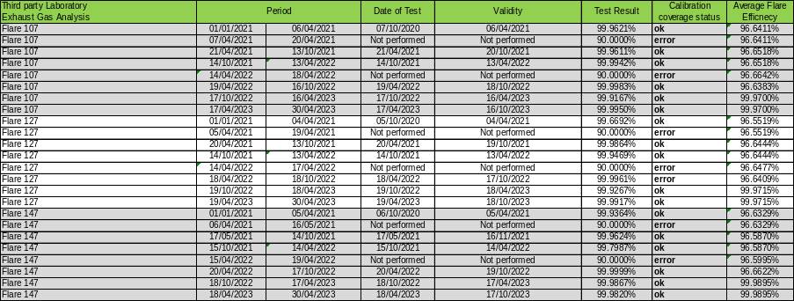
Monitoring frequency | Continuously.
QA/QC procedures | Measures of the mass flow of methane in the exhaust gas carried out according to an appropriate international standard (USEPA). The time period t over which the mass flow is measured must be at least one hour. The average flow rate to the flare during the time period t must be greater than the average flow rate observed for the previous six months. The accuracy and uncertainty characteristics of the monitoring equipment will be under responsibility of the third party accredited entity.
Purpose of data | Determination of the flare efficiency
Additional comment | Measurement instruments may read ppmv or % values. To convert from ppmv to mg/m3 simply multiply by 0.716. 1% equals 10 000 ppmv

Relevant SDG Indicator | SDG 13.2.1
Data / Parameter | Flame_{m}
Unit | Flame on or Flame off
Description | Flame detection of flare in the minute m
Source of data | Project Participant
Value(s) applied | Data available in the CERs calculation spreadsheet
Measurement methods and procedures | Measurements by project participants using a continuous Ultra Violet flame detector
Monitoring frequency | Continuous
QA/QC procedures | Equipment shall be maintained and calibrated in accordance with manufacturer’s recommendations
Purpose of data | Calculation of baseline and project emissions when the flame is on.
Additional comment | -

Relevant SDG Indicator | SDG 13.2.1
Data / Parameter | Maintenance_{y}
Unit | Calendar dates
Description | Maintenance events completed in year y
Source of data | Project participants
Value(s) applied | As per the applied maintenance practice for the project activity, general inspection services on the flare are performed daily.  Performed maintenance and overhauling services in the flare are performed under by specialized technical service team under conformance with maintenance requirements for the flare (as established by equipment manufacturer) and as required by the ex-ante determined parameter SPECflare. Further details about the parameter SPECflare are included in Section D.1.
Measurement methods and procedures | Record the date that maintenance events were completed in year y. Records of maintenance logs must include all aspects of the maintenance including the details of the person(s) undertaking the work, parts replaced, or needing to be replaced, source of replacement parts, serial numbers and calibration certificates
Monitoring frequency | Daily
QA/QC procedures | Records must be kept in a maintenance log for two years beyond the life of the flare
Purpose of data | Calculation of baseline and project emissions when the flame is on.
Additional comment | Monitoring of this parameter is required for the case of enclosed flares and the project participant selects Option B to determine flare efficiency. These dates are required so that they can be compared to the maintenance schedule to check that maintenance events were completed within the minimum time between maintenance events specified by the manufacturer (S_{PEC,flare}).

Relevant SDG Indicator | SDG 13.2.1
Data / Parameter | T_{EG,m}
Unit | ºC
Description | Temperature in the exhaust gas of the enclosed flare in minute m
Source of data | Measurements by project participants
Value(s) applied | Data available in the CERs calculation spreadsheet
Measurement methods and procedures | 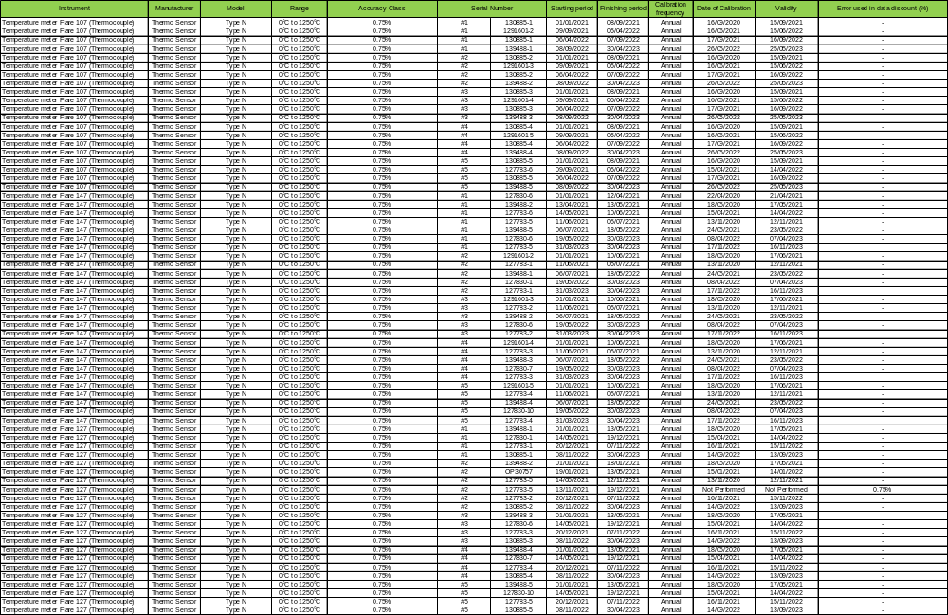
Monitoring frequency | Once per minute
QA/QC procedures | Thermocouples will be replaced or calibrated every year.
Purpose of data | (b) Calculation of project emissions or actual net GHG removals by sinks
Additional comment | -

Tool to calculate project or leakage CO₂ emissions from fossil fuel combustion

Relevant SDG Indicator | SDG 7.1.1 / 7.1.2 / 7.2.1  SDG 13.2.1
Data / Parameter | EF_{CO2,NG,y}
Unit | tCO₂ /TJ
Description | Average CO2 emission factor of natural gas in the natural gas network or dedicated pipeline or in the trucks in year y
Source of data | 2006 IPCC Guidelines on National GHG Inventories. Value at the upper limit of the uncertainty at a 95% confidence interval.
Value(s) applied | 58.3
Measurement methods and procedures | Not applicable since IPCC default value is used.
Monitoring frequency | Any future revisions of the IPCC Guidelines should be taken into account.
QA/QC procedures | Not applicable since IPCC default value is used.
Purpose of data | (b) Calculation of baseline emissions or actual net GHG removals by sinks;
Additional comment | Since this parameter is related to project renewable energy generation and consumption, it contributes to:  - Indicator 7.1.1: Proportion of population with access to electricity  - Indicator 7.1.2: Proportion of population with primary reliance on clean fuels and technology  - Indicator 7.2.1: Renewable energy share in the total final energy consumption  Since this parameter is related to climate change measures in means of a development of a GHG emission reduction project activity authorized by its national Designated National Authority (DNA), it contributes to:  Indicator 13.2.1: Number of countries that have communicated the establishment or operationalization of an integrated policy/strategy/plan which increases their ability to adapt to the adverse impacts of climate change, and foster climate resilience and low greenhouse gas emissions development in a manner that does not threaten food production (including a national adaptation plan, nationally determined contribution, national communication, biennial update report or other)

Relevant SDG Indicator | SDG 13.2.1
Data / Parameter | FC_{i,j,y}
Unit | kg/yr
Description | Quantity of fuel tIpe i combusted in process j during the year y
Source of data | Sales of receipt
Value(s) applied
  Month/Year | Quantity  (kg)
  January/2021 | -
  February/2021 | -
  March/2021
  April/2021
  May/2021 | 90
  June/2021 | 45
  July/2021
  August/2021 | 180
  September/2021
  October/2021
  November/2021
  December/2021
  January/2022
  February/2022
  March/2022
  April/2022
  May/2022
  June/2022
  July/2022
  August/2022
  September/2022
  October/2022
  November/2022
  December/2022
  January/2023
  February/2023
  March/2023
  April/2023 | -
  TOTAL | 315
Measurement methods and procedures | The mass of LPG purchased by the project developer will be stated in the invoices issued by the LPG supplier. Hard copies of the invoices will be kept in files during the crediting period and two years after.
Monitoring frequency | Continuously
QA/QC procedures | The consistency of metered fuel consumption quantities should be cross-checked by an annual energy balance that is based on purchased quantities and stock changes.  Where the purchased fuel invoices can be identified specifically for the CDM project, the metered fuel consumption quantities should also be cross-checked with available purchase invoices from the financial records.
Purpose of data | Calculation of project emissions from fossil fuel combustion in process
Additional comment | -

Relevant SDG Indicator | SDG 13.2.1
Data / Parameter | NCV_{i,y}
Unit | GJ/kg
Description | Weighted average net calorific value of fuel Iype i in yeIr y (i = LPG)
Source of data | National Energy Balance–2022 - Base year 2021
Value(s) applied | 0.04916
Measurement methods and procedures | -
Monitoring frequency | Review appropriateness of values annually
QA/QC procedures | Verify if the value is within the uncertainty range of the IPCC default values as provided in Table 1.2, Vol. 2 of the 2006 IPCC Guidelines. If the values fall below this range collect additional information from the testing laboratory to justify the outcome or conduct additional measurements. The laboratories in a), b) or c) should have SO17025 accreditation or justify that they can comply with similar quality standards.
Purpose of data | Calculation of project emissions from fossil fuel consumption for the flare ignition.
Additional comment | Option c) is used since a liquid fuel is considered and is based on well documented reliable sources (i.e. Brazilian Energy Balance). Information used with the purpose of calculating expected emission reductions is in accordance with the values provided in 2006 IPCC Guidelines.

Relevant SDG Indicator | SDG 13.2.1
Data / Parameter | EF_{CO2,LPG,y}
Unit | tCO₂/GJ
Description | Weighted average CO2 emission factor of fueI type i in Iear y (i = LPG)
Source of data | d) IPCC default values at the upper limit of the uncertainty at 95% confidence interval as provided in Table 1.2 of Chapter 1 of Vol.2 (Energy) of the 2006 IPCC Guidelines on National GHG Inventories
Value(s) applied | 0.0656
Measurement methods and procedures | Not applicable since IPCC default value is used.
Monitoring frequency | Any future revisions of the IPCC Guidelines should be taken into account.
QA/QC procedures | Not applicable since IPCC default value is used.
Purpose of data | Calculation of project emissions from fossil fuel consumption for the flare ignition
Additional comment | -

Relevant SDG Indicator | GSDG-I4.4.1
Data / Parameter | Number of people from local community attendin’ company's socioenvironmental activities events. Based on monthly attendance list and/or monthly activities reports
Unit | -
Description | Presents in site activities and speeches containing topics such as Municipal Solid Waste Management, Environmental and human education, Environmental actions such as recycling, Environmental awareness and waste sector labor job valorization.
Source of data | Project Participant: Based on attendance list and/or monthly activities reports
Value(s) applied | 2021 395 PARTICIPANTS  2022 4,351 PARTICIPANTS  2023 2,301 PARTICIPANTS
Measurement methods and procedures | Education Program carried out by Project Participant
Monitoring frequency | At least twice per year
QA/QC procedures | -
Purpose of data | -
Additional comment | -

Relevant SDG Indicator | GSDM-I8.5.1  Related to SDG Target 8  Safeguarding Principle 6.1
Data / Parameter | Total number of jobs.
Unit | -
Description | Refers to total jobs generated as a result of the project.
Source of data | Project participant.  Based on signed functional organizational chart
Value(s) applied | 2021: 34 Jobs  2022: 34 Jobs  2023: 36 Jobs
Measurement methods and procedures | Based on signed functional organizational“chart  "The project disclosed the following infation  - i. Total number of employees by employment contract (permanent and temporary), by gender.  ii. Total number of employees by employment type (full-time and part-time), by gender.
Monitoring frequency | Once per year
QA/QC procedures | -
Purpose of data | -
Additional comment | -

Relevant SDG Indicator | Proposed Monitored Indicator  Related to SDG Target 5
Data / Parameter | Quantity of women in managerial positions
Unit | -
Description | Demonstrates that the company shares participation in leadership and decision-making positions between Men and Women
Source of data | Project participant. Based on signed functional organizational chart showing women in leadership and decision-making positions
Value(s) applied | Signed functional organizational chart showing 1 women in leadership and decision-making positions
Measurement methods and procedures | Signed functional organizational chart showing women in leadership and decision-making positions carried out by the Project Participant
Monitoring frequency | Once per year
QA/QC procedures | -
Purpose of data | -
Additional comment | -

Relevant SDG Indicator | Proposed Monitored Indicator  Related to SDG Target 7
Data / Parameter | Amount of methane selling to costumers through dedicated pipeline
Unit | m³
Description | Amount of methane selling to costumers through dedicated pipeline by the project activity in year y
Source of data | Proposed Monitored Indicator  Related to SDG Target 7
Value(s) applied | 2021 34,537,415 Nm³_methane  2022 32,667,119 Nm³_methane  2023 9,894,389 Nm³_methane
Measurement methods and procedures | Monitor the methane amount being sold to costumers
Monitoring frequency | Continuous
QA/QC procedures | -
Purpose of data
Additional comment | -

Relevant SDG Indicator | Safeguarding Principle 3
Data / Parameter | Environmental Permit
Unit | -
Description | Provides Environmental Permit of the Project Activity
Source of data | Project participant. Based on valid Operational License issued by the Local Environmental Agency.
Value(s) applied | 1
Measurement methods and procedures | -
Monitoring frequency | yearly
QA/QC procedures | -
Purpose of data
Additional comment | Since this parameter is related to Community Health, Safety and Working Conditions, it contributes to:  Safeguarding Principle 3

D.3. Comparison of monitored parameters with last monitoring period

Sustainable Development Goals Targeted | SDG Impact | Actual values achieved during this monitoring period | Value obtained last monitoring period
13 Climate Action (mandatory) | Yearly emission reductions | 1,909,610 | 539,055
4 Quality Education | Number of people from local community attending company's socioenvironmental activities events. Based on monthly attendance list and/or monthly activities reports | 7,047 | 0
5 Gender Equality | Quantity of women in managerial positions | 1 | 1
7 Affordable and Clean Energy | Amount of electricity generated using LFG by the project activity in year y | 0 | 0
7 Affordable and Clean Energy | Amount of methane selling to costumers through dedicated pipeline | 77,098,923 | 20,077,804
8 Decent Work and Economic Growth | Total jobs generated as a result of the project | 36 | 0

D.4. Implementation of sampling plan
>>
Not aplicable

SECTION E. CALCULATION OF SDG IMPACTS

E.1. Calculation of baseline value or estimation of baseline situation of each SDG Impact
>>
Baseline emission calculation

The table below shows the consolidated collected and calculated data for the current monitoring period.

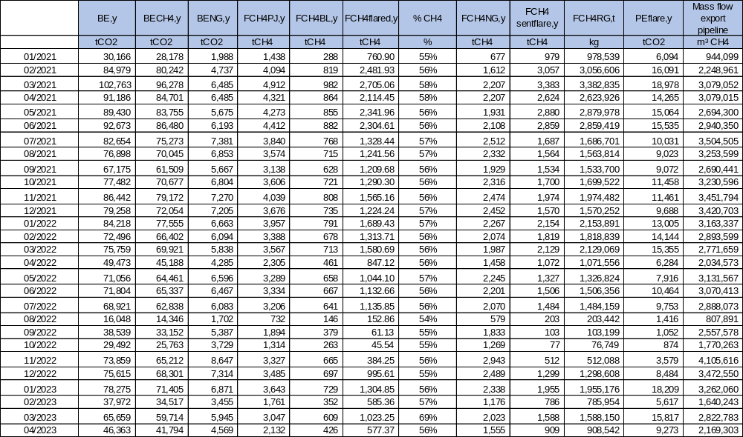

The baseline emission was calculated according to the following formula:

BE_{y} = BE_{CH4,y} + BE_{EC,y} + BE_{NG,y}
Where:

BE_{y} | = | Baseline emissions in year y (t CO₂e/yr)
BE_{CH4,y} | = | Baseline emissions of methane from the SWDS in year y (t CO₂e/yr)
BE_{EC,y} | = | Baseline emissions associated with electricity generation in year y (t CO₂/yr)
BE_{NG,y} | = | Baseline emissions associated with natural gas use in year y (t CO₂/yr)

Therefore, BE_{y} = BE_{CH4,y} + BE_{EC,y} + BE_{NG,y}

Step (A): Baseline emissions of methane from the SWDS (BE_{CH4,y})

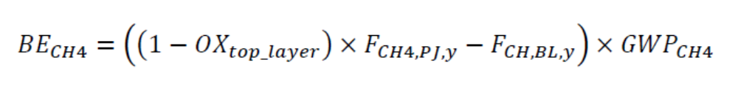
Where:

BE_{CH4,y} | = | Baseline emissions of LFG from the SWDS in year y (t CO₂e/yr)
OX_{top_layer} | = | Fraction of methane in the LFG that would be oxidized in the top layer of the SWDS in the baseline (dimensionless)
F_{CH4,PJ,y} | = | Amount of methane in the LFG which is flared and/or used in the project activity in year y (t CH₄/yr)
F_{CH4,BL,y} | = | Amount of methane in the LFG that would be flared in the baseline in year y (t CH₄/yr)
GWP_{CH4} | = | Global warming potential of CH₄ (t CO₂e/t CH₄)

Step A.1: Ex-post determination of F_{CH4,PJ,y}

During the crediting period, the F_{CH4,PJ,y} will be determined as follows:

F_{CH4,PJ,y} = F_{CH4,flared,y} + F_{CH4,EL,y} + F_{CH4,NG,y}

F_{CH4,EL,y} is considered as zero, since energy plant was not installed yet, therefore F_{CH4,EL,y} = Amount of methane in the LFG which is used for electricity generation in year y (tCH4/yr) was not considered in the monitoring period.
F_{CH4,NG,y} is determined using the “Tool to determine the mass flow of a greenhouse gas in a gaseous stream” and monitoring the working hours of the power plant(s), boiler(s), air heater(s), glass melting furnace(s) and kiln(s), so that no emission reduction are claimed for methane destruction during non-working hours. This is taken into account by monitoring the hours that the equipment utilizing the LFG is operating in year y (Op_{j,h,y}).
The following requirements apply:
  - The gaseous stream the tool shall be applied to the LFG delivery pipeline to each item of electricity generation or heat generation equipment j, or the natural gas distribution system, or the dedicated pipeline, or the trucks. F_{CH4,EL,y} and F_{CH4,HG,y} are then calculated as the sum of mass flows to each item of electricity generation or heat generation equipment j;
  - CH₄ is the greenhouse gas for which the mass flow should be determined;
  - The simplification offered for calculating the molecular mass of the gaseous stream is valid (equations (3) or (17) in the tool);
  - The mass flow should be calculated on an hourly basis for each hour h in year y;
  - The mass flow calculated for hour h is 0 if the equipment is not working in hour h (Op_{j,h}=not working), the hourly values are then summed to a yearly unit basis.

The amount of methane destroyed by flaring (F_{CH4,flared,y}) will be determined as follows:

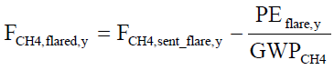
Where:

F_{CH4,flared,y} | = | Amount of methane in the LFG which is destroyed by flaring in year y (t CH₄/yr)
F_{CH4,sent_flare,y} | = | Amount of methane in the LFG which is sent to the flare in year y (t CH₄/yr)
PE_{flare,y} | = | Project emissions from flaring of the residual gas stream in year y (t CO₂e/yr)
GWP_{CH4} | = | Global warming potential of CH₄ (t CO₂e/t CH₄)

F_{CH4,sent_flare,y} will be determined directly using the “Tool to determine the mass flow of a greenhouse gas in a gaseous stream”, applying the requirements described below. The tool shall be applied to the gaseous stream flowing in the LFG delivery pipeline to each flare.

According to “Tool to determine the mass flow of a greenhouse gas in a gaseous stream” the following option will be considered for the present project activity:

- Option A (Volume flow in dry basis and volumetric fraction in dry basis) when the temperature of the gaseous stream is less than 60ºC (333.15 K) at the flow measurement point

Option A

Flow measurement on a dry basis is not doable for a wet gaseous stream. Therefore, it is necessary to demonstrate that the gaseous stream is dry to use this option. The demonstration will be made as following:

- Demonstrate that the temperature of the gaseous stream (T_{t}) is less than 60ºC (333.15 K) at the flow measurement point.

The mass flow of greenhouse gas i (F_{i,t}) is determined as follows:

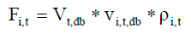

With

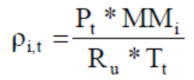

Where:
F_{i,t} = Mass flow of greenhouse gas i in the gaseous stream in time interval t (kg gas/h)
V_{t,db} = Volumetric flow of the gaseous stream in time interval t on a dry basis (m³ dry gas/h)
v_{i,t,db} = Volumetric fraction of greenhouse gas i in the gaseous stream in a time interval t on a dry basis (m³ gas i/m³ dry gas)
ρ_{i,t} = Density of greenhouse gas i in the gaseous stream in time interval t (kg gas i/m³ gas i)
P_{t} = Absolute pressure of the gaseous stream in time interval t (Pa)
MM_{i} = Molecular mass of greenhouse gas i (kg/kmol)
R_{u} = Universal ideal gases constant (8,314 Pa.m³/kmol.K )
T_{t} = Temperature of the gaseous stream in time interval t (K)

PE_{flare,y} shall be determined using the methodological tool “Project emissions from flaring. If LFG is flared through more than one flare, then PE_{flare,y} is the sum of the emissions for each flare determined separately.

Enclosed flare(s) have been installed in the project activity to increase the destruction efficiency. Those flares reach 98% (minimum) of methane destruction efficiency.

To determine the project emissions from flaring gases was used the tool “Project emissions from flaring”. The project emissions calculation procedure is given in the following steps:

STEP 1: Determination of the methane mass flow of the residual gas;
STEP 2: Determination of the flare efficiency;
STEP 3: Calculation of project emissions from flaring.

Step 1: Determination of the methane mass flow in the residual gas

The “Tool to determine the mass flow of a greenhouse gas in a gaseous stream” shall be used to determine the following parameter:

Parameter | SI Unit | Description
F_{CH4,m} | kg | Mass flow of methane in the residual gaseous stream in the minute m

The following requirements apply:
- The gaseous stream tool shall be applied to the residual gas;
- The flow of the gaseous stream shall be measured continuously;
- CH4 is the greenhouse gas i for which the mass flow should be determined;
- The simplification offered for calculating the molecular mass of the gaseous stream is valid (equations 3 and 17 in the tool); and
- The time interval t for which mass flow should be calculated is every minute m

F_{CH4,m}, which is measured as the mass flow during minute m, shall then be used to determine the mass of methane in kilograms fed to the flare in minute m (F_{CH4,RG,m}). F_{CH4,m} shall be determined on a dry basis.

The option chosen for the “Tool to determine the mass flow of a greenhouse gas in a gaseous stream” by the project participant is option A.

Step 2: Determination of flare efficiency

Enclosed flare
In the case of enclosed flares, project participants may choose between the following two options to determine the flare efficiency for minute m (nf_{lare,m}).

Option A: Apply a default value for flare efficiency

Option B: Measure the flare efficiency.

The project participant has chosen Option B.

In the present project activity the flare efficiency for minute m (ηflare,m) will be determined by Option B.1 of the methodological tool “Project emissions from flaring”, where the flare efficiency is measured in a biannual basis or, if the biannual measurements are not available, Option A of the methodological tool “Project emissions from flaring” will be used. Both options are described below:

For enclosed flares that are defined as low height flares, which is the case of the project activity, the flare efficiency in the minute m (n_{flare,m}) shall be adjusted, as a conservative approach, by subtracting 0.1 from the efficiency as determined in Option A. For example, the default value applied should be 80%, rather than 90%, and if for example the measured value was 99%, then the value to be used shall correspond to 89%.

Option A: Default value

The flare efficiency for the minute m (n_{flare,m}) is 90% when the following two conditions are met to demonstrate that the flare is operating:

(1) The temperature of the flare (T_{EG.m}) and the flow rate of the residual gas to the flare (F_{RG,m}) is within the manufacturer’s specification for the flare (SPEC_{flare}) in minute m; and

(2) The flame is detected in minute m (Flame_{m}).

Otherwise n_{flare,m} is 0%.

Option B: Measured flare efficiency

The flare efficiency in the minute m is a measured value (n_{flare,m} = n_{flare,calc,m}) when the following three conditions are met to demonstrate that the flare is operating:

(1) The temperature of the flare (TEG.m) and the flow rate of the residual gas to the flare (FRG,m) is within the manufacturer’s specification for the flare (SPECflare) in minute m;
(2) The flame is detected in minute m (Flamem); and

Otherwise n_{flare,m} is 0%.

In applying Option B, the project participants chose to determine n_{flare,calc,m} using Option B.1 where the measurement is conducted by an accredited entity on a biannual basis.

Option B.1: Biannual measurement of the flare efficiency

The calculated flare efficiency ηflare,calc,m is determined as the average of two measurements of the flare efficiency made in year y (ηflare,calc,y), as follows:

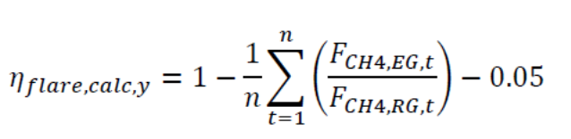
Where:
η_{flare,calc,y} | = | Flare efficiency in the year y
FCH4,EG,t | = | Mass flow of methane in the exhaust gas of the flare on a dry basis at reference conditions in the time period t (kg)
F_{CH4,RG,t} | = | Mass flow of methane in the residual gas on a dry basis at reference conditions in the time period t (kg)
t | = | The two time periods in year y during which the flare efficiency is measured, each a minimum of one hour and separated by at least six months

FCH4, EG,t is measured according to an appropriate national or international standard. FCH4,RG,t is calculated according to Step 1, and consists of the sum of methane flow in the minutes m that make up the time period t.

The following table shows the data for the correspondent monitoring period:
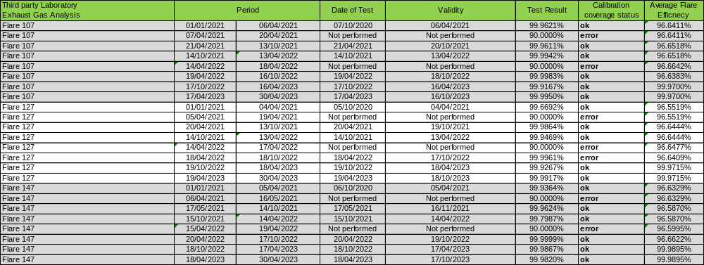

Obs 1: Since the calculated flare efficiency “ηflare,calc,m” is determined as the average of two measurements of the flare efficiency, each a minimum of one hour and separated by at least six months, last column “Average Flare Efficiency” in the table above shows that the results of the flare efficiency is estimated based on the two measurements, separated by at least six months and it was evidenced that the tests were carried out during at least one hour.
Obs 2: F_{CH4,EG,t} is measured following all requirements of the tool “Project emissions from flaring”, carried out by a third party accredited entity:

- CEIMIC Air Quality (JAPH SERVIÇOS ANALÍTICOS LTDA.) using technical norm ABNT NBR ISO/IEC 17025 under number CRL 0398 and National Institute of Metrology, Quality and Technology (Inmetro) website attests the laboratory accreditation (http://www.inmetro.gov.br/laboratorios/rble/docs/CRL0398.pdf ).
- PRISMA Soluções Ambientais using technical norm ABNT NBR ISO/IEC 17025 under number CRL 0700 and National Institute of Metrology, Quality and Technology (Inmetro) website attests the laboratory accreditation (http://www.inmetro.gov.br/laboratorios/rble/docs/CRL0700.pdf ).

Tests were carried out during at least one hour and the average flow rate to the flare during the time period t is greater than the average flow rate observed for the previous six months.

Step 3: Calculation of project emissions from flaring

Project emissions from flaring are calculated as the sum of emissions for each minute m in year y, based on the methane mass flow in the residual gas (FCH4,RG,m) and the flare efficiency (ηflare,m), as follows:

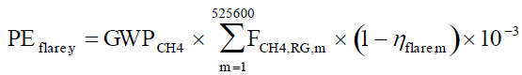

Where:
PE_{flare,y} | = | Project emissions from flaring of the residual gas in year y (tCO2e)
GWPCH4 | = | Global warming potential of methane valid for the commitment period (tCO2e/tCH4)
F_{CH4,RG,m} | = | Mass flow of methane in the residual gas in the minute m (kg)
η_{flare,m} | = | Flare efficiency in minute m

Table 4 – Parameters used in the Tool “Project emissions from flaring”
Parameter | Description | Value | Unit
P_{ref} | Atmospheric pressure at reference conditions | 101,325 | Pa
R_{u} | Universal ideal gas constant | 0.008314472 | Pa.m³/kmol.K
T_{ref} | Temperature at reference conditions | 273.15 | K
GWP_{CH4} | Global warming potential of methane valid for the commitment period | 28 | tCO₂/tCH₄
ρ_{CH4,n} | Density of methane at reference conditions | 0.716 | kg/m³

Step A.2: Determination of F_{CH4,BL,y}

In the baseline there are no regulatory or contractual requirements, or to address safety and odour concerns to capture and destroy LFG. Thus, the case of the project activity for determining methane captured and destroyed in the baseline is Case 3 because there is existing LFG capture system (passive system), however there is no requirement to destroy methane. In this case:

F_{CH4,BL,y} = F_{CH4,BL,sys,y} = F_{CH4,sent_flare,y}

Where:

F_{CH4,BL,sys,y} | = | Amount of methane in the LFG that would be flared in the baseline in year y for the case of an existing LFG capture system (t CH₄/yr)
F_{CH4,sent_flare,y} | = | Amount of methane in the LFG which is sent to the flare in year y (t CH₄/yr)

The amount of methane captured with the existing system will be monitored along with the amount captured under the project activity and there is no historic data on the amount of methane that was captured in the year prior to the implementation of the project activity. Thus, the situation to determine F_{CH4,BL,y} is:

If there is no monitored or historic data on the amount of methane that was captured in the year prior to the implementation of the project situation, then:

F_{CH4,BL,sys,y} = 20% × F_{CH4,PJ,y}; or

F_{CH4,BL,y} = 20% × F_{CH4,PJ,y}

Baseline emissions associated with electricity generation (BE_{EC,y})

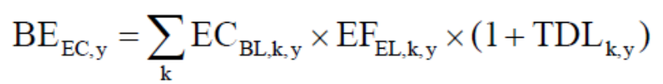

Where:

BE_{EC,y} | = | Baseline emissions from electricity generation in year y (tCO2/yr)
EC_{BL,k,y} = EG_{PJ,y} | = | Net amount of electricity generated using LFG in year y (MWh/yr)
EF_{EL,k,y} | = | Emission factor for electricity generation for source k in year y (tCO2/MWh)
TDL_{k,y} | = | Average technical transmission and distribution losses for providing electricity to source k in year y.
The baseline emissions associated with electricity generation in year y (BE_{EC,y}) shall be calculated using the "Methodological tool: Baseline, project and/or leakage emissions from electricity consumption and monitoring of electricity generation".

During the monitoring period, no electricity was generated by the project activity.

Baseline emissions associated with natural gas use (BE_{NG,y})

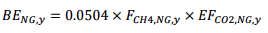

Where:

BE_{NG,y} | = | Baseline emissions associated with natural gas use in year y (tCO2/yr)
EF_{CO2,NG,y} | = | Average CO2 emission factor of natural gas in the natural gas network or dedicated pipeline or in the trucks in year y (tCO2e/TJ).
F_{CH4,NG,y} | = | Amount of methane in the LFG which is sent to the natural gas distribution network or dedicated pipeline or to the trucks in year y (tCH4/yr)
EF_{CO2,NG,y} is determined using the “Tool to calculate project or leakage CO2 emissions from fossil fuel combustion”

E.2. Calculation of project value or estimation of project situation of each SDG Impact
>>

Project emissions:
The table below shows the consolidated collected and calculated data for the current monitoring period.

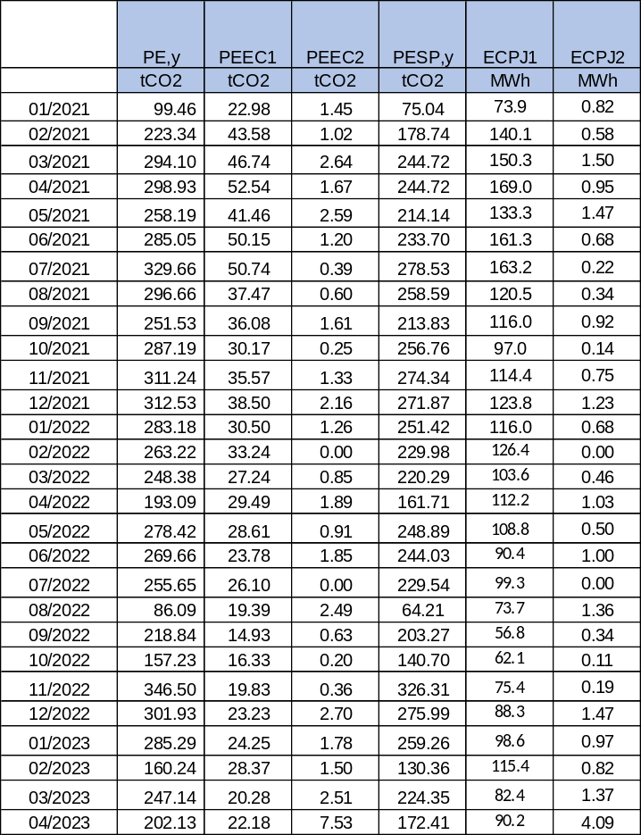
$${PE}_{y}={PE}_{EC,y}+{PE}_{FC,y}+{PE}_{SP,y}$$
Where:
$${PE}_{y}$$ | = | Project emissions in year y (t CO₂/yr)
$${PE}_{EC,y}$$ | = | Emissions from consumption of electricity due to the project activity in year y (t CO₂/yr)
$${PE}_{FC,y}$$ | = | Emissions from consumption of fossil fuels due to the project activity, for purpose other than electricity generation, in year y (t CO₂/yr)
$${PE}_{SP,y}$$ |  | Emissions from the supply of LFG to consumers through a dedicated pipeline, in year y (t CO₂/yr)

The parameter PE_{DT,y} is not used in the calculation of project emissions since there is no distribution of compressed/liquefied LFG using trucks in the project activity.

Calculation of PE_{EC,y} – project emission from consumption of electricity

According to “Methodological tool: Baseline, project and/or leakage emissions from electricity consumption and monitoring of electricity generation”, the project emission from consumption of electricity will be from two sources:

- PE_{EC1,y} - Grid (Brazilian interconnected electric system);
- PE_{EC2,y} - Diesel generator(s) (off-grid captive power plant)

Thus,

PE_{EC,y} = PE_{EC1,y} + PE_{EC2,y}

PE_{EC1,y} - Project emission from electricity consumption from the grid

As electricity will be consumed from the grid, the option A1 of the scenario A was chosen, as follows:

Option A1: Calculate the combined margin emission factor of the applicable electricity system, using the procedures in the latest approved version of the “Tool to calculate the emission factor for an electricity system” (EF_{EL,j/k/l,y} = EF_{grid,CM,y}).

Thus, the project emission is calculated as following:

Where:

EC_{PJ1,y} | = quantity of electricity consumed from the grid by the project activity during the year y (MWh);
EF_{grid,CM,y} | = the emission factor for the grid in year y (tCO₂/MWh);
TDL_{y} | = average technical transmission and distribution losses in the grid in year y for the voltage level at which electricity is obtained from the grid at the project site.

PE_{EC2,y} - Project emission from electricity consumption from an off-grid captive power plant (diesel generator(s))

As electricity will be consumed from diesel generators (off-grid captive power plant), a conservative approach was adopted and the option B2 of the scenario B was chosen because: “The electricity consumption source is a project or leakage electricity consumption source”. Therefore, the value used will be 1.3 tCO2/MWh for project emission from diesel generator(s).

Where:

EC_{PJ2,y} | = quantity of electricity consumed from diesel generator by the project activity during the year y (MWh);
EF_{diesel_generator,y} | = the emission factor for the diesel generator in year y (tCO₂/MWh);
TDL_{y} | = average technical transmission and distribution losses in the grid in year y for the voltage level at which electricity is obtained from the grid at the project site.

Calculation of PE_{FC,y} – project emission from consumption of heat

The consumption of heat will be provided by the burning of liquefied petroleum gas (LPG) from pilot flames of the flares.

According to “Tool to calculate project of leakage CO2 emissions from fossil fuel combustion”, the equation is:

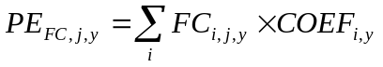Where:

- PE_{FC,j,y} is the CO₂ emissions from LPG combustion in flares during the year y (tCO₂/yr);
- FC_{i,j,y} is the quantity of LFG combusted in pilot flames of flares during year y (mass /yr); and
- COEF_{i,y} is the CO₂ emission coefficient of LPG in year y (tCO₂/mass).

In Brazil, there is data about chemical composition in diesel invoices. Therefore, option B was chosen for calculation of COEF_{i,y}.
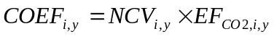

Where:

- NCV_{i,y} is the weighted average net caloric value of fuel type i in year y (GJ/mass); and
- EF_{CO2,I,y} is the weighted average emission factor of fuel type i in year y (tCO₂/GJ).

Calculation of PE_{SP,y} – from the supply of LFG to consumers through a dedicated pipeline

Project emissions from the supply of LFG to consumers through a dedicated pipeline (PE_{SP,y}) is determined by possible leaks during the transportation of LFG to the consumer through a dedicated pipeline, as follows:
${PE}_{SP,y}$ = 0.0504 x DEFT_{SP,y} x $F_{CH4,NG,y}$
Where:
$${PE}_{SP,y}$$ | = | Project emissions from the supply of LFG to consumers through a dedicated pipeline, in year y (t CO₂/yr)
DEFT_{SP,y} |  | Default emission factor from the supply of LFG to consumers through a dedicated pipeline (tCO₂/TJ)
F_{CH4,NGy} |  | Amount of methane in the LFG which is sent to the consumer through a dedicated pipeline in year y (tCH₄/yr)

E.3. Calculation of leakage
>>
No applicable. As per PDD, no leakage emissions have been identified for the project activity.

E.4. Calculation of net benefits or direct calculation for each SDG Impact

Sustainable Development Goals Targeted | SDG Impact | Units/ Products | Baseline Estimate | Project Estimate | Net Benefit
13 Climate Action (mandatory) | Yearly emission reductions | VERs | 1,916,656 | 7,045 | 1,909,610
4 Quality Education | Number of people from local community attending company's socioenvironmental activities events. Based on monthly attendance list and/or monthly activities reports | PARTICIPANTS | 0 | 7,047 | 7,047
5 Gender Equality | Quantity of women in managerial positions | Women | 0 | 1 | 1
7 Affordable and Clean Energy | Amount of electricity generated using LFG by the project activity in year y | MWh | 0 | 0 | 0
7 Affordable and Clean Energy | Amount of methane selling to costumers through dedicated pipeline | Nm³_methane | 0 | 77,098,923 | 77,098,923
8 Decent Work and Economic Growth | Total jobs generated as a result of the project | Jobs | 0 | 36 | 36

E.5. Comparison of actual SDG Impacts with estimates in approved PDD

SDG Impact | Values estimated in ex ante calculation of approved PDD for this monitoring period |  | Actual values achieved during this monitoring period
Yearly emission reductions | 2021 | 1,147,614 | 2021 | 957,858
Yearly emission reductions | 2022 | 1,200,590 | 2022 | 724,378
Yearly emission reductions | 2023 | 1,245,088 | 2023 | 227,374
Number of people from local community attending company's socioenvironmental activities events. Based on monthly attendance list and/or monthly activities reports | 2021 | 1 | 2021 | 395
 | 2022 | 1 | 2022 | 4,351
 | 2023 | 1 | 2023 | 2,301
Quantity of women in managerial positions | 2021 | 1 | 2021 | 1
Quantity of women in managerial positions | 2022 | 1 | 2022 | 1
Quantity of women in managerial positions | 2023 | 1 | 2023 | 1
Amount of electricity generated using LFG by the project activity in year y | 2021 | 35,369 | 2021 | 0
 | 2022 | 35,369 | 2022 | 0
 | 2023 | 11,790 | 2023 | 0
Amount of methane selling to costumers through dedicated pipeline | 2021 | 52,574,017 | 2021 | 34,537,415
 | 2022 | 57,350,372 | 2022 | 32,667,119
 | 2023 | 20,039,435 | 2023 | 9,894,389
Total jobs generated as a result of the project | 2021 | 1 | 2021 | 34
Total jobs generated as a result of the project | 2022 | 1 | 2022 | 34
Total jobs generated as a result of the project | 2023 | 1 | 2023 | 36

E.5.1. Explanation of calculation of value estimated ex ante calculation of approved PDD for this monitoring period
>>
The ex-ante amount of emission reduction estimated for this monitoring period was calculated on a pro-rata basis considering of 346 days in 2021, 2022 and 120 days in 2023.

E.6. Remarks on increase in achieved SDG Impacts from estimated value in approved PDD
>>
SDG 13: There was a decrease of 64% in overall emission reductions during the monitored period when comparing the total emission reductions estimated in the ex-ante PDD.

SDG 5: There no increase nor decrease of total number of women in managerial positions when comparing to the number estimated in the ex-ante PDD.

SDG 4: There was an increase of participants attending to company Education Program when comparing the number estimated in the ex-ante PDD.

SDG 7: There was a decrease in the amount of methane selling to costumers through dedicated pipeline when comparing the number estimated in the ex-ante PDD. There was no electricity generated by the project since the LFG power plant has not been implemented yet.

SDG 8: There was an increase of total number of jobs when comparing the number estimated in the ex-ante PDD.

SECTION F. SAFEGUARDS REPORTING
>>
As per section D.1 Safeguarding principles assessment of the approved PDD:
- Safeguarding Principle 6.1 was achieved by the PP:
Relevant SDG Indicator | GSDM-I8.5.1  Related to SDG Target 8  Safeguarding Principle 6.1
Data / Parameter | Total number of jobs.
Unit | -
Description | Refers to total jobs generated as a result of the project.
Source of data | Project participant.  Based on signed functional organizational chart
Value(s) applied | 2021: 34 Jobs  2022: 34 Jobs  2023: 36 Jobs
Measurement methods and procedures | Based on signed functional organizational chart  "The project disclosed the following information  i. Total number of employees by employment contract (permanent and temporary), by gender.  ii. Total number of employees by employment type (full-time and part-time), by gender.
Monitoring frequency | Once per year
QA/QC procedures | -
Purpose of data | -
Additional comment | -

- Safeguarding Principle 3 was achieved by the PP:
Relevant SDG Indicator | Safeguarding Principle 3
Data / Parameter | Environmental Permit
Unit | -
Description | Provides Environmental Permit of the Project Activity
Source of data | Project participant. Based on valid Operational License issued by the Local Environmental Agency.
Value(s) applied | 1
Measurement methods and procedures | -
Monitoring frequency | yearly
QA/QC procedures | -
Purpose of data
Additional comment | Since this parameter is related to Community Health, Safety and Working Conditions, it contributes to:  Safeguarding Principle 3

SECTION G. STAKEHOLDER INPUTS AND LEGAL DISPUTES

G.1. List all Inputs and Grievances which have been received via the Continuous Input and Grievance Mechanism together with their respective responses/mitigations.
>>
No feedback received.
Grievance Mechanism adopted:
 | Method Chosen (include all known details e.g. location of the book, phone, number, identity  of mediator) | Justification of Choice  (best practice)
Continuous Input / Grievance Expression Process Book (mandatory) | A record book will be made available at the plant entrance to register comments, suggestions or complaints. | The location does not requires requesting direct access to the company to accesses the book.
GS Contact (mandatory) | help@goldstandard.org
Telephone access (optional) | +55 (11) 4083-8260 | May be more convenient to a stakeholder.
Internet/email access (optional) | visitas@ecourbis.com.br  www.ecourbis.com.br | The website of the company and an e-mail address were informed for stakeholder convenience.

G.2. Report on any stakeholder mitigations that were agreed to be monitored.
>>
Not applicable

G.3. Provide details of any legal contest that has arisen with the project during the monitoring period
>>
Not applicable

Revision History

Version | Date | Remarks
1.1 | 14 October 2020 | Hyperlinked section summary to enable quick access to key sections  Improved clarity on Key Project Information  Section for POA monitoring  Forward action request section  Improved Clarity on SDG contribution/SDG Impact term used throughout  Clarity on safeguard reporting  Clarity on design changes  Leakage section added for VER/CER projects  Addition of Comparison of monitored parameters with last monitoring period  Provision of an accompanying Guide to help the user understand detailed rules and requirements
1.0 | 10 July 2017 | Initial adoption

The major landfill gas contents are methane (CH₄) and carbon dioxide (CO₂).
Due to the Post Registration Changes, it is important to highlight that at the time of the registration of the original PDD (registered 27th July 2012), CTL Landfill was defined as new in the PDD by the reason of the closure of São João Landfill, located in a neighbouring area where CTL Landfill is currently located and responsible for the waste disposal of solid waste in region East and South of the city of São Paulo. CTL Landfill began its operation on 24 November 2010 and was designed with a passive LFG collection and open flaring system (at the top of the vertical draining wells) in order to meet with the landfill operation geotechnical, environmental and safety conditions according to the EIA/RIMA approved by the Environmental Agency CETESB (Companhia Ambiental do Estado de São Paulo) With the approval of the EIA/RIMA, CTL landfill received, from CETESB, the Operational License no. 30006398, process number 30/00847/08, issued on 23/11/2010 and valid until 23/11/2015. Regarding the environmental license from the landfill area expansion, a new Operational License has been issued by CETESB, no 30010065, process number 30/00847/08, issued on 26/02/2016 and valid until 26/02/2021. Currently, the landfill count on an updated operational license 30012899 issued on 09/04/2021 and valid until 09/04/2026. Thus, besides being defined as new landfill in the PDD, CTL Landfill already had an existing passive LFG capture system at the start of its operation but not an existing active LFG capture system and flaring as the project activity.
According to the Termo of Agreement issued and signed by Ecourbis and SJEA on 31th July 2015, item 1.6. – The CERs from LFG produced at CTL Landfill are exclusive propriety of Ecourbis Ambiental.
According to the Termo of Agreement issued and signed by Ecourbis and SJEA on 31th July 2015, item 1.6. – The CERs from LFG produced at CTL Landfill are exclusive propriety of Ecourbis Ambiental.
For more information access the site: http://www.ecourbis.com.br/
Both days included.
The information is in the environmental impact report (EIA) of the CTL landfill and the document was given to DOE in validation visit.
https://cdm.unfccc.int/methodologies/DB/JPYB4DYQUXQPZLBDVPHA87479EMY9M
https://cdm.unfccc.int/methodologies/PAmethodologies/tools/am-tool-02-v7.0.pdf
https://cdm.unfccc.int/methodologies/PAmethodologies/tools/am-tool-04-v8.0.pdf
https://cdm.unfccc.int/methodologies/PAmethodologies/tools/am-tool-05-v3.0.pdf
https://cdm.unfccc.int/methodologies/PAmethodologies/tools/am-tool-06-v3.0.pdf
https://cdm.unfccc.int/methodologies/PAmethodologies/tools/am-tool-08-v3.0.pdf
https://cdm.unfccc.int/methodologies/PAmethodologies/tools/am-tool-09-v2.0.pdf
https://cdm.unfccc.int/methodologies/PAmethodologies/tools/am-tool-10-v1.pdf
https://cdm.unfccc.int/methodologies/PAmethodologies/tools/am-tool-12-v1.1.0.pdf
https://cdm.unfccc.int/methodologies/PAmethodologies/tools/am-tool-07-v7.0.pdf
https://cdm.unfccc.int/methodologies/PAmethodologies/tools/am-tool-11-v3.0.1.pdf
https://cdm.unfccc.int/methodologies/PAmethodologies/tools/am-tool-32-v2.0.pdf
Initial Start date from the other standard (CDM: https://cdm.unfccc.int/Projects/DB/LRQA_Ltd1332768548.38/view )
Considering the crediting period cycle of 5 years according to GS Rules. The start date of crediting period of the project activity as per paragraph 10.2.3 of the GHG EMISSIONS REDUCTIONS & SEQUESTRATION PRODUCT REQUIREMENTS shall be the start date of the crediting period under CDM or maximum of two years prior to the date of first submission (submission for preliminary review), whichever occurs later. Therefore, considering that the preliminary review was made on 20/01/2023, the start date of CP is 20/01/2021
The destruction of the methane content in the LFG is above 98%, according to manufacturer specifications. The document was given to DOE in validation visit.
The information has been corrected in accordance with manufacturer's specifications and technical literature. Evidences made available to DOE.
There will not be claimed CERs for LFG Facility electricity consumption because the electricity consumption is a consequence of the CDM Project.
The maximum duration in days between maintenance events by the equipment manufacturer is not available. Thus, the number of maintenance events completed in a determined year has been chosen considering preventive maintenance program which defines the frequency for checking flare equipment situation continuously every day.
When the flame is off, neither baseline nor project emissions occurs since the LFG is not combusted and instead released to the atmosphere.
When the maintenance is being carried out, neither baseline nor project emissions occurs since the LFG is not combusted and released to the atmosphere.
https://www.epe.gov.br/pt/publicacoes-dados-abertos/publicacoes/balanco-energetico-nacional-2022
The document about the specification of the flare efficiencies has been provided to DOE.
As the Option B.1 of the tool “Project emissions from flaring” has been adopted to calculate the flare efficiency, the molecular mass parameters are not mentioned.
Updated as per Applicability of Global Warming Potential for Gold Standard for the Global Goals Projects available at https://globalgoals.goldstandard.org/standards/RU-2020-PR-V1.2-GWP-values.pdf
According to the “Tool to calculate project or leakage CO2 emissions from fossil fuel combustion”, EF_{EL,k,y} = EF_{grid,CM,y}
This default value (0.6 x 10⁻⁶) was based on Tool 15 - Upstream leakage emissions associated with fossil fuel use, version 2, Table 4, in item – Transport mode: Pipeline (Natural gas distribution).

