Key Project Information & project Design Document (PDD)

PUBLICATION DATE 14.10.2020
VERSION v. 1.2
RELATED SUPPORT

- TEMPLATE GUIDE Key Project Information & Project Design Document v.1.2

This document contains the following Sections
Key Project Information
SECTION A – Description of project
SECTION B - Application of approved Gold Standard Methodology (ies) and/or demonstration of SDG Contributions
SECTION C – Duration and crediting period
SECTION D – Summary of Safeguarding Principles and Gender Sensitive Assessment
SECTION E – Outcome of Stakeholder Consultations
Appendix 1 – Safeguarding Principles Assessment (mandatory)
Appendix 2 - Contact information of Project participants (mandatory)
Appendix 3 - LUF Additional Information (project specific)
Appendix 3 - Summary of Approved Design Changes (project specific)

KEY PROJECT INFORMATION
GS ID of Project | GS 2475
Title of Project | Icdas Biga Wind Farm Project
Time of First Submission Date | 09/03/2023
Date of Design Certification | 11/01/2017
Version number of the PDD | For first crediting period: V6.0  For second crediting period: V1.0
Completion date of version | Version 05-15/02/2024
Project Developer | İçdaş Çelik Enerji Tersane ve Ulaşım San. A.Ş.
Project Representative | SEEM
Project Participants and any communities involved | İçdaş Çelik Enerji Tersane ve Ulaşım San. A.Ş.(project  owner)  SEEM (Project consultant)
Host Country (ies) | Turkey
Activity Requirements applied | Community Services Activities  Renewable Energy Activities  Land Use and Forestry Activities/Risks & Capacities  N/A
Scale of the project activity | Micro scale  Small Scale  Large Scale
Other Requirements applied | -
Methodology (ies) applied and version number | ACM0002 - Grid-connected electricity generation from  renewable sources, version 20.0
Product Requirements applied | GHG Emissions Reduction & Sequestration  Renewable Energy Label  N/A
Project Cycle: | Regular  Retroactive

Table 1 – Estimated Sustainable Development Contributions
Sustainable Development Goals Targeted | SDG Impact  (defined in B.6.) | Estimated Annual Average | Units or Products
4 Quality Education | 4 monthly scholarship and local teenagers trained at ICDAŞ sailing and swimming  school | 8  40 | local students given scholarship  local teenagers trained
7 Affordable and Clean Energy | MWh of renewable  energy generated | 153.674 | GWh/year
8 Decent Work and Economic Growth | Employee | 13 | workers for operation
13 Climate Action | Emissions  Reductions | 99,611 | tCO₂/year

SECTION A. DESCRIPTION OF PROJECT

A.1 Purpose and general description of project
The project aims to generate electricity from wind, reduce the need of fossil fuel and import needs, and increase the diversity in energy generation. The project corresponds to the İçdaş Biga Wind Power Plant of İçdaş Çelik Enerji Tersane ve Ulaşım San. A.Ş. The firm capacity of the plant is 60 MW and consists of 19 turbines with 3.2 MW capacity. The average annual electricity generation between years 2016 and 2021 is 153.674 GWh to be fed to the national grid. The greenhouse gas emission-free electricity generated by the project enables the grid mix to lower its carbon intensity. The project’s contribution to reduce emissions was approximately 85,228 tonnes of CO₂ per year and 596,595 tonnes of CO₂ for the first crediting period. For the second crediting period, 99,611tCO₂/year annual reduction is expected for a total of 657,982 tCO₂ for 6 years and 9 months. Second crediting period is not 7 years due to the foregone period until the crediting renewal. Calculations are conducted considering the delayed and foregone period.
The main sources for energy generation in Turkey are fossil fuels. The greenhouse gas emissions (GHG) resulting from the generation of electricity from fossil fuels accumulate into the atmosphere, indirectly provoking climate change. This project contributes to mitigate the emission of greenhouse gases.
The area where the turbines and switchyard are going to be installed was forest land. The building and equipment covers only 5% of the total project area and it is possible to continue forestation activities within the area. The nearest residential areas are Değirmencik, Örtülüce, Çakırlı, Kemer and Aksaz villages and Karabiga town.
The project helps Turkey in many aspects of sustainable development path. By increasing the renewable energy share in Turkey’s energy mix, both the pollutant (e.g NO_{x}, SO₂) and GHG emissions from fossil fuel combustion are reduced. The project is compatible with local environmental as well as regional and national regulations. It has also been approved by the Çanakkale Provincial Directorate of Environment and Forestry that the project does not require EIA.
The project also has economical positive impacts. The construction of the project was done by hiring people from surrounding localities and hence contributing to the local economy.
Moreover, as a part of the project activities, some physical support for local schools are being provided, for example, construction of new classes, granting computers and projectors. Scholarships for high school and university students are provided and young people are educated at the yachting and swimming clubs of the company. Al these activities have been helping to increase the Human and institutional capacity of the local people.
    - Eligibility of the project under Gold Standard
Project is eligible as per section 3.1.1 of GS4GG Principles & Requirements and meets the criteria as follows.
- Project follows the methodology ACM0002 Version 20.0, that is an approved methodology under Gold Standard.
- Project is a wind type which is an eligible project type in accordance with the Eligible Project Types & Scope under Renewable Energy Activity Requirements.
- Project activity results in displacement of electricity from thermal power stations while contributing to sustainable development of Turkey. Thus, it supports the Gold Standard vision and mission.
- Project is not registered with any other voluntary or compliance schemes.
- There is no potential for double counting of impacts since the Project is not registered under another programme of a similar nature.
- Project meets the General Eligibility criteria as depicted below.
Type of project: Wind
Location: Turkey, Çanakkale
Project Area, Project Boundary and Scale: Project area and boundaries are explained in detail in this document. Project is Large Scale.
Host Country Requirements: Project meets the legal regulations in Turkey.
Contact Details: It is provided in this document.
    - Legal ownership of products generated by the project and legal rights to alter use of resources required to service the project
İçdaş Çelik Enerji Tersane ve Ulaşım San. A.Ş.

A.2 Location of project
The project is located on the hills around Canakkale in Turkey. This project shall be implemented at location of Keçibayırı Tepe-Muhittin Tepe, Zeytin Tepe-Boz Tepe, Hacıdede Tepe-Güllüdere Tepe, Küçükalan Tepe- Üçyollar around Biga District, which is the largest district of Çanakkale Province, around 90km from the city centre.
The district is surrounded by Gönen in the east, by Lapseki in the west, by Çan in the South and by Sea of Marmara in the north. Total population of the district is 80,849 and total population of the central district is 36,542. The coordinates of the turbines installed at the project activity are listed in Table 2 and Figure 1.

Table 2 Coordinates of the location of the planned wind turbines
 | East | North |  | East | North
T1 | 512085 | 4474369 | T11 | 515729 | 4471836
T2 | 512372 | 4474171 | T12 | 516038 | 4471648
T3 | 513246 | 4474221 | T13 | 515958 | 4471222
T4 | 513341 | 4473807 | T14 | 516529 | 4471091
T5 | 513650 | 4473663 | T15 | 519248 | 4477433
T6 | 513460 | 4472973 | T16 | 519483 | 4477183
T7 | 513717 | 4472675 | T17 | 520077 | 4477458
T8 | 513631 | 4471981 | T18 | 521462 | 4478454
T9 | 514500 | 4472930 | T19 | 521819 | 4478189
T10 | 514607 | 4472437
Source: Çanakkale Governorship, Directorate of Cadastre

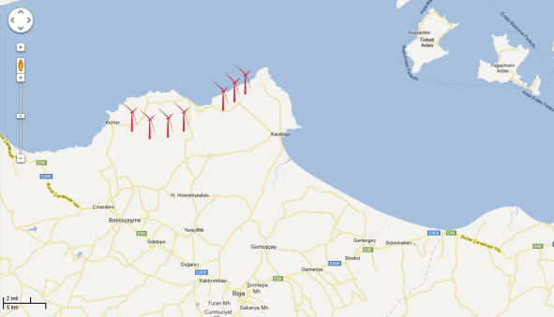
Figure 1 Project Location

A.3 Technologies and/or measures
Wind power is a well-established technology that, once built and in operation, has no carbon emissions and has no fuel costs. It has the advantage of quick installation but the disadvantage of supply-demand mismatch, due to the variability of wind. Nevertheless, there is great potential for wind power in Turkey. According to the Turkish Wind Potential Atlas developed in 2007, the country has minimum wind energy potential of 5,000 MW in regions with annual wind speeds of 8.5 m/s and higher and 48,000 MW in areas with speeds higher than 7.0 m/s. (Tunç & Pak, 2012)
The Icdas Biga Wind Power Plant has a capacity of 60MW with 19 wind turbines which generated on average 153,674 MWh/year between years 2016-2021. There are 19 wind turbines with rated power of 3.2 MW and rotor diameter of 103 m. It is firstly designed to be carried out with a production capacity of 106 MW. However, since the installed power is limited to a production capacity of 60 MW, which is the transformer power in that location, it is revised as 60 MW. The project started to generate electricity on 16.10.2015 with 5 turbines. On 02.12.2015, 7 of the remaining turbines started to operate and on 31.12.2015 4 more turbines started to operate. On 22.01.2016, the remaining 3 turbines started to generate electricity and the project reached full capacity.
The wind turbines are purchased from the General Electric Company. The wind turbine employs a doubly-fed induction generator with a power converter interfacing the rotor to the grid. The wind turbine is capable of supplying/drawing reactive power to/from the grid thus contributing to grid voltage support.
3.2 is a three-bladed horizontal axis upwind wind turbine with rated power of 2000kW and rotor diameter of 103m. The SL3000/113 Normal Temperature Type is applicable to areas in normal environmental temperature with survival ambient temperature of -20°C ～+50°C and operational ambient temperature of -15°C～+30°C. It consists of rotor, blades, blade pitch control system, hub, gearbox, bearings, brake system, generator, gearbox/generator coupling, yaw system, tower, nacelle, wind sensor and lightning rod, lightning protection, control system, power converter and medium voltage transformer and switch gear. The rotor is connected to the gearbox flange via a hub spacer which is fitted in the inner ring of main bearing. The outer ring of the main bearing is bolted to the main frame. The rotor load transmits to the main frame via main bearing. The main frame is connected to the tower top flange via yaw bearing. Inside the nacelle there employs a maintenance crane to perform maintenance, overhaul, and exchange for gearbox, generator, and rotor blades.
Table 3 Turbine Specifications
Design Data
Rated Power | 3.2 MW
Rotor Blade Diameter | 103 m
Tower Hub Height | 85m
Life Time | 20 years*
Rotor Blade
Number of rotor blades | 8,332 m²
Swept Area | 7389.8 m²
Rated Speed | 14 rpm
Rotating Speed Range | 9.2-14.8 rpm
Rotation | Clockwise
Number of Rotor Blades | 3
Lightning Detector
Signal | Ultrasonic
Generator
Type | Double-fed induction generator
Gear Box
Stages | multi-stage planetary/helical design
Reference: Project Design Document for the first crediting period
*The life time of the equipment is gathered from the Design Evaluation Conformity Statement by Tüv Nord.

İçdaş wind farm is connected to the grid via Turkish Electricity Transmission Company’s (TEİAŞ) Biga and Çan transformer stations. The connection point and the location of the electricity metering equipment are demonstrated in the single line diagram. (Figure 2) The plant load factor is 32%. This figure is derived from operating practices. It is calculated via dividing the total amount of energy the plant produced during a period of time by the amount of energy the plant would have produced at full capacity.
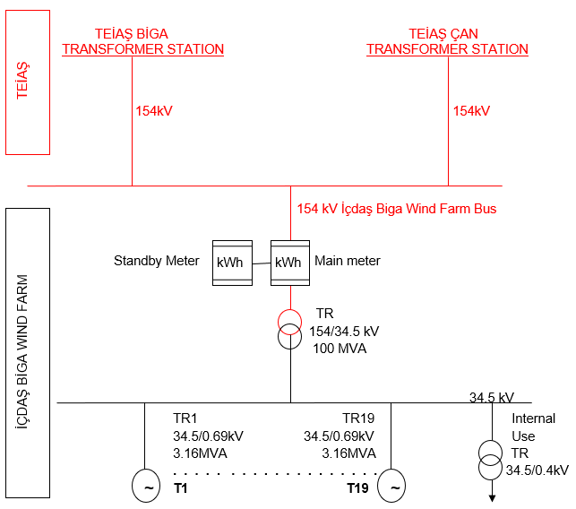
Figure 2 Single Line Diagram of the Power Plant
In the absence of the project activity, the electricity delivered to the grid by the project activity would have otherwise been generated by the operation of grid-connected power plants and by the addition of new generation sources.

A.4 Scale of the project
Large scale

A.5 Funding sources of project
No public funding is used for the project activity.

SECTION B. APPLICATION OF APPROVED GOLD STANDARD METHODOLOGY (IES) AND/OR DEMONSTRATION OF SDG CONTRIBUTIONS

B.1. Reference of approved methodology (ies)
The approved methodology applied to the project is ACM0002, “Large-scale Consolidated Methodology: Grid-connected electricity generation from renewable sources”, version 20.0. The following methodological tools in line with the methodology are used:
- “Tool for the demonstration and assessment of additionality”, Version 07.0
- “Combined tool to identify the baseline scenario and demonstrate additionality”, Version 07.0
- “Tool to calculate project or leakage CO2 emissions from fossil fuel combustion”, Version 03.0
- “Tool to calculate the emission factor for an electricity system”, Version 07.0
- “Tool to determine the remaining lifetime of equipment”, Version 01
- “Assessment of the validity of the original/current baseline and update of the baseline at the renewal of the crediting period” Version 3.0.1

B.2. Applicability of methodology (ies)
According to UNFCCC (paragraph 28, decision 1/CMP.2), a renewable energy project activity can be classified as small-scale CDM project if the project activity has a maximum output capacity of 15 MW. The project output capacity is 60MW, so, the project activity is identified as large-scale and a large-scale methodology, ACM0002, is applied. ACM0002 applies to project activities that include retrofitting, rehabilitation (or refurbishment), replacement or capacity addition of an existing power plant or construction and operation of a Greenfield power plant. Since, the project activity includes construction of a Greenfield wind power project, this methodology is applicable. The other applicability criteria and their justifications are listed at the table below.
Table 4 ACM0002 Applicability Conditions
Applicability conditions | Justification
This methodology is applicable to grid-connected renewable energy power generation project activities that:  - Install a Greenfield power plant;  - Involve a capacity addition to (an) existing plant(s);  - Involve a retrofit of (an) existing operating plants/units;  - Involve a rehabilitation of (an) existing plant(s)/unit(s); or  - Involve a replacement of (an) existing plant(s)/unit(s). | The proposed project activity involves the installation of a new power plant for renewable electricity generation that is delivered to the grid.
The project activity may include renewable energy power plant/unit of one of the following types: hydro power plant/unit with or without reservoir, wind power plant/unit, geothermal power plant/unit, solar power plant/unit, wave power plant/unit or tidal power plant/unit; | The project activity consists in the installation of a wind power plant; therefore, the project activity complies with the activity condition and type of plant/unit.
In the case of capacity additions, retrofits, rehabilitations or replacements (except for wind, solar, wave or tidal power capacity addition projects the existing plant/unit started commercial operation prior to the start of a minimum historical reference period of five years, used for the calculation of baseline emissions and defined in the baseline emission section, and no capacity expansion, retrofit, or rehabilitation of the plant/unit has been undertaken between the start of this minimum historical reference period and the implementation of the project activity | The project is a green field power plant; thus, this criterion is not applicable.
In case of hydro power plants, one of the following conditions shall apply:  (a) The project activity is implemented in existing single or multiple reservoirs, with no change in the volume of any of the reservoirs; or  (b) The project activity is implemented in existing single or multiple reservoirs, where the volume of the reservoir(s) is increased and the power density calculated using equation (3), is greater than 4 W/m²; or  (c) The project activity results in new single or multiple reservoirs and the power density, calculated using equation (3), is greater than 4 W/m²; or  (d) The project activity is an integrated hydro power project involving multiple reservoirs, where the power density for any of the reservoirs, calculated using equation (3), is lower than or equal to 4 W/m², all of the following conditions shall apply:  (i) The power density calculated using the total installed capacity of the integrated project, as per equation (4), is greater than 4 W//m²;  (ii) Water flow between reservoirs is not used by any other hydropower unit which is not a part of the project activity;  (iii) Installed capacity of the power plant(s) with power density lower than or equal to 4 W//m² shall be:  a. Lower than or equal to 15 MW; and  b. Less than 10 per cent of the total installed capacity of integrated hydro power project. | The project activity is not a hydropower plant. The criteria are not assessed.
The methodology is not applicable to:  (a) Project activities that involve switching from fossil fuels to renewable energy sources at the site of the project activity, since in this case the baseline may be the continued use of fossil fuels at the site; (b) Biomass fired power plants/units | The project does not involve  switching from fossil fuels to  renewable energy sources  and is not a biomass fired  power plant.
In the case of retrofits, rehabilitations, replacements, or capacity additions, this methodology is only applicable if the most plausible baseline scenario, as a result of the identification of baseline scenario, is “the continuation of the current situation, that is to  use the power generation equipment that was  already in use prior to the implementation of the project activity and undertaking business as usual maintenance”. | The project does not involve  retrofits, rehabilitations,  replacements, and it’s not a  capacity addition.

B.3. Project boundary
According to ACM0002, the spatial extent of the project boundary includes the project power plant/unit and all power plants/units connected physically to the electricity system, which the Turkish electricity grid, that the VER project power plant is connected to. The following diagram describes the project’s spatial boundary.
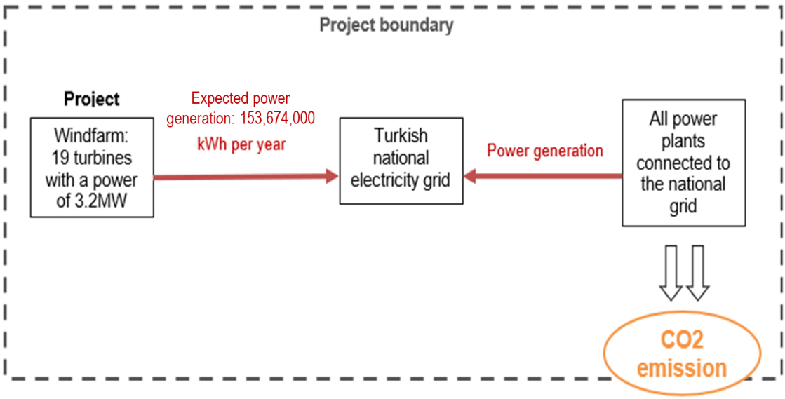
Figure 3 Project boundary
The greenhouse gases and emission sources included in or excluded from the project boundary are shown in Table 5.
Table 5 Emission Sources
Source |  | GHGs | Included? | Justification/Explanation
Baseline scenario | CO₂ emissions from electricity generation in fossil fuel fired power plants that are displaced due to the project activity | CO₂ | Yes | According to ACM0002, CO₂ is included in the project boundary because it is a main emission source
Baseline scenario |  | CH₄ | No | According to ACM0002, CH₄ is not included in the project boundary because it is a minor emission source
Baseline scenario |  | N₂O | No | According to ACM0002, N₂O is not included in the project boundary because it is a minor emission source
Project scenario | For geothermal power plants, fugitive emissions of CH₄ and CO₂ from non-condensable gases contained in geothermal steam | CO₂ | No | The project is not a geothermal plant but a wind farm; these GHGs emissions should then not be considered.
Project scenario |  | CH₄ | No
Project scenario |  | N₂O | No
Project scenario | CO₂ emissions from combustion of fossil fuels for electricity generation in solar thermal power plants and geothermal power plants | CO₂ | No | The project is neither a solar thermal power plant nor a geothermal plant but a wind farm, these GHGs emissions should then not be considered.
Project scenario |  | CH₄ | No
Project scenario |  | N₂O | No
Project scenario | For hydro power plants, emissions of CH₄ from the reservoir | CO₂ | No | The project is not a hydropower plant but a wind farm, these GHGs should not be considered.
Project scenario | For hydro power plants, emissions of CH₄ from the reservoir | CH₄ | No
Project scenario | For hydro power plants, emissions of CH₄ from the reservoir | N₂O | No

B.4. Establishment and description of baseline scenario
The proposed project activity includes the installation of 19 wind turbines with rated power of 3.2MW each. The electricity generated is delivered to the grid. Hence, according to the baseline methodology ACM0002, since the project activity is the installation of a new grid-connected renewable power plant, the baseline scenario is as follows:
“Electricity delivered to the grid by the project activity would have otherwise been generated by the operation of grid-connected power plants and by the addition of new generation sources, as reflected in the combined margin (CM) calculations described in the ‘Tool to calculate the emission factor for an electricity system’.”
According to ACM0002 (Version 20), if the project activity is the installation of a new grid connected renewable power plant, the baseline scenario is the electricity delivered to the grid by the project activity that otherwise would have been generated by the operation of grid-connected power plants and by the addition of new generation sources. Tool “Assessment of the validity of the original/current baseline and update of the baseline at the renewal of the crediting period”, Version 03.0.1 has been applied to demonstrate that the baseline of the project is still valid.
Step 1: Assess the validity of the current baseline for the next crediting period
The “Procedures for the renewal of the crediting period of a registered CDM project activity” approved by the CDM Executive Board require assessing the impact of new relevant national and/or sectoral policies and circumstances on the baseline.
The validity of the current baseline is assessed using the following Sub-steps:
Step 1.1: Assess compliance of the current baseline with relevant mandatory national and/or sectoral policies
The Project baseline is the “grid-connected electricity generation from renewable sources”. The Project is still compliant with Electricity Market Law with Number 4628 and dated 03/03/2001 and Law on Utilization of Renewable Energy Resources for the Purpose of Generating Electrical Energy with Number 5346 and dated 18/05/2005 (current legal framework, all required relevant regulations and laws). The current baseline complies with all relevant mandatory national and/or sectoral policies that came into effect after the submission of the project activity for validation and are still applicable at the time of requesting renewal of the crediting period.
Step 1.2: Assess the impact of circumstances
The baseline scenario identified at the validation of the project activity is the continuation of the current practice without any investment, an assessment of the changes in market characteristics at the time of the renewal of the crediting period is depicted as follows.
The electricity generation is still mainly composed of fossil fuel fired power plants in Turkey. The share of primary energy sources in the electricity generation in Turkey is shown in Figure 4.
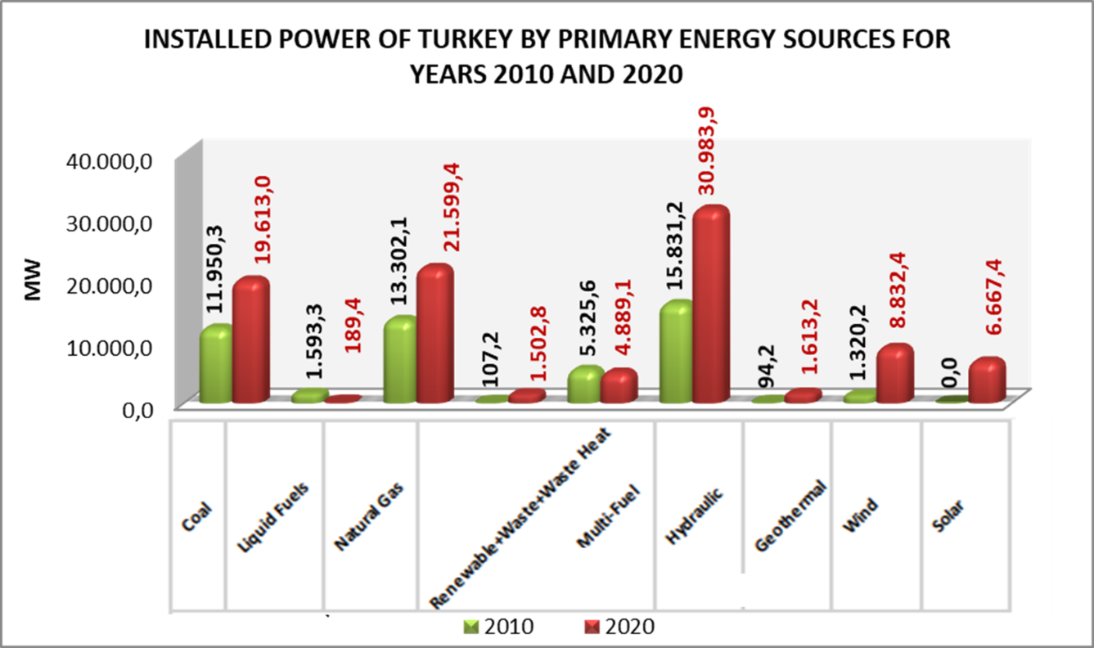
Figure 4 Installed capacity by primary energy sources between years 2010-2020
In reference to 5-year capacity projection published by TEIAS, it is clear that fossil fuels will continue to dominate other energy sources for electricity generation until 2025. According to the report, wind power share is expected to be only around %10.6 in 2025. This projection is consistent with continuing fossil fuel dependent characteristics of Turkish electricity sector. Therefore, it can be said that the baseline scenario is still valid for the second crediting period in accordance with the tool “Assessment of the validity of the original/current baseline and update of the baseline at the renewal of the crediting period”.
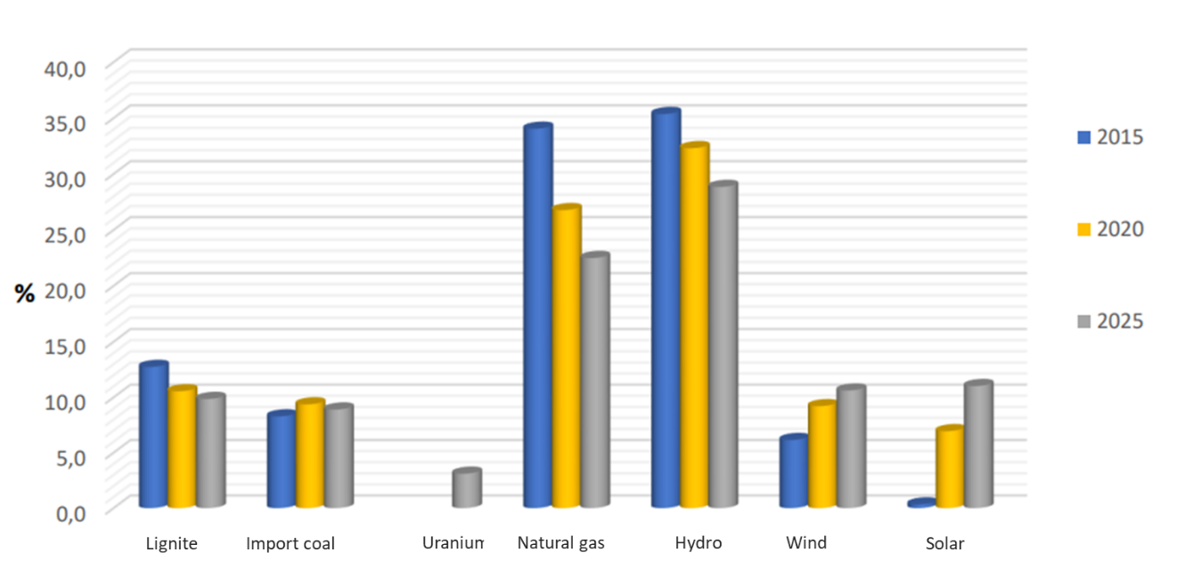
Figure 5 Share of Resources in Turkey's Total Installed Power by Years, TEIAS

Step 1.3: Assess whether the continuation of use of current baseline equipment(s) or an investment is the most likely scenario for the crediting period for which renewal is requested
The baseline scenario identified at the validation of the project activity was the continuation of grid-connected electricity generation from renewable sources. Under this scenario, no investment from the project’s proponent or third party (or parties) has been envisioned later specifically for the project. So, this sub-step in not applicable.
Step 1.4: Assessment of the validity of the data and parameters
The emissions reduction calculations are based on two main parameters: the energy
produced and the grid emission factor. These parameters have been revised in relevant sections of this document.
Step 2: Update the current baseline and the data and parameters
Step 2.1: Update the current baseline
The project baseline for the next crediting period is the use of electricity from the national grid. This is in line with the latest version of the approved applicable methodology ACM0002 version 20.0.
Step 2.2: Update the data and parameters
The grid emission factor has been updated according to the latest version of “Tool to
calculate the emission factor for an electricity system (Version 07.0)”. According to this tool, three options has been provided. The PP used Option 1 as the national EF published by the Ministry of Energy and Natural Resources. Detailed explanations are provided in the following sections of this document.

B.5. Demonstration of additionality
For the demonstration of additionality, “Tool to for the Demonstration and Assessment of Additionality Version 7.0.0” has been used. There has been no additional investment and design change for the project. The additionality had been evaluated during the time of the first validation and that information will be used again during the second crediting period. Hence, no new additionality assessment is done.
Milestones of the Project activity is given in the below table.
Table 6 Schedule of the Project activities
Date | Activity
22.04.2011 | Bidding Invitation from TEİAŞ for the electricity generation license.  Issuance of the initial license
19.08.2011 | Issuance of document that the project does not require EIA
11.01.2012 | Issuance of Electricity Generation License
07.02.2012 | Investment decision date (Board decision on consideration of carbon finance)
11.01.2012 | Issuance of Electricity Generation License
01.04.2012 | Agreement with the Carbon Project Developer
24.05.2013 | Date of Local Stakeholder Meeting
10.07.2013 | Remark of Directorate Of Nature Conservation And National Parks on the cancellation of the six turbines and precautions on bird migration routes.
23.08.2013 | First submission of Local Stakeholder Consultation Report to Gold Standard.
9.12.2014 | The project start date (agreement with the equipment provider)
10.12.2014 | Completion of the Energy Assessment Report
15.12.2014 | 1st Loan Agreement
27.01.2015 | Revision of the Electricity Generation Licence according to the new turbine capacities.
27.03.2015 | 2nd Loan Agreement
25.03.2015 | Construction Agreement
18.09.2015 | System usage agreement
16.10.2015 | Certificate of provisional acceptance of the Project(start date of the crediting period)
11.01.2016 | Start of Validation (Contract date between the project owner and the DOE)
01.08.2016 | Start of Stakeholder Feedback Round(SFR) (the project documents were publically available on the project owner’s website)
08.08.2016 | Live SFR meeting at Örtülüce Village
24.11.2016 | 1st verification date
14.01.2021 | 2nd verification date
17.06.2022 | Preparation of the draft PDD for the crediting period renewal

B.5.1 Prior Consideration
N/A
B.5.2 Ongoing Financial Need
The revenue from Gold Standard certification is still material to the ongoing sustainability of the project given the low demands for the VERs with even lower prices in Turkey. Although already issued VERs provided support to the ongoing financial sustainability of the Project, the revenue was not high as expected. In 2016, the revenues from the VERs was only around 1% of the total RES revenues for the company. While the revenues from electricity sales were around 165 M USD, the project was only able to achieve VER revenues of 21,000 USD. In addition, the project is not included in the YEKDEM since the beginning of 2023 and no revenue is gained through that. Therefore, it can be said that the Project still needs the financial support that may be beneficial for the Project Owner.

B.6. Sustainable Development Goals (SDG) outcomes
Relevant Target/Indicator for each of the three SDGs
SDG Targeted | Most relevant  SDG Target | SDG Impact
SDG Targeted | Most relevant  SDG Target | Indicator (Proposed or SDG Indicator)
4 Quality Education | By 2030, substantially increase the number of youth and adults who have relevant skills, including technical and vocational skills, for employment, decent jobs and  Entrepreneurship  By 2020, substantially expand globally the number of  scholarships available to developing countries, in particular  least developed countries, small island developing States and African countries, for enrolment in higher education, including vocational training and information and communications technology, technical, engineering and scientific programmes, in  developed countries and other developing countries | Human and institutional  capacity  - Number of local primary and  high school students who get  scholarship  - Number of youths educated  at the water sport club  - Quantity of physical support  to the local schools/local  communities.
7 Affordable and Clean Energy | By 2030, increase substantially the share of renewable energy in the global energy mix | Access to affordable and  clean energy services:  1. Amount of electricity  generated from wind power
8 Decent Work and Economic Growth | By 2030, achieve full and productive employment and decent work for all women and men, including for young people and persons with disabilities, and equal pay for work of equal  value  By 2020, substantially reduce the  proportion of youth not in employment, education or training | Quality employment:  - Training records of  employees during operation period  Quantitative employment  and income generation:  - Number of jobs created during  operation period  Human and institutional  capacity & Technology  transfer and technological self-reliance  - Number of trainings carried  out for employees of the power plant
13 Climate Action | Integrate climate change measures  into national policies, strategies  and planning | Emission reductions in tCO₂

B.6.1 Explanation of methodological choices/approaches for estimating the SDG Impact
SDG 4 - Quality Education
The project creates positive impact on SDG 4 - Quality Education by improving human capacity, especially for the young people. Scholarships are being provided for successful students to ensure their education. Physical support for local schools is provided. Informative activities are being organised for students on environment. Water sports activities for children and teenagers are being provided at the ICDAŞ sport club. The quantitate indicators for this SDG are the number of local primary and high school students who get scholarship; the number of youths educated at the water sport club and the quantity of physical support to the local schools/local communities. These parameters are monitored by the project owner. The list of students and the records of financial aids are kept at the project owner’s financial records. The records will be provided to the DOE for each year during verifications.
SDG 7 - Affordable and Clean Energy
The electricity generation from a renewable resource will help Turkey to reduce the dependency on imported fossil fuel for electricity generation. In order to estimate the impact on SDG 7 - Affordable and Clean Energy, the quantity of electricity generated is monitored continuously. The data measured via main meter is read every hour by the technicians and recorded on an excel file for the records of the project owner. In addition to company records, the hourly data is saved automatically on TEİAŞ’s load dispatch centre’s online system via remote reading of the meters. The monthly records of TEAIŞ and project owner are used for crosschecking.
SDG 8 - Decent Work and Economic Growth
The project has also a positive impact on the SDG 8 - Decent Work and Economic Growth. The impact is estimated with the indicators of quality of employment and quantitative employment and income generation. The quality of employment is estimated by the training records provided to the employees of the plant. To provide a safe and healthy labour environment for the workers the project owner took necessary precautions during the operation phase according to Work Health and Safety Law. During construction and the monitoring period the health and safety activities are managed by the equipment supplier. The equipment supplier has an employee health and safety plan19 (EHS) and took all the necessary precautions in line with that plan. No severe injury has been recorded during the monitoring period. In addition to the equipment supplier’s plan the project owner also has Labour Safety Instructions and Emergency Plan for the wind farm. The project owner holds OHSAS 8001 certification. Every year the training requirements are reviewed, and a training plan is prepared by the occupational safety specialist. The staff of the wind farm plant was trained on working aloft at wind farms (GWO BST) and usage of wind turbine elevators (HAILO). Moreover, the fair wage and working hours conditions are determined by the Ministry of Labour and Social Security in the Labour Law (No: 4857) and the project owner complies with the requirements of this labour law. The quantitative employment is measured with number of Jobs created due to the project activity. 13 people are working at the operation of the wind farm. The education level of the operating employees are 2 university graduates, 6 vocational high school graduate, 4 technical high school and a primary school graduate and one of the operation team members is a female electronical engineer. 4 of the employees are graduated from the vocational and technical high schools of Biga, Çanakkale.
SDG 13: Climate Action
In order to estimate the impact on SDG 13: Climate Action, ACM0002, “Large-scale Consolidated Methodology: Grid-connected electricity generation from renewable sources”, version 20.0 is used and the project emissions, baseline emissions, leakage and resulting emission reductions are calculated.
For developing the baseline and calculating the emission reductions for the proposed project activity, “Tool to calculate the emission factor of an electricity system” version 07.0 is used.
The emission reductions are calculated based on the below formula:
ER_{y}=BE_{y}-PE_{y}- LE_{y}
Where:
ER_{y} = Emission reductions in year y (tCO₂/yr)
BE_{y} = Baseline emissions in year y (tCO₂/yr)
PE_{y}= Project emissions in year y (tCO₂/yr)
LE_{y} = Leakage emissions in year y (t CO₂/y)
Project Emissions
As the proposed project activity is a new grid-connected wind power plant. For this reason, PE_{y} is considered as “0” in line with ACM0002 Version 20.0
PE_{y}=0
Leakage
Leakage emission (LE_{y}) is considered as “0” as suggested in ACM0002 Version 20.0
LE_{y}=0
Baseline Emissions
The baseline emissions are calculated as follows:
BE_{y}=EG_{facility,y} * EF_{CO2,i,y}
Where:
BE_{y} = Baseline emissions in year y (tCO₂/yr)
EG_{m,y} = Net quantity of electricity generated and delivered to the grid by power unit m in year y (MWh)
EF_{CO2,i,y} = CO₂ emission factor of fuel type i in year y (t CO₂/MWh)
Option 1 has been selected according the “Tool to Calculate the Emission Factor for an Electricity System v 07.0.0”. Option 1 allows the use of a national grid EF. The national EF published by the Ministry of Energy and Natural Resources is used as 0.6482 tCO2/MWh.
Then annual estimated impact on SDG 13: Climate Action is;
153,674 MWh/year * 0.6482 tCO₂/MWh = 99,611 tCO₂ per annum.

B.6.2 Data and parameters fixed ex ante
SDG13
Data/parameter | EF_{grid,CM,y}
Unit | tCO₂/MWh
Description | Combined margin CO₂ emission factor for the  project electricity system in year y
Source of data | Republic of Turkey Ministry of Energy and Natural Resources¹³
Value(s) applied | 0.6482
Choice of data or Measurement methods and procedures | Official national data
Purpose of data | Baseline emission calculation
Additional comment | -

B.6.3 Ex ante estimation of SDG Impact
Emission Reduction
ER_{y}=BE_{y}-PE_{y}- LE_{y}
Where:
ER_{y} = Emission reductions in year y (tCO₂/yr)
BE_{y} = Baseline emissions in year y (tCO₂/yr)
PE_{y}= Project emissions in year y (tCO₂/yr)
LE_{y} = Leakage emissions in year y (t CO₂/y)
Project Emissions
As the proposed project activity is a new grid-connected wind power plant. For this reason, PE_{y} is considered as “0” in line with ACM0002 Version 20.0
PE_{y}=0
Leakage
Leakage emission (LE_{y}) is considered as “0” as suggested in ACM0002 Version 20.0
LE_{y}=0
Baseline Emissions
The baseline emissions are calculated as follows:
BE_{y}=EG_{facility,y} * EF_{CO2,i,y}
Where:
BE_{y} = Baseline emissions in year y (tCO₂/yr)
EG_{m,y} = Net quantity of electricity generated and delivered to the grid by power unit m in year y (MWh)
EF_{CO2,i,y} = CO₂ emission factor of fuel type i in year y (t CO₂/MWh)
The national EF published by the Ministry of Energy and Natural Resources is used as 0.6482 tCO2/MWh.
Annual estimated impact on SDG 13: Climate Action is;
153,674 MWh/year * 0.6482 tCO₂/MWh = 99,611 tCO₂ per annum.

B.6.4 Summary of ex ante estimates of each SDG Impact
SDG 7
Year | Baseline estimate | Project estimate | Net benefit  MWh
10.03.2023-31.12.2023 | 0 | 125,044 | 125,044
01.01.2024-31.12.2024 | 0 | 153,674 | 153,674
01.01.2025-31.12.2025 | 0 | 153,674 | 153,674
01.01.2026-31.12.2026 | 0 | 153,674 | 153,674
01.01.2027-31.12.2027 | 0 | 153,674 | 153,674
01.01.2028-31.12.2028 | 0 | 153,674 | 153,674
01.01.2029-16.10.2029 | 0 | 121,676 | 121,676
Total | 0
Total number of crediting years | 7 years
Annual average over the crediting period | 0 | 153,674

SDG 13
Year | Baseline estimate | Project estimate | Net benefit  tCO₂/MWh
10.03.2023-31.12.2023 | 0 | 81,054 | 81,054
01.01.2024-31.12.2024 | 0 | 99,611 | 99,611
01.01.2025-31.12.2025 | 0 | 99,611 | 99,611
01.01.2026-31.12.2026 | 0 | 99,611 | 99,611
01.01.2027-31.12.2027 | 0 | 99,611 | 99,611
01.01.2028-31.12.2028 | 0 | 99,611 | 99,611
01.01.2029-16.10.2029 | 0 | 78,870 | 78,870
Total | 0
Total number of crediting years | 7
Annual average over the crediting period | 0 | 99,611

B.7. Monitoring plan
B.7.1 Data and parameters to be monitored
SDG 13
Data / Parameter | 𝑬𝑹_{y}
Unit | tCO₂/yr
Description | Emission reduction achieved in year y
Source of data | Measurement, official national EF data and calculation
Value(s) applied | Approximately 99,611 tCO₂ per annum
Measurement methods and procedures | ACM0002, “Large-scale Consolidated Methodology: Grid-connected electricity generation from renewable sources”, version 20.0 was used and the project  emissions, baseline emissions, leakage and resulting emission reductions are calculated. The formulas are as follows;  𝑬𝑹𝒚 = 𝑩𝑬𝒚 − 𝑷𝑬𝒚  Since y PEy= 0 and LEy= 0  Then ERy = BEy  BEy = EFy * Eg_{facility,y}
Monitoring frequency | EG_{facility,y} is measured continuously.  EFgrid,CM,y is fixed ex ante for the crediting period.
QA/QC procedures | The emission reduction calculations are based on two parameters EFy and EG_{facility,y}.  EFy is fixed for the first crediting period and officially published by the MoENR.  The QA/QC procedures for EG_{facility,y} is provided in the next table.
Purpose of data | To monitor the contribution of the project to SDG 13: Climate Action through baseline calculation
Additional comment | The details of emission reduction calculations are provided at section B.6.3.

SDG 7 and 13
Data / Parameter | Eg_{pj,grid,y}
Unit | MWh/yr
Description | Quantity of net electricity generation supplied by the project to the grid in year y
Source of data | Meter readings
Value(s) applied | Approximately 153,674 MWh/year
Measurement methods and procedures | The electricity generation is measured via a three-phase electricity meter and a standby meter in case of failures of the main meter, which are in control of TEİAŞ.
   | Type | Accuracy class | Serial number
  Main meter | LZQJ-XC | Active Energy Class: 0.2S  Reactive Energy Class: 0.5S | 10879418
  Standby meter | LZQJ-XC | Active Energy Class: 0.2S  Reactive Energy Class: 0.5Slass 2 | 10879419
Monitoring frequency | The data is measured continuously and recorded hourly and monthly
QA/QC procedures | The data measured via main meter is read every hour by the technicians and recorded on an excel file for the records of the project owner. In addition to company records, the electricity generation of the plant is calculated based on meter readings and crosschecked with EPIAS records that are the basis of sold electricity.  The quality assurance of the meters are meters by annual periodic inspections,  which includes;  - Testing of the meters to confirm that the measurement accuracy within the allowed range.  - Controlling of the measurement equipment  - Physical control of the equipment  The meters will be renewed every 10 years. The requirements of periodic inspections are gathered from the system usage agreement between TEİAŞ and  project owner.  Both meters are subject to national metrological control legislation and calibrated before installation. The sanity tests are applied every year.
Purpose of data | Baseline emission calculations
Additional comment | -

Safeguarding Principle 9.10 - High Conservation Value Areas and Critical
Habitats
Data / Parameter | Biodiversity / Number of affected birds and mammals
Unit | -
Description | Number of affected birds and mammals  Progress of commitments in the commitment letter.
Source of data | The monitoring records carried out by expert academicians and the biologist working for the project owner  Assessment reviews of the DNCNP on the monitoring process.
Value(s) applied | Estimated to be zero (0)
Measurement methods and procedures | -Carry out monitoring activities the bird migrations and mammal species  -Employment of a bird watcher or biologist to monitor the bird migrations  -Shut down the turbines during the bird migrations  -Carry out any required mitigation measures upon the request of DNCNP other than the measures stated in the commitment letter of the project owner to the DNCNP on 10.02.2015.
Monitoring frequency | The monitoring activities are carried every migration period (spring and fall) by full day observations for at least 15 days.
QA/QC procedures | During the bird immigration periods the number of birds affected by the turbines are monitored for two years and a report are sent to DNCNP every six months.  The DNCNP assessed the monitoring reports and provided feedback about the monitoring.
Purpose of data | Maintain the current habitat and avoid harming birds on migration.
Additional comment | -

SDG 4
Data / Parameter | Human and institutional capacity / Number students provided scholarship, sports training and quantity of support provided.
Unit | Number of person/people or TL value of support
Description | The project owner provides scholarships and sport trainings at Içdaş Sport Club for local students and physical support for local schools and villages.
Source of data | Project owner financial and operational records
Value(s) applied | It is planned to provide scholarships to at least 50 students and to provide sports training to at least 100 students through the sports school located within the project borders.
Measurement methods and procedures | The records of the number and list of students attending to the Içdaş Sport Club and scholarship awards are kept by the project owner. Moreover, physical and financial aids for local schools and villages are also kept by the project owner.  The accounting records are used to calculate the parameters.
Monitoring frequency | The records are kept as they occur. The reporting is provided annually
QA/QC procedures | The list of students who attend the Içdaş sailing/swimming schools and the financial value of the supports are provided to the VVB during each  verification.
Purpose of data | To monitor the contribution of the project to SDG 4: Quality Education
Additional comment | -

SDG 8
Data / Parameter | Number of Jobs created due to the project activity
Unit | -
Description | Number of Jobs created due to the project activity during the operation phase.
Source of data | Official records from Social Security Institution
Value(s) applied | It is planned to provide employment to at least 20 people from the local people in the project area.
Measurement methods and procedures | In order to contribute the SDG, the project owner;  - Set priority to local people for any new job opportunity.  - Is in contact with local education centres (high schools, universities) to develop more education courses to train more local people and create opportunities to  create them get a more qualified job.  The number of employees working for the project and their professional background information are kept by the human resources department.
Monitoring frequency | The records are being kept by the human resources department and reported annually.
QA/QC procedures | The records of human resources records are supported by the official records of Social Security Institution.
Purpose of data | To monitor the contribution of the project to SDG 8 – Decent work and Economic Growth
Additional comment | -

Safeguarding Principle 9.5 - Hazardous and Non-hazardous Waste
Data / Parameter | Amount of waste controlled
Unit | Kg
Description | Amount of waste oil and waste lubricants
Source of data | Official records
Value(s) applied | Around 2000 kg annually
Measurement methods and procedures | The waste oil and waste lubricants occur during the  maintenance of wind turbines will be collected and  not discharged at the site. These liquid wastes are  classified as hazardous waste according to the  regulation on control of hazardous wastes. The collected waste oil and waste lubricants will be transferred and  disposed by the companies having relevant licences.
Monitoring frequency | Yearly  Data is recorded at the time each waste occurs. It is sent to the licensed recycling facility every 6 months. This parameter will be monitored yearly for every verification.
QA/QC procedures | -
Purpose of data | To monitor the contribution of the project to Safeguarding Principle 9.5
Additional comment | -

B.7.2 Sampling plan
N/A
B.7.3 Other elements of monitoring plan
The most important parameter to estimate the emission reductions is the quantity of net electricity generation supplied by the project plan to the grid every year. The monitoring of the net electricity generation is online and continuous. The net electricity generation are being monitored via two meters, one main and one standby, and the metering are recorded by TEİAŞ remotely. The hourly readings are recorded by the technicians of the project owner every hour to the SCADA system and the readings of the TEAİŞ and project owner are crosschecked with EPIAS records that are the basis of sold electricity. Calibration has been made every 10 year in line with the national regulation.
In order to keep the monitoring system continuous and reliable there are around 15 people working with the following qualifications:
- Eight technicians who will work on three shifts and monitor the system and keep the records.
- Two management staff for operational control.
- Two workers for the maintenance.
The management structure is also demonstrated at the below Figure.
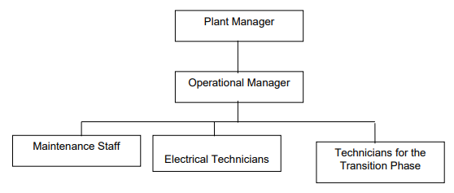
According to Gold Standard continuous input / grievance mechanism rules, the request and complaints from the local stakeholders are considered during the monitoring period. As agreed at the local stakeholder meeting, the Continuous Input / Grievance Expression Process Book are located at the Headman’s offices in neighbor villages (Örtülüce, Çakırlı, Değirmencik, Aksaz and Kemer). In addition to the Continuous Input / Grievance Expression Process Book, the contact person details of Içdaş is also available. The Headmen of the villages provide regular feedbacks on the continuous inputs and grievance expression. Each request is evaluated by the project owner and feedback is provided to the stakeholders. If the request/grievance cannot be considered/solved, the underlying reasons are explained.

SECTION C. DURATION AND CREDITING PERIOD

C.1. Duration of project
C.1.1 Start date of project
9.12.2014
C.1.2 Expected operational lifetime of project
The expected lifetime of the project activity is 20 years.

C.2. Crediting period of project
C.2.1 Start date of crediting period
First crediting period: 17.10.2015 – 16.10.2022
Second crediting period: 10.03.2023 – 16.10.2029
C.2.2 Total length of crediting period
21 years (3 periods of 7 years)

SECTION D. SUMMARY OF SAFEGUARDING PRINCIPLES AND GENDER SENSITIVE ASSESSMENT

D.1 Safeguarding Principles that will be monitored
A completed Safeguarding Principles Assessment is presented in Appendix 1.

D.2. Assessment that project complies with GS4GG Gender Sensitive requirements
Question 1 - Explain how the project reflects the key issues and requirements of Gender Sensitive design and implementation as outlined in the Gender Policy? | The project does not have a specific aspect for empowerment of women; however, the project owner is against any kind of discrimination in employment. The women are encouraged during the public consultation process to provide feedback  on the project. The project does not specifically promote gender equality. However, the girls are equally treated for the selection of scholarship awards and  sailing/swimming school. The project does not involve any kind of discrimination. The project being a wind power project is not gender sensitive project. The project does not adversely impact women or men.
Question 2 - Explain how the project aligns with existing country policies, strategies and best practices | The project does not involve and is not  complicit in any form of discrimination  based on gender, race, religion, sexual  orientation, or any other basis. Turkey is  party to Convention on Discrimination  since 1972 to prevent any form of  discrimination. The project owner respects Article 5/8425 of Labour Law; which states no discrimination based on gender, race, religion, sexual orientation or any other basis is allowed.
Question 3 - Is an Expert required for the Gender Safeguarding Principles & Requirements? | No
Question 4 - Is an Expert required to assist with Gender issues at the Stakeholder Consultation? | No

SECTION E. SUMMARY OF LOCAL STAKEHOLDER CONSULTATION
The below is a summary of the 2 step GS4GG Consultation for monitoring purposes. Please refer to the separate Stakeholder Consultation Report for a complete report on the initial consultation and stakeholder feedback round.

E.1 Summary of stakeholder mitigation measures
In accordance with “Gold standard procedure for the renewal of a crediting period”, Project participants shall discuss if and why there is or is not a need to conduct a complementary stakeholder consultation for the renewal of the crediting period. The PP did not conduct a complementary stakeholder consultation for the renewal of the crediting period for the following reasons:
• Both Çakırlı and Aksaz villages have stated that there has not been any feedback or suggestion by the villagers. Written statements have been submitted as reference documents.
• Prior to the first credit period, there were meetings with several stakeholders including the Project management, municipality responsibles and local people. Stakeholders declared their satisfaction with operation of plants. Stakeholders also added that the Project would contribute to the social and economic development of the region and Turkey.
• The project has been operated since 2015 in accordance with the registered PDD. There has been no difference between the first crediting period and the second crediting period in terms of the project operation. Also, there is no change in the project boundary or the impact area.
• The previous and ongoing verifications of the project have shown that the project has been operated in accordance with relevant Gold Standard requirements.
Therefore, no complimentary stakeholder consultation meeting was held.

Before the start of first crediting period, As required by the Gold Standard an Initial Stakeholder Consultation (ISC) has been undertaken. The consultation meeting was held on 24 May 2012 in Aksaz Village, Biga, Çanakkale. Full report is presented to the VVB at the time of first crediting period. All the stakeholders were asked to comment on the project in the invitation letters if they were unable to attend the stakeholder consultation meeting. None of the stakeholders, who did not attend the meeting, have sent any feedback yet. However, they will be requested to comment once more during the stakeholder feedback round.
During the consultation process the following documents were made publicly available for two months between the above given dates. The documents were:
- The complete PDD
- A non-technical summary of the project
The consultation process started by identifying the relevant stakeholders, then the relevant documents were made available on the website, and on the local newspapers and stakeholders were asked to provide feedback through e-mail and fax. The documents were delivered by hand to the mayors of the villages since access to the internet might not be readily available for use. Also, hard copies of the documents were present at both project sites and also at the mayors of the closest villages.
To open the meeting, the stakeholders were informed about the aim of the meeting and the project. Climate change and its impacts were also explained to make them understand the overall objective. Then the questions from the stakeholders are answered. There were a couple of questions about the project; such as; how close from the turbines they could come and whether they would be able to get electricity directly from the turbines. Although the villagers were informed that the meeting was about the wind farm project, most of them commented about Icdas’ Steel manufactory. For example, although not related to the project, some local fishermen requested to be able to enter the bay in front of the manufacturing site, but this is banned by governmental authorities. They were frequently reminded to comment about the wind farm project.
The blind sustainable development exercise followed the questions and answers. The sustainability indicators were explained and discussed one by one with the stakeholders.
After the sustainability development exercise, the continuous input/grievance mechanism was discussed. Each mechanism was explained to decide the best option for the local people. They preferred to use the Continuous Input / Grievance Expression Process Book. The book was located at the Headman’s office. In addition to the Continuous Input / Grievance Expression Process Book, the details of the contact person from Icdas.
The last exercise was a discussion around sustainable development monitoring. The villagers did not provide many ideas on how the monitor the indicators but said that they will be able to provide more feedback when the physical project activities will commence.
The meeting was successful in terms of the stakeholders’ attention to the project. The villagers view on the project was positive and they believe that it will be beneficial for the local community and Turkey in general. 23 people attended the physical meeting. A large number of people attended to the meeting. Although women were encouraged to attend the meeting, not many of them did so. Mostly local people and representatives from governmental authorities attended. The original participant list in Turkish was available to the VVB during the first crediting period. Further comments will be followed through the Grievance Expression Process Book.

E.2 Final continuous input / grievance mechanism
Method | Include all details of Chosen Method (s) so that they may be understood and, where relevant, used by readers.
Continuous Input / Grievance Expression Process Book | Continuous Input / Grievance Expression Process Book will be located at the Headman offices in Aksaz, Değirmencik, Örtülüce and Çakırlı villages. The stakeholders chose to use this method.
Telephone access | Barış Bora, Environmental Engineer Phone:00 90 286 395 12 39  This method can be easily used by the stakeholders since telephone is widely used in Turkey.
Internet/email access | Barış Bora, Environmental Engineer baris.bora@icdas.com.tr  Although, this method might not be used commonly, it’s also provided to the stakeholders.
GS Contact | help@goldstandard.org

Appendix 1 - Safeguarding Principles Assessment
Complete the Assessment below and copy all Mitigation Measures for each Principle into SECTION D above. Please refer to the instructions in the Guide to Completing this Form.
Assessment Questions/  Requirements | Justification of Relevance (Yes/potentially/no) | How Project will achieve Requirements through design, management or risk mitigation. | Mitigation Measures added to the Monitoring Plan (if required)
Principle 1. Human Rights
- The Project Developer and the Project shall respect internationally proclaimed human rights and shall not be complicit in violence or human rights abuses of any kind as defined in the Universal Declaration of Human Rights  - The Project shall not discriminate with regards to participation and inclusion | No | 1. Turkey is a party to  European Convention on  Human Rights since 18th May,  1954.  2. Project activities are not expected to cause any  human rights abuse. As a  member of United Nations  and part of UN Agreement on  Human Rights, it is ensured  by law in Turkey that no  action can be taken against  human rights. | N/A
Principle 2. Gender Equality
- The Project shall not directly or indirectly lead to/contribute to adverse impacts on gender equality and/or the situation of women  - Projects shall apply the principles of nondiscrimination, equal treatment, and equal pay for equal work  - The Project shall refer to the country’s national gender strategy or equivalent national commitment to aid in assessing gender risks  - (where required) Summary of opinions and recommendations of an Expert Stakeholder(s) | No | 1. The project does not reduce access to or control of resources for women. The project does not adversely affect men and women in marginalized or vulnerable communities.  2. Project does not involve any form of discrimination in any kind of forms. Turkey  ratified ILO 100 Equal Remuneration Convention and 111 Discrimination (Employment and Occupation) Convention. Therefore, the  safeguarding principle related to Gender Equality and Women’s Rights is not triggered.  3. The project does not have any scope to apply gender strategy.  4. N/A | N/A
Principle 3. Community Health, Safety and Working Conditions
- The Project shall avoid community exposure to increased health risks and shall not adversely affect the health of the workers and the community |  | The project owner is committed to the safe and  healthy working conditions during all phases of the  project. Also, the wind farm project does not release any emission or waste to the environment. So, the project does not pose an adverse effect on the workers and the community. | N/A
Principle 4.1 Sites of Cultural and Historical Heritage
Does the Project Area include sites, structures, or objects with historical, cultural, artistic, traditional or religious values or intangible forms of culture? | No | During the operation of the project, there was not any damage, alteration or removal to the critical cultural heritage. The project location does not involve any critical cultural heritage. | N/A
Principle 4.2 Forced Eviction and Displacement
Does the Project require or cause the physical or economic relocation of peoples (temporary or permanent, full or partial)? | No | The project does not involve any settlement areas. So, this project does not cause any physical or economic relocation of people. | N/A
>> | No |  | N/A
Principle 4.3 Land Tenure and Other Rights
- Does the Project require any change, or have any uncertainties related to land tenure arrangements and/or access rights, usage rights or land ownership?  - For Projects involving land use tenure, are there any uncertainties with regards to land tenure, access rights, usage rights or land ownership? | No | The affected project area covers only the erection areas of 19 turbines and the area is rented from the Çanakkale Biga Forestry Operation Directorate according to the Turkish laws. Thus, there are no uncertainties related to land tenure. Moreover, the  project activities do not restrict the use of land. The project area is open to public use. | The area rented from the  Çanakkale Biga Forestry  Operation Directorate for  the erection of each turbine was 105m*105m. However, the project owner reduced this area to 50m*50m for  each turbine. Thus, the area  affected from the project  activities are reduced. There  are no restricted areas in the  project, thus, no conflict in land tenure. So, not applicable.
>> | No
Principle 4.4 - Indigenous people
Are indigenous peoples present in or within the area of influence of the Project and/or is the Project located on land/territory claimed by indigenous peoples? | No | The generation of electricity by wind power does not create any negative impact on local communities. The project does not prevent any local economic or cultural activities. Hence, it created new job opportunities for the local people. Moreover, support for local communities and scholarships for local students are provided. | N/A
>> | No |  | N/A
Principle 5. Corruption
- The Project shall not involve, be complicit in or inadvertently contribute to or reinforce corruption or corrupt Projects | No | The Project does not involve and is not complicit in any kind of corruption. | N/A
Principle 6.1 Labour Rights
- The Project Developer shall ensure that all employment is in compliance with national labour occupational health and safety laws and with the principles and standards embodied in the ILO fundamental conventions  - Workers shall be able to establish and join labour organisations  - Working agreements with all individual workers shall be documented and implemented and include:  - Working hours (must not exceed 48 hours per week on a regular basis), AND  - Duties and tasks, AND  - Remuneration (must include provision for payment of overtime), AND  - Modalities on health insurance, AND  - Modalities on termination of the contract with provision for voluntary resignation by employee, AND  - Provision for annual leave of not less than 10 days per year, not including sick and casual leave.  - No child labour is allowed (Exceptions for children working on their families’ property requires an Expert Stakeholder opinion)  - The Project Developer shall ensure the use of appropriate equipment, training of workers, documentation and reporting of accidents and incidents, and emergency preparedness and response measures | No | 1.The Project Developer ensures that all employment follows national labour occupational health and safety laws and with the principles and standards embodied in the ILO fundamental conventions  2. Workers are able to establish and join labour organisations  3.Working agreements with all individual workers are documented and implemented.  4.No child labour is allowed (Exceptions for children working on their families’ property requires an Expert Stakeholder opinion)  5.The Project Developer ensures the use of appropriate equipment, training of workers, documentation and reporting of accidents and incidents, and emergency preparedness and response measures | All employees are trained  about health and safety  issues.
Principle 6.2 Negative Economic Consequences
- Does the project cause negative economic consequences during and after project implementation? | No | The generation of electricity by wind power does not create any negative impact on local communities. The project does not prevent any local economic or cultural activities. Hence, it created new job opportunities for the local people. Moreover, support for local communities and scholarships for local students are provided. | N/A
>> | No |  | N/A
Principle 7.1 Emissions
Will the Project increase greenhouse gas emissions over the Baseline Scenario? | No | The project activity covers electricity generation only from wind power, which is a renewable energy source and does not create GHG emissions, on the contrary it reduces GHG emissions over the baseline scenario. | N/A
>> | No |  | N/A
Principle 7.2 Energy Supply
Will the Project use energy from a local grid or power supply (i.e., not connected to a national or regional grid) or fuel resource (such as wood, biomass) that provides for other local users? | No | The wind power plant is connected to the national grid, only supplying and consuming electricity from the same source. The project does not include any other fuel source other than wind. | N/A
>> | No |  | N/A
Principle 8.1 Impact on Natural Water Patterns/Flows
Will the Project affect the natural or pre-existing pattern of watercourses, ground-water and/or the watershed(s) such as high seasonal flow variability, flooding potential, lack of aquatic connectivity or water scarcity? | No | For the construction of the power plant (wind turbines) existing forest roads are used and the transmission lines between the turbines are buried underground. | N/A
>> | No |  | N/A
Principle 8.2 Erosion and/or Water Body Instability
- Could the Project directly or indirectly cause additional erosion and/or water body instability or disrupt the natural pattern of erosion?  - Is the Project’s area of influence susceptible to excessive erosion and/or water body instability? | a. No  b. No | There was a risk of erosion, due to the excavation during the construction phase. However, the risk is eliminated by using existing forest roads. Thus, no  additional risk of erosion occurred during and after the construction. | Usage of existing forest road  eliminated the risk; thus, no  further mitigation measure will be applied during the operation.
>> | a. No  b. No
Principle 9.1 Landscape Modification and Soil
Does the Project involve the use of land and soil for production of crops or other products? | No | The project does not cover any agricultural production. Only 5% of the project area is  used for wind turbines. | N/A
>> | No |  | N/A
Principle 9.2 Vulnerability to Natural Disaster
Will the Project be susceptible to or lead to increased vulnerability to wind, earthquakes, subsidence, landslides, erosion, flooding, drought or other extreme climatic conditions? | Potentially | The land change at the project site during the  construction period of the turbines might have increased the risk of erosion. The operation of the wind farm project does not lead to increase the vulnerability to landslides, erosion or any other extreme climatic conditions in the project area. | N/A  The area was rented from the  Çanakkale Biga Forestry  Operation Directorate for  the turbine erection was 105m*105m for each turbine.  However, the project owner  reduced this area to 50m*50m for each turbine.  Thus, the area affected from  the project activities is  reduced. The construction  phase had been completed with  the mitigation measures  explained above and no erosion or landslide occurred. No further mitigation  measure is required during  the operation of the wind farm as justified in the  “justification” section.
>> | Potentially
Principle 9.3 Genetic Resources
Could the Project be negatively impacted by or involve genetically modified organisms or GMOs (e.g., contamination, collection and/or harvesting, commercial development, or take place in facilities or farms that include GMOs in their processes and production)? | No | The project site is being utilised for generating  electricity from wind turbines with no requirement for GMOs. | N/A
>> | No |  | N/A
Principle 9.4 Release of pollutants
Could the Project potentially result in the release of pollutants to the environment? | No | The wind farm project does not release any emission or waste to the environment. The turbines create noise, but they are not close enough to be heard from the residential areas. According to Assessment and Management of  Environmental Noise Regulation, the noise level for  industrial plants in highly residential areas is 65dBA for daytime, 60 for evening time and 55  for night-time. The noise calculation for wind turbines showed that the noise level in each  residential area (Değirmencik, Örtülüce, Çakırlı,  Kemer and Aksaz villages and Karabiga town) is  below these noise level limits when the turbines are in operation. The nearest settlement among  these residential areas is Örtülüce village, located at 837 m air distance to the turbine number 14.  During the construction phase, the activities were  carried out only daytime. The construction phase  noise levels calculations also showed that the  limits set by the noise regulations are met for the residential areas and workers. The wind turbines do not create shadow flickering effect. Shadow flicker is more of an issue in high latitude countries  since lower sun casts longer shadows. Although  there is no regional requirement about shadow flickering effect of the wind turbines, it is commonly considered that shadow flickering  effect does not occur at distances greater than 500-1000 m from a wind turbine. The closest  wind turbine is located at 837 m away from Örtülüce village. Considering the latitude of  Turkey, the turbines are not close enough to create shadow or flickering effect to the residential areas. | N/A
>> | No |  | N/A
Principle 9.5 Hazardous and Non-hazardous Waste
Will the Project involve the manufacture, trade, release, and/ or use of hazardous and non-hazardous chemicals and/or materials? | Yes | The project does not involve use or release of  hazardous and non-hazardous chemicals. The wind turbines do not create any emission or waste.  During the construction phase, the water required  for the sanitary purposes of the workers for the  construction phase was provided at the project owner’s steel plant close to the project area. Thus,  no additional wastewater treatment was required.  The solid waste occurred during the installation of the turbines were separated according to the relevant classes and disposed by the companies having licences. | The waste oil  and waste  lubricants occur  during the  maintenance of  wind turbines will  be collected and  not discharged  at the site. These  liquid wastes are  classified as  hazardous waste  according to the  regulation on  control of  hazardous  wastes. The collected waste  oil and waste  lubricants will be  transferred and  disposed by the  companies  having relevant  licences.
>> | Yes
Principle 9.6 Pesticides & Fertilisers
Will the Project involve the application of pesticides and/or fertilisers? | No | The project does not involve any agricultural elements that requires the use of pesticides and/or  fertilisers. | N/A
>> | No |  | N/A
Principle 9.7 Harvesting of Forests
Will the Project involve the harvesting of forests? | No | The project owner used existing forest roads, which are originally constructed by Çanakkale Biga  Forestry Operation Directorate to respond forest fires. Thus, it was not required to harvest existing trees for the construction and operation phase. No  further harvesting of forests is required for the operation phase. | N/A  The existing  forest roads are  used to avoid  harvesting trees  on project area.  No further  mitigation  measure is  required.
>> | No
Principle 9.8 Food
Does the Project modify the quantity or nutritional quality of food available such as through crop regime alteration or export or economic incentives? | No | The project does not cover any agricultural activity  or any kind of agricultural products. The project area does not include any agricultural site. | N/A
>> | No |  | N/A
Principle 9.9 Animal husbandry
Will the Project involve animal husbandry? | No | The project only covers electricity generation from  wind power. There are no animal husbandry activities carried out in the project. | N/A
>> | No |  | N/A
Principle 9.10 High Conservation Value Areas and Critical Habitats
Does the Project physically affect or alter largely intact or High Conservation Value (HCV) ecosystems, critical habitats, landscapes, key biodiversity areas or sites identified? | No | Project does not physically affect or alter largely intact or High Conservation Value (HCV) ecosystems, critical habitats, landscapes, key biodiversity areas or sites since there are no such sites in the project area. | N/A
>> | No |  | N/A
Principle 9.11 Endangered Species
a. Are there any endangered species identified as potentially being present within the Project boundary (including those that may route through the area)?  - Does the Project potentially impact other areas where endangered species may be present through transboundary affects? | a. No  b. No | a. There are not any endangered species identified as potentially being present within the Project boundary.  b. Project does not have an impact on other areas where endangered species may be present through transboundary affects. | N/A
>> | a. No  b. No |  | N/A

Appendix 2- Contact information of project participants

Organization name | İçdaş Çelik Enerji Tersane ve Ulaşım San. A.Ş.(project owner
Registration number with relevant authority | 108593 / Istanbul Chamber of Commerce
Street/P.O. Box | Mahmutbey Mahallesi Dilmenler Caddesi
Building | No: 20 Bağcılar
City | İstanbul
State/Region | -
Postcode | 34218
Country | Turkey
Telephone | +90 (0) 212 604 04 04
E-mail | enerjiticaret@icdas.com.tr
Website | www.icdas.com.tr
Contact person
Title | Energy Sales Marketing and Cost Accounting Manager
Salutation | Mr.
Last name | Cehiz
Middle name | -
First name | Serhat
Department | Energy Sales Marketing and Cost Accounting
Mobile | +90 (0) 533 305 84 47
Direct tel. | +90 (0) 212 604 04 04
Personal e-mail | serhat.cehiz@icdas.com.tr

Appendix 3- LUF Additional Information
Not applicable

Appendix 4-Summary of Approved Design Changes
Please refer to Design Change Requirements for more information on procedures governing Design Changes

Revision History

Version | Date | Remarks
1.2 | 14 October 2020 | Hyperlinked section summary to enable quick access to key sections  Improved clarity on Key Project Information  Inclusion criteria table added  Gender sensitive requirements added  Prior consideration (1 yr rule) and Ongoing Financial Need added  Safeguard Principles Assessment as annex and a new section to include applicable safeguards for clarity  Improved Clarity on SDG contribution/SDG Impact term used throughout  Clarity on Stakeholder Consultation information required  Provision of an accompanying Guide to help the user understand detailed rules and requirements
1.1 | 24 August 2017 | Updated to include section A.8 on ‘gender sensitive’ requirements
1.0 | 10 July 2017 | Initial adoption

Average annual generation amount is calculated using the 2016-2021 actual generation values.
https://cdm.unfccc.int/methodologies/DB/XP2LKUSA61DKUQC0PIWPGWDN8ED5PG
https://cdm.unfccc.int/methodologies/PAmethodologies/tools/am-tool-01-v7.0.0.pdf
https://cdm.unfccc.int/methodologies/PAmethodologies/tools/am-tool-02-v7.0.pdf
https://cdm.unfccc.int/methodologies/PAmethodologies/tools/am-tool-03-v3.pdf
https://cdm.unfccc.int/methodologies/PAmethodologies/tools/am-tool-07-v7.0.pdf
https://cdm.unfccc.int/methodologies/PAmethodologies/tools/am-tool-10-v1.pdf
https://cdm.unfccc.int/methodologies/PAmethodologies/tools/am-tool-11-v3.0.1.pdf
The Project site is a forest land prior to the Project activity, so the project is green field project. (Project Description Document)
The electricity generation license.
https://www.teias.gov.tr/tr-TR/turkiye-elektrik-uretim-iletim-istatistikleri
https://www.epdk.gov.tr/Detay/Icerik/3-0-66/elektrikuretim-kapasite-projeksiyonlari , 2021-2025
Please see the approved PDD from the first crediting period.
All reference documents had been submitted during the approval of the PDD for the first crediting period. Please see the approved PDD for the first crediting period.
https://enerji.gov.tr//Media/Dizin/EVCED/tr/%C3%87evreVe%C4%B0klim/%C4%B0klimDe%C4%9Fi%C5%9Fikli%C4%9Fi/T%C3%BCrkiyeUlusalElektrik%C5%9EebekesiEmisyonFakt%C3%B6r%C3%BC/Belgeler/EK-2.pdf
https://enerji.gov.tr//Media/Dizin/EVCED/tr/%C3%87evreVe%C4%B0klim/%C4%B0klimDe%C4%9Fi%C5%9Fikli%C4%9Fi/T%C3%BCrkiyeUlusalElektrik%C5%9EebekesiEmisyonFakt%C3%B6r%C3%BC/Belgeler/EK-2.pdf
Please see the approved PDD from the first crediting period.
https://www.icdas.com.tr/PageGalleryFiles/PdfFiles/%C4%B0%C3%87DA%C5%9E%202018%20S%C3%B Crd%C3%BCr%C3%BClebilirlik%20Raporu.pdf, p. 40
Please See Official Website of Ministry of Foreign Affairs of Turkey: http://www.mfa.gov.tr/the-european-convention-on-human-rights.en.mfa
http://www.resmigazete.gov.tr/main.aspx?home=http://www.resmigazete.gov.tr/arsiv/7217.pdf&main=http ://www.resmigazete.gov.tr/arsiv/7217.pdf
http://www.ilo.org/dyn/normlex/en/f?p=NORMLEXPUB:11200:0::NO::P11200_COUNTRY_ID:102893
https://www.mevzuat.gov.tr/MevzuatMetin/1.5.4857.pdf

