Gold standard for the global goals
Monitoring report



June 2017, version 1

Title of the project | Yuntdağ Wind Power Project, Turkey
Gold Standard project id | GS 352
Version number of the monitoring report | 2
Completion date of the monitoring report | 12/06/2019
Date of project design certification | 07/03/2008 (Design Certification Renewal: 21/03/2016)
Start date of crediting period | 21/03/2016
Duration of this monitoring period | 01/05/2018 to 30/04/2019 (both days are included, 2. Crediting period, 3. Monitoring period)
Duration of previous monitoring period | 01/04/2017 to 30/04/2018 (both days are included, 2. Crediting period, 2. Monitoring period)
Project representative(s) | Innores Elektrik Üretim A.Ş.
Host Country | Turkey
Certification pathway (activity certification/impact certification) | Impact Certification
SDG Contributions targeted (as per approved PDD) | 1 – SDG 13  2 – SDG 7  3 – SDG 8  4 – SDG 6
Gold Standard statement/product certification sought (GSVER/ADALYs/RECs etc.) | GSVER
Selected methodology(ies) | ACM0002 Version 16
Estimated amount of annual average certified SDG impact (as per approved PDD) | 112,582 tCO₂/year
Total amount of certified SDG impact (as per approved methodology) achieved in this monitoring period
  SDG 13:  Emission Reduction: 113,945 tCO₂  Air Quality:  CO: 33.06 tons/y  NMVOC: 7.06 tons/y | SDG 6:  Water Quality:  No wastewater discharge to the environment in the project area. Wastewater transportation invoices are provided.
  SDG 8:  Quality of Employment:  Training records of all employees are provided. 17 employees have received HSE trainings. HSE training certificates for 2 office employees were not provided since they are not physically working in the plant. There is 1 new employee in the plant and he will complete the HSE trainings in 2019. After his HSE trainings will be completed, his training certificate will be provided in the next verification.  Quantitative Employment:  Current employment records are presented. There are 18 employees in the plant and there are additional 2 office employees who are not physically work in the plant. There are 20 employees in total. There are 10 local employees and 9 of them works physically in the plant.  Human and institutional capacity (including empowerment, education, involvement, gender): Training records for the local workers are provided such as occupational health and safety trainings, security training renewal cards etc. | SDG 7:  Energy (206,386.46 MWh) is generated by using renewable energy systems throughout the project (Wind Power Plant).

- Description of project
  - Purpose and general description of project

Innores Elektrik Üretim AŞ (“Innores”) installed and commissioned a 42.5 MW wind power plant in Yuntdağ/Bergama/İzmir in Turkey in 2008. Initial project capacity was 42.5 MW consisting of 17 turbines with 2.5 MW each, which was planned to be increased by 15 MW in 2011 with a revised license for 57.5 MW which was granted by EMRA to Innores on 09/06/2010. Finally, capacity is increased of 2,5 MW with an additional turbine. Revised licence for 60.0 MW is granted by EMRA to Innores on 24/05/2013.

The increased capacity was also registered under Gold Standard for consideration of emission reduction on 11th of May 2015. Yuntdağ WPP including additional capacity is consisted of 24 wind turbines Nordex N90 of the 2.5 MW output, 90m in diameter and 80m hub height. The wind turbines connected to the wind farm substation through 34.5 kV underground cables. The voltage is raised to 154 kV and is transferred to the National Electricity System (Alosbi Transformer Station) via a 26 km long transmission line for 60.0 MW installed capacity.

2nd crediting period of Yuntdağ WPP started on 21/03/2016 and the crediting period is 7 years which will end on 20/03/2023. The expected yearly net electricity generation is 203,900 MWh which leads to emission reductions of 788,074 tCO₂ over the period of 7 years. The third monitoring period of the second crediting period is between 01/05/2018 to 30/04/2019. In this monitoring period, 206,386.46 MWh of net electricity is supplied to the grid and 113,945 tCO₂ emission reduction has achieved.

Yuntdağ WPP completed its transition process to Gold Standard for the Global Goals on 16/11/2018. Environmental and social monitoring parameters are revised in transition process and are connected to specific SGD parameters. Yuntdağ WPP is now compatible with Gold Standard for the Global Goals and this monitoring report has taken revised monitoring parameters and SGDs into consideration.

The purpose of the project is to generate electricity and to feed it into the grid. Yuntdağ WPP was registered as a Voluntary Emission Reduction project in order to enable the project implementation by means of financial inflows coming from the credits sale. Because of its significant contribution to climate protection and to sustainable development in the region, this project fulfils the requirements of the Gold Standard Organization.
  - Location of project

The Project located near Koyuneli village of Bergama district in İzmir, Turkey. The site is located on two ridgelines at the elevation between 490m and 530m. Location of the project site is presented in Figure 1.

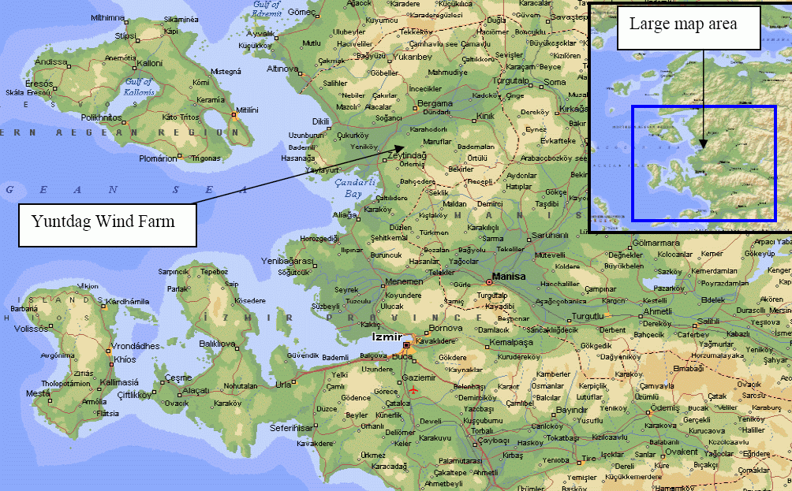
Figure 1: Map of the Project Area

The coordinates of the turbines are given below. Yuntdağ WPP including additional capacity consisting of 24 wind turbines Nordex N90 of the 2.5 MW output, 90m in diameter and 80m hub height. The project coordinates were provided below which are under ED 50, zone 35 coordinate system.

Table 1: Coordinates of the Turbines
Turbine No. | Easting | Northing
T01 | 516633 | 4313956
T02 | 516615 | 4313686
T03 | 516642 | 4313426
T04 | 516697 | 4313168
T05 | 516744 | 4312913
T06 | 516757 | 4312647
T07 | 516772 | 4312347
T08 | 516786 | 4312100
T09 | 516846 | 4311849
T10 | 516854 | 4311595
T11 | 516936 | 431349
T12 | 517036 | 4311122
T13 | 515532 | 4311741
T14 | 515563 | 4311485
T15 | 515585 | 4311081
T16 | 515533 | 4310674
T17 | 515431 | 4310288
T18 | 516495 | 4311954
T19 | 515390 | 4311545
T20 | 516120 | 4311545
T21 | 516410 | 4311460
T22 | 515318 | 4309878
T23 | 515573 | 4309771
T24 | 517209 | 4311030

  - Reference of applied methodology

For the determination of the baseline, the official methodology ACM0002 version 16.0, “Large-scale Consolidated baseline methodology for grid-connected electricity generation from renewable sources”, is applied, using conservative options and data as presented in the following section. This methodology refers to four Tools, which are:

- Tool to calculate the emission factor for an electricity system (Version 04.0.0);
- Tool for the demonstration and assessment of additionality (Version 07.0.0);
- Combined tool to identify the baseline scenario and demonstrate additionality (version 06.0.0)
- Tool to calculate project or leakage CO₂ emissions from fossil fuel combustion (Version 02.0.0)
- Tool to determine the remaining lifetime of the equipment
- Assessment of the validity of the original/current baseline and update of the baseline at the renewal of the crediting period (version 03.0.1)

For baseline calculation the first tool, for additionality assessment the second tool is used. As third tool is the combination of the first and second tool, it is not used. Since no project emission or leakage calculation is required for wind power project fourth tool is not used, either. To determine the remaining lifetime of the equipment fifth tool is used. Moreover, for the renewal of the crediting period, the sixth tool is used.
  - Crediting period of project

21/03/2016 to 20/03/2023 (Crediting period of the project is 7 years which is twice renewable.)
- Implementation of project
  - Description of implemented project

The project consists of the 24 wind turbines that are connected to the grid via a 26 km transmission line. Yuntdağ WPP including additional capacity is consisted of 24 wind turbines Nordex N90 of the 2.5 MW output, 90m in diameter and 80m hub height. The wind turbines connected to the wind farm substation through 34.5 kV underground cables. The voltage is raised to 154 kV and is transferred to the National Electricity System (Alosbi Transformer Station) via a 26 km long transmission line for 60.0 MW installed capacity.The wind power project does not comprise any emission sources.
The project spatial extend of Yuntdag WPP is the project power plant and all power plants connected physically to the electricity system which is discussed and applied with calculation of combined margin in accordance of “Tool to calculate the emission factor for an electricity system”

The project uses wind energy to produce electricity. Kinetic power of the wind is converted to electrical energy, which then will be transferred to the grid. Back-up power generators in the wind farm will only be used when the wind farm is out of service and power cannot be supplied from grid. Hence, emissions due to usage of back-up power generation are expected to be very low and are taken to be zero complying with the “Tool to calculate project or leakage CO₂ emissions from fossil fuel combustion “(v.2).

A general operation diagram of the project is given in Figure 2.
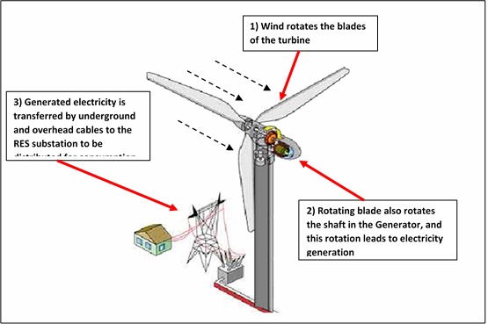
Figure 2: Operation diagram of the project

The project installation is completed according to the description in the PDD and completely operational. The project consists only one site. The most important milestones are included in the following table:

Table 2: Milestones of the Yuntdağ Wind Power Project
Date | Milestone
25/07/2007 | Initial Stakeholder Consultation in Koyuneli Village
07/03/2008 | Commissioning of the first 6 turbines: Start of the first crediting period and first monitoring period
18/03/2008 | Final Validation Report
04/06/2008 | Commissioning of 11 Turbines.
31/07/2008 | Gold Standard Registration
30/04/2009 | End of the first monitoring period
31/03/2010 | End of the second monitoring period
09/06/2010 | License granted by EMRA for capacity extension (for 57.5 MW)
31/12/2010 | End of the third monitoring period
01/04/2011 | Start date of construction for capacity extension
13/07/2011 | Registration of capacity extension under Gold Standard
27/09/2011 | Commissioning of 4 turbines which is belongs to capacity extension
31/12/2011 | End of fourth monitoring period
18/01/2012 | Date of the commissioning of 2 Turbines
31/12/2012 | End of fifth monitoring period
24/05/2013 | License granted by EMRA for capacity extension (for 60.0 MW)
05/12/2013 | Date of replacement of the meters due to failure of both meters
31/12/2013 | End of sixth Monitoring period
29/01/2014 | Commissioning of 1 turbine which belongs to capacity extension
06/03/2015 | End of the seventh Monitoring period
07/08/2015 | Registration of capacity extension under Gold Standard
21/03/2016 | Start date of the second crediting period (Design Certification Renewal)
30/03/2017 | End of the first monitoring period of the second crediting period
01/04/2017 | Start date of the second monitoring period of the second crediting period
30/04/2018 | End of the second monitoring period of the second crediting period
01/05/2018 | Start date of the third monitoring period of the second crediting period
15/08/2018 | Start date of the transition process
16/11/2018 | End date of the transition process
30/04/2019 | End of the third monitoring period of the second crediting period
20/03/2023 | End date of the second crediting period

  - Post-registration changes
    - Temporary deviations from Certified Key Project Information, Project Design Document, Monitoring & Reporting Plan, applied methodology or applied standardized baseline
None
    - Corrections

None
    - Changes to start date of crediting period

The start date of crediting period has been revised according to crediting period renewal.
    - Permanent changes from registered monitoring plan, applied methodology or applied standardized baseline
None
    - Changes to project design of approved project

None
- Description of monitoring system applied by the project

The second crediting period starts according to crediting period renewal starting on 21/03/2016. The third monitoring period of second crediting period started on 01/05/2018. As the second crediting period started on 21/03/2016, the estimated emission reductions from the first and last year of the crediting period sum up to the amount of the estimated yearly reductions.

C.1 Data Processing and Archiving

C.1.1. Data Processing

Data handling was slightly revised due to innovation in technology that enables TEİAŞ to read meters remotely. Thus, under this process, the meter is read remotely at the end of every month and published through website of TEİAŞ which can be accessed by project owner to check the correctness of the data. Besides, project owner carries monthly protocol to cross-check the data. By this way a cross check is done. Once the meter data is correct, then project owner also publishes the amount in EPİAŞ website that is also accessible. When all data is correct, an invoice (receipt of sale) is prepared by Innores and delivered to TEİAŞ. The electricity generation amount, the collected data, are kept in both hardcopy and softcopy in daily and monthly basis indefinitely. Moreover, these data are submitted to several authorized people. Thus, several additional copies of these data are stored at different computers. The project owner will keep the collected data during the monitoring period at least two years after the last issuance of VERs.

As the necessary baseline emission factors are all defined ex ante, the only information to be monitored is the amount of electricity fed into the grid by Yuntdağ WPP. The data which is base for the invoices and published in EPİAŞ website is used as input for emission reduction calculation. Electricity transfer from turbine to transmission line can be seen in Figure 3.

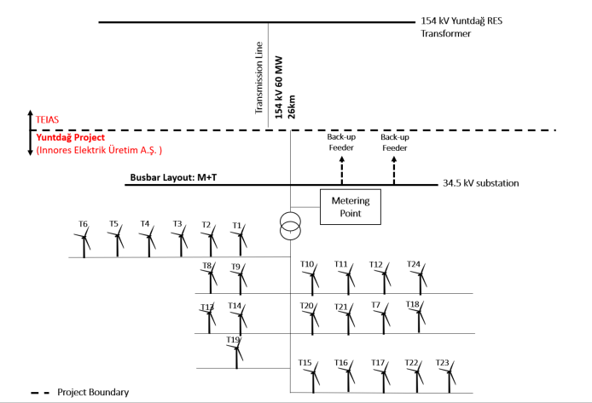
Figure 3: Line Diagram of the Yuntdağ WPP

SCADA system and remote control of meters can be seen in Figure 4 and monitoring system can be visualized.
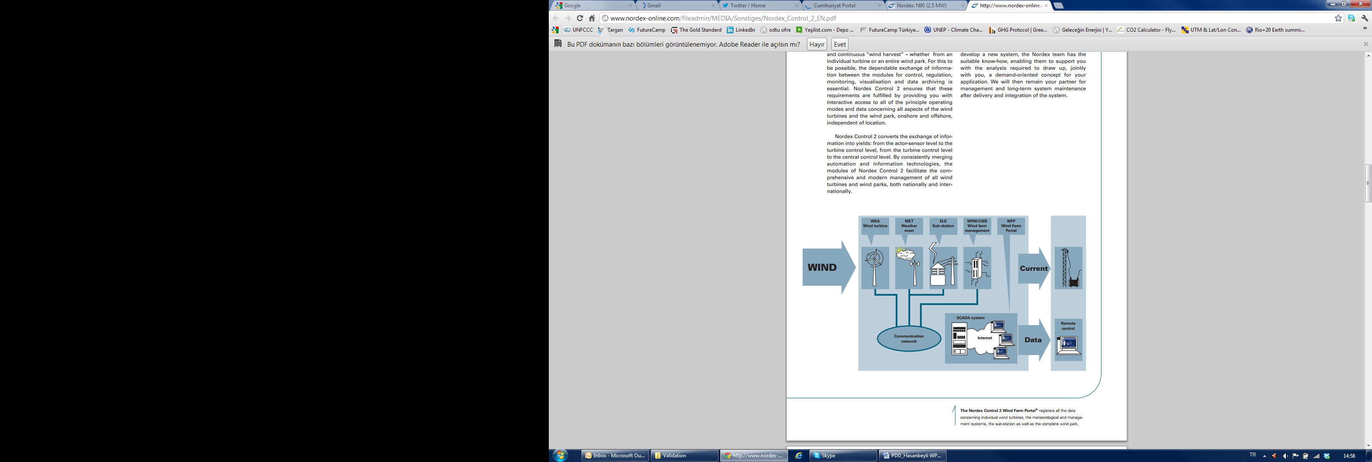
Figure 4: Electricity transmission from turbine to transmission line

Note: On 01/09/2015, PMUM was renamed as EPİAŞ.

C.1.2. A Backup Unit for Systematic Storage

The fact that two reliable best practice meters are installed in a redundant manner keeps the uncertainty level of the only parameter for baseline calculation low. High data quality of this parameter is not only in the interest of the emission reduction monitoring, but paramount for the business relation between the plant operator and the electricity buyer. Since the meters are reading electricity supplied to the system and withdrawn from the system separately, the net electricity amount supplied to the grid will be calculated by electricity supplied minus electricity withdrawn which will be taken from monthly settlement notifications.

Monthly data from TEIAS are stored electronically on TEIAS website and this data can be accessed by login of Project Developer. Innores also stores a hardcopy of the monthly meter reading protocols for back up of systematic storage of data.

Moreover, there are always internal reviews of the meters data which is checked by different parties. First of all, data of the meters is collected by technicians daily in written forms. The data collected daily is saved in plant manager computer and backed up and shared by headquarter of Innores in Istanbul. Besides the data that can be get from meters, production amount can be checked from SCADA system of Nordex. SCADA figures differ a bit with meter data due to internal losses.

Operation and management diagram is presented in Figure 5.

Figure 5: Operation and management diagram of the Yuntdağ WPP

C.1.3 Calibration Procedures:

The calibration of the monitoring equipment was carried out according to the information provided in the GS-VER PDD (version 09, dated 08/04/2016). The GS-VER PDD mainly includes the following obligation for the calibration of the appropriate meters:
“The Turkish Electricity Market Regulation Agency (EPDK) sets rules on the accuracy of electricity meters that are used by power plants feeding into the grid. The rules are part of the EPDK regulation 25056 from 22 March 2003. The table in Article 11 of the regulation specifies the use of electricity meters of the accuracy class 0.5S for power plants between 10 MW and 100 MW and refers to compliance with International Electro technical Commission’s norm EN 60687. TEIAŞ conducts remote reading. In addition, operative manager, employee of Innores Enerji, conducts reading from the project site and sends to TEIAŞ. By this way, a cross-check is done. Also, with the readings from project site, continuously these two meters are compared with each other and if any differences are detected the necessary control measures are taken. Lastly as can be seen from the replacement protocol signed on 05/12/2013, the calibration date of the metering devices is 2013. Thus, the metering devices don’t need any calibration for the next ten years. However, PO runs test protocols on a voluntary basis. The last test protocol was run in 2018. There is new test protocol for 2019.
Table 3: Specification of the electricity meters
Name | Serial Number | Brand –Model | Year of Manufacture
Main Meter | 4364955 | EMH –LZQJ-XC | 2013
Backup meter | 4364956 | EMH –LZQJ-XC | 2013

Accuracy class: 0.5S, Reactive 2

C.1.4. Troubleshooting Procedures

As the measuring devices are sealed by TEIAŞ, Innores cannot intervene with the devices. In case of unforeseen problems or failures of the meters or if any differences occur between primary and secondary devices TEIAŞ has to be informed for necessary maintenance and calibration. There is an agreement between Innores and TEIAŞ that in case of problems or failures of the meters TEIAŞ reacts as fast as possible to solve the problem.

For this monitoring period, there have not been an accident or an incident, which may affect the electricity generation of the project.
- Data and parameters
  - Data and parameters fixed ex ante or at renewal of crediting period

Relevant SDG Indicator | SDG 13, SDG 7
Data/parameter: | EFgrid,CM,y
Unit | tCO₂/MWh
Description | Combined margin CO₂ emission factor for grid connected power generation in year y calculated using the “Tool to calculate the emission factor for an electricity system (Version 04.0.0)”
Source of data | Tool to calculate the emission factor for an electricity system (Version 04.0.0)
Value(s) applied) | 0.5521 tCO₂/MWh
Choice of data  or measurement methods and procedures | Combined Margin Emission Factor (EFgrid,CM,y) is calculated ex ante as the weighted average CO₂ of Operating Margin Emission Factor (EFgrid,OM,y) and Build Margin Emission Factor (EFgrid,BM,y). Please see registered PDD and Transition Annex document.
Purpose of data | Calculation of baseline emissions
Additional comments | Other parameters are not specified as they are used in calculations in accordance with the registered PDD. Please see registered PDD and Transition Annex document.
  - Data and parameters monitored

Relevant SDG Indicator | SDG 7
Data/parameter: | EG_{facility,y}
Unit | MWh/yr
Description | Quantity of net electricity generation supplied by the project plant to the grid in year y
Measured/calculated/default | Measured
Source of data | Electricity meter(s)
Value(s) of monitored parameter | 206,386.46 MWh
Monitoring equipment | Regarding the electricity meters: two meters will be placed (one main and one reserve). The fact that two meters are installed in a redundant manner keeps the uncertainty level of the only parameter for baseline calculation low. High data quality of this parameter is in the interest of not only the emission reduction monitoring, but also paramount for the business relation between the plant operator and the electricity buyer.  On the last day of each month, the production index will be taken from the main as well as the reserve meter by EPİAŞ (a state institution responsible for electricity market settlement operations) via Automatic Meter Reading System (OSOS). In following month, EPİAŞ issue electricity generation records for each generation unit that can be accessed by plant operators via logging to secured website. These records are used to monitor net monthly generation of the power plant. For each month, the net electricity amount supplied to the grid will be calculated by electricity fed into grid minus electricity withdrawn from the grid available in EPİAŞ records.  However, as of 01/09/2015, EPIAS took over the PMUM procedures from TEIAS. After that date, EPIAS will supply the PMUM data. This means that the main source is the EPIAS data.  TEIAS notices are used to cross-check the EPİAŞ records. TEIAS sends an electronic spreadsheet that includes daily and monthly electricity generation and withdrawn amounts for each power plant. Thus, cross-check source is the TEIAS meter readings.  Since the meters are reading electricity supplied to the system and withdrawn from the system separately, the net electricity amount supplied to the grid will be calculated by electricity supplied minus electricity withdrawn. Thus, with this procedure, monitoring is sufficient and no extra monitoring has to be implemented.  The above described measurement method follows Article 81 of the official regulation “Electricity Market Balancing And Settlement Regulation”  The specification of electricity meters are provided below:  Accuracy class: 0.5S, Reactive 2
  Name | Serial Number | Brand –Model | Year of Manufacture
  Main Meter | 4364955 | EMH –LZQJ-XC | 2013
  Backup meter | 4364956 | EMH –LZQJ-XC | 2013
Measuring/reading/recording frequency: | Continuous measurement and at least monthly readings
Calculation method  (if applicable): | -
QA/QC procedures: | The calibration of the monitoring equipment was carried out according to the information provided in the GS-VER PDD. The GS-VER PDD mainly includes the following obligation for the calibration of the appropriate meters:  “The Turkish Electricity Market Regulation Agency (EPDK) sets rules on the accuracy of electricity meters that are used by power plants feeding into the grid. The rules are part of the EPDK regulation 25056 from 22 March 2003. The table in Article 11 of the regulation specifies the use of electricity meters of the accuracy class 0.5S for power plants between 10 MW and 100 MW and refers to compliance with International Electro technical Commission’s norm EN 60687. Technicians, employees of Innores Enerji, conduct readings from two meters from the project site and sends it to TEIAŞ. By this way, a cross-check is done. Moreover, continuously these two meters are compared with each other and if any differences are detected the necessary control measures are taken.  According to the Article 2 of the Communiqué : ‘The meters to be used in the electricity market shall be compliant with the standards of Turkish Standards Institute or IEC and have obtained “Type and System Approval” certificate from the Ministry of Trade and Industry.’ Therefore, Ministry of Trade and Industry (Ministry) is responsible from control and calibration of the meters.  paragraph b) of the Article 9 of the 'Regulation of Metering and Testing of Metering Systems' 7 (Regulation) of Ministry states that: ‘ b) Periodic tests of meters of electricity, water, coal gas, natural gas and current and voltage transformers are done every 10 years’. Therefore periodic calibration of the meters will be done every 10 years.  As above mentioned, the data acquisition and management and quality assurance procedures that are anyway in place, no additional procedures have to be established for the monitoring plan.
Purpose of data: | Calculation of emission reduction of the project
Additional comments: | Plant Manager will be responsible for monitoring data.
  - Implementation of sampling plan

N/A
- Calculation of SDG outcomes
  - Calculation of baseline value or estimation of baseline situation of each SDG outcome

Used Formulas:
The total emission reductions can be calculated with the results of the below described equations. The emission reduction is equal to the baseline emissions minus project emissions and leakage emissions. Leakage emissions in this project are considered to be negligible. There are no project emissions in this kind of project. The general equation is as follows:
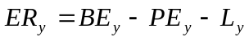 (1)
Where:
ER_{y} = Emission reduction
BE_{y} = Baseline emissions
PE_{y} = Project emissions
L_{y} = Leakage
y = Refers to a given period

The electricity meters are measuring two parameters: The electricity supplied to the grid (EGexport) and the electricity consumption from the grid (EGimport). To achieve the net amount of supplied electricity, the difference has to be calculated:

GEN_{y} = EGexport – EGimport (2)

Where:
GEN_{y} = Net electricity supplied to the Grid in MWh
EGexport = Electricity supplied to the Grid in MWh
EGimport = Electricity consumption from the Grid in MWh

According to the applied methodology version the emission reduction is the baseline emissions calculated as the net electricity supplied to the grid multiplied by the grid emission factor.

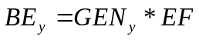 (3)
Where:
BE_{y} = Baseline emissions in tonnes CO₂
EF = Grid emission factor for the electricity displaced due to the project activity during the year y [tCO₂/MWh].
GEN_{y} = Net electricity supplied to the Grid in MWh (ID 1)
y = Refers to a given period
  - Calculation of project value or estimation of project situation of each SDG outcome

Explained in the registered PDD (version 09, dated 08/04/2016) and Transition Annex (version 3, dated 07/11/2018).
  - Calculation of net benefits as difference of baseline and project values or direct calculation for each SDG outcome

Emission reduction values for period of 01/05/2018-30/04/2019 is presented below:

Dates | Emission Reduction  (tCO₂)
01.05.2018 - 31.05.2018 | 7,686
01.06.2018 - 30.06.2018 | 6,770
01.07.2018 - 31.07.2018 | 7,126
01.08.2018 - 31.08.2018 | 15,887
01.09.2018 - 30.09.2018 | 10,203
01.10.2018 - 31.10.2018 | 9,607
01.11.2018 - 30.11.2018 | 13,335
01.12.2018 - 31.12.2018 | 7,413
01.01.2019 - 31.01.2019 | 8,980
01.02.2019 - 28.02.2019 | 10,178
01.03.2019 - 31.03.2019 | 9,669
01.04.2019 - 30.04.2019 | 7,090
Total | 113,945
  - Summary of ex-post values of each SDG outcome for the current monitoring period

- Item | Baseline estimate | Project estimate | Net benefit
- SDG 13 | Emission Reduction: 112,582 tCO₂  Air Quality:  CO: 32.7 tons/y  NMVOC: 7.0 tons/y | N/A | N/A
- SDG 6 | Water Quality:  No wastewater discharge to the environment in the project area. | N/A | N/A
- SDG 8 | Quality of Employment:  Training records of all employees are provided.  Quantitative Employment:  Current employment records are presented.  Human and institutional capacity (including empowerment, education, involvement, gender): Training records for the local workers are provided such as occupational health and safety trainings, security training renewal cards etc. | N/A | N/A
- SDG 7 | Energy is generated by using renewable energy systems throughout the project (Wind Power Plant). | N/A | N/A
- Other pollutants | Soil condition  (Waste collection):  Letter from the municipality for the waste collection is provided. | N/A | N/A
- Other pollutants | Biodiversity (Number of observed bird strikes):  Letter from the muhtar and ornithology reports will be provided. | N/A | N/A

  - Comparison of actual value of outcomes with estimates in approved PDD
Item | Values estimated in ex ante calculation of approved PDD | Actual values achieved during this monitoring period
- SDG 13 | Emission Reduction: 112,582 tCO₂  Air Quality:  CO: 32.7 tons/y  NMVOC: 7.0 tons/y | Emission Reduction: 113,945 tCO₂  Air Quality:  CO: 33.06 tons/y  NMVOC: 7.06 tons/y
- SDG 6 | Water Quality:  No wastewater discharge to the environment in the project area. | Water Quality:  No wastewater discharge to the environment in the project area. Wastewater transportation invoices are provided.
- SDG 8 | Quality of Employment:  Training records of all employees are provided.  Quantitative Employment:  Current employment records are presented.  Human and institutional capacity (including empowerment, education, involvement, gender): Training records for the local workers are provided such as occupational health and safety trainings, security training renewal cards etc. | Quality of Employment:  Training records of all employees are provided. 17 employees have received HSE trainings. HSE training certificates for 2 office employees were not provided since they are not physically working in the plant. There is 1 new employee in the plant and he will complete the HSE trainings in 2019. After his HSE trainings will be completed, his training certificate will be provided in the next verification.  Quantitative Employment:  Current employment records are presented. There are 18 employees in the plant and there are additional 2 office employees who are not physically work in the plant. There are 20 employees in total. There are 10 local employees and 9 of them works physically in the plant.  Human and institutional capacity (including empowerment, education, involvement, gender): Training records for the local workers are provided such as occupational health and safety trainings, security training renewal cards etc.
- SDG 7 | Energy is generated by using renewable energy systems throughout the project (Wind Power Plant). | Energy (206,386.46 MWh) is generated by using renewable energy systems throughout the project (Wind Power Plant).
- Other pollutants | Soil condition  (Waste collection):  Letter from the municipality for the waste collection is provided. | Soil condition  (Waste collection):  Letter from the municipality for the waste collection is provided.
- Other pollutants | Biodiversity (Number of observed bird strikes):  Letter from the muhtar and ornithology reports will be provided. | Biodiversity (Number of observed bird strikes):  Official letter from Ministry of Forestry and Water Affairs, stating bird observation and ornithological monitoring are not needed anymore, is provided

Names of Employees

Name and Surname | Local Or Not
INNORES
Hamit Alptekinoğlu | Not Local
Uğur Eker | Not Local
Serdar Yeşilırmak | Not Local
Hasan Soyer | Local
Resul Gündüz | Local
*Özüm Molvalıoğlu | Local
*Senem Albayrak | Not Local
SECURITAS
Alaattin Kanat | Local
Ali Köycüoğlu | Local
Erdal Karakuzu | Local
Feridun Çelik | Local
NORDEX
Gökhan Taşkın | Not Local
Oğuz Kopal | Not Local
İlhan Tülek | Not Local
Koray Bilgiç | Local
Semih Özel | Not Local
GÜNGÖR
Bahattin Dilber | Local
Necmettin Arıcı | Local
Yasin Karabıyık | Not Local
**Furkan Akyol | Not Local
* Özüm Molvalıoğlu and Senem Albayrak are office personnel. They are not working at the plant. Thus, their HSE training documents were not provided.
** Furkan Akyol is a new employee. Thus, he will complete the HSE trainings in 2019. After his HSE trainings will be completed, his training certificate will be provided to DOE in the next verification.

Training Records of Employees

INNORES
Name and Surname | Date | Training
Hamit Alptekinoğlu | 08.02.2018/19.04.2018/16.05.2018 | Health and Safety
Uğur Eker | 08.02.2018/19.04.2018/16.05.2018 | Health and Safety
Resul Gündüz | 08.02.2018/19.04.2018/16.05.2018 | Health and Safety
Serdar Yeşilırmak | 08.02.2018/19.04.2018/16.05.2018 | Health and Safety
Hasan Soyer | 08.02.2018/19.04.2018/16.05.2018 | Health and Safety
Resul Gündüz | 26.07.2018 | Emergency Drill and Fire Training
Uğur Eker | 26.07.2018 | Emergency Drill and Fire Training
Hasan Soyer | 26.07.2018 | Emergency Drill and Fire Training
Hamit Alptekinoğlu | 26.07.2018 | Emergency Drill and Fire Training
Serdar Yeşilırmak | 26.07.2018 | Emergency Drill and Fire Training
Hasan Soyer | 12.08.2018 | First Aid Training
Serdar Yeşilırmak | 12.08.2018 | First Aid Training
Uğur Eker | 12.08.2018 | First Aid Training
Hamit Alptekinoğlu | 12.08.2018 | First Aid Training
Resul Gündüz | 12.08.2018 | First Aid Training
GÜNGÖR
Name and Surname | Date | Training
Yasin Karabıyık | 08.02.2018/19.04.2018/16.05.2018 | Health and Safety
Necmettin Arıcı | 08.02.2018/19.04.2018/16.05.2018 | Health and Safety
Bahattin Dilber | 08.02.2018/19.04.2018/16.05.2018 | Health and Safety
Bahattin Dilber | 26.07.2018 | Emergency Drill and Fire Training
Necmettin Arıcı | 12.08.2018 | First Aid Training
Bahattin Dilber | 12.08.2018 | First Aid Training
Yasin Karabıyık | 12.08.2018 | First Aid Training
SECURITAS
Name and Surname | Date | Training
Alaattin Kanat | 21.05.2018/22.05.2018 | Health and Safety
Feridun Çelik | 20.03.2018/22.05.2018 | Health and Safety
Erdal Karakuzu | 20.03.2018/22.05.2018 | Health and Safety
Ali Köycüoğlu | 21.05.2018/22.05.2018 | Health and Safety
Erdal Karakuzu | 26.07.2018 | Emergency Drill and Fire Training
Erdal Karakuzu | 08.02.2018/19.04.2018/16.05.2018 | Health and Safety
Erdal Karakuzu | 12.08.2018 | First Aid Training
Alaattin Kanat | 12.08.2018 | First Aid Training
Ali Köycüoğlu | 12.08.2018 | First Aid Training
Feridun Çelik | 12.08.2018 | First Aid Training
NORDEX
Name and Surname | Date | Training
Gökhan Taşkın | 19.01.2018/20.01.2018 | Health and Safety
Gökhan Taşkın | 22.06.2018 | Working at Height Training
Gökhan Taşkın | 26.06.2018 | First Aid Training
İlhan Tülek | 19.01.2018/20.01.2018 | Health and Safety
İlhan Tülek | 30.04.2018 | Working at Height Training
İlhan Tülek | 2.05.2018 | First Aid Training
Koray Bilgiç | 2.07.2018 | Health and Safety
Koray Bilgiç | 23.07.2018/24.07.2018 | Working at Height Training
Koray Bilgiç | 20.06.2018 | First Aid Training
Oğuz Kopal | 19.01.2018/20.01.2018 | Health and Safety
Oğuz Kopal | 30.05.2018 | Working at Height Training
Semih Özel | 6.08.2018 | Health and Safety
Semih Özel | 07.08.2018/08.08.2018 | Working at Height Training
Semih Özel | 09.08.2018/10.08.2018 | First Aid Training

  - Remarks on difference from estimated value in approved PDD

Estimated emission reduction in ex ante calculation of registered PDD is 112,582 tCO₂. Moreover, actual emission reduction achieved during this monitoring period is 113,945 tCO₂. When they are compared, actual emission reduction achieved during this monitoring period is nearly equal to the estimated figure.

- Stakeholder inputs and legal disputes
  - List all inputs/grievances which have been received for the project during the monitoring period together with their respective answers/actions

Stakeholder engagement procedure was conducted at the Yuntdağ Wind Power Project control room with the local stakeholders and heads of the Balaban and İsmailli villages on 8th of May 2019.

As validated during the site visit, muhtars (heads of the village) of Balaban and İsmailli villages had already taken the contact information of Company Executive of the company so that the local stakeholders will be able to reach company executive whenever they have any complaints, suggestions or ideas about the project.

Since muhtar is the head of the village, he will be the main contact person between the project owner and the local stakeholders. Muhtar will make sure that there is continuous communication between the two parties. Moreover, logbook was delivered to the head of İsmailli village since muhtar of the village was changed and logbook was lost. This logbook will be checked in the next verifications to see whether there has been any complaints from the local stakeholders.

During the site visit, it is validated that there was no negative comments from the stakeholders.
  - List all inputs/grievances from previous monitoring period where follow up action is to be verified in this monitoring period

There is no FAR from previous monitoring period to follow up. The parameters which have to be checked each year are evaluated.
  - Provide details of any legal contest or dispute that has arisen with the project during the monitoring period

N.A.

See, Generation License for coordinates and http://www.rcn.montana.edu/Resources/Converter.aspx for the conversion.
https://cdm.unfccc.int/methodologies/DB/EY2CL7RTEHRC9V6YQHLAR6MJ6VEU83
See; http://cdm.unfccc.int/methodologies/PAmethodologies/tools/am-tool-07-v4.0.pdf
See; http://cdm.unfccc.int/methodologies/PAmethodologies/tools/am-tool-01-v7.0.0.pdf
See; http://cdm.unfccc.int/methodologies/PAmethodologies/tools/am-tool-02-v5.0.0.pdf
See; http://cdm.unfccc.int/methodologies/PAmethodologies/tools/am-tool-03-v2.pdf
See; http://cdm.unfccc.int/methodologies/PAmethodologies/tools/am-tool-10-v1.pdf
See; https://cdm.unfccc.int/methodologies/PAmethodologies/tools/am-tool-11-v3.0.1.pdf
Please see; Meter replacement protocol signed on 05/12/2013.
Please see test report of the meters, dated 29.04.2018
See, http://www.sanayi.gov.tr/download/osgm/olcu_aletleri_muayene_yonetmelik.zip , page 2

