Key Project Information & project Design Document (PDD)

PUBLICATION DATE 29.06.2023
VERSION v.1.5
RELATED SUPPORT

- TEMPLATE GUIDE Key Project Information & Project Design Document

This document contains the following sections

SECTION A. DESCRIPTION OF PROJECT
SECTION B. APPLICATION OF APPROVED GOLD STANDARD METHODOLOGY (IES) AND/OR DEMONSTRATION OF SDG CONTRIBUTIONS
SECTION C. DURATION AND CREDITING PERIOD
SECTION D. SUMMARY OF SAFEGUARDING PRINCIPLES AND GENDER SENSITIVE ASSESSMENT
SECTION E. SUMMARY OF LOCAL STAKEHOLDER CONSULTATION

Appendix 1 - Safeguarding Principles Assessment (mandatory)
Appendix 2 - Contact information of project developer(s) (mandatory)
Appendix 3 - LUF Additional Information (project specific)
Appendix 4 - Design Changes

KEY PROJECT INFORMATION
GS ID of Project | GS4238
Title of Project | “Methane Gas Capture and Electricity Production at Kubratovo Wastewater Treatment Plant, Sofia, Bulgaria”
Time of First Submission Date | 14/05/2015
Date of Design Certification | 01/04/2016
Version number of the PDD | 05
Completion date of version | 21/04/2026
Project Developer | Sofiyska voda AD
Project Representative | Sofiyska voda AD
Project Participants and any communities involved | Sofiyska voda AD
Host Country (ies) | Bulgaria
Activity Requirements applied | Community Service Activity  Renewable Energy  Land-Use and Forests Activity Requirements/Risks & Capacities  N/A
Scale of the project activity | Micro scale  Small Scale  Large Scale
Other Requirements applied
Methodology (ies) applied and version number | Sectoral scope 01: Energy Industries  AMS-I.C./Version 22.0: Thermal energy production with or without electricity, dated 11 March 2022:  AMS-I.F/Version 05.0 “Renewable electricity generation for captive use and mini-grid  ”,dated 08 September 2022.  Sectoral scope 13: Waste handling and disposal  AMS-III.H/Version 19.0: Methane recovery in wastewater treatment, dated 14 June 2019;
Product Requirements applied | GHG Emissions Reduction & Sequestration  Renewable Energy Label  N/A
Project Cycle: | Regular  Retroactive

Table 1 – Estimated Sustainable Development Contributions
SUSTAINABLE DEVELOPMENT GOALS TARGETED | SDG IMPACT  (DEFINED IN B.6) | ESTIMATED ANNUAL AVERAGE | UNITS OR PRODUCTS
13 Climate Action (mandatory) | 13.2 Integrate climate change measures into national policies, strategies and planning | 71,120 | tCO_{2e}
6 Clean water and sanitation | 6.3 By 2030, improve water quality by reducing pollution, eliminating dumping and minimizing release of hazardous chemicals and materials, halving the proportion of untreated wastewater and substantially increasing recycling and safe reuse globally | Outlet water treated  662,976.03 | m³
7. Affordable and clean energy | 7.2 By 2030, increase substantially the share of renewable energy in the global energy mix | 22,217.27  136,597.70 | MWh  GJ

SECTION A. DESCRIPTION OF PROJECT

A.1 Purpose and general description of project
The developer of the project Sofiyska Voda AD was established in October 2000 by a 25-year Concession Agreement. Under it the Municipality of Sofia granted to the Company the operation and maintenance of Sofia’s WSS system. The shareholding capital is divided between the Municipality of Sofia (22.9 %) and the French company Veolia Water (77.1 %). Sofiyska Voda AD is not the owner, but rather the Concessionaire of the WSS assets – which are public state property. All new facilities constructed with the Company’s funds are also the property of the City.
“Methane Gas Capture and Electricity Production at Kubratovo Wastewater Treatment Plant, Sofia, Bulgaria” applies for re-certification as a GS4GG Voluntary Emission Reduction (GS-VER) project. Due to its significant contribution to climate change mitigation and sustainable development in the region, this project is expected to fulfil the all present and future requirements of GS4GG rigorously.

The project is both a methane emissions reduction and energy production project.
Methane produced in Kubratovo wastewater treatment plant is captured in common methane tanks serving as a buffer and then supplied to the installed CHP gas engines for electricity and heat production, which in turn substitutes both the plant’s electricity purchases from the grid and fossil fuel usage. Excess electricity is supplied to the grid.
The main purpose of the project is to transform the existing low tech sludge treatment process at Kubratovo that existed before implementation of the project into a modern advanced treatment process matching the best sludge treatment practice available in Western Europe. This transformation has a major effect on the environment through dramatically reducing the existing methane gas emissions at the plant while also reducing the volume of sludge (to as much as 50%) that needs to be transported, hence reducing GHG emissions from transportation as well (not included in GHG abatement calculations).
The overall objective of the project is to provide an environmentally friendly sludge treatment process reducing methane and carbon dioxide emissions that – under a business-as-usual scenario – would have continued.
Other objectives are:
- replace the traditional sludge drying beds and landfill options with mesophilic digestion of all primary and secondary sludge followed by mechanical dewatering in order to reduce GHG emissions;
- effectively mitigate odour problems from the existing treatment of sludge and sludge liquors through introduction of digestion;
- production of fertiliser by mechanical dewatering of the digested stabilised sludge;
- production of electricity from utilisation of the biogas in CHP gas engines thereby reducing GHG emissions from electricity production by the grid.

The project delivers the following key results:
- all primary and secondary sludge thickened and digested as per EU recommendations and guidelines;
- all biogas produced within the digestion process used for power and heat generation via CHP gas engines thus reducing on-site electricity purchases from the national grid; reduction in on-site fossil fuel usage as all site-heating requirements will be met by the CHP gas engines;
- excess gas is flared and destroyed by highly efficient closed flame flares;
- all sludge is stabilised and pathogen free.

Long term strategic reductions of GHG emissions include:
- reduction in open release of CH₄ from open anaerobic sludge tanks and drying beds;
- reduction in open release of CH₄ from landfill disposal site;
- reduction in CO₂ emissions due to replacement of electricity production from fossil fuels;
- reduction in CO₂ emissions due to replacement of heat generation from fossil fuels.
The project had been implemented in several stages:
- Erection of a new digester system consisting of 4 digesters, 7,000 m³ each, designed, supplied and erected by PASSAVANT ROEDIGER Anlagenbau (see Section A.5).
For destroying of the excess methane in case of emergency a flaring system have been implemented, consisting of 2 x DN150 flares, type ZA1-F2-0/N0 designed and manufactured by HEGWEIN GmbH, Germany.
- Erection of 3 new co-generation sets GE JMS 320 GS-B.LC with 1,063 kW electric capacity each and 1,088 kW thermal capacity, for generation of electric and thermal energy by combusting biogas from digesters;
- Implementation of CHP exhaust gasses heat recovery system in 2017. This system has not been accounted for during the first crediting period.
The 4 digesters were commissioned at the end of 2006 and started operation on 01 January 2007 but due to some technical problems in the adjustment of the biological process the generation of biogas was interrupted in the end of June 2007 and resumed on 01 May 2008, so the first industrial quantities of biogas were registered in May, 2008.
- Erection of Digester # 5. Will be commissioned and will start operation in March,2021.
The CHP was commissioned and started generating electricity and thermal energy for plant’s needs in November, 2009.
The project was initially developed and registered as a Joint Implementation (JI) project and started operation in 2007. The project was determined positively by TUEV SUD with Determination Report No 743 691, dated 25 Jan 2006 and received a Letter of Approval by the Ministry of Environment and Water of Bulgaria dated 01 Aug 2007.
Since 01 Jan 2007 the plant that was built under the project has been in regular operation. For the period until the end of the first Kyoto period (31 Dec 2012) the project has undertaken 4 verifications and been issued emission reductions equal to a total of 572,372 tCO₂e.

The JI crediting period of the project was as follows:
Start of the crediting period – 01/01/2007
End of the crediting period – 31/12/2012

On 24 June 2010 the project was registered under UNFCCC Track 1 procedure with project ID BG1000166.
The first crediting period of the Kyoto Protocol ended on 31 Dec 2012 and the Doha amendment to the Kyoto Protocol still has not been signed into force. At 11 April 2014, 8 out of the required 144 instruments of acceptance had been submitted to the UNFCCC.
As a result, countries have not yet received Assigned Amount Units which make transaction under the JI mechanism possible. Existing JI projects can no longer receive JI carbon credits for their verified emission reductions.
That is why the project owner decided to pursue registration of the project under the Gold Standard (GS) in order to monetize the emission reductions from the installation.
As a result the project was registered retroactively by GS with registration ID GS4328. Starting date of the GS crediting period was fixed on 01/04/2014.
In the beginning of 2020 the project was successfully transitioned to GS4GG system.
It was re-certified for a second 7-years crediting period starting 01/04/2021.
The new installation regarded as a design change of the project was put in full operation on 15/11/2024.
    - Eligibility of the project under Gold Standard
The project demonstrated successfully its applicability under GS during the initial certification. Nethertheless we shall demonstrate that it is uplicable under the new GS4GG standard.
The applicability of the project against the requirements of GS4GG – Principles and Requirements and Community Services Activity Requirements (version 1.2) is demonstrated in the table below.

Applicability condition | Compliance of the condition
GS4GG-Principles and Requirements:  (a) ELIGIBLE PROJECT TYPES  4.1.3 A Project type is automatically eligible for Gold Standard Certification if there are Gold Standard approved Activity Requirements and/or Impact Quantification Methodologies associated with it or it’s referenced in the Gold Standard Product Requirements. These are published to the Gold Standard website and shall be followed where provided for a given Project type  . | The project covers the definition of a type, given in the GS4GG document Community Services and Requirements, v.1.2 – 3.1.1 Waste Management and Handling.  3.1.1 (a) Types of Project: Eligible projects shall include physical action/implementation on the ground. Pre-identified eligible project types are identified in the Eligibility Principles and Requirements section.  The project generates biogas by anaerobic treatment of municipal wastewater sludge and destroys it by combustion to deliver thermal and electric energy for local use.  Hence the project is pre-identified CSA type and is automatically eligible for GS4GG certification.

    - Legal ownership of products generated by the project and legal rights to alter use of resources required to service the project
The project participant Sofiyska voda AD is the legal owner of the project and has the legal rights for the VER credits that will be issued under Gold Standard. The project owner owns full concession on water supply and wastewater treatment for the city of Sofia, Bulgaria as stated in Section A.1.

A.2 Location of project
The project is located near the city of Sofia.
The geographic coordinates of the project site are as follows:

Table 2: Geographic coordinates of the project.
Latitude | Longitude
42º45’13.25”N | 23º22’11.15”E

Fig.1: Location of the project site.
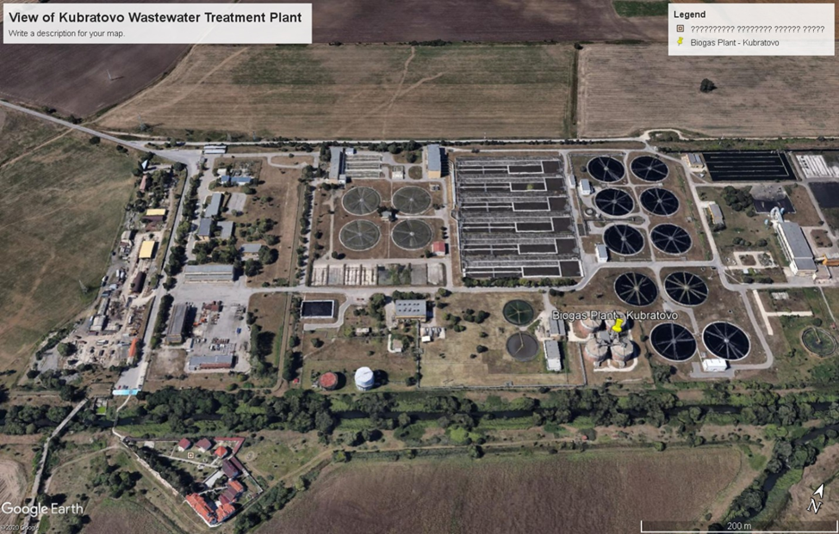

Fig.2: Location of the city of Sofia in Bulgaria
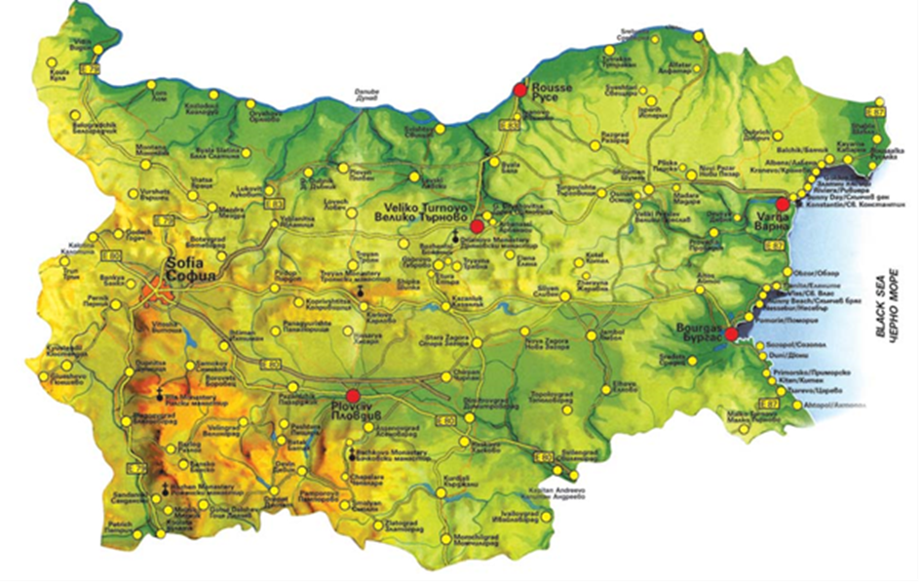

Fig.3: Plant diagramme before design change

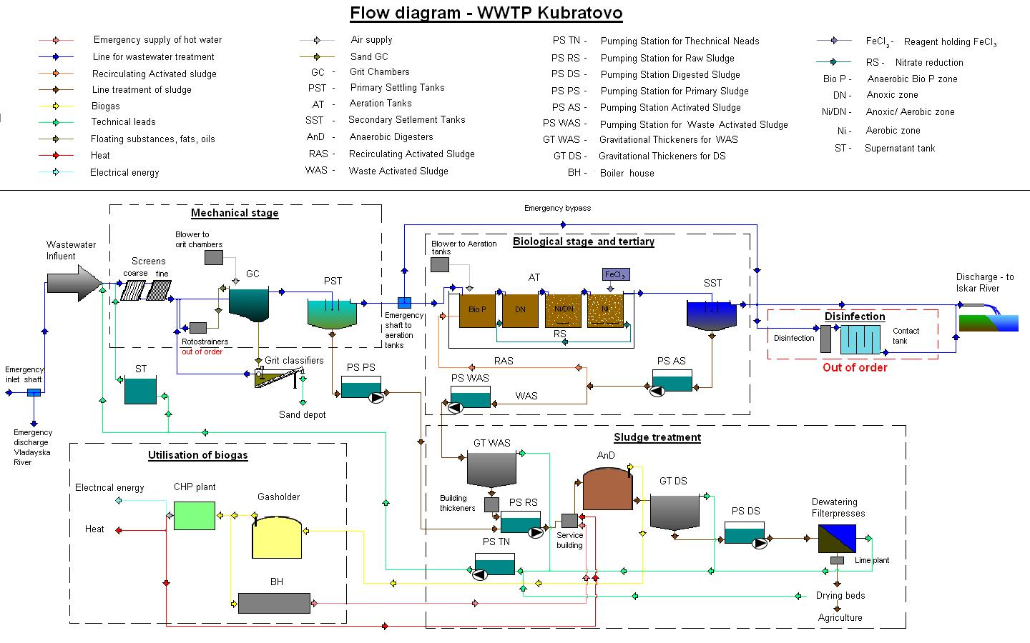

A.3 Technologies and/or measures
The project destroys methane in the biogas generated by the bioreactors and supplies Kubratovo waste-water treatment plant with thermal and electrical energy. The project falls under CDM methodologies Type III - AMS-III.H: Methane recovery in wastewater treatment (Version 19.0) and Type I – AMS-I.C,” Thermal energy production with or without electricity”, Version 22.0.
“Methane Gas Capture and Electricity Production at Kubratovo Wastewater Treatment Plant, Sofia, Bulgaria” project falls in GS4GG document Community Services and Requirements, v.1.2 – 3.1.1 Waste Management and Handling.
The following overall measures have been implemented by the project in order to achieve its goals:
• Digesters for anaerobic sludge treatment
The project activity aimed the erection of a new digester system consisting of 4 digesters, 7,000 m3 each, designed, supplied and erected by PASSAVANT ROEDIGER Anlagenbau.
The anaerobic sludge treatment plant stabilises the sludge anaerobically. With this procedure the organic part of the sludge is reduced which also effects a reduction on the dry solid mass of the total sludge. This process has a positive influence on the sizing of the sludge treatment units following digestion and also on the properties of sludge regarding the ability to dewater and elimination of odour nuisance. The goal of anaerobic digestion is the stabilization of the sewage sludge in order to prevent odour nuisance and improve dewatering.
After the process of digestion the sludge is dewatered and afterwards transported to the temporary pits and then transported for land use as fertiliser.
The maximal biogas generating capacity of the digesters is 1,816 Nm3/h.

Fig.4: Digesters
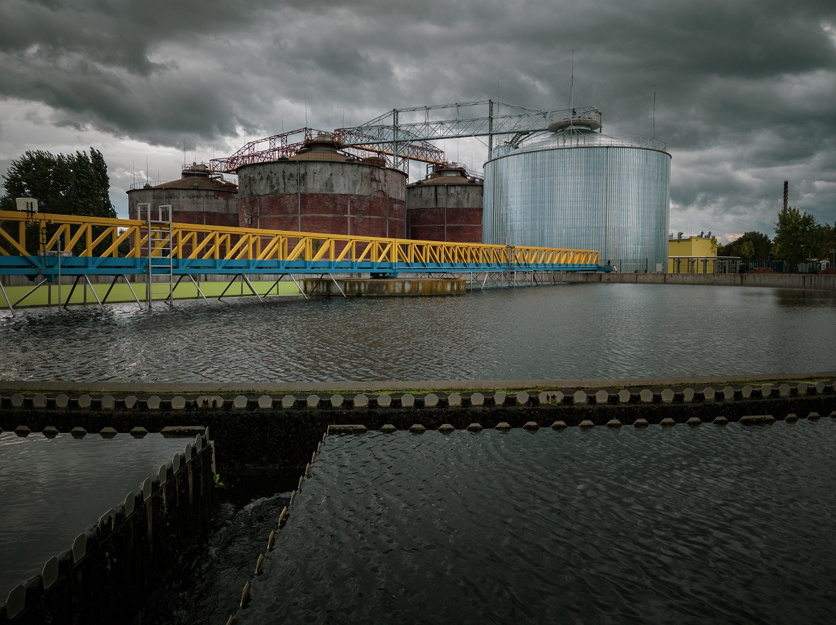

Fig.5: Digesters
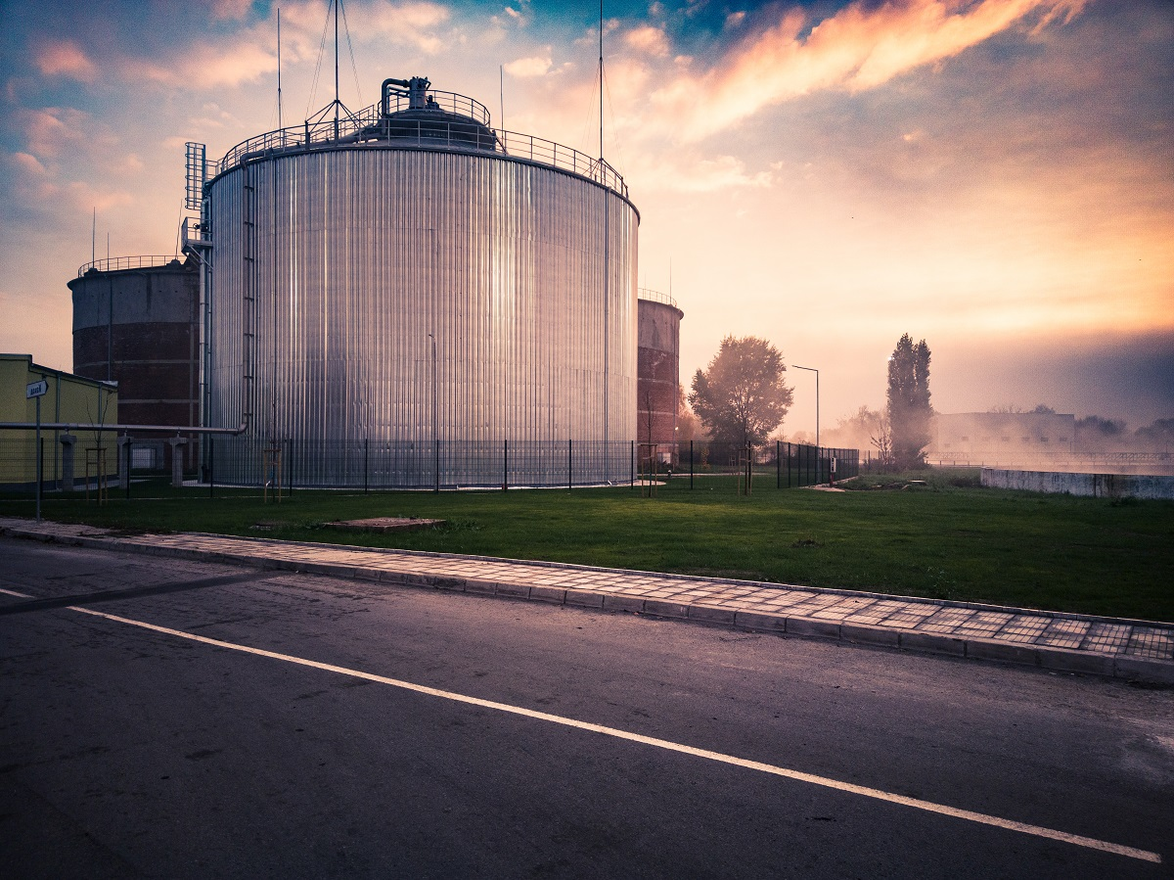
- Combined Heat and Power Plant
The CHP comprises of 3 new co-generation sets GE JMS for generation of electric and thermal energy by combusting biogas from digesters. The electric energy generated is used to cover the plant’s need of electricity and replaces the energy supplied from the grid in the baseline. The thermal energy generated by the CHP is also used for internal needs and replaces the thermal energy that would have been generated by the on-site fossil fuelled hot water boilers.
The CHP plant is equipped with exhaust gasses heat recovery system and is with the following unit technical parameters:
            - Module BHKW JMS 320 GS-B.LC
            - Electrical capacity (at Power factor=1) – 1,063 kW
            - Thermal capacity (at Power factor=1) – 1,088 kW
            - Fuel – biogas

- Additional anaerobic digester
In 2020 the construction of an additional 5th digester type PASSAVANT ROEDIGER Anlagenbau has started. Starting of operation is scheduled for March 2021.
The technical characteristics of the new digester are the same as of the existing ones, namely:

Working volume | 7 000 m³
Working regime | Parallel
Type of process | Mezophilic
Working temperature | 33÷37 °С
Quantity of raw sludge | 420÷480 m³/d
Biogas generated | 6 750÷10 000 Nm³/d
Working pressure of the system | 35 mbar
Parameters of the biogas generated | СН₄ – 63÷68 %
Flowmeters | Magnetic-induction, DN 100
Flowmeters type | AVITE combined

The purpose of this digester is to allow step by step stopping of the old digesters for overhauling after 2021. All 5 digesters will be operational until the end of 2020 feeding the biogas generated to the CHP plant and hot water boiler to the maximum capacity technically allowed by the existing equipment. The excess biogas will be destroyed by flaring.

Starting 2021 the existing digesters will be stopped one by one for one year period each and the system will operate with 4 digesters for the rest of the crediting period.

Preliminary time-table for overhauling of the digesters is placed below:
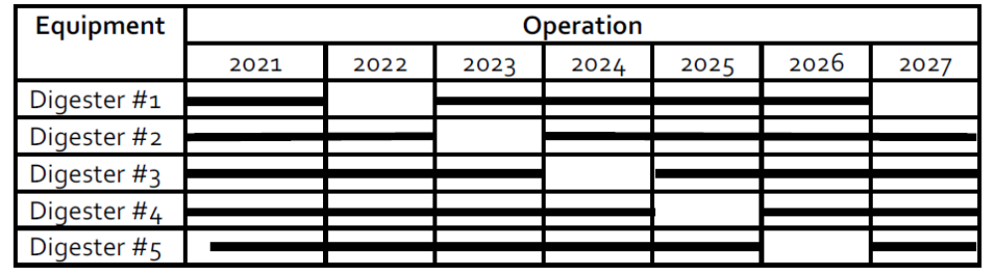

The installation implemented in the process of treatment of wastewater sludge in Kubratovo wastewater Treatment Plant and regarded as a permanent design change of the validated project is an experimental one and applied for the first time in any of Bulgaria’s waste-water treatment plants. In this respect it is a first-of-its-kind.
The design change related to the project does not influence the quantity of the sludge entering the bio-reactors and the biological content in it (Biological Oxygen Demand – BOD). The purpose of the implemented process is to atomize the particles of the inlet waste-water sludge and to improve the process of sludge stabilisation in order to decrease the quantity of ammonia and nitrogen in the effluent water.
In general the design-change objectives are the following:
• Reducing the high ammonia content in the sludge water from sludge dewatering, through anaerobic ammonium oxidation (Anammox). The main objective is to lower the final ammonia content in the treated water and then reduce eutrophication. The goal is to achieve ammonia removal up to 80-90% and total nitrogen removal up to 75-85%.
• Reducing the amount of sludge generated, by upgrading the capacity of the sludge management - construction of a thermal hydrolysis of sludge (THP) installation in addition to the currently existing anaerobic stabilization.

Anaerobic Ammonia Oxidation Plant – Anammox – Process Description
• The technology combines the advantages of activated sludge and attached biomass.
• The Anammox process is used to purify water rich in ammonia and poor in carbon. This process will be used to treat the sludge water from the dewatering of stabilized sludge.
• The Anammox process works on the principle of partial nitrification of NH₄-N to nitrite by ammonium-oxidizing bacteria (AOB) under aerobic conditions and the subsequent removal of the remaining NH₄-N and the produced NO₂-N by Anammox bacteria under anoxic conditions. The combined result of these two reactions is that the main part of the NH₄-N is transformed into nitrogen gas. However, a small amount of NO₃-N is also formed.
• The deammonification process consists of aerobic nitrification and anaerobic ammonia oxidation (anammox) reaction. Both steps occur simultaneously in the reactor and are carried out by two different types of microorganisms that have different environmental requirements. AOB require aerobic conditions, while Anammox bacteria need anaerobic conditions. For these two different types of bacteria to coexist on the same biofilm, it is necessary for the biofilm on the carrier to have an oxygen gradient, i.e. the conditions are achieved in the deeper layers of the biofilm. In practice, this is achieved by controlling the concentration of dissolved oxygen (DO) in the bulk liquid at a lower level (1 - 1.5 mg/l) than is usual in conventional nitrifying MBBRs (4 mg/l).

Fig.6: Thermal Hydrolysis Plant (THP)
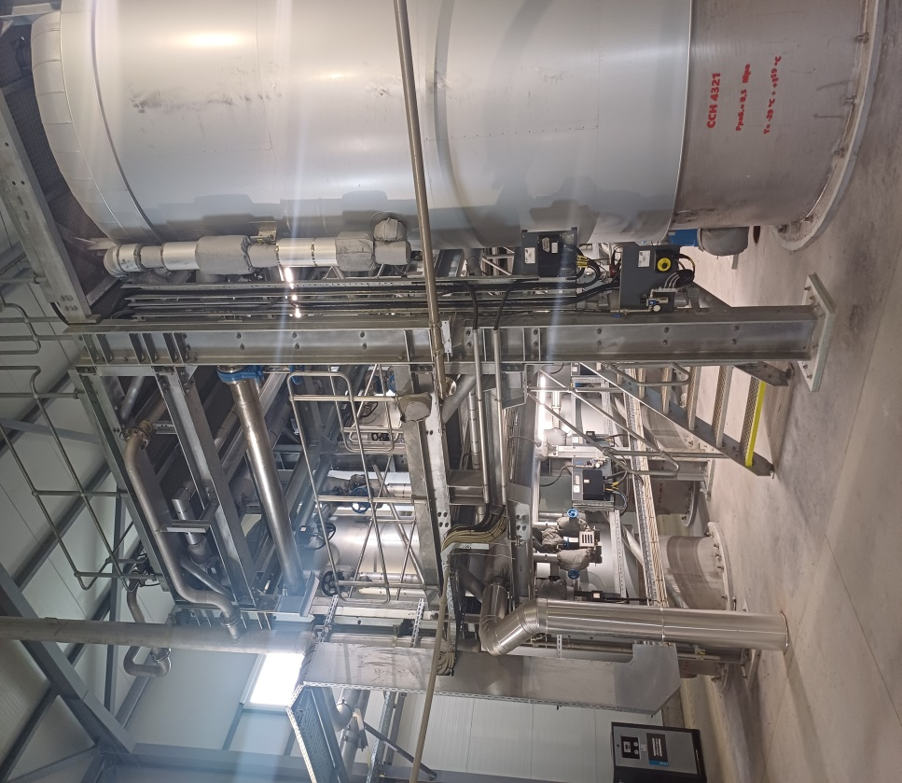

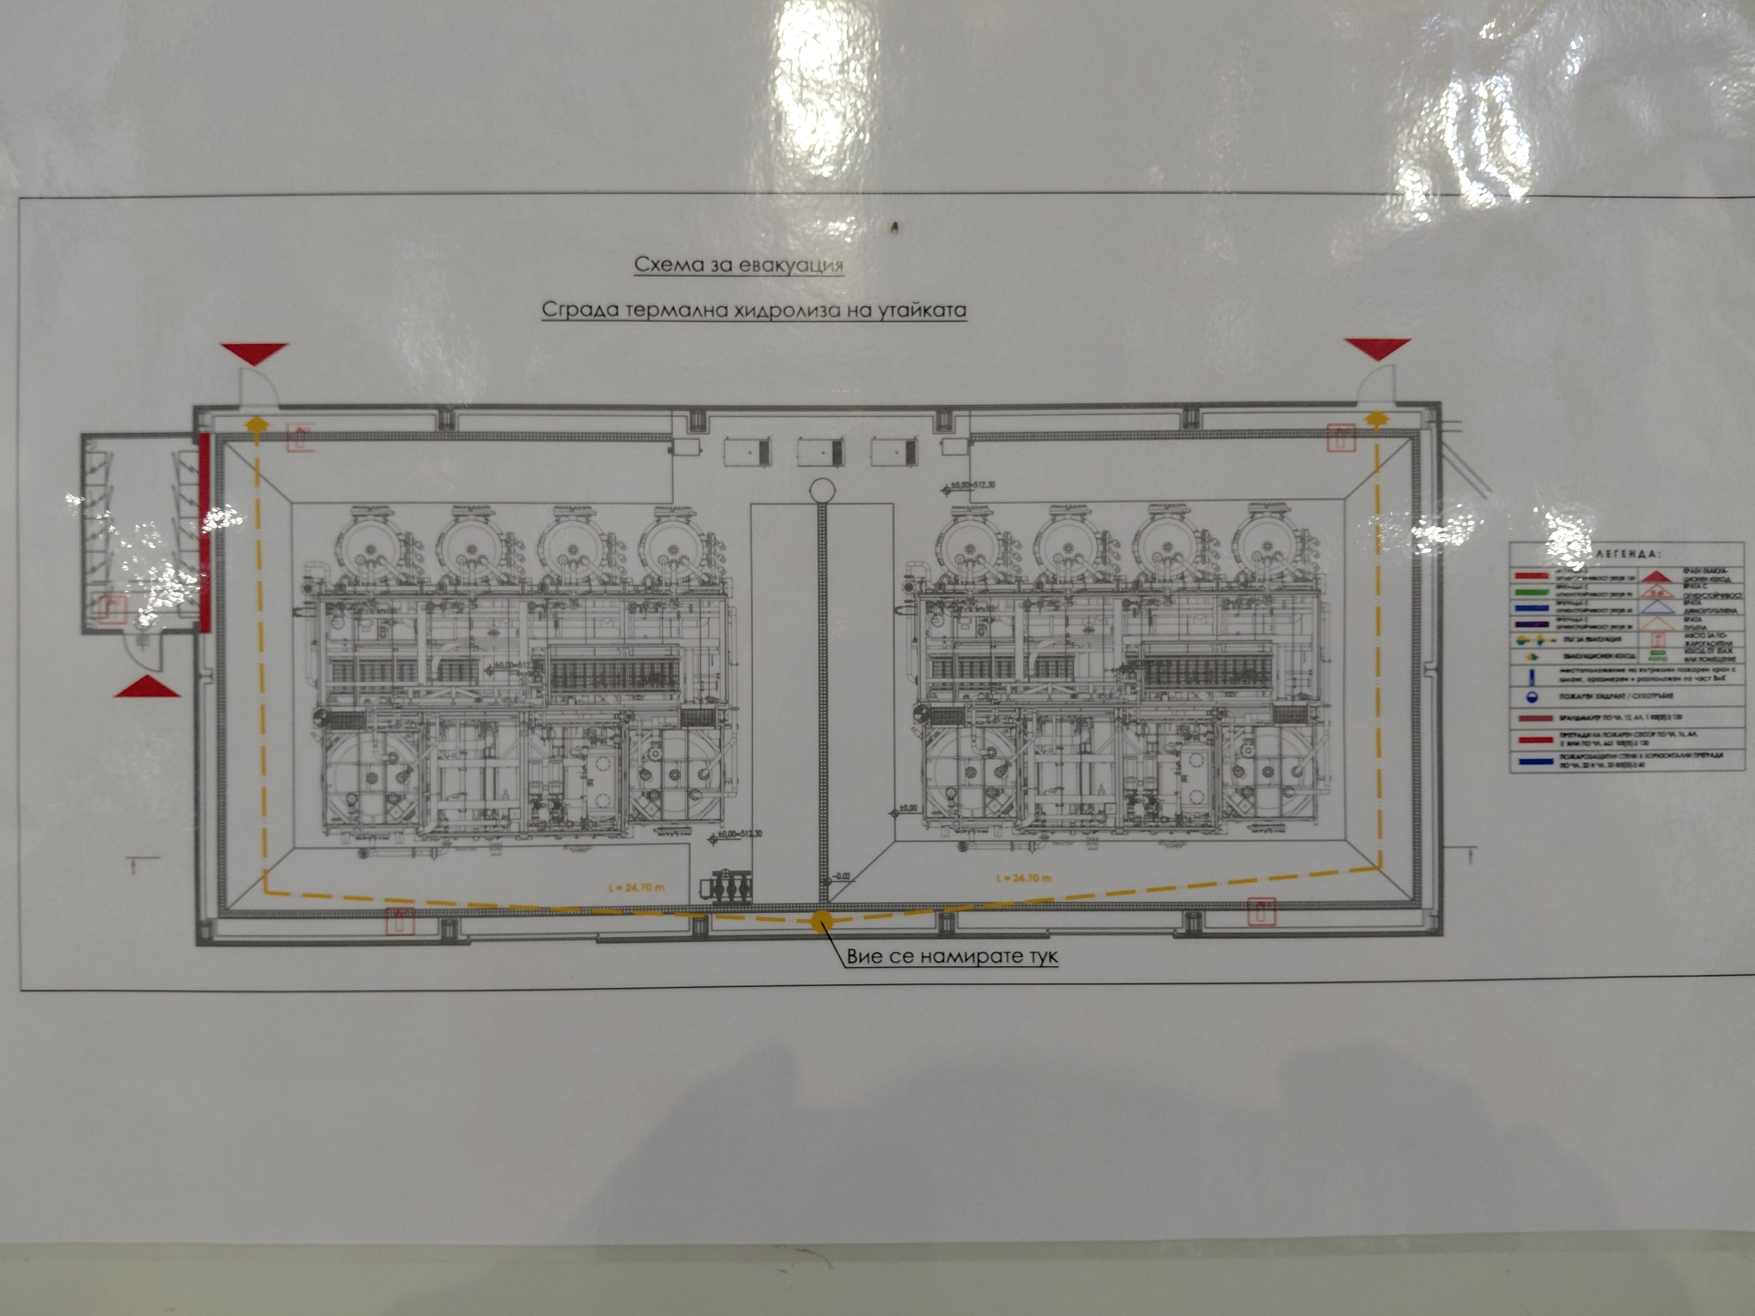

Fig.7: Thermal Hydrolysis Plant (THP)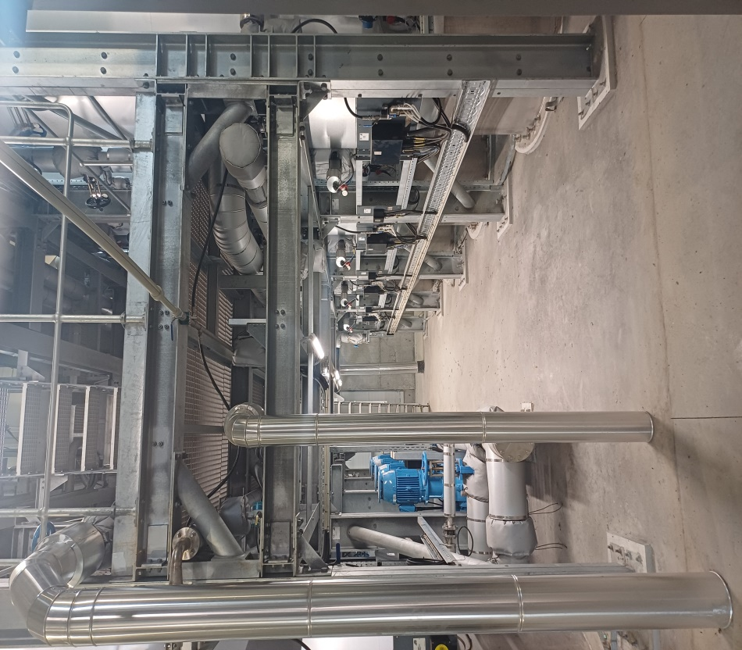

Thermal Hydrolysis Plant (THP) – Process Description
• The thickened IAU, together with PU are mixed in an existing thickened IAU tank. The mixed primary sludge and thickened IAU will be pumped to new centrifuges for pre-dewatering before the THP plant
In this process, the pre-dewatered sludge is hydrolyzed and crushed, turning into a sterilized liquid with reduced viscosity, which allows more than twice as high loading volumes compared to conventional anaerobic treatment. The thermal treatment, in turn, destroys the hydrophilic nature of the sludge, which allows a significant improvement in its dewatering.
• The pre-dewatered sludge enters the hydrolysis reactor, which is heated by direct steam injection. The temperature in the reactors is about 160°C and the pressure is about 6 bar. At these temperatures and pressures, the organic matter hydrolyzes to soluble compounds. After a certain time, the pressure is released and the sludge moves to the next tank. The sharp drop in pressure causes a steam explosion, which leads to the fragmentation of cells and tissues. In addition, the heating and cooling of the sludge is done by direct heat transfer using steam.

Fig.8: Anammox Installation

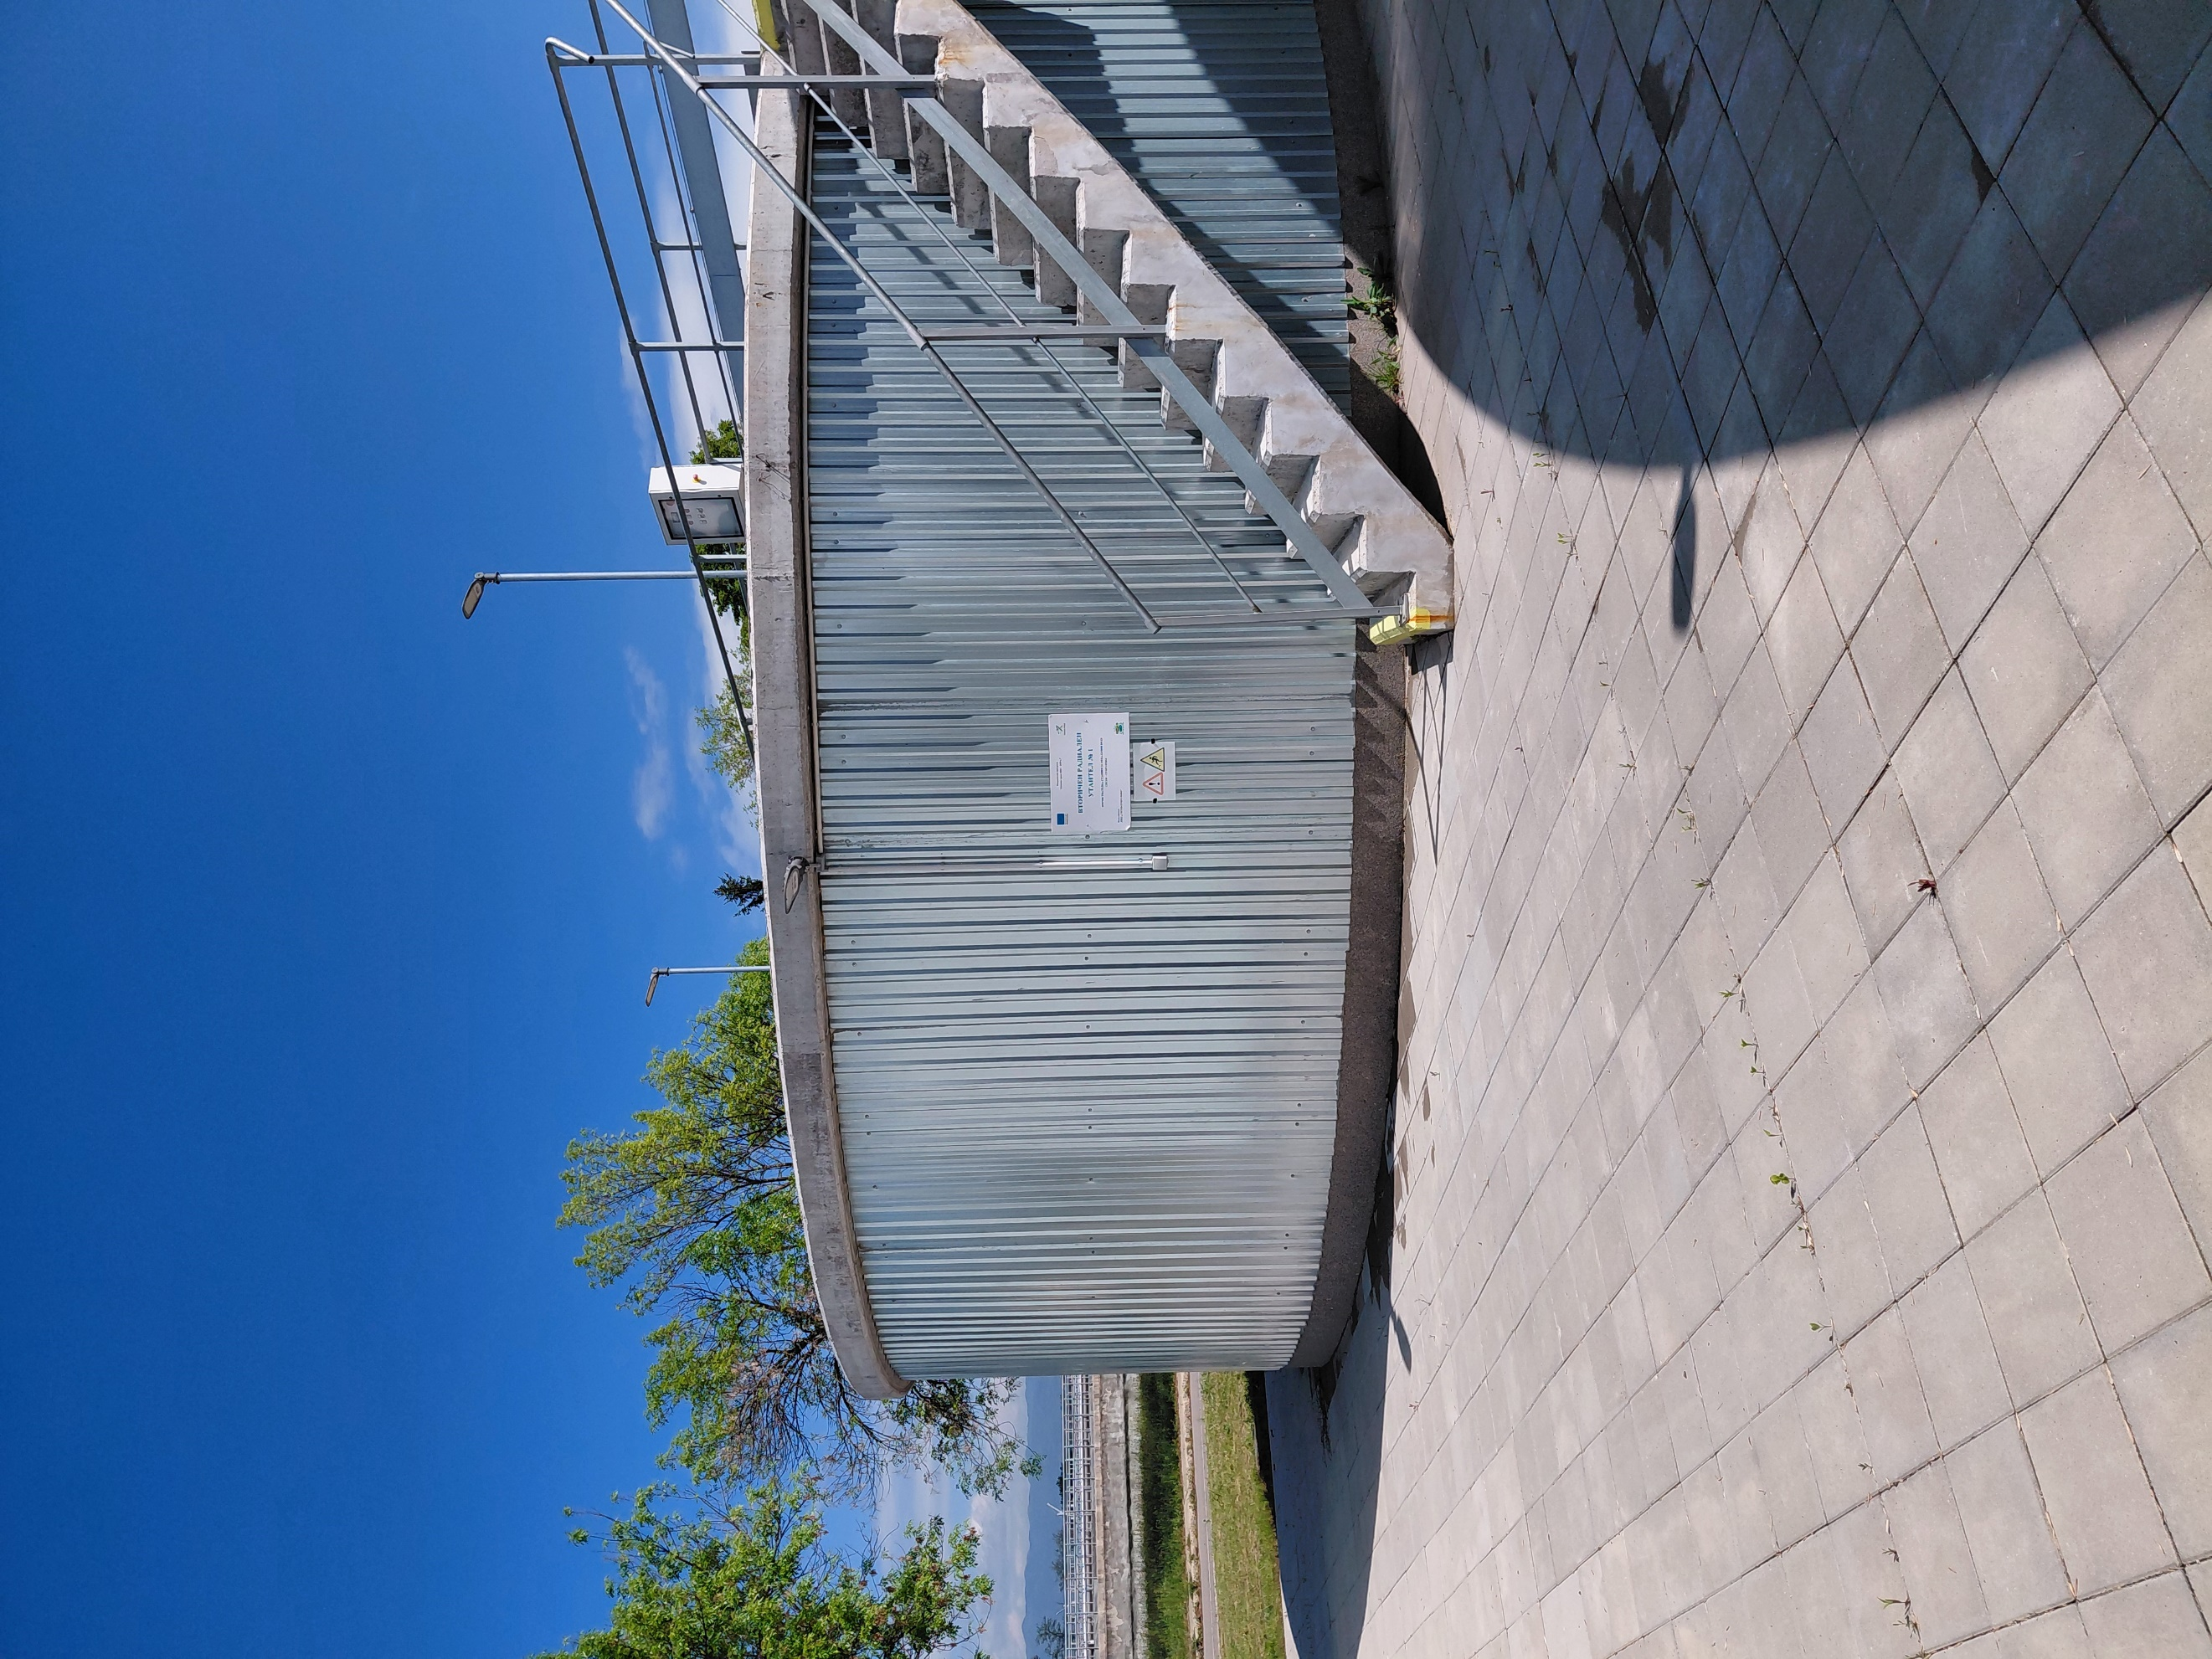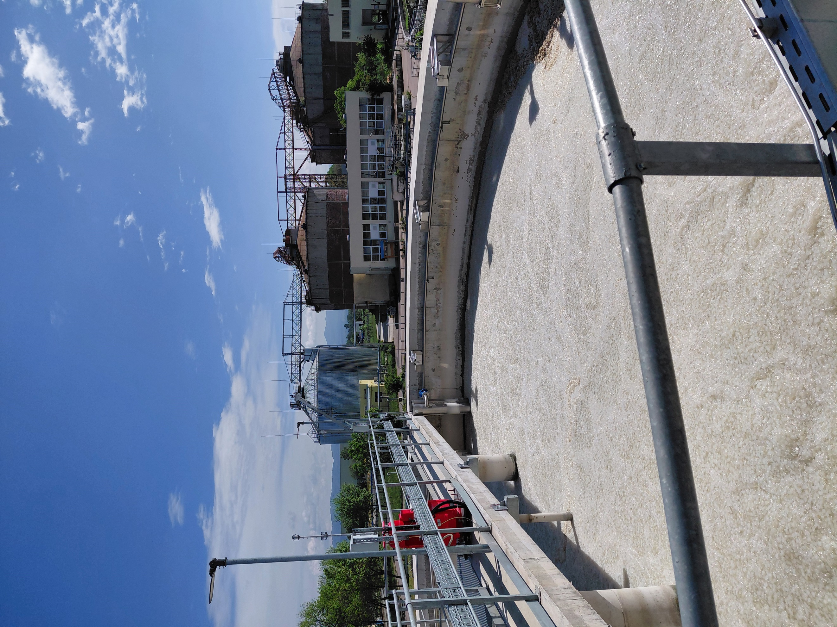

The THP process proceeds in the following steps:
• Pre-dewatering - The sludge is dewatered (pre-) to about 16.5% DM;
• Thermal hydrolysis reactors - The mixed, pre-dewatered sludge is treated for a minimum of 20 minutes residence time in the hydrolysis reactors. The hydrolyzed sludge leaves the plant at about 14.5% DS and is diluted to 10-12% DS before entering the Methane Tanks, therefore the thermal hydrolysis pre-treatment saves volume for stabilization and energy for stirring in the Methane Tanks. • Before entering the methane tank, the hydrolyzed sludge is cooled to maintain the temperature in the methane tanks between 38 and 42°C under all operating conditions within the specified design parameters.
• The methane tanks will be charged with the hydrolyzed sludge after the THP installation.
• Subsequent dewatering - After using this technology, the cake is easily dewatered to high dry matter concentrations. ¬ By building a Thermal Hydrolysis installation, it will be achieved:
• reducing the viscosity of the sludge and ensuring a high degree of decomposition of the dry matter; • achieving complete decontamination of the treated sludge;
• increasing the conversion of organic matter into biogas;
• improving the dehydration process of the decomposed sludge;
• producing a stable final product with low odor and high dry matter content.
Description of the technological equipment related to the Thermal Hydrolysis (THP) installation for additional sludge treatment (in addition to the currently existing anaerobic stabilization).

Preliminary de-watering
• Centrifuge for pre-dewatering - SS input = 3.03%, SS output = 16.5% with a capacity of 91 m3/h and 2750 kg of solids /h
• Feeding screw pumps to centrifuges with frequency control of revolutions. Q = 91m3 / h, H = 2.0 bar, SS = 3.03%
• Installation for preparing polymer, Q = 8000 l / h for dehydration
• Installation for feeding dry polymer type "Big Bag"
• Dosing pumps for polymer solution Q = 4000 l / h, H = 10 m.
• Pump for liquid polymer concentrate Q=20-150 l/h
• Pump for dewatered sludge to sludge silo Q = 16.5 m3/h, H=2.0 bar

Thermal hydrolysis plant
• Number of lines - 2 pcs.
• THP reactors B6-4, set (Pulper, 4 pcs. reactors, Flash tank) - 2 pcs.
• Process gas cooler - 2 pcs.
• Process gas treatment module - 2 pcs.
• Pump-hydrophore system Q=36.5-37.5m3/h, Riz.=6.0 – 8.0bar.2.
• Air-cooled screw compressor set with controller and automatic condensate separator. Flow rate: 1.0 m3/min, max. 1.31m3/h with buffer: min 0.4 m3 dried compressed air, required for safe shutdown

Steam boilers for THP – 2 units (replacing the existing hot water boiler)
• Saturated steam with the following parameters:
- capacity - 4.0 t/h (2.7 MW_{th}/9.72 GJ).
- fresh steam pressure - 12 barg
- fresh steam temperature – 191.7°C
- enthalpy Δi ~2,450 kJ/kg
- feed water temperature - 87°C

Fig.9: New steam boilers
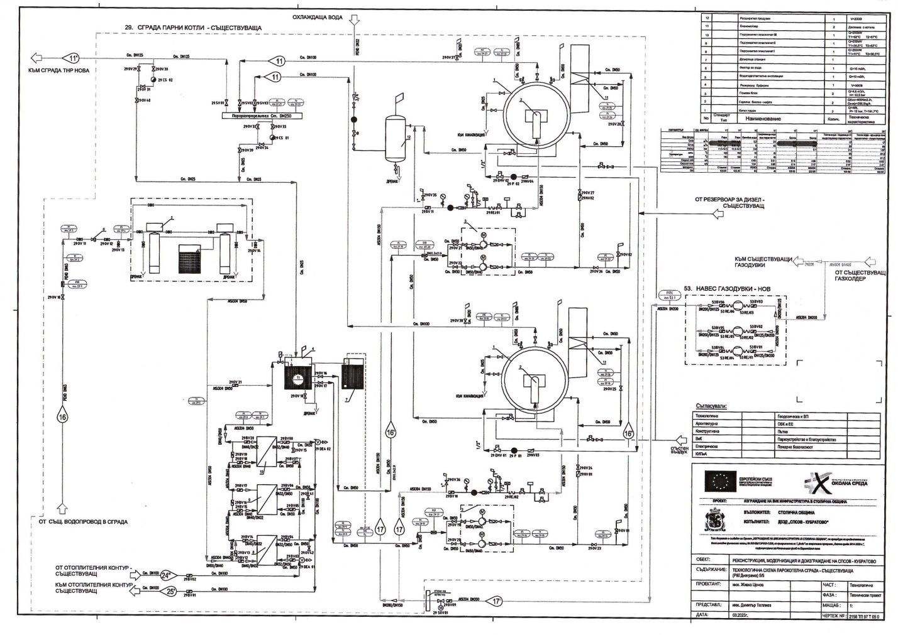
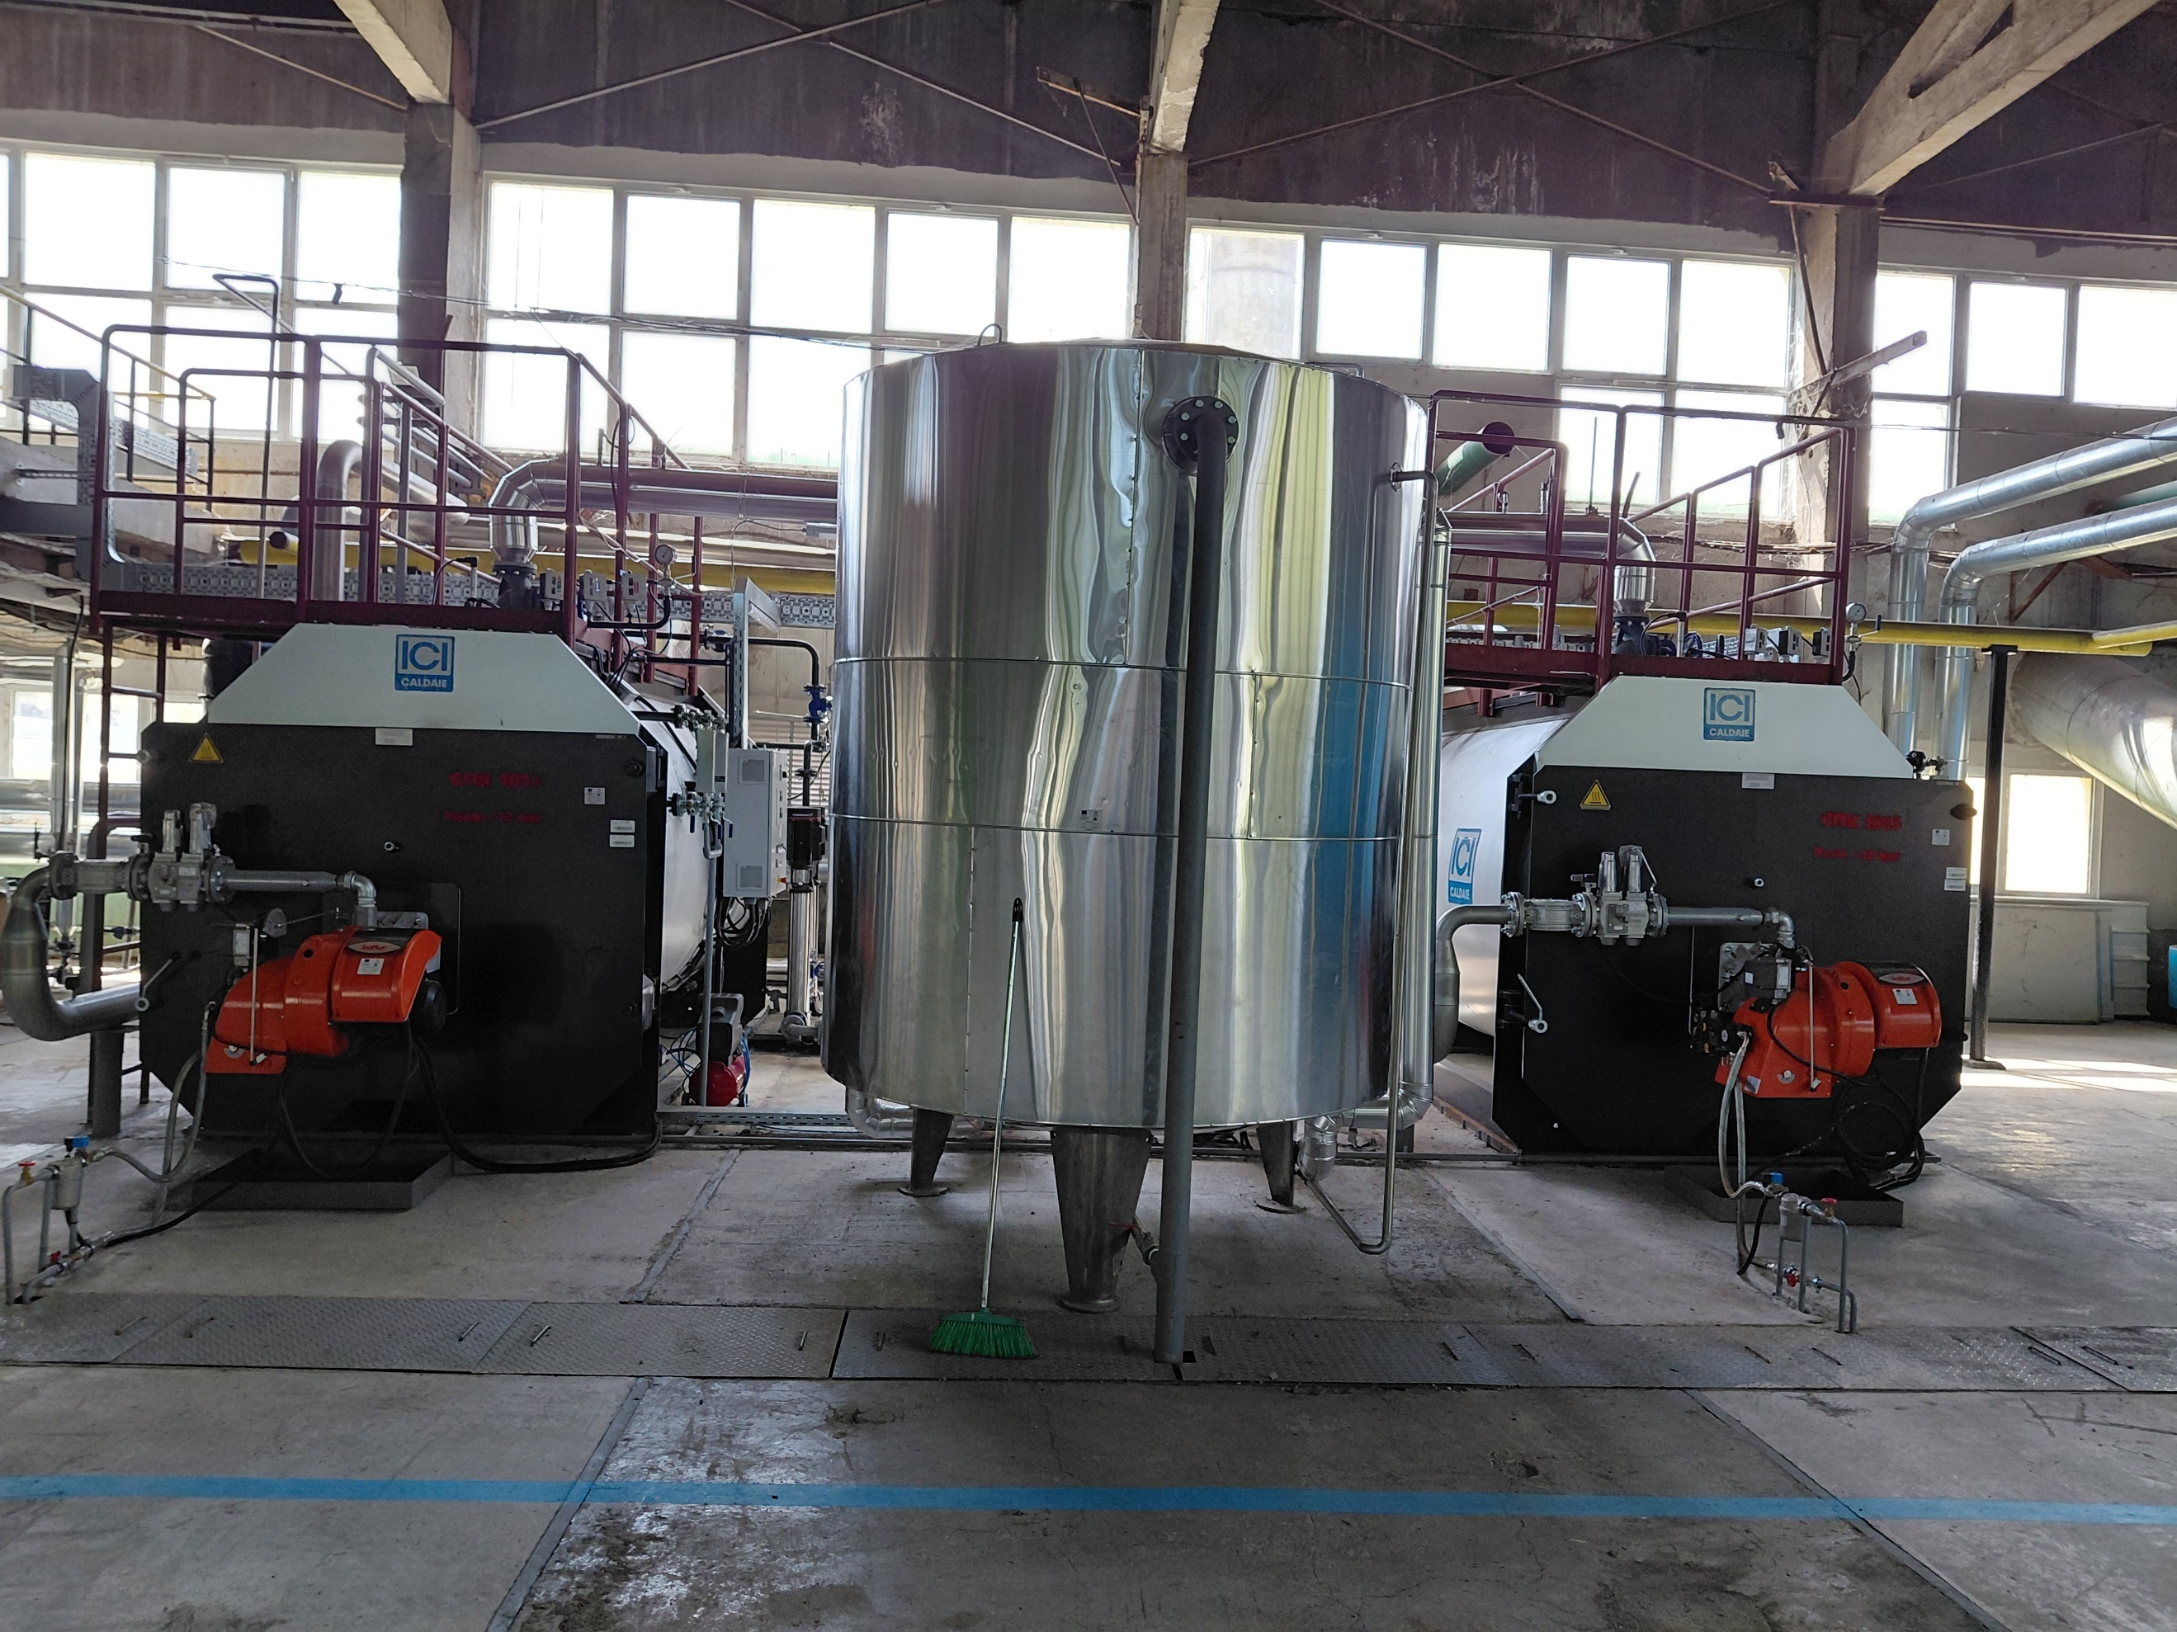

Anammox reactors
• Bioreactors with V = 1,259m³, D=16.35m, H = 6.0m. 2 pcs.

Fig.10: Installation diagramme after design change
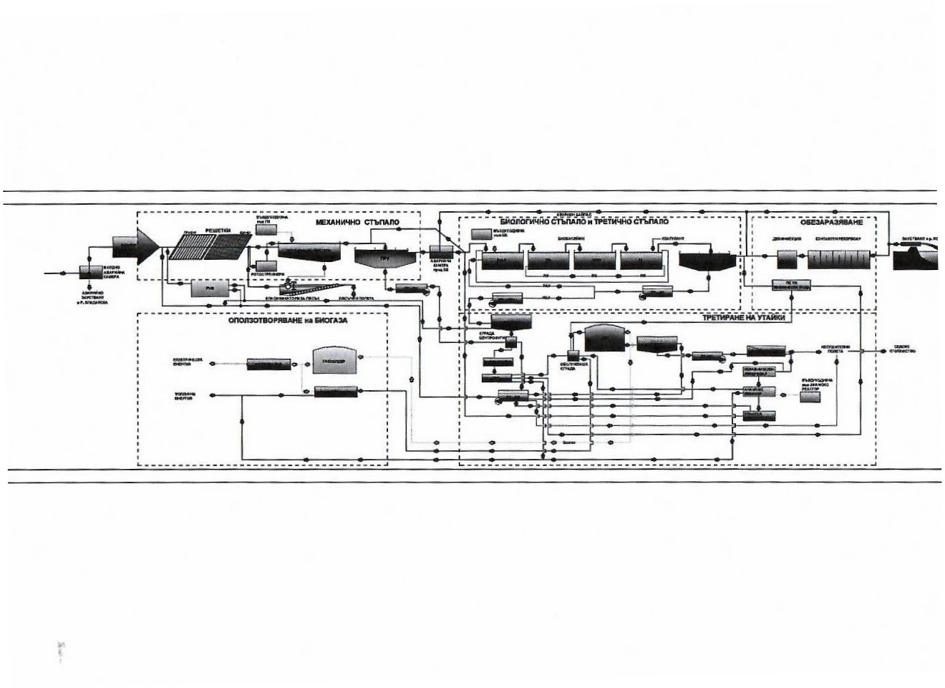

The implementation of the design change makes obsolete and replaces the following equipment included in the project’s valitated PDD:
- Raw Sludge Pumping Station
- Sludge Circulation System
- Hot water boiler (replaced by steam boilers)

A.4 Scale of the project
The project can be classified for GS as “Small”, following the classification provided in CDM AMS-III.H. The estimated total annual emission reductions after the design change relevant to AMS-III.H are less than 60,000 tCO_{2e}.

A.5 Funding sources of project
The project was financed and implemented by equity capital provided by the project owner Sofiyska voda AD.
Total financial expenses were as follows:

1st phase expenses | Eur | 7,020,432
2nd phase investment costs | Eur | 2,270,810
Design | Eur | 12,026
Equipment | Eur | 2,200,063
Construction works | Eur | 58,721
Total project costs | Eur | 9,291,242

SECTION B. APPLICATION OF APPROVED GOLD STANDARD METHODOLOGY (IES) AND/OR DEMONSTRATION OF SDG CONTRIBUTIONS

B.1. Reference of approved methodology (ies)
For determination of the baseline, the methodology AMS-III.H: Methane recovery in wastewater treatment (Version 19.0 ), AMS-I.C: Thermal energy production with or without electricity”, (Version 22.0 ) and AMS-I.F: “Renewable electricity generation for captive use and mini-grid” (Version 05.0), approved by the CDM Executive Board, are applied, using conservative options and data as presented in the following section.

The project has been approved as additional by VVB and GS.
To demonstrate additionality during the initial certification in 2014, the official methodologies: “Guidelines on the Demonstration of Additionality of Small-scale Project Activities”, Ver.09.0 (previously known as “Attachment A to Appendix B of the simplified modalities and procedures for small-scale CDM project activities version 08”) were used.
For the current design change re-certification process the additionality of the project will not be assessed because the co-generation plant that generates electric energy as the only source of financial income of the project is not affected and no changes are planned.

In addition, the following methodological tools are applied in the validated PDD (ver.06 of 23/06/2021) and still valid for the present PDD revised after the design change.:
- TOOL 03:“Tool to calculate project or leakage CO2 emissions from fossil fuel combustion” Version 03.0;
- TOOL 04:“Emissions from solid waste disposal site”, Version 08.0;
- TOOL 05:“Baseline, project and/or leakage emissions from electricity consumption and monitoring of electricity generation”,Version 03.0;
- TOOL 06:“Project emissions from flaring”, Version 03.0;
- TOOL 10:Tool to determine the remaining lifetime of equipment”, Version 01;
- TOOL 14:“Project and leakage emissions from anaerobic digesters”, Version 02.0;
To reflect and assess the effect of the design change to the project the following guidelines and standards are taken into consideration:
- GS4GG: Design Change Requirements, version 1.1, dated 13/04/2023.

B.2. Applicability of methodology (ies)
The project uses approved CDM methodologies listed above in Section B.1.
The key elements of the applied methodology AMS-III.H (version 19.0) which define its applicability are as follows:

2.1.Scope
- This methodology comprises measures that recover biogas from biogenic organic matter in wastewater by means of one, or a combination, of the following options:
- Substitution of aerobic wastewater or sludge treatment systems with anaerobic systems with biogas recovery and combustion.
The present project completely satisfies this condition because it is designed to treat the sludge that is contained in the wastewater generated by the Municipality of Sofia in anaerobic reactors with biogas recovery.The process is organised on the territory of Kubratovo wastewater treatment plant which is the only municipal wastewater treatment installation at the territory of Sofia Municipality. The content of the organic matter in the effluent tewater and the organic sludge is measured continuously by an accredited laboratory. The resulting protocols are archived by the project owner and are at disposal for inspection by DOE at any time.

Applicability conditions  in the AMS-III.H. / Version 19.0 | Compliance of the condition
- The methodology is applied in general to projects for “Recovery of biogas resulting from anaerobic decay of organic matter in wastewater through introduction of an anaerobic treatment system for wastewater and/or sludge treatment with biogas recovery. | The project is aimed to replace the traditional sludge drying beds and landfill options with mesophilic digestion of all primary and secondary sludge followed by mechanical dewatering in order to reduce GHG emissions.  The proposed project therefore complies with this applicability condition.
- This methodology comprises measures that recover biogas from biogenic organic matter in wastewater by means of one, or a combination, of the following options:  - Substitution of aerobic wastewater or sludge treatment systems with anaerobic systems with biogas recovery and combustion;  - Introduction of anaerobic sludge treatment system with biogas recovery and combustion to a wastewater treatment plant without sludge treatment;  - Introduction of biogas recovery and combustion to a sludge treatment system;  - Introduction of biogas recovery and combustion to an anaerobic wastewater treatment system such as anaerobic reactor, lagoon, septic tank or an on-site industrial plant;  - Introduction of anaerobic wastewater treatment with biogas recovery and combustion, with or without anaerobic sludge treatment, to an untreated wastewater stream;  - Introduction of a sequential stage of wastewater treatment with biogas recovery and combustion, with or without sludge treatment, to an anaerobic wastewater treatment system without biogas recovery (e.g. introduction of treatment in an anaerobic reactor with biogas recovery as a sequential treatment step for the wastewater that is presently being treated in an anaerobic lagoon without methane recovery). | The project activity satisfies the applicability condition (a) Substitution of aerobic wastewater or sludge treatment systems with anaerobic systems with biogas recovery and combustion;  The project is designed to:  • replace the traditional sludge drying beds and landfill options with mesophilic digestion of all primary and secondary sludge followed by mechanical dewatering in order to reduce GHG emissions;  • effectively mitigate odour problems from the existing treatment of sludge and sludge liquors through introduction of digestion;  • production of fertiliser by mechanical dewatering of the digested stabilised sludge;
- In cases where baseline system is anaerobic lagoon the methodology is applicable if:  - The lagoons are ponds with a depth greater than two meters, without aeration. The value for depth is obtained from engineering design documents, or through direct measurement, or by dividing the surface area by the total volume. If the lagoon filling level varies seasonally, the average of the highest and lowest levels may be taken;  - Ambient temperature above 15°C, at least during part of the year, on a monthly average basis;  - The minimum interval between two consecutive sludge removal events shall be 30 days. | Not applicable.  The baseline system does not apply anaerobic lagoons.  The sludge in the baseline is stored in pits and after 1 year is transferred to a landfill.
- The recovered biogas from the above measures may also be utilised for the following applications instead of combustion/flaring:  - Thermal or mechanical, electrical energy generation directly;  - Thermal or mechanical, electrical energy generation after bottling of upgraded biogas, in this case additional guidance provided in Annex 1 shall be followed; or  - Thermal or mechanical, electrical energy generation after upgrading and distribution, in this case additional guidance provided in Annex 1 shall be followed:  - Upgrading and injection of biogas into a natural gas distribution grid with no significant transmission constraints;  - Upgrading and transportation of biogas via a dedicated piped network to a group of end users; or  - Upgrading and transportation of biogas (e.g. by trucks) to distribution points for end users.  - Hydrogen production;  - Use as fuel in transportation applications after upgrading. | The project activity satisfies condition (a) Thermal or mechanical, electrical energy generation directly;  The recovered biogas generated by the anaerobic digesters is directed for combined generation of thermal and electric energy in gas engines and for generation of thermal energy in steam boilers.
- If the recovered biogas is used for project activities covered under paragraph 4 (a) of AMS-III.H, that component of the project activity can use a corresponding methodology under Type I. | The project activity satisfies condition 3(a) above.  The component of the project that accounts for the activities under paragraph 3(a) of the methodology uses SSC methodology AMS- I.C. “Thermal energy production with or without electricity”, Version 22 as stated in Section B.1
- For project activities covered under paragraph 4 (b) of AMS-III.H, if bottles with upgraded biogas are sold outside the project boundary, the end-use of the biogas shall be ensured via a contract between the bottled biogas vendor and the end-user. No emission reductions may be claimed from the displacement of fuels from the end use of bottled biogas in such situations. If however the end use of the bottled biogas is included in the project boundary and is monitored during the crediting period CO₂ emissions avoided by the displacement of fossil fuel can be claimed under the corresponding Type I methodology, e.g. AMS-I.C “Thermal energy production with or without electricity”. | Not applicable.  The project activity satisfies condition 3(a) as mentioned above.  The biogas generated will be used for cogeneration of electric and thermal engines in co-generation units and for generation of peak thermal energy in boilers.
- For project activities covered under paragraph 4 (c) (i) of AMS-III.H, emission reductions from the displacement of the use of natural gas are eligible under this methodology, provided the geographical extent of the natural gas distribution grid is within the host country boundaries. | Not applicable.  The project activity satisfies condition 3(a) as mentioned above.  The biogas generated will be used for cogeneration of electric and thermal energy in co-generation units and for generation of peak thermal energy in boilers.
- For project activities covered under paragraph 4 (c) (ii) of AMS-III.H, emission reductions for the displacement of the use of fuels can be claimed following the provision in the corresponding Type I methodology, e.g. AMS-I.C. | Not applicable.  The project activity satisfies condition 3(a) as mentioned above.  The biogas generated will be used for cogeneration of electric and thermal engines in co-generation units and for generation of peak thermal energy in boilers.
- In particular, for the case of 4 (b) and (c) (iii) of AMS-III.H, the physical leakage during storage and transportation of upgraded biogas, as well as the emissions from fossil fuel consumed by vehicles for transporting biogas shall be considered. Relevant procedures in paragraph 11 of Annex 1 of AMS-III.H “Methane recovery in wastewater treatment” shall be followed in this regard. | Not applicable.  The project activity satisfies condition 3(a) as mentioned above.  The biogas generated will be used for cogeneration of electric and thermal engines in co-generation units and for generation of peak thermal energy in boilers.
- For project activities covered under paragraph 4 (b) and (c) of AMS-III.H, this methodology is applicable if the upgraded methane content of the biogas is in accordance with relevant national regulations (where these exist) or, in the absence of national regulations, a minimum of 96% (by volume). | Not applicable.  The project activity satisfies condition 3(a) as mentioned above.  The biogas generated will be used for cogeneration of electric and thermal engines in co-generation units and for generation of peak thermal energy in boilers.
- If the recovered biogas is utilized for the production of hydrogen (project activities covered under paragraph 4 (d)) of AMS-III.H, that component of the project activity shall use the corresponding methodology AMS-III.O “Hydrogen production using methane extracted from biogas”. | Not applicable.  The project activity satisfies condition 3(a) as mentioned above.  The biogas generated will be used for cogeneration of electric and thermal engines in co-generation units and for generation of peak thermal energy in boilers.
- If the recovered biogas is used for project activities covered under paragraph 4 (e) of AMS-III.H, that component of the project activity shall use corresponding methodology AMS-III.AQ “Introduction of Bio-CNG in road transportation”. | Not applicable.  The project activity satisfies condition 3(a) as mentioned above.  The biogas generated will be used for cogeneration of electric and thermal engines in co-generation units and for generation of peak thermal energy in boilers.
- New facilities (Greenfield projects) and project activities involving a change of equipment resulting in a capacity addition of the wastewater or sludge treatment system compared to the designed capacity of the baseline treatment system are only eligible to apply this methodology if they comply with the relevant requirements in the “General guidelines to SSC CDM methodologies”. In addition the requirements for demonstrating the remaining lifetime of the equipment replaced, as described in the general guidelines shall be followed. | The project activity is an existing facility and is implemented in an existing plant for treatment of municipal wastewaters and affects the sludge treatment system only.  The project replaces the baseline sludge drying beds and landfill options with mesophilic digestion of all primary and secondary sludge followed by mechanical dewatering in order to reduce GHG emissions. The waste-water treatment system is not affected hence the capacity of the primary waste-water treatment system remains the same as in the baseline and there is no capacity addition.
- The location of the wastewater treatment plant as well as the source generating the wastewater shall be uniquely defined and described in the PDD. | The exact location of the Wastewater treatment plant is given in Section A.2.  The source of the wastewater is the complete Sofia Municipality which is evident from the Concession Agreement between Sofiyska voda AD (owner of the Wastewater Treatment Plant in Kubratovo) and the Municipality of Sofia.
- Measures are limited to those that result in aggregate emissions reductions of less than or equal to 60 kt CO₂ equivalent annually from all Type III components of the project activity. | The emission reductions from the Type III components of the project activity are less than 60 kt CO₂ as demonstrated further in the PDD.

For project activity related to the way of destruction of the biogas used in this project, methodology AMS-I.C (version 22.0):Thermal energy production with or without electricity is applied, as recommended by AMS-III.H.

Applicability conditions  in the AMS-I.C. / Version 22.0 | Compliance of the condition
- This methodology comprises renewable energy technologies that supply users with thermal energy that displaces fossil fuel use. These units include technologies such as solar thermal water heaters and dryers, solar cookers, energy derived from renewable biomass and other technologies that provide thermal energy that displaces fossil fuel. | The project activity supplies the waste-water treatment plant with electric energy that would be imported in the baseline from the National grid and with thermal energy that would be generated by local boilers using fossil fuel. The project utilises as fuel the bio-gas generated in anaerobic digesters by treatment of sludge which is considered a renewable energy source.
- Biomass-based cogeneration and trigeneration systems are included in this category. | The proposed project is a biomass-based co-generation system because it generates thermal and electric energy by the use of 3 new co-generation sets GE JMS 320 GS-B.LC with 1,063 kW electric capacity each and 1,088 kW thermal capacity.
- Emission reductions from a biomass cogeneration system can accrue from one of the following activities:  - Electricity supply to a grid;  - Electricity and/or thermal energy (steam or heat) production for on-site consumption or for consumption by other facilities;  - Combination of (a) and (b). | The proposed project is a biomass-based co-generation system because it generates thermal and electric energy. The electric energy in the baseline has been imported from the grid. The thermal energy has been generated by on-site fossil-fuel boilers.  In this particular project the activity is under (c).
- Project activities that seek to retrofit or modify an existing facility for renewable energy generation are included in this category. | Not applicable.  The proposed project is an existing facility applying for GS recertification for a new creditting period facility.
- In the case of new facilities (Greenfield projects) and project activities involving capacity additions the relevant requirements related to determination of baseline scenario provided in the “General guidelines for SSC CDM methodologies” for Type-II and Type-III Greenfield/capacity expansion project activities also apply. | The present part of the project activity fells under Type I - “Indicative simplified baseline and monitoring methodologies for selected small-scale CDM project activity categories – I.C. Thermal energy production with or without electricity”.
- The total installed/rated thermal energy generation capacity of the project equipment is equal to or less than 45 MW thermal (see paragraph 9 for the applicable limits for cogeneration and trigeneration project activities). | The project activity utilises 3 existing co-generation sets GE JMS 320 GS-B.LC with 1.063 kW electric capacity each (total 3.189 kWe) and 1,088 kW thermal capacity (total 3.264 kWth).
- For co-fired systems, the total installed thermal energy generation capacity of the project equipment, when using both fossil and renewable fuel, shall not exceed 45 MW thermal (see paragraph 9 for the applicable limits for cogeneration project activities). | Not applicable.  The proposed project is not a co-fired system. The co-generators use gas-fuelled engines GE JMS 320. Light oil is used as fuel only in emergency cases when biogas is not generated. The eventual use of light oil for thermal energy generation in the back-up (peak) boilers is monitored on yearly basis and accounted for in the calculation of the project emissions.
- The following capacity limits apply for biomass cogeneration and trigeneration units:  - If the project activity includes emission reductions from both the thermal and electrical energy components, the total installed energy generation capacity (thermal and electrical) of the project equipment shall not exceed 45 MW thermal. For the purpose of calculating this capacity limit the conversion factor of 1:3 shall be used for converting electrical energy to thermal energy (i.e. for renewable energy project activities, the maximal limit of 15 MW(e) is equivalent to 45 MW thermal output of the equipment or the plant);  - If the emission reductions of the cogeneration project activity are solely on account of thermal energy production (i.e. no emission reductions accrue from the electricity component), the total installed thermal energy production capacity of the project equipment of the cogeneration unit shall not exceed 45 MW thermal;  - If the emission reductions of the cogeneration project activity are solely on account of electrical energy production (i.e. no emission reductions accrue from the thermal energy component), the total installed electrical energy generation capacity of the project equipment of the cogeneration unit shall not exceed 15 MW. | The total installed energy generation capacity (thermal and electrical) of the project activity is 6.453 kW which is far below the limit of 45 MW.
- The capacity limits specified in paragraphs 7 to 9 above apply to both new facilities and retrofit projects. In the case of project activities that involve the addition of renewable energy units at an existing renewable energy facility, the total capacity of the units added by the project should comply with capacity limits in paragraphs 7 to 9, and should be physically distinct from the existing units. | The proposed project activity is an existingbuilt to replace the energy supplied in the baseline by the grid and by the on-site fossil fuelled boilers.  The installed capacity of the biomass boiler in the project is 6.453 MW (thermal+electric) as specified in Section A above and satisfies the capacity limits set by the methodology.
- If solid biomass fuel (e.g. briquette) is used, it shall be demonstrated that it has been produced using solely renewable biomass and all project or leakage emissions associated with its production shall be taken into account in the emissions reduction calculation. | Not applicable.  The project uses biogas generated in anaerobic digesters that treat the sludge from the municipal waste-water.
- Where the project participant is not the producer of the processed solid biomass fuel, the project participant and the producer are bound by a contract that shall enable the project participant to monitor the source of the renewable biomass to account for any emissions associated with solid biomass fuel production. Such a contract shall also ensure that there is no double-counting of emission reductions. | Not applicable.  The project activity does not use solid biomass.
- If electricity and/or steam/heat produced by the project activity is delivered to a third party i.e. another facility or facilities within the project boundary, a contract between the supplier and consumer(s) of the energy will have to be entered into that ensures there is no double-counting of emission reductions. | The energy generated by the project activity is used by the project owner to supply its own waste-water treatment plant with thermal and electric energy.
- If the project activity recovers and utilizes biogas for power/heat production and applies this methodology on a stand-alone basis i.e. without using a Type III component of a SSC methodology, any incremental emissions occurring due to the implementation of the project activity (e.g. physical leakage of the anaerobic digester, emissions due to inefficiency of the flaring), shall be taken into account either as project or leakage emissions. | Not applicable.  The project activity uses AMS-III.H methodology in order to account for baseline and project emissions due to the generation of biogas.
- If project equipment contains refrigerants, then the refrigerant used in the project case shall have no ozone depleting potential (ODP). | Not applicable.  The project activity is not a trigeneration installation and does not contain refrigerants.
- Charcoal based biomass energy generation project activities are eligible to apply the methodology only if the charcoal is produced from renewable biomass sources provided:  - Charcoal is produced in kilns equipped with methane recovery and destruction facility; or  - If charcoal is produced in kilns not equipped with a methane recovery and destruction facility, methane emissions from the production of charcoal shall be considered. These emissions shall be calculated as per the procedures defined in the approved methodology AMS-III.K. Alternatively, conservative emission factor values from peer reviewed literature or from a registered CDM project activity can be used, provided that it can be demonstrated that the parameters from these are comparable e.g. source of biomass, characteristics of biomass such as moisture, carbon content, type of kiln, operating conditions such as ambient temperature. | Not applicable.  The project activity does not use charcoal but directly combusts biogas.
- In cases where the project activity utilizes biomass, sourced from dedicated plantations, applicability conditions prescribed in the tool “Project emissions from cultivation of biomass” shall apply. | Not applicable.  The project activity utilises biogas.

The applicability of methodology AMS-I.F is assessed in the table below:
Applicability conditions  in the AMS-I.F / Version 05.0 | Compliance of the condition
- This methodology is applicable to project activities that:  (a)Install a Greenfield plant;  (b)Involve a capacity addition in (an) existing plant(s);  (c)Involve a retrofit of (an) existing plant(s);  (d)Involve a rehabilitation of (an) existing plant(s)/unit(s); or  (e)Involve a replacement of (an) existing plant(s). | The plant was a new one installed in a green field, Hence the methodology is applicable as per (a).
2. Hydro power plants with reservoirs that satisfy at least one of the following conditions are eligible to apply this methodology:  (a)The project activity is implemented in an existing reservoir with no change in the volume of reservoir;  (b)The project activity is implemented in an existing reservoir, where the volume of reservoir is increased and the power density of the project activity, as per definitions given in the project emissions section, is greater than 4 W/m2;  (c)The project activity results in new reservoirs and the power density of the power plant, as per definitions given in the project emissions section, is greater than 4 W/m2. | Not applicable. The plant combusts biogas to generate electric and thermal energy.
3.This methodology is applicable for project activities that: (a) Install a new power plant at a site where there was no renewable energy power plant operating prior to the implementation of the project activity (Greenfield plant); (b) Involve a capacity addition, (c) Involve a retrofit of (an) existing plant(s); or (d) Involve a replacement of (an) existing plant(s). | Condition (a) is applicable for this project, hence AMS-I.F is applicable.
4.In the case of project activities that involve the capacity addition of renewable energy generation units at an existing renewable power generation facility, the added capacity of the units added by the project should be lower than 15 MW and should be physically distinct from the existing units. | Not applicable.The project activity involves the installation of a new plant.
5.In the case of retrofit or replacement, to qualify as a small-scale project, the total output of the retrofitted or replacement unit shall not exceed the limit of 15 MW. | Not applicable.The project activity involves the installation of a new plant.
6.If the new unit has both renewable and non-renewable components (e.g. a wind/diesel unit), the eligibility limit of 15 MW for a small-scale CDM project activity applies only to the renewable component. If the new unit co-fires fossil fuel, the capacity of the entire unit shall not exceed the limit of 15 MW. | Not applicable. The new units have no non-renewable components.
7.Combined heat and power (co-generation) systems are not eligible under this category. | Not applicable. AMS-I.C, (version 22.0):Thermal energy production with or without electricity explicitly refers to AMS-I.F for the definition of the grid emission factor. This methodology is used for that purpose only.
8.If electricity and/or steam/heat produced by the project activity is delivered to a third party, i.e. another facility or facilities within the project boundary, a contract between the supplier and consumer(s) of the energy will have to be entered that ensures that there is no double counting of emission reductions. | Not applicable. The plant delivers electric and thermal energy for internal consumption.
9.In case biomass is sourced from dedicated plantations, the applicability criteria in the tool “Project emissions from cultivation of biomass” shall apply | Not applicable. The plant uses biogas as a fuel for generation of energy.

The applicability of AMS-I.F: “Renewable electricity generation for captive use and mini-grid” (Version 05.0) for the calculation of the grid emission factor is further discussed and justified in Section B.6.1 Determination of emission factor for electricity.

B.3. Project boundary
The project boundary is the physical, geographical site where the wastewater and sludge treatment takes place, in the baseline and project situations. It covers all facilities affected by the project activity including sites where processing, transportation and application or disposal of waste products as well as biogas takes place.
The project activity affects only the sludge-treatment system of the plant. The wastewater system is not affected by the project activity and operates in the project scenario under the same operational conditions as in the baseline scenario (e.g. wastewater inflow and COD content, temperature, retention time, etc.) It is described in the PDD, but the emissions from that section are not accounted for in the baseline and project emission calculations (since the same emissions would occur in both baseline and project scenarios). The assessment and identification of the systems affected by the project activity will be undertaken ex-ante, and the PDD justifies the exclusion of sections or components of the system.
The greenhouse gasses and emission sources are defined for the project activity and the baseline scenario.

As a result, the project boundary for “Methane Gas Capture and Electricity Production at Kubratovo Wastewater Treatment Plant, Sofia, Bulgaria” is as demonstrated in the figure below:

Fig.11: Project boundary
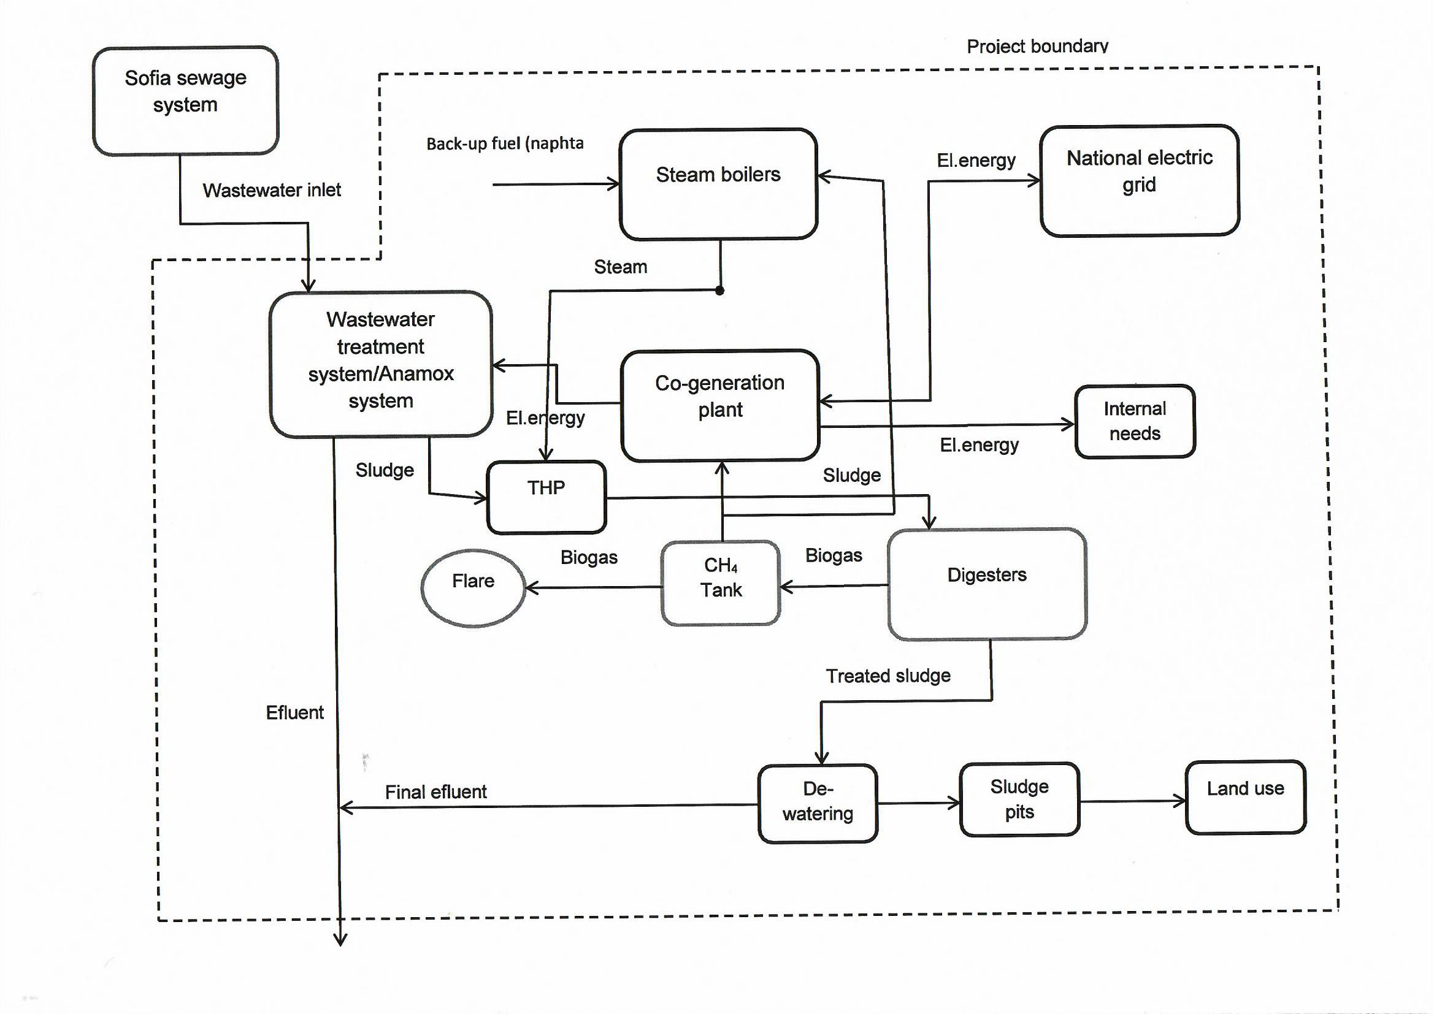

Source |  | GHGs | Included? | Justification/Explanation
Baseline scenario | Sludge treatment process | CO₂ | No | CO2 emissions from the decomposition of organic sludge are not accounted for.
Baseline scenario | Sludge treatment process | CH₄ | Yes | Major source of emissions in the baseline from sludge pits (decay of organic matter in anaerobic conditions)
Baseline scenario | Sludge treatment process | N₂O | No | Minor emission source and excluded by the methodology.
Baseline scenario | Sludge treatment process | …
Baseline scenario | Electricity consumption/ Electricity generation | CO₂ | Yes | AMS.I.C component:  The project activity involves the installation of a new grid-connected renewable power unit, whereas the baseline scenario is the electricity delivered to / consumed from the grid that, in the absence of the project, would have been generated by the operation of grid-connected power plants and by the addition of new generation sources.
Baseline scenario | Electricity consumption/ Electricity generation | CH₄ | No | Excluded for simplification. This is conservative.
Baseline scenario | Electricity consumption/ Electricity generation | N₂O | No | Excluded for simplification. This is conservative.
Baseline scenario | Electricity consumption/ Electricity generation | …
Baseline scenario | Thermal energy generation | CO₂ | Yes | AMS.I.C component:  The thermal energy would have been generated by using natural gas in the thermal boiler in the baseline scenario in the absence of biogas as a fuel.
Baseline scenario | Thermal energy generation | CH₄ | No | Excluded for simplification. This is conservative.
Baseline scenario | Thermal energy generation | N₂O | No | Excluded for simplification. This is conservative.
Project scenario | Sludge treatment process | CO₂ | No | Minor emission source and excluded by the methodology.
Project scenario | Sludge treatment process | CH₄ | Yes | Main source of emissions.  The treatment of wastewater sludge under the project activity may cause different emissions:  (i) Fugitive emissions due to inefficiencies in capture systems  (ii) Methane emissions from incomplete flaring
Project scenario | Sludge treatment process | N₂O | No | Minor emission source and excluded by the methodology.
Project scenario | Sludge treatment process | …
Project scenario | On-site electricity consumption | CO₂ | No | The biogas reactor uses electricity generated from the biogas fired gas engines and this is excluded.
Project scenario | On-site electricity consumption | CH₄ | No | Minor emission source and excluded by the methodology.
Project scenario | On-site electricity consumption | N₂O | No | Minor emission source and excluded by the methodology.
Project scenario | On-site electricity consumption | …
Project scenario | On-site fossil fuel consumption | CO₂ | Yes | Fossil fuel used in the dual-fuel steam boilers for thermal energy generation shall be monitored and considered in emission reduction calculations.
Project scenario | On-site fossil fuel consumption | CH₄ | No | Minor emission source and excluded by the methodology.
Project scenario | On-site fossil fuel consumption | N₂O | No | Minor emission source and excluded by the methodology.

B.4. Establishment and description of baseline scenario
According to the PDD validated by RINA (VR No 2015-BG-MD-02 ) and registered by GS in 2016 the baseline of the project in its type III component is described as follows:
The raw sludge is pumped for chemical conditioning followed by belt pressing with the resulting sludge cake being transported to the on-site drying beds and left for a period of 15 to 18 months to dry. The dry sludge cake is then transported some 18 km. to the landfill site, Kremikovtzi.
The main source of baseline CH₄ emissions is the sludge deposited in the sludge drying beds and the landfill to decompose in anaerobic conditions.
The baseline of the type I component of the initial project has also been described as “business as usual”, i.e. generation of thermal energy in the on-site boilers using light oil as a fuel and import of electric energy from the grid. The project activity displaces thermal energy from the boilers and electric energy from the grid by using the biogas for combustion in co-generating modules.
The baselines both of the type I and type III components have been validated positively by RINA with Validation report No 2015-BG-MD-02 and re-validated for the Second crediting period with a validation report GS_RCP REPORT_2021BGMD1_Sofiyska Voda_Rev 1.1Aa_23032021.
The project applies for a re-certification due to the implementation of a design change of the validated PDD.
A summary of the design change is presented in Section A.3 and Appendix 4 below.
As stated in the description the design change does not influence the baseline of the project and it remains the same as validated in the PDD presented for the renewal of the crediting period as follows:
Baseline emissions for the systems affected by the project activity may consist of:
- Emissions on account of electricity or fossil fuel used (BE_{power,y});
- Methane emissions from baseline wastewater treatment systems (BE_{ww,treatment,y});
- Methane emissions from baseline sludge treatment systems (BE_{s,treatment,y});
- Methane emissions on account of inefficiencies in the baseline wastewater treatment systems and presence of degradable organic carbon in the treated wastewater discharged into river/lake/sea (BE_{ww,discharge,y});
- Methane emissions from the decay of the final sludge generated by the baseline treatment systems (BE_{s,final,y}).
()
Where:
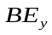 | Baseline emissions in year y (tCO₂e)
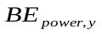 | Baseline emissions from electricity or fuel consumption in year y (tCO₂e)  Will be calculated following the requirements of AMS-I.C, version 22.0.
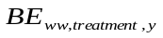 | Baseline emissions of the wastewater treatment systems affected by the project activity in year y (tCO₂e)  These emissions will not be taken into account because the project activity does not concern the wastewater treatment system.
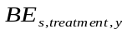 | Baseline emissions of the sludge treatment systems affected by the project activity in year y (tCO₂e)  These emissions will not be taken into account because the project activity does not concern this part of the sludge treatment system
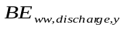 | Baseline methane emissions from degradable organic carbon in treated wastewater discharged into sea/river/lake in year y (tCO₂e). The value of this term is zero for the case 2 (b)  These source of baseline emissions will not be accounted for simplicity and conservativeness
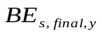 | Baseline methane emissions from anaerobic decay of the final sludge produced in year y (tCO₂e). This emission source is the main in the baseline. The dewatered sludge is stored for 15 to 18 months in drying beds and then transported to a landfill without biogas recovery. The emissions from the landfill are not taken into account for simplicity and conservativeness.

Applied to the baseline defined, formula (1) is reduced to the following:
BE_{y} = BE_{power,y} + BE_{s,treatment.y} (2)
Where:
Baseline emissions in year y (tCO₂e)
Baseline emissions from electricity or fuel consumption in year y (tCO2e)
Baseline methane emissions from anaerobic decay of the treated sludge produced in year y (tCO2e)

B.5. Demonstration of additionality
The additionality of the project was demonstrated in the PDD presented for the first certification by GS in 2016 and was positively validated by VVB RINA with Validation report No 2015-BG-MD-02. The project was re-validated for the Second crediting period ( val. Report GS_RCP REPORT_2021BGMD1_Sofiyska Voda_Rev 1.1Aa_23032021).
As the generation of electric energy by the project and saving fossil fuel are the only sources of virtual financial income related to the additionality, there will be changes in the financial parameters of the investment analysis validated in the initial PDD.
The following table demonstrates the project input parameters used for the investment analysis in the initial PDD with parameter changed due to the design change:

Parameter |  | Value | Reference
Investment costs
1st phase expenses | Eur | 7,020,432 | Sofiyska voda accounting records
2nd phase investment costs | Eur | 2,270,810
Design | Eur | 12,026 | Feasibility Report REUP
Equipment | Eur | 2,200,063 | Feasibility Report REUP
Construction works | Eur | 58,721 | Feasibility Report REUP
Total project costs | Eur | 9,291,242
O&M expenses
O&M expenses for 1st phase equipment | Eur/year | 37,335 | Sofiyska voda accounting records
O&M expenses for 2nd phase equipment | Eur/year | 52,600 | Feasibility Report REUP
Total O&M expenses | Eur/year | 89,935
Total installed capacity (electrical) | MW_{el} | 3.189 | Feasibility Report REUP
Total installed capacity (thermal) | MW_{th} | 3.264 | Feasibility Report REUP
Annual el.energy generation amount net to plant | MW_{el} | 22 217.27 | PDD design change
Annual thermal energy generation amount net to plant | MW_{th} | 52353.6 | PDD design change
Plant load factor | - | 0.55 | Feasibility Report REUP
Lifetime of the project | years | 25 (16 for CHP) | JI PDD ID BG1000166; Tool to determine the remaining lifetime of equipment, ver. 01
Investment analysis period | years | 20 | Guidelines on the Assessment of the Investment Analysis, (Version 05)
Installed electric capacity (gross) | MW | 3.189 | GS PDD; supplier technical specifications;  Feasibility Report REUP
Electric energy price | Eur/MWh_{el} | 33.65 | Feasibility Report REUP
Light fuel oil (LFO) price | Eur/t | 798.00 | Feasibility Report REUP
Grant KIDFS | Eur | 200,000 | Feasibility Report REUP
Equity | Eur | 8,291,242 | Feasibility Report REUP
Loan amount | Eur | 1,000,000 | Feasibility Report REUP
Depreciation rate (II category-equipment) | %/year | 30 | Depreciation rates in Bulgaria

The following changes have been made as estimated in the design change PDD:
- The period of the investment analysis have been extended with 3 years to reach the end of the second creditting period and the end of the project;
- The energy generated by the CHP and regarded as saved electric energy have been increased in line with the really generated average annual electric energy as validated for the 2nd creditting period PDD;
- The thermal energy supplied by the project has been increased in line with the estimations calculated in the design change PDD.
In this respect it has to be specially noted that there is no change in the configuration of the co-generation power plant and it is the same as during the validation of the initial PDD. The installed capacity of the 3 CHP units is still 3.189 MW gross.

The changes have been applied in the investment analysis for the last 3 years until the end of the project creditting period in which the design change will be in opeartion.
The revised IRR calculations result in an IRR of 14.71% which is lower than the benchmark of 16.40% that had been validated during the initial certification of the project under GS4GG.
As no changes in the operational expenses are estimated and the investment costs had already been realised, it only makes sence to apply sensityvity analysis for energy savings only. In this respevt a 10% increase of the eletric and thermal energy savings leads to an IRR of 14.90% which is still lower than the benchmark of 16.40%.
Hence it can be considered that the project is still additional after the design change.

The general purpose of the design change is to improve the quality of the effluent water after the wastewater treatment plant by decreasing the content of ammonia and nitrogen in it. The quantity of the sludge entering the bio-reactors is not affected and remains the same as in the validated PDD.
The quantity of the biogas generated by the project is expected to increase with about 10% but the generation of electric energy by the co-generation plant will remain the same. The number of co-generating units will remain the same as in the validated PDD and the additional quantity of biogas will be destroyed by combusting in the steam boilers to generate process steam.
B.5.1 Prior Consideration
N/A. The project applies for re-certification for a permanent design change.
B.5.2 Ongoing Financial Need
As a result of the project additional revenues from selling GS VERs amounting to EUR 325,543 were generated for the period from 2018 to 2020.The total revenue from selling of green energy and VERs for the period 2013-2020 amounts to EUR 1,939,250.
The chart below represents the annual revenues generated from sale of green energy and VER for the period 2013-2020:

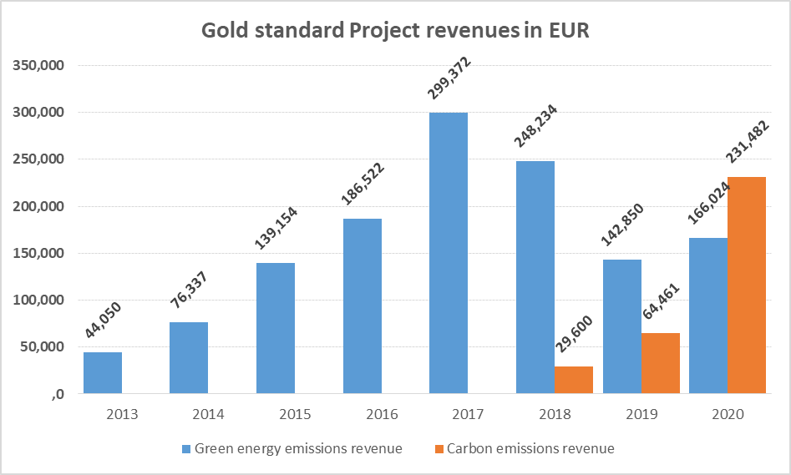
Investment projects for green energy implemented in WWTP Kubratovo 2013-2020 | EUR
Overhaul of co-generators | 1 601 497
Gasholder | 298 743
Digestor/Methane tank-new | 2 564 087
Total | 4 464 326

This additional income from the project boosted the internal projects and company investments for improvement of the processes in WWTP Kubratovo aiming highest level and quality of municipal waste-water treatment for the capital of Bulgaria.
Eventual future revenue from selling of VERs will considerably back Sofiyska voda AD re-novation program to increase plant capacity and quality of effluent water.

B.6. Sustainable Development Goals (SDG) outcomes
Relevant Target/Indicator for each of the three SDGs
Sustainable Development  Goals Targeted | Most relevant  SDG Target | SDG Impact
Sustainable Development  Goals Targeted | Most relevant  SDG Target | Indicator (Proposed or SDG Indicator)
13 Climate Action | 13.2 Integrate climate change measures into national policies, strategies and planning | 13.2.2 Total greenhouse gas emissions per year
6 Clean water and sanitation | 6.3 By 2030, improve water quality by reducing pollution, eliminating dumping and minimizing release of hazardous chemicals and materials, halving the proportion of untreated wastewater and substantially increasing recycling and safe reuse globally | 6.3.1 Proportion of wastewater safely treated
7. Affordable and clean energy | 7.2 By 2030, increase substantially the share of renewable energy in the global energy mix | 7.2.1 Total electricity produced: Renewable  7.2.2 Total thermal energy produced: Renewable

B.6.1 Explanation of methodological choices/approaches for estimating the SDG Impact

SDG 13: Climate action
13.2 Integrate climate change measures into national policies, strategies and planning
Baseline emissions
The project activity applies for re-certification due to a permanent design change under the requirements of GS4GG. It was initialy certified for GS starting 01/04/2014 and re-certified for a second 7-years crediting period starting 01/04/2021.
Substantial and detailed information and data for the operation of the project have been recorded for that time and is available at the plant. For the calculation of the baseline emissions for the new crediting period and after the design change the procedure described in paragraph 36 of AMS-III.H, ver. 19.0 will be used.
According that paragraph “In determining baseline emissions using equation 1, historical records of at least one year prior to the project implementation shall be used”. This shall include for example the COD removal efficiency of the wastewater treatment systems, the amount of dry matter in sludge, power and electricity consumption per m³ of wastewater treated, the amount of final sludge generated per tonne of COD removed, and all other parameters required for determination of baseline emissions.
The new crediting period started from 01/04/2021 so the data collected for the year 2020 will be used for the calculation of the baseline emissions.
Default values of parameters from AMS-III.H and other applicable tools will also be used for that purpose.
The type I component of the project will be accounted as stated above according to the requirements of AMS-I.C, version 22.0. Paragraph 26 states that for project activities implemented in existing facilities, baseline calculations shall be based on operational data on energy use (e.g. electricity, fossil fuel) and plant output (e.g. thermal and/or electrical energy) using:
- Most recent three years operational data immediately prior to the start date of the project activity in case of existing facilities which has more than three years of operation history;
- A minimum of most recent one year data in case of existing facilities which has more than three years of operation history but do not have three years operational data; or
- A performance test/measurement campaign carried out prior to the implementation of the project activity in case of existing facilities which has more than three years of operation history but do not have operational data/information such as efficiency, energy consumption and output or the available data is not reliable due to various factors such as the use of imprecise or non-calibrated measuring equipment. The project proponent may follow the relevant provisions from the “Tool to determine baseline efficiency of thermal and electricity systems”.
Option (a) will be used to calculate ex-ante the baseline emissions of the project due to thermal and electric energy from fossil fuel used in the plant displacement.
Methane emissions component
According to AMS-III.H, version 19.0, para.35:
Methane emissions from anaerobic decay of the final sludge produced are determined as follows:
${BE}_{final,s,y}=\sum_{j}{S_{j,BL,y}×{MCF}_{s,final,BL,j}×{DOC}_{s}×{UF}_{BL}×{DOC}_{F}×F×16/12×{GWP}_{CH4}}$ (3)
Where:
$$S_{j,BL,y}$$ | Amount of dry matter in the treated sludge.  The baseline wastewater treating system is not different from the project system so no correction of the monitored amount of dry matter in the treated sludge generated is required. In this case j=final and S_{final,BL,y} =S_{final, PJ,y}
$${MCF}_{s,final,BL,j}$$ | 0.4-Methane correction factor of the disposal site that receives the sludge in the baseline situation, estimated as per the procedures described in the “Tool to determine methane emissions avoided from disposal of waste at a solid waste disposal site, ver.08.0”,para.6.4. This is necessary because in the baseline the sludge generated is separated, dewatered and deposited in sludge pits for long period of time (~18 months) before transported to waste desposal site.
$${DOC}_{s}$$ |  | Degradable organic content of the untreated sludge generated in the year y (fraction, dry basis). Default values of 0.5 for domestic sludge shall be used. (AMS-III.H,ver.19.0, para.30)
$${DOC}_{F}$$ | Fraction of DOC dissimilated to biogas (IPCC default value of 0.5); (AMS-III.H,ver.19.0, para.30)
F | Fraction of CH₄ in biogas (IPCC default of 0.5);(AMS-III.H,ver.19.0, para.30)
$${UF}_{BL}$$ | Model correction factor to account for model uncertainties (0.89); (AMS-III.H,ver.19.0, para.30)
$${GWP}_{CH4}$$ | Global Warming Potential for methane (value of 28)
j | Index for baseline sludge treatment system. In this case j=1 because the treating system is only one.

Thermal and electricity displacement component
As discussed in Section B.4, Step 2.1 above the project activity falls under paragraph 29(a) of the methodology AMS-I.C, version 22.0:
Electricity is imported from a grid and thermal energy is produced using fossil fuel.
Baseline emissions for electricity production
Baseline emissions for supply of electricity to and/or displacement of electricity from a grid shall be calculated as follows:
$${BE}_{grid,y}={EG}_{grid,y}×{EF}_{grid,y}$$ | (4)
Where:
$${BE}_{grid,y}$$ | Baseline emissions for the grid electricity displaced by the project in year y (t CO_{2e})
$${EG}_{grid,y}$$ | Amount of grid electricity displaced by project in year y (MWh)
$${EF}_{grid,y}$$ | Emission factor of the grid (tCO_{2e}/MWh)
According to paragraph 35 of the methodology for cases 28(a), (b) and (c), baseline emissions shall be calculated as the sum of emissions from the production of electricity and thermal energy considering most recent historical records (average of the data from a minimum of the three most recent years excluding abnormal years is required).
Determination of emission factor for electricity
As per paragraph 37 of AMS-I.C, ver.22 for project activities that do not displace captive electricity generated by an existing plant but displace grid electricity import and/or supply electricity to a grid, the emission factor of the grid shall be calculated as per the procedures detailed in “AMS-I.D: Grid connected renewable electricity generation” or “AMS-I.F: Renewable electricity generation for captive use and mini-grid”.
For the purpose of this document the emission factor of the grid will be defined as per the requirements of AMS-I.F, ver.05.0 which is the latest version of this methodology.
According to Table 3, i.2 of the methodology:
If “Project displaces grid electricity consumption (e.g. grid import) and/or captive fossil fuel electricity generation at the user end (excess electricity may be supplied to a grid)” methodology AMS-I.F is applicable.
According to para.19 the “Emission factor for captive electricity generation shall be calculated as per the procedures described in the latest version of the “Tool to calculate baseline, project and/or leakage emissions from electricity consumption”
According to this tool:
5. If emissions are calculated for electricity consumption, the tool is only applicable if one out of the following three scenarios applies to the sources of electricity consumption:
(a) Scenario A: Electricity consumption from the grid. The electricity is purchased from the grid only, and either no captive power plant(s) is/are installed at the site of electricity consumption or, if any captive power plant exists on site, it is either not operating or it is not physically able to provide electricity to the electricity consumer;
(b) Scenario B: Electricity consumption from (an) off-grid fossil fuel fired captive power plant(s). One or more fossil fuel fired captive power plants are installed at the site of the electricity consumer and supply the consumer with electricity. The captive power plant(s) is/are not connected to the electricity grid; or
(c) Scenario C: Electricity consumption from the grid and (a) fossil fuel fired captive power plant(s). One or more fossil fuel fired captive power plants operate at the site of the electricity consumer. The captive power plant(s) can provide electricity to the electricity consumer. The captive power plant(s) is/are also connected to the electricity grid. Hence, the electricity consumer can be provided with electricity from the captive power plant(s) and the grid.
This project falls under the requirements of (a) Scenario A because before implementation of the project electric energy was purchased from the grid only.
For the purpose of this project the emission factor of the electricity grid is defined according para.20, Option A2 (b):
A value of 0.400 tCO_{2e}/MWh for electricity grids where hydro power plants constitute less than 50% of total grid generation in 1) average of the five most recent years.
The data regarding the hydro power plants and total energy generation in Bulgaria is given below:
Table 3: Percentage of electric energy generated by hydro power plants in Bulgaria
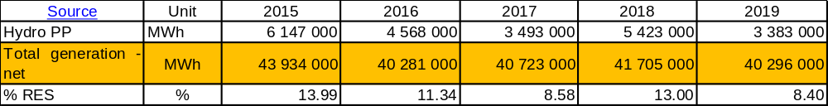
Source: https://www.iea.org/data-and-statistics?country=BULGARIA&fuel=Energy%20supply&indicator=TPESbySource
Baseline emissions for heat production
As per paragraph 33 of AMS-I.C, version 22:
For thermal energy produced using fossil fuels and/or grid electricity the baseline emissions are calculated as follows:
$${BE}_{thermal,Co2,y}=\left(\frac{{EG}_{thermal,y}}{{}_{BL,thermal}}\right)×{EF}_{FF,CO2}$$ | (5)
Where:
$${BE}_{thermal,Co2,y}$$ | Baseline emissions from thermal energy displaced by the project activity during the year y (t CO₂)
$${EG}_{thermal,y}$$ | Net quantity of thermal energy supplied by the project activity during the year y (TJ)
$${EF}_{FF,CO2}$$ | CO₂ emission factor of the fossil fuel that would have been used in the baseline plant obtained from reliable local or national data if available, alternatively, IPCC default emission factors can be used (t CO₂/TJ)
$${}_{BL,thermal}$$ | Efficiency of the plant using fossil fuel that would have been used in the absence of the project activity determined as per paragraph 42 (c) – 100% default value

It can be stated that after the design change implementation there will not be any change in the baseline scenario so all sources and parameters monitored or not monitored for the project activity remain unchanged.
Project emissions
According to AMS-III.H, Version 19, para.39 the project emissions from the systems affected by the project activity are:
- CO₂ emissions from electricity and fuel used by the project facilities (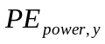);
- Methane emissions from wastewater treatment systems affected by the project activity, and not equipped with biogas recovery in the project scenario (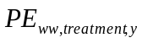);
- Methane emissions from sludge treatment systems affected by the project activity, and not equipped with biogas recovery in the project situation (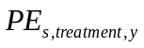);
- Methane emissions on account of inefficiency of the project activity wastewater treatment systems and presence of degradable organic carbon in treated wastewater (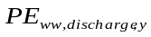);
- Methane emissions from the decay of the final sludge generated by the project activity treatment systems (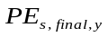);
- Methane fugitive emissions due to inefficiencies in capture systems (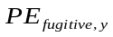);
- Methane emissions due to incomplete flaring (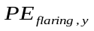);
- Methane emissions from biomass stored under anaerobic conditions which would not have occurred in the baseline situation (PE_{biomass,y}).

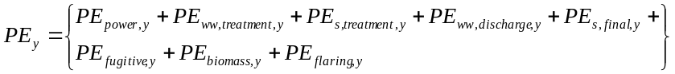 (6)
Where
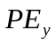 | Project activity emissions in the year y, (tCO₂e)
 | Emissions from electricity or fuel consumption in the year y, (tCO₂e).
 | Methane emissions from wastewater treatment systems affected by the project activity, and not equipped with biogas recovery, in year y, (tCO₂e).
 | Methane emissions from sludge treatment systems affected by the project activity, and not equipped with biogas recovery, in year y, (tCO₂e).
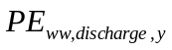 | Methane emissions from degradable organic carbon in treated wastewater in year y ,(tCO₂e).
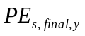 | Methane emissions from anaerobic decay of the final sludge produced in year y, (tCO₂e).
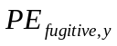 | Methane emissions from biogas release in capture systems in year y, calculated as per paragraph 40 of the AMS-III.H,version 19 (tCO₂e)
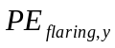 | Methane emissions due to incomplete flaring in year y, (tCO₂e).
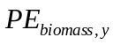 | Methane emissions from biomass stored under anaerobic conditions.

The project activity involves some project emissions as below:
PE_{fugitive,y} Methane emissions from the capturing systems will be accounted for in the proposed project as the project activity involves capture of biogas for power generation.
PE_{flaring,y} Methane emissions due to incomplete flaring will be accounted for in the proposed project as flaring will occur in case of emergency.
The project activity does not involve the sources of project emissions listed below:
PE_{power,y} Project emissions from combustion of fossil fuel (naphta) in case of emergency PE_{s,treatment,y} Methane emissions from sludge treatment systems will not be accounted for the project because the project activity involves methane recovery for energy generation. The escape methane emissions from the system will be treated as fugitive emissions.
PE_{ww,treatment,y} Methane emissions from wastewater treatment systems will not be accounted for in the proposed project as the project activity does not involve the wastewater treatment system.
PE_{ww, discharge,y} Methane emissions from degradable organic carbon in treated wastewater will not be accounted for the project because the treated wastewater in the project activity is the same as in the baseline.
PE_{s,final,y} Methane emissions from anaerobic decay of the final sludge will not be accounted for the project because the final sludge from sludge treatment system will be used as fertilizer.
PE_{biomass,y} Methane emissions from biomass stored will not be accounted for the project because the project activity does not involve the storing of biomass.
The project emissions calculation is shown below.
Project Emission from power (thermal energy) consumption
After the design change the new steam boilers envisage the use of liquid fossil fuel (naphta) as an emergency fuel which in this case will be a source of project emissions and therefore monitored.
Methane emissions from biogas release in capture system
As per paragraph 39 of the AMS-III.H,version 19 fugitive emissions from the capture system are estimated in this component.
PE_{fugitive,y} = PE_{fugitive,ww,y} + PE_{fugitive,s,y} (7)

Where,
PE_{fugitive,y} Emissions from biogas release in capture system in year y, (tCO2e)
PE_{fugitive,ww,y} Fugitive emissions through capture inefficiencies in the anaerobic wastewater treatment system in the year y, (tCO2e)
PE_{fugitive,s,y} Fugitive emissions through capture inefficiencies in the anaerobic sludge treatment systems in the year y, (tCO2e)

Since there will be no anaerobic wastewater treatment,

PE_{fugitive,y} = PE_{fugitive,s,y} (8)
The fugitive emissions through capture inefficiencies in the anaerobic sludge treatment systems in the year y will be determined as per paragraph 40 (b) of AMS-III.H: a default value of 0.05 m³ biogas leaked/m³ biogas produced will be used as an alternative.
Emissions due to incomplete flaring
For ex-ante calculations, baseline emission calculation for sludge treatment (equation 3 of this document) will be used but without the consideration of GWP for CH4 (as per AMS-III.H, paragraph 40).
For ex-post calculations the tool ”Project emissions from flaring”, ver.3.0 by using actual monitored data will be applied.
An enclosed flare is used in project activity, therefore the abovementioned tool is applicable.
The calculation procedure in this tool determines the project emissions from flaring the residual gas (PE_{flare,y}) based on the flare efficiency (η_{flare,m}) and the mass flow of methane to the flare (F_{CH4,RG,m}). The flare efficiency is determined for each minute m of year y based either on monitored data or default values.
The project emissions calculation procedure is given in the following steps:
STEP 1: Determination of the methane mass flow of the residual gas;
STEP 2: Determination of the flare efficiency;
STEP 3: Calculation of project emissions from flaring.
Step 1: Determination of the methane mass flow in the residual gas
The “Tool to determine the mass flow of a greenhouse gas in a gaseous stream”, version 03.0 will be used to determine the following parameter:

Parameter | SI unit | Description
F_{CH4,m} | kg | Mass flow of methane in the residual gaseous stream in the minute m

F_{CH4,m}, which is calculated as the mass flow during minute m, shall then be used to determine the mass of methane in kilograms fed to the flare in minute m (F_{CH4,m}). Option 2 and Option A are used fro determination of this parameter (i.e. the gaseous steram is considered dry). This is a conservative approach because the methodology is used for calculation of the project emissions.
For simplification equation (17) from the above tool will be used:
AS per Option 2:

m_{H2O,t,db,sat} | = 0 | Saturation absolute humidity in time interval t on a dry basis (kg H₂O/kg dry gas)

The gaseous stream can be considered dry because the temperature at the point of measurement is ~36ºC. The temperature of the sludge inside the bioreactors is maintained at about 37ºC to provide mesophilic conditions.
As per Option A:
The mass flow of greenhouse gas (in this case CH₄) (F_{CH4,m})is determined as follows:
F_{CH4,m} = V_{t,db}*ν*ρ (9)
Where
F_{CH4,m} | = | Mass flow of CH4 (kg/y)
V_{t,db} | = | Volumetric flow of CH₄(m³/y)
ν | = | Volumetric fraction of CH₄ (m³/m³)
ρ= D_{CH4} | = | 0.00067 Density of CH₄ (t/m³) as per ACM 0010

Step 2: Determination of flare efficiency (enclosed flare)
For the determination of the flare efficiency Option A of the “Tool to determine project emissions from flaring”, version 03.0 will be applied:
The flare efficiency for the minute m (η_{flare,m}) is 90% when the following two conditions are met to demonstrate that the flare is operating:
(a) The temperature of the flare (T_{EG.m}) and the flow rate of the residual gas to the flare (F_{RG,m}) is within the manufacturer’s specification for the flare (SPEC_{flare}) in minute m; and
(b) The flame is detected in minute m (Flame_{m}).
Otherwise η_{flare,m} is 0%.
For conservativeness the default efficiency of the flare is adjusted downwards to 80%.
Step 3: Calculation of project emissions from flaring
Project emissions from flaring are calculated as the sum of emissions for each minute m in year y, based on the methane mass flow in the residual gas (F_{CH4,RG,m}) and the flare efficiency (η_{flare,m}), as follows:
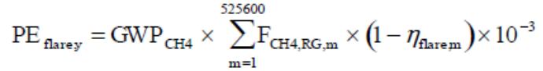 (10)
Where:
PE_{flare,y} | Project emissions from flaring of the residual gas in year y (tCO2e)
GWP_{CH4} | 28, Global warming potential of methane valid for the commitment period (tCO2e/tCH4)
F_{CH4,m} | Mass flow of methane in the gas flared in the minute m (kg)
η_{flare,m} | Flare efficiency in minute m

Leakage
There is no leakage from the project activity. There is no equipment transferred from another activity.
Emission reductions
The emission reductions will be estimated ex ante in the PDD using the equations provided in the baseline, project and leakage emissions sections above. Emission reductions will be estimated ex ante as follows:
(11)
Where:
ER_{y,ex ante} Ex ante emission reduction in year y (tCO2e)
LE_{y,ex ante} =0, Ex ante leakage emission in year y (tCO2e). There are no leakage emissions from the project.
PE_{y,ex ante} Ex ante project emission in year y (tCO2e)
BE_{y, ex ante} Ex ante baseline emission in year y (tCO2e)
The project activity is classified under paragraph 2(a) of AMS-III.H so the ex post calculation of the emission reductions will be performed as per paragraph 46 of the methodology.
The emission reduction achieved by the project activity (ex post) will be the difference between the baseline emissions and the project emissions.
ER_{y,ex post} = BE_{y,ex post} – PE_{y,ex post} (12)
The historical records of electricity and fuel consumption and the quantity of sludge produced by the replaced units will be used for the baseline calculation. Project emissions from fugitive emissions and incomplete flaring (PE_{fugitive,y}, PE_{flaring,y}) will also be considered in the calculation of the emission reductions, however the emissions from the wastewater outflow and final sludge (PE_{ww,discharge,y}, PE_{s,final,y}) will be disregarded.
7. Affordable and clean energy The project is related to Target 7.3 - By 2030, reduce the adverse per capita environmental impact of cities, including by paying special attention to air quality and municipal and other waste management.
The quality of the air in cities is of main priority of the European Union and radical measures have been taken to decrease the emissions of harmful gaseous pollutants.
The production of electricity from biogas replaces the use of fossil fuels thus reducing other air pollutants such as NO_{x} gases. These emissions are concerning stack flue gas and are monitored regularly.The project has major positive effect on the air quality through dramatically reducing the existing methane gas emissions at the plant.
Another big problem is waste management .
In this respect the project follows the highest standards in the European Union.
The company owner of the project is certified in ISO 14001:2015 standard and has all necessary permissions from the Ministry of Environment and Water to handle the waste products generated by the project, like waste oil and waste water.
The quantification of the targets of the project is achieved by continuous monitoring and measuring are described in details in Section B.7.1 – Data and parameters mnitored.
The parameters monitored are:
- Total electric energy produced:renewable
- Total thermal energy produced:renewable

SDG 6: Clean water and sanitation
The project is related to Target 6.3.1. - Proportion of wastewater safely treated
The project reduces in a considerable extent the risk of contaminating the natural water resources in the area and abroad. The water effluent released by the wastewater treatment plant is delivered to the Iskar river which flows into the Danube river and further into the Black sea.
Providing deepest purification of the water effluent is the main target achieved by the project.
In the absence of the plant and related project will allow contaminated municipal wastewater to go directly into the river and compromise all life in it and the quality of water sources used for drinking and irrigation.
The project helps to improve the access to safe and affordable drinking water for local population;
By stimulating investments in widening and perfection of the sewage system of the city of Sofia the project helps providing access to adequate and equitable sanitation and hygiene for all local citizens;
The project helps improving water quality by reducing pollution, eliminating dumping and minimizing release of hazardous chemicals and materials, considerably decreases the proportion of untreated wastewater and substantially increases recycling and safe reuse in the local community;
The project owner holds the concession of Sofia city water supply and sewage so the project helps implement integrated water resources management at all levels in the capital city and surrounding area;
The project helps to protect and restore water-related ecosystems, rivers, aquifers and lakes;
The project owner is the French company Veolia operating internationally so the implementation of the project expands international cooperation and capacity-building support in water- and sanitation-related activities and programmes, including water harvesting, water efficiency, wastewater treatment, recycling and reuse technologies;
The project supports and strengthens the participation of local communities in improving water and sanitation management.

Bulgaria is a Member State of the European Union, and as such is subject to EU legislation and guidance on the precautionary principle, including:
- The Treaty on the Functioning of the European Union (Article 191)
- Communication from the European Commission of 2 February 2000 on the precautionary principle [COM(2000) 1]
The process of waste water treatment itself is a prerequisite and leads to the restoration and maintenance of diversity of species along the Iskar river. Apart from this, "Sofiyska voda" AD carries out numerous environmental initiatives aimed at afforestation, cleaning of tourist areas and others.
Sofiyska Voda has its policy on environmental protection and reports its achievements in this field by means of annual ecological reports. Company’s activities affects the environment and therefore it is committed to:
- effectively preserving and protecting the environment from pollution;
- working in compliance with the laws, ordinances and standards on environmental protection;
- effectively and efficiently using natural resources, incl. energy for the sake of their preservation.
Sofiyska Voda has a Certificate in Environmental Management under the international standard ISO 14001:2015 by Tuev Nord and has certificate No 44 104 22 32 0109. The Waste-water Treatment olant (WwTP) is also certified under ISO 45001:2018.The introducing and the supporting of an environmental management system ensures the passing of continuous process which reduces the level of risk pollution and other unfavorable environmental impacts, the effective use of the resources to enhance the Company’s activities and to create a positive image of Sofiyska Voda among the society, the regulator and the control bodies, all stakeholders.
The company is performing self-monitoring on the following environmental elements:
- Wastes;
- Air emissions;
- Technological processes;
- Treated wastewaters;
- Used underground waters;
- Industrial enterprises;
The project is a major part of waste-water treatment of the whole city of Sofia which takes place in the Waste-water treatment plant operated by Sofiyska voda. That means to collect and treat the waste-waters of more than 1,5 mln. people living in the area.The effluent of the project is of quality that allows its delivery to the river Iskar.
The plant possesses Permission for deposition of the effluent outlet water into the Iskar river No 1295/14.04.2014, issued by the Ministry of Environment and Water. The Permission defines the quantity of inlet and outlet water and the quality of the effluent water. The quality of the effluent water and heavy metals content is monitored and measured according to the plan and frequency part of the Permission.
No depletion or contamination of local reservoirs/ aquifers occurs.
The quality of the water is monitored by the accredited laboratory part of Kubratovo Wastewater Treatment Plant. The results of the monitoring are issued in routine Protocols, available for inspection in the plant.
The quantification of the targets of the project is achieved by continuous monitoring and measuring of the biochemical and chemical content and characteristics of the inlet and effluent water described in Section B.7.1 – Data and parameters monitored.
B.6.2 Data and parameters fixed ex ante

Copy the table for each piece of data and parameter; use headings to group parameter tables by SDG
SDG13
13.2 Integrate climate change measures into national policies, strategies and planning Table 4
Data/parameter | EF_{EL,y}
Unit | tCO_{2e}/MWh
Description | Emission factor of the national power grid of Bulgaria
Source of data | Default value
Value(s) applied | 0.400
Choice of data or Measurement methods and procedures | According to “Tool to calculate baseline, project and/or leakage emissions from electricity consumption”  This project falls under the requirements of (a) Scenario A because before implementation of the project electric energy was purchased from the grid only.  For the purpose of this project the emission factor of the electricity grid is defined according para.20, Option A2 (b):  A value of 0.4 t CO2e/MWh for electricity grids where hydro power plants constitute less than 50% of total grid generation in 1) average of the five most recent years.
Purpose of data | Calculation of baseline emissions
Additional comment | This parameter has been fixed ex-ante for the whole crediting period.

13.2 Integrate climate change measures into national policies, strategies and planning Table 5
Data/parameter | MCF_{s,BL,treatment}
Unit | -
Description | Methane correction factor of the disposal site that receives the treated sludge in the baseline situation,
Source of data | IPCC 2006 Guidelines for national Greenhouse Gas Inventories
Value(s) applied | 0.4
Choice of data or Measurement methods and procedures | CDM Tool “Emissions from solid waste disposal sites”, Version 08
Purpose of data | Calculation of baseline emissions
Additional comment

13.2 Integrate climate change measures into national policies, strategies and planning Table 6
Data/parameter | DOC_{s}
Unit
Description | Degradable organic content of the untreated sludge generated in the year y (fraction, dry basis)
Source of data | IPCC 2006 Guidelines for national Greenhouse Gas Inventories
Value(s) applied | 0.5
Choice of data or Measurement methods and procedures | Default value from AMS-III.H
Purpose of data | Calculation of baseline emissions
Additional comment

13.2 Integrate climate change measures into national policies, strategies and planning Table 7
Data/parameter | DOC_{F}
Unit | -
Description | Fraction of DOC dissimilated to biogas
Source of data | IPCC 2006 Guidelines for national Greenhouse Gas Inventories
Value(s) applied | 0.5
Choice of data or Measurement methods and procedures | Default value from AMS-III.H
Purpose of data | Calculation of baseline emissions
Additional comment

13.2 Integrate climate change measures into national policies, strategies and planning Table 8
Data/parameter | F
Unit | -
Description | Fraction of CH4 in biogas
Source of data | IPCC 2006 Guidelines for national Greenhouse Gas Inventories
Value(s) applied | 0.5
Choice of data or Measurement methods and procedures | Default value from AMS-III.H
Purpose of data | Calculation of baseline emissions
Additional comment

13.2 Integrate climate change measures into national policies, strategies and planning Table 9
Data/parameter | UFB_{L}
Unit | -
Description | Model correction factor to account for model uncertainties
Source of data | AMS-III.H
Value(s) applied | 0.89
Choice of data or Measurement methods and procedures | Default value from AMS-III.H
Purpose of data | Calculation of baseline emissions
Additional comment

13.2 Integrate climate change measures into national policies, strategies and planning Table 10
Data/parameter | GWP_{CH4}
Unit | -
Description | Global Warming Potential for methane
Source of data | IPCC
Value(s) applied | 28
Choice of data or Measurement methods and procedures | Default value from 5th IPCC Assessment Report is used as per the recommendations of GS
Purpose of data | Baseline/project emissions calculation
Additional comment

13.2 Integrate climate change measures into national policies, strategies and planning Table 11
Data/parameter | η_{flare}
Unit | %
Description | Flare efficiency
Source of data | “Project emissions from flaring” , Version 03.0.0
Value(s) applied | 80%
Choice of data or Measurement methods and procedures | Default value from “Project emissions from flaring” , Version 03.0.0.  The flare efficiency for the minute m (η_{flare,m}) is 90% when the following two conditions are met to demonstrate that the flare is operating:  (1) The temperature of the flare (T_{EG.m}) and the flow rate of the residual gas to the flare (F_{RG,m}) is within the manufacturer’s specification for the flare (SPEC_{flare)} in minute m; and  (2) The flame is detected in minute m (F_{lame,m}).  Otherwise η_{flare,m} is 0%.
Purpose of data | Project emissions calculation
Additional comment | The value is 10% less the default value for conservativeness.

13.2 Integrate climate change measures into national policies, strategies and planning Table 12
Data/parameter | η_{BL,thermal}
Unit | %
Description | Efficiency of the plant using fossil fuel that would have been used in the absence of the project activity determined as per paragraph 39 or 40
Source of data | AMS-I.C, version 22 – default value
Value(s) applied | 100%
Choice of data or Measurement methods and procedures | Efficiency of the plant using fossil fuel that would have been used in the absence of the project activity determined as per paragraph 42 (c) of of AMS-I.C, version 22 – 100% default value
Purpose of data | Baseline emissions calculation
Additional comment | The baseline fuel is changed from light oil to natural gas.

13.2 Integrate climate change measures into national policies, strategies and planning
Table 13
Data/parameter | EF_{FF,CO2}
Unit | tCO_{2e}/TJ
Description | CO2 emission factor of the fossil fuel that would have been used in the baseline plant obtained from reliable local or national data if available, alternatively, IPCC default emission factors can be used
Source of data | 2006 IPCC Guidelines for national Greenhouse Gas Inventories, Volume 2.2 Stationary Combustion, Table 2.2
Value(s) applied | 54.30
Choice of data or Measurement methods and procedures | Lower value at 95% confidence interval for natural gas
Purpose of data | Baseline emissions calculation
Additional comment | The baseline fuel is changed from light oil (naphta) to natural gas

13.2 Integrate climate change measures into national policies, strategies and planning Table 14
Data/parameter | EF_{CO2,i,y}
Unit | tCO_{2e}/GJ
Description | CO2 emission factor of the light oil (naphta) used for emergency cases in year y
Source of data | 2006 IPCC Guidelines on National GHG Inventories
Value(s) applied | 76.30
Choice of data or Measurement methods and procedures | IPCC default values at the upper limit of the uncertainty at a 95% confidence interval as provided in Table 1.4 of Chapter 1 of Vol. 2 (Energy) of the 2006 IPCC Guidelines on National GHG Inventories
Purpose of data | Project emissions calculation
Additional comment

13.2 Integrate climate change measures into national policies, strategies and planning
Table 15
Data/parameter | PE_{fugitive,s,y}
Unit | Nm³ leaked/Nm³ produced
Description | Portion of methane leaked from the system
Source of data | AMS-III.H, paragraph 40(b)
Value(s) applied | 0.05
Choice of data or Measurement methods and procedures | Default value
Purpose of data | Project emissions calculation
Additional comment

13.2 Integrate climate change measures into national policies, strategies and planning
Table 16
Data/parameter | D_{CH4}
Unit | t/m³
Description | Density of methane
Source of data | Methane density calculator and CDM ACM 0010 (v8.0), p.30
Value(s) applied | 0.00067
Choice of data or Measurement methods and procedures | Default value
Purpose of data | Project emissions calculation including emissions from incomplete flaring.
Additional comment

There are no parameters fixed ex-ante for SDG 6 & SDG 11.
B.6.3 Ex ante estimation of SDG Impact
SDG 13: Take climate action
Baseline emissions
The baseline emissions are calculated according to formula (2):
BE_{y} = BE_{power,y} + BE_{s,final,y}
Methane emissions from anaerobic decay of the sludge at digesters inlet are determined as per formula (3):
${BE}_{final,s,y}=\sum_{j}{S_{j,BL,y}×{MCF}_{s,final,BL,j}×{DOC}_{s}×{UF}_{BL}×{DOC}_{F}×F×16/12×{GWP}_{CH4}}$
No any change in the baseline scenario is expected after the implementation of the design change because it does not affect the quantity of wastewater sludge and dry matter that enters the digesters. Hence the quantities of sludge validated in the PDD for the second GS4GG crediting period for ex-ante calculation of the baseline emissions will remain the same after the design change.
The data used for the calculation is taken from plant records and Verification Reports for the last 3 years (2018,2019 & 2019) before start of the new crediting period and are presented in the following table:
Table 17: Quantity of sludge and dry matter in the sludge generated in the last 3 years before start of the second crediting period (started 01/04/2021) for 2018,2019 & 2020.
Month/Year | Quantity of sludge entering the digesters | Quantity of dry substance in the sludge
Month/Year | Q_DGs_inlet | Sfinal,PJ,y
Month/Year | [m3] | [t]
Jan 2018 | 60,760.00 | 3,385.41
Feb 2018 | 54,880.00 | 3,395.70
Mar 2018 | 60,760.00 | 4,241.54
Apr 2018 | 58,700.00 | 3,436.00
May 2018 | 60,760.00 | 3,714.69
Jun 2018 | 58,400.00 | 3,851.44
July 2018 | 58,640.00 | 3,191.45
Aug 2018 | 58,240.00 | 3,122.49
Sep 2018 | 55,200.00 | 3,226.44
Oct 2018 | 57,820.00 | 2,816.27
Nov 2018 | 47,452.00 | 2,407.78
Dec 2018 | 38,815.00 | 2,005.81
Total 2018 | 670,427.00 | 38,795.03
Jan 2019 | 38,703.00 | 1,839.04
Feb 2019 | 41,310.00 | 2,199.44
Mar 2019 | 55,210.00 | 2,780.06
Apr 2019 | 57,975.00 | 2,807.38
May 2019 | 60,760.00 | 3,142.57
Jun 2019 | 55,970.00 | 3,327.98
July 2019 | 56,720.00 | 3,248.49
Aug 2019 | 43,300.00 | 2,283.04
Sep 2019 | 54,720.00 | 2,550.35
Oct 2019 | 58,220.00 | 2,809.46
Nov 2019 | 58,360.00 | 2,845.25
Dec 2019 | 60,760.00 | 3,060.25
Total 2019 | 642,008.00 | 32,893.29
Jan 2020 | 61,440.00 | 2,796.19
Feb 2020 | 57,000.00 | 3,080.70
Mar 2020 | 62,000.00 | 3,433.50
Apr 2020 | 60,040.00 | 2,767.51
May 2020 | 64,360.00 | 2,848.19
Jun 2020 | 61,880.00 | 3,389.90
July 2020 | 59,020.00 | 3,299.04
Aug 2020 | 54,840.00 | 2,362.84
Sep 2020 | 61,440.00 | 2,370.98
Oct 2020 | 54,640.00 | 2,893.13
Nov 2020 | 59,520.00 | 2,531.34
Dec 2020 | 58,800.00 | 3,112.99
Total 2020 | 714 487.00 | 34,886.31
Total 3 years | 2,026,922.00 | 106,574.63
Annual average (3 years basis) | 675,640.67 | 35,524.87
Capacity addition by Digester #5 for 1 year (25% of annual averageover 7 years period) | 24,130 | 1,269.77
Estimated quantity for the new crediting period | 699,770.67 | 36,794.64
Average density of dry matter in the sludge [t/m3] |  | 0.052581

Source: Plant records / Verified Periodical Monitoring reports
The design change does not influence the quantity of sludge entering the digesters, hence the baseline of the project will not change and the baseline emissions due to avoidance of methane emitted in the atmosphere in the baseline will remane unchanged.
For conservativeness the GWP of CH₄ is left as per the 5th IPCC Report.
The baseline emission reductions are as follows:
BE_{s,treatment,y}=699,770.67*0.052581*0.4*0.5*0.89*0.5*0.5*(16/12)*28 = 61,128 tCO_{2e}/y
Baseline emissions are calculated in the excel sheet name: Sofiyska_voda_VER_Calculation_ver.02_21.04.2026_GS_design_change , attached to this PDD.
Baseline emissions for supply of electricity to and/or displacement of electricity from a grid shall be calculated as per formula (4):
${BE}_{grid,y}={EG}_{grid,y}×{EF}_{grid,y}$

The electricity generation after the design change will remain as estimated in the validated PDD for the second crediting period because the CHP will continue to generate electricity and thermal energy in optimal conditions.
The electric energy generated by the CHP and displaced from the grid is taken from plants records for years 2018, 2019 and 2020 and is presented in the following table:
Table 18: Electric energy displaced from the grid and thermal energy supplied to the project in the last 3 years (2018,2019 & 2020) before start of the new crediting period
Month/year | El. energy generated (net)
Month/year | EG_{grid}
Month/year | [MWh_{el}]
Jan 2018 | 2,100.06
Feb 20108 | 1,912.62
Mar 2018 | 2,126.46
Apr 2018 | 2,071.83
May 2018 | 2,235.34
Jun 2018 | 2,075.29
July 2018 | 1,663.72
Aug 2018 | 1,568.80
Sep 2018 | 1,483.65
Oct 2018 | 2,048.16
Nov 2018 | 1,787.60
Dec 2018 | 1,186.13
Total 2018 | 22,259.65
Jan 2019 | 695.07
Feb 2019 | 887.87
Mar 2019 | 1,660.12
Apr 2019 | 1,562.94
May 2019 | 1,650.86
Jun 2019 | 2,075.34
July 2019 | 2,002.70
Aug 2019 | 1,475.13
Sep 2019 | 1,888.44
Oct 2019 | 2,161.44
Nov 2019 | 2,197.26
Dec 2019 | 2,111.31
Total 2019 | 20,368.49
Jan 2020 | 2,043.30
Feb 2020 | 2,097.82
Mar 2020 | 2,274.89
Apr 2020 | 1,968.26
May 2020 | 2,011.75
Jun 2020 | 2,051.01
July 2020 | 1,954.82
Aug 2020 | 1,652.01
Sep 2020 | 1,902.30
Oct 2020 | 2,040.87
Nov 2020 | 2,054.18
Dec 2020 | 1,972.47
Total 2020 | 24,023.68
Total 3 years | 66,651.82
Annual average (3 years basis) | 22,217.27
Plant Load Factor (PLF) | 0.7953

Source: Plant records/Verified Periodical Monitoring reports
The conservative assumption is that the CHP will operate at optimal conditions during that historical period.
BE_{grid,y} = 22,217.27*0.400 = 8,886 tCO_{2e}/y
Baseline emissions are calculated in the excel sheet name: Sofiyska_voda_VER_Calculation_ver.02_21.04.2026_GS_recertification , attached to this PDD.
As per the certified PDD for the new GS4GG crediting period the co-generation plant consists of 3 units with the following capacity:
Electric capacity – 3 x 1.063 = 3.189 MW_{el}
Thermal capacity – 3 x 1.088 = 3.264 MW_{th}
The average Plant Load Factor verified for the last 3 years period before the design change is 0.7953 (Table 18).
The thermal energy generated by the CHP only, in this case is calculated as:
3 x 1.088 x 8760 x 0.7953 =22,739.73 MWh_{th}/y or 81.863 TJ/y
The design change envisages the replacement of the existing hot water boiler with 2 steam boilers combusting biogas for direct heating of the sludge. The boilers are with 4 t/h saturated steam generation capacity (~2.7 MW_{th} / 9.72 GJ) and will operate in full capacity during winter period and half capacity during summer. Taking into consideration the PLF of 0.8347 stated above the estimated thermal energy generated is calculated as follows:
Winter time: 2*9.72*4,380*0.8347 = 71.07 TJ
Summer time: 9.72*4,380*0.8347 = 35.54 TJ
Total for the year: 71.07 + 35.54 = 106.61 TJ
Combined with the thermal energy generated by the CHP the estimated thermal energy generated by the project activity after the design change is calculated ex-ante as:
81.863 + 106.61 = 188.473 TJ per year.
For thermal energy produced using fossil fuels and/or grid electricity the baseline emissions due to the usefull application of the exhaust heat from the co-generators and steam boilers are calculated as per formula (5):
${BE}_{thermal,Co2,y}=\left(\frac{{EG}_{thermal,y}}{{}_{BL,thermal}}\right)×{EF}_{FF,CO2}$
(188.473/1.0)*54.3 = 10,234 tCO_{2e}/y
Baseline emissions are calculated ex-ante in the excel sheet name: Sofiyska_voda_VER_Calculation_ver.01_20.01.2025_GS_design_change , attached to this PDD.
The total baseline emissions after the design change estimated ex-ante for the project are:
BE_{y} = 61,128 + 8,886 + 10,234 = 80,248 tCO_{2e}/y
Total baseline emissions are calculated in the excel sheet name: Sofiyska_voda_VER_Calculation_ver.02_21.04.2026_GS_design_change , attached to this PDD.
For ex-post determination of the baseline emissions due to thermal energy generation, parameter EG_{thermal,y} will be defined by direct measuring of the thermal energy generated at the steam boilers delivery side.
The useful thermal energy generated by the CHP units is used for preheating of the steam boilers feed water and no return condensate is present. In this case the thermal energy measured at steam boilers outlet is equal to the combined useful thermal energy generated by the CHP and the steam boilers.
Project emissions
The project emissions are estimated ex-ante according to the adjusted formula (6):
PE_{y} = PE_{power,y} + PE_{fugitive,y} + PE_{flare,y}
For the ex-ante calculations the Project emissions from emergency fossil fuel combustion is estimated as zero because usually there is no need of using emergency fuel:
PE_{power,y} = 0
The fugitive project emissions are estimated for the needs of the ex-ante calculations at 0.05 of the total methane content in the average annual quantity of biogas generated by the anaerobic digesters in the starting years of the second crediting period and before the start of the new installation in May,2024– 2021 (started 01/04/2021), 2022 & 2023, increased by 10% as per technical designers estimation.
The production of biogas and the methane content in it (at normal conditions) is taken from the plant’s records and is presented in Table 19 below:
Table 19: Generation of biogas and methane content for 2021, 2022 & 2023:
Month/year | Biogas captured and combusted | CH₄ concentration | CH₄ content in the biogas | Density of CH₄ | CH₄ captured and combusted
Month/year | BG_{burnt,y} | W_{CH4} | CH_{4burnt,y} | D_{CH4} | CH_{4burnt,y}
Month/year | [m³] | [%] | [m³] | [kg/m³] | [t]
Jan 2021 | - | - | - | - | -
Feb 2021 | - | - | - | - | -
Mar 2021 | - | - | - | - | -
Apr 2021 | 886 023.00 | 65.24 | 578 082.82 | 0.670 | 387.3155
May 2021 | 930 950.00 | 66.00 | 614 427.00 | 0.670 | 411.6661
Jun 2021 | 887 566.88 | 66.00 | 585 794.14 | 0.670 | 392.4821
July 2021 | 886 310.65 | 66.00 | 584 965.03 | 0.670 | 391.9266
Aug 2021 | 847 616.97 | 66.00 | 559 427.20 | 0.670 | 374.8162
Sep 2021 | 851 169.92 | 66.00 | 561 772.15 | 0.670 | 376.3873
Oct 2021 | 895 300.00 | 66.00 | 590 898.00 | 0.670 | 395.9017
Nov 2021 | 1 060 946.00 | 66.00 | 700 224.36 | 0.670 | 469.1503
Dec 2021 | 935 083.00 | 66.00 | 617 154.78 | 0.670 | 413.4937
Total 2021 | 8 180 966.42 |  | 5 392 745.48 |  | 3613.139
Jan 2022 | 1 007 270.00 | 62.00 | 624 507.40 | 0.670 | 418.42
Feb 2022 | 949 230.00 | 62.00 | 588 522.60 | 0.670 | 394.31
Mar 2022 | 931 040.00 | 62.00 | 577 244.80 | 0.670 | 386.75
Apr 2022 | 818 168.00 | 62.00 | 507 264.16 | 0.670 | 339.87
May 2022 | 995 910.00 | 62.00 | 617 464.20 | 0.670 | 413.70
Jun 2022 | 855 800.00 | 62.00 | 530 596.00 | 0.670 | 355.50
July 2022 | 817 415.00 | 62.00 | 506 797.30 | 0.670 | 339.55
Aug 2022 | 731 090.00 | 62.00 | 453 275.80 | 0.670 | 303.69
Sep 2022 | 718 030.00 | 62.00 | 445 178.60 | 0.670 | 298.27
Oct 2022 | 803 081.00 | 62.00 | 497 910.22 | 0.670 | 333.60
Nov 2022 | 853 060.00 | 62.00 | 528 897.20 | 0.670 | 354.36
Dec 2022 | 875 730.00 | 62.00 | 542 952.60 | 0.670 | 363.78
Total 2022 | 10 355 824.00 |  | 6 420 610.88 |  | 4 301.81
Jan 2023 | 991 162.00 | 63.00 | 624 432.06 | 0.670 | 418.37
Feb 2023 | 993 630.00 | 62.00 | 616 050.60 | 0.670 | 412.75
Mar 2023 | 1 074 874.00 | 62.00 | 666 421.88 | 0.670 | 446.50
Apr 2023 | 992 320.00 | 61.92 | 614 464.72 | 0.670 | 411.69
May 2023 | 1 016 810.00 | 61.90 | 629 373.38 | 0.670 | 421.68
Jun 2023 | 856 430.00 | 61.75 | 528 815.79 | 0.670 | 354.31
July 2023 | 734 875.00 | 61.37 | 451 027.29 | 0.670 | 302.19
Aug 2023 | 662 420.00 | 62.04 | 410 958.74 | 0.670 | 275.34
Sep 2023 | 876 080.00 | 61.11 | 535 335.23 | 0.670 | 358.67
Oct 2023 | 1 000 040.00 | 61.79 | 617 963.43 | 0.670 | 414.04
Nov 2023 | 850 266.00 | 62.44 | 530 867.76 | 0.670 | 355.68
Dec 2023 | 750 480.00 | 62.66 | 470 219.30 | 0.670 | 315.05
Total 2023 | 10 799 387.00 |  | 6 695 930.17 |  | 4 486.27
Total 3 years (33 months) | 29 336 177.42 |  | 18 509 286.53 |  | 12 401.22
Annual average (33 months basis) | 10 667 700.88 |  | 6 730 649.65 |  | 4 509.54
10% increase due to the new installation | 1 066 770.09 |  | 6 730 64.96 |  | 450.95
Estimated annual quantity | 11 734 470.97 | 63.094 | 7 403 714.61 |  | 4 960.49

PE_{fugitive,y} = 4,960.49*0.05*28 = 6,945 tCO_{2e}
The Project emissions from unefficient flares are calculated for ex-ante purposes according to formula (3) omitting the factor GWP_{CH4}.
PE_{flare,y} = 36,794.64*0.4*0.5*0.89*0.5*0.5*(16/12) = 2,183 tCO_{2e}/y
The total project emissions estimated ex ante are:
PE_{y} = 6,945+2,183 = 9,128 tCO_{2e}/y
Project emissions are calculated in the excel sheet name: Sofiyska_voda_VER_Calculation_ver.02_21.04.2026_GS_design_change , attached to this PDD.
Leakage emissions
LE_{y} = 0
Emission reductions
ER_{y} = 80,248 – 9,128 = 71,120 tCO_{2e}/year
Emission reductions are calculated in the excel sheet name: Sofiyska_voda_VER_Calculation_ver.02_21.04.2026_GS_design_change , attached to this PDD.
SDG 7. Affordable and clean energy
The project is related to Target 7.2 By 2030, increase substantially the share of renewable energy in the global energy mix.
The parameters monitored are:
7.2.1 Total electric energy produced: rrenewable
The electric energy generated by the CHP and displaced from the grid is taken from plants records for years 2018, 2019 and 2020 and is presented in table 18 above.
7.2.2 Total thermal energy produced: renewable
The thermal energy generated by the project is estimated in paragraph “baseline emissions” above.

SDG 6: Clean water and sanitation
6.3.1 Proportion of wastewater safely treated
The quantity of the treated effluent water is calculated as the difference between the quantity of sludge entering the digesters minus the quantity of solid substance contained in the sludge.
The estimated ex-ante values of the monitored parameters are based on latest available data for 3 years prior the start of the new installation in May,2024.
The values of the quantity of sledge and solid content is given in Table 17 above.
For the purpose of calculating the quantyty of treated efluent water it is assumed that the specific weight of the solid substances suspended in the sludge is equal to that of water (i.e. 1m³ = 1t).:

In details data are presented in the excel file named Sofiyska_voda_VER_Calculation_ver.02_21.04.2026_GS_design_change, attached to this PDD.
The outcome of SDG 6 is to provide effluent from the treatment of the municipal waste-water with highest possible quality lower than the allowed by the contry’s regulations in order to avoid pollution of the river systems affected by the project.

B.6.4 Summary of ex ante estimates of each SDG Impact
SDG13 Climate action
13.2 Integrate climate change measures into national policies, strategies and planning
GHG Emission reductions (ex-ante) [tCO_{2e}]
Year | Baseline estimate | Project estimate | Net benefit
2021 (01.04-31.12) | 56,107 | 6,485 | 49,622
2022 | 74,808 | 8,384 | 66,424
2023 | 74,808 | 8,384 | 66,424
2024 (01.01-14.11) | 65,458 | 7,336 | 58,122
2024 (15.11–31.12) | 10,030 | 1,879 | 8,151
2025 | 80,248 | 9,128 | 71,120
2026 | 80,248 | 9,128 | 71,120
2027 | 80,248 | 9,128 | 71,120
2028 (01.01-31.03) | 20,061 | 2,348 | 17,713
Total | 542,016 | 62,201 | 479,815
Total number of crediting years | 7 years 0 months
Annual average over the crediting period | 77,431 | 8,886 |  | 68,545
The average annual quantity of emission reductions (VER) certified in the validated PDD for the second GS4GG period is 66,424 tCO_{2e} and the estimated annual quantity of VERs generated by the project after the design change is calculated ex-ante as 71,120 tCO_{2e} or with a 7.07 % increase compared to the validated PDD for the second crediting period. This is within the limit of 20% for the increase of emission reductions after a design change as per GS4GG Gesign Change Requirements, ver.1.1, dated 13/04/2023.
SDG 7 Affordable and clean energy
7.2 By 2030, increase substantially the share of renewable energy in the global energy mix
7.2.1 Total electricity produced: Renewable
7.2.2 Total thermal energy produced: Renewable

The production of electricity and thermal energy from biogas is considered as renewable and replaces the use of fossil fuels thus reducing greenhouse gasses and other air pollutants such as CO₂, NO_{x} and others.

SDG 6 Clean water and sanitation

6.3.1 Proportion of wastewater safely treated

The project reduces in a considerable extent the risk of contaminating the natural water resources in the area and abroad. The water effluent released by the wastewater treatment plant is delivered to the Iskar river which flows into the Danube river and further into the Black sea.
Providing deepest purification of the water effluent is the main target achieved by the project.
In the absence of the plant and related project will allow contaminated municipal wastewater to go directly into the river and compromise all life in it and the quality of water sources used for drinking and irrigation.
The project helps to improve the access to safe and affordable drinking water for local population;
By stimulating investments in widening and perfection of the sewage system of the city of Sofia the project helps providing access to adequate and equitable sanitation and hygiene for all local citizens;
The project helps improving water quality by reducing pollution, eliminating dumping and minimizing release of hazardous chemicals and materials, considerably decreases the proportion of untreated wastewater and substantially increases recycling and safe reuse in the local community;
The project owner holds the concession of Sofia city water supply and sewage so the project helps implement integrated water resources management at all levels in the capital city and surrounding area;
The project helps to protect and restore water-related ecosystems, rivers, aquifers and lakes;
The project owner is the French company Veolia operating internationally so the implementation of the project expands international cooperation and capacity-building support in water- and sanitation-related activities and programmes, including water harvesting, water efficiency, wastewater treatment, recycling and reuse technologies;
The project supports and strengthens the participation of local communities in improving water and sanitation management.

The quantification of the targets of the project is achieved by monitoring and measuring of the biochemical and chemical content and characteristics of the inlet and effluent water.

B.7. Monitoring plan
B.7.1 Data and parameters to be monitored

SDG 13: Climate action

13.2 Integrate climate change measures into national policies, strategies and planning

Table 20
Data / Parameter | S_{final,PJ,y}
Unit | t/y
Description | Amount of dry matter in the sludge in the year y
Source of data | Plant records. Data from Table 17 for ex-ante calculations.
Value(s) applied | 36,794.64
Measurement methods and procedures | Samples taken every hour by the laboratory
Monitoring frequency | Measured hourly. Recorded monthly and yearly.
QA/QC procedures | The activities outlined here are undertaken under the ISO 14001:2015, and the internal quality procedures implemented. This will ensure that all management and operational systems will meet the requirements of external auditors.  QA/QC internal procedures are implemented in the plant and all measurement processes, as device technical description and documentation, position, calibration, training, temporally replacing procedures etc. are included.
Purpose of data | Calculation of baseline emissions
Additional comment | The quantity of sludge delivered to the digesters is equal to the quantity of sludge delivered for dewatering in the baseline.

13.2 Integrate climate change measures into national policies, strategies and planning
Table 21
Data / Parameter | EG_{thermal,y}
Unit | TJ/y
Description | The net quantity of heat supplied by the project activity in the year y
Source of data | Plant records. Data from Table 18 for ex-ante calculations.
Value(s) applied | 188.473
Measurement methods and procedures | Measured by digital thermal energy meters.  The thermal energy is measured by meters, installed at the outlet of the CHPs, uti;iser and boiler as follows:  - Serial No: 69303430/2013, last calibrated on 20/10/2020  - Serial No: 69303431/2013, last calibrated on 21/10/2020  - Serial No:69303432/2013, last calibrated on 21/10/2020  - Serial No: 78347526, last calibrated in 10/2020  The period for re-calibration is 5 years, as per Bulgarian laws.  Details are listed in Table 36, rows 17,18,19 & 20 of the PDD.
Monitoring frequency | Measured continuously. Recorded monthly and yearly.  All protocols for the calibration of the meters post 2020 will be presented during next verification.
QA/QC procedures | The activities outlined here are undertaken under the ISO 14001:2015, ISO 45001:2018 and the internal quality procedures implemented. This will ensure that all management and operational systems will meet the requirements of external auditors.  QA/QC internal procedures are implemented in the plant and all measurement processes, as device technical description and documentation, position, calibration, training, temporally replacing procedures etc. are included.
Purpose of data | Calculation of baseline emissions
Additional comment | The thermal energy is generated by steam boilers using biogas as fuel. The thermal energy generation by the CHP units will be measured by digital thermal energy meter installed at the common steam supply line to the THP. At present a thermal energy meter at the steam boilers delivery side is still not installed. For the period prior to the installation of the meters the thermal energy generated will be calculated based on the technical specification of the boilers and the residual quantity of biogas combusted in the steam boilers applying the default NCV of methane (as natural gas) of 34.869 MJ/m³ (at 20º C as more conservative)

13.2 Integrate climate change measures into national policies, strategies and planning
Table 22
Data / Parameter | EG_{grid,y}
Unit | MWh/y
Description | Electricity generated by the CHP in the year y
Source of data | Plant records. Data from Table 18 for ex-ante calculations.
Value(s) applied | 22,217.27
Measurement methods and procedures | Measured by digital electric energy meters  The electric energy is measured by meters, installed at the electric control room as follows:  - Serial No 95591181  - Serial No9 5591212  The meters are property of the local utility company which is responsible for their support.  The period for re-calibration is 4 years, as per Bulgarian laws.  The date of last check was 23/10/2020 for the first meter and 27/10/2020 for the second one.  Details are listed in Table 35, rows 5 & 6 of the PDD.
Monitoring frequency | Measured continuously. Recorded monthly and yearly.  All protocols for the calibration of the meters post 2020 will be presented during next verification.
QA/QC procedures | The activities outlined here are undertaken under the ISO 14001:2015, ISO 45001:2018 and the internal quality procedures implemented. This will ensure that all management and operational systems will meet the requirements of external auditors.  QA/QC internal procedures are implemented in the plant and all measurement processes, as device technical description and documentation, position, calibration, training, temporally replacing procedures etc. are included.
Purpose of data | Calculation of baseline emissions
Additional comment | In case records are missing due to meters failure or replacement the electricity consumption for that period and that part of the installation will be estimated by multiplying the installed capacity of the electric motors and devices involved times the working hours of the installation as per plant’s records.

13.2 Integrate climate change measures into national policies, strategies and planning
Table 23
Data / Parameter | BG_{burnt,y}
Unit | Nm³/y
Description | Quantity of biogas generated by the anaerobic digesters in the year y
Source of data | Plant records. Data from Table 19 for ex-ante calculations.
Value(s) applied | 11,734,470.97
Measurement methods and procedures | Measured by digital combined flowmeters  The quantity of bio-gas generated is measured by Automatic gas analyser, flow-meter system Draeger, Awite AwiFlex, installed at the outlet of reactors 1,2,3 & 4 as follows:  - Serial No 564_09, last calibrated on 25/10/2023  The bio-gas generated by Reactor #5 is measured by Automatic gas analyser, flow-meter system Draeger, Awite AwiFlex Cool+:  - Serial No 2764, last calibrated on 25/10/2023  The period for re-calibration is 6 months, as per Bulgarian laws.  Details are listed in Table 35, rows 1 & 2 of the PDD.
Monitoring frequency | Measured continuously. Recorded monthly and yearly.  All protocols for the calibration of the meter/analysers post 2023 will be presented during next verification.
QA/QC procedures | The activities outlined here are undertaken under the ISO 14001:2015, ISO 45001:2018 and the internal quality procedures implemented. This will ensure that all management and operational systems will meet the requirements of external auditors.  QA/QC internal procedures are implemented in the plant and all measurement processes, as device technical description and documentation, position, calibration, training, temporally replacing procedures etc. are included.
Purpose of data | Project emissions calculation including emissions from incomplete flaring
Additional comment | The analyser takes into consideration the pressure and temperature of the biogas. The final result is normalized.

13.2 Integrate climate change measures into national policies, strategies and planning
Table 24
Data / Parameter | CH_{4,burnt,y}
Unit | m³/y
Description | Quantity of methane generated by the anaerobic digesters in the year y
Source of data | Plant records. Data from Table 19 for ex-ante calculations.
Value(s) applied | 7,403,747.11
Measurement methods and procedures | Calculated based on the quantity of bio-gas generated and specific content of methane in the bio-gas WCH4
Monitoring frequency | Measured continuously. Recorded monthly and yearly.
QA/QC procedures | The activities outlined here are undertaken under the ISO 14001:2015, ISO 45001:2018 and the internal quality procedures implemented. This will ensure that all management and operational systems will meet the requirements of external auditors.  QA/QC internal procedures are implemented in the plant and all measurement processes, as device technical description and documentation, position, calibration, training, temporally replacing procedures etc. are included.
Purpose of data | Project emissions calculation including emissions from incomplete flaring
Additional comment | The analyser takes into consideration the pressure and temperature of the biogas. The final result is normalized.

13.2 Integrate climate change measures into national policies, strategies and planning
Table 25
Data / Parameter | CH_{4,burnt,y}
Unit | t/y
Description | Quantity of methane generated by the anaerobic digesters in the year y
Source of data | Plant records. Data from Table 19 for ex-ante calculations.
Value(s) applied | 4,960.51
Measurement methods and procedures | Calculated based on the quantity of bio-gas generated, specific content of methane in the bio-gas WCH4 and density of methane.
Monitoring frequency | Measured continuously. Recorded monthly and yearly.
QA/QC procedures | The activities outlined here are undertaken under the ISO 14001:2015, ISO 45001:2018 and the internal quality procedures implemented. This will ensure that all management and operational systems will meet the requirements of external auditors.  QA/QC internal procedures are implemented in the plant and all measurement processes, as device technical description and documentation, position, calibration, training, temporally replacing procedures etc. are included.
Purpose of data | Project emissions calculation including emissions from incomplete flaring
Additional comment | The analyser takes into consideration the pressure and temperature of the biogas. The final result is normalized.

13.2 Integrate climate change measures into national policies, strategies and planning
Table 26
Data / Parameter | Q_DG_{s_inlet,y}
Unit | m³/y
Description | Quantity of sludge entering the anaerobic digesters in the year y.
Source of data | Plant records. Data from Table 17 for ex-ante calculations.
Value(s) applied | 699,770.67
Measurement methods and procedures | Measured by digital combined flowmeters  The quantity of sludge entering the bio-reactors is measured by Automatic flow-meter system ABB Electromagnetic Flowmeter  FXE4000 (COPA-XE/MAG-XE) DE41F , installed at the inletof reactors 1,2,3,4 & 5 as follows:  1.Serial No 000015791/x0001  2. Serial No 000015791/x0002  3. Serial No 000015791/x0003  4. Serial No 000015791/x0004  Re-calibration is not required if there are no range changes.  Details are listed in Table 36, rows 7 to10 of the PDD.
Monitoring frequency | Measured continuously. Results are integrated hourly, recorded monthly and yearly.
QA/QC procedures | The activities outlined here are undertaken under the ISO 14001:2015, ISO 45001:2018 and the internal quality procedures implemented. This will ensure that all management and operational systems will meet the requirements of external auditors.  QA/QC internal procedures are implemented in the plant and all measurement processes, as device technical description and documentation, position, calibration, training, temporally replacing procedures etc. are included.
Purpose of data | Baseline emissions calculation.
Additional comment

13.2 Integrate climate change measures into national policies, strategies and planning
Table 27
Data / Parameter | ρ_{sludge}
Unit | t/m³
Description | Dry substance content in the sludge
Source of data | Plant records. Data from Table 17 for ex-ante calculations.
Value(s) applied | 0.05281
Measurement methods and procedures | The tests are made by an accredited laboratory on-site the plant.
Monitoring frequency | Samples taken by laboratory
QA/QC procedures | Laboratory samples taken every hour.  Results are recorded hourly, monthly and yearly
Purpose of data | The activities outlined here are undertaken under the ISO 14001:2015, ISO 45001:2018 and the internal quality procedures implemented. This will ensure that all management and operational systems will meet the requirements of external auditors.  QA/QC internal procedures are implemented in the plant and all measurement processes, as device technical description and documentation, position, calibration, training, temporally replacing procedures etc. are included.
Additional comment | Baselines emissions calculation.

13.2 Integrate climate change measures into national policies, strategies and planning
Table 28
Data / Parameter | w_{CH4,y}
Unit | %
Description | Methane content in biogas in the year y
Source of data | Plant records, Data from Table 19 for ex-ante calculations.
Value(s) applied | 63.094
Measurement methods and procedures | Measured by digital combined gas-meters AWITE  The concentration of CH₄ in the bio-gas generated is measured by Automatic gas analyser, flow-meter system Draeger, Awite AwiFlex, installed at the outlet of reactors 1,2,3 & 4 as follows:  1. Serial No 564_09, last calibrated on 25/10/2023  The concentration of CH₄ in the bio-gas generated by Reactor #5 is measured by Automatic gas analyser, flow-meter system Draeger, Awite AwiFlex Cool+  2. Serial No 2754, last calibrated on 25/10/2023  The period for re-calibration is 6 months, as per Bulgarian laws.  Details are listed in Table 35, rows 1 & 2 of the PDD.
Monitoring frequency | Measured continuously. Aggregated hourly and recorded monthly and yearly.
QA/QC procedures | The activities outlined here are undertaken under the ISO 14001:2015, ISO 45001:2018 and the internal quality procedures implemented. This will ensure that all management and operational systems will meet the requirements of external auditors.  QA/QC internal procedures are implemented in the plant and all measurement processes, as device technical description and documentation, position, calibration, training, temporally replacing procedures etc. are included.
Purpose of data | Project emissions calculation including emissions from incomplete flaring
Additional comment | The analyser takes into consideration the pressure and temperature of the biogas. The final result is normalized.

13.2 Integrate climate change measures into national policies, strategies and planning
Table 29
Data / Parameter | V_{t,db}
Unit | m³CH₄/h
Description | Volumetric flow of the gaseous stream
Source of data | Plant records (quantity of biogas generated). Data from Table 19 for ex-ante calculations.
Value(s) applied | For ex-ante calculations formula (3) is used omitting GWP of methane.
Measurement methods and procedures | Calculated based on the measured content of methane in the biogas wCH4,y , the time flares have been in operation and the maximal capacity of the flares.
Monitoring frequency | Measured evry minute, Integrated hourly, recorded hourly and monthly
QA/QC procedures | The activities outlined here are undertaken under the ISO 14001:2015, ISO 45001:2018 and the internal quality procedures implemented. This will ensure that all management and operational systems will meet the requirements of external auditors.  QA/QC internal procedures are implemented in the plant and all measurement processes, as device technical description and documentation, position, calibration, training, temporally replacing procedures etc. are included.
Purpose of data | Project emissions calculation.
Additional comment

13.2 Integrate climate change measures into national policies, strategies and planning
Table 30
Data / Parameter | F_{CH4,y}
Unit | KgCH₄/y
Description | Mass flow of methane in the residual biogas flared in the year y
Source of data | Plant’s records. Data from Table 19 for ex-ante calculations.
Value(s) applied | For ex-ante calculations formula (3) is used omitting GWP of methane.
Measurement methods and procedures | The quantity and quality of biogas is measured continuously and normalized.  The mass flow is calculated based on above measurements.
Monitoring frequency | Continuously, calculated for every minute interval
QA/QC procedures | The procedure is integrated in the ISO 9001:2015 system implemented by the plant. The meters are checked and calibrated every year.
Purpose of data | Ex-post project emissions calculation.
Additional comment

13.2 Integrate climate change measures into national policies, strategies and planning
Table 31
Data / Parameter | FC_{y}
Unit | t/y
Description | Quantity of fossil fuel (naphta) used for emergency needs in the year y.
Source of data | Plant records
Value(s) applied | 0
Measurement methods and procedures | The yearly quantity is calculated using accounting documents for the purchased quantity of fuel during the reported period the initial and the residual content of the reservoirs.
Monitoring frequency | yearly
QA/QC procedures | The activities outlined here are undertaken under the ISO 45001:2018 and the internal quality procedures implemented. This will ensure that all management and operational systems will meet the requirements of external auditors.  QA/QC internal procedures are implemented in the plant and all measurement processes, as device technical description and documentation, position, calibration, training, temporally replacing procedures etc. are included.
Purpose of data | Project emissions calculation
Additional comment

13.2 Integrate climate change measures into national policies, strategies and planning
Table 32
Data / Parameter | ER
Unit | tCO_{2e}/y
Description | GHG emission reductions
Source of data | PDD-VER calculation table, filename: Sofiyska_voda_VER_Calculation_ver.01_ddmmyyyy_GS_design_change
Value(s) applied | 71,120
Measurement methods and procedures | Calculated as per equation (14)
Monitoring frequency | Yearly
QA/QC procedures | The procedure is integrated in the ISO 9001:2015 system implemented by the plant. The meters are checked and calibrated every year.
Purpose of data | Estimation of the GHG emission reductions from the project
Additional comment

SDG 7.2 By 2030, increase substantially the share of renewable energy in the global energy mix

7.2.1 Total electric energy produced: Renewable

Table 33
Data / Parameter | EG_{grid,y}
Unit | MWh/y
Description | Electricity generated by the CHP in the year y
Source of data | Plant records. Data from Table 18 for ex-ante calculations.
Value(s) applied | 22,217.27
Measurement methods and procedures | Measured by digital electric energy meters  The electric energy is measured by meters, installed at the electric control room as follows:  - Serial No 95591181  - Serial No9 5591212  The meters are property of the local utility company which is responsible for their support.  The period for re-calibration is 4 years, as per Bulgarian laws.  The date of last check was 23/10/2020 for the first meter and 27/10/2020 for the second one.  Details are listed in Table 36, rows 5 & 6 of the PDD.
Monitoring frequency | Measured continuously. Recorded monthly and reported yearly.
QA/QC procedures | The activities outlined here are undertaken under the ISO 14001:2015, ISO 45001:2018 and the internal quality procedures implemented. This will ensure that all management and operational systems will meet the requirements of external auditors.  QA/QC internal procedures are implemented in the plant and all measurement processes, as device technical description and documentation, position, calibration, training, temporally replacing procedures etc. are included.
Purpose of data | Quantification of the SDG 6 impact – Monitoring parameter 7.2.1.
Additional comment | In case records are missing due to meters failure or replacement the electricity consumption for that period and that part of the installation will be estimated by multiplying the installed capacity of the electric motors and devices involved times the working hours of the installation as per plant’s records.

7.2.2 Total thermal energy produced: Renewable

Table 34

Data / Parameter | EG_{thermal,y}
Unit | GJ/y
Description | The net quantity of heat supplied by the project activity in the year y
Source of data | Plant records. Data from paragraph “baseline emissions” for ex-ante calculations.
Value(s) applied | 188 473.00
Measurement methods and procedures | Measured by digital thermal energy meters.  The thermal energy is measured by meters, installed at the outlet of the CHPs, uti;iser and boiler as follows:  - Serial No: 69303430/2013, last calibrated on 20/10/2020  - Serial No: 69303431/2013, last calibrated on 21/10/2020  - Serial No:69303432/2013, last calibrated on 21/10/2020  - Serial No: 78347526, last calibrated in 10/2020  The period for re-calibration is 5 years, as per Bulgarian laws.  Details are listed in Table 36, rows 17,18,19 & 20 of the PDD.
Monitoring frequency | Measured continuously. Recorded monthly and reported annually yearly.
QA/QC procedures | The activities outlined here are undertaken under the ISO 14001:2015, ISO 45001:2018 and the internal quality procedures implemented. This will ensure that all management and operational systems will meet the requirements of external auditors.  QA/QC internal procedures are implemented in the plant and all measurement processes, as device technical description and documentation, position, calibration, training, temporally replacing procedures etc. are included.
Purpose of data | Quantification of SDG 6 impact. Monitoring parameter 7.2.2.
Additional comment | The thermal energy is generated by steam boilers using biogas as fuel. The thermal energy generation by the CHP units will be measured by digital thermal energy meter installed at the common steam supply line to the THP. At present a thermal energy meter at the steam boilers delivery side is still not installed. For the period prior to the installation of the meters the thermal energy generated will be calculated based on the technical specification of the boilers and the residual quantity of biogas combusted in the steam boilers applying the default NCV of methane (as natural gas) of 34.869 MJ/m³ (at 20º C as more conservative)

SDG 6 Clean water and sanitation

6.3.1 Proportion of wastewater safely treated

Table 36
Data / Parameter
Unit | m³
Description | Efluent water quantity treated
Source of data | Plant records. Data from Table 17 for ex-ante presentation.
Value(s) applied | 662 976.03
Measurement methods and procedures | Calculated as the difference of the quantity of sludge entering the bioreactors and the quantity of solid substance separated after the bioreactors. Assumption: 1 cub.m. of suspended dry matter = 1 t
Monitoring frequency | Annual
QA/QC procedures | As per ISO 9001:2015
Purpose of data | Ex-post monitoring of the treated water quantity
Additional comment

B.7.2 Sampling plan
N/A

B.7.3 Other elements of monitoring plan
Monitoring objective
The objective of the monitoring plan is to assure the complete, consistent, clear, and accurate monitoring and calculation of the project emission reductions during the whole crediting period. The project owner is responsible for the implementation of the monitoring plan.
General information
The Kubratovo WwTP is certified under ISO 14001:2015 by Tuev Nord and has certificate No 44 104 22 32 0109, valid until 02 July 2025.
The scope of services is:
“Management and maintenance of water supply and sewerage systems on the territory of Sofia Municipality. Water supply, sewerage and treatment of waste waters services on the territory of Sofia Municipality.”
The operator of the Waste water Treatment Plant is required to comply with the data collection, testing and analysis, and data management obligations of this MP. The operator must integrate the following data collection requirements into the company’s data basis and information collection policies.
Monitoring data
The following diagram shows the main measuring points related to the project:
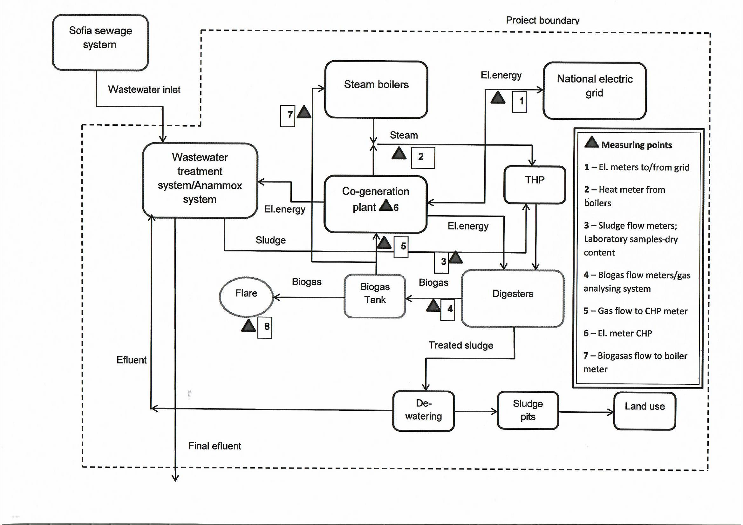

1. Data on CHP plant performance:
- Total electricity generation (MWh/yr)
The data will be collected and processed on yearly basis

- Data on steam boilers performance:
- Total net heat production (TJ/yr)
The data will be collected and processed on yearly basis
3.Data on biogas generation and sludge:
- Quantity and quality of biogas generated (m³/year)

- Quantity of CH₄ flared (kg/year)
- Quantity of sludge entering digesters (m³/y)
- Quantity of dry substance in the sludge entering digesters (t/y)

The data is collected continuously and recorded and processed monthly and yearly.
The operator has the responsibility to input the required data feeds on a monthly and annual basis as required in the monitoring methodology and input data templates in the electronic workbook. The workbook should be saved after each update. Back-up copies of the workbook are saved and stored on a secure system on a monthly basis to avoid loss of information.
The following measuring equipment will be used for monitoring of the project activity:

Table 36: List of measuring equipment
No | Measuring equipment | Measured parameter, variable | Equipment producer and type | Serial number | Installation date | Date of latest calibration | Periodicity of calibration | Measurement error data | Comments
1 | Automatic gas analyser, flow-meter system | Methane concentration in the biogas w_{CH4,y}  Methane – 0-100 Vol%  Oxygen – 0-25 Vol%  Carbon dioxide – 0-100 Vol%  H2S – 0-500 ppm  Absolute pressure 0-1600 mbar | Draeger, Awite AwiFlex | 564_09 | 01 July 2009 | 08.11.2022  05.05.2023  25.10.2023 | 6 months | +/-1 % for Methane and Carbon Dioxide  +/- 0.015 % for temperature | Analysis the content of the biogas (normalised) in bio-reactors#1,2,3 &4.
2 | Automatic gas analyser, flow-meter system | Biogas flow  24 V DC ; max. 3 W; IP 65 by EN 60529  -20 oC to +60 oC  BGburnt,y | Draeger, Awite AwiFlex Cool+ | S.No 2764 | 2019 | 08.11.2022  05.05.2023  25.10.2023 | 6 months | +/-1 % for Methane and Carbon Dioxide  +/- 0.015 % for temperature | Analysis the content of the biogas (normalised) in bio-reactor #5. Flow-meter is integrated in the system
3 | Automatic gas analyser, flow-meter system | Biogas flow BG_{burnt,y} | FCI International LLC ST51 MASS FLOW METER | MODEL 022218-0620J1  S/N 642404 | January 2018 | N/A | Not required if there are no range changes | +/-1% | Biogas flowmeter for Digester 5 (normalised).  Used for reference and control/crosschecking
4 | Digital electric meter | Electricity generated by the CHP EGgrid,y | Schneider Electric PM 5560 | Ser. No 600 008 706 annunciator module LSB6RGB | January 2016 | New | N/A | +/- 0.5% | The electric meter is used only for internal control of the electric energy generated by the SCADA system and is not for commercial use or monitoring for the needs of this project.
5 | Digital electric meter | Electricity exported to the grid EG_{grid,y} | ZMQ 202C.8; L+G | Ser. No 95591181 | 23/10/2020 | 23/10/2020 | 4 years according to the regulation | +/- 0.5% | The commercial electric meter is property of the electric distribution company (NEC)
6 | Digital electric meter | Electricity exported to the grid EG_{grid,y} | ZMQ 202C.8; L+G | Ser. No 95591212 | 27/10/2020 | 27/10/2020 | 4 years according to the regulation | +/- 0.5% | The commercial electric meter is property of the electric distribution company (NEC)
7 | Inlet sludge flow to digester | Sludge Flow in m3/h  Qmax:600m3/h  Tmax:90ºC  Q_DGs_inlet | ABB Electromagnetic Flowmeter  FXE4000 (COPA-XE/MAG-XE) DE41F | 000015791/X001 | 2006 | N/A | Not required if there are no range changes | Standard Calibration +-0.5% of rate | Sludge flow meter for Digester 1
8 | Inlet sludge flow to digester | Sludge Flow in m3/h  Qmax:600m3/h  Tmax:90ºC  Q_DGs_inlet | ABB Electromagnetic Flowmeter  FXE4000 (COPA-XE/MAG-XE) DE41F | 000015791/X003 | 2006 | N/A | Not required if there are no range changes | Standard Calibration +-0.5% of rate | Sludge flow meter for Digester 2
9 | Inlet sludge flow to digester | Sludge Flow in m3/h  Qmax:600m3/h  Tmax:90ºC  Q_DGs_inlet | ABB Electromagnetic Flowmeter  FXE4000 (COPA-XE/MAG-XE) DE41F | 000015791/X004 | 2006 | N/A | Not required if there are no range changes | Standard Calibration +-0.5% of rate | Sludge flow meter for Digester 3
10 | Inlet sludge flow to digester | Sludge Flow in m3/h  Qmax:600m3/h  Tmax:90ºC  Q_DGs_inlet | ABB Electromagnetic Flowmeter  FXE4000 (COPA-XE/MAG-XE) DE41F | 000015791/X002 | 2006 | N/A | Not required if there are no range changes | Standart Calibration +-0.5% of rate | Sludge flow meter for Digester 4
11 | Automatic gas analyser, flow-meter system | Biogas flow  24 V DC ; max. 3 W; IP 65 by EN 60529  -20 oC to +60 ºC  BG_{burnt,y} | Binder , Combimass eco basic switch bio EEx de Messystems | S.No.C080650 | 01 July 2009 | N/A | Not required if there are no range changes | +/-1% | Biogas flowmeter for Digester 1 (normalised).  Used for reference and control/crosschecking.
12 | Automatic gas analyser, flow-meter system | Biogas flow  24 V DC ; max. 3 W; IP 65 by EN 60529  -20 oC to +60 ºC  BG_{burnt,y} | Binder , Combimass eco basic switch bio EEx de Messsystems | S.No.C080647 | 01 July 2009 | N/A | Not required if there are no range changes | +/-1% | Biogas flowmeter for Digester 2 (normalised).  Used for reference and control/crosschecking.
13 | Automatic gas analyser, flow-meter system | Biogas flow  24 V DC ; max. 3 W; IP 65 by EN 60529  -20 oC to +60 ºC  BG_{burnt,y} | Binder , Combimass eco basic switch bio EEx de Messystems | S.No.C080649 | 01 July 2009 | N/A | Not required if there are no range changes | +/-1% | Biogas flowmeter for Digester 3 (normalised).  Used for reference and control/crosschecking.
14 | Automatic gas analyser, flow-meter system | Biogas flow  24 V DC ; max. 3 W; IP 65 by EN 60529  -20 oC to +60 ºC  BG_{burnt,y} | Binder , Combimass eco basic switch bio EEx de Messystems | S.No.C080648 | 01 July 2009 | N/A | Not required if there are no range changes | +/-1% | Biogas flowmeter for Digester 4 (normalised).  Used for reference and control/crosschecking.
15 | Automatic gas analyser, flow-meter system | Biogas flow to CHPs,  Nm3/h | Binder , Combimass eco ver.2014-02 | S.No.C120564 | July 2014 | N/A | Not required if there are no range changes | +/-0.25%+0.025% of max calibrated value(4245,24Nm3/h) | The flowmeter is measuring the gas used in the CHPs (normalised)  For crosschecking purposes
16 | Turbine gas meter | Biogas flow to boilers  50-1000m3/h | Common  Turbine gas meter | 450345/2011 | 09.2014 | N/A | Not required if there are no range changes | 0.2Qmax-Qmax<+/-1%  Qmin-0.2Qmax<+-2% | The flowmeter is measuring the gas used in the boilers.  For crosschecking purposes.
17 | Digital thermal energy meter | Thermal energy generated by the CHP units. EG_{thermal,y} | Kamstrup,  Type 602C00070D1233 | Ser.No: 69303430/2013 | 30.12.2013 (with factory calibration) | 20.10.2020 | 5 years | EC± (0.5 + ∆Θmin/∆Θ) % | The heatmeter is installed at the delivery side of the CHP unit to measure the generated useful heat.  For crosschecking purposes.
18 | Digital thermal energy meter | Thermal energy generated by the CHP units. EG_{thermal,y} | Kamstrup,  Type 602C00070D1233 | Ser.No: 69303431/2013 | 30.12.2013 (with factory calibration) | 21.10.2020 | 5 years | EC± (0.5 + ∆Θmin/∆Θ) % | The heatmeter is installed at the delivery side of the CHP unit to measure the generated useful heat. For crosschecking purposes.
19 | Digital thermal energy meter | Thermal energy generated by the CHP units. EG_{thermal,y} | Kamstrup,  Type 602C00070D1233 | Ser.No: 69303432/2013 | 30.12.2013 (with factory calibration) | 21.10.2020 | 5 years | EC± (0.5 + ∆Θmin/∆Θ) % | The heatmeter is installed at the delivery side of the CHP unit to measure the generated useful heat. For crosschecking purposes.
20 | Digital thermal energy meter | Thermal energy generated by the CHPs exhaust gasses | Kamstrup  602C00070D1233 | S.No 78347526 | 2017 | 10.2020 | 5 years | EC± (0.5 + ∆Θmin/∆Θ) % | The heatmeter is installed at the delivery side of the utiliser to measure the generated useful heat. For crosschecking purposes.
21 | Digital thermal energy meter | Thermal energy generated by the boiler. EGthermal,y |  |  |  | 23.10.2020 | 5 years | EC± (0.5 + ∆Θmin/∆Θ) % | The heatmeter will be installed at the delivery side common line of the steam boiler units to measure the generated useful heat.

The management and operation of the project is а responsibility of Sofiyska voda AD (the project operator). Ensuring the environmental credibility of the project through accurate and systematic monitoring of the project’s implementation and operation, for the purpose of achieving trustworthy VERs is the key responsibility of the operator.
The project operator has the responsibility to procure and install all the necessary equipment and data acquisition systems to enable the collection and of the stipulated data at the required frequency, and to manage and present this data in the electronic workbook as part of a wider data management system that would be sufficient to meet the needs of the monitoring and the independent verifier.
The establishment of transparent, auditable systems for the collection and storage of data, including adequate record keeping and data monitoring systemsis is also a responsibility of the operator. The operator developped and implemened a protocol that provided for these critical functions and processes, fit for independent auditing.
For electronic and paper based data entry and record keeping system, there is clarity in terms of the procedures and protocols for collection and entry of data, use of workbooks and spreadsheets and any assumptions made, so that compliance with requirements could be assessed by a third party. Stand-by processes and systems, e.g. paper based systems, are outlined to provide for the possibility of electronic system failures and used in the event of such failure. The record keeping system provides for a paper trail that could be audited.
The operator appointed a competent manager who has been in charge of and accountable for the generation of VERs including monitoring, record keeping, computation of VERs, audits and verification. The operator officially signed off on all official paper versions of GHG emission worksheets.
The general project management was implemented by Mr. Jelyaz R. – Manager of Kubratovo WwTP through supervising and coordinating activities of his subordinates, such as head of laboratory, head of Process Management dept.,head of accounting department, head of planning unit. During the daytime a group of mechanics who are responsible for maintenance of all technological and measuring equipment as well as automation tools are present on-site.
On-line information was transmitted to the Chief Engineer Mr. Boris P.. His department calculated finally emission reductions based on that data and l archived all data.
The personnel of Treating and Dewatering of the sludge process, listing 34 people and headed by the Process manager Mr. Hristo D. are authorized to take all measurements related to the generationof biogas.
The plant laboratory managed by Mrs. Vesela S. and Mrs. Damyana D.measure the dry substance content in the sludge at inlet of anaerobic digesters. The data are transferred to the Process Management dept. for further processing.
Flow chart with procedures for monitoring, reporting and data flow

Treating & Sludge Dewatering Shop | Laboratory | CHP | Mechanical & Biological Purification Shop
Hristo D. - Process Manager | Vesela S. - Chief of Laboratory, Damyana D. - Lab. Supervisor | Vladimir M. - Manager Energy Resources | Teodor L. - Supervisor
- Biogas after digesters measure & report; - CH4 content in biogas measure & report | - Dry substance content at inlet digesters measure & report | - Biogas flow to CHP measure & report; - Electricity generated by CHPmeasure & report; - Electric energy exported to grid measure & report | - Sludge quantity before entering digesters measure & report
Bojanka B. - Specalist Process Management
- Collects data for parameters monitored from all departments; - Collects data for electricity generated by CHP; - Follows and checks tha parameters not monitored; - Processes data according to Monitoring Plan; -Calculates emission Reduction Units; - Sends calculations to Process Manager for audit |  |  | DATA ARCHIVE (electronic & on paper)
Boris P. - Chief Engineer
- Makes internal crosscheck of collected data; - Makes internal audit of the procedures for monitoring; - Gives permission for archiving of data and calculations
Jeljaz R. - WwTP Manager

SECTION C. DURATION AND CREDITING PERIOD

C.1. Duration of project
C.1.1 Start date of project
As per GS TAC decision from September 2014 the crediting period is a renewable 3*7 year period with a maximum of 21 years overall. The starting date of the first crediting period under JI and under a Green Investment Scheme is 1 January 2007. The baseline got renewed retroactively 2 years prior to the date of registration of the project under Gold Standard.
The 6-week review by the Gold Standard expired on 31/03/2016 and the project is considered registered on 01/04/2016. According to the GS regulations the start date of the GS crediting period was 01/04/2014 (2 years prior GS registration).
The length of the 1st GS crediting period is 7 years 0 months (renewable period).
C.1.2 Expected operational lifetime of project
25 years as validated in the initial GS certified PDD.

C.2. Crediting period of project
C.2.1 Start date of crediting period
As per the above GS TAC decision dated September 2014 the total crediting period of the project activity is 21 years for the period 01/01/2007 - 31/12/2028.This was confirmed by GS when transition of the project to GS4GG took place.
The overall crediting period includes the following schemes:
01/01/2007 – 31/12/2007 – Green Investment Scheme
01/01/2008 – 31/12/2012 – Joint Implementation Scheme
01/04/2014 – 31/03/2021 – 1st 7-years GS crediting period
01/04/2021 – 31/03/2028 – 2nd 7-years GS crediting period (approved by GS4GG)
Design change start date – 15/11/2024
C.2.2 Total length of crediting period
21 years 0 months

SECTION D. SUMMARY OF SAFEGUARDING PRINCIPLES AND GENDER SENSITIVE ASSESSMENT

D.1 Safeguarding Principles that will be monitored
A completed Safeguarding Principles Assessment is in Appendix 1
No mitigation measures need to be added to the monitoring plan.

D.2. Assessment that project complies with GS4GG Gender Sensitive requirements
Question 1 - Explain how the project reflects the key issues and requirements of Gender Sensitive design and implementation as outlined in the Gender Policy? | In accordance with the discussion provided in Gold Standard Gender Policy’s Foundational gender-sensitive requirement, the project will strengthen Gold Standard’s ‘do no harm’ approach and addresses safeguards to prevent or mitigate adverse impacts on women or men and girls and boys. It is very well understood that such action is mandatory for all projects seeking Gold Standard certification and includes compliance with the gender ‘do no harm’ safeguards, gender gap analysis and gender sensitive stakeholder consultations. From this point of view, the renewable energy source provided by this project does not discriminate people on gender. The Project does not impact women or men directly or indirectly. The gender sensitiveness of the Project will be checked during the local stakeholder engagement rounds in the future
Question 2 - Explain how the project aligns with existing country policies, strategies and best practices | Answer: Bulgaria ratified the UN’s Convention on the Elimination of All Forms of Discrimination against Women (CEDAW) in 20/12/1985. It has also ratified ILO conventions C100 & C111 in 1967, making illegal the discrimination based on sex. Moreover, Bulgaria views gender equality as a key priority in the national human rights agenda and an absolute necessity for the full realization of human rights. To achieve full gender equality in the next 10 years, adopted in April,2016 a new specialized law on gender equality, and will ensure that a gender perspective is mainstreamed into all policies.  As one of the 47 member states of the Council of Europe, Bulgaria has signed the Council’s Convention on Preventing and Combating Violence against Women and Domestic Violence (Istanbul Convention) and aims to implement the Council of Europe Gender Equality Strategy 2018-2023. The Strategy defines its goals and strategic objectives as ‘prevent and combat gender stereotypes and sexism’, ‘prevent and combat violence against women and domestic violence’, ‘ensure the equal access of women to justice’, ‘achieve balanced participation of women and men in political and public decision-making’, ‘protect the rights of migrants, refugee and asylum-seeking women and girls’, and ‘achieve gender mainstreaming in all policies and measures’.  The Project respects all of these relevant conventions, laws, commitments and strategies. Hence, it has been designed in accordance with the principles of gender equality, non-discrimination and women’s empowerment.  According to the Bulgarian Labour Code, art.243 :” Women and men shall have the right to equal remuneration for identical and equal work.
Question 3 - Is an Expert required for the Gender Safeguarding Principles & Requirements? | No expert is required for the Gender Safeguarding Principles & Requirements.
Question 4 - Is an Expert required to assist with Gender issues at the Stakeholder Consultation? | The Stakeholder Consultation has been performed and certified by GS during the initial certification of the project in 2016.

SECTION E. SUMMARY OF LOCAL STAKEHOLDER CONSULTATION
The Local stakeholder consultation process was organised according to the requirements of Gold Standard during the process of initial certification of the project after GS.
Sofyiska Voda invited a wide range of stakeholders, covering the categories suggested by Gold Standard. In addition to the relevant governmental institutions were invited local and international NGOs, as well as representatives of GS.
In order to invite stakeholders from Category A (Local People), announcements were published in one national newspaper, three news websites, on the information board of the head office of Sofyiska voda and the WWTP Kubratovo, as well as on the web page of Sofyiska Voda.
The meeting took place on April 15th, 2015 in Sofia, Kubvratovo WWTP. 15 stakeholders attended the meeting representing a diverse group of stakeholders from ministries, municipalities, agencies and NGOs.
Detailed information on the Stakeholder consultations can be found at the GS sustaincert here: https://impact.sustain-cert.com/public_projects/780.

In addition when a decision was taken to apply for re-certification of the project for a new crediting period, requests were sent by e-mail and post to stakehoders to up-date and share their opinion on the project.
Formal requests were sent to the following organisations and persons:
1. Ministry of Environment and Water
2. Sofia Municipality
3. Daniela R. – Mayor of “Novi Iskar” Municipality
4. Eng. Todor K.- Mayor of “Serdika” Municipality
5. The Regional Inspectorate of Environment and Water-Sofia
6. WWF Bulgaria – Georgi S., Manager “Climate Change and Green Economy”
7. „Greenpeace” - Bulgaria
8. Renewable Energy and Energy Efficiency Partnership (REEP)
9. Helio international
10. Gold standard Foundation
Until present day official answers were received only from the Ministry of Environment and Water (letter No 26-00-1478/17/12/2020) and Sofia Municipality (letter No COA20-TD26-11995 – [1]/19.12.2020).
Updated information for the project is published on the site of Sofiyska voda AD here:
https://www.sofiyskavoda.bg/CustomPages.aspx?PageID=41

E.1 Summary of stakeholder mitigation measures
After the presentation of the project a discussion was held and questions were posed. The stakeholders performed the Blind SD Matrix exercise and filled in evaluation forms.
A few questions rather than comments were raised:

• Would the employees working on the project have been hired in the absence of project?
• What is the produces heat used for?
• How is the remaining sludge after the process managed?
• Is there any information about the effect of the sludge/soil fertilizer on the soils?Answers to these questions were given by the Management of the plant and project consultants.

E.2 Final continuous input / grievance mechanism
METHOD | INCLUDE ALL DETAILS OF CHOSEN METHOD (S) SO THAT THEY MAY BE UNDERSTOOD AND, WHERE RELEVANT, USED BY READERS.
Continuous Input / Grievance Expression Process Book (mandatory) | The overall evaluation of the meeting by the participants was very positive. The attendees expressed opinion that the project should be better publicized in order to serve as an example.  No negative comments/remarks were received. All the questions raised were answered accordingly.  A detailed description of the Local stakeholders consultation process is given in the LSCR, uploaded on the web site of GS during the initial certification in 2016.  The grievance mechanism provided for the project includes:  - Special book for comments, questions and propositions regarding the project is organized at the office of the Waste-water Treatment Plant in the village of Kubratovo, near Sofia;  - An e-mail address for any comments and opinions is published on the web site of Sofiyska voda here:  https://www.sofiyskavoda.bg/CustomPages.aspx?PageID=41  - Contact telephones and name of the contact person are also published there.  Until now no any comments have been made in the book or by e-mail.
GS Contact (mandatory) | help@goldstandard.org
Other | N/A

Appendix 1 - Safeguarding Principles Assessment
SOCIAL SAFEGUARDING PRINCIPLES
Reference requirement | Question | Response
P.1 |Human Rights
P.1.1.1 | | Does the project developer, its representatives and the Project disrespect internationally proclaimed human rights? | ☐ YES  X NO
P.1.1.1 | | Is the project involved or complicit in violence or human rights abuses of any kind as defined in the Universal Declaration of Human Rights? | ☐ YES  X NO
P.1.1.2 | | Have local communities or individuals raised human rights concerns regarding the project (e.g., during the stakeholder engagement process, grievance processes, public statements)? | ☐ YES  X NO
P.1.1.3 | | Is there a risk that rights-holders (e.g., Project-affected stakeholders) do not have the capacity to claim their rights? | ☐ YES  X NO
P.1.1.3 | | Does this project undermine national or regional measures for the realisation of the right to development? | ☐ YES  X NO
Would the project potentially involve or lead to:
P.1.1.1 | | adverse impacts on enjoyment of the human rights (civil, political, economic, social or cultural) of the affected population and particularly of marginalised groups? | ☐ YES  ☐ POTENTIALLY  ☒ NO
P.1.1.2 | | inequitable or discriminatory impacts on affected populations, particularly people living in poverty or marginalised or excluded individuals or groups, including persons with disabilities? | ☐ YES  ☐ POTENTIALLY  ☒ NO
P.1.1.3 | | restrictions in availability, quality of and/or access to resources or basic services, in particular to marginalised individuals or groups, including persons with disabilities? | ☐ YES  ☐ POTENTIALLY  ☒ NO
P.1.1.3 | | exacerbation of conflicts among and/or the risk of violence to project-affected communities and individuals? | ☐ YES  ☐ POTENTIALLY  ☒ NO
- The Project is not in conflict with the general economic life in Bulgaria or of the local community. The Project does not cause any human rights abuse. Moreover, by providing of wastewater treatment to the capital of Bulgaria the project guarantees the right to high standard living conditions to more than 1,5 million sitizens of Sofia.
Bulgaria has ratified the Universal Declaration of Human Rights.
Bulgaria has also ratified all relevant conventions on human rights, including,without limitation:
- The European Convention of Human Rights, and Protocols 1 (protection of property), 4 7 and 13
- International Covenant on Civil and Political Rights;
- International Covenant on Economic, Social and Cultural Rights;
- Convention on the Elimination of all forms of Racial Discrimination;

2.Project activities are not expected to cause any human rights abuse. Bulgaria is a member of the European Union and of the United Nations and part of UN Agreement on Human Rights.
As part of the EU Bulgaria is obliged to strictly follow all European standards regarding preservation of human rights.
No action against human rights is tolerated what-so-ever.

P.2 |Gender Equality and Women’s Empowerment
P.2.1.1 | | Have women’s groups/leaders raised gender equality concerns regarding the project, (e.g., during the stakeholder engagement process, grievance processes, public statements)? | ☐ YES  ☒ NO
P.2.1.2 | | Does the project undermine the principles of non-discrimination, equal treatment, and equal pay for equal work? | ☐ YES  ☒ NO
P.2.1.2 | | Does the project prevent men and women from having equal opportunities to participate in identified tasks and activities, whether through paid work, volunteer work, or community contributions, as appropriate? | ☐ YES  ☒ NO
P.2.1.2 | | Does the project limit the participation of women or men based on pregnancy, maternity/paternity leave, or marital status? | ☐ YES  ☒ NO
P.2.1.2 | | Is information about project objectives being communicated in a way that is inappropriate for the local context and not tailored to the methods of understanding of both women and men, which could hinder their participation? | ☐ YES  ☒ NO
P.2.1.3 | | Has the project assessed gender risks without referencing the country's gender strategy or equivalent national commitment? | ☐ YES  ☒ NO
P.2.1.4 | | Has expert stakeholder(s) been involved, and has their input been requested for the project design on gender equality and women's empowerment? | ☐ YES  ☒ NO
Would the project potentially involve or lead to:
P.2.1.1 | | adverse impacts on gender equality and/or the situation of women and girls? | ☐ YES  ☐ POTENTIALLY  ☒ NO
P.2.1.1 | | exacerbation of risks of gender-based violence? For example, through the influx of workers to a community, changes in community and household power dynamics, increased exposure to unsafe public places and/or transport, etc. | ☐ YES  ☐ POTENTIALLY  ☒ NO
P.2.1.2 | | reproducing discriminations against women based on gender, especially regarding participation in design and implementation or access to opportunities and benefits? | ☐ YES  ☐ POTENTIALLY  ☒ NO
P.2.1.2 | | limitations on women’s ability to use, develop and protect natural resources, taking into account different roles and positions of women and men in accessing environmental goods and services?  For example, activities that could lead to natural resources degradation or depletion in communities who depend on these resources for their livelihoods and well-being. | ☐ YES  ☐ POTENTIALLY  ☒ NO
- The project respects Women’s rights, including dignity, cultural property and uniqueness of indigenous people. Participation is completely voluntary and the project respects personal freedom and liberty. The project respects internationally proclaimed human rights.
Bulgaria has ratified the Convention on the Elimination of all forms of Discrimination Against Women;
- The personnel of 32 engaged in the running of the project includes 9 women that occupy positions requiring high level of education and abilities.
- The project takes into account the roles of women and men and their possibilities to work for the project following the requirements of the Ministry of Labour and Social Care;
- The project has a potential to contribute to the increase of women’s workload, having in mind that working for the project is a full-time job which can influence the possibility to take care for children and family. In this respect the government and local authorities are taking all possible measures to provide care for children in kindergardens and schools.
The project involves operation of mechanical, electrical and biological equipment which potentially can expose women workers to some risks and hazards in case of accidents or not following safety rules. However the company policy in that respect is very strict and involves regular trainings in safety measures and safety knowledge improvement.
P.3 |Community Health AND Safety
P.3.1.1 | | Does the project involve potential risks to the health and safety of affected communities during its life cycle? | ☐ YES  ☐ NO
P.3.1.2 | | Does the project involve any potential risks to the workers' safety and health? | ☐ YES  ☒ NO
Would the project potentially involve or lead to:
P.3.1.1 | | construction and/or infrastructure development (e.g., roads, buildings, dams)? | ☐ YES  ☒ NO
P.3.1.2 | | air pollution, noise, vibration, traffic, injuries, physical hazards, poor surface water quality due to runoff, erosion, sanitation? | ☐ YES  ☐ POTENTIALLY  ☒ NO
P.3.1.2 | | harm or losses due to failure of structural elements of the project (e.g., collapse of buildings or infrastructure)? | ☐ YES  ☐ POTENTIALLY  ☒ NO
P.3.1.2 | | risks of water-borne or other vector-borne diseases (e.g., temporary breeding habitats), communicable and noncommunicable diseases, nutritional disorders, mental health? | ☐ YES  ☐ POTENTIALLY  ☒ NO
P.3.1.2 | | transport, storage, and use and/or disposal of hazardous or dangerous materials (e.g., explosives, fuel and other chemicals during construction and operation)? | ☐ YES  ☐ POTENTIALLY  ☒ NO
P.3.1.2 | | adverse impacts on ecosystems and ecosystem services relevant to communities’ health (e.g., food, surface water purification, natural buffers from flooding)? | ☐ YES  ☐ POTENTIALLY  ☒ NO
he Project avoids community exposure to increased health risks and does not adversely affect the health of the workers and the community.
The Project developer Sofiyska voda AD is certified by ISO 45001:2018 – Health and safety management (reg.# 4410422320109) and ISO 14001:2015 – Operation, maintenance and management of the water supply and sewerage systems, including treatment, control and monitoring of drinking and waste water, design and customer service (reg.# 4410422320109)

P.4 |Cultural Heritage, Indigenous People, Displacement and Resettlement
P.4.1 |Sites of Cultural and Historical Heritage
P.4.1.1 | | Does the project involve altering, damaging, or removing sites, objects, or structures of significant cultural heritage? | ☐ YES  ☒ NO
Would the project potentially involve or lead to:
P.4.1.1 | | activities adjacent to or within a cultural heritage site? | ☐ YES  ☐ POTENTIALLY  ☒ NO
P.4.1.1 | | significant excavations, demolitions, movement of earth, flooding or other environmental changes? | ☐ YES  ☐ POTENTIALLY  ☒ NO
P.4.1.1 | | alterations to landscapes and natural features with cultural significance? | ☐ YES  ☐ POTENTIALLY  ☒ NO
P.4.1.1 | | adverse impacts to sites, structures, or objects with historical, cultural, artistic, traditional or religious values or intangible forms of culture (e.g., knowledge, innovations, practices)? (Note: projects intended to protect and conserve Cultural Heritage may also have inadvertent adverse impacts) | ☐ YES  ☐ POTENTIALLY  ☒ NO
P.4.1.2 | | utilisation of tangible and/or intangible forms (e.g., practices, traditional knowledge) of Cultural Heritage  for commercial or other purposes? | ☐ YES  ☐ POTENTIALLY  ☒ NO
P.4.1.2 | | If answer to question above is “YES” or “POTENTIALLY” - are the communities made aware of their right under the law, scope and nature of proposed development and its potential consequences? | ☐ YES  ☐ NO  ☒ NA
P.4.1.3 | | If answer to question above is “YES” - does the project provide equitable sharing of benefits from commercialisation of such knowledge, innovation, or practice, consistent with their customs and traditions? | ☐ YES  ☐ NO  ☒ NA
P.4.1.4 | | If answer to question above is “YES” - are opinions and recommendations of an Expert Stakeholder(s) not sought and demonstrated as being included in the project design? | ☐ YES  ☐ NO  ☒ NA
P.4.1.4 | | If answer to question above is “YES”, has project design been changed, modified, updated considering opinions and recommendations of an Expert Stakeholder? | ☐ YES  ☐ NO  ☒ NA
P.4.2 |Forced Eviction and Displacement
P.4.2.1 | | Does the project involve any risks related to involuntary relocation of people? | ☐ YES  ☒ NO
Would the project potentially involve or lead to:
P.4.2.1 | | risk of forced evictions or involuntary relocation of people? | ☐ YES  ☐ POTENTIALLY  ☒ NO
P.4.2.2 | | temporary or permanent and full or partial physical displacement (including people without legally recognisable claims to land)? | ☐ YES  ☐ POTENTIALLY  ☐ NO
P.4.2.2 | | economic displacement (e.g., loss of assets or access to resources due to land acquisition or access restrictions – even in the absence of physical relocation)? | ☐ YES  ☐ POTENTIALLY  ☒ NO
P.4.2.2 | | If answer to question above is “YES” or “POTENTIALLY”,  - has the project developed Resettlement Action Plan or Livelihood Action Plan in consultation and agreement with affected individual, group or community?  - has the project integrated Resettlement Action Plan or Livelihood Action Plan into the Project design? | ☐ YES  ☐ NO  ☒ NA
P.4.2.3 | | If answer to question above is “YES” - are opinions and recommendations of an Expert Stakeholder(s) not sought and demonstrated as being included in the project design? | ☐ YES  ☐ NO  ☒ NA
P.4.2.3 | | If answer to question above is “YES”, have project design been changed, modified, updated considering opinions and recommendations of an Expert Stakeholder? | ☐ YES  ☐ NO  ☒ NA
P.4.3 |Land tenure and other rights
P.4.3.1 | | Does the project involve any risks related to identifying and managing legitimate tenure rights that may be affected by the project? | ☐ YES  ☒ NO
Would the project potentially involve or lead to:
P.4.3.1 | | impacts on or changes to land tenure arrangements and/or community-based property rights/customary rights to land, territories and/or resources? | ☐ YES  ☐ POTENTIALLY  ☒ NO
P.4.3.1 | | uncertainties with regards to land tenure, access rights, usage rights or land ownership?  Examples include, but are not limited to water access rights, community-based property rights and customary rights. | ☐ YES  ☐ POTENTIALLY  ☒ NO
P.4.3.2 | | Changes in legal arrangements, if yes, are the changes done in line with relevant laws and regulations? | ☐ YES  ☐ NO  ☒ NA
P.4.3.2 | | Changes in legal arrangements, if yes, are these changes agree with free, prior and informed consent of the involved stakeholders? | ☐ YES  ☐ NO  ☒ NA
P.4.3.3 | | Does some other entity (other than the project developer) hold uncontested land title for the entire Project Boundary? | ☐ YES  ☐ NO  ☒ NA
P.4.3.4 | | Are opinions and recommendations of an Expert Stakeholder(s) not sought and demonstrated as being included in the project design? | ☐ YES  ☐ NO  ☒ NA
P.4.3.4 | | If answer to question above is “YES”, have project design been changed, modified, updated considering opinions and recommendations of an Expert Stakeholder? | ☐ YES  ☐ NO  ☒ NA
P.4.3.5 | | Have project developer in consultation with stakeholders established a functioning mechanism to receive, process, resolve, communicate and record grievances? | ☐ YES  ☐ NO  ☒ NA
P.4.4 |Indigenous peoples
P.4.4.1 | | Does the project involve Indigenous People within the Project area of influence who may be affected directly or indirectly by the Project? | ☐ YES  ☒ NO
Would the project potentially involve or lead to:
P.4.4.1 | | affect areas where indigenous peoples are present (including project area of influence) | ☐ YES  ☐ POTENTIALLY  ☒ NO
P.4.4.1 | | affect areas, land and territory claimed by indigenous peoples? | ☐ YES  ☐ POTENTIALLY  ☒ NO
P.4.4.1 | | impacts (positive or negative) to the human rights, lands, natural resources, territories, and traditional livelihoods of indigenous peoples? | ☐ YES  ☐ POTENTIALLY  ☒ NO
P.4.4.7 | | If answer to above questions is ’’YES’’ or “POTENTIALLY”,  - Is it determined that the proposed project may affect the rights, lands, resources, or territories of indigenous people?  - Has an "Indigenous People Plan" (IPP) or "Indigenous People Plan Framework" been elaborated and included in the project documentation?  - Was the plan developed in accordance with the effective and meaningful participation of indigenous peoples and in accordance with UNDP Guidelines? | ☐ YES  ☐ NO  ☒ NA
P.4.4.3 | | risk of forcibly removing indigenous people from their lands and territories? | ☐ YES  ☐ POTENTIALLY  ☒ NO
P.4.4.4 | | utilisation and/or commercial development of natural resources on lands and territories claimed by indigenous peoples?  Consider, and where appropriate ensure, consistency with the answers under Principle 4.1 above | ☐ YES  ☐ POTENTIALLY  ☒ NO
P.4.4.5 |  P.4.4.6 | | If answer to question above is “YES” or “POTENTIALLY”  - Did the project obtain free, prior and informed consent from indigenous people before taking their cultural, intellectual, religious, and/or spiritual property?  - Does the project ensure that the indigenous people receive an equitable sharing of benefits resulting from the use of their traditional knowledge and practices? ?  - Does the project ensure that the sharing of benefits resulting from the use of indigenous peoples' traditional knowledge and practices is culturally appropriate and inclusive?  - Does the project ensure that the provision of equitable sharing of benefits does not impede land rights or equal access to basic services including health services, clean water, energy, education, safe and decent working conditions, and housing? | ☐ YES  ☐ NO  ☒ NA
P.4.4.8 | | Does the project lack appropriate feedback and grievance channels for Indigenous Peoples and their representatives? | ☐ YES  ☐ NO  ☒ NA
P.4.4.8 | | Has a grievance mechanism not been established at the beginning of programme or project implementation with due consideration given to customary dispute settlement mechanisms among the Indigenous Peoples concerned and will it remain operational throughout the project cycle? | ☐ YES  ☐ NO  ☒ NA
P.4.4.9 | | Are opinions and recommendations of an Expert Stakeholder(s) not sought and demonstrated as being included in the project design? | ☐ YES  ☐ NO  ☒ NA
P.4.4.9 | | If answer to question above is “YES”, have project design been changed, modified, updated considering opinions and recommendations of an Expert Stakeholder? | ☐ YES  ☐ NO  ☒ NA
P.5 |Corruption
P.5.1.1 | | Does the project involve, or is it complicit in, contributing to or reinforcing corruption or corrupt projects? | ☐ YES  ☒ NO
P.5.1.1 | | Does the project have a risk of encouraging bribery, kickbacks, or other unethical behavior? | ☐ YES  ☒ NO
ECONOMIC SAFEGUARDING PRINCIPLES
P.6 |Economic Impacts
P.6.1 |Labour Rights and Working Conditions
P.6.1.1 | | Does the project involve, facilitate, or condone forced labor, or pose a potential risk of forced labor? | ☐ YES  ☒ NO
P.6.1.1 | | Does the project violate any labor or health and safety laws, international obligations, or ILO conventions? | ☐ YES  ☒ NO
P.6.1.2 | | Does the project violate the principles of equal opportunity and fair treatment in its employment decisions? | ☐ YES  ☒ NO
P.6.1.3 | | Does the project violate national laws, if available regarding non-discrimination in employment? | ☐ YES  ☒ NO
P.6.1.4 |  P.6.1.5 | | Does the project allow child labor? | ☐ YES  ☒ NO
P.6.1.7 |  P.6.1.8 | | Does the project have insufficient processes and measures in place to ensure the safety and health of project workers? | ☐ YES  ☒ NO
P.6.1.9 | | Does the project have insufficient measures to safeguard and support vulnerable project workers, such as women, people with disabilities, migrant workers, and young workers, and to prevent any kind of harassment, abuse, bullying, or exploitation, including gender-based violence (GBV)? | ☐ YES  ☒ NO
P.6.1.10 | | Does the project have no grievance mechanism available for workers to voice workplace concerns? Is information about this mechanism not provided to workers at the time of recruitment, or is it not easily accessible? | ☐ YES  ☒ NO
Would the project potentially involve or lead to:
(note: applies to both project and contractor workers)
P.6.1.1 | | use of forced labour? | ☐ YES  ☐ POTENTIALLY  ☒ NO
P.6.1.1 | | working conditions that do not meet national labour laws and international commitments? | ☐ YES  ☐ POTENTIALLY  ☒ NO
P.6.1.1 | | working conditions that may deny freedom of association and collective bargaining? | ☐ YES  ☐ POTENTIALLY  ☒ NO
P.6.1.1 | | absence of documented working agreements with all individual workers  if such agreements do not exist, or do not address working conditions and terms of employment, the project developer shall provide reasonable working conditions and terms of employment. | ☐ YES  ☐ POTENTIALLY  ☒ NO
P.6.1.1 | | use of migrant workers?  if engaged, the developer shall ensure that they are engaged substantially equivalent terms and conditions to non-migrant workers carrying out similar work. | ☐ YES  ☐ POTENTIALLY  ☐ NO
P.6.1.1 | | having no arrangements for basic services for workers?  the project developer shall put in place and implement policies on the quality and management of the accommodation and provision of basic services in a manner consistent with the principles of non-discrimination and equal opportunity. Workers’ accommodation arrangements should not restrict workers’ freedom of movement or of association | ☐ YES  ☐ POTENTIALLY  ☒ NO
P.6.1.2 | | any form of discrimination or harassment based on factors unrelated to job requirements, such as gender, race, nationality, ethnicity, social or indigenous origin, religion or belief, disability, age, or sexual orientation? | ☐ YES  ☐ POTENTIALLY  ☒ NO
P.6.1.2 | | any form of discrimination in any aspect of employment, such as recruitment, compensation, working conditions, training, job assignment, promotion, termination, or discipline? | ☐ YES  ☐ POTENTIALLY  ☒ NO
P.6.1.2 | | harassment, intimidation, and/or exploitation, especially in regard to women? | ☐ YES  ☐ POTENTIALLY  ☒ NO
P.6.1.3 | | discriminatory working conditions and/or lack of equal opportunity where national law provides provision to address non-discrimination in employment? | ☐ YES  ☐ POTENTIALLY  ☒ NO
P.6.1.4 | | use of child labour? (including third-party engaged workers) | ☐ YES  ☐ POTENTIALLY  ☒ NO
P.6.1.4 | | inadequate and verifiable mechanisms for age verification? | ☐ YES  ☒ NO
P.6.1.7 | | no processes and measures in place for the safety and health of project workers? | ☐ YES  ☒ NO
P.6.1.7 | | No provision of safety and health training provisions, including on the proper use and maintenance of personal protective equipment conducted by competent persons and the maintenance of training records? | ☐ YES  ☒ NO
P.6.1.7 | | No provision to record and document accidents, diseases, incidents, and any resulting injuries, illnesses, or deaths? | ☐ YES  ☒ NO
P.6.1.8 | | occupational health and safety risks due to physical, chemical, biological and psychosocial hazards (including violence and harassment) throughout the project life-cycle? | ☐ YES  ☒ NO
P.6.1.9 | | No measures to protect vulnerable project workers from harassment, exploitation, and gender-based violence (GBV)? This includes women, people with disabilities, migrant workers, and young workers. | ☐ YES  ☒ NO
P.6.1.10 | | No grievance mechanism available for workers to voice workplace concerns. | ☐ YES  ☒ NO
P.6.1.11 | | No measures for due diligence and the establishment of policies and procedures to manage and monitor the performance of third-party employees in the project? | ☐ YES  ☒ NO
  - Sofiyska voda, as Project Developer, has ensured that all employment is in compliance with national labour occupational health and safety laws and with the principles and standards embodied in the ILO fundamental conventions. The company is certified by ISO 45001:2018 – Health and safety management and ISO 14001:2015.
  - All workers are able to establish and join labour organisations as per the Labour Code of Bulgaria.
  - Working agreements with all individual workers are documented and implemented and include:
- Working hours (do not exceed 48 hours per week on a regular basis), AND
- Duties and tasks, AND
- Remuneration (include provision for payment of overtime), AND
- Modalities on health insurance, AND
- Modalities on termination of the contract with provision for voluntary resignation by employee, AND
- Provision for annual leave of not less than 10 days per year, not including sick and casual leave.
All personal labour contracts follow the requirements of the Bulgarian Labour Code.
  - Children labour is not allowed in Bulgaria as per the Labour Code. Bulgaria has also ratified Convention on the Rights of the Child.
The Project Developer ensured the use of appropriate equipment, training of workers, documentation and reporting of accidents and incidents, and emergency preparedness and response measures
P.6.2 |Negative Economic Consequences
P.6.2.1 | | Is there a risk of project failure during implementation or after project certification due to a lack of financial resources? | ☐ YES  ☒ NO
P.6.2.2 | | Does the project have potential negative impacts or pose a risk to the local economy? | ☐ YES  ☒ NO
P.6.2.2 | | Are there any potential risks or negative impacts this project may have on vulnerable or marginalised social groups, despite the benefits it may bring? | ☐ YES  ☒ NO
Would the project involve or lead to:
P.6.2.2 | | economic impacts (negative/detrimental) to the local economy? | ☐ YES  ☐ POTENTIALLY  ☒ NO
P.6.2.2 | | negative economic consequences during and after project implementation, e.g., for vulnerable and marginalised social groups in targeted communities? | ☐ YES  ☐ POTENTIALLY  ☒ NO
No negative economic consequences during and after implementation of the project were registered. On the contrary, the project strengthened the economic status of the company and near-by communities by providing 32 additional working positions, some of them for local citizens.

P.7 |Climate and Energy
P.7.1 |GHG Emissions
P.7.1.1 | | Does the project have a risk of increasing greenhouse gas emissions over the Baseline Scenario? | ☐ YES  ☒ NO
Would the project involve or lead to:
P.7.1.1 | | increase greenhouse gas emissions over the Baseline Scenario? | ☐ YES  ☐ POTENTIALLY  ☒ NO
P.7.2 |Energy supply
P.7.2.1 | | Does the project pose a risk to the availability and reliability of energy supply to other users? | ☐ YES  ☒ NO
Would the project involve or lead to:
P.7.2.1 | | negative impact on the availability and reliability of energy supply to other users? | ☐ YES  ☐ POTENTIALLY  ☒ NO
If the answer is "yes" or "potentially" to the above question, please provide a brief description of the project situation below. Also, provide justification and/or evidence as necessary to demonstrate compliance with applicable requirements.
The methane produced by the WWTP is captured in methane tanks and utilised as a fuel for energy production. This leads to the reduction of high amounts of CH₄ (powerful greenhouse gas). In addition the production of electricity and heat from biogas replaces the use of fossil fuels thus reducing greenhouse gases such as CO₂.
The project is self-sufficient in energy terms. It produces electricity, which in the absence of the project would have been supplied from the local grid. The fuel resource (methane) could not be used by local users in the absence of the project.
P.8 |Water
P.8.1 |Impact on Natural Water Patterns/Flows
P.8.1.1 | | Does the project increase water usage to a level that will not allow for the maintenance of environmental flows? | ☐ YES  ☒ NO
P.8.1.1 | | Does the project result in the discharge of wastewater that does not meet the required standard for beneficial reuse and could therefore negatively impact the environmental flow? | ☐ YES  ☒ NO
P.8.1.1 | | Does the project have the potential risk to exceed the rate of recharge for the groundwater source? | ☐ YES  ☒ NO
P.8.1.1 | | Does the project involve any processes or activities that could contaminate the groundwater and render it unsuitable for use? | ☐ YES  ☒ NO
Would the project involve or lead to:
P.8.1.1 | | affect the natural or pre-existing pattern of watercourses, groundwater and/or the watershed(s) such as high seasonal flow variability, flooding potential, lack of aquatic connectivity or water scarcity? | ☐ YES  ☐ POTENTIALLY  ☒ NO
P.8.1.1 | | Wastewater discharge of quality that does not meet the required standard for beneficial reuse? | ☐ YES  ☐ POTENTIALLY  ☒ NO
P.8.1.1 | | significant extraction, diversion of ground water? For example, construction of dams, reservoirs, river basin developments, groundwater extraction | ☐ YES  ☐ POTENTIALLY  ☒ NO
P.8.1.2 | | Are opinions and recommendations of an Expert Stakeholder(s) not sought and demonstrated as being included in the project design? | ☐ YES  ☐ NO  ☒ NA
The project does not affect the natural water pattern and flow. No depletion or contamination of local reservoirs/ aquifers occurs.
Water consumed in the whole range of the project is to prepare a solution of a flocculent for compression and dewatering of the treated sludge, as well as for washing the machines and to supplement the heating system if necessary. Part of the water used is technical water. The wastewater formed in the process is returned to the entrance of the plant for processing.
The plant possesses Permission for deposition of the effluent outlet water into the Iskar river No 1295/14.04.2014, issued by the Ministry of Environment and Water. The Permission defines the quantity of inlet and outlet water and the quality of the effluent water. The quality of the effluent water and heavy metals content is monitored and measured according to the plan and frequency part of the Permission.
The quality of the water is monitored by the accredited laboratory part of Kubratovo Wastewater Treatment Plant.

P.8.2 |Erosion and/or Water Body Instability
P.8.2.1 | | Does the project have a risk of negatively impacting the catchment and has it been assessed and addressed? | ☐ YES  ☒ NO
Would the project involve or lead to:
P.8.2.2 |  P.8.2.5 | | negatively impact on the catchment area?  If yes, Erosion prevention measures, including soil and slope protection measures, must be implemented before project commencement. These measures should involve natural terracing, infiltration strips, permanent ground cover, hedge and tree rows, and effective slope length assessment. Regular reassessment of these measures is necessary. | ☐ YES  ☐ POTENTIALLY  ☒ NO
P.8.2.6 | | Are opinions and recommendations of an Expert Stakeholder(s) not sought and demonstrated as being included in the project design? | ☐ YES  ☐ NO  ☒ NA
The project does not result in soil erosion, and does not contribute to soil contamination by pollutants.
The deactivated sludge coming out of the digesters is dewatered, dried and used as fertilizer.

P.9 |Environment, ecology and land use
P.9.1 |Landscape Modification and Soil
P.9.1.1 |  -  P.9.1.3 | | Is there any risk of soil resource degradation or loss of ecosystem services provided by soils in the project?  If yes, the project shall maintain healthy soils by minimising negative impacts on soil health, productivity, structure, and water retention. Steps to minimise soil degradation include crop rotation, composting, using N-fixing plants, and reducing tillage and ecologically harmful substances. | ☐ YES  ☒ NO
Would the project involve or lead to:
P.9.1.4 | | production, harvesting, and/or management of living natural resources by small-scale landholders and/or local communities? | ☐ YES  ☐ POTENTIALLY  ☒ NO
P.9.1.4 | | if answer to above question “yes” or “potentially”, does project adopt appropriate and culturally sensitive sustainable resource management practices? | ☐ YES  ☐ No  ☒ NA
The project does not involve the use of any land and soil for production of crops or other production. The equipment needed for the project is situated on the land of the WWTP.
P.9.2 |Vulnerability to Natural Disaster
P.9.2.1 | | Does the project have any risks associated with natural or man-made hazards that could result from land use changes due to the project? | ☐ YES  X NO
Would the project involve or lead to:
P.9.2.2 | | any potential risks that require emergency preparedness and response planning? | ☐ YES  X POTENTIALLY  ☐ NO
P.9.2.2 | | if answer to above question “yes” or “potentially”, did the project developer disclose appropriate information about emergency preparedness and response to affected communities? | ☐ YES  ☐ No  ☐ NA
The project is a municipal wastewater treatment and has no any direct relation to vulnerability to natural disaster. However in case of very heavy and long lasting rains in the area there is a potential threat of flooding the premises. That threat exists for the whole area around the capital of Sofia and is taken into account by the Municipality authorities.
P.9.3 |Biosafety and Genetic Resources
P.9.3.1 | | Does the project involve the transfer, handling, and use of genetically modified organisms/living modified organisms that may result in adverse effects on biological diversity? | ☐ YES  X NO
Would the project involve or lead to:
P.9.3.1 | | the transfer, handling and use of genetically modified organisms/living modified organisms (GMOs/LMOs) that result from modern biotechnology | ☐ YES  ☐ POTENTIALLY  ☒ NO
P.9.3.1 | | If answer to above question is “yes” has a risk assessment by a competent Expert stakeholder been carried out in accordance with Annex iii of the Cartagena protocol on biosafety to the convention on biological diversity? | ☐ YES  ☐ No  ☒ NA
P.9.3.2 | | If answer to above question is “yes” has any risks identified in the risk assessment? | ☐ YES  ☐ No  ☒ NA
P.9.3.3 | | Forestry (for example Afforestation/Reforestation) involving GMO planting?  Note - Forestry projects (for example Afforestation/ Reforestation) involving GMO planting are not eligible for Certification under Gold Standard for the Global Goals. | ☐ YES  ☐ No  ☒ NA
P.9.4 |Release of pollutants
P.9.4.1 | | Does the project have a risk of releasing pollutants to air, water, and land in routine, non-routine, or accidental circumstances? | X YES  ☐ NO
If the answer to question above is "yes," please explain project situation and how the project will ensure compliance with applicable requirements.
The risks exists only in a case of major accident related to the operation of the digesters and biogas collecting and transport systems. That risk is reduced to negligible by strict following of the process operation and control procedures, fire protection and fighting systems implemented guaranteed by the high training of the personal involved nad internal procedures implemented. The company owner of the project is certified under both ISO 45001:2018 and 14001:2015 management systems.

Would the project involve or lead to:
P.9.4.1 | | any potential risk of pollutant release that cannot be avoided? | ☐ YES  ☐ POTENTIALLY  ☒ NO
P.9.4.3 | | If answer to above question is “Yes” or “potentially”, has the project identified all potential pollution sources that may degrade the quality of soil, air, surface, and groundwater in the project area? | ☐ YES  ☐ No  ☒ NA
P.9.4.2 | | If answer to above question is “Yes” or “potentially”, do the pollution prevention and control technologies and practices applied during the project life cycle align with national regulations or international best practices? | ☐ YES  ☐ No  ☒ NA
P.9.4.3 | | If answer to above question is “Yes”, is there a monitoring plan to ensure that mitigation measures are implemented, and resources are protected? | ☐ YES  ☐ No  ☒ NA
The project has major positive effect on the air quality through dramatically reducing the existing methane gas emissions at the plant while also reducing the volume of sludge (to as much as 50%) that needs to be transported, hence reducing GHG emissions from transportation as well.
Waste oil is disposed according to the Complex permission for Operation , issued by the Bulgarian Ministry of Environment and Water.
P.9.5 |Hazardous and Non-hazardous Waste
P.9.5.1 | | Does the project involve the generation of waste materials (both hazardous and non-hazardous)? | ☐ YES  X NO
P.9.5.3 | | Does the project involve risk of release of hazardous materials resulting from their production, transportation, handling, storage, or use? | ☐ YES  X NO
P.9.5.5 | | Does the project involve the use of any chemicals or materials subject to international bans or phase-outs? | ☐ YES  X NO
Would the project involve or lead to:
P.9.5.1 | | the generation and management of waste materials? | ☐ YES  ☐ POTENTIALLY  ☒ NO
P.9.5.1 | | treatment, destruction, or disposal of waste material? | ☐ YES  ☐ No  ☒ NA
P.9.5.1 | | If answer to above question is “Yes”, does the project involve an environmentally friendly method that includes appropriate control of emissions and residues resulting from the handling and processing of waste material? | ☐ YES  ☐ No  ☒ NA
P.9.5.3 | | risk of release of hazardous materials resulting from their production, transportation, handling, storage, or use? | ☐ YES  ☐ No  ☒ NA
P.9.5.3 | | If answer to above question is "yes”, does project has measures in place to address health risks? | ☐ YES  ☐ No  ☒ NA
P.9.5.4 | | Involve manufacture, trade, and use of chemicals and hazardous materials subject to international bans or phase-outs due to their high toxicity to living organisms, environmental persistence, potential for bioaccumulation, or potential for depletion of the ozone layer | ☐ YES  ☐ POTENTIALLY  ☒ NO
If the answer is "yes" or "potentially" to any of the above questions, please provide a brief description of the project situation below. Also, provide justification and/or evidence as necessary to demonstrate compliance with applicable requirements.
One of the products as a result of the project is the deactivated sludge coming out of the digesters. It is dewatered, dried and used as fertilizer. The quality of the deactivated sludge is monitored and checked regularly by an accredited third party and the results are issued in a special Protocol for testing.
The tests guarantee that the deactivated sludge corresponds to all requirements for use as a fertilizer and does not contaminate the soil whatsoever.
The Protocols are available for inspection at the plant.
The quantity of deactivated sludge shipped for use as fertilizer on the field is monitored by recording the trucks shipped and the tonnage of sludge shipped.
Another waste product from the project is the waste oil used in the equipment. The collection of the waste oil is done by an authorized company certified for collection and treatment of waste oil. The waste oil is disposed according to the requirements of the Decision for Waste Treatment No 12-ДО-1204-00 dated 20.02.2013, issued by the Regional Inspection for Environment.
P.9.6 |Pesticides & Fertilisers
P.9.6.1 | | Does the project involve the use of chemical pesticides? | ☐ YES  X NO
P.9.6.5 | | Does the project involve purchase, store, manufacture, trade or use products that fall in Classes IA (extremely hazardous) and IB (highly hazardous) | ☐ YES  X NO
P.9.6.6 | | Does the project use fertilisers, and if so, are measures being taken to minimise their use and nutrient losses to the environment? | ☐ YES  X NO
Would the project involve or lead to:
P.9.6.1 | | chemical pesticides use for pest management? | ☐ YES  ☐ POTENTIALLY  ☒ NO
P.9.6.4 | | If answer to question above is “yes” or “potentially”, does project has documented Chemical Pesticides Policy in place? | ☐ YES  ☐ No  ☒ NA
P.9.6.5 | | purchase, store, use, manufacture, or trade in Class II (moderately hazardous) pesticides? | ☐ YES  ☐ POTENTIALLY  ☒ NO
P.9.6.5 | | If answer to question above is “yes” or “potentially”, does project has appropriate controls on manufacture, procurement, or distribution and/or use of these chemicals? | ☐ YES  ☐ No  ☒ NA
The project is a municiplal wastewater treatment project and does not involve any pesticides and chemical fertilisers.

P.9.7 |Harvesting of Forests
P.9.7.1 | | Does the project have a risk of unsustainable forest management, including timber harvesting? | ☐ YES  X NO
P.9.7.1 | | Does the project pose a risk of depleting biodiversity and ecosystem functionality in areas where improved forest management is undertaken? | ☐ YES  X NO
P.9.7.1 | | Does the project risk not meeting requirements for environment-friendly, socially beneficial, and economically viable plantations using native species whenever possible? | ☐ YES  X NO
P.9.8 |Food Security
P.9.8.1 | | Does the project involve the risk of negatively influencing access to and availability of food for people affected? | ☐ YES  X NO
Would the project involve or lead to:
P.9.8.1 | | modification of the quantity or nutritional quality of food available such as through crop regime alteration or export or economic incentives? | ☐ YES  ☐ POTENTIALLY  ☒ NO
The project is a municiplal wastewater treatment project and is not food related.

P.9.9 | Animal Welfare
P.9.9.1 | | Does the project involve any risks to animal welfare?  Animal welfare shall be ensured by providing access to water and food, appropriate environment, humane treatment, and staff training. Evidence of mistreatment will be treated as an immediate non-conformity. | ☐ YES  X NO
P.9.9.2 | | Does the project involve any potential risk of excessive or inadequate use of veterinary medicines? | ☐ YES  X NO
P.9.9.4 | | Does the project involve the risk of administering synthetic growth promoters, including hormones? | ☐ YES  X NO
Would the project involve or lead to:
P.9.9.1 | | animal husbandry or harvesting of fish populations or other aquatic species? | ☐ YES  ☐ No  ☒ NA
P.9.9.1 | | limiting access for animals to basic needs like drinking water, adequate food, daylight, appropriate shelter etc.? | ☐ YES  ☐ POTENTIALLY  ☒ NO
P.9.9.3 | | inadequate measures to isolate sick animals and control the spread of disease, especially zoonotic diseases? | ☐ YES  ☐ no  ☒ NA
P.9.9.5 | | inadequate low-stress methods, equipment, and facilities that facilitate calm animal movement. | ☐ YES  ☒ No  ☐ NA
P.9.9.6 | | inadequate measures to ensure that animals are exposed to the least stress possible during transportation and slaughtering? | ☐ YES  ☐ No  ☒ NA
P.9.9.7 | | inappropriate spacing per animal and stocking rates per land unit? | ☐ YES  ☐ No  ☒ NA
P.9.9.8 | | inadequate measures to address the specific needs of aquatic animals? | ☐ YES  ☐ No  ☒ NA
P.9.9.9 | P.9.9.10 | | primary production of living natural resources such as animal husbandry, aquaculture, and fisheries?  If the answer is yes, implement industry-standard sustainable management practices in line with to one or more relevant and credible standards and utilise available technologies. | ☐ YES  ☐ No  ☒ NA
If the answer is "yes" or "potentially" to any of the above question, please provide a brief description of the project situation below. Also, provide justification and/or evidence as necessary to demonstrate compliance with applicable requirements.
The project is a municiplal wastewater treatment project and does not involve any anymals.

P.9.10 |High Conservation Value Areas and Critical Habitats
P.9.10.1 | | Does the project have the risk of negatively impacting HCV areas and/or critical habitats? | ☐ YES  X NO
P.9.10.2 | | Does the project in the project area or area of downstream impacts have risks to the following: native tree patches, individual native trees, freshwater resources (including rivers, lakes, swamps, temporary water bodies, and wells), habitats of rare, threatened, and endangered species, and biodiversity-enhancing areas? | ☐ YES  X NO
Would the project involve or lead to:
P.9.10.1 | | identified habitats as HCV areas and or Critical habitats? | ☐ YES  ☐ POTENTIALLY  ☒ NO
P.9.10.1 | | If answer to above question is “yes”, does the project have any risks that could negatively impact the catchment, project success, and surrounding HCV and ecological assets, as well as any measurable adverse impacts on the criteria or biodiversity values for which the critical habitat was designated, and on the ecological processes supporting that biodiversity? | ☐ YES  ☐ NO  ☒ NA
P.9.10.1 | | If answer to above question is “yes”, is a robust, appropriately designed, and long-term Habitats and Biodiversity Action Plan absent which will make the project unable to achieve net gains of those biodiversity values for which the critical habitat was designated? | ☐ YES  ☐ NO  ☒ N/A
P.9.10.2 | | Does the project area or area of downstream impacts have native tree patches, individual native trees, freshwater resources (including rivers, lakes, swamps, temporary water bodies, and wells), habitats of rare, threatened, and endangered species, and biodiversity-enhancing areas? | ☐ YES  ☐ POTENTIALLY  ☒ NO
P.9.10.2 | | If the answer to the above question is “yes”, will the project have any adverse effects on these areas? | ☐ YES  ☐ No  ☒ NA
P.9.10.3 | | If the answer to above question is “yes”, does the project has opportunities to minimise unwarranted conversion or degradation of the habitat and to enhance the habitat as part of its development? | ☐ YES  ☐ No  ☒ NA
P.9.10.4 | | Is the project applying Land Use & Forest Activity Requirements and managing a minimum 10% of the project area to protect or enhance the biological diversity of native ecosystems following HCV approach as per the given requirements? | ☐ YES  ☐ No  ☒ NA
P.9.10.5 | | Are opinions and recommendations of an Expert Stakeholder(s) not sought and demonstrated as being included in the project design? | ☐ YES  ☐ NO  ☒ NA
P.9.11 |Endangered Species
P.9.11.1 | | Does the project lead to the reduction or negative impact on any recognised Endangered, Vulnerable or Critically Endangered species? | ☐ YES  ☒ NO
If the answer to question above is "yes," please explain project situation and how the project will ensure compliance with applicable requirements.
Please add text here….

Would the project involve or lead to:
P.9.11.2 | | distortion of habitats of endangered species? | ☐ YES  ☐ Potentially  ☒ NA
P.9.11.2 | | If answer to the above question is “yes”, does the project plan to protect and enhance them? | ☐ YES  ☐ POTENTIALLY  ☐ NO  ☒ N/A
P.9.11.2 | | Are opinions and recommendations of an Expert Stakeholder(s) not sought and demonstrated as being included in the project design? | ☐ YES  ☐ NO  ☒ NA
P.9.12 |Invasive Alien species
P.9.12.1 | | Does project introduce any alien species (not currently established in the country or region of the project) into new environments? | ☐ YES  ☒ NO
Would the project involve or lead to:
P.9.12.1 | | risk of introducing any alien species with a high risk of invasive behaviour regardless of whether such introductions are permitted under the existing regulatory framework? | ☐ YES  ☐ POTENTIALLY  ☒ NO
P.9.12.1 | | risk of potential accidental or unintended introductions including the transportation of substrates and vectors (such as soil, ballast, and plant materials) that may harbour alien species. | ☐ YES  ☐ POTENTIALLY  ☒ NO
P.9.12.2 | | risk of spreading alien species into areas in which they have not already been established? | ☐ YES  ☐ POTENTIALLY  ☒ NO

Appendix 2 - Contact information of project developer(s)

Organization name | Sofiyska voda AD
Registration number with relevant authority | BG130175000
Street/P.O. Box
Building
City | Sofia
State/Region | Sofia
Postcode | 1766
Country | Bulgaria
Telephone | +359 2 812 25 30
E-mail | sstanev@sofiyskavoda.bg
Website | www.sofiyskavoda.bg
Contact person | Stanislav S.
Title | Operations and Maintenance Director
Salutation | Mr.
Last name | S.
Middle name
First name | Stanislav
Department | Head office
Mobile | +359 888206952
Direct tel. | +359 2 812 25 30
Personal e-mail | sstanev@sofiyskavoda.bg

Appendix 3 - LUF Additional Information
Risk of change to the Project Area during Project Certification Period: | N.A. Left blank on purpose.
Risk of change to the Project activities during Project Certification Period:
Land-use history and current status of Project Area:
Socio-Economic history:
Forest management applied (past and future)
Forest characteristics (including main tree species planted)
Main social impacts (risks and benefits)
Main environmental impacts (risks and benefits)
Financial structure
Infrastructure (roads/houses etc):
Water bodies:
Sites with special significance for indigenous people and local communities ‐ resulting from the Stakeholder Consultation:
Where indigenous people and local communities are situated:
Where indigenous people and local communities have legal rights, customary rights or sites with special cultural, ecological, economic, religious or spiritual significance:

Appendix 4 - Design Changes
A4.1. Details of proposed or actual design change
The installation implemented in the process of treatment of waste-water sludge in Kubratovo waste-water Treatment Plant is an experimental one and applied for the first time in any of Bulgaria’s waste-water treatment plants. In this respect it is a first-of-its-kind.
The design change related to the project does not influence the quantity of the sludge entering the digesters and the biological content in it (Biological Oxygen Demand – BOD). The purpose of the implemented process is to atomize the particles of the inlet wastewater sludge and to improve the process of sludge stabilisation in order to decrease the quantity of ammonia and nitrogen in the effluent water

Fig.: The biological nitrogen cycle, with dissimilatory nitrate reduction to ammonium

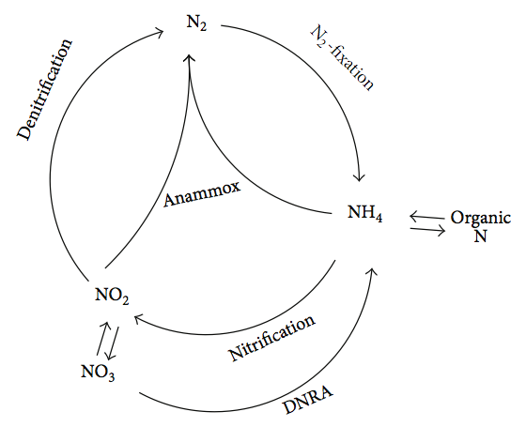

(Source:By Shou-Qing N. and Jian Z. - Anaerobic Ammonium Oxidation: From Laboratory to Full-Scale Application. BioMed Research International, vol. 2013, pp. 1-10, 2013., CC BY 3.0, https://commons.wikimedia.org/w/index.php?curid=29964149)

In general the design-change objectives are the following:
• Reducing the high ammonia content in the sludge water from sludge dewatering, through anaerobic ammonium oxidation (Anammox). The main objective is to lower the final ammonia content in the treated water and then reduce eutrophication. The goal is to achieve ammonia removal up to 80-90% and total nitrogen removal up to 75-85%.
• Reducing the amount of sludge generated, by upgrading the capacity of the sludge management - construction of a thermal hydrolysis of sludge (THP) installation in addition to the currently existing anaerobic stabilization.

Anaerobic Ammonia Oxidation Plant – Anammox – Process Description
• The technology combines the advantages of activated sludge and attached biomass.
• The Anammox process is used to purify water rich in ammonia and poor in carbon. This process will be used to treat the sludge water from the dewatering of stabilized sludge.
• The Anammox process works on the principle of partial nitrification of NH₄-N to nitrite by ammonium-oxidizing bacteria (AOB) under aerobic conditions and the subsequent removal of the remaining NH₄-N and the produced NO₂-N by Anammox bacteria under anoxic conditions. The combined result of these two reactions is that the main part of the NH₄-N is transformed into nitrogen gas. However, a small amount of NO₃-N is also formed.
• The deammonification process consists of aerobic nitrification and anaerobic ammonia oxidation (anammox) reaction. Both steps occur simultaneously in the reactor and are carried out by two different types of microorganisms that have different environmental requirements. AOB require aerobic conditions, while Anammox bacteria need anaerobic conditions. For these two different types of bacteria to coexist on the same biofilm, it is necessary for the biofilm on the carrier to have an oxygen gradient, i.e. the conditions are achieved in the deeper layers of the biofilm. In practice, this is achieved by controlling the concentration of dissolved oxygen (DO) in the bulk liquid at a lower level (1 - 1.5 mg/l) than is usual in conventional nitrifying MBBRs (4 mg/l).

Thermal Hydrolysis Plant (THP) – Process Description
The thermal hydrolysis process (THP) achieves enhanced treated sludge and the final sludge cake dryness is improved. The treated sludge can then be recovered for agricultural purposes. Increased biogas is produced by the anaerobic digestion and this can be used to generate green electricity. Alternatively, it can be injected in the gas grid after treatment. (Source:Veolia)
• The thickened IAU, together with PU are mixed in an existing thickened IAU tank. The mixed primary sludge and thickened IAU will be pumped to new centrifuges for pre-dewatering before the THP plant
In this process, the pre-dewatered sludge is hydrolyzed and crushed, turning into a sterilized liquid with reduced viscosity, which allows more than twice as high loading volumes compared to conventional anaerobic treatment. The thermal treatment, in turn, destroys the hydrophilic nature of the sludge, which allows a significant improvement in its dewatering.
• The pre-dewatered sludge enters the hydrolysis reactor, which is heated by direct steam injection. The temperature in the reactors is about 160°C and the pressure is about 6 bar. At these temperatures and pressures, the organic matter hydrolyzes to soluble compounds. After a certain time, the pressure is released and the sludge moves to the next tank. The sharp drop in pressure causes a steam explosion, which leads to the fragmentation of cells and tissues. In addition, the heating and cooling of the sludge is done by direct heat transfer using steam.

The THP process proceeds in the following steps:
• Pre-dewatering - The sludge is dewatered (pre-) to about 16.5% DM;
• Thermal hydrolysis reactors - The mixed, pre-dewatered sludge is treated for a minimum of 20 minutes residence time in the hydrolysis reactors. The hydrolyzed sludge leaves the plant at about 14.5% DS and is diluted to 10-12% DS before entering the Methane Tanks, therefore the thermal hydrolysis pre-treatment saves volume for stabilization and energy for stirring in the Methane Tanks. • Before entering the methane tank, the hydrolyzed sludge is cooled to maintain the temperature in the methane tanks between 38 and 42°C under all operating conditions within the specified design parameters.
• The methane tanks will be charged with the hydrolyzed sludge after the THP installation.
• Subsequent dewatering - After using this technology, the cake is easily dewatered to high dry matter concentrations. ¬ By building a Thermal Hydrolysis installation, it will be achieved:
• reducing the viscosity of the sludge and ensuring a high degree of decomposition of the dry matter; • achieving complete decontamination of the treated sludge;
• increasing the conversion of organic matter into biogas;
• improving the dehydration process of the decomposed sludge;
• producing a stable final product with low odor and high dry matter content.
Description of the technological equipment related to the Thermal Hydrolysis (THP) installation for additional sludge treatment (in addition to the currently existing anaerobic stabilization).

Preliminary de-watering
• Centrifuge for pre-dewatering - SS input = 3.03%, SS output = 16.5% with a capacity of 91 m3/h and 2750 kg of solids /h
• Feeding screw pumps to centrifuges with frequency control of revolutions. Q = 91m3 / h, H = 2.0 bar, SS = 3.03%
• Installation for preparing polymer, Q = 8000 l / h for dehydration
• Installation for feeding dry polymer type "Big Bag"
• Dosing pumps for polymer solution Q = 4000 l / h, H = 10 m.
• Pump for liquid polymer concentrate Q=20-150 l/h
• Pump for dewatered sludge to sludge silo Q = 16.5 m3/h, H=2.0 bar

Thermal hydrolysis plant
• Number of lines - 2 pcs.
• THP reactors B6-4, set (Pulper, 4 pcs. reactors, Flash tank) - 2 pcs.
• Process gas cooler - 2 pcs.
• Process gas treatment module - 2 pcs.
• Pump-hydrophore system Q=36.5-37.5m3/h, Riz.=6.0 – 8.0bar.2.
• Air-cooled screw compressor set with controller and automatic condensate separator. Flow rate: 1.0 m³/min, max. 1.31m³/h with buffer: min 0.4 m³ dried compressed air, required for safe shutdown

Steam boilers for THP – 2 units (replacing the existing hot water boiler)
• Saturated steam with the following parameters:
- capacity - 4.0 t/h (2.7 MW_{th}/ 9.72 GJ).
- fresh steam pressure - 12 barg
- fresh steam temperature – 191.7°C
- enthalpy Δi ~2,450 kJ/kg
- feed water temperature - 87°C

Anammox reactors
• Bioreactors with V = 1259m³, D=16.35m, H = 6.0m. 2 pcs.

The implementation of the design change makes obsolete and replaces the following equipment included in the project before that:
- Raw Sludge Pumping Station
- Sludge Circulation System
- Hot water boiler (replaced by steam boilers)

A4.2. Describe the impacts of design change on the following
- Additionality
The general purpose of the design change is to improve the quality of the effluent water after the wastewater treatment plant by decreasing the content of ammonia and nitrogen in it. The quantity of the sludge entering the bio-reactors is not affected and remains the same as in the validated PDD. The quantity of the biogas generated by the project is expected to increase with about 10% but the generation of electric energy by the co-generation plant is expected to remain at nominal level of CHP operation. The number of co-generating units will remain the same as in the validated PDD and the eventual additional quantity of biogas will be destroyed by combusting in the steam boilers to generate process steam.
As the generation of electric energy by the project and saving fossil fuel isare the only sources of virtual financial income related to the additionality, there will be no changes in the financial parameters of the investment analysis validated in the initial PDD.
The following table demonstrates the project input parameters used for the investment analysis in the initial PDD with parameter changed due to the design change:

Parameter |  | Value | Reference
Investment costs
1st phase expenses | Eur | 7,020,432 | Sofiyska voda accounting records
2nd phase investment costs | Eur | 2,270,810
Design | Eur | 12,026 | Feasibility Report REUP
Equipment | Eur | 2,200,063 | Feasibility Report REUP
Construction works | Eur | 58,721 | Feasibility Report REUP
Total project costs | Eur | 9,291,242
O&M expenses
O&M expenses for 1st phase equipment | Eur/year | 37,335 | Sofiyska voda accounting records
O&M expenses for 2nd phase equipment | Eur/year | 52,600 | Feasibility Report REUP
Total O&M expenses | Eur/year | 89,935
Total installed capacity (electrical) | MW_{el} | 3.189 | Feasibility Report REUP
Total installed capacity (thermal) | MW_{th} | 3.264 | Feasibility Report REUP
Annual el.energy generation amount net to plant | MW_{el} | 22 217.27 | PDD design change
Annual thermal energy generation amount net to plant | MW_{th} | 52353.6 | PDD design change
Plant load factor | - | 0.55 | Feasibility Report REUP
Lifetime of the project | years | 25 (16 for CHP) | JI PDD ID BG1000166; Tool to determine the remaining lifetime of equipment, ver. 01
Investment analysis period | years | 20 | Guidelines on the Assessment of the Investment Analysis, (Version 05)
Installed electric capacity (gross) | MW | 3.189 | GS PDD; supplier technical specifications;  Feasibility Report REUP
Electric energy price | Eur/MWh_{el} | 33.65 | Feasibility Report REUP
Light fuel oil (LFO) price | Eur/t | 798.00 | Feasibility Report REUP
Grant KIDFS | Eur | 200,000 | Feasibility Report REUP
Equity | Eur | 8,291,242 | Feasibility Report REUP
Loan amount | Eur | 1,000,000 | Feasibility Report REUP
Depreciation rate (II category-equipment) | %/year | 30 | Depreciation rates in Bulgaria

The following changes have been made as estimated in the design change PDD:
1. The period of the investment analysis have been extended with 3 years to reach the end of the second creditting period and the end of the project;
2. The energy generated by the CHP and regarded as saved electric energy have been increased in line with the really generated average annual electric energy as validated for the 2nd creditting period PDD;
3. The thermal energy supplied by the project has been increased in line with the estimations calculated in the design change PDD.
In this respect it has to be specially noted that there is no change in the configuration of the co-generation power plant and it is the same as during the validation of the initial PDD. The installed capacity of the 3 CHP units is still 3.189 MW gross.

The changes have been applied in the investment analysis for the last 3 years until the end of the project creditting period in which the design change will be in opeartion.
The revised IRR calculations result in an IRR of 14.71% which is lower than the benchmark of 16.40% that had been validated during the initial certification of the project under GS4GG.
As no changes in the operational expenses are estimated and the investment costs had already been realised, it only makes sence to apply sensityvity analysis for energy savings only. In this respevt a 10% increase of the eletric and thermal energy savings leads to an IRR of 14.90% which is still lower than the benchmark of 16.40%.
Hence it can be considered that the project is still additional after the design change.

The installation related to the project is a part of greater rehabilitation of the wastewater treatment plant and is financed by a European Union grant and does not affect and change the project investment analysis parameters.

- Applicability of methodology and other methodological regulatory documents with which the project activity has been certified
The design change does not influence the applicability of the methodologies and tools applied and validated in the initial PDD.
There is no change in the baseline and the project line as the project boundary and the sources of GHG emissions are the same as in the certified project activity.

- Compliance with the monitoring plan of the applied methodology
No changes in the monitoring plan validated in the initial PDD are required. Technically the position of the digital thermal energy metering point will be moved to the THP steam supply line to measure the thermal energy generated by the steam boilers and the digital thermal energy meters that measured the heat generated by the CHP units and utiliser will no longer be used.

- Level of accuracy and completeness in the monitoring of the project activity compared with the requirements contained in the registered monitoring plan
There will be no difference in the level of accuracy and completeness in the monitoring of the activity compared to the validated and registered monitoring plant.

- Scale of the project activity
The total installed energy generation capacity (thermal and electrical) of the project activity will remain 6.453 MW which is far below the limit of 45 MW for small scale project.
The estimated annual emission reductions related to AMS-III.H are calculated at 53,214 tCO_{2e} which is below the limit of 60,000 tCO_{2e} for a small scale project.
The new installation is to a greater extend an experimental one and the first-of-its-kind in Bulgaria. The designers believe that about 10% increase in the generation of biogas can be expected. If any increase of the biogas were to be registered it will affect the project emissions only, leading to their increase.
This will be reflected in the next Monitoring report following the start of the installation.

- Stakeholder consultation
There is no need of organising a new stakeholders consultation due to the following circumstances:
- The design change does not lead to an increase of the installed electric capacity of the project involving the same co-generation engines as in the certified project;
- The new installation has been built on the same area inside the Wastewater Treatment Plant and did not require extending to new sites or selecting different sites from those originally envisioned during stakeholder consultations;
- The purpose of the design change is to improve the quality of the effluent waters delivered to the local river system compared to the conditions originally envisioned during stakeholder consultations;
- The design change provides a better quality of the stabilised and dewatered sludge exiting the digesters compared to the conditions originally envisioned during stakeholder consultations and improves its application as a firtiliser.

- Sustainable development criteria
As the project activity is contributing to sustainable development and result in real,
measurable benefits, the project is developed in line with “Gold Standard” rules and
requirements. More information on contribution of the project to environment and
sustainable development of the region can be found in Appendix 1.

- Safeguarding assessment
A completed Safeguarding Principles Assessment is in Appendix 1. There are no changes as in the already validated PDD for the Second crediting period.

- Compliance with applicable legislation
There are no changes or additional legislative requirements concerning the project activity as in the already validated PDD for the Second crediting period. The plant possesses a Permission for deposition of the effluent outlet water into the Iskar river No 1295/14.04.2014, issued by the Ministry of Environment and Water. The Permission defines the quantity of inlet and outlet water and the quality of the effluent water. The quality of the effluent water and heavy metals content is monitored and measured according to the plan and frequency part of the Permission.

- Only for LUF Projects
Transparent summary of all approved changes in Project Area, Eligible Area and accompanying changes in ex-ante emissions removals.
N.A.

DOCUMENT History

Version | Date | Remarks
1.5 | 29 June 2023 | Editorial changes to match V2.1 of the Safeguarding Principles Requirements
1.4 | 21 June 2023 | Editorial changes to match V2.0 of the Safeguarding Principles Requirements
1.3 | 14 April 2023 | Integrated the design change memo as annex of the document.  Editorial changes
1.2 | 14 October 2020 | Hyperlinked section summary to enable quick access to key sections  Improved clarity on Key Project Information  Inclusion criteria table added  Gender sensitive requirements added  Prior consideration (1 yr rule) and Ongoing Financial Need added  Safeguard Principles Assessment as annex and a new section to include applicable safeguards for clarity  Improved Clarity on SDG contribution/SDG Impact term used throughout  Clarity on Stakeholder Consultation information required  Provision of an accompanying Guide to help the user understand detailed rules and requirements
1.1 | 24 August 2017 | Updated to include section A.8 on ‘gender sensitive’ requirements
1.0 | 10 July 2017 | Initial adoption

https://www.sofiyskavoda.bg/docs.aspx?docs=7
http://ji.unfccc.int/UserManagement/FileStorage/AY829537NMFZCB0ROTQGXDIV1LE4PS
http://ji.unfccc.int/UserManagement/FileStorage/MTDX4KFZNGO7J2SI60WEHCY83VPL5Q
http://ji.unfccc.int/JIITLProject/DB/XJ4JK5GTVPT7EE9KERYMNS8SIHUMYS/details
https://www.goldstandard.org/sites/default/files/documents/gs_gender_equality_guidelines_consultation.pdf
https://cdm.unfccc.int/methodologies/DB/K7FDTJ4FL3432I1UKRNKLDCUFAMBX7
https://cdm.unfccc.int/methodologies/DB/VJWCB0FBX89L3K73D4S1QPUP0UBXGC
https://cdm.unfccc.int/methodologies/PAmethodologies/tools/am-tool-04-v8.0.pdf/history_view
https://cdm.unfccc.int/methodologies/PAmethodologies/tools/am-tool-06-v3.0.pdf/history_view
https://cdm.unfccc.int/methodologies/PAmethodologies/tools/am-tool-10-v1.pdf/history_view
https://cdm.unfccc.int/methodologies/PAmethodologies/tools/am-tool-14-v2.pdf/history_view
https://cdm.unfccc.int/methodologies/DB/K7FDTJ4FL3432I1UKRNKLDCUFAMBX7
Other technologies in Table 6.3 of Chapter 6: Wastewater Treatment and Discharge of 2006 IPCC Guidelines for National Greenhouse Gas Inventories are included.
http://www.sofiyskavoda.bg/SVDocuments/Dogovor_za_Koncesia.pdf
https://cdm.unfccc.int/methodologies/DB/VJWCB0FBX89L3K73D4S1QPUP0UBXGC
These are residential, industrial or commercial facilities.
https://cdm.unfccc.int/methodologies/DB/9KJWQ1G0WEG6LKHX21MLPS8BQR7242
https://cdm.unfccc.int/methodologies/PAmethodologies/tools/am-tool-05-v3.0.pdf/history_view
https://cdm.unfccc.int/methodologies/PAmethodologies/tools/am-tool-08-v3.0.pdf/history_view
https://globalgoals.goldstandard.org/applicability-of-global-warming-potential-for-gold-standard-for-the-global-goals-projects/
https://www.engineeringtoolbox.com/methane-density-specific-weight-temperature-pressure-d_2020.html?vA=20&degree=C&pressure=1bar#
https://unfccc.int/documents/644994
https://unfccc.int/documents/644994
https://lex.bg/en/laws/ldoc/2136803101
Ratification by Parliament pending
Please see the recent situation of Istanbul Convention
https://www.mlsp.government.bg/eng/legislation-1
https://www.cpdp.bg/en/index.php?p=element&aid=32
https://www.sofiyskavoda.bg/about/safety_and_health.aspx
Basic services requirements refer to minimum space, supply of water, adequate sewage and garbage disposal system, appropriate protection against heat, cold, damp, noise, fire, and disease-carrying animals, adequate sanitary and washing facilities, ventilation, cooking and storage facilities and natural and artificial lighting, and in some cases basic medical services.
https://www.sofiyskavoda.bg/about/safety_and_health.aspx
https://www.mlsp.government.bg/zakoni
'Involve' means if the project mechanism and/or impact(s) are achieved via changing animal husbandry practices in some way.

