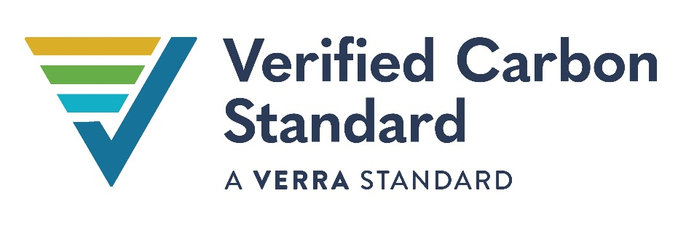

VCS Monitoring Report Template

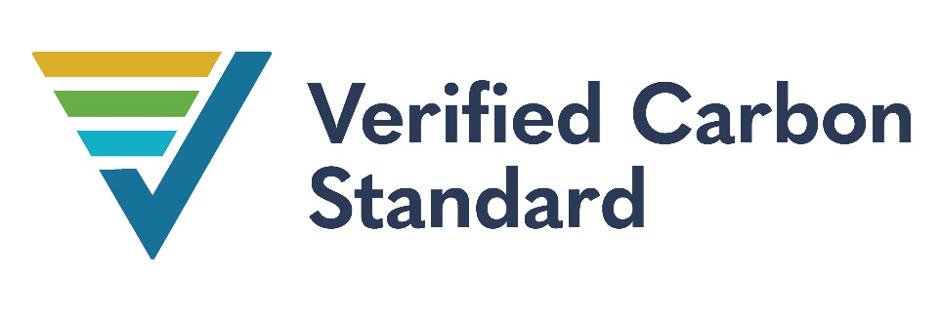

Monitoring Report TITLE
Logo (optional)
Document Prepared by GHD Advisory
Contact Information Jason Clarke P.E.

Project Title | Red Hills Wind Project, L.L.C.
Version | Version 1
Report ID | 730506959-1
Date of Issue | 11-June-2015
Project ID | 288
Monitoring Period | 01-January-2015 to 31-December-2015
Prepared By | David J. Harris / Contracts Analyst
Contact | 701 NE 7th Street  Anadarko, OK 73005  (405)247-4304 Telephone  david.harris@wfec.com  www.wfec.com

Contents
1 Project Details 4
1.1 Summary Description of the Implementation Status of the Project 4
1.2 Sectoral Scope and Project Type 4
1.3 Project Proponent 4
1.4 Other Entities Involved in the Project 4
1.5 Project Start Date 5
1.6 Project Crediting Period 5
1.7 Project Location 5
1.8 Title and Reference of Methodology 5
1.9 Participation under other GHG Programs 5
1.10 Other Forms of Credit 5
1.11 Sustainable Development 6
2 Safeguards 6
2.3 AFOLU-Specific Safeguards 7
3 Implementation Status 7
3.1 Implementation Status of the Project Activity 7
3.2 Deviations 8
3.3 Grouped Projects 8
4 Data and Parameters 8
4.1 Data and Parameters Available at Validation 8
4.2 Data and Parameters Monitored 9
4.3 Monitoring Plan 10
5 Quantification of GHG Emission Reductions and Removals 10
5.1 Baseline Emissions 10
5.2 Project Emissions 11
5.3 Leakage 11
5.4 Net GHG Emission Reductions and Removals 11
APPENDIX X: <title of appendix> 13

Project Details

Summary Description of the Implementation Status of the Project
The objective of the project activity has resulted in the construction, operation and maintenance of a wind power project in Southern Custer and Roger Mills counties in the North American state of Oklahoma. The project provides renewable power to Southwest Power Pool (SPP) Regional Transmission Organization (RTO) and is interconnected with the Western Farmers Electric Cooperative. The project will reduce greenhouse gas emissions caused by reliance on fossil fuels.
The 123 MW project activity is comprised of 82 Acciona Wind Turbine Generators (WTGs), with each WTG having a capacity of 1.5 MW. Turbines commissioning dates were as follows:

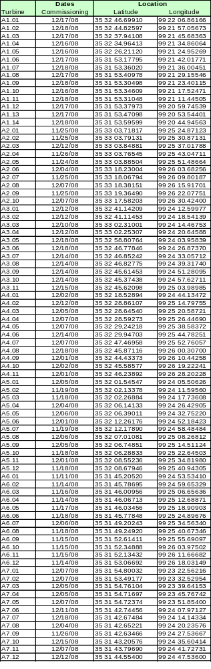
The project is located 10 miles north of Elk City in Western Oklahoma at grid coordinates: Latitude: 35.5°N Longitude: -99.4°W.

Technology employed by the project activity

The Red Hills wind project consists of 82 Acciona AW-77/1500 Class IEC IIa turbines. Each turbine has a hub height of 80 meters (m) and a rotor diameter of 77 m, for a total height of approximately 118.5 m. The turbines are accessed by constructed project roads, and interconnected by communication and electric power collection cable within the wind farm.

The design of the AW-77/1500 was developed based on the experience gained by Acciona in the course of operating turbines manufactured by others, and the lessons learned from over ten years of operations were incorporated into the AW-77/1500 design. The Acciona AW77/1500 is a proprietary design that incorporates features such as the dual-bearing main shaft to reduce axial loads on the gearbox, internal access to the inside of the hub, and a wider nacelle enclosure to make servicing the AW-77/1500 easier and safer than servicing other manufacturer’s turbines. The turbines also have noise insulation and utilize non-flammable materials. These design elements create an unsurpassed turbine known for performance that exceeds the highest industry standards.

Each wind turbine is connected to a pad mount transformer located at the base of the tower. The individual pad mount transformers are interconnected in series (“Daisy Chained”) with other pad mount transformers forming a series of circuits or “strings” called the collection system. The collection system (34.5 kV electrical lines) runs underground to the project substation. Here the voltage is increased to 138 kV and then sent via an overhead transmission line to the interconnection substation at the Point of Interconnect (POI) at Western Farmers Electric Cooperative transmission line.
The purpose is to report the emission reductions generated by 123 MW wind power project in Oklahoma, USA, during the period 1 January 2015 to 31 December 2015. During this time period all the emissions reductions will be sold as VCU’s. The total production of 388,047 MWh’s of production less allocated consumption of 1,599 MWh’s or net MWh’s of 386,448 will be sold as VCU’s (tC02). The net MWh’s of 386,448 MWh’s multiplied by .67 tCO2 per MWh resulted in 258,920 VCU’s.

Sectoral Scope and Project Type
The project activity is considered under zero-emissions ‘grid-connected electricity generation from renewable sources’ that generates electricity in excess of 15 MW (limit for small scale project). Therefore as per the scope of the project activity enlisted in the ‘list of sectoral scopes and related approved baseline and monitoring methodologies’, the project activity may principally be categorized in Scope Number 1, Sectoral Scope – Energy industries (renewable / non-renewable sources.) The project is not a grouped project. See Section 2.3 below.
Grouped projects are projects structured to allow the expansion of a project activity subsequent to project validation. This does not apply to Red Hills since the project description did not set out geographic areas within which new project activity instances would be developed.

Project Proponent
Provide contact information for the project proponent(s). Copy and paste the table as needed.
Organization name | Red Hills Wind Project, L.L.C.
Contact person | Mr. James Fahey
Title | Power Originator
Address | 55 E Monroe St., Chicago, IL 60603
Telephone | (312) 673-3066
Email | jfahey@acciona.com

As the project proponent Acciona is the owner of the project. Acciona was responsible for the construction of the project and is responsible for the ongoing operations and maintenance of the project. On the monitoring of this project Acciona is responsible for testing and calibration of the check meter. They also play a role in the execution of the monitoring plan to assist WFEC with monitoring requirements as needed. They are responsible for granting access to the site for purposes of conducting the site visit required as part of the verification process.

Other Entities Involved in the Project
The other entity involved in the project as the off-taker of the energy and environmental attributes under the terms of a long-term power purchase agreement is:
Organization name | Western Farmers Electric Cooperative
Role in the Project | Off-taker of the energy and environmental attributes under the terms of a long-term power purchase agreement
Contact person | David Sonntag
Title | VP of Special Projects
Address | 701 N.E. 7th Street
Telephone | (580) 326 -1593
Email | d_sonntag@wfec.com

WFEC is contractually committed to the purchase of energy and all related environmental attributes produced by the project. As the owner of the environmental attributes WFEC is responsible for executing the monitoring procedures, preparing the monitoring report and keeping evidence of each formal monitoring period. Commencing with this monitoring report WFEC is responsible for hiring the verifier and providing evidence of net electric energy supplied to the grid and other forms of evidence required during monitoring. WFEC is also responsible for the calculation of emissions avoided to the atmosphere. WFEC as a transmission provider is responsible for the testing and calibration of the meter of record. WFEC provides the communication network to get production and consumption data telemetered to WFEC and Acciona.

Project Start Date

The start of operations, marked by the start of commercial operations which is 26 October 2008, is the start of the crediting period, which will last for ten years per the Project Description (PD).

Project Crediting Period

This is the Seventh Monitoring Report for the referred project activity. The final version (3) of the sixth monitoring report covered the period 1 January 2014 through 31 December 2014.The final version (2) of the fifth monitoring report covered the period 1 January 2013 through 31 December 2013. The final version (3) of the fourth monitoring report covered the period 1 January 2012 through 31 December 2012. The final version (2) of the third monitoring report covered the period 1 January 2011 through 31 December 2011. The final version (3) of the second monitoring report covered the period 1 June 2009 through 31 December 2010. The final version (2) of the first monitoring report covered the period 11 November 2008 through 31 May 2009. The purpose of this document is to:
- Report the emission reductions generated by 123 MW wind power project in Oklahoma, USA (VCS Project ID 157, with validation report dated 31 December 2009) during the period 1 January 2015 to 31 December 2015. During this time period all of the emission reductions were sold as VCU’s. 388,047 MWh’s of production less allocated consumption of 1,599 MWh’s or net MWh’s of 386,448 were sold as VCU’s (tC02). The net MWh’s of 386,448 MWh’s multiplied by .67 tCO2 per MWh resulted in 258,920 VCU’s.

- To serve as the basis for verification, certification and issuance of VCUs.

The start of the monitoring period for this Monitoring Report is 1 January 2015, because that is the beginning of the period subsequent to the final date covered in the fourth monitoring report.

Project Location
The project is located in Southern Custer and Roger Mills counties in the North American state of Oklahoma. The Latitude and Longitude coordinates noting the location of each turbine that comprises the project is noted in the table set forth above in Section 1.1. The project will provide renewable power to Southwest Power Pool (SPP) Regional Transmission Organization (RTO) and is interconnected with Western Farmers Electric Cooperative.

Title and Reference of Methodology

Among the methodologies approved by UNFCCC for grid connected electricity generation from renewable sources, ACM0002 (version 09) was chosen as the most suitable for this project activity. This consolidated baseline and monitoring methodology is used in conjunction with the approved monitoring methodology ACM0002 "Consolidated baseline and monitoring methodology for grid-connected electricity generation from renewable sources".

Taking into account that the project uses ex-ante Operating Margin and ex-ante Building Margin, the main parameter being monitored is the Net electricity supplied to the grid by the project (EGy), which is composed of total electricity produced (TEGy) minus electricity consumed by the project.

The data unit will be MWh and the plant maintains the records of the total energy produced to the grid and the total energy consumed from the grid. Net electricity supply to the grid is calculated from the production and consumption data.

Participation under other GHG Programs

WFEC did not participate the renewable attributes of this project in any other emission trading programs for the year 2015.

Other Forms of Credit

Sustainable Development
.

Safeguards

No Net Harm
The project activity did not contribute to any net harm to the environment during the 2015 monitoring period. Refer to the environmental impact section of the Project Description (PD) document (Section 5.0) as well as the Environmental Analysis & Permitting Compliance Matrix document from HDR Engineering, Inc. dated December 16, 2008.

Local Stakeholder Consultation
No stakeholder consultation was conducted during the 2015 monitoring/reporting period. Stakeholder consultation was completed at the outset of the project as described in the PD (Section 6.0) and the Environmental Analysis & Permitting Compliance Matrix.

AFOLU-Specific Safeguards

This project activity is not an AFOLU project, therefore this is not applicable.

Implementation Status of the Project Activity
- The start of operations, marked by the start of commercial operations which is October 26, 2008, is the start of the crediting period, which will last for ten years from this moment, as per the PD.
- The purpose is to report the emission reductions generated by 123 MW wind power project in Oklahoma, USA (VCS Project ID 288), with validation report dated 31 December 2009) during the period 1 January 2015 to 31 December 2015. During this time period all the emissions reductions were sold as VCU’s. The total production of 388,047 MWh’s of production less allocated consumption of 1,599 MWh’s or net MWh’s of 386,448 were sold as VCU’s (tC02). The net MWh’s of 386,448 MWh’s multiplied by .67 tCO2 per MWh resulted in 258,920 VCU’s.
- According to ACM0002, the main emissions potentially giving rise to leakage in the context of electric sector projects are emissions arising due to activities such as power plant construction, fuel handling (extraction, processing, and transport), and land inundation (for hydroelectric projects). Project participants do not need to consider these emission sources as leakage in applying this methodology. Project activities using ACM0002 shall not claim any credit for the project on account of reducing these emissions below the level of the baseline scenario. Thus the leakage emissions are NIL There is no leakage to this project so Ly = 0. Thus, ERy = BEy. i.e. the emission reductions are the baseline emissions in this.

Deviations

Methodology Deviations
For the monitoring period covered by this monitoring report commencing 1 January 2015 to 31 December 2015 there were no deviations from the monitoring plan methodology.

Project Description Deviations
For the monitoring period covered by this monitoring report commencing 1 January 2015 to 31 December 2015 there were no deviations of the project description.

Grouped Projects
Grouped projects are projects structured to allow the expansion of a project activity subsequent to project validation. This does not apply to Red Hills since the project description did not set out geographic areas within which new project activity instances would be developed.

Data and Parameters

Data and Parameters Available at Validation

Data / Parameter | EFy
Data unit | tCO2e/MWh
Description | Operating Emission Factor of Southwest Power Pool
Source of data | Emission Factor has been calculated ex-ante for crediting period of ten years as per PD registered
Value applied | .67tCO2/MWH
Justification of choice of data or description of measurement methods and procedures applied | This parameter will be used to calculate baseline emissions. EFy times Electricity Supplied to the grid (EGy). Electricity Supplied to the grid is the Monitored Parameter set forth in the table below. Baseline emissions equals emissions reductions (ERy).
Purpose of Data | Calculation of project emissions
Comments | None

Data and Parameters Monitored

Data / Parameter | EGy
Data unit | MWh (Mega-watt hour)
Description | Net electricity supplied to the grid by the project
Source of data | Electricity supplied to the grid by the Project
Description of measurement methods and procedures to be applied | Please refer to Section 3.3
Frequency of monitoring/recording | Monthly at the meter of record
Value monitored | MWh
Monitoring equipment | Please refer to Section 3.3
QA/QC procedures to be applied | Please refer to Section 3.3
Purpose of the data | Calculation of project emissions
Calculation method | BEy=EFy*EGy.
Comments | None

Monitoring Plan
- Among the methodologies approved by UNFCCC for grid connected electricity generation from renewable sources, ACM0002 (version 09) was chosen as the most suitable for this project activity. This consolidated baseline and monitoring methodology shall be used in conjunction with the approved monitoring methodology ACM0002 "Consolidated baseline methodology for grid-connected electricity generation from renewable sources ". Taking into account that the project used ex-ante Operating Margin and ex-ante Building Margin, the main parameter to be monitored is the Net electricity supplied to the grid by the project (EGy), which is composed of total electricity produced (TEGy) minus electricity consumed by the project. The data unit will be MWh and the plant maintains the records of the total energy produced to the grid and the total energy consumed from the grid. Net electricity supply to the grid is calculated from those two data.
- Organizational structure, roles and responsibilities are stated in a separate document titled: ‘Monitoring and verification manual for VCS purposes’.
- QA/QC Procedure
  - Electricity supplied to the grid by the project is measured through national standard electricity metering instruments recorded monthly by the project entity.
- Two meters (Meter of Record and Check) are installed at the Point of Interconnection. Production and consumption registered by the Meter of Record alone is adequate for the purpose of billing. The Check meter should be used when the Meter of Record fails to register, in which case the meter agent, shall adjust measurements by using the Interconnection Customer’s Check meter, if installed. Both the meters are read for electricity generation and electricity consumption purposes on a monthly basis.
- The import of electricity from the grid is recorded by the same meters, since these are import-export meters. Net electricity supply to the grid (EGy), the total electricity produced by the project activity (TEGy) minus the electricity consumed from the grid, is used to calculate VERs. This data has been cross-verified with the invoices raised by SPP and payment received against the invoices.
- The Meter of Record and Check meters have the same accuracy level of 0.1%, and both were tested for accuracy before installation.
- Serial numbers for the meters are as follows:
    - Meter of Record: 82093242
    - Check meter: LT-0808A309-01

- Meter Reading Procedure
  - Meter of record. As per the interconnection agreement, data is telemetered to one or more locations. Such telemetered data is used as the official measurement of the amount of energy delivered from the Large Generating Facility to the Point of Interconnection.
  - CECD performs meter data monitoring tasks for the Red Hills wind farm. A meter communication port has been made available to CECD by Western Farmers Electric Cooperative for the Meter of Record. A meter communication port has also been made available for the Check Meter.
  - The order of events leading from meter readings to invoices from Southwest Power Pool is as follow:
    - Bidirectional hourly meter data is directly measured by the Meter of Record
    - Meter data is telemetered to CECD
    - Daily meter data is sent from CECD to SPP
    - SPP generates Settlement Statements based on meter data and market prices
    - SPP generates an invoice based on Settlement Statements
    - SPP pays Red Hills via a wire transfer
- Calibration of the Meters
  - The Meter of Record was calibrated before installation on 15 October 2008 by Western Farmers Electric Cooperative. Periodic tests should be done every two years.
  - The Check meter was calibrated before installation on 6 September 2008 by Schneider Electric. Even though test procedures for the Check Meter are not governed by the Interconnection Agreement and periodic tests will only be necessary every four years, periodic controls discovered the Check Meter was not reading voltage. After trying to reboot it, it did not return to normal operation. On 1 May 2009 the decision was made to remove the meter and send it off for testing and repair, so high quality measurement is guaranteed. New calibration on the meter was done by Power Measurement on 11 May 2009 and the meter was reinstalled on 28 May 2009. Additional tests of the meter of record were conducted 14 July 2010, 28 December 2011, 24 October 2012, 20 November 2013, 25 September 2014 and 30 July 2015. A test of the check meter was conducted August 28, 2015 with no adjustments being made.
- Following data verification process, during monthly meter readings, the variation between the main meter and check meter have been less than +/- 2%. Data has been provided to verifier for verification along with excel sheet results.
- There are no interim internal audit verification procedures performed only the annual verification process. As part of that process the meter of record and the check meters results are verified and any differences outside the range allowed by contract are investigated and resolved. No unacceptable differences were identified for the period 1 January 2015 through 31 December 2015. Any non-conformances to extent identified through the review and payment of monthly production and consumption invoices are timely resolved according to provisions set forth in the renewable energy purchase agreement. Any differences identified through the meter testing procedures are resolved according to the contract. There were no non-conformance issues, billing or meter testing discrepancies identified during the monitoring period 1 January 2015 through 31 December 2015.

Quantification of GHG Emission Reductions and Removals

Baseline Emissions

The baseline emissions (BE_{y} in tCO₂) are the product of the baseline emissions factor (EF_{y} in tCO₂/MWh) times the electricity supplied by the project activity to the grid (EG_{y} in MWh).

BE_{y} = EF_{y} * EG_{y}
Auxiliary power supply will be required for operation of equipment like hydraulic motors and yaw system for which active power will be drawn from the grid. The metering of the drawn power will be done by the same import-export meters.
Net electricity supply to the grid (EG_{y}) is the total electricity produced by the project activity (TEG_{y}) minus the electricity consumed from the grid.
Baseline emission factor (EF_{y}) has been calculated ex-ante and will not be updated during the crediting period of ten years. As per PD registered, EF_{y}=0.67 tCO2/MWh.
Net electricity supplied to the grid by the project (EG_{y}) is measured by the meters, resulting in the net production figures set forth item 20 of the Information Reference List.

The meter reading of the Meter of Record with the related invoices and payment details during the monitoring period were provided to the verifier.Quantify Project Emissions

Leakage

According to ACM0002, the main emissions potentially giving rise to leakage in the context of electric sector projects are emissions arising due to activities such as power plant construction, fuel handling (extraction, processing, and transport), and land inundation (for hydroelectric projects). Project participants do not need to consider these emission sources as leakage in applying this methodology. Project activities using ACM0002 shall not claim any credit for the project on account of reducing these emissions below the level of the baseline scenario. Thus the leakage emissions are NIL.

There is no leakage to this project so L_{y} = 0. Thus, ER_{y} = BE_{y.} i.e. the emission reductions are the baseline emissions in this project.

Net GHG Emission Reductions and Removals
For non-AFOLU projects, use the following table:
Year | Baseline emissions or removals  (tCO₂e) | Project emissions or removals (tCO₂e) | Leakage emissions (tCO₂e) | Net GHG emission reductions or removals  (tCO₂e)
Year 2015 | 258,920 | 0 | 0 | 258,920
Year…
Total | 258,920 | 0 | 0 | 258,920

The following table reflects expected baseline emissions from the original project validation compared to the actual baseline emissions achieved for the period 1 January 2015 through 31 December 2015.
For AFOLU projects, use the following table:
Year | Baseline emissions or removals (tCO₂e) | Project emissions or removals (tCO₂e) | Leakage emissions (tCO₂e) | Net GHG emission reductions or removals (tCO₂e) | Buffer pool allocation | VCUs eligible for issuance
Year 2015 | 293,839 | 258,920 |  | 34,919
Year…
Total | 293,839 | 258,920 |  | 34,919

As explained above, ER_{y} = BE_{y}.
The Meter of Record has been working properly in the crediting period for which this report is prepared and when compared with the results of the check meter were found to be within allowed tolerances. Since the meter of record has been used reliably for billing purposes the meter of record measurement alone is adequate for the purpose of emissions reductions during the period covered by this report. Total emission reductions during the monitoring period were 258,920Oc tn CO_{2.}
The deviation calculation is purely pro-rated by the number of days in the monitoring period and does not correlate with the wind pattern during the year.

APPENDIX X: <title of appendix>

Reference no. | Document or type of information supplied to verifier
 | Items Delivered to Verifier Prior to and subsequent to Site Visit:
1 | Electronic delivery of 2015 Spreadsheet for Renewable Attribute Production from Red Hills Wind Farm contracted to WFEC
2 | Electronic delivery Green-e Energy Renewable Generator Registration Form and Attestations 1st – 4th Quarters 2015
3 | Electronic delivery of contract for sale of VCU’s covered by this report. This is the same contract delivered as part of the Seventh Monitoring Report
4 | Electronic delivery of email correspondence for exercise of option to purchase additional VCU’s production for 2015 in excess of base quantity in contract.
5 | Electronic delivery of Reconciliation of Meter-of-Record production and consumption data versus Check Meter record of production and consumption data for the period 1 January 2015 through 31 December 2015
6 | Electronic delivery of Final Seventh monitoring calculation to support the calculation of 258,920 tCO2 covered by this monitoring report
7 | Electronic delivery of Red Hills production invoices for period 1 January 2015 through 31 December 2015
8 | Electronic delivery of Red Hills consumption invoices for period 1 January 2015 through 31 December 2015
9 | Electronic delivery Hourly Raw Meter data for production and consumption in kilowatt hours.
10 | Electronic delivery of Hourly Check Meter data for production and consumption in kilowatt hours.
11 | Electronic delivery Meter Test Results 28 August 2015 and Check Meter Test Results 30 July 2015
12 | Electronic delivery of Record Retention of at least five (5) years and for all production data for life of contract.
13 | Electronic delivery of Environmental Permitting Summary for the Red Hills Wind Farm.

