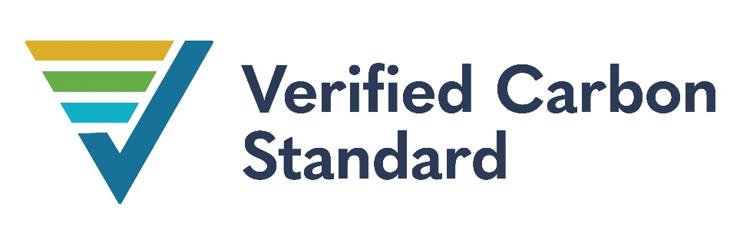

Reducting Gas Leakages within North, West and other Sub-Areas of the Titas Gas Distribution Network in Bangladesh
Project Title | Reducing Gas Leakages within North West and other sub-areas of the Titas Gas Distribution Network in Bangladesh
Version | 1
Date of Issue | 07 April 2022
Prepared By | Kevin James, Climate Compass LLC
Contact | 5004 River Rd. Bethesda, MD 20816 USA +1 202 340-1112, kjamesqt@gmail.com
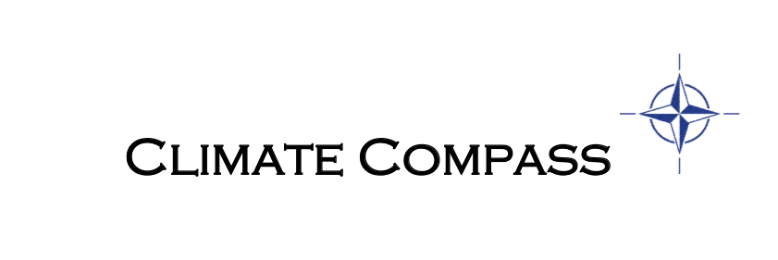

Contents
1 Project Details 4
1.1 Summary Description of the Project 4
1.2 Sectoral Scope and Project Type 5
1.3 Project Eligibility 5
1.4 Project Design 5
1.5 Project Proponent 6
1.6 Other Entities Involved in the Project 6
1.7 Ownership 6
1.8 Project Start Date 6
1.9 Project Crediting Period 7
1.10 Project Scale and Estimated GHG Emission Reductions or Removals 7
1.11 Description of the Project Activity 7
1.12 Project Location 15
1.13 Conditions Prior to Project Initiation 17
1.14 Compliance with Laws, Statutes and Other Regulatory Frameworks 18
1.15 Participation under Other GHG Programs 18
1.16 Other Forms of Credit 18
1.17 Sustainable Development Contributions 18
1.18 Additional Information Relevant to the Project 20
2 Safeguards 20
2.1 No Net Harm 20
2.2 Local Stakeholder Consultation 20
2.3 Environmental Impact 26
2.4 Public Comments 26
2.5 AFOLU-Specific Safeguards 27
3 Application of Methodology 27
3.1 Title and Reference of Methodology 27
3.2 Applicability of Methodology 27
3.3 Project Boundary 30
3.4 Baseline Scenario 32
3.5 Additionality 34
3.6 Methodology Deviations 42
4 Quantification of GHG Emission Reductions and Removals 43
4.1 Baseline Emissions 43
4.2 Project Emissions 52
4.3 Leakage 53
4.4 Net GHG Emission Reductions and Removals 53
5 Monitoring 59
5.1 Data and Parameters Available at Validation 59
5.2 Data and Parameters Monitored 61
5.3 Monitoring Plan 72

Project Details

Summary Description of the Project
The proposed project aims to reduce gas leakages from components in the natural gas transmission and distribution system operated Titas Gas Transmission and Distribution Company Limited (Titas) in the People’s Republic of Bangladesh in the Divisions/Areas of Titas’ service area outlined in more detail in section 1.12.
The project will lead to reductions of methane, a potent greenhouse gas (GHG). It is estimated that the project will reduce 1,124,113 TCO2e per year and a total of 10,913,263 TCO2e over the 10-year project crediting period.
Construction began on the gas system in the 1960s and over the years it has not been adequately maintained. As a result, a significant percentage of the natural gas throughput which is more than 95% methane (CH₄) leaks from components in the system and is released into the atmosphere contributing to global warming. Leaks in the transmission/distribution system are caused by normal component wear, thermal and vibrational stresses and seasonal expansion/contraction cycling from ambient air temperature changes. Natural gas leaks occur through various sources including, thread connections of gas pipes, broken gaskets and other broken parts of ball/plug valves, broken membranes of pressure regulators and connectors, etc. These components are not routinely checked for leaks under the existing safety practices of Titas.
The company’s operators lack the advanced leak detection equipment, advanced repair materials and trained workers to identify chronically leaking components, accurately measure the leak rates and make reliable repairs of the leaks within the project boundary. Teams generally rely on odor and soap bubbles to identify leaks. This approach is ineffective as odor does not allow a repairman to pinpoint a leak or its size. In fact, above ground outdoor equipment odor is extremely ineffective in isolating leaks. Soap can be used to isolate leaks, but this method gives no information on the actual size of the leak which is critical to making cost effective repairs. Furthermore, even for those leaks that are identified through bubbles and odor, the company lacks the modern repair materials required to fix all but the simplest leaks that require only tightening of components.
The project will lead to the reduction of methane emissions at valves, insulating joints, pressure regulators and other above ground gas transmission/distribution infrastructure. The project activity will reduce natural gas leakage in the transmission and distribution network of Titas in the project area through the implementation of advanced leak detection and repairs (LDAR) procedures using advanced leak detection and measurement technology including HiFlow Samplers. Leak Measurement Devices and Gasurveyors. The project activities will include inspection and leak measurements, as well as repair works at components in the natural gas above ground distribution system using advanced repair materials such as (ePFTE) sealing material, advanced membrane replacement materials, advanced sealing paste for conical connections, Tangit string for thread connections, and nitrile-rubber O-rings.

Sectoral Scope and Project Type
Sectoral Scope 10 – Fugitive emissions from fuels
This project is not a grouped project.

Project Eligibility
The scope of the VCS Program includes:
1. The six Kyoto Protocol greenhouse gases: The emissions reductions from the project comes from reduced Methane (CH4) emissions as a result of the previously leaking gas that will be eliminated by finding and repairing the leak in the project scenario; Thus, the project is applicable to this scope.
2. Ozone-depleting substances: NA This project does not involve ODSs.
3. Project activities supported by a methodology approved under the VCS Program through the methodology approval process: NA This project does not use a methodology approved under the VCS Program through the methodology approval process.
4. Project activities supported by a methodology approved under a VCS approved GHG program, unless explicitly excluded under the terms of Verra approval: The methodology AM0023 (Version 04) the project utilized is a methodology approved under CDM Program, that is a VCS approved GHG program.
5. Jurisdictional REDD+ programs and nested REDD+ projects as set out in the VCS Program document Jurisdictional and Nested REDD+ (JNR) Requirements: NA This project does not involve REDD+.
Additionally, the project is not included in the projects excluded in Table 1 of VCS Standard 4.0. Thus, the project is eligible under the scope of VCS program.

Project Design
The project has been designed to include a single installation (gas distribution system) of an activity and is not a grouped project. Many individual leaks however will be repaired in equipment located across the entire project area.

Project Proponent

Organization name | Carbon Projects LLC
Contact person | Daragh Glynn
Title | Co-Director
Address | 9E, Loockerman St. Suite 311, Dover (County of Kent), DE 19901, USA
Telephone | +376640743
Email | daraghglynn@ne-climate.com

Other Entities Involved in the Project

Organization name | Climate Compass LLC
Role in the project | Project Development and Implementation
Contact person | Kevin James
Title | Managing Director
Address | 5004 River Road, Bethesda, MD 20816, USA
Telephone | +12023401112
Email | kjamesqt@gmail.com

Ownership
Carbon Projects LLC, by virtue of enforceable and irrevocable contract agreements has the rights to undertake the Project with Titas Gas Company Limited, the holder of the statutory rights in the gas distribution system where the methane leaks are found and repaired by the project proponent.

Project Start Date
June 1, 2022. This is the estimated date on which the project proponents plan to start the baseline study and make repairs, which is estimated to take 7 months to complete, to identify and measure leaks and undertake repairs. The training of the operators will commence on May 9th. The training period from May 9- May 31, 2022 may include some leak reductions which will be done as part of the field portion of the training, but the project is estimated to only begin activities reducing leakage on June 1, 2022

Project Crediting Period
June 1, 2022 –May 31, 2032 (10 years fixed)

Project Scale and Estimated GHG Emission Reductions or Removals

Project Scale
Project
Large project | x

Year | Estimated GHG emission reductions or removals (tCO₂e)
2022 (June1-Decmber 31) | 327,866
2023 | 1,124,113
2024 | 1,124,113
2025 | 1,124,113
2026 | 1,124,113
2027 | 1,124,113
2028 | 1,124,113
2029 | 1,124,113
2030 | 1,124,113
2031 | 1,124,113
2032 (January 1- May 31) | 468,380
Total estimated ERs | 10,913,263
Total number of crediting years | 10
Average annual ERs | 1,091,326

Description of the Project Activity
Project activity
The project activity will reduce natural gas (CH₄) leakage in the transmission and distribution network of Titas Gas for the following regions and adjacent areas: Dhaka, Narayanganj, Sonargaon, Gazipur, Savar, identified in more detail in section 1.12, through the implementation of advanced leak detection and repairs (LDAR) procedures which currently does not exist in these areas. The project activities will include inspection and leak measurements using advanced leak detection and measurement equipment which Titas does not possess, as well as repair works at components in the natural gas above ground distribution system using advanced repair materials not currently used by the Titas Gas Company or typically available in Bangladesh. In addition, selected staff will be trained in advanced leak detection, measurement, and repair techniques. Additional experts will need to be hired to implement the project.
Staff within Titas and local implementation partner Prokaushali Sangsad LTD (PSL) will implement the day-to-day Project operations and monitoring activities by performing advanced LDAR activities (detection, measurement, repair and documentation of leaks) throughout the crediting period. Climate Compass will provide training to local project staff on how to organize and implement an LDAR, utilize advance measurement equipment and repair materials, and provide its proprietary database and data management system, methodological supervision and project oversight. Carbon Projects LLC will provide all the funds required to implement the project. The project implementation management and execution will be completely separated in time and space from conventional LDAR and emergency/capital repairs implemented by Titas. Project leak detection and repair crews will be dispatched to facilities at different times from the regular conventional LDAR program crews. There will be no data sharing between two types of crews to prevent possible bias, which could impact project implementation. Conventional repair teams lack the equipment and expertise required to make the measurements required to claim emission reductions ensuring that there will be no overlap.

The following monitoring procedures will be implemented:

Establishment of a database
All data collected during project implementation will be entered into a database. The database will be continuously updated during the crediting period. The data in the database will also be included in each monitoring report. Only leaks measured and repaired as part of this project will be included in the database.

Data collection during the project implementation
The implementation of the project will involve an initial baseline survey and regular subsequent surveys of each component within the project boundary.
During the project activity, data will be collected and collated by the project leak detection and repair teams, the database manager will review the data and check that it has been recorded correctly. Procedures will include: 1) tracing data from individual spreadsheets to the collated spreadsheet; 2) identifying outliers and verifying the measurement with the responsible technical operator; and 3) reviewing measurements from each individual leak using a flow measurement device (such as a Hi-Flow Sampler™ or Leak Measurement Device), to ensure that no leak flow measurement device in particular is making measurements that appear to be outliers on a constant basis. If such discrepancies are found, the machine will be recalibrated and checked immediately.
Additionally, to ensure data is not lost if leak tags are damaged or lost, or digital photos are accidently deleted, or electronic data files corrupted, etc., three concurrent ways of tagging leak locations and tracking leak measurements will be implemented: 1) a digital photo of the leak will be taken including the filled out tag; 2) a physical tag will be placed on-site and the leak rate and measurement date written on the tag; and 3) when the leak measurement and date are entered into the database the original hard-copy measurement records will be saved.
The project will utilize an independent third-party consulting firm MBS, to provide QA/QC oversight for the project. Their role and responsibilities will include: 1) verify that maintenance and monitoring of leaks is being conducted in accordance with the Monitoring Plan; 2) observe database team to ensure that data is being recorded and handled as per the requirements of this Monitoring Plan; and 3) conduct audits of the data to ensure that adequate records are being kept, and that leaks found and leaks repaired have been accurately documented in the database.

Monitoring
- All teams conducting leak surveys will be formally trained and certified by technical experts in leak detection and measurement techniques, and advanced repair techniques. The training program is described in more detail below.
- Training Program
A training program will be conducted by Climate Compass and MBS to train local staff on how to use advanced LDAR techniques, such as how to use advanced detection and measurement equipment, how to execute effective repairs, and how to document the leaks found in an effective manner. The training will be conducted by technical experts with experience in advanced gas leak detection and measurement, and advanced repair materials to be used in the project. These experts will provide detailed instructions and written materials on how to conduct the leak detection, measurements and repairs.
- Each project leak detection and repair team will be equipped with the following equipment:
- Gas Flow measuring device such as the Hi-flow™ sampler or Leak Measurement Device
- Access to Certified calibration gas canisters: low concentration ~2.5% methane in air concentration; and high concentration ~97%% methane
- Electronic Gas Concentration Detector such as the GMI Gasurveyor™ (500 Series)
- Smartphone able to get GPS coordinates and make photos of leaky facilities
- Weather resistant tags
- Advanced Repair materials as required for particular repairs
- Data sheets with draft schematics for data input on-site
- Toolkit
- Transportation

Monitoring requirements

For each component where a physical leak has occurred, the following procedures will be undertaken and information will be collected:

Leak Detection and Measurement
The project leak detection and repair teams will survey the components in the project boundary using advanced leak detection instruments, such as the GMI Gasurveyor (500 series), which is an electronic gas detector. Once identified, the leaks will be tagged, and numbered. The flow rate for each leak will then be quantified using a gas leak flow measurement device such as a Hi-Flow™ sampler or Leak Measurement Device. A digital photograph will be taken of the leaking component including the tag filled with the pertinent data. These photographs will be archived by the Database Management Team. In addition, the type of repair expected given the nature of the leak and its location will be recorded.
After leaks have been detected and measured, they will be repaired. Before each repair is made, another gas leak flow measurement will be taken. In case there is any discrepancy between the final measurement and the original measurement greater than 15%, a third measurement will be taken to confirm the change. The final, confirmed leak rate will be used to determine baseline leakage as per the AM0023 (Version 04.0.0) methodology, regardless of whether the leak rate is lower or higher than the original leak measurement. After the repair, a new leak measurement will be carried out to ensure that the leak was properly repaired. If required, additional repairs will be made until no further leak can be detected. The date of the repair (or discovery of remaining leak) will be recorded in the Project Database.

Monitoring Repaired Leaks
All leaks that have been subject to repair will be monitored – using the same leak detection technologies (such as the Gasurveror 500, Hi-Flow™ sampler, or Leak Measurement Device) on each leak identified in the baseline – to ensure they are maintained. If a leak for some reason cannot be monitored during a monitoring period (shut-off, in area under construction, etc.) then, in order to be conservative, no VRUs will be calculated from that leak for that crediting period. Where a leak repair fails, it is conservatively assumed that the leak resumed at the measured rate on the day after the last inspection in the same period, the end of the previous monitoring period, or in the case of the first inspection, the day after the repair has taken place. Emission reductions will be calculated based on the difference between the original leak rate and the newly measured rate until it is re-repaired. A reappeared leak rate greater than the leak rate at the original measurement will be considered zero for emission calculations as the increased leak would be part of the baseline case. Such reappeared leaks will be repaired again followed by new leak measurement to confirm the repair.
In summary, for each component where a physical leak has occurred, the following information will be collected during regular monitoring checks:
- Date of monitoring;
- An assessment whether the relevant component has been replaced after the repair of the leak;
- The number of hours during which the component is in pressurized natural gas service;
- An assessment whether the repair of the leak functions appropriately.

All information will be added to the database and be included in the monitoring reports.

Project Technology:

The project involves state-of-the-art technology (i.e., advanced LDAR program) to detect, measure (via concentration and flow rate) and repair leaks. Detected and repaired leaks will be tagged, logged manually and electronically, and stored in the database. Digital photos of each leaking component shall also help in locating and knowing conditions before and after the repairs of leaks have taken place. Training is conducted for the local implementation team so that trained experts in the repair and measurement techniques required for an Advanced LDAR program will remain in Bangladesh following the conclusion of the project. Furthermore, members of the local gas company are also trained as part of the project to ensure that they understand the details of the project implementation techniques and can oversee the project. The results in terms of leakage reduced and money saved will be shared regularly with senior management in each company and with senior government officials, with the hope that they will understand the benefits of continuing such a program following the conclusion of the activity.
The section below explains briefly the technical highlights of the advanced equipment to be used in the project activity.

1. Leak Detection technology:

During the proposed project activity, leaks will be detected using advanced technologies such as catalytic oxidation/thermal conductivity detectors; potentially including the GMI Gasurveyor™ (500 Series) (Figure 1). The GMI Gasurveyor™ (500 Series) is a highly flexible, electronic portable gas detector designed as per latest standards and is certified for use in hazardous areas. The detector has LCD screen with automatic backlighting, audio, visual and fault alarms and are one of the state-of-the-art gas detectors. During the monitoring phase, all project inspections will be carried out with accuracy not less than that of the GMI Gasurveyor™ (500 Series).
Figure 1 Gasurveyor Model
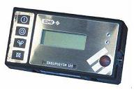
2. Leak Measurement technology:

For most leak measurements, gas leak flow measurement equipment such as the Hi-Flow™ samplers or Leak Measurement Devices will be applied. Gas leak flow measurement equipment such as Hi-Flow™ samplers (Figure 2) and Leak Measurement Devices capture all the emissions from a leaking component to accurately quantify leak emissions rates. Leak emissions, plus a large volume sample of the air around the leaking component, are pulled into the instrument through a vacuum sampling hose. A dual-element hydrocarbon detector (catalytic-oxidation/ thermal-conductivity) measures hydrocarbon concentrations in the captured air stream ranging from 0.01 to 100 percent. Sample measurements are corrected for the ambient hydrocarbon concentration, and mass leak rate is calculated by multiplying the flow rate of the measured sample by the difference between the ambient gas concentration and the gas concentration in the measured sample. Hi-Flow™ samplers, for example, measure leak rates up to 10.5 cubic feet per minute (equivalent of 0.297 m³/min), equal to 15.1 thousand cubic feet (428.2 m³) per day, with the accuracy of calculated leak rate of +/- 10%. As per the methodology, a calibrated bag or other bagging techniques specified by the methodology may be employed as needed.

Figure 2 High-flow Sampler
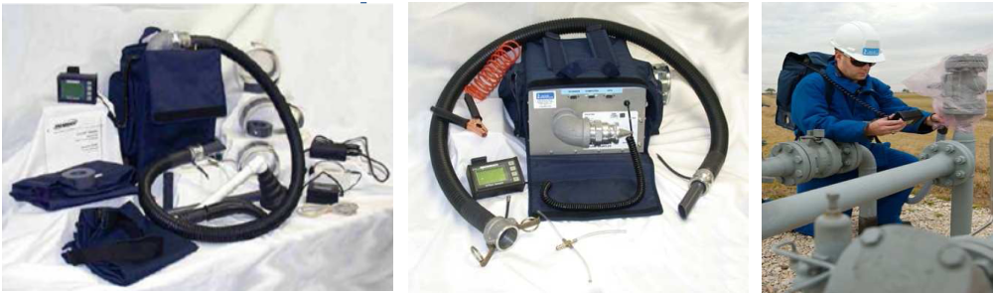

3. Advanced Leak Repair Material:

After the leak is detected, the actual repair works on leaks can vary from replacing seals, fittings, valves and other leaking components or replacing entire equipment sets.

The project activity proposes to use the following types of materials:

1. For leaks at valves, advanced and environmentally safe materials made from expanded polytetrafluoroethylene (ePFTE) such as that produced under license of W.L. Gore & Associates, Inc can be used as to make repairs. The technical features of this type of material are presented below using as an example excerpts from the manufacturer of GORE®:

- GORE® Valve Stem Packing is a pliable, self-lubricating packing that eliminates stem wear and lasts indefinitely (3). This continuous-length packing installs easily and forms a cohesive cylinder when compressed, eliminating the need to cut and form rings. In most cases, it is not necessary to remove the valve from service, and no disassembly is required. When GORE® valve stem packing is wound around a valve stem, pushed into the stuffing box and compressed by tightening the gland nut, it is compacted into a high-density packing. The result is a perfect, high-precision fit and a packing that fills flaws and irregularities — including those caused by wear. Once installed, a slight turn on the gland nut is all the maintenance that is usually required.

Figure 3: GORE® sealing material


- GORE® Valve Stem Packing offers a high degree of pliability, allowing the packing to conform to worn valve stems and stuffing boxes. GORE® Valve Stem Packing will not deteriorate with age, has a low coefficient of friction, and withstands temperatures from -450°F to +650°F
(-268°C to +315°C). This soft, flexible packing is unaffected by all common chemicals and will not contaminate product flow. The softness and self-lubricating nature of GORE® Valve Stem packing practically eliminates stem wear.

Implementation of expanded polytetrafluoroethylene (ePFTE) sealing material is a significant improvement compared to the current sealing approach of Polyethylene tape or simply tightening the components. Polyethylene, the most common material used in plastic shopping bags, can easily dry out allowing leaks to quickly re-emerge. Implementation of this new sealing material that does not dry out is expected to significantly reduce re-emergence of leaks in the system between regular maintenance inspections. Manufacture performance data shows that seal integrity is maintained for 10 years and more, as opposed to a few months for the currently used materials.

2. Other advanced repair materials such as advanced membrane replacement materials, advanced sealing paste for conical connections, Tangit string for thread connections, and nitrile-rubber O-rings will also be utilized as required.

3. Leaks at insulating joints will be addressed by replacing leaking components with new ones. All new insulating joints will be designed and installed according to ANSI/ASME standards (or other comparable standards used in Bangladesh) for gas distribution systems.

Project Location
The entire above ground gas transmission and distribution system found in the service and franchise areas operated by Titas Gas distribution network for the following six regions and adjacent areas:
Dhaka, Narayanganj, Sonargaon, Gazipur, Savar, in the following areas:
Table 1
DIVISION | Division Code | Territory
 | (Metro Dhaka-South)
MD-2 | 165 | Jinjira, Keraniganj (Hasnabad to Jhilmil project) (Ati bazar to Narayanganj Gudaraghat)
 | (Metro Dhaka-North)
MD-4 | 141 | Chalabon/Uttara
MD-4 | 129 | Dhaka Cantonment
MD-4 | 142 | Ashkona/Uttara
MD-5 | 190 | Backside of Kamrangir Char
MD-6 | 104 | Mirpur (Both sides of road Mirpur Road to Gabtoli bridge; (Back side of police training center)
NA-J (NARAYANGANJ)
NARAYANGANJ | 105 | Naraynaganj (Jhalkuri, Mizmizi, Sahebpara)
NARAYANGANJ | 106 | Fatullah (Panchoboti, Gudaraghat)
SONARGAON | 137 | Sonargaon (Sonargaon, Tarabo, Bondor, Rupshi, Borpa)
SONARGAON | 133 | Murapara (Modonpur, Bhulta, Gozaria, Gousia)
SONARGAON | 133 | Araihazar Sadar
SONARGAON | 170 | Munshiganj (Munshiganj sadar-Sirajdikhan, Pashchim Muktarpur, Rikabi Bazar-Forgongga munshir hat, Sipahipara more-Dholagaon bazar))
 | GA-R (GAZIPUR)
GAZIPUR | 132 | Joydevpur (Mozukhan-Pubail-Dhaka bypass-Tongi)
GAZIPUR | 103 | Tongi (Tongi (partial)-Duttapara, Ershadnagar, Gazipura, Bonomala, Gazibari, Khailkur)
GAZIPUR | 160 | Kaliakair sadar and its adjacent areas
GAZIPUR | 191 | Chandra (Dhaka city bypass-Nowjor, Kodda Police Station-Kaliakair Bridge, Tairunesa Medical Collage-Chowrasta, Gacha)
SAVAR | 155 | Manikganj (Dhamrai, Saturia, Shibaloy, Manikganj town, Aricha)

The project is hosted by Titas Gas Transmission & Distribution Co. Ltd. (referred to as “Titas” in this document). The company’s headquarters are based in Dhaka, Bangladesh. Much of the team tasked with implementing the project will be based in the operational offices of Prokaushali Sangsad LTD (PSL)with the coordinates of 23.790176ºN, 90.401100ºE.
The exact locations of all the identified and repaired leaks will be recorded in the monitoring system database using the unique GPS coordinates for each piece of equipment repaired, and a street address when possible or a description of the location. A photo of the leak repair will also be provided for each leak include in the project. The orange shaded areas in the pink region of the following map indicate the areas included in this project.

Map 1

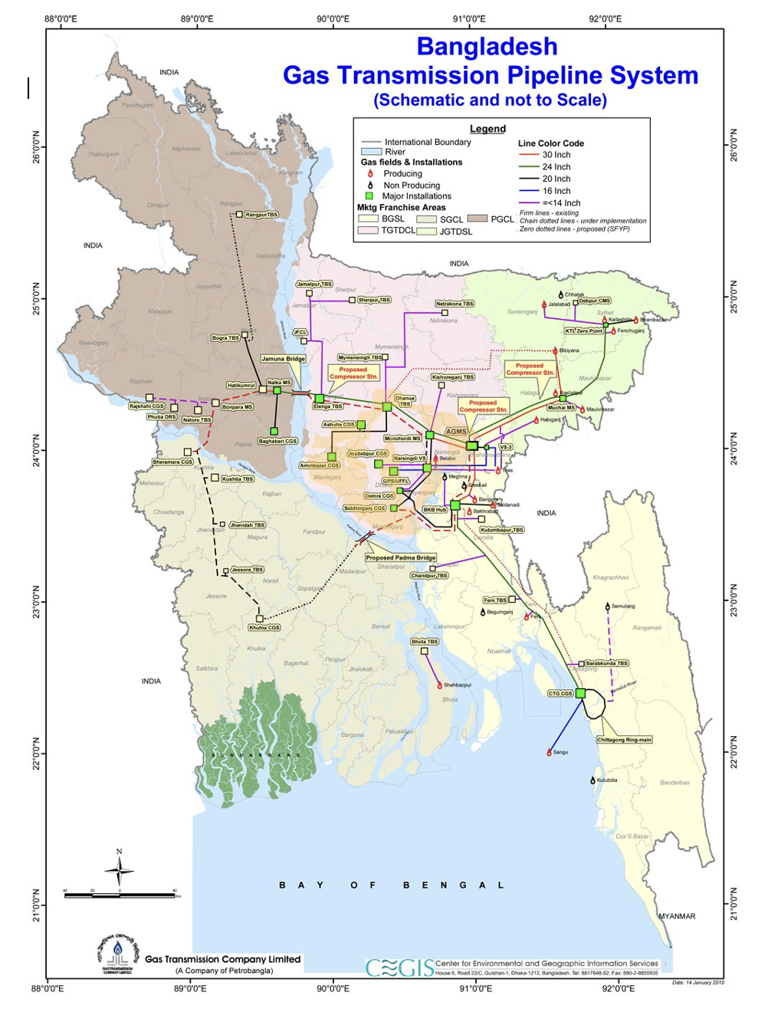

A similar project covering other distinct subareas of the Titas service area was registered under CDM (project 10077) and proposed for registration under VCS (project 22930). None of the subdistricts, regions, or infrastructure in this project are included in the CDM project. The emission reductions implemented through this project will be demonstrably unique in their location through GPS coordinates and other identification data like street address and visual markings and not included in any other project claiming emission reduction credits under other GHG programs.

Conditions Prior to Project Initiation
The baseline scenario is the same as the conditions existing prior to the project initiation. Please refer to Section 3.4 (Baseline Scenario) for details.

Compliance with Laws, Statutes and Other Regulatory Frameworks
The project complies with all Bangladesh laws. While the activities included in the project are not required, they conform to the ‘Natural Gas Security Law’ also known as ‘Prakitik Gas Nirapatta Bidhimala, 1991 - Revised in 2003’. Per the ‘Natural Gas Security Law’. Leakage reports prepared and submitted to the Department of Explosives as required under this law (attached to the Department of the Ministry of Energy and Mineral Resources, Government of Bangladesh) are confined to major incidents involving explosions. For these events, a special team not associated with the project is dispatched to make repairs and a report sent instantly. For other less catastrophic incidents, monthly reports are prepared. Any leaks or repairs made as part of this safety effort will be excluded from the project as they are part of the baseline case. A separate team from the project effort is completely responsible for this activity thereby preventing the accidental inclusion of safety related repairs into the project. As another safeguard, the safety team will have no access to the advanced monitoring equipment required to include a repair in the project.

Participation under Other GHG Programs

Projects Registered (or seeking registration) under Other GHG Program(s)
NA- This Project is not registered or seeking registration under another GHG Program.

Projects Rejected by Other GHG Programs
NA- This Project has not been rejected by other GHG programs.

Other Forms of Credit

Emissions Trading Programs and Other Binding Limits
The project does not reduce GHG emissions from activities that are included in an emissions trading program or any other mechanism that includes GHG allowance trading.
The project proponent is not part of any emission trading program. The net GHG emission reductions from the project will not be used for compliance with local emission trading programs or to meet binding limits on GHG emissions. The project activity has not participated under any other GHG programs.

Other Forms of Environmental Credit
The project hasn’t sought or received another form of environmental credits.

Sustainable Development Contributions
Natural gas leaks result in emissions of methane (CH₄) into the atmosphere. The implementation of the project is expected to reduce these emissions. In addition to reducing greenhouse gas emissions, this project will also contribute to the People’s Republic of Bangladesh’s sustainable development goals by:

- Improving environmental quality and minimizing risks for employees and local communities due to the reduction of harmful pollutants (methane);
- Preserving a finite resource (natural gas). The reduction in gas losses will mean that the same amount of service can be provided to customers but with a lesser amount of gas required. Using a finite resource more efficiently, and thus preventing waste of that resource, is an important example of sustainable development;
- Capacity building of the local staff in advanced LDAR techniques;
- Transferring advanced technology in the form of leak detection kit and repair materials that have heretofore not been utilized in this region of Bangladesh;
- Job creations through the hiring of local staff;
- Strengthening human capital in the country through retention and employment of locals to support the project implementation (leak measurement program, repair works, and monitoring).

Bangladesh has domestic natural gas reserves of 16.36 Trillion cubic feet. With current output (2.3 billion cubic feet (BcF)/day) trailing demand (2.7-3.0 Bcf/day), and demand growth estimated at 10% per year, recoverable gas reserves could be depleted within 10 years. As such, reducing waste such as leaking natural gas from the distribution system is a critical step in improving resource efficiency and ensuring energy security.

The emissions reductions and methane savings resulting from project will be measured and reported. Job creation, training, technology transfer will also be tracked with reported.

Additional Information Relevant to the Project

Leakage Management
NA- There is no expected change of emissions outside the project boundary expected from reducing gas leakage from pipelines.

Commercially Sensitive Information
No commercially sensitive information has been excluded from the public version of the project description.

Further Information
NA- There is no further information we wish to provide.

Safeguards

No Net Harm
The project is focused on reducing natural gas losses from the distribution network of the People’s Republic of Bangladesh. As such, the project does not require any infrastructure or components that would create any local or regional air/water/pollution impacts. In particular, materials and equipment used in this project do not emit harmful substances into the atmosphere, and are not a source of noise, vibration, or any other harmful physical impact. The project activity has no transboundary environmental impacts, and requires no environmental impact assessment (EIA) per Bangladesh’s environmental legislation.

Local Stakeholder Consultation
A Local Stakeholder meeting was held on October 21, 2021 to announce the details of the proposed project to more than 40 stakeholders and to solicit questions and comments from the stakeholders prior to project implementation. The meeting was conducted remotely (Figure 4) to allow for the maximum participation from stakeholders given the limitations and health concerns caused by the ongoing COVID-19 epidemic.

The meeting was a culmination of efforts to identify local stakeholders and elicit their input. A list of stakeholders was prepared with input from all the project participants, Titas Gas, and various academic and government advisors. The identified stakeholder invitees received a couriered invitation letter directly from the Managing Director of Titas Gas sent, as per local norms and protocols, over a week before the meeting date. This invitation was followed up by email both to try to ensure direct participation in the event, but also to provide an opportunity for questions and comments from those who could not attend the actual meeting.

The meeting itself was held several months before the expected kick-off of the actual project work to ensure stakeholders had the time to call or email additional comments, questions or concerns via the contacts provided in the presentation and invitations. Therefore, the stakeholders have the ability to contact directly those in charge of the project implementation during the course of the project if any problems arise. In addition, Titas Gas maintains its own customer outreach mechanisms including for customer complaints that will be fed into the project as appropriate.

Following project presentations from Titas Gas, the project investor, and the project implementors to the stakeholders, the floor was open to questions. Individuals representing the main stakeholder organizations including academics and government officials invited were given the floor to ask questions or provide feedback. The floor was then opened for any additional input from all the stakeholders. During the entire event the chat feature was enabled and questions were asked and answered in real time. Detailed notes were taken during the Q&A session. The summary list of questions/comments and the responses were recorded and are provided table 2 below. However, most of the comments expressed support for the efforts of the project to reduce gas leakage and made note of the co-benefits in terms of improved health, safety and service. Other comments suggested ways to expand the project to include other parts of the gas system that might also have significant leakage that may fit into future projects requiring new methodologies. Since the comments were all supportive of this effort, no changes to the Project were made from the comments.
Figure 4
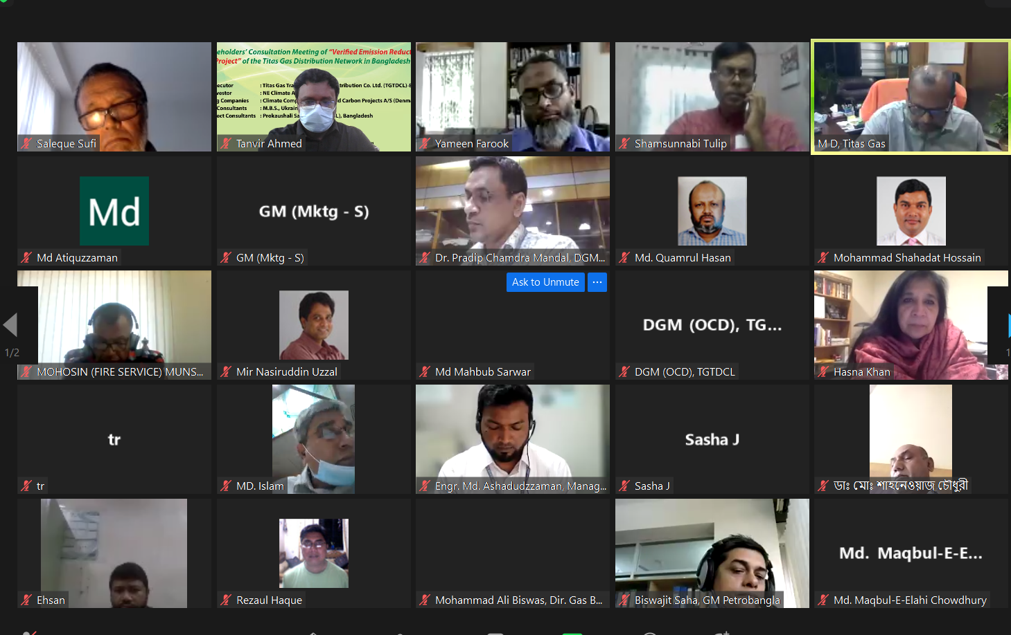
Screenshot of the Stakeholder Video Call on October 21, 2021

Table 2
Meeting of “Reducing Gas Leakages within North West and other sub-areas of the Titas Gas Distribution Network in Bangladesh”
Titas Gas Distribution Network in Bangladesh
Venue: Online (via zoom)
Meeting date & time: 10:30 am; Thursday, 21 October 2021

Comments and Given Replies at the Meeting:
SN | Name of the Participants | Questions | Given reply
1 | Engr. Khondkar Abdus Saleque (Sufi)  International Energy Consultant, Melbourne, Australia. | What will the machines do after completing the baseline study? Will these be left to Titas to use?  What is the plan for underground leaks?  Using medium density polyethylene pipe for distribution in Europe is common, do you think it is applicable for Bangladesh especially in distribution system? | We will hand over some of the equipment to Titas when the project is over.  It is difficult to repair the underground leaks because the process is different. And the methodology that we are going to use in this project does not support working such leaks.  Hope it could be done, actually we do not know exactly if it would work in the Bangladesh circumstance.
2 | Dr. Ijaz Hossain  Professor,  Department of Chemical Engineering, BUET. | How is the survey area fixed?  Titas has many areas that are more than 20 years old, is this project be implemented just selected areas or will all networks be included in this work?  Data showed that 6% risers were leaky. Can we consider that 5-6% risers are leaky for across the country?  When project be finish, will the project run by itself? How can project maintenance cost will be maintained?  What are the direct benefits of the projects for us? | All areas not included in the previous CDM project have been identified as potential survey areas for this project. We did a feasibility study, and selected the territories based on its result.  Yes, this would be a good estimate based on our work.  The project tenure is 10 years. The maintenance cost after finishing the project would be done by the gas company, but they should have the technical knowledge to do the job going forward.  Saved gas as well as saved money.
3 | Md. Atiquzzaman  Energy Expert  Ex MD-GTCL, Bapex | Under the ongoing CDM project you repaired leaks only for residential and commercial risers. These are very low-pressure leaks. If we consider the survey area for the upstream high pressure transmission line, gas field process plant, abandoned gas field there would be very big leaks.  The project should have extended the survey area to DRS, TBS, CGS and valve pits of distribution line. Do you have any plan to cover such leaks under this project? | We are mainly focusing on the leaks of residential and commercial risers under this project. We hope to do future projects repairing upstream leaks like gas fields, process plant, and abandoned gas field.  We surveyed some DRSs, CGS, and TBS when we started the original project and assumed there would be many leaks since these are high pressure facilities. But in practice we did not find any leaks there. So, we decided not include such big facilities to be surveyed under this project.  These low-pressure leaks are fugitive leaks and these could be more dangerous leaks than high pressure leaks are under more control of maintenance teams.  These high-pressure leaks repair project could be another project with a different methodology.
4 | Engr. Md. Shaheenur Islam  Director (PSC),  Petrobangla, Kawran Bazar C/A, Dhaka-1215. | Are you going to implement the project in the same model as in past (CDM project)?  Are we only using this methodology for regulators and locking point valves?  The Service-T is not included in your list. Can you please include them?  What about the leaks of underground distribution pipelines?  Can you consider the leakages that are occurring at the customer side i.e. the GI pipelines after the low pressure valves to burners? | Yes, the methodology of VCS project is the same one used in the CDM projects.  Yes, you are right. The survey area of RMSs under this project would be from input of lock-wing cock valves to end of low-pressure valves.  We basically are covering things those are allowed under the methodology. We will look for a new methodology which would cover such leaks.  The methodology does not allow any kind of underground leaks. These leak repairs may not bet economically viable with current emission reduction price.  This is very difficult to repair such leaks because customers do not allow us to enter inside of their homes.
5 | Engr. Kazi Mohammad Saidul Hasan  Deputy General Manager (Operation Control Department), TGTDCL, Dhaka, Bangladesh. | Can we do something to rise the market value of emission reductions? | We have no way to control the price of emission reductions. It is a global market.
6 | Prof. Dr. M. Tamim,  Professor,  Department of Chemical Engineering, BUET | Definitely this project is a worthy task since we can ensure the safety, save the environment as well as reduce the global warming by this project. But creating leak is a continuing process so what will you do after 10 years when your project will finish, and what will you do with these costly machines? | Some engineers and technicians from TGTDCL will be engaged permanently with PSL’s skilled survey and repair teams. So, technology transfer will occur and after 10 years TGTDCL can take some initiative to continue the process by its own cost or may find some donor to finance like the JICA prepaid meter installation project.

Comments and Responses during the meeting in chatroom:

From Saleque Sufi -It is an excellent initiative. Would like to know how TGTDCL monitor leakage from flanges of DRS. TBS, underground flanged valves of Distribution pipelines?
In Western World Smart Sensing of Buried pipelines through laying fiber optics cables along the pipeline and setting special devices at given intervals are useful technology that TGTDCL can consider for future distribution pipelines. What is in NDC of Denmark about GHG emission reduction targets? Are you going to leave some of equipment to TGTDCL after the project?

From Daragh Glynn- Denmark Climate Goals are: 70% below 1990 levels by 2030. Zero fossil fuels by 2050. Some of the equipment from CDM project is remaining with Titas Gas, so that the leak detection can continue after 10-year project

From Kevin James- This project will focus on only above ground leaks. That is a requirement of the United Nations methodology we use for this project. There are a lot of exciting technologies to use for finding underground leaks but unfortunately, we can’t include unground infrastructure in this project.

From Engr. Md. Ashadudzzaman, Manager, PDD, TG
please write to us regarding any suggestions or concerns: cdm.tgtdcl@gmail.com

From Mohammad Tamim- I caught the last part of the presentation but I am aware of the project. Please extend this work for the entire gas value chain. Unfortunately, I have to leave early. Thanks. That is fine and if just the exposed valves and connections are checked, that would be great work.

Environmental Impact
NA- There are no significant negative environmental impacts resulting from repairing leaks on a gas distribution system.

Public Comments
This section will be updated following the 30-day public comment period.

AFOLU-Specific Safeguards
Not required as this is not an AFOLU project.

Application of Methodology

Title and Reference of Methodology
Approved baseline and monitoring methodology for large-scale CDM project activities: AM0023 (Version 04.0.0): “Leak detection and repair in gas production, processing, transmission, storage and distribution systems and in refinery facilities

The methodology above refers also to the latest “Combined tool to identify the baseline scenario and demonstrate additionality” Version 7.0.

No standardized baselines apply.

Applicability of Methodology
The rationale behind the choice of the approved methodology AM0023 (Version 04.0.0) is that the project activity meets all its applicability conditions. Table 3 explains the relevancy of the selected methodology to the proposed project activity in the People’s Republic of Bangladesh.

Table 3 Relevancy of the selected methodology to the proposed project activity
Applicability condition | Relevancy to the project activity
This methodology is applicable to project activities that reduce leaks in components through the introduction of an advanced LDAR program. | The scope of the project activity includes the reduction of gas leaks from components in the natural gas distribution systems of Titas. As a result of the project implementation, advanced LDAR practices will be established.  Outcome: The project activity meets the applicability condition.
This methodology is applicable under the following conditions:  - During the last three years prior to the implementation of the project activity, no advanced LDAR program was in place to address physical leakage from components that are included in the project boundary. | During the last three years prior to the implementation of the project activity, no advanced LDAR program was in place to address physical leakage from components that are included in the project boundary.  Outcome: The project activity meets the applicability condition.
This methodology is applicable under the following conditions:  - New physical leaks that are detected at components during the crediting period (e.g., not at the time the project starts) are accountable only if the components were included in the project boundary at the validation of the project activity | The project will only address components that were included in the project boundary at the validation of the project activity. For instance, the project boundary will not include new sections of the distribution network.  Outcome: The project activity meets the applicability condition.
This methodology is applicable under the following conditions:  - Physical leaks that need to be repaired due to current regulations and legislation are accountable only if it can be demonstrated that relevant regulations and legislation are not enforced in the country. | National regulations (i.e., the «natural gas security law» called «Prakitik Gas Nirapatta Bidhimala, 1991 (Revised in 2003) only focus on leaks that present a safety concern. However, they do not specify exactly what counts as a safety concern– this is left to the discretion of the gas company. Historically reported leaks have only occurred in underground piping, with no leaks flagged in above ground components. Typically, leaky above ground components are well ventilated and do not pose a major safety risk and therefore have not been included in compliance activities.  Outcome: The project activity meets the applicability condition.
This methodology is applicable under the following conditions:  - The most likely baseline scenario is the continuation of the current practice | The continuation of the current situation with existing practices of leak detection and routine maintenance is the most likely baseline scenario.  Outcome: The project activity meets the applicability condition.
This methodology is not applicable to:  - Physical leaks that are detected and repaired under a conventional LDAR program. | Physical leaks detected and repaired as part of the current maintenance program will not be covered by the proposed project activity. The leaks repaired under current practices by the Emergency Repair team will be excluded from the project. The proposed project aims at reducing leaks that will be detected using the advanced technology and repaired using advanced repair materials (i.e., under the advanced LDAR). Only those leaks measured using the advanced equipment and repaired using advanced materials supplied by the project can be included in the project.  Outcome: The project activity does not meet the exclusion condition.
This methodology is not applicable to:  - Physical leaks that can be repaired by tightening/re-greasing or by similar measures | Physical leaks that can be repaired by tightening/re-greasing (incl. connectors and plug valves steams) or by similar measures will not be covered by the proposed project activity. Only leaks repaired by using advanced repair materials and new parts will be included.  Outcome: The project activity does not meet the exclusion condition.
This methodology is not applicable to:  - Physical leaks that are identified on components where the latest scheduled maintenance or replacement was not done before the starting date of a project activity as documented through maintenance logs, maintenance schedules, maintenance guidelines, worker logbooks, or other similar sources | No regularly scheduled maintenance and replacement occur currently in the gas distribution system. Only major, typically underground systems, are repaired and this is done on an ad hoc basis when a dangerous leak arises. These will be repaired by the emergency repair team and not included in the project activity. No regularly scheduled replacement occurs. Component replacement is only done when a part fails. Replacements done as a result of a failed part are not included in the project activity.  Outcome: The project activity does not meet the exclusion condition.
This methodology is not applicable to:  - Reductions in process venting | The proposed project activity aims at reducing natural gas leakages from components (e.g., valves) in the natural gas distribution network. As such, leakages associated with the project activity are not related to process venting.  Outcome: The project activity does not meet the exclusion condition.
This methodology is not applicable to:  - Reductions in natural gas or refinery gas combustion by process heaters or boilers, engines and thermal oxidizers | The project does not cover any reductions in natural gas or refinery gas combustion by process heaters or boilers, engines and thermal oxidizers.  Outcome: The project activity does not meet the exclusion condition.

Project Boundary

Source |  | Gas | Included? | Justification/Explanation
Baseline | Physical leaks from components included in the project boundary | CO₂ | No | The CO₂ content in natural gas is negligible.
Baseline |  | CH₄ | Yes | This project activity will reduce emissions of methane from gas distribution facilities, which are above-ground. This project covers only methane, and the baseline will measure these emissions.
Baseline |  | N₂O | No | The N₂O content in natural gas is negligible.
Baseline |  | Other | NA
Project | Physical leaks from components included in the project boundary | CO₂ | No | This project activity will use a device to measure and repair leaks. This device does not use any significant energy, and there is no leakage from these types of projects. Thus, there should be no project activity emissions from this project activity.
Project |  | CH₄ | Yes | The monitoring function of this methodology is designed to ensure no methane is escaping from repaired leaks. If repairs cease to function for any reason, the newly measured leakage is excluded from the baseline for any time period the repair is not functioning. No new methane emissions will occur as a result of the project.
Project |  | N₂O | No | The N₂O content in natural gas is negligible.
Project |  | Other

Figure 5 Titas distribution network components and project boundary
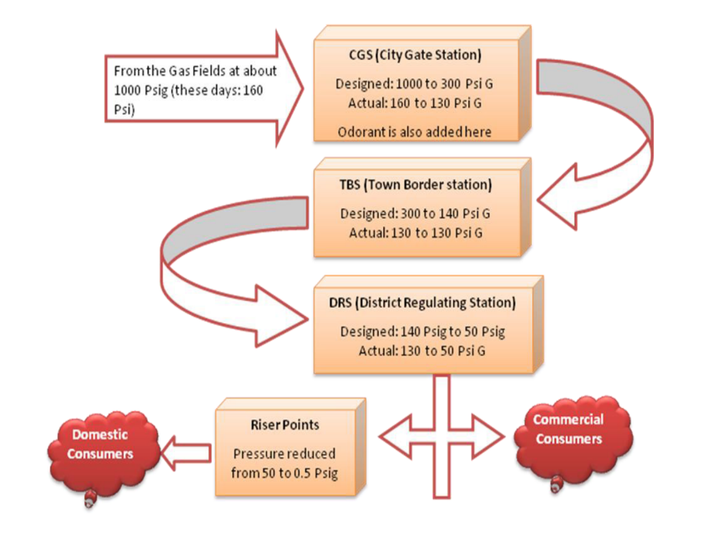
Project boundary
Components within the Titas transmission and distribution system do not have a unique identification number; however, all physical leaks detected at valves will be clearly referenced in a database to ensure their identification and monitoring including GPS coordinates. A photo of each unique piece of equipment repaired that can also be used to easily identify the location. Additionally, during the full-scale implementation of the project each above ground location will be tagged with unique geographical co-ordinates for the purposes of easy identification and monitoring.
The project boundary will be defined in detail in a database, of all the leaking components identified and repaired during the baseline study completed on the above ground equipment in the Titas gas system for the regions highlighted in section 1.12.

Baseline Scenario
The approved methodology AM0023 (Version 04.0.0) requires to follow the steps given in the latest approved version of the “Combined tool to identify the baseline scenario and demonstrate additionality”, (i.e., Version 07.0) in order to select the baseline scenario. As requested by Step 1 of the Combined Tool, the project proponents have determined plausible alternatives that could yield the same or similar results as the proposed activity, and analyzed them in detail. This is described below.

Step 1: Identification of alternative scenarios
Step 1a: Define alternative scenarios to the proposed project activity
The main services provided by Titas are transmitting and delivering natural gas to consumers at specified pressures and volumes. Given the nature of this type of project, the proposed project activity has only three feasible baseline scenario alternatives:

- Continuation of the current situation with existing practices of leak detection and routine maintenance;
- The proposed project activity undertaken without being registered as a project activity; and
- Similar efforts have been made or are expected to be made to reduce methane leaks from key components, using similarly capable leak detection and measurement technology as described in AM0023 (Version 04.0.0).

Scenario 1: Continuation of the current situation with existing practices of leak detection and routine maintenance

This is the most plausible scenario. The current practices comply with national regulations and Titas lacks the financial resources, technology and training to undertake the kind of advanced leak detection and repair program proposed in the project.

Current practices exclude any kind of systematic leak detection or routine maintenance activity on above ground infrastructure. This approach is in compliance with the National Gas Security Law which prescribes Titas to carefully maintain areas of significant risk to public health and safety of the gas distribution system. Well ventilated above ground gas leaks do not rise to this threshold.

Titas maintenance personnel do not currently possess advanced LDAR devices needed to enhance existing practices, such as the tools prescribed by AM0023 (Version 04.0.0). These advanced devices would be critical for staff to upgrade current practices by effectively identifying the leak source and accurately quantifying the volume of leakage. Titas currently does not have leak detection devices, the examination of leaks is primarily undertaken through visual (i.e., bubbling of leaks with soap) and odor detection. As such, existing procedures are not systematically detecting leaks in above ground equipment. A fact highlighted by the feasibility measurement study that detected numerous leaks at above ground sites in the project area. Given the lack of measuring equipment, the current leak detection practices are unlikely to change.

In addition, currently if a repair is required, work is carried out using outdated and ineffective materials. For example, valve stems are repaired using Polyethylene (PE) tape and clamps. However, this approach does not maintain long term sealing. Titas does not have any experience or training using more advanced materials such expandable PFTE. Given the higher cost point of more advanced materials, lack of availability of advanced materials on the local market, and the lack of training and experience with such materials, continued utilization of ineffective repair materials is likely.

The continuation of existing practices is made more likely given that Titas lacks the financial resources to alter its current approach (see also additionality justification). It does not have the resources at its disposal to buy the required leak detection equipment, repair materials and train staff to use them.

Thus, the continuation of the current situation with existing practices of leak detection and routine maintenance (i.e., the conventional LDAR program) described above is the most likely course of action. This scenario, based on the factual evidence seen on the ground in the company, is deemed the most plausible baseline scenario.

Only with the initiation of the VERRA project will Titas gain access to advance leak detection and measurement technologies, have key staff members trained in the operation and implementation of an advanced leak reduction program, and have access to the funds required to execute the activities.

Scenario 2: The proposed project activity undertaken without being registered as a VERRA project activity
This scenario is discussed in detail in the additionality assessment of the proposed project activity. As described above (see scenario 1), Titas’ conventional LDAR program lacks the technical and financial resources to comprehensively and accurately detect, measure and repair leaks in the gas distribution system. There is no systematic detection and repair program employed by Titas operators, to effectively and comprehensively reduce chronic leaks from components. In addition, obsolete equipment is used to perform routine inspections, which are driven by safety and component maintenance concerns, rather than leak quantification and minimization. Titas staff lacks the experience and training with advanced repair materials and leak detection equipment required to implement the project. Without the additional financial resources and expertise that is brought with the project, the proposed project activity could not advance.

Therefore, this scenario is not plausible.

Scenario 3: Similar efforts have been made or are expected to be made to reduce methane leaks from key components, using similarly capable leak detection and measurement technology as described in AM0023 (Version 04.0.0).
In the past, Titas has not considered systematically reducing gas leakages in its distribution system outside CDM/VCS efforts and the company does not intend to do so in the near future since Titas lacks the technical and financial resources to implement a leak reduction program.

However, it is possible that components currently leaking would be scheduled for replacement, regardless of VCS project support. Yet, analyzing the past experience of Titas, this is unlikely to happen. If components are in a satisfactory condition, regardless of age, they continue to be used. Replacement only occurs if the component is worn out and not operational (or a hazard), otherwise it remains in service. At city gate, town boarder and district regulator stations, operators are required to check equipment for leakage; although, with no leak detection equipment, this is done by staff reviewing equipment through visual and olfactory approaches. However, there is no dedicated team employed for leak detection.

As such, Titas is constrained by available funding/resources to develop a robust LDAR program and to undertake any major investment in components, which makes this scenario unrealistic (see Barrier Analysis for further details).

Furthermore, without assistance, the project company would continue using the components that are currently leaking. The repairs would continue to be done as per existing practices, i.e. not systematically identifying leaks and addressing them, and not preventing leaks from re-occurrence.
As such, the company has no other alternative than to continue with the existing practices.

Given the above analysis, Scenario 1: Continuation of the current situation with existing practices of leak detection and routine maintenance has been identified as the baseline scenario. This is further discussed below.

Additionality

Demonstration of project additionality:
The additionality is determined following the “Combined tool to identify the baseline scenario and demonstrate additionality” (Version 07.0), as required by the AM0023 (Version 04.0.0).

The following paragraphs are complimentary with Section 3.4.

Step 0: Demonstration whether the proposed project activity is the First-of-its-kind

As per the “Combined tool to identify the baseline scenario and demonstrate additionality” (Version 07.0), this step is optional. It is not undertaken for this proposed project activity.

Step 1: Identification of alternatives scenarios

Sub-step 1a: Define alternative scenarios to the proposed VCS project activity

In continuation with the discussion on baseline identification, the following three scenarios have been identified as plausible alternatives to the proposed project activity:

- Continuation of the current situation with existing practices of leak detection and routine maintenance;
- The proposed project activity undertaken without being registered as a VCS project activity;
- Similar efforts have been made or are expected to be made to reduce methane leaks from key components, using similarly capable leak detection and measurement technology as described in AM0023 (Version 04.0.0).

Sub-step 1b: Consistency with mandatory applicable laws and regulations:

Scenario 1: Continuation of the current situation with existing practices of leak detection and routine maintenance is consistent with the existing laws and regulations in the gas sector of Bangladesh, including: the “natural gas security law‟ called “Prakitik Gas Nirapatta Bidhimala, 1991 (Revised in 2003)” and the “gas marketing law‟ called “Gas Bipanan Niyomaboli 2004”.

Scenario 2 and Scenario 3: Under existing laws and regulations in Bangladesh, there is no threshold above which leaks are illegal. Furthermore, activities included in the proposed project activity (systematic leak detection and repair program) are neither prohibited nor required by the existing mandatory laws and regulations. Scenario 2 and 3 are therefore compliant with applicable laws but not mandated under those laws.

Outcome of Step 1: the list of alternative scenarios to the proposed project activity has been established, and all three options are in compliance with the existing legislation and regulations.

Step 2: Barrier analysis

For this section, the “Guidelines for objective demonstration and assessment of barriers” (version 01) have been taken into account, as referred in the “Combined tool to identify the baseline scenario and demonstrate additionality” (Version 07.0).

The Guidelines require providing information such as the nature of the company, its organization and ownership and, financial information, when demonstrating the barriers related to the lack of access to capital, technologies and skilled labor.

Titas was formed in November 1999 with an objective of transmitting and distributing natural gas in its service area. It is a company of PetraBangla -the Bangladesh Oil Gas and Mineral Corporation. Petrobangla operates as a public sector statutory body pursuant to Bangladesh Oil, Gas and Mineral Corporation Ordinance, 1985 and Bangladesh Oil, Gas and Mineral Corporation (Amendment) Act, 1989. The general direction and administration of the affairs and business of the corporation vest in its Board of Directors. It is the policy making and managing body of the corporation, with members from Energy, Finance and Planning Ministries. The corporation is under the administrative control of the Energy and Mineral Resources Division of the Ministry of Power, Energy and Mineral Resources.

Sub-step 2а: Identify barriers that would prevent the implementation of alternative scenarios:

Below is a list and description of the main identified barriers which would impact the implementation of the alternative scenarios 2 and 3. These barriers would have no impact on scenario 1.

Investment barriers:

After accounting for the cost of gas purchases (i.e., payments to the government, and PetroBangla’s subsidiaries for purchasing and transmitting the gas), as well as administrative expenses, interest payments, etc, Titas had annual after-tax profits in 2018 of about 359.81 million BDT about ($4.2 million). TITAS has an annual transmission and distribution maintenance budget of approximately 76 million BDT (slightly less than $900,000) to address reactive repairs and maintenance (i.e., emergency call outs).

Estimated Cost of Project Implementation:
- 6 Hi-Flow samplers or Leak Measurement Devices will need to be purchased, at a cost of approximately $25,000 per device (i.e. more than $150,000 in total not including shipping and import duties).
- Leak detection devices (GMI Gasurveyor (500 series)) will cost on the order of $1,850 per unit. Although much cheaper than Hi-Flow samplers, all monitoring teams will need to be equipped with this advanced equipment and 6 units will therefore also need to be purchased (i.e., more than $11,100 in total).
- There will be a consulting cost associated with training staff and participating in / managing / reviewing initial measurements, repair activities and subsequent yearly measurement activities. These costs are estimated to be around $40,000 per year on average.
- Additional staff will need to be hired, resulting in an annual cost of $295,000 on average.
- IT equipment (hardware and software) will need to be purchased to collect and store data (one-off cost of around $5,000).
- Advanced repair materials will need to be purchased which will cost around $6,000 per year.
In addition, there will be a cost associated with fixing each component. Considering the project sample size and the leak statistics presented in the feasibility study, a significant number of valves/insulating joints will need repair during project implementation leading to costs on the order of $10,000.

In conclusion, it is estimated that a total of about $517,100 for the baseline study and $351,000 each year meaning about €4.02 million over 10 years will be required to implement the project and address leaks. The baseline study alone would require about 57% of the entire annual maintenance budget, which currently covers required emergency workers and emergency operations. Assuming the maintenance budget remains similar each year, every annual monitoring event would require 39% of the yearly maintenance budget to implement. In this case, the distribution company could not continue to maintain its required emergency teams, maintain underground pipes which pose a much greater explosion risk and implement the project given current budget limitations.

As such, the proposed project activity represents a significant investment for Titas and would not be implemented under the baseline scenario given the budget constraints.

In addition, per the “Combined tool to identify the baseline scenario and demonstrate additionality”, the project proponents must demonstrate that “No private capital is available from domestic or international capital markets due to real or perceived risks associated with investments in the country where the project activity is to be implemented, as demonstrated by the credit rating of the country or other country investment reports of reputed origin”.

In the case of Bangladesh and the Titas project, the applicability of the above statement is demonstrated by the credit rating of Bangladesh provided by, for example, Standard & Poor and Moody’s. Standard & Poor currently rate Bangladesh as BB- and Moody’s as Ba3. This makes Bangladesh a country considered as non-investment grade speculative.

In addition, in spite of the gas savings from the project, the gas distribution company will not actually reap any additional revenue stream that could be used to help secure private financing. This is the case because in Bangladesh, natural gas consumption is highly subsidized and locally produced supply is dwindling and unable to meet demand. LNG is being imported to meet current demand. The sales price of gas is well below the import price. Therefore, any gas savings derived from the project will either reduce the losses from the subsidies as less imported LNG will be required to meet demand or allow for more subsidized sales at a loss. In either case, there is no new revenue stream that could be shown to a bank or other investor in order to secure funds.

Consequently, Titas lacks the financial resources and access to finance to implement the proposed project activity without external support/investment.

Technological barriers:

The “Combined tool to identify the baseline scenario and demonstrate additionality” provides examples of technological barriers:
- Skilled and/or properly trained labor to operate and maintain the technology is not available in the applicable geographical area, which leads to an unacceptably high risk of equipment disrepair, malfunctioning or similar underperformance;
- Lack of infrastructure for implementation and logistics for maintenance of the technology (e.g. natural gas cannot be used because of the lack of a gas transmission and distribution network);
- Risk of technological failure: the process/technology failure risk in the local circumstances is significantly greater than for other technologies that provide services or outputs comparable to those of the proposed VCS project activity, as demonstrated by relevant scientific literature or technology manufacturer information;
- The particular technology used in the proposed project activity is not available in the applicable geographical area.

Alternative scenarios 2 and 3 face the barriers (i) and (iv), as explained below. This barrier does not affect Alternative Scenario 1.

Skilled and/or properly trained labor to operate and maintain the technology are not available in the applicable geographical area (i.e. People’s Republic of Bangladesh):
The project activity involves the use of advanced technology and materials for leak detection and repair. To date, Titas operators and management are not familiar with managing or implementing advanced leak detection and measurement practices as prescribed by AM0023 (Version 04.0.0) or other similar advanced technologies. In fact, their methods/equipment (e.g., visual / odor detection) are rudimentary at detecting leaks and do not enable leak quantification, Also, the local staff is trained to use the cheap, ineffective materials found locally and have no experience using expandable PFTE and other advanced materials.

Through interviews with Titas personnel, it was confirmed that there is a lack of internal procedures and technical capacity to establish and implement advanced leak detection and repair (LDAR) activities in the natural gas distribution network. Therefore, considering that (a) the project company is a regional monopoly governing the natural gas distribution system and (b) the technology envisaged by the project activity has never been used in Bangladesh beforehand for as a non-CDM/VCS activity; there is a lack of skilled and/or trained labor to operate and maintain the technology covered by this VCS project activity.

In addition, given the scale of this project and the need to hire and manage a significant workforce, the project implementation will be highly complex and require important staff training activities.

In summary, without support from VCS, an advanced LDAR program would not be implemented because of the lack of technical capacity and skills and the significant additional human resources necessary to implement the project.

Regarding the barrier of the particular technology used in the proposed project activity not being available in the applicable geographical area (i.e. People’s Republic of Bangladesh):
The Hi-Flow™ sampler is made by only one company (Bacharach, Inc.) in the United States, and has never been used outside Annex 1 countries (with the exception of donor-funded programs in Ukraine, Kyrgyzstan, India, Brazil and other CDM/JI projects). The initial cost of $25,000 per unit is a significant impediment for a company like Titas especially when they have no direct experience with the operational benefits of the device in Bangladesh and it is not locally available from a supplier. This is also true of the advanced repair materials required for an advanced LDAR program. Much of this material is not readily available from local shops and suppliers and must be purchased from abroad at significantly higher prices than cheaper local goods currently used.
The dearth of local experience and training with the types of leak measurement equipment and leak repair materials required for and advanced LDAR combined with the lack of local suppliers of advanced measurement kit and materials is a potent barrier making alternative scenarios 2 and 3 implausible for Titas.

In summary, the type of leak detection, repair and monitoring activities, that are needed to be put in place in order to have VCUs generated, will require a coordinated and well-funded program to train and certify staff in operating advanced measurement technologies and in repairing leaks using state-of-art materials. This entails not only incurring significant costs to procure the equipment from abroad but also building managerial and technical capacity. The fact that no such extensive leak detection and repair program has been undertaken to date demonstrates that the opportunity for VCU based project financing has raised the awareness and incentivized Titas to begin such an intensive effort.

Sub-step 2b: Eliminate alternative scenarios which are prevented by the identified barriers:

Scenario 1, continuation of the current situation with existing practices of leak detection and routine maintenance (i.e. Business as Usual) does not lead to additional procurement costs (e.g., materials and/or monitoring equipment, staff training), and thus does not require Titas to seek additional financing in the local or international markets. Titas’ current maintenance program is satisfactory from the company’s operational stand-point, and will continue to be primarily guided by personnel safety and operational maintenance concerns, not by leak reduction for economic and / or environmental reasons. Thus, only the implementation of Scenario 1 is not prevented by the barriers identified in Step 2a. Scenarios 2 and 3 are deemed implausible based on the aforementioned barriers.

Outcome of Step 2: Only Scenario 1 (“1. Continuation of the current situation with existing practices of leak detection and routine maintenance”) is not prevented by any of the analyzed barriers. As such, it is considered the baseline scenario.

Additionally, per the “Combined tool to identify the baseline scenario and demonstrate additionality” (Version 07.0), since there is only one alternative scenario that is not prevented by any barrier and it is not the proposed project activity without being registered as a VCS project activity, the project proponents are required to explain how the registration of the VCS project activity will alleviate the barriers that prevent the proposed project activity from occurring in the absence of the VCS.

Due to the opportunities presented by registering the project under the VCS, Titas will be able to secure the necessary financing based on the anticipated VCU revenue to implement the project, including purchasing equipment/repair materials to conduct on-going leak measurements/ repairs, as well as the necessary hiring, training and certification of staff to use the equipment. As such, the prospect of VCUs attracted investors that would normally not finance this type of project, and allowed the project company to overcome the barriers identified above. Such support conditional to VCS registration is confirmed in the signed Project Investment Agreement.

In conclusion, the VCS alleviates the identified barrier, and therefore, Step 4 (Common practice analysis) is performed.

Step 4: Common practice analysis
This step is the credibility check to demonstrate additionality and complements the Barrier analysis undertaken under Step 2 above.

The proposed VCS project activity does not apply any of the measures that are listed in the Definitions section of the “Combined tool to identify the baseline scenario and demonstrate additionality” (Version 07.0). As such, Step 4b is followed.

Step 4b: The proposed VCS project activity(s) does not apply any of the measures that are listed in the Definitions section of the “Combined tool to identify the baseline scenario and demonstrate additionality” (Version 07.0).

As per the “Guidelines on common practice” (Version 02.0), the applicable geographical area for this analysis is the entire host country. In the case of the proposed VCS project activity this is the People’s Republic of Bangladesh.

The project will be implemented across the Titas transmission and distribution network for the regions identified in section 1.12.

Based on the considerations above, advanced LDAR practices, utilizing tools described by AM0023 (Version 04.0.0), have not been independently implemented by Titas, as the company lacks the technical and financial resources to implement an advanced LDAR program. In addition, in the identified applicable geographical area, an advanced LDAR program – similar to the one envisaged by the proposed project activity – has never been developed or introduced without CDM/VCS.

Furthermore, the key components of the LDAR, advanced measurement devices, advanced repair materials, and advanced training in implementation of an LDAR have not been found in Bangladesh heretofore without CDM/VCS.

Outcome of the Step 4: The proposed project is not regarded as “common practice”, since no other similar non-CDM/VCS activities have been observed in the applicable geographical area. As per the Guidelines on Common Practice, F=0 and N_{all}-N_{dif} = zero making this proposed project not a common practice.

Based on the additionality analysis performed above it is concluded that the proposed project activity is additional and its implementation is only possible within the VERRA framework.

Methodology Deviations

No methodology deviation is applied in the project.

Quantification of GHG Emission Reductions and Removals

Baseline Emissions
Baseline emissions are determined based on the quantity of CH₄ emitted through physical leaks that are detected and repaired as part of the project activity (i.e. by the advanced LDAR program).

The baseline emissions are calculated in several steps:
- Establishment of criteria to identify which types of physical leaks are eligible for crediting.
- Establishment of a database to manage all information related to the project activity.
- Documentation of the schedules for the maintenance and replacement of components.
- Calculation of baseline emissions.

Below we detail Steps 1 to 4.

- Establishment of criteria to identify which types of physical leaks are eligible for crediting

In order to ensure as per the methodology, a clear distinction between leaks that would (“not included” in the project) and would not (“included”) have been identified and repaired under existing practices prior to the project implementation, it is first necessary to assess and describe current leak detection and repair practices in the company. Only those types of leaks that are not detected and repaired under current practices are considered in the calculation of emission reductions.

The following criteria are relevant for classification of leaks in the system:
Emergency/ safety repairs – Titas makes some repairs and component replacements in direct response to safety concerns connected to outright emergency situations. According to regulations in Bangladesh, there is no specification on what exactly counts as a safety concern – this is left to the discretion of the gas company. However, safety concerns for above ground leaks are defined by operational staff as being cases where there is significant risk to public health and safety of the gas distribution system (e.g., explosion or inflammation risk, or where a high concentration of gas can accumulate in an enclosed space (risk of suffocation due to lack of oxygen)). However, the majority of the above ground leaks in the Titas network do not fall under this category (i.e., components are typically located outdoors, in open well-ventilated spaces).

In order to deal with emergencies, there is a separate emergency team that is dedicated 24 hours a day to the implementation of repairs in these more dangerous emergency situations (e.g., customer call-outs). The emergency services team that deals with these immediate safety concerns will continue to operate completely independently of the project team at Titas, throughout the course of the project. None of the leaks identified or repaired by this team will be included in the VCS project. This will be ensured since each VCS project leak will require multiple Hi-Flow sampler or Leak Measurement Device readings to be included in the project and the separate emergency repair team will not have access to Hi-Flow Samplers/ Leak Measurement Devices or training how to use them.

Leaks detected by visibility, audibility and/or smell – In line with the «natural gas security law» called «Prakitik Gas Nirapatta Bidhimala, 1991 - Revised in 2003», Titas has no “planned” inspection and maintenance (I&M) schedule for its above-ground facilities. Generally, staff identify leakage through odor and audio detection (i.e., hissing noise associated with leakage). This approach is in compliance with regulations governing the Bangladesh natural gas sector.
The lack of many of the basic tools and training required for proper leak identification, means that many leaks are missed. The fact that these leaks are not found and properly repaired illustrates the inadequate approach currently being implemented by Titas.
In addition, even when a leak is identified, there is no requirement that the leak be repaired using appropriate materials. According to interviews with managers of the Titas team, the repair materials currently available to the repair teams (PE tape, clamps, and non-gas-rated Teflon tape) are ineffective at repairing leaks and repairs undertaken with these materials continue to have significant leak rates.
Without the Hi-Flow samplers, Leak Measurement Devices or other similar technology, the Titas staff has little opportunity to judge the size and importance of the leaks they find, and do not systematically repair all or even most leaks they identify. As a result, the only leaks that can be effectively IDENTIFIED and REPAIRED under existing non-emergency practices are those leaks that can be fixed by tightening connections and tightening thread fittings. These are the only types of leaks that can be both:
- IDENTIFIED using existing leak detection approach (smell and audio).
- REPAIRED using the only effective technology typically available to the staff – wrenches to tighten the fittings.

In order to be conservative, ALL repairs composed of simply tightening loose fittings and connections (e.g., threaded fittings, unions) are excluded from the project as it is plausible that they could be detected and repaired under the current practices. This type of leak is excluded from the project.

However, all other leaks (e.g., insulation joints, valve with conical connection, etc.) require more advanced technologies and practices to identify and repair. They will require new advanced materials, components, seals, etc. and will therefore continue to leak as long as advanced equipment and materials are not part of the repair teams’ toolkit.

The key facts documenting this assessment are to be demonstrated to the validator through:
- Interviews with key staff,
- Documentation on the current technologies used to measure leaks, and
- Leak repair material used.

- Establishment of a database to manage all information related to the project activity

All data collected during project implementation will be entered into a database. The database will be continuously updated during the crediting period. The key data in the database will also be included in each monitoring report.
A proprietary Microsoft Excel database will be used to track leak and repair data. The data parameters tracked will be as follows:

- (j) Total number of leaks – each leak will be tagged with a unique number and monitored after repair for any additional leaks.
- T_{j} Hours of operation, during which time the component was under pressurized natural gas during the crediting period
- Date of leak measurement
- Measurement method used (e.g., Hi-flow, Leak Measurement Device, calibrated bag)
- Measurement equipment ID (Serial number)
- Leak Flow Rate F_{CH4,j} (liters per minute) – Leak rates will be measured and double checked before repair with the second measurement used in the calculation– in the rare case major discrepancies (>15%) between the two measurements are found, the operator will undertake a third measurement to be used in the calculation.
- Temperature and Pressure – Temperature and pressure are measurements taken into account by volume samplers such as the Hi-Flow™ sampler and Leak Measurement Device at the time of measurement and are integrated into the results and margin of error from the device. The device will be calibrated on a regular basis as per manufacturer recommendations (i.e. Hi-Flows within 30 days prior to date of measurement).
- Uncertainty factor – The IPCC Good Practice Guidance will be consulted in compiling uncertainty estimates.
- Eligibility of physical leak to be included in the project activity – Evidence/ information to determine that the leak was detected by advanced LDAR activities using advanced repair materials, rather than the simply tightening loose fittings and connections and emergency repairs.
- Date of physical leak repair.
- Time period that leak is eligible for crediting.

In order to ensure complete record keeping and proper identification of leaks, the following data will also be tracked:
- Location of the regulator system (street address and building number and GPS coordinates)
- Region
- Names of lead technical operators
- Date of leak detection
- Detection method (name and ID of equipment)
- Weatherproof tag attached leaky point with key data about leak and repair
- Unique leak ID number
- Type of component that is leaking
- Location of the component that is leaking on an engineering schematic of the leaking equipment
- Digital photo of Leak
- Any other relevant observations

The data will be entered regularly, during the leak detection and measurement phase of the project, and this will continue during the initial repair phase. After that, data will be entered on an on-going basis as and when monitoring and maintenance works are conducted. The database will include records of re-emerging and re-repaired leaks and records generated by Monitoring teams.

In addition to the information that is required to be entered in the database, all of the following three ways of tagging leak locations and tracking leak measurements will be applied to clearly identify a leak location, as described below:
- Technical operator will record data while out in the field for each component separately. That is, information (i.e., leak rate and measurement date) will be recorded on the tagged leak itself, and a digital photograph taken of the component and associated leak rate.
- Afterwards, the technical operator will bring their handwritten notes and digital photograph data to the Database Management team at the head office, and they will enter the data collected into an excel spreadsheet. This spreadsheet will contain a technical drawing of the respective regulation point or stand-alone valve with the component measured, and each leak location identified on that drawing.

- On a regular basis, the Database Management team will collate the data into a master spreadsheet, containing data from all operators.

- Documentation of the schedules for the maintenance and replacement of components

With regards to the expected time schedules for replacement of components that may be subject to leaks – there is no existing long-term component replacement schedule for above ground components in the regular budget. The replacement of components follows the «natural gas security law» called «Prakitik Gas Nirapatta Bidhimala, 1991 - Revised in 2003», which require only ad-hoc replacement in case of emergencies, or if there has been significant component deterioration, which is impacting safety. Therefore, for most components of the system, no long-term replacement schedule/plan exists. The components will continue to be used until they cease to function or are no-longer needed.
Due to a lack of resources, the company does not have the option to retire the components in a planned manner and Titas does not see the need to schedule additional replacements under current practice and Bangladesh regulations (e.g., «natural gas security law» called «Prakitik Gas Nirapatta Bidhimala, 1991 - Revised in 2003»). Replacements are done solely on an unforeseen emergency basis when the component has completely ceased to function, or if significant wear and tear has been reported. Titas subsidiaries / departments develop annual plans for replacement/repair activities. These plans require approval from the Board of Directors; who allocate budgets based on system priorities (i.e., emergency repairs will take priority over planned maintenance) and available financial resources.
It should be noted that just because a component is leaking, this does not mean it is not capable of functioning – this is true in both developing and developed world as leaks abound in all systems, which, in spite of leakage, continue to function safely and properly. As such, the focus is repairs, with replacements only made when there is a complete breakdown of the component and it is not functioning. This is best illustrated by the current in-service lifetimes of surface facilities included in the project boundary (below). In particular, during the last 20 years, only minor repairs for maintenance have been undertaken at surface facilities. No major replacements have been made.
Components within many above ground facilities have a theoretical lifetime of 20 years; however, this is generally not followed and most components have an average in-service life greater than 40 years. Consequently, the theoretical lifetime of the components is not relevant as existing components are expected to continue to be utilized a period greater than the VCS crediting period. Instead, replacement of components is only done in emergencies, or if the component’s technical performance has deteriorated sufficiently to impact gas supply operations. Thus, if components are identified for repair, they are included in annual capital repair budgets and schedules.
Thus, the two scenarios in which the component would have been replaced under normal practice are, as detailed above:
- In emergency situations when the component has ceased to function; and
- Those components in the priority list that can be replaced based on annual budget allocations as they are made known.

Therefore, leaks that are stopped due to replacement of component that has entirely ceased to function will not be included in the VCS project, as it will be assumed that this component would have been replaced under normal practice.

The project developer will follow the decision tree (see below), which corresponds with the criteria defined in AM0023 (Version 04.0.0), for each leak, in order to determine if that particular leak reduction can be considered additional. To be completely clear, the purpose of this decision tree is to ensure that the existing teams, their findings, and their limited repair activities (i.e., as part of the conventional LDAR program) are not included in the project if they are considered part of the baseline.
- The first step of the decision tree determines if the leak was identified and repaired as part an emergency repair action as this is part of the current baseline case maintenance. Repairs made in this category are excluded. No scheduled maintenance is undertaken on the above ground components included in the project.
- All leaks being repaired will be cross-referenced with the list of components that have been replaced. Leaks from components that after repair have been replaced are excluded from the project following their replacement.
- The following step pertains to checking if the leak can be repaired effectively by tightening loose fittings or connections. If so, then these leaks are excluded from the project activity.

Once the leaks have been repaired, each repair case will be entered into the leak database. These records will ensure that there is clarity on which leaks have been repaired as part of the baseline, and which are additional as part of the VCS project.

Is Leak found in equipment scheduled for replacement?
Yes
Repair can only be ‘included’ during time period before replacement
Can leak be detected and repaired using the leak detection equipment and repair materials available to pre-project team (by tightening loose fittings)?
No
‘not included’
Is the repair an emergency repair?
Yes
Only further leaks found after the repairs are complete can be ‘included’.

No
No
Yes
Included

Figure 6 Decision tree to determine if a particular leak reduction is additional

- Calculation of baseline emissions

Per AM0023 (Version 04.0.0), Option 2 will be used to calculate baseline emissions, as the proposed project activity will use gas leak flow measurement equipment such as the Hi-flow™ sampler and Leak Measurement Devices (as part of the advanced LDAR program) to quantify the physical leaks.

Option 2: Measure the flow rates of the physical leaks through the use of gas leak flow measurement equipment such as the Hi-Flow Samplers™, Leak Measurement Devices, calibrated bag, or other suitable flow measurements technology.

Baseline emissions are calculated as follows:

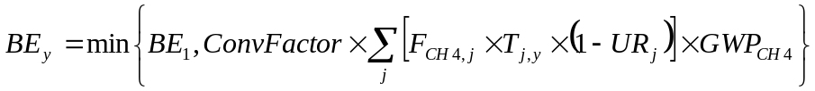 (1)
With,

(2)

Where:
BE₁ = Baseline emissions for the first crediting year of the crediting period (tCO₂e).
BE_{y} = Baseline emissions for crediting year y (tCO₂e)
ConvFactor = Conversion factor to convert Nm³ CH₄ into tCH₄. Gas leak flow measurement equipment such as the Hi-Flow sampler automatically accounts for standard temperature and pressure in data readings; as such this factor amounts to 0.0007168tCH₄/Nm³ CH₄ (i.e., 0 degree Celsius and 101.3 kPa).
j = All physical leaks that are included in the project activity for which physical leaks were detected and repaired and which would leak in the baseline scenario during the crediting year y.
F_{CH4,j} = Measured flow rate of methane for the physical leak j from the leaking component (Nm³ CH₄/h)
UR_{j} = Uncertainty range for the flow rate measurement method applied to physical leak j. The uncertainty of the measurement is taken into account by using the flow rate at the lower end of the uncertainty range for the measurement at a 95% confidence interval for baseline emissions from leaks
T_{j,y} = The time the relevant component, in which physical leak j occurred, would leak in the baseline scenario and would be eligible for crediting during the crediting period y (hours)
GWP_{CH4} = The global warming potential for methane valid for the commitment period (tCO₂e/tCH₄). After the commitment period, this value may be revised based on any decision by the CMP.

For each physical leak identified, the gas leak flow measurement equipment such as the Hi-Flow™ sampler or Leak Measurement Device will be used to capture all emissions from a leaking component to accurately quantify leak flow rates. Leak emissions, plus a large volume sample of the air around the leaking component, are pulled into the instrument through a vacuum sampling hose. High volume samplers are equipped with dual hydrocarbon detectors that measure the concentration of hydrocarbon gas in the captured sample, as well as the ambient hydrocarbon gas concentration. Sample measurements are corrected for the ambient hydrocarbon concentration, and the leak rate is calculated by multiplying the flow rate of the measured sample by the difference between the ambient gas concentration and the gas concentration in the measured sample. Methane emissions are estimated by calibrating the hydrocarbon detectors to a range of concentrations of methane-in-air. High volume samplers are equipped with special attachments designed to ensure complete emissions capture and to prevent interference from other nearby emissions sources. The hydrocarbon sensors are used to measure the exit concentration in the air stream of the system. The sampler essentially makes rapid vacuum enclosure measurements. The leak flow rate of methane is calculated as follows:

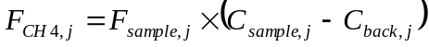 (3)

Where:
F_{CH4,j} = Measured flow rate of methane for the physical leak j from the leaking component (Nm³ CH₄/h)
F_{sampler,j} = The sample flow rate of the sampler for leak j (m³/h)
C_{sample,j} = The concentration of methane in the sample flow from leak j (volume percent)
C_{back,j} = The concentration of methane in the background near the component (volume percent)
For all physical leaks detected, the following assumptions will be applied in calculating the baseline emissions:
- For repaired components where no physical leaks were detected at the initial baseline survey and where physical leak(s) were detected during a subsequent survey, baseline emissions shall be accounted from the moment when the leak was detected;
- Baseline emissions from a specific leak j or a specific component r are included in the calculations until whichever of the following occurs first:
  - The component concerned is replaced for a non-leak related reason (i.e., it breaks down); or
  - The end of the last crediting period of the overall project activity.

Project Emissions
Project emissions include physical leaks that take place on components included in the project boundaries in the following cases:
- If a repair of a physical leak ceases to function, for as long as it is not repaired again after monitoring; or
- If a new physical leak is detected in a piece of equipment which was part of the initial baseline survey and for which no physical leak was detected during that survey, as long as that physical leak is not repaired.

Project emissions are calculated using the following formula (Option 2):

(4)
Where:
PE_{y} = Project emissions in crediting year y (tCO₂e).
ConvFactor = Conversion factor to convert Nm³ CH₄ into tCH₄. Gas leak flow measurement equipment such as the Hi-Flow sampler automatically accounts for standard temperature and pressure in data readings; as such this factor amounts to 0.0007168tCH₄/Nm³ CH₄ (i.e., 0 degree Celsius and 101.3 kPa).
z = All leaks that are accounted for as project emissions during the crediting year y
F_{CH4,z} = Measured leak flow rate of methane for the physical leak z from the leaking component (Nm³ CH₄/h)
UR_{z} = Uncertainty range for the flow rate measurement method applied to physical leak z. The uncertainty of the measurement is taken into account by using the flow rate at the upper end of the uncertainty range for the measurement at a 95% confidence interval for project emissions from leaks.
T_{z} = The time the relevant component has been leaking during the crediting year y
GWP_{CH4} = Global warming potential of methane valid for the commitment period (tCO₂e/tCH₄). After the commitment period, this value may be revised based on any decision by the CMP.

The following assumptions will be made in the calculation of project emissions:
If a repair of a physical leak ceases to function, it is conservatively assumed that the leak resumed either:
  - At the same flow rate that was measured prior to its repair when using only leak detection equipment;
  - At the newly measured leak rate if the leak is re-measured using leak measurement equipment at the time of monitoring (in case of Option 2);

It is further assumed that the leak resumed at the day when the leak was last checked and confirmed not to leak and that it continued to leak for the entire time in the relevant monitoring period since that date. Thus, leaks where the repair failed should be included in the project emissions;
- For components where no physical leak was detected at the initial baseline survey and where physical leak(s) were detected during a subsequent monitoring survey, project emissions from these components shall be accounted since the moment when the leak was detected;
- Project emissions from a specific physical leak are included in the calculations until whichever of the following are earlier:
  - The date of any repair of the physical leak, as long as the repair does not cease to function (no project emissions will be included if a newly found leak or newly reemerged leak is repaired on the same day); or
  - The equipment concerned is replaced (i.e. it breaks down).

Leakage
Leakage: no significant leakage emissions are expected from this project.

Net GHG Emission Reductions and Removals

Emission reductions: are calculated as follows:
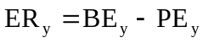 | (5)
Where:
ER_{y} | = | Emission reductions for crediting year y (tCO₂e)
BE_{y} | = | Baseline emissions for crediting year y (tCO₂e)
PE_{y} | = | Project emissions for crediting year y (tCO₂e)  Ex-ante Emission Reductions were calculated as per the formula above.  Results from the feasibility study have been extrapolated to the Titas project area to develop an estimate of baseline emissions (BE_{y}).  Additionally, since the project has not been implemented, it is assumed that PE_{y} = 0.  Measurement results and extrapolations can be found in the spreadsheet with Emission Reductions calculations. In summary, ex-ante emission reductions were calculated using the approach below:  - The first step was to calculate leak flow rate (F_{CH4,j}) as per formula (3):  - F_{Sample,j} has been determined by multiplying average leak rate for each facility type (litres per minute) and the total number of surface facilities within each category (Table 3):  Table 4 Determination of Fsample,j parameter  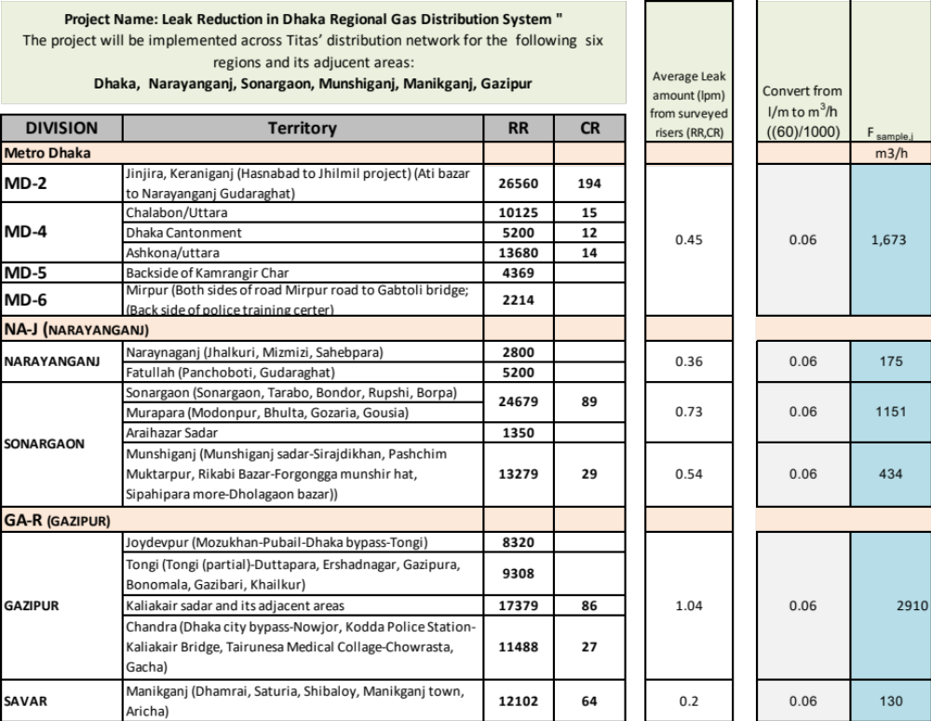  - The average leak rate has been determined based on sample measurements for each facility type, taken during the feasibility study with a Hi-Flow™ sampler  - The resulting F_{sample} figures were then refined to only include methane by multiplying them by the percentage of methane in the gas (C_{sample}) minus any background methane (C_{back}). This generated F_{CH4,j} as per the formula (3) (Table 3). Note the HFS measures only methane and the results given are in flow of 100% methane.  Table 5 Determination of leak flow rate F_{CH4,j}  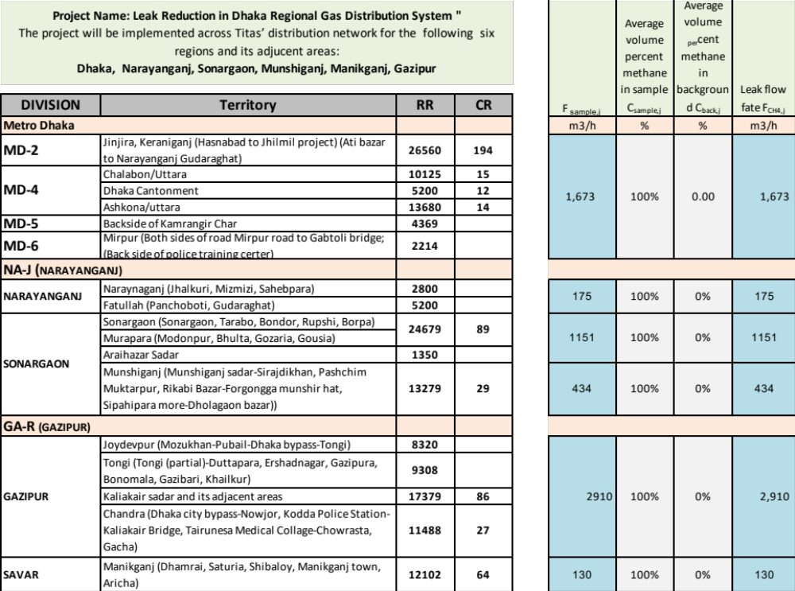  - The F_{CH4,j} figures were then used in the formula (1).  - Since the Hi-Flow™ sampler results are given for standard temperature and pressure in data readings and margin of error, the conversion factor (ConvFactor) of 0.0007168tCH₄/Nm³ CH₄ was used.  - Since the distribution system is in continuous operation, time (T_{j,y}) was considered to be 8760 for the purpose of this estimate. However, actual emissions will incorporate real operational hours.  - The uncertainty range (UR_{j}) was calculated, as per formula 6 below, using guidance of the IPCC “Good Practice Guidance and Uncertainty Management in National Greenhouse Gas Inventories” Chapter 6, page 12, which provides an approach for combining uncertain quantities.  - (Please note that “U” and “U_{total}” used in the IPCC document have been replaced by “UR” and “UR_{j}” respectively to make it consistent with the acronyms used in the AM0023 (Version 04.0.0).  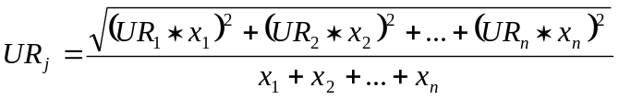 (6)  Where  UR_{j} = the percentage uncertainty in the sum of the quantities (half the 95% confidence interval divided by the total (i.e. mean) and expressed as a percentage);  x_{n} and UR_{n} = the uncertain quantities and the percentage uncertainties associated with them, respectively.  (Note: “n” in this case refers to each recorded leak rate of each component surveyed)  - Firstly, the “sum of the squares’ has been calculated, using the results of the feasibility study (i.e. each recorded leak rate of each component surveyed, x_{n}) and multiplying each by 10% (i.e. at 95% confidence interval as per IPCC Guidance, UR_{n}). Then, the square root of the resulting sum has been derived, and divided by the sum of recorded leak rate of each component surveyed (Table 10).  Table 6 Determination of uncertainty range, UR_{j}  - The result (_{URj}) has been used to estimate the final baseline. Detailed calculations are provided in the VRU calculation data sheet provided to the DOE. The final value will be determined based on the actual number and value of baseline and monitoring measurements taking during the project.  - Global Warming Potential for CH₄ (GWP _{CH4}) is 28 tCO₂e/tCH₄, as adopted by the Fifth Assessment Report of the IPCC.  - Since the project activity has not been implemented, it is assumed that Leakage and Project Emissions, (PE y) equal 0. As such, ex-ante emission reductions are assumed to equal baseline emissions (BE_{y}). However, during project implementation, actual project emissions (such as, re-emerging leaks) will be reported and incorporated into the emissions reduction calculations (per equation 5).  Summary data based on results from the feasibility study is presented below (Table 11):  Table 7 Summary of ex-ante emission reductions calculations  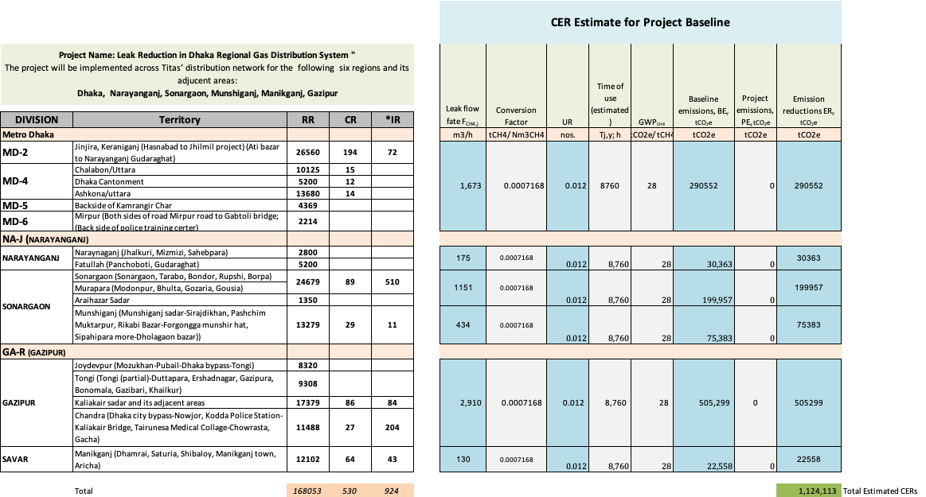  Note: The ex-ante estimates of emission reductions are based on the results of the feasibility study. Yet, the actual emission reductions will be based on the actual baseline survey, which will cover all eligible equipment in the Titas distribution system project area.
  Sum of (UR_{n}*x_{n})² | Square root of the sum | Sum of x_{n} | URj
  A | √A | B | √A/B
  82.1 | 9.0600055 | 736.9 | 0.012

Year | Estimated baseline emissions or removals  (tCO₂e) | Estimated project emissions or removals  (tCO₂e) | Estimated leakage emissions (tCO₂e) | Estimated net GHG emission reductions or removals  (tCO₂e)
2022 | 327,866 | 0 | 0 | 327,866
2023 | 1,124,113 | 0 | 0 | 1,124,113
2024 | 1,124,113 | 0 | 0 | 1,124,113
2025 | 1,124,113 | 0 | 0 | 1,124,113
2026 | 1,124,113 | 0 | 0 | 1,124,113
2027 | 1,124,113 | 0 | 0 | 1,124,113
2028 | 1,124,113 | 0 | 0 | 1,124,113
2029 | 1,124,113 | 0 | 0 | 1,124,113
2030 | 1,124,113 | 0 | 0 | 1,124,113
2031 | 1,124,113 | 0 | 0 | 1,124,113
2032 | 468,380 | 0 | 0 | 468,380
Total | 10,913,263 | 0 | 0 | 10,913,263

Monitoring

Data and Parameters Available at Validation

Data / Parameter | GWP_{CH4}
Data unit | tCO_{2e}/tCH₄
Description | Global warming potential
Source of data | Fifth Assessment Report of the Intergovernmental Panel on Climate Change
Value applied | GWPs will be updated according to any decisions by the CMP.  GWP_{CH4} = 28
Justification of choice of data or description of measurement methods and procedures applied | 5th Assessment Report of the IPCC
Purpose of Data | Calculation of baseline and project emissions- Convert tCH₄ to tCO_{2e}
Comments | This value applies for the calculation of the baseline and project emissions.

Data / Parameter | ConvFactor
Data unit | tCH₄/ Nm³ CH₄
Description | The factor to convert Nm³ CH₄ to tCH₄
Source of data | -
Value applied | 0.0007168
Justification of choice of data or description of measurement methods and procedures applied | Conversion factor
Purpose of Data | Calculation of baseline and project emissions- Convert Nm³ CH₄ to tCH₄
Comments | The leak flow rate (F_{CH4,j}) and conversion factor (ConvFactor) should be reduced to the same reference conditions. Flow measurement devices such as the Hi-Flow™ sampler and Leak Measurement Device automatically account for standard temperature and pressure (i.e., 0 degree Celsius and 101.3 kPa) in its leak flow rate (F_{CH4,j}) measurements. As such, a conversion factor (ConvFactor) of 0.0007168 reflects the methane density at 0 degree Celsius and 101.3 kPa, which is derived by dividing the methane density at standard conditions by Avogadro constant (22.414 l/mol). This value is taken from the US Government PubChem Database where it is listed in grams/litre. It is converted to tonnes per litre using standard unit conversion (gram/litre=0.001 tonne/cubic meter). The same value can also be found on the Engineering Toolbox website listed in kg/m³ (kg/m³=0.001 tonne/cubic meter). It is applied to convert Nm³ CH₄ to tCH₄.

Data and Parameters Monitored

Data / Parameter | T_{j,y}
Data unit | Hours
Description | The time the relevant component, in which physical leak j, occurred, would leak in the baseline scenario and would be eligible for crediting during the crediting period y (hours)
Source of data | operation log
Description of measurement methods and procedures to be applied | Any outages will be recorded
Frequency of monitoring/recording | Constant
Value applied | 8760
Monitoring equipment | NA
QA/QC procedures to be applied | Any outages resulting from system repairs will be documented and logged in the project database in the form of a reduction in the time of operation of each affected leak repair. To be clear, if an unrelated activity requires the shut-down of an already repaired piece of component, the hours of operation for every piece of affected component with be reduced in the database for the entire duration of the shut-down. Any other unscheduled shutdown will also be timed and accounted for through a reduction of operating hours
Purpose of data | This value applies for the calculation of the baseline emissions
Calculation method | NA
Comments | Hours of operation will end when components concerned is replaced for a non-leak related reason (e.g., it breaks down).

Data / Parameter | Tz
Data unit | Hours
Description | The time (in hours) the relevant component has been leaking following leak identification during the crediting period y
Source of data | operation log
Description of measurement methods and procedures to be applied | Any outages will be recorded
Frequency of monitoring/recording | Constant
Value applied | 0
Monitoring equipment | NA
QA/QC procedures to be applied | Any outages resulting from system repairs will be documented and logged in the project database in the form of a reduction in the time of operation. To be clear, if an unrelated activity requires the shut-down of an already repaired piece of component, the hours of operation for every piece of affected component with be reduced in the database for the entire duration of the shut-down. Any other unscheduled shutdown will also be timed and accounted for through a reduction of operating hours.
Purpose of data | This value applies for the calculation of project emissions
Calculation method | NA
Comments | Hours of operation will end when components concerned is replaced for a non-leak related reason (e.g., it breaks down). Repairs undertaken on the same day as the leak was identified will not count towards project emissions

Data / Parameter | Temperature and pressure of natural gas
Data unit | °C and bar
Description | The temperature and pressure at the point at the time of measurement
Source of data | Conditions observed at the point and time of the leak rate measurement
Description of measurement methods and procedures to be applied | Volume flow measurement devices such as the Hi-Flow™ Sampler automatically adjust readings to standard temperature and pressure (0°C and 101.3 kPa) and is included in the machine’s margin of error therefore there is no need to monitor these separately.
Frequency of monitoring/recording | At the time of each leak measurement
Value applied | NA
Monitoring equipment | Leak Flow Measuring Equipment such as the Hi-Flow Sampler or Leak Measurement Device
QA/QC procedures to be applied | The machine is calibrated and double checked every 30 days while in use with the date and name of the person in-charge of the calibration recorded in a calibration log.
Purpose of data | This value applies for the calculation of baseline and project emissions
Calculation method | NA
Comments | Any significant corruption of sensors between the typical 30-day calibration period that might eventually affect the accuracy and function of the Hi-Flow or Leak Measurement Device will be quickly recognized by operators before it affects the accuracy of the results. The reason the operator will be able to detect a problem before it affects the accuracy, stems from the fact that gas purge times after measurements are taken will begin to increase with corrupted sensors; slowing down the measurement process. The operators are all trained to recognize this condition, and will quickly replace the sensors and recalibrate the device. Each operator has a target number of measurements to make per day in order to get paid, so a slow purge will motivate the operator to replace the sensor and recalibrate so as not to miss their target.

Data / Parameter | URj
Data unit | Fraction
Description | The uncertainty range for the measurement method applied to leak j
Source of data | Manufacturer’s data for leak flow measurement device, such as the Hi-Flow™ Sampler or Leak Measurement Device
Description of measurement methods and procedures to be applied | Estimated using a 95% confidence interval per guidance provided in Chapter 6 of the 2000 IPCC Good Practice Guidance.  The URj will be calculated using leakage flow rates and the respective UR of the device used for measuring the leak. The uncertainty calculations have been described above and are included in the VRU calculations spreadsheet.
Frequency of monitoring/recording | Periodically
Value applied | 0.012 for measurements with Hi-Flow Sampler
Monitoring equipment | NA
QA/QC procedures to be applied | NA
Purpose of data | This value applies for the calculation of the baseline emissions
Calculation method | (6)  Where  UR_{j} = the percentage uncertainty in the sum of the quantities (half the 95% confidence interval divided by the total (i.e. mean) and expressed as a percentage);  x_{n} and UR_{n} = the uncertain quantities and the percentage uncertainties associated with them, respectively.  (Note: “n” in this case refers to each recorded leak rate of each component surveyed)
Comments | Applicable only in the case that Option 2 for the calculation of baseline and project emissions is selected

Data / Parameter | URz
Data unit | Fraction
Description | The uncertainty range for the measurement method applied to reappeared leak z that is not re-repaired and therefore counted as a project emission
Source of data | Manufacturer’s data for leak flow measurement device, such as Hi-Flow™ Sampler or Leak Measurement Device
Description of measurement methods and procedures to be applied | Estimated using a 95% confidence interval per guidance provided in Chapter 6 of the 2000 IPCC Good Practice Guidance.  The URz will be calculated using leakage flow rates and the respective UR of the Hi-Flow sampler used for the leak. The uncertainty calculations have been described above and are included in the VRU calculations spreadsheet.
Frequency of monitoring/recording | Periodically
Value applied | 0 for measurements with Hi-Flow Sampler
Monitoring equipment | NA
QA/QC procedures to be applied | NA
Purpose of data | This value applies for the calculation of Project emissions
Calculation method | Using same equation as UR_{j} except including only measurements for reappeared leaks that are not re-repaired therefore counting as project emissions  Where  UR_{Z} = the percentage uncertainty in the sum of the quantities (half the 95% confidence interval divided by the total (i.e. mean) and expressed as a percentage);  x_{n} and UR_{n} = the uncertain quantities and the percentage uncertainties associated with them, respectively.  (Note: “n” in this case refers to each recorded leak rate of each component surveyed)
Comments | Applicable only in the case that Option 2 for the calculation of baseline and project emissions is selected

Data / Parameter | FCH4, j/FCH4, z/
Data unit | m³CH4/h
Description | The leak flow rate of methane for leak (j, z) from the leaking component
Source of data | Hi-Flow™ sampler or Leak Measurement Device readings during on-site measurements
Description of measurement methods and procedures to be applied | Manufacturer procedures applied. Measurements with Hi-Flow™ Sampler are automatically adjusted to the methane content, temperature and pressure and, thus, will directly yield methane leak flow rates.
Frequency of monitoring/recording | At the conclusion of each monitoring period
Value applied | The measurement accuracy is +/-10%, as per the technical specification of a Hi-Flow sampler.
  Project Name: Leak Reduction in Dhaka Regional Gas Distribution System "  The project will be implemented across Titas’ distribution network for the following six regions and its adjacent areas:  Dhaka, Narayanganj, Sonargaon, Munshiganj, Manikganj, Gazipur |  |  |  |  |  |  | Leak flow fate F_{CH4,j}
  DIVISION | Territory | RR | CR |  |  |  | Leak flow fate F_{CH4,j}
  Metro Dhaka |  |  |  |  |  |  | m3/h
  MD-2 | Jinjira, Keraniganj (Hasnabad to Jhilmil project) (Ati bazar to Narayanganj Gudaraghat) | 26560 | 194 |  |  |  | 1673
  MD-4 | Chalabon/Uttara | 10125 | 15 |  |  |  | 1673
  MD-4 | Dhaka Cantonment | 5200 | 12 |  |  |  | 1673
  MD-4 | Ashkona/uttara | 13680 | 14 |  |  |  | 1673
  MD-5 | Backside of Kamrangir Char | 4369 |  |  |  |  | 1673
  MD-6 | Mirpur (Both sides of road Mirpur road to Gabtoli bridge; (Back side of police training certer) | 2214 |  |  |  |  | 1673
  NA-J (NARAYANGANJ)
  NARAYANGANJ | Naraynaganj (Jhalkuri, Mizmizi, Sahebpara) | 2800 |  |  |  |  | 175
  NARAYANGANJ | Fatullah (Panchoboti, Gudaraghat) | 5200 |  |  |  |  | 175
  SONARGAON | Sonargaon (Sonargaon, Tarabo, Bondor, Rupshi, Borpa) | 24679 | 89 |  |  |  | 1151
  SONARGAON | Murapara (Modonpur, Bhulta, Gozaria, Gousia) | 24679 | 89 |  |  |  | 1151
  SONARGAON | Araihazar Sadar | 1350 |  |  |  |  | 1151
  SONARGAON | Munshiganj (Munshiganj sadar-Sirajdikhan, Pashchim Muktarpur, Rikabi Bazar-Forgongga munshir hat, Sipahipara more-Dholagaon bazar)) | 13279 | 29 |  |  |  | 434
  GA-R (GAZIPUR)
  GAZIPUR | Joydevpur (Mozukhan-Pubail-Dhaka bypass-Tongi) | 8320 |  |  |  |  | 2910
  GAZIPUR | Tongi (Tongi (partial)-Duttapara, Ershadnagar, Gazipura, Bonomala, Gazibari, Khailkur) | 9308 |  |  |  |  | 2910
  GAZIPUR | Kaliakair sadar and its adjacent areas | 17379 | 86 |  |  |  | 2910
  GAZIPUR | Chandra (Dhaka city bypass-Nowjor, Kodda Police Station-Kaliakair Bridge, Tairunesa Medical Collage-Chowrasta, Gacha) | 11488 | 27 |  |  |  | 2910
  SAVAR | Manikganj (Dhamrai, Saturia, Shibaloy, Manikganj town, Aricha) | 12102 | 64 |  |  |  | 130
Monitoring equipment | NA
QA/QC procedures to be applied | NA
Purpose of data | This value applies for the calculation of baseline and project emissions.
Calculation method | NA
Comments | Applicable only in the case that Option 2 for the calculation of baseline and project emissions is selected. The leak flow rate (F_{CH4,j}) and conversion factor (ConvFactor) should be reduced to the same reference conditions. As noted by Heath Consultants, the Hi-Flow™ sampler automatically accounts for standard temperature and pressure (i.e., 0 degree Celsius and 101.3 kPa) in its leak flow rate (F_{CH4,j}) measurements. As such, a conversion factor (ConvFactor) of 0.0007168 reflects the methane density at 0 degree Celsius and 101.3 kPa, which is derived by dividing the methane density at standard conditions by Avogadro constant (22.414 l/mol This value is taken from the US Government PubChem Database where it is listed in grams/litre. It is converted to tonnes per litre using standard unit conversion (gram/litre=0.001 tonne/cubic meter). The same value can also be found on the Engineering Toolbox website listed in kg/m³ (kg/m³=0.001 tonne/cubic meter). It is applied to convert Nm³ CH₄ to tCH₄).

Data / Parameter | BE_{CAP}
Data unit | tCO2e
Description | Capped quantity of the baseline emissions, defined as the baseline emissions for the first year of the crediting period
Source of data | Monitored baseline emissions identified during the first year of the first crediting period
Description of measurement methods and procedures to be applied | NA
Frequency of monitoring/recording | Once at completion of first monitoring
Value applied | 1,124,113
Monitoring equipment | NA
QA/QC procedures to be applied | NA
Purpose of data | To cap the quantity of baseline emissions
Calculation method | Total annual baseline emissions calculated at first monitoring based on the total leak reductions identified during the first year of the crediting period calculated as per the methodology over a twelve month period.
Comments | Does not apply in to the calculations for this estimate as each year is predicted to have an equal baseline so no cap applies.

Monitoring Plan
Staff within Titas and local implementation partner Prokaushali Sangsad LTD (PSL) will manage and implement the day-to-day Project operations and monitoring activities by performing advanced LDAR activities (detection, measurement, repair and documentation of leaks) throughout the crediting period. Climate Compass will provide training to local project staff on how to organize and implement an LDAR, provide its proprietary database and data management system, methodological supervision and project management and oversight. Carbon Projects LLC will provide all the funds required to monitor the project.
The following monitoring procedures will be implemented:

Establishment of a database
All data collected during project implementation will be entered into a database. The database will be continuously updated during the crediting period. The data in the database will also be included in each monitoring report.

Data collection during the project implementation
The implementation of the project will involve an initial baseline survey and regular subsequent surveys of each component within the project boundary.
During the project activity, data will be collected and collated by the project leak detection and repair teams, the Titas database manager will review the data and check that it has been recorded correctly. Procedures will include: 1) tracing data from individual spreadsheets to the collated spreadsheet; 2) identifying outliers and verifying the measurement with the responsible technical operator to double check the number; and 3) reviewing measurements by each individual measuring device such as a Hi-Flow™ or Leak Measurement Device, to ensure that no device in particular is making measurements that appear to be outliers on a constant basis. If such discrepancies are found, the measuring device will be recalibrated and checked immediately, and any erroneous leaks will be re-measured.
Additionally, to ensure data is not lost if leak tags are damaged or lost, or digital photos are accidently deleted, etc., three concurrent ways of tagging leak locations and tracking leak measurements will be implemented: 1) a digital photo of the leak will be taken with the tag filled out; 2) a physical tag will be placed on-site and the leak rate and measurement date written on the tag; and 3) when the leak measurement and date are entered into the database the original measuring device records will be saved.

The project will utilize an independent third-party consulting firm MBS, to provide QA/QC oversight for the project. Their role and responsibilities will include: 1) verify that maintenance and monitoring of leaks is being conducted in accordance with the Monitoring Plan; 2) observe the database team to ensure that data is being recorded and handled as per the requirements of this Monitoring Plan; and 3) conduct audits of the data to ensure that adequate records are being kept, and that leaks found and leaks repaired have been accurately documented in the database.

The flow of data in the project occurs as follows:

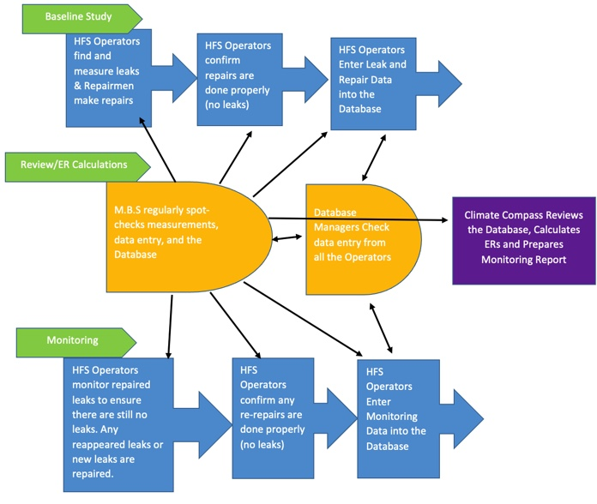

Monitoring
All teams conducting leak surveys will be formally trained and certified by technical experts in leak detection and measurement techniques, and advanced repair techniques. The training program is described in more detail below.

Training Program
A training program will be conducted to train local staff at Titas and PSL on how to use advanced LDAR techniques, such as how to use advanced detection and measurement equipment, how to execute effective repairs, and how to document the leaks found in an effective manner. The training will be conducted by technical experts with experience in advanced gas leak detection and measurement, and advanced repair materials to be used in the project. These experts will provide detailed instructions and written materials on how to conduct the leak detection, measurements and repairs.

Each project leak detection and repair team will be equipped with the following equipment:
- Gas leak flow measurement equipment such as a Hi-flow™ sampler or Leak Measurement Device
- Calibration gas canisters: low concentration ~2.5% methane in air concentration; and high concentration ~97%% methane
- GMI Gasurveyor™ (500 Series) (or similar electronic gas detector)
- Smartphone able to receive GPS coordinates and make photos of leaky facilities
- Tags
- Advanced Repair materials as required for particular repairs
- Data sheets with draft schematics for data input on-site
- Toolkit
- Car

Monitoring requirements

For each component where a physical leak has occurred, the following procedures will be undertaken and information will be collected:

Leak Detection and Measurement
The project leak detection and repair teams will survey the components in the project boundary using advanced leak detection instruments, such as the GMI Gasurveyor (500 series), which is an electronic gas detector. Once identified, the leaks will be tagged, and numbered. The flow rate for each leak will then be quantified using the Hi-Flow™ sampler, Leak Measurement Device, calibrated bag, or other method/device approved in the methodology. A digital photograph will be taken of the leaking component, tag. These photographs will be archived by the Database Management Team. In addition, the type of repair expected given the nature of the leak and its location will be categorized for future repair planning.

After leaks have been detected and measured, they will be repaired. Before each repair is made, another Hi-Flow™ sampler or Leak Measurement Device measurement will be taken which is used in the VRU calculations. Discrepancy between the first two measurements must be 15% or less or the third measurement is taken and used. The final (2nd or 3rd), confirmed leak rate will be used to determine baseline leakage as per the AM0023 (Version 04.0.0) methodology, regardless of whether the leak rate is lower or higher than the original leak measurement. After the repair, a new leak measurement will be carried out to ensure that the leak was properly repaired. If required, additional repairs will be made until no further leak can be detected. The date of the repair (or discovery of remaining leak) will be recorded in the Project Database.

Monitoring Repaired Leaks
All leaks that have been subject to repair will be monitored – using the same leak detection technologies (i.e., Gasurveror 500, Hi-Flow™ sampler or Leak Measurement Device) on each leak identified in the baseline – to ensure they are maintained, on an annual basis. In case where a Gasurveyor or similar equipment cannot confirm the absence of a reappeared leak on a repair (zero reading), a measurement with a Gas leak flow measurement device such as a Hi-Flow™ sampler or Leak Measurement Device, will be used to assess if leakage is occurring and quantify leak rates as appropriate. Where a leak repair fails, it is conservatively assumed that the leak resumed the day after the last monitoring event in the same monitoring period, the last day of the previous monitoring period, or in the case of the first monitoring, the day after the repair has taken place. Emission reductions are counted from the date of subsequent repair of that same leak, and are measured using the same type of equipment as in the initial baseline survey. Such reappeared leaks will be repaired again followed by new leak measurements. Data collected will be included in the periodic monitoring reports stored in the Database.

In summary, for each component where a physical leak has occurred, the following information will be collected during regular monitoring checks:
- Date of monitoring;
- An assessment whether the relevant component has been replaced after the repair of the leak;
- The number of hours during which the component is in pressurized natural gas service;
- An assessment whether the repair of the leak functions appropriately.

All information will be added to the database and be included in the monitoring reports.

Inte

The selected methodology AM0023 (Version 04.0.0) defines a component as “above-ground process equipment in natural gas production, processing, transmission, storage, distribution systems”, including valves, flanges and other connectors etc.
Technical details of GMI Gasurveyor™ (500 Series): http://www.heathus.com/_hc/index.cfm/products/gas/gasurveyor-500-series
Technical details of a Hi-Flow™ sampler: http://www.heathus.com/_hc/index.cfm/products/gas/hi-flow-sampler
GORE® Valve Stem Packing DP: http://www.gore.com/en_xx/products/sealants/packing/gore-tex_valve_stem_packing.html
The GORE® Valve Stem Packing DP is not subject to ageing within the material’s temperature range (from -268ºC to +315ºC), as per material specification (http://www.gore.com/MungoBlobs/304/192/GORE_Valve_Stem_Packing_Datasheet_en.pdf). Considering that extreme temperatures outside of this material’s temperature range are not recorded in the People's Republic of Bangladesh, it is safe to state that GORE® Valve Stem Packing DP has an operational lifetime of 10 years and more.
An estimate based on other registered projects, which apply the AM0023 methodology and used similar leak repair materials prior to the project implementation (Project 5176: http://cdm.unfccc.int/Projects/DB/SGS-UKL1315231968.24/view; and Project 4883: http://cdm.unfccc.int/Projects/DB/SGS-UKL1307194985.17/view).
For example, American National Standard Institute (ANSI)/American Society of Mechanical Engineers (ASME) B 31.8 (gas transmission and distribution piping systems)
http://www.platts.com/latest-news/natural-gas/Dhaka/Bangladeshs-existing-gas-reserves-to-run-out-26046254
ibid
https://www.titasgas.org.bd//temp/source/AR20192020.pdf (p.71)
https://www.titasgas.org.bd//temp/source/AR20192020.pdf (p.144)
Price based on used HFS bought in 2019
Oct 16, 2020 quote from Heath Consulting
https://tradingeconomics.com/bangladesh/rating
https://tradingeconomics.com/bangladesh/rating
World Bank report submitted to the DoE.
http://cdm.unfccc.int/Reference/Guidclarif/meth/meth_guid44.pdf
HI FLOW® Sampler Natural Gas Leak Rate Measurement; Instruction 0055-9017; Operation & Maintenance Rev. 5 – June 2010 (http://www.bacharach-inc.com/PDF/Instructions/55-9017.pdf)
https://pubchem.ncbi.nlm.nih.gov/source/hsdb/167#section=Density&fullscreen=true
https://www.engineeringtoolbox.com/methane-d_1420.html
https://pubchem.ncbi.nlm.nih.gov/source/hsdb/167#section=Density&fullscreen=true
https://www.engineeringtoolbox.com/methane-d_1420.html

