monitoring report
KARIBA REDD+ PROJECT
SUMMARY IN ENGLISH
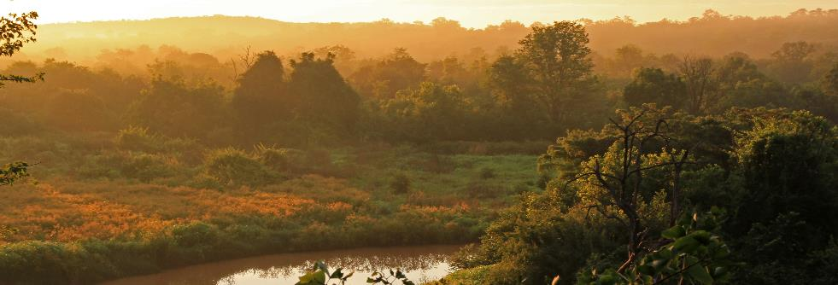
Document prepared by:

Contact: +57 4 352 4428; a.marcarini@southpole.com
Project Title | Kariba REDD+ Project
Project ID | 902
Version | 1.1
Report ID
Date of Issue | 20 December 2019
Project Location | Zimbabwe
Project Proponent(s) | Carbon Green Investments (CGI)  Contact Name: Steve Wentzel  Email: steve@carbongreenafrica.net  Phone: +263 77 417 4025
Prepared By | South Pole  Contact Name: Abel Alan Marcarini  Email: a.marcarini@southpole.com  Phone: +57 4 352 4428
Validation/Verification Body | Aster Global Environmental Solutions, Inc.  Contact Name: Shawn McMahon  Email: smcmahon@asterglobal.com  Phone: +1 330 294 1242
GHG Accounting/Crediting Period | VCS: July 01, 2011 – June 30, 2041  CCB: October 01, 2011 – September 30, 2041
Monitoring Period of this Report | VCS: July 01, 2016 – June 30, 2019  CCB: July 01, 2016 – June 30, 2019
History of CCB Status | Validation Approved - CCB Standards Second Edition, Climate Adaptation & Biodiversity Gold Level (February 8, 2012)  Verification Approved – CCB Standards Second Edition, Climate Adaptation & Biodiversity Gold Level (July 24, 2014)  Verification Approved (second verification) – CCB Standards Second Edition, Climate Adaptation & Biodiversity Gold Level (30 June 2017)
Gold Level Criteria | The Kariba REDD+ Project maintains two CCBS Gold Level criteria, Climate Change Adaptation Benefits and Exceptional Biodiversity benefits. The project’s activities provide substantial contributions to climate change adaptation through its activities in conservation farming and beekeeping. Conservation farming techniques are more drought-adapted than conventional agriculture and beekeeping provided alternative livelihoods, which is a broadly accepted measure to adapt to climate change. Both conservation farming and beekeeping have been successfully promoted by the project since project start. From July 2016 to June 2019, over 8,250 participants benefited from several workshops on improved agriculture, and 18 community gardens have been active in the area. The project also promotes beekeeping as an alternative and environmentally friendly source of income. From July 2016 to June 2019, 107 beekeeping workshops have been held across the project area. This activity has 4,567 beneficiaries as workshop participants. In addition, 152 boreholes were resuscitated or repaired from July 2016 to June 2019.  The exceptional Biodiversity Benefits are guaranteed through anti-poaching activities such as snare removal and patrolling to release the pressure on wildlife and conservation farming and beekeeping that promote deforestation reduction. From July 2016 to June 2019, 3,876 team-days where spent patrolling, and over 3,400 snares have been removed from the field, which means a substantial relieve of the pressure on the local wildlife. The exceptional Biodiversity Benefits are based on the broad range of endangered and vulnerable animals, which occur in the project area. Species include painted dog (EN), elephant VU), lion (VU), southern ground hornbill (VU), white-headed vulture (CR), white-backed vulture (CR) and leopard (CR).

Table of Contents
1. Summary of project Benefits 5
1.2 Standardized Benefit Metrics 7
1.3 Summary of Benefits 13
2. Project location 14
3. Stakeholder consultation 15
4. Climate impacts 15
5. Community impact 16
6. Biodiversity impact 17

List of Figures
Figure 1: Location of the project area 15
Figure 2: Fauna spotted in the project area during patrols 18
Figure 3: Flora species in the project area 20

List of Tables
Table 1: Satisfaction with the Kariba REDD+ Project 16
Table 2: Reported project impact on livelihoods by beneficiaries and employees 16
Table 3: Reported project impact on food security by beneficiaries and employees 17
Table 4: Reported project impact on children’s access to education by beneficiaries and employees 17
Table 5: Reported project impact on healthcare by beneficiaries and employees 17
Table 6: Sightings and tracks of wildlife in the project from 1st July 2016 until 30th June 2019 19
Table 7: Ten most common tree species during field campaign during this monitoring period 20
Table 8: Overview of project’s anti-poaching activities from 1st July 2016 until 30th June 2019 21

summary of project Benefits
This project summary is part of the third verification audit under the CCB, for which the site visit with the auditor will take place from August 24-31, 2019. The project aims to reduce the local deforestation in the RDCs Mbire, Hurungwe, Nyaminyami and Binga through a range of community activities in close cooperation with the RDC administrations. The project is certified under two standards: The Verified Carbon Standard (VCS) and Climate, Community and Biodiversity Standards (CCBS). For both standards, the project management creates regular monitoring reports, and external auditors visit the project area to confirm the reports.
The project has proven successful in reducing deforestation in the project area. Since its start, over 29,064,310 tCO₂e of greenhouse gas emissions have been avoided through the reduction of deforestation and degradation. The climate benefits are also certified under the Verified Carbon Standard (VCS).
With regards to community benefits, the project includes a wide range of activities, which have direct positive effects on communities. Farmers are trained for conservation agriculture and necessary material inputs are provided. Community gardens are established and provided improved nutrition. From July 2016 to June 2019, over 8,250 participants benefited from several workshops, and there was over $117,000 of income generated in the project area.
The project also promotes beekeeping as an alternative and environmentally friendly source of income. From July 2016 to June 2019, 107 beekeeping workshops have been held across the project area. There have been 4,567 beneficiaries from this activity, as workshop participants. Schools and hospitals are supported through the provision of direct inputs. Fuelwood plantations are in initial stages and over 28,700 planting pockets were distributed during this monitoring period. A monthly project newsletter is produced and distributed through the local RDC offices. Fire management is a very important activity to reduce forest loss through firefighting training workshops, awareness meetings and early burning. Brick making activities are planned and subject to the availability of funding.
During a survey carried out in February and March 2019, most interview partners reported being satisfied or very satisfied with the project, and less than 5% reported being not satisfied. For employees and direct beneficiaries, the project has a positive impact on livelihoods, food security, children’s education and healthcare. No participant reported being restricted in use of the forest for basic livelihood or cultural needs.
No grievances have been received to date through the survey or other channels. The OGM teams serve as primary entry point for any grievances.
More indirect social effects of the project have been assessed in a community survey covering all participating Rural District Councils (RDCs) in February and March 2019. In the survey, 281 community members, 86 direct beneficiaries and 25 employees were interviewed.
The project’s biodiversity benefits include a reduction of the poaching pressure on wildlife through regular patrolling, in close cooperation with the local RDCs. From July 2016 to June 2019, 3,876 team-days were spent patrolling, and over 3,400 snares have been removed from the field, which means a substantial decrease in pressure on the local wildlife. As part of the project’s biodiversity monitoring, 165 trees species have been identified and many threatened wildlife species have been sighted.
1.1 Unique Project Benefits
Outcome or Impact | Achievement during the Monitoring Period | Section Reference | Achievement during the Project Lifetime
Food security enhancement | Community gardens and conservation farming has trained over 8,258 people. Community gardens account for over $ 117,000 U$D in income generated from the sales of produce. | 4.3.2 | Community gardens and conservation farming has trained over 12,000 people since the project started. Community gardens account for over $156,000 USD in income generated from the sale of produce from July 1st 2014 to June 30th 2019.
Alternative sources of income and forest conservation | Beekeeping is an alternative and environmentally friendly source of income as well as an efficient forest conservation activity. There have been 4,567 beneficiaries from this activity, as workshop participants. | 4.3.2 | Beekeeping is an alternative and environmentally friendly source of income as well as an efficient forest conservation activity. There have been 5,087 beneficiaries from this activity, as workshop participants.
Improved education | Over U$S 10,000 was spent on schools. | 4.3.2 | Over U$S 33,000 was spent on schools since project start.
Forest cover conservation | Early burning is part of fire management activities and are essential to guarantee proper regeneration of the project and prevent forest fires. Early burning covered over 2,100 km. | 4.3.2 | Early burning covered over 3,300 km from July 1st 2014 to June 30th 2019.

1.2 Standardized Benefit Metrics
Category | Metric | Achievements during Monitoring Period | Section Reference | Achievements during the Project Lifetime
GHG emission reductions & removals | Net estimated emission removals in the project area, measured against the without-project scenario | Not applicable | - | Not applicable
GHG emission reductions & removals | Net estimated emission reductions in the project area, measured against the without-project scenario | 10,870,864 tCO2e | 3.2 | 29,016,370 tCO2e
Forest cover | For REDD projects: Number of hectares of reduced forest loss in the project area measured against the without-project scenario | Not apllicable | - | Not applicable
Forest cover | For ARR projects: Number of hectares of forest cover increased in the project area measured against the without-project scenario | Not applicable | - | Not applicable
Improved land management | Number of hectares of existing production forest land in which IFM practices have occurred as a result of the project’s activities, measured against the without-project scenario | Not applicable | - | Not applicable
Improved land management | Number of hectares of non-forest land in which improved land management has occurred as a result of the project’s activities, measured against the without-project scenario | Data not available | - | Data not available
Training | Total number of community members who have improved skills and/or knowledge resulting from training provided as part of project activities | 12,718 | 4.3.2 | 17,726
Training | Number of female community members who have improved skills and/or knowledge resulting from training provided as part of project activities of project activities | 3,599 | - | Data not available
Employment | Total number of people employed in of project activities, expressed as number of full time employees | 22 people | 4.1.2 | 22 people
Employment | Number of women employed in project activities, expressed as number of full time employees | 20% | - | 20%
Livelihoods | Total number of people with improved livelihoods or income generated as a result of project activities | Data not available |  | Data not available
Livelihoods | Number of women with improved livelihoods or income generated as a result of project activities | Data not available | - | Data not available
Health | Total number of people for whom health services were improved as a result of project activities, measured against the without-project scenario | Data not available | - | Data not available
Health | Number of women for whom health services were improved as a result of project activities, measured against the without-project scenario | Data not available | - | Data not available
Education | Total number of people for whom access to, or quality of, education was improved as a result of project activities, measured against the without-project scenario | Data not available | - | Data not available
Education | Number of women and girls for whom access to, or quality of, education was improved as a result of project activities, measured against the without-project scenario | Data not available | - | Data not available
Water | Total number of people who experienced increased water quality and/or improved access to drinking water as a result of project activities, measured against the without-project scenario | 37,000 | 4.3.2 | 44,500
Water | Number of women who experienced increased water quality and/or improved access to drinking water as a result of project activities, measured against the without-project scenario | Data not available | - | Data not available
Well-being | Total number of community members whose well-being was improved as a result of project activities | Data not available |  | Data not available
Well-being | Number of women whose well-being was improved as a result of project activities | Data not available |  | Data not available
Biodiversity conservation | Change in the number of hectares significantly better managed by the project for biodiversity conservation, measured against the without-project scenario | 784,987 | 3.2.1 | 784,987
Biodiversity conservation | Number of globally Critically Endangered or Endangered species benefiting from reduced threats as a result of project activities, measured against the without-project scenario | 16 | 5.3.2 | 16

1.3 Summary of Benefits
Summary of Climate, Community and Biodiversity Benefits | Climate Benefits  The Kariba REDD+ Project is located in the major ecosystem of 784,987 ha of mopane and miombo woodland. By reducing emissions from deforestation and degradation (REDD) through avoid mosaic deforestation of tropical forests, the total GHG emission reduction generated in this monitoring period of 01 July 2016 to 30 June 2019 is 12,640,544 tCO₂e.  Community Benefits  The Kariba REDD+ Project has direct and indirect impacts on the local community. Direct effects have been created though project activities such as agriculture improving, community gardens, beekeeping, and biogas digesters. Trainings and workshops have been provided to local community for skills and experiences enhancement. These activities have been implemented to stop deforestation and illegal logging, as well as to generate alternative income for the local community. Community gardens are established and provided improved nutrition. From July 2016 to June 2019, over 8,250 participants benefited from several workshops on improved agriculture, and 18 community gardens have been active in the area. The project also promotes beekeeping as an alternative and environmentally friendly source of income. From July 2016 to June 2019, 107 beekeeping workshops have been held across the project area. This activity has 4,567 beneficiaries as workshop participants. In addition, 152 boreholes were resuscitated or repaired between July 2016 and June 2019. Schools and hospitals are supported through the provision of direct inputs. Fire management is a very important activity to reduce forest loss through firefighting training workshops, awareness meetings and early burning.  The project’s indirect social effects have been measured through an extensive survey. A total of 392 local community members, direct project beneficiaries and employees have been reached. Project activities that have been carried out in order to implement these impacts include creating sustainable employment through field patrols, firefighting, monitoring and seedlings production.  Biodiversity Benefits  During the monitoring period of July 1, 2016 to June 30, 2019, the project created multiple positive biodiversity impacts which would not have occurred without the presence of the project. Under the baseline scenario, the wildlife populations would continue to decrease sharply due to undamped deforestation and poaching. The Kariba REDD+ Project does not only reduce the deforestation rate in the project area significantly, it also reduces the poaching pressure on wildlife through patrolling and further anti‐poaching measures. These activities are positive impacts to increase the population of globally threatened and endangered species. From July 2016 to June 2019, 3,876 team-days were spent patrolling, and over 3,400 snares have been removed from the field, which means a substantial decrease in pressure on the local wildlife. As part of the project’s biodiversity monitoring, 165 trees species have been identified and many threatened wildlife species have been sighted.

project location
The Kariba REDD+ Project is located in northwestern Zimbabwe, partly along the southern shore of Lake Kariba, the largest artificial lake in the world by volume (Figure 1). The project area spans four provinces: Matabeleland North, Midlands, Mashonaland West and Mashonaland Central. The project is administered by four Rural District Councils (RDCs): Binga, Nyaminyami, Hurungwe and Mbire. The project is community-based and implements activities in conjunction with the local population. The affected communities all live within the boundaries of the project area, so under CCBS, the project zone equals the project area in this project. A brief description of the four participating RDCs is given below.
Binga
The Binga RDC area is located in the Matabeleland North province. It encompasses a prime wildlife area that includes 22 kilometers of Lake Kariba’s shoreline. It serves as a corridor, connecting the Chizarira National Park, the Omay South Wildlife Area and the Matusadona National Park. The resulting area makes for a vast and contiguous wildlife area that is roughly 900,000 ha in size.
Nyaminyami
The Nyaminyami RDC area lies in the district of Kariba in the province of Mashonaland West. The Nyaminyami forest connects the Matusadona National Park with the Charara Safari Area. It shares borders with the Binga RDC area. Ecotourism is popular in Nyaminyami, and the most popular ecotourism destination is the shore of Lake Kariba, with its several fishing and safari camps.
Hurungwe
The Hurungwe RDC lies in a remote, rural part of the province of Mashonaland West. It is adjacent to Mana Pools National Park.
Mbire
The Mbire forest area lies within the province of Mashonaland Central. It serves as a stepping-stone between Mana Pools National Park in the northwest and the Umfurudzi Safari Area in the southeast.

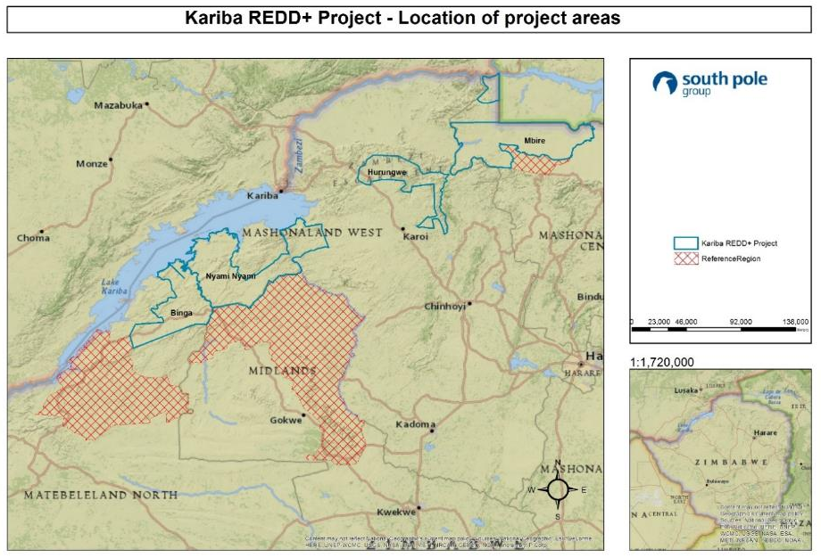
Figure 1: Location of the project area

stakeholder consultation
For this monitoring period of 01 July 2016 to 30 June 2019, a summary of the VCS CCB Monitoring Report is translated into each Shona and Tonga and made available to the public through the CCBS website and through the local RDC offices. In addition, local communities are notified of the auditor’s site visit 30 days before the site visit.
In more detail, the dissemination was done as follows: one copy of the full Monitoring Report was sent to each council office, with an additional copy sent to the council satellite office in Binga giving a total of five copies. As for the Monitoring Report summaries, one copy was sent to each council office, one copy to each chief, and one copy to each ward councillor. All these copies were hard copies delivered in person by the OGM who followed up with an explanation of the need to submit any grievances through the communications channels, either directly to council, OGM or CGA head office.

climate impacts
During the period of July 2011 to June 2016, the Kariba REDD+ Project avoided 18,145,502 tCO₂e of GHG emissions. Between July 2016 and June 2019, the Kariba REDD+ Project has reduced 12,640,544 tCO₂e of GHG emissions in project area equivalent through the reduction of deforestation, and forest degradation in 784,987 ha, has been avoided.

community impact
The Kariba REDD+ Project’s direct and indirect impacts on the local communities have been monitored according to the project’s monitoring plan and Standard Operating Procedures, available in the Supporting Documents, SOPs, Social Monitoring SOP.
With regards to the project’s direct effects, 174 workshops in improved agriculture and community gardens have been conducted, reaching a total of 8,258 participants. 18 community gardens are active and 24 have been supported. A total of 4,567 participants benefited from our 107 beekeeping workshops. Also, schools and clinics have been supported.
To monitor the project’s indirect social effects, an extensive survey campaign has been implemented in February and March 2019. A total of 392 local community members, direct project beneficiaries and employees have been reached. Interviews where necessary were conducted in the local language, Shona, and participants were selected randomly. Most interview partners expressed their satisfaction with the project, as shown in Table 1. Direct beneficiaries and employees reported consistently positive impacts of the Kariba REDD+ Project on their livelihoods, food security, children’s access to education and healthcare, as shown in Table 2, Table 3, Table 4 and Table 5. This shows the project’s positive impacts in community aspects.
Table 1: Satisfaction with the Kariba REDD+ Project
 | Community Members (%) | Beneficiaries (%) | Employees (%)
Very unsatisfied | 0.0 | 0.0 | 0.0
Unsatisfied | 0.7 | 0.0 | 4.0
Indifferent | 10.0 | 0.0 | 0.0
Satisfied | 60.1 | 51.2 | 40.0
Very satisfied | 25.3 | 48.8 | 56.0
N/A | 3.9 | 0.0 | 0.0

Table 2: Reported project impact on livelihoods by beneficiaries and employees
 | Beneficiaries (%) | Employees (%)
Very negatively | 0.0 | 0.0
Negatively | 0.0 | 0.0
No impact | 0.0 | 4.0
Positively | 51.2 | 56.0
Very positively | 48.8 | 40.0

Table 3: Reported project impact on food security by beneficiaries and employees
 | Beneficiaries (%) | Employees (%)
Very negatively | 0.0 | 0.0
Negatively | 0.0 | 0.0
No impact | 3.5 | 0.0
Positively | 60.5 | 68.0
Very positively | 36.0 | 32.0

Table 4: Reported project impact on children’s access to education by beneficiaries and employees
 | Beneficiaries (%) | Employees (%)
Very negatively | 0.0 | 0.0
Negatively | 0.0 | 0.0
No impact | 3.5 | 0.0
Positively | 59.3 | 64.0
Very positively | 37.2 | 36.0

Table 5: Reported project impact on healthcare by beneficiaries and employees
 | Beneficiaries (%) | Employees (%)
Very negatively | 0.0 | 0.0
Negatively | 0.0 | 0.0
No impact | 3.5 | 0.0
Positively | 53.5 | 56.0
Very positively | 43.0 | 44.0

biodiversity impact
As described in the CCB PDD, in the without project case, the wildlife populations would continue to decline sharply due to undamped deforestation and poaching. The Kariba REDD+ Project not only reduces the deforestation rate in the project area significantly, it also reduces the poaching pressure on wildlife through patrolling and further anti‐poaching measures.
The results of the project’s biodiversity impact monitoring are given in Table 6 and Table 7. It shows a significant presence of wildlife in the area, including several threatened and endangered species: elephants, hippopotamus and pangolin are very commonly seen in the project area (Figure 2). The number of sightings of threatened species per team-day shows a higher value in 2019 when comparing to previous years. Evidence of biodiversity monitoring and anti-poaching activities are given under the Supporting Documents, CCB monitoring, Biodiversity Monitoring, Supporting Documents.

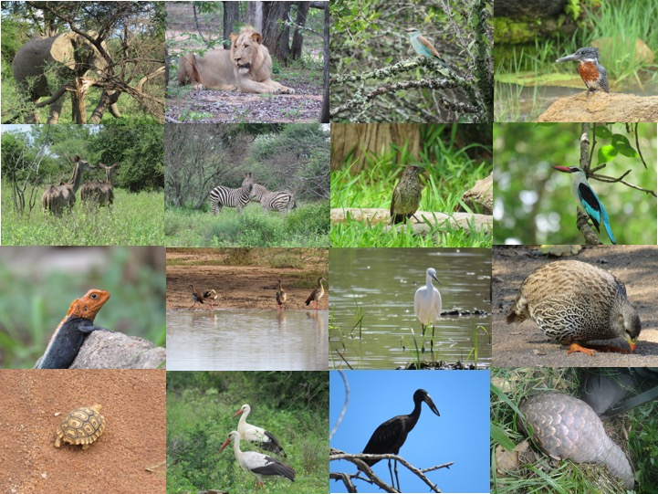
Figure 2: Fauna spotted in the project area during patrols

Table 6: Sightings and tracks of wildlife in the project from 1st July 2016 until 30th June 2019
Year |  | 2016 | 2017 | 2018 | 2019
Team-days spent monitoring |  | 536 | 1,027 | 1,003 | 420
Species | Status
Lion | VU | 38 | 122 | 58 | 55
Elephant | VU | 1,194 | 2,763 | 2,396 | 2,084
Black Rhino | CR | 0 | 0 | 0 | 0
Common Hippo | VU | 689 | 3,865 | 3,942 | 2,412
Cheetah | VU | 0 | 0 | 0 | 0
Southern Ground hornbill | VU | 27 | 72 | 68 | 106
Hooded Vulture | CR | 69 | 34 | 29 | 82
Egyptian Vulture | EN | 0 | 0 | 0 | 0
Cape Vulture | EN | 0 | 0 | 0 | 0
Lappet‐faced vulture | EN | 0 | 6 | 4 | 7
White‐headed vulture | CR | 0 | 47 | 62 | 58
White-backed Vulture | CR | 254 | 202 | 200 | 74
Martial Eagle | VU | 8 | 30 | 19 | 24
Crowned Eagle | NT | 6 | 30 | 23 | 10
Bateleur | NT | 4 | 37 | 27 | 19
Lilian's Lovebird | NT | 97 | 1,847 | 2,342 | 959
Painted Dog | EN | 0 | 2 | 50 | 31
Leopard | CR | 30 | 46 | 52 | 43
Buffalo |  | 591 | 728 | 547 | 251
Zebra |  | 53 | 133 | 140 | 106
Other spp. |  | 1,815 | 7,724 | 12,704 | 10,410
Total threatened spp. |  | 2,424 | 9,069 | 9,232 | 5,943
Total all spp. |  | 4,783 | 17,700 | 22,675 | 14,040
Threatened spp. / team day |  | 4.52 | 8.83 | 9.20 | 11.74
All spp. / team day |  | 8.92 | 17.23 | 22.61 | 33.43

Tree diversity was assessed during a monitoring campaign throughout the monitoring period. The monitoring campaign was fully integrated into the carbon stock assessment implemented for VCS on 235 Permanent Sampling Plots (PSPs) of 254 m² each. During the campaign, a total of 165 tree species was identified. Of the about 11,083 living trees measured, the ten most common species identified are shown below in Table 7. The complete analysis is provided in the Supporting Documents, CCB monitoring, Tree Biodiversity
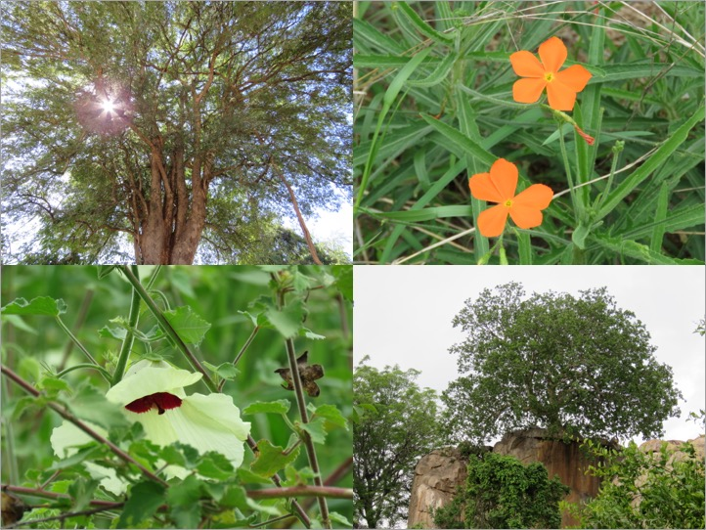
Figure 3: Flora species in the project area

Table 7: Ten most common tree species during field campaign during this monitoring period
Tree species | Abundance (%)
Colophospermum mopane | 11.52
Combretum celastroides | 6.79
Combretum apiculatum | 6.23
Diospyros quiloensis | 5.89
Julbernardia globiflora | 5.78
Combretum eleagnoides | 4.35
Brachystegia boehmii | 3.77
Combretum mossambicense | 2.89
Croton longipedicellatus | 2.66
Freisoldelsia obovata | 2.40
Total | 52.29

The project’s positive impact on biodiversity is particularly visible in its anti-poaching measures, e.g. through snares that are removed from the forest habitats. Anti‐poaching patrols are implemented in close cooperation with the local RDCs. Patrols monitor wildlife, remove snares and other traps from the forest, inform local communities and, where necessary enforce the existing anti‐poaching regulations.

Table 8 below gives an overview over the project’s anti‐poaching activities for the second monitoring period. During a total of over 3,876 team-days spent patrolling, over 3,400 snares were removed from the field and over 120 poachers were arrested, resulting in a substantial relief of pressure on the local wildlife. Nevertheless, poached wildlife was still recorded, including the poaching of threatened species, particularly elephants. Elephants are typically poached by commercial poachers, which partly come from outside the project area. Poaching of other animals, such as impala, is typically done by locals for subsistence. Poaching is illegal in the project area and would be illegal without the project.

The project is working on further reducing the pressure of poaching on the local wildlife as a necessary complementary activity to habitat conservation in order to further increase the project’s positive impact on the local biodiversity.

Table 8: Overview of project’s anti-poaching activities from 1st July 2016 until 30th June 2019
Year |  |  | 2016 | 2017 | 2018 |  |  | 2019
Team-days spent patrolling |  |  | 768 | 1,275 | 1,235 |  |  | 598
No of snares removed |  |  | 496 | 968 | 1,323 |  |  | 712
No of poachers arrested |  |  | 25 | 41 | 29 |  |  | 31
Poached species |  | Status
Lion |  | VU | 0 | 0 | 0 |  | 0
Elephant |  | VU | 2 | 7 | 2 |  | 2
Black Rhino |  | CR | 0 | 0 | 0 |  | 0
Common Hippo |  | VU | 0 | 0 | 1 |  | 0
Cheetah |  | VU | 0 | 0 | 0 |  | 0
Southern Ground hornbill |  | VU | 0 | 0 | 0 |  | 0
Lappet‐faced vulture |  | EN | 0 | 0 | 0 |  | 0
White‐headed vulture |  | CR | 0 | 0 | 0 |  | 0
Painted Dog |  | EN | 0 | 0 | 0 |  | 0
Buffalo |  |  | 0 | 1 | 4 |  | 2
Leopard |  | CR | 0 | 0 | 0 |  | 0
Impala |  |  | 1 | 5 | 7 |  | 3
Other spp. |  |  | 15 | 33 | 41 |  | 14
Total threatened spp. |  |  | 2 | 7 |  | 3 |  |  | 2
Total all spp. |  |  | 18 | 46 |  | 55 |  |  | 21

Land with woody vegetation that meets an internationally accepted definition (e.g., UNFCCC, FAO or IPCC) of what constitutes a forest, which includes threshold parameters, such as minimum forest area, tree height and level of crown cover, and may include mature, secondary, degraded and wetland forests (VCS Program Definitions)
Reduced emissions from deforestation and forest degradation (REDD) - Activities that reduce GHG emissions by slowing or stopping conversion of forests to non-forest land and/or reduce the degradation of forest land where forest biomass is lost (VCS Program Definitions)
Afforestation, reforestation and revegetation (ARR) - Activities that increase carbon stocks in woody biomass (and in some cases soils) by establishing, increasing and/or restoring vegetative cover through the planting, sowing and/or human-assisted natural regeneration of woody vegetation (VCS Program Definitions)
Improved forest management (IFM) - Activities that change forest management practices and increase carbon stock on forest lands managed for wood products such as saw timber, pulpwood and fuelwood (VCS Program Definitions)
Although this figure is not monitored directly, it is estimated that around each person implementing conservation farming techniques implement the techniques in 1 ha of land, summing 4,810 ha of improved land management.
This data is not included in the report because it is not a requirement, but the project team have supporting documents to support this figure.
Although the data is not monitored directly, an estimated 10,178 female community members were trained. This includes women who have benefitted from trainings as well as direct beneficiaries from project activities
Employed in project activities means people directly working on project activities in return for compensation (financial or otherwise), including employees, contracted workers, sub-contracted workers and community members that are paid to carry out project-related work.
Full time equivalency is calculated as the total number of hours worked (by full-time, part-time, temporary and/or seasonal staff) divided by the average number of hours worked in full-time jobs within the country, region or economic territory (adapted from UN System of National Accounts (1993) paragraphs 17.14[15.102];[17.28])
Livelihoods are the capabilities, assets (including material and social resources) and activities required for a means of living (Krantz, Lasse, 2001. The Sustainable Livelihood Approach to Poverty Reduction. SIDA). Livelihood benefits may include benefits reported in the Employment Metrics of this table.
Although this data is not represented in the Monitoring Report because this was only monitored for the last year of the monitoring report, 123,751 people have improved livelihoods during the period from July 2018 to June 2019. This includes direct and indirect beneficiaries form project activities and includes health, education, borehole resuscitation, trainings etc. For boreholes, a conservative number of 250 people impacted by each borehole was considered. For schools that have received support through educational material, community garden and borehole establishment, the total number of students enrolled are accounted for.
Although this data is not presented in the Monitoring Report, the livelihoods of an estimated 450,784 people were improved since the project started. This is a cumulative figure and includes the general population that have continued to benefit cumulatively.
Although this data is not monitored directly, an estimated 52,125 women have improved livelihoods. This includes women involved in direct project activities, training received and also from resuscitated boreholes. Where boreholes have been included, the total female gender group is used, which includes infants and girls. It should be noted that the figure used for boreholes was 51% of the total recorded number people impacted.
Although this data is not monitored directly, an estimated 164,687 women have improved livelihoods. This is a cumulative figure since project start and so includes women from the same general population. It includes all project activities, trainings and benefits from resuscitated boreholes.
Although this data is not monitored directly, an estimated 89,662 people had access to improved health services for the period from July 2018 to June 2019. This figure is based on the total number of people in the wards where the clinics are located, according to the 2012 population census.
Although this data is not monitored directly, an estimated 104,901 people had access to improved health services. This is the estimated total number of people impacted from boreholes repaired for clinics since the project started. The figures are based on ward level population records from last census in 2012.
Although this data is not monitored directly, an estimated 35,543 women had access to improved health services for the time period from July 2018 to June 2019. It includes the entire female gender group, including infants and girls, who have benefitted as a result of water restoration at clinics or cement provided for renovation or construction.
Although this data is not monitored directly, an estimated 53,500 women had access to improved health services, based on 51% of total population at ward level where the clinics are located. This also includes the entire female gender group, including infants and girls.
Although this data is not presented in the Monitoring Report, education improves for an estimated 14,832 people. The number of students and gender ratio was not always monitored as it was not a requirement under the present methodology. Therefore, an average is used for the estimation.
Although this data is not presented in the Monitoring Report, an estimated 25,136 people had improved education. The number of students and gender ratio was not always monitored as it was not a requirement under the present methodology. Therefore, an average is used for the calculation. A total of 61 schools were recorded to have received support since the project started, either in the form of stationery, or materials for income generating projects such as planting pockets for tree nurseries, from the sale of moringa leaf, or gardening, which is also part of the agriculture-learning curriculum. These are direct benefits, and do not include indirect benefits that may have the potential to improve learning, such as borehole repairs giving children access to clean water.
Although this data is not presented in the Monitoring Report, education improves for an estimated of 7,564 women. The 2012 population census was used for this estimation, in which 51% of the total population is female.
Although this data is not presented in the Monitoring Report, education improved for an estimated 12,819 women. The 2012 population census was used for this estimation, in which 51% of the total population is female.
Although this data is not presented in the Monitoring Report, an estimated 18,743 women experienced improved water quality and/or increased access to drinking water. The 2012 population census was used for this estimation, in which 51% of the total population is female, including infants and girls.
Although this data is not monitored directly, an estimated 22,695 women experienced improved water quality and/or increased access to drinking water. The 2012 population census was used for this estimation, in which 51% of the total population is female, including infants and girls.
Well-being is people’s experience of the quality of their lives. Well-being benefits may include benefits reported in other metrics of this table (e.g. Training, Employment, Health, Education, Water, etc.), but could also include other benefits such as empowerment of community groups, strengthened legal rights to resources, conservation of access to areas of cultural significance, etc.
Although this data is not monitored directly, well-being was improved for an estimated 123,752 people. The impact on the total population, covering all forms of project related activities for both direct and indirect beneficiaries, was estimated using an average of 4.3 members per household.
Although this data is not monitored directly, the wellbeing of an estimated 450,784 people was improved. Cumulative impact since the project start from the same general population for both direct and indirect beneficiaries was estimated based on a 4.3 average per household.
Although this data is not monitored directly, well-being was improved for an estimated 63,114 women. Estimated as 51% of total population.
Although this data is not monitored directly, well-being was improved for an estimated 229,900 women. Estimated as 51% of total population, cumulative from the same general population since the project started.
Biodiversity conservation in this context means areas where specific management measures are being implemented as a part of project activities with an objective of enhancing biodiversity conservation.
Per IUCN’s Red List of Threatened Species
In the absence of direct population or occupancy measures, measurement of reduced threats may be used as evidence of benefit
Only a sample of the anti-poaching evidences are provided. Additional evidence material is available under request.

