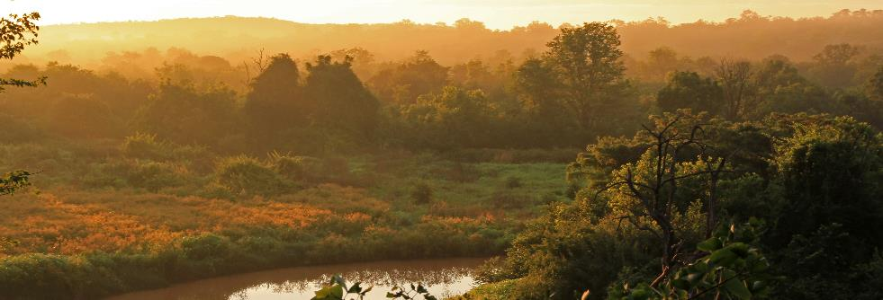
kariba REDD+ project
monitoring report 2016-2019

Document Prepared By South Pole
www.southpole.com

Project Title | Kariba REDD+ Project
Project ID | 902
Version | 1.1
Report ID
Date of Issue | 20 December 2019
Project Location | Northern Zimbabwe, provinces Matabeleland North, Midlands, Mashonaland West and Mashonaland Central
Project Proponent(s) | Carbon Green Investments (CGI)  Contact Name: Steve Wentzel  Email: steve@carbongreenafrica.net  Phone: +263 77 417 4025
Prepared By | South Pole  Contact Name: Abel Alan Marcarini  Email: a.marcarini@southpole.com  Phone: +57 4 352 4428
Validation/Verification Body | Aster Global Environmental Solutions, Inc.  Contact Name: Shawn McMahon  Email: smcmahon@asterglobal.com  Phone: +1 330 294 1242
GHG Accounting/Crediting Period | The VCS and CCB do not have coincident crediting period. For VCS, the project crediting period is 30 years, extending from 01 July 2011 to 30 June 2041. For CCB, the project crediting period is 30 years, extending from 01 October 2011 to 30 September 2041.
Monitoring Period of this Report | From 01 July 2016 to 30 June 2019
History of CCB Status | Validation Approved - CCB Standards Second Edition, Climate Adaptation & Biodiversity Gold Level (08 February 2012)  Verification Approved (first verification) – CCB Standards Second Edition, Climate Adaptation & Biodiversity Gold Level (24 July 2014)  Verification Approved (second verification) – CCB Standards Second Edition, Climate Adaptation & Biodiversity Gold Level (30 June 2017)
Gold Level Criteria | The Kariba REDD+ Project (KRP) maintains two CCBS Gold Level criteria, Climate Change Adaptation Benefits and Exceptional Biodiversity benefits. The project’s activities provide substantial contributions to climate change adaptation through its activities in conservation farming and beekeeping. Conservation farming techniques are more drought-adapted than conventional agriculture, and beekeeping provided alternative livelihoods, which is a broadly accepted measure to adapt to climate change. Both conservation farming and beekeeping have been successfully promoted by the project. From July 2016 to June 2019, over 8,250 participants benefited from several workshops on improved agriculture, and 18 community gardens have been active in the area. The project also promotes beekeeping as an alternative and environmentally friendly source of income. From July 2016 to June 2019, 107 beekeeping workshops have been held across the project area. This activity has 4,567 beneficiaries as workshop participants. In addition, 152 boreholes were resuscitated or repaired from July 2016 to June 2019.  The exceptional Biodiversity Benefits are guaranteed through anti-poaching activities such as snare removal and patrolling to release the pressure on wildlife and conservation farming and beekeeping that promote deforestation reduction. From July 2016 to June 2019, 3,876 team-days where spent patrolling, and over 3,400 snares have been removed from the field, which means a substantial relieve of the pressure on the local wildlife. The exceptional Biodiversity Benefits are based on the broad range of endangered and vulnerable animals, which occur in the project area. Species include painted dog (EN), elephant (VU), lion (VU), southern ground hornbill (VU), white-headed vulture (CR), white-backed vulture (CR) and leopard (CR).

Table of Contents

1 Summary of Project Benefits 7
1.1 Unique Project Benefits 8
1.2 Standardized Benefit Metrics 9
2 General 13
2.1 Project Description 13
2.1.1 Implementation Description 13
2.1.2 Project Category and Activity Type 15
2.1.3 Project Proponent(s) 15
2.1.4 Other Entities Involved in the Project 16
2.1.5 Project Start Date (G3.4) 17
2.1.6 Project Crediting Period (G3.4) 17
2.1.7 Project Location (G3.3) 18
2.1.8 Title and Reference of Methodology 20
2.1.9 Other Programs (CL1.5) 20
2.1.10 Sustainable Development 20
2.2 Project Implementation Status 21
2.2.1 Implementation Schedule (G3.4) 21
2.2.2 Methodology Deviations 21
2.2.3 Minor Changes to Project Description (Rules 3.5.6) 21
2.2.4 Project Description Deviations (Rules 3.5.7 – 3.5.10) 22
2.2.5 Risks to the Project (G3.5) 22
2.2.6 Enhancement of High Conservation Values (G3.6) 23
2.2.7 Benefit Permanence (G3.7) 23
2.3 Stakeholder Engagement 24
2.3.1 Community Consultation (G3.8) 24
2.3.2 Public Comment Period Publicity (G3.9) 24
2.3.3 Distribution of Project Information (G3.9) 24
2.3.4 Conflicts and Grievances (G3.10) 24
2.4 Management Capacity and Best Practices 25
2.4.1 Required Technical Skills and Expertise (G4.2) 25
2.4.2 Worker Training (G4.3) 25
2.4.3 Community Employment Opportunities (G4.4) 26
2.4.4 Relevant Laws and Regulations Related to Worker’s Rights (G4.5) 26
2.4.5 Occupational Safety Assessment (G4.6) 26
2.4.6 Financial Health of Implementing Organization(s) (G4.7) 27
2.5 Legal Status and Property Rights 27
2.5.1 National and Local Laws (G5.1) 27
2.5.2 Free, Prior and Informed Consent (G5.3) 27
2.5.3 Property Rights Protection (G5.4) 27
2.5.4 Identification of Illegal Activity (G5.5) 28
3 Climate 28
3.1 Monitoring GHG Emission Reductions and Removals 28
3.1.1 Data and Parameters Available at Validation 28
3.1.2 Data and Parameters Monitored 29
3.1.3 Monitoring Plan 34
3.1.4 Dissemination of Monitoring Plan and Results (CL3.2) 39
3.2 Quantification of GHG Emission Reductions and Removals 40
3.2.1 Baseline Emissions 40
3.2.2 Project Emissions 40
3.2.3 Leakage 41
3.2.4 Net GHG Emission Reductions and Removals 41
3.3 Optional Criterion: Climate Change Adaptation Benefits 43
3.3.1 Activities and/or Processes Implemented for Adaptation (GL1.4) 44
4 Community 45
4.1 Net Positive Community Impacts 45
4.1.1 Community Impacts (CM1.1) 45
4.1.2 Net Positive Community Well-Being Impacts (CM1.1) 45
4.1.3 Protection of High Conservation Values (CM1.2) 47
4.2 Offsite Stakeholder Impacts 47
4.2.1 Mitigation of Negative Impacts on Other Stakeholders (CM2.2) 48
4.2.2 Net Impacts on Other Stakeholders (CM2.3) 48
4.3 Community Impact Monitoring 48
4.3.1 Community Monitoring Plan Development (CM3.3) 48
4.3.2 Community Monitoring Plan Results (CM3.1, CM3.2, GL2.5) 48
4.3.3 Dissemination of Monitoring Plan and Results (CM3.3) 83
4.4 Optional Criterion: Exceptional Community Benefits 83
4.4.1 Barriers to Benefits (GL2.3) 83
4.4.2 Protections for Poorer and More Vulnerable Households and Individuals (GL2.4) 83
5 Biodiversity 83
5.1 Net Positive Biodiversity Impacts 83
5.1.1 Biodiversity Changes (B1.1) 83
5.1.2 High Conservation Value Protection (B1.2) 84
5.1.3 Invasive Species (B1.3) 84
5.1.4 Impacts of Non-native Species (B1.4) 84
5.1.5 GMO Exclusion (B1.5) 85
5.2 Offsite Biodiversity Impacts 85
5.2.1 Negative Offsite Biodiversity Impact Mitigation (B2.2) 85
5.2.2 Net Offsite Biodiversity Benefits (B2.3) 85
5.3 Biodiversity Impact Monitoring 85
5.3.1 Biodiversity Monitoring Plan Development (B3.3) 85
5.3.2 Biodiversity Monitoring Results (B3.1, B3.2) 85
5.3.3 Monitoring Plan and Results Dissemination (B3.3) 90
6 Additional Project Implementation Information 90
7 Additional Project Impact Information 90

List of Tables
Table 1: Overview of Baseline Emissions 40
Table 2: Eligible VCUs 43
Table 3: Satisfaction with the Kariba REDD+ Project 46
Table 4: Reported project impact on livelihoods by beneficiaries and employees 46
Table 5: Reported project impact on food security by beneficiaries and employees 46
Table 6: Reported project impact on children’s access to education by beneficiaries and employees 46
Table 7: Reported project impact on healthcare by beneficiaries and employees 46
Table 8: Sightings and tracks of wildlife in the project from 1st July 2016 until 30th June 2019 86
Table 9: Ten most common tree species during field campaign 88
Table 10: Overview of project’s anti-poaching activities from 1st January 2016 until 30th June 2019 89

List of Figures
Figure 1: Implementation schedule of project activities 14
Figure 2: Maize farming in the project area 49
Figure 3: School field visit at community garden 55
Figure 4: Introducing the carrot plant to the community garden 56
Figure 5: Training on improved agriculture in community garden 61
Figure 6: Training on beekeeping 65
Figure 7: School supporting on indigenous trees and fuel wood seeding 67
Figure 8: Implementing biogas digester for cooking at Chitsungo hospital 69
Figure 9: Fire-fighting training workshops in the project area 71
Figure 10: Community mobilization for boreholes resuscitation 74
Figure 11: Fauna spotted in the project area during patrols 86
Figure 12: Flora species in the project area 88

Summary of Project Benefits
The project has proven successful in reducing deforestation in the project area. Since the project start, over 29,064,310 tCO₂e of greenhouse gas emissions have been avoided through the reduction of deforestation. The climate benefits are also certified under the Verified Carbon Standard (VCS).
With regards to community benefits, the project includes a wide range of activities that have direct positive effects on communities. Farmers are trained for conservation agriculture. Community gardens are established and provide improved nutrition. From July 2016 to June 2019, over 8,250 participants benefited from several workshops, and 18 community gardens are active in the area.
The project also promotes beekeeping as an alternative and environmentally friendly source of income. From July 2016 to June 2019, 107 beekeeping workshops have been held across the project area. This activity has 4,567 beneficiaries as workshop participants. In addition, 152 boreholes were resuscitated or repaired between July 2016 and June 2019. Schools and hospitals are supported through the provision of direct inputs. Fire management is a very important activity to reduce forest loss through firefighting training workshops, awareness meetings and early burning. Fuel wood plantations are in initial stages and over 28,700 planting pockets were distributed during this monitoring period. Brickmaking activities are planned and subject to the availability of funding and finding an alternative that is cheaper than locally made bricks.
During a survey carried out in February and March 2019, most interview partners reported being satisfied or very satisfied with the project. Less than 5% reported being unsatisfied. For employees and direct beneficiaries, the project has had a positive impact on livelihoods, food security, children’s education and healthcare. No participant reported being restricted in use of the forest for basic livelihood or cultural needs. No grievances have been received to-date through the survey or other channels. More indirect social effects of the project have been assessed in a community survey covering all participating Rural District Councils (RDCs) in February and March 2019. In the survey, 281 community members, 86 direct beneficiaries and 25 employees were interviewed.
The project’s biodiversity benefits include a decrease in poaching pressure on wildlife through regular patrolling, in close cooperation with the local RDCs. From July 2016 to June 2019, 3,876 team-days were spent patrolling, and over 3,400 snares were removed from the field, which means a substantial decrease in pressure on the local wildlife. As part of the project’s biodiversity monitoring, 165 trees species have been identified and many threatened wildlife species have been sighted.

Unique Project Benefits
Outcome or Impact | Achievements during the  Monitoring Period | Section Reference | Achievements during the Project Lifetime
Food security enhancement | Community gardens and conservation farming has trained over 8,258 people. Community gardens account for over $ 117,000 U$D in income generated from the sales of produce. | 4.3.2 | Community gardens and conservation farming has trained over 12,000 people since the project started. Community gardens account for over $156,000 USD in income generated from the sale of produce from July 1st 2014 to June 30th 2019.
Alternative sources of income and forest conservation | Beekeeping is an alternative and environmentally friendly source of income as well as an efficient forest conservation activity. There have been 4,567 beneficiaries from this activity, as workshop participants. | 4.3.2 | Beekeeping is an alternative and environmentally friendly source of income as well as an efficient forest conservation activity. There have been 5,087 beneficiaries from this activity, as workshop participants.
Improved education | Over U$S 10,000 was spent on schools. | 4.3.2 | Over U$S 33,000 was spent on schools since project start.
Forest cover conservation | Early burning is part of fire management activities and are essential to guarantee proper regeneration of the project and prevent forest fires. Early burning covered over 2,100 km. | 4.3.2 | Early burning covered over 3,300 km from July 1st 2014 to June 30th 2019.

Standardized Benefit Metrics
Category | Metric | Achievements during Monitoring Period | Section Reference | Achievements during the Project Lifetime
GHG emission reductions & removals | Net estimated emission removals in the project area, measured against the without-project scenario | Not applicable | - | Not applicable
GHG emission reductions & removals | Net estimated emission reductions in the project area, measured against the without-project scenario | 10,870,864 tCO2e | 3.2 | 29,016,370 tCO2e
Forest cover | For REDD projects: Number of hectares of reduced forest loss in the project area measured against the without-project scenario | Not applicable | - | Not applicable
Forest cover | For ARR projects: Number of hectares of forest cover increased in the project area measured against the without-project scenario | Not applicable | - | Not applicable
Improved land management | Number of hectares of existing production forest land in which IFM practices have occurred as a result of the project’s activities, measured against the without-project scenario | Not applicable | - | Not applicable
Improved land management | Number of hectares of non-forest land in which improved land management has occurred as a result of the project’s activities, measured against the without-project scenario | Data not available | - | Data not available
Training | Total number of community members who have improved skills and/or knowledge resulting from training provided as part of project activities | 12,718 | 4.3.2 | 17,726
Training | Number of female community members who have improved skills and/or knowledge resulting from training provided as part of project activities | 3,599 | - | Data not available
Employment | Total number of people employed in of project activities, expressed as number of full time employees | 22 people | 4.1.2 | 22 people
Employment | Number of women employed in project activities, expressed as number of full time employees | 20% | - | 20%
Livelihoods | Total number of people with improved livelihoods or income generated as a result of project activities | Data not available |  | Data not available
Livelihoods | Number of women with improved livelihoods or income generated as a result of project activities | Data not available | - | Data not available
Health | Total number of people for whom health services were improved as a result of project activities, measured against the without-project scenario | Data not available | - | Data not available
Health | Number of women for whom health services were improved as a result of project activities, measured against the without-project scenario | Data not available | - | Data not available
Education | Total number of people for whom access to, or quality of, education was improved as a result of project activities, measured against the without-project scenario | Data not available | - | Data not available
Education | Number of women and girls for whom access to, or quality of, education was improved as a result of project activities, measured against the without-project scenario | Data not available | - | Data not available
Water | Total number of people who experienced increased water quality and/or improved access to drinking water as a result of project activities, measured against the without-project scenario | 37,000 | 4.3.2 | 44,500
Water | Number of women who experienced increased water quality and/or improved access to drinking water as a result of project activities, measured against the without-project scenario | Data not available | - | Data not available
Well-being | Total number of community members whose well-being was improved as a result of project activities | Data not available |  | Data not available
Well-being | Number of women whose well-being was improved as a result of project activities | Data not available |  | Data not available
Biodiversity conservation | Change in the number of hectares significantly better managed by the project for biodiversity conservation, measured against the without-project scenario | 784,987 | 3.2.1 | 784,987
Biodiversity conservation | Number of globally Critically Endangered or Endangered species benefiting from reduced threats as a result of project activities, measured against the without-project scenario | 16 | 5.3.2 | 16

General

Project Description

Implementation Description
The Kariba REDD+ Project is located in northwestern Zimbabwe, partly along the southern shore of Lake Kariba, the largest artificial lake in the world by volume. The project area of 784,987 hectares of forest (consisting of woodland and open woodland) spans four provinces: Matabeleland North, Midlands, Mashonaland West and Mashonaland Central. The project is administered by four Rural District Councils (RDCs): Binga, Nyaminyami, Hurungwe and Mbire.
The project is community-based and consists of implementation of activities in conjunction with the local population. The project, which started on July 1, 2011, will generate a total of around 51,925,950 carbon credits from the reduction of deforestation. The main causes of deforestation are socioeconomic (subsistence agriculture, the collection of firewood and poaching activities) and settlements. Decreasing deforestation will be achieved through a series of activities that are designed to significantly improve the livelihood of locals, through improved agriculture, beekeeping, fuel wood plantations and fire management. In addition, a significant share of the project’s carbon income (20% of net profit) are invested in general activities that promote and guarantee project sustainability. The project’s Community and Project Sustainability Fund is structured to benefit entire communities, specifically including the poorest members of society. The fund is used to improve health and education in the project area due to long-term activities.
The schedule to implement the project activities are an ongoing effort and are always performed along the project lifetime up to date. Fuel wood plantations activities started in early 2016 and alternative construction like biogas digester was launched in October 2018. Please, see Figure 1 below for the implementation schedule.

Figure 1: Implementation schedule of project activities
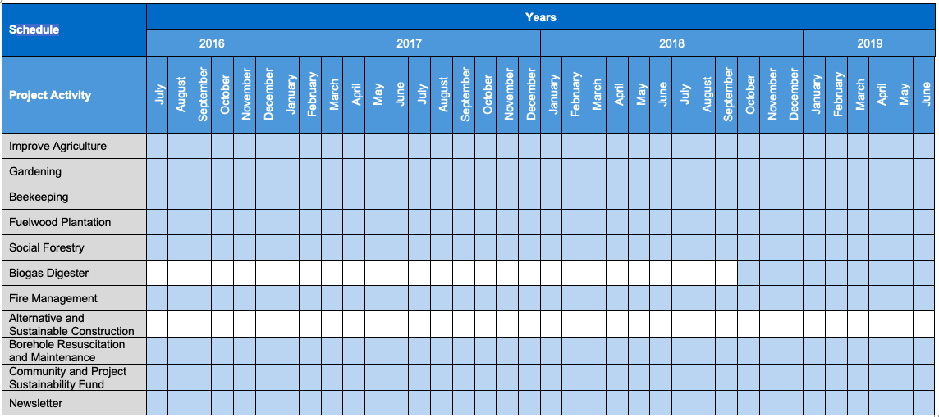

The project area lies within the Zambezian biome of the Zambezi basin. The major ecosystem includes mopane and miombo woodland. The project area is an important wildlife area, showing significant populations of African elephants, lions, impalas, hippos, buffalo, leopard and crocodiles, along with a wide variety of birds, including the IUCN red list vulnerable species Southern Ground Hornbill, Lappet-faced Vulture, White-headed Vulture and White-headed Vulture.
In the past, the natural resources of the project areas supported significant populations of wildlife, including elephants, which, in turn, supported a variety of tourism and safari activities. However, the economic and political crises over the past decade led to a decrease in tourism. Poaching also escalated in the project area before the project start. As a result, wildlife populations have been severely reduced.
There was no significant income to offset the cost of activities to mitigate deforestation without carbon revenues. In the absence of active protection that creates sustainable economic alternatives for communities, the land in the project area would be cleared for non-sustainable alternative land-use scenarios.
The project boundary includes CO₂ emissions in the project and the baseline scenario and includes the following carbon pools:
- Above-ground (large & small) tree biomass
- Above-ground non-tree (shrub) biomass
- Below-ground (large-and small) tree biomass
- Below-ground non-tree (shrub) biomass
- Standing dead wood
- Soil
- Long-lived wood products

Long-lived wood products have been proven and validated to not occur in the project area and are therefore not monitored. Biomass of large and small trees is not separated as discussed in the VCS PD, section 2.3.
The total GHG emission reduction generated in the monitoring period from July 1, 2016 to June 30, 2019 is 12,640,544 tCO₂e.
The major project climate, community and biodiversity objectives are the same as the one validated in the CCB PDD. For CCB G3.1, please refer to page 30 of CCB PDD.
Leakage is monitored using 50 leakage plots in the reference area for every monitoring period.
There are no major non-permanence risk factors during the monitoring period, however in case any non- permanence risk arises, they are discussed as part of the adaptive management process. Forest fires are considered a risk, especially during the dry season and they are prevented in the area through early burning and road maintenance activities.

Project Category and Activity Type
Project Scope: 14. Agriculture, Forest and other Land Use (AFOLU);
Project Category: Reduction Emission from Deforestation and Degradation (REDD);
Type of Activity: Avoided Mosaic Deforestation and Degradation.
The project is not a group project.

Project Proponent(s)
Organization name | Carbon Green Investments (Guernsey)
Contact person | Steve Wentzel
Title | Manager
Address | 18-20 Le Pollet Street St. Peter Port Guernsey  UK, GY1 1WH
Telephone | +263 77 417 40 25
Email | steve@carbongreenafrica.net

Carbon Green Investments Guernsey (CGI) is the project proponent in partnership with the landowners of Binga RDC, Hurungwe RDC, Nyaminyami RDC and Mbire RDC. CGI is a Guernsey-based company established to facilitate REDD projects in Zimbabwe. CGI is the project’s central entity involved in project management, development, implementation and operation, both from a technical and a financial perspective. Carbon Green Africa (CGA) is a private company founded to implement and manage the Kariba REDD+ Project. Carbon Green Investments (CGI), the official project proponent, holds the majority of CGA. CGI contracts CGA as local project implementer and overseer. CGA’s mandate is to work with council and community to ensure that the community project activities and direct inputs are correctly implemented, and to assist in the ongoing maintenance of these. CGA is also required to do the biodiversity monitoring and conservation in conjunction with each council, as well as the monitoring of social and climate impacts.
Expertise in project development, carbon monitoring and accounting is provided by South Pole Carbon Asset Management Ltd. (“South Pole”), a globally active carbon project developer and consultant, with a successful track record in forest-based carbon projects.

Other Entities Involved in the Project
Organization name | South Pole Carbon Asset Management (South Pole)
Role in the project | Project Developer  South Pole elaborates and oversees the development of appropriate project design and monitoring techniques in line with the guidelines of the VCS and CCBS.
Contact person | Abel Alan Marcarini
Title | Mr.
Address | Technoparkstrasse 1  8005 Zurich  Switzerland
Telephone | +57 4 352 4428
Email | a.marcarini@southpole.com

Organization name | Carbon Green Africa (CGA)
Role in the project | Project Implementer  CGA is a 100% subsidiary of the project proponent Carbon Green Investments. CGA is operating the monitoring and project activities of the Kariba REDD+ Project.
Contact person | Pieter Bezuidenhout
Title | Mr.
Address | 32 Domboshawa Road, Helensvale,  Harare, Zimbabwe
Telephone | +263 774 567 729
Email | pieter@carbongreenafrica.net

There has been one change in staff during this monitoring period: the OGM for Mbire left the project two months before the end of the monitoring period. Carbon Green Africa’s Project General Manager, Rory Muil has been filling in that position until a new person is employed. See project staff listed below:
- Rory Muil - Project General Manager
- Rob Lee - Project Technical Manager
- Shadreck Ndloyu - OGM for Binga
- Manuel Nebiri - OGM for Nyaminyami
- Japie Smit/Rory Muil - OGM for Mbire
- Jerry Matiza - OGM for Hurungwe
The Kariba REDD+ Project continues to engage government personnel as and when the need arises. Some of these are Agritex staff since they have the trained skills for agriculture in rural communities. Also involved is the Environmental Management Agency (EMA), which brings fire management expertise and general environmental management expertise to the project. They have one or two officers in each district and are usually our first point of contact on matters relating to the natural environment. CGA continues to support their work wherever necessary through, for example, the provision of fuel for transportation to carry out fire fighting training and awareness. This is seeing as a dual benefit for all stakeholders in the area.
Financial resources have been adequate to implement the project as supported by the results of each project activity under section 4.3.2 and by the financial supporting documents for the Kariba REDD+ Project (refer to Supporting documents, Financial folder).

Project Start Date (G3.4)
The project start date for CCB is October 1, 2011 and for VCS is July 1, 2011.

Project Crediting Period (G3.4)
The project crediting period is 30 years. The start date of the crediting period for CCB is October 1, 2011, the end date is September 30, 2041. The crediting period for VCS is also 30 years, starting July 1, 2011 and ending June 30, 2041.
The implementation of the management structure and activities addressing the deforestation drivers (protection plans) began on, July 1, 2011 together with the associated investments. These investments refer to research, fieldwork and capacities conducted by Black Crystal and Environment Africa as well as management and protection work such as reporting, communication, capacity and control activities. In addition, all bilateral agreements for the verified emission reductions between CGI and the RDC were signed before the project start date, in March 2011 (for Binga, Hurungwe, Mbire and Nyaminyami). Supporting documentation has been separately provided to the auditor upon project validation.
The baseline is reassessed every 10 years after the project start date during the crediting period and is validated at the same time as the subsequent verification. The baseline will thus be re-assessed after June 30, 2021 and revalidated together with the verification.
The project lifetime coincides with the project crediting period.

Project Location (G3.3)
The Kariba REDD+ Project is located in northwestern Zimbabwe, partly along the southern shore of Lake Kariba, the largest artificial lake in the world by volume. The project area spans four provinces: Matabeleland North, Midlands, Mashonaland West and Mashonaland Central. The project is administered by four Rural District Councils (RDCs): Binga, Nyaminyami, Hurungwe and Mbire. The project is community-based and implements activities in conjunction with the local population. As the affected communities all live within the boundaries of the project area, under CCBS, the project zone equals the project area in this project. A brief description of the four participating RDCs is given below.
Binga
The Binga RDC area is located in the Matabeleland North province. It encompasses a prime wildlife area that includes 22 kilometers of Lake Kariba’s shoreline. It serves as a corridor, connecting the Chizarira National Park, the Omay South Wildlife Area and the Matusadona National Park. The resulting area makes for a vast and contiguous wildlife area that is roughly 900,000 ha in size.
Nyaminyami
The Nyaminyami RDC area lies in the district of Kariba in the province of Mashonaland West. The Nyaminyami forest connects the Matusadona National Park with the Charara Safari Area. It shares borders with the Binga RDC area. Ecotourism is popular in Nyaminyami, and the most popular ecotourism destination is the shore of Lake Kariba, which has several fishing and safari camps.
Hurungwe
The Hurungwe RDC lies in a remote, rural part of the province of Mashonaland West. It is adjacent to Mana Pools National Park.
Mbire
The Mbire forest area lies within the province of Mashonaland Central. It serves as a stepping-stone between Mana Pools National Park in the northwest and the Umfurudzi Safari Area in the southeast.
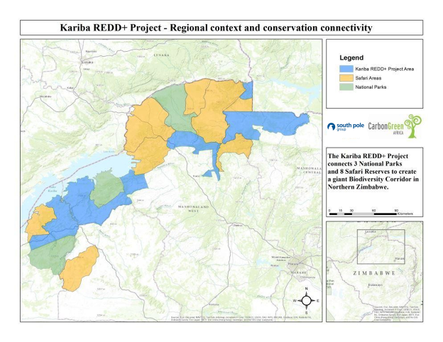

Map 1: Location of the project in Zimbabwe

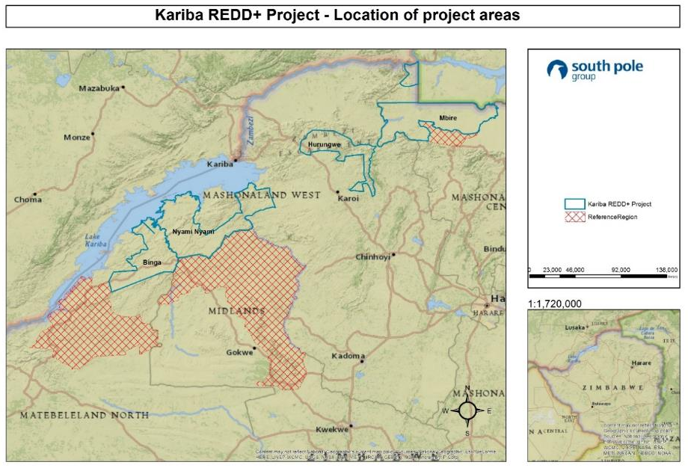
Map 2: Location of the project areas

The description of project location and basic physical parameters are the same as validated on CCB PDD. For CCB G1.1, please refer to page 3 of CCB PDD. The boundaries of the project area and the project zone are the same as those validated on CCB PPD. For CCB G1.3, please refer to page 11 of CCB PDD as no changes occurred since validation. Maps on project location and boundaries are the same as those validated on the CCB PDD. For maps on CCB G3.3, please refer to page 36 of CCB PDD.

Title and Reference of Methodology
The Kariba REDD+ project follows the framework of Reducing Emissions from Deforestation and Degradation (REDD) through Avoid Mosaic Deforestation of Tropical Forests using methodology VM0009 version 1.1 approved 10 November 2011.
Also, the Risk Report Calculation Tool, V3.1 were used.

Other Programs (CL1.5)
Not applicable. The project does not participate or seek registration in other GHG programs.

Sustainable Development
The country of Zimbabwe was part of the 2017 Voluntary National Review of the High-Level Political Forum on Sustainable Development and has submitted its Voluntary National Review (VNR) of SDGs for the High-Level Political Forum in July of 2017. The country has committed fully to the Agenda 2030. Zimbabwe has committed to implementing all the SDGs with an emphasis on SDGs 2, 3, 4, 5, 6, 7, 8, 9, 13 and 17.
The Kariba REDD+ Project contributes to numerous SDGs through its project activities and some of the indicators related to the SDGs are presented below.
SDG 1: No Poverty
Over $117,000 USD in income generated from the sale of produce from community gardens

SDG 2: Zero Hungry
Over 4,500 people implementing conservation farming techniques
18 community gardens established

SDG 3: Good Health and Well-Being
89,662 people benefiting with access to improved health services
18 nutritional gardens established
14 health clinics supported

SDG 4: Quality Education
Over 13,000 people benefiting from training activities
49 schools benefiting from improved education
Over $10,000 USD spent on schools

SDG 6: Clean Water and Sanitation
37,000 people provided with access to safe water through borehole resuscitation

SDG 8: Decent Work and Economic Growth
22 permanent jobs created
Over $117,000 USD in income generated from the sales of produce from community gardens

SDG 13: Climate Action
12,640,544 tCO₂e total GHG emission reduction generated in this monitoring period

SDG 15: Life on Land
784,987 hectares of land conserved

Project Implementation Status

Implementation Schedule (G3.4)
Date | Milestone(s) in the project’s development and implementation
Since project start on July 1, 2011 | The main project activities include improved agriculture, beekeeping, fire management, newsletter publication, and the community and project sustainability fund which supports schools and clinics. On the ground management team activities such as maintenance and resuscitation of boreholes, community meetings, monitoring and biodiversity are also ongoing activities that are being implemented since the project start date. For further information on these activities for this monitoring period, please refer to the results sections for the Climate (section 3.2), Biodiversity (section 5.3.2) and Community (section 4.3.2).
Early 2016 | The fuel wood plantation activity, which includes Eucalyptus planting as well as multipurpose trees such as fruit trees and Moringa oleifera started in early 2016.
October 18, 2018 | The biogas digester was installed in the Chitsungo Hospital in Mbire District and commissioned in October.

Methodology Deviations
No methodology deviations were applied during this monitoring period.

Minor Changes to Project Description (Rules 3.5.6)
There is no minor change during this monitoring period.

Project Description Deviations (Rules 3.5.7 – 3.5.10)
No deviations to the project description were applied. However, some minor deviations were applied for the last VCS monitoring period and gap validation was performed to allow the project developer to use the same climate method under CCB and VCS (refer to the last Monitoring Report going from July 1st 2014 to June 30th 2016, section 4.2, page 37 and 38). Also, the biomass SOP was updated during the second VCS monitoring period (refer to the second VCS Monitoring Report going from July 1st 2012 to June 30th 2014, section 2.2.2, page 22 and 23).

Risks to the Project (G3.5)
For section G3.5, please refer to CCB PDD, section G3.5, page 37.
In addition, fire risks are mitigated through project’s fire management activities. For a description of this activity, please refer to section 4.3.2 below.
Other risks have been discussed as part of CGA’s adaptive management process (minutes of the 2016-2017, 2017-2018 and 2018-2019 meetings are provided in the Supporting Documents, Adaptive Management Plan, Adaptive Management Meeting.
Risks identified during the adaptive management process include the following topics:
Lack of community commitment and lack of water source for community gardens
As in previous monitoring periods, sometimes there is a lack of community commitment, which resulted in low usage and reduced productivity of the garden, as in the Mola Secondary School garden. This often occurred because the communities’ focus was more on their personal gardens, rather than the communal one. In order to address this, the three gardens were relocated to be closer to the school. The school did not take responsibility for the garden, and so a group of women was identified to be responsible for it. Water is crucial for a community garden, because this activity is mainly carried out during the dry season. The Tashinga garden borehole broke down in 2019 due to extensive use. To fix this, additional pipes and material have been sourced and the repair will take place as soon as funds are available.
Bees absconding the hives
This was discussed before with the beekeepers and trainings were carried out, therefore this was mainly caused due to lack of discipline by the beekeepers. The beekeepers are aware of the cause of the problem and they are able to take action to prevent it.
Under application of mulch
Application of mulch is recommended for conservation farming because it conserves moisture in the soil and the crops continued to growth when comparing with crops without mulching. Some farmers didn’t apply mulch and had their yield reduced or lost it completely when comparing to the farmers that applied mulch, especially for the last severe dry season. Mulching is covered in all trainings and this is mainly due to lack of discipline of the individual farmers.

Lack of interest for the tree nurseries and plantation
The community members are more interested in activities that have immediate benefits and a direct impact on food security, quick income generation, like the community garden and conservation farming, due to its marginalized characteristics of the region. As a result, tree planting is not the most attractive activity for the general community, and so this activity was instead implemented with the schools. However, the seedlings would not be cared for during school holidays and would die. To mitigate the risks, the Kariba REDD+ Project supports increasing awareness, improving site locations and beneficiary selection, as well as exploring synergies with tobacco companies who are interested in the wood for curing.
Illegal settlements and deforestation
Due to population growth, illegal settlements causing deforestation is one of the greatest challenges. The KRP continues to engage with relevant authorities to solve this problem.
No newly emerging risks with regard to climate change have been identified.

Enhancement of High Conservation Values (G3.6)
Conservation of threatened species—those with identified natural high conservation value (HCV1)—lies at the core of the Kariba REDD+ project’s activities. By reducing the deforestation rate in the project area, the project preserves the habitat for endangered and vulnerable species. Anti-poaching patrolling addresses the intensive poaching challenge.
The high conversation values related to the communities (HCV5 and HCV6) are maintained by our community-based approach. We aim to change natural resource management by setting incentives, providing viable alternatives to deforestation, and through education. Namely, access to forest lands is not restricted. Thereby, the cultural value of the woodlands for the locals is preserved. The supply of building material for housing also is not restricted.
Please, refer to section 4.1.3 for further information on HCV.

Benefit Permanence (G3.7)
The project activities are designed to be financially self‐sufficient in the long run. By opening new sources of income, and after initial investments have been made and capacity reaches a certain level, the local population will be able and willing to continue with the project activities to generate additional income through the production of honey and increase agricultural yields. Thus, we expect the project activities to continue far beyond the lifetime of the project. In addition, the financial architecture of the Kariba REDD+ Project includes a Community and Project Sustainability Fund. This fund will ensure that the basic project activities will be continued for at least a total of 100 years. An update on the fund’s status from July 2016 to June 2019 is provided in the Supporting Documents, Financial, KRT Overview, file “KRT Overview”.

Stakeholder Engagement

Community Consultation (G3.8)
A plan for ongoing communication and consultation between the project and affected communities is included in the project’s adaptive management plan, an updated version of which is submitted in the Supporting Documents, Adaptive Management Plan. In addition to this process, the project’s On the Ground Management (OGM) team is in continuous contact with the local communities about the project during site visits, meeting with chiefs and other leaders, and through field staff. Through this communication, the project team receives most comments from local communities. As a result of these comments, several improvements and adjustments to the project have been implemented, as part of the adaptive management approach (refer to section 2.2.5). Since the project start in June 2011 to date, the Kariba REDD+ Project has not received any formal grievances from any community member as a result of the project. There have only been numerous requests for additional support, awareness, training and more inputs, none of which can be recorded as a grievance.

Public Comment Period Publicity (G3.9)
For this monitoring period, a summary of the VCS CCB Monitoring Report is translated into both Shona and Tonga and made available to the public through the CCBS website and through the local RDC offices. In addition, local communities are notified of the auditor’s site visit 30 days before the site visit.
In more detail, the dissemination was done as follows: one copy of the full Monitoring Report was sent to each council office with an additional copy sent to the council satellite office in Binga giving a total of five copies. As for the Monitoring Report summaries, one copy was sent to each council office, one copy to each chief and one copy to each ward councilor. All these copies were delivered as hard copies in person by the OGM who followed up with an explanation on how to submit any grievances through the communications channels outlined in the Adaptive Management Plan either directly to council, OGM or CGA head office.

Distribution of Project Information (G3.9)
Across the project area, a summary of the CCB Monitoring report and the VCS and CCB Monitoring report is made available for the community for one month before the auditor site visit. In addition to that, the project updates are available in the monthly newsletter available.

Conflicts and Grievances (G3.10)
The established communications channels and grievance procedures has been explained and understood by all the stakeholders and community members through the development and implementation of the project and through the personal relationship developed between these stakeholders and the OGM teams. This combined with the constant presence of the OGM teams working and interacting daily with the community members, provides opportunities for any person to submit or bring to our attention any grievance, either verbally or in writing. Members of the communities have been encouraged to submit any grievances in writing as the preferred way for recording and documenting purposes. To date no grievances have been received only requests for additional inputs and more help.

Management Capacity and Best Practices

Required Technical Skills and Expertise (G4.2)
The Kariba REDD+ Project started in 2011 and since it began, the project team received training in the necessary technical skills and expertise to perform the activities. Since the project started, only a few project members have changed and because the project activities, community engagement and monitoring are ongoing in the project area, the project team is responsible for training the new staff to perform the work. Also, anytime a question arises, the project team is always in contact and available to solve any problems. The SOPs are also available to make sure the procedures are performed accordingly throughout the project monitoring period. More information on how the required technical skills and expertise are maintained is available under sections 2.4.2, section 2.4.3 and section 3.1.3.

Worker Training (G4.3)
The OGM members and their teams have received sufficient training to fulfill their obligations in their various employment positions. All the training was hands-on. The OGM team leaders and their team members all have previous experience working with communities in the project areas in one form or another, which was enhanced by the hands-on training. All the employees are familiar with their rights as laborers. With regards to the biomass sampling, training was done under the professional guidance of the environmental consulting company, Black Crystal, for former monitoring periods. Since biomass monitoring is an ongoing effort, the field team is highly qualified to perform the biomass monitoring (refer to Supporting Documents, Training, ‘Biomass and Soil’ folder for training evidence on biomass sampling).
The safety of the OGM teams and other employees is very important. Obviously anti‐poaching patrolling and firefighting carry significant risk. Our OGM teams are trained by experienced members of the project team and the employees have been trained appropriately.
For these, the OGM teams conduct their activities with the assistance of the RDC game scouts who all received training for their positions of employment even before the inception of the project. Trainings on anti-poaching were carried out during the last monitoring period in basic to intermediate levels, which included techniques on patrolling and apprehending or arresting, map reading and GPS use, tracking and identification of animals and signs. No additional extensive training on anti-poaching was provided during the present monitoring period because anti-poaching activity is an ongoing effort and the team has not changed since the last verification. Firefighting training was also conducted at ward and village level, where community members received trainings across all four RDCs, learning how to suppress fires and make fireguards. They also received assistance establishing their own fire-fighting teams with committees.
Training and capacity building are key for our agriculture project activities e.g. improved agriculture and community gardens, in which over 8,258 farmers were provided with training (refer to section 4.3.2). The project’s newsletter also serves a means for capacity building (refer to Supporting Documents, Newsletter for Implementation Progress Reports/Newsletter).
The project’s capacity building particularly also focuses on women and widows as potentially less privileged groups. Several widows have been encouraged to take part in the Conservation Farming (CF) program. Most community gardens are cultivated primarily by women, who also receive training and inputs.
To further formalize the project’s risk management, an Employee Risk Management Plan was developed and is used to inform employees on the key risks related to their job and to set a reporting framework around risks for employees. The plan is provided in the Supporting documents, Employee Risk Management Plan.
To guarantee that capacity is maintained, SOPs are available and are consulted by the project team when needed. Also, the project team members are the same since project start and this guarantee that the capacity built is not lost. When a question arises, the project team is always in contact and available to solve any problems to make sure the procedures will be performed accordingly throughout the project monitoring period
Additional information on worker training is available under the section 3.1.3

Community Employment Opportunities (G4.4)
Employees of the Kariba REDD+ Project are preferably recruited from the project area. Special care is given to an adequate training (refer to previous section 2.4.2) and remuneration.
If vacancies for particular positions are available, then postings of these vacancies are advertised at the council offices, community centers, clinics etc. for all the communities. Both genders are free to apply. However, women and underrepresented groups will be encouraged to apply, which will be indicated on the advertised vacancy posting, giving these groups an equal opportunity to fill positions and be trained for in the project.
These efforts are already successfully, as indicated by the many widowed women who have already received training in CF, beekeeping and gardening, and have leadership roles within these activities.
While many positions in the project require an above‐average education for simpler jobs (e.g. camp attendant), less educated applicants are given preference and trained.

Relevant Laws and Regulations Related to Worker’s Rights (G4.5)
Relevant laws and regulations related to worker’s right are listed CCB PDD, and compliance is demonstrated. Refer to CCB PDD, section G4.5, page 44. There have been no changes since validation.

Occupational Safety Assessment (G4.6)
The safety of the OGM teams and other employees is very important. Obviously anti‐poaching patrolling and firefighting carry significant risk. Our OGM teams are trained by experienced members of the project team and the employees have been trained appropriately.
To further formalize the project’s risk management, an Employee Risk Management Plan was developed and is used to inform employees on the key risks related to their job and to set a reporting framework around risks for employees. The plan is provided in the Supporting documents, Employee Risk Management Plan.

Financial Health of Implementing Organization(s) (G4.7)
Carbon Green Investments is a privately funded project developer and implementer. The project’s activities on the ground are designed to be scalable according to the project’s revenues. This allows the project to be viable, even if carbon revenues turn out to be significantly under the projections. Also, to ensure long‐term longevity of the project, a fixed share of the sales revenues is held back in the Kariba REDD+ Trust, so that there will be adequate funds to continue to implement the project.
Further evidence on the project’s financial health is given in the overview of the project’s trust fund, provided in the Supporting documents, Financial, KRT Overview, document “KRT Overview”.

Legal Status and Property Rights

National and Local Laws (G5.1)
All relevant laws, statutes and other regulatory frameworks are listed in the CCB and VCS PDD, and compliance is demonstrated. Refer to VCS PDD, section 1.11, page 21 and CCB PDD, section G4.5, page 44 and section G5.1, page 46 for more detailed information. There have been no changes since validation.
Refer to CCB PDD, section G5.2, page 47 for evidence that the project has ongoing approval from the authorities.

Free, Prior and Informed Consent (G5.3)
Refer to CCB PDD, section G5.3, page 48 for demonstration that free, prior and informed consent has been obtained from those whose rights may be affected by project activities.
Refer to CCB PDD, section G5.4, page 49 for demonstration that the project does not include any involuntary relocation.

Property Rights Protection (G5.4)
The project activities do not lead to involuntary removal or relocation of property rights holders from their lands or territories and have not forced rights holders to relocate activities important to their culture or livelihood, therefore no compensation was needed.
On the contrary, the project protects High Conservation Values such as HCV 5 (fundamental basic needs) and HCV 6 (cultural identity). This is supported by the four questions from the social impact survey as presented in section 4.1.3.

Identification of Illegal Activity (G5.5)
Refer to CCB PDD, section G5.5, page 49 for the identification of illegal activities and how to reduce such activities in the project area to avoid that project benefits derive from illegal activities. To reduce poaching, illegal logging and fires, patrolling is carried out in the project area and those activities are reported. To reduce poaching, snares are removed from the field and poachers can be arrested. Conservation farming techniques and beekeeping are implemented to reduce deforestation. To reduce fires, awareness campaigns, early burning and road maintenance is performed.

Climate

Monitoring GHG Emission Reductions and Removals

Data and Parameters Available at Validation
The allometric equations and densities of tree species used on MOVERS (web-based Monitoring and Verification System) were validated and used for the calculations (for allometric equations, please refer to Supporting Documents, MOVERS, file “Allometric eqns_v3”). The auditor has access to the MOVERS where an updated list of the tree species and the data can be found. The wood densities (refer to MOVERS for wood density of the tree species) are needed to convert volume (m³) to biomass in case the allometric equation only provides results in m³. A description of the functions of MOVERS is described in an accompanying document in the supporting documents (refer to Supporting documents, MOVERS, file “MOVERS Kariba_V2”). In case the allometric equation only provides results for the commercial timber (stem wood), a conservative root to shoot ratio is applied to calculate the belowground biomass.

Data / Parameter | Belowground small and large tree biomass (BGLT)
Data unit | t of dry matter
Description | The belowground tree biomass is calculated by applying a root to shoot ratio
Source of data | The project participants use for all tree species the Rs mean value obtained by Ryan et al., 2011 in “Above-and Below-ground Carbon Stocks in a Miombo Woodland Landscape of Mozambique”.  The Rs given on page 426 represent a mean belowground ratio (t d.m./t d.m.) and is obtained of a similar ecoregion as the project area.
Value applied | 0.42
Justification of choice of data or description of measurement methods and procedures applied | The project participants are using the Rs from local sources. The value applies due to similar forest formations in Mozambique and is therefore applicable to the project area.  Held constant throughout the entire project lifetime.
Purpose of the data | Calculate belowground small and large tree biomass (BGLT)
Comments

Data / Parameter | Belowground non-tree biomass (BGNT)
Data unit | t of dry matter
Description | The belowground non-tree biomass is calculated by applying a root to shoot ratio.
Source of data | The project participants use for all tree species the Rs mean value obtained by Ryan et al., 2011 in “Above-and Belowground Carbon Stocks in a Miombo Woodland Landscape of Mozambique”.  The Rs given on page 426 represent a mean belowground ratio (t d.m./t d.m.) and is obtained from a similar ecoregion as the project area.
Value applied | 0.42
Justification of choice of data or description of measurement methods and procedures applied | The project participants are using the Rs from local sources. The value applies to similar forest formations in Mozambique and is therefore applicable to the project area.  Held constant throughout the entire project lifetime.
Purpose of the data | Calculate Belowground non-tree biomass (BGNT)
Comments

Data and Parameters Monitored
Refer to the tables below for data and parameters monitored under VCS. For CCB data and parameters monitored, refer to CCBS monitoring plan, which is available under the Kariba REDD+ Project on CCBS webpage or under Supporting Documents, CCB monitoring, Monitoring plan CCB.
Data / Parameter | Aboveground small and large tree biomass (AGLT)
Data unit | t of dry matter
Description | The aboveground tree biomass is calculated applying allometric relationships.
Source of data | Aboveground woody biomass
Description of measurement methods and procedures to be applied | Tree species, number of trees (numeric), diameter at breast height (DBH, cm) and tree height (m) of trees located in the permanent sample plot (PSP) are measured.
Frequency of monitoring/recording | Each monitoring periods. At least every five years, which may be accomplished on an intermittently rotating basis.
Value monitored | Allometric equations are applied. Wood density values are used to convert volume (m³) to biomass (t.d.m.); biomass is converted to carbon (tC) by a default value of 0.47; and carbon is converted to CO₂e (tCO₂) by a default value of 3.667
Monitoring equipment | Measuring tape, tree height-measuring equipment: clinometers, standard operating procedure, data webpage.
QA/QC procedures to be applied | QA/QC coordinator is CTO of CGI. Before starting the fieldwork, the forestry engineers meet with CGI’s CTO in the office of CGI, to schedule the exact monitoring activity. The same engineers are then responsible for the supervision during the monitoring. During the monitoring and after termination of the activity, they report directly to the CTO of CGI, who also checks if the data are reported as outlined in the monitoring plan. In addition, once CGI’s CTO does his regular site visits, he verifies the monitoring activity randomly.
Purpose of the data | Calculation of baseline emissions.
Calculation method | Allometric relationships
Comments

Data / Parameter | Aboveground non-tree biomass (shrubs) (AGNT)
Data unit | t of dry matter
Description | The aboveground non-tree biomass is calculated applying allometric relationships.
Source of data | Aboveground woody biomass (shrubs)
Description of measurement methods and procedures to be applied | Species, number of shrubs (numeric), diameter at breast height (DBH, cm) and height (m) of shrubs located in the permanent sample plot (PSP) are measured.
Frequency of monitoring/recording | Each monitoring period: at least every five years, which may be accomplished on an intermittently rotating basis.
Value monitored | Allometric equations are applied. Wood density values are used to convert volume (m³) to biomass (t.d.m.); biomass is converted to carbon (tC) by a default value of 0.47; and carbon is converted to tCO₂e (tCO₂e) by a default value of 3.667
Monitoring equipment | Measuring tape, tree height measuring equipment: clinometers, standard operating procedure, data web page.
QA/QC procedures to be applied | QA/QC coordinator is the CTO of CGI. Before starting the fieldwork, the forestry engineers meet with CGI’s CTO in the office of CGI, to schedule the exact monitoring activity. The same engineers are then responsible for the supervision during the monitoring. During the monitoring and after termination of the activity, they report directly to the CTO of CGI, who also checks if the data are reported as outlined in the monitoring plan. In addition, once CGI’s CTO does his regular site visits, he verifies the monitoring activity randomly.
Purpose of the data | Calculation of baseline emissions.
Calculation method | Size class, standard weight stem / shrub
Comments

Data / Parameter | Leakage
Data unit | Biomass / CO₂e
Description | Represented by forest degradation and deforestation
Source of data | 2.1 ha (145m x 145m) leakage plots monitored using walking transects
Description of measurement methods and procedures to be applied | 2 walking transects per plot to determine anthropogenic clearing relative to intact forest; specific leakage training provided to each team member. The GPS coordinates are taken for each leakage plot.
Frequency of monitoring/recording | Prior to the end of the first monitoring period in order to estimate the lag period for the leakage model and at every subsequent monitoring period in order to estimate actual emissions due to leakage.
Value monitored | Degradation / deforestation percentage (0%-100%)
Monitoring equipment | GPS, standard operating procedure
QA/QC procedures to be applied | QA/QC coordinator is the CTO of CGA. Before starting the fieldwork, the forestry engineers meet with CGI’s CTO in the office of CGI, to schedule the exact monitoring activity. The same engineers are then responsible for the supervision during the monitoring. During the monitoring and after termination of the activity, they report directly to the CTO of CGI, who also checks if the data are reported as outlined in the monitoring plan. In addition, once CGI’s CTO does his regular site-visits, he verifies the monitoring activity randomly.
Purpose of the data | Calculation of leakage
Calculation method | Leakage period, leakage model
Comments | Leakage data collected in the (first) monitoring period is used to calculate the leakage lag period and build the leakage model, against which empirical measurements of leakage will be compared. Subsequent empirical measurements of leakage are used to calculate leakage deductions. Ex-ante estimates of leakage have no bearing on actual leakage calculations.

Data / Parameter | Standing Dead Wood (SDW)
Data unit | t of dry matter
Description | The standing dead wood biomass is calculated applying allometric relationships.
Source of data | Standing dead wood biomass
Description of measurement methods and procedures to be applied | Standing dead trees are conservatively all categorized as decay class II. The carbon stock of standing dead wood is thus estimated as the biomass in the remaining boles only.
Frequency of monitoring/recording | Each monitoring period: At least every five years, which may be accomplished on an intermittently rotating basis.
Value monitored | Wood density values are used to convert volume (m³) to biomass (t.d.m.); biomass is converted to carbon (tC) by a default value of 0.47; and carbon is converted to tCO₂e (tCO₂e) by a default value of 3.667
Monitoring equipment | Measuring tape, tree height-measuring equipment: clinometers, standard operating procedure, data web page.
QA/QC procedures to be applied | QA/QC coordinator is the CTO of CGI. Before starting the fieldwork, the forestry engineers meet with CGI’s CTO in the office of CGI, to schedule the exact monitoring activity. The same engineers are then responsible for the supervision during the monitoring. During the monitoring and after termination of the activity, they report directly to the CTO of CGI, who also checks if the data are reported as outlined in the monitoring plan. In addition, once CGI’s CTO does his regular site- visits, he verifies the monitoring activity randomly.
Purpose of the data | Calculation of baseline emissions.
Calculation method | Using equation 51 and 52 of the methodology.
Comments

Data / Parameter | Bulk density
Data unit | kg/m³
Description | Mass-equivalent bulk density of fine portion of soil sample
Source of data | Soil sampled in the project area and reference area
Description of measurement methods and procedures to be applied | Measured according to the SOP “SOPs Tree and soil collection”.
Frequency of monitoring/recording | Updated at the monitoring event at least once every five years.
Value monitored | Volume of soil and rocks and dry weight of soil and rocks.
Monitoring equipment | As described in the SOP:  Shovel, hoe, pickaxe; gardening trowel, rigid tape, metal ring, hammer, flat bladed knife, plastic wrap, buckets, water, GPS, plastic measuring cylinders
QA/QC procedures to be applied | The quality of the sample collection is ensured because the field team received training on how to take soil samples. Also, a SOP was developed to be used by the field team during fieldwork to guarantee quality data. In addition, the samples are sent to a third-party laboratory to perform the analysis.
Purpose of the data | Calculation of baseline emissions.
Calculation method | Calculated using equation 60 of the methodology.
Comments | Soil organic carbon is not monitored during this monitoring period.

Data / Parameter | Soil organic carbon
Data unit | kg carbon per kg of soil
Description | Carbon fraction of soil sample in plot j in stratum k
Source of data | Estimated from laboratory analysis of soil samples.
Description of measurement methods and procedures to be applied | Measured according to the SOPs “SOPs Tree and soil collection”.
Frequency of monitoring/recording | Updated at the monitoring event at least once every five years.
Value monitored | Soil organic carbon from the soil samples collected in the field.
Monitoring equipment | As described in the SOP:  Shovel, hoe, pickaxe; gardening trowel, rigid tape, metal ring, hammer, flat bladed knife, plastic wrap, buckets, water, GPS, plastic measuring cylinders. In addition, lab procedures include the use of additional equipment to carry out the analysis.
QA/QC procedures to be applied | The quality of the samples collected is guaranteed by the training provided to the field team to perform the collection of soil data. Moreover, a SOP was developed to be used by the field team during fieldwork to guarantee quality data to the lab. In addition, the samples are sent to a third-party laboratory to perform the analysis.
Purpose of the data | Calculation of baseline emissions.
Calculation method | Calculated from laboratory analysis
Comments | Soil organic carbon is not monitored during this monitoring period.

Monitoring Plan

Overview
The climate impact monitoring of the project has been monitored and reported in line with the VCS PDD requirements and the applied VCS methodology. In line with the VCS PDD and the monitoring plan, the project’s monitoring followed the approach laid out in the applied VCS methodology and the VCS PDD, using a network of permanent sampling points.
The procedures described in this section refer to the data needed to calculate the total carbon stock in selected pools within the project area, and their uncertainty. These procedures are used both for establishing the initial carbon stock within the project area and the carbon stock at each monitoring event. The project employs permanent sample plots (PSP) coupled with allometric equations for estimating carbon stocks in trees. Non-tree biomass and standing dead wood are also measured in the PSP, while carbon pools of lying dead wood is conservatively omitted. Soil carbon is estimated using soil samples collected, however not sampled during this monitoring period. These sampling procedures are designed to detect both increases in carbon stocks, such as those that occur as a result of forest growth, and decreases in carbon stocks, such as changes that may take place as a result of degradation or natural disturbance events.
Carbon stocks are estimated for the fourth monitoring period by sampling 235 (100%) of the previously established PSPs. This achieves a target of re-measurement of 20% of all PSPs per year of the crediting period and a complete re-measurement every five years as recommend in the VM0009 v1.1. Please, see Map 3 below for the location of biomass plots in the project area.
The climate impact is monitored for every monitoring period and should take place at least once at every five years.
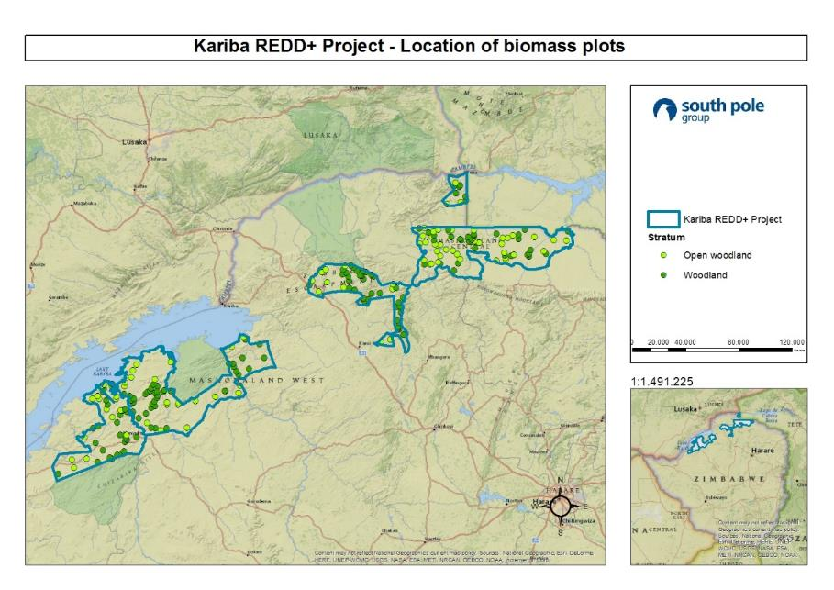
Map 3: Location of biomass plots in the project area

In the monitoring process, the project team applied the update version of the validated SOP.
The stratum Woodland accounts for 269,457 ha, the stratum Open Woodland accounts for 478,345 ha and the temporarily unstocked forest stratum Non-Forest accounts for 37,186 ha.

Sampling
PSP are used to measure changes in carbon stocks in conjunction with the baseline models to quantify the net GHG emissions or removals as a result of project activities. The measurements reflect changes due to natural processes, like growth and mortality, and changes due to human activities, such as management, harvest and degradation. Plots are permanently marked with a magnetic marker buried in the ground and their GPS coordinates recorded. In cases where obstacles (tree, rock, river etc.) obstruct a particular location, the permanent marker is placed as close as possible to the starting point of the plot and notes are made on the field data sheet.
The sampling error is calculated by using equation 47 of the methodology.
To sample biomass, coordinates of random biomass plot locations are used.
Leakage plots are assessed differently than the biomass plots. They are located in the reference area/leakage area, and necessarily placed in random spatial locations. They therefore cannot be conspicuously marked like the biomass plots. Within the leakage area, a sample of plot locations were randomly selected with uniform probability with a sample size determined by equation 10 of the methodology or based on the Sourcebook for LULUCF projects. The dimension (2 square ha; 145m x 145m) of all plots are the same. The proportion of degradation is determined by the observed aboveground biomass that is absent for each plot area. Record factors (i.e. 0.2, 0.4, etc.) corresponding to degradation is applied. The leakage plot is recorded in a GIS system. The Kariba REDD+ Project implemented a total of 50 leakage plots following its SOPs for leakage plots following the requirements of VM0009 v1.1.
So far, no systematic variations potentially present in the project area due to topography, management history, or other factors have been identified. In case systematic variation is identified in the future, how the sampling design avoids bias that may result from these variations will be documented in the monitoring report.
Soil organic carbon plots are assessed differently than biomass plots. They are located in forest areas inside the biomass plots and non-forested areas in the reference area in fallow fields and agricultural lands with different age classes. Each stratum must contain at least two sample plots. Soil organic carbon was not monitored during this monitoring period.
For further information on tree biomass, soil organic carbon, leakage monitoring, please refer to Supporting Documents, SOPs for SOPs on Tree and Soil and Leakage.
The sampling teams have been specially trained for each monitoring activity described above.

Organization structure
The project entity implemented procedures that ensure independent verification. Should there be differences in the electronic and paper-based formats, these are clarified in the terms defined and procedures followed. Particular attention has been paid to monitoring and measurement errors. This issue will be addressed through mandatory data checks and training of sampling teams.
The forest inventory field crews had at least two members, taking into account the amount of information to be collected and the tasks of each individual. Additional persons may be included to improve performance of the field crews when conditions require greater resources. If necessary, some in the field crews were hired locally and acted as guides in the field.
One of the crewmembers has been experienced in tree species identification or has been familiar with methods of plant collection and identification using taxonomic keys.
The responsibilities of each crewmember have been clearly defined. Their tasks are proposed as follows:
The crew leader is responsible for organizing all the phases of the fieldwork, from the preparation to the data collection. He/she has the responsibility of contacting and maintaining good relationships with the community and the informants, and has a good overview of the progress achieved in the fieldwork. He/she administers the location of plots; takes care of crew logistics by organizing and obtaining information on accommodation facilities; recruits local workers; organizes access to the plots; interviews external informants and local people; ensures field forms are properly filled in and collected data are reliable; organizes meetings after fieldwork in order to sum up daily activities; and implements field worker safety measures.
Training of the crews on the survey methodology were undertaken at the beginning of the fieldwork in theoretical and practical sessions during which techniques of different forest and tree measurements, tally of data and techniques were reviewed.

Data collection and storage
The personnel involved in the measurement of carbon pools have been fully trained in field data collection and analysis by the technical manager, Pieter Bezuidenhout. SOPs have been developed for each step of the field measurements and followed so that measurements are comparable over time. If different interpretations of the SOPs exist among the sampling teams, they have been jointly revised to ensure clearer guidance.
Proper data entry is required to produce reliable carbon estimates. Therefore, a web-based data entry form is used for all the data, except soil carbon and leakage, measured in the field, as required by the methodology. All data sheets included a field to record crew composition. Hard copies are kept for the data on soil carbon. The data is analyzed using an excel sheet and various copies are kept as a backup. Communication between all personnel involved in measuring and analyzing data took place to resolve any apparent anomalies before final analysis of the monitoring data was completed. If there were any problems with the monitoring plot data that cannot be resolved, the plot has not been used in the analysis. Additionally, field data have been reviewed by the technical manager or a team leader of the sampling team to ensure that the data are accurate, and analyses are realistic.
Due to the long length of the project and the speed at which technology changes, data archiving will be an essential component of the project. Data is archived in several forms: all original field data sheets are saved, and copies of the original data sheets are stored in another file as backup. All documents are stored in the CGI office. Furthermore, the Monitoring and Verification System (MOVERS) is used for obtaining, recording, compiling and analyzing data relevant for the project. MOVERS is a centralized online data system, which is server-based and backed-up, and serves as the project’s GHG information system. All data are therefore kept in a secure and retrievable manner for at least two years after the end of the crediting period. Access to MOVERS has been provided to the auditors.

Quality Assurance (QA)/ Quality Control (QC)
The project follows the IPCC GPG, using two types of procedures in order to ensure that the inventory estimates and their contributing data are of high quality:,,The plan that describes specific QA/QC procedures is as follows:,
Standard Operating Procedures (SOP) are used for field data measurements.
    - Training courses are held for all relevant personnel on all data collection and analysis procedures.
    - To reduce uncertainty in leakage measurement, trainings and field protocol for sampling forest degradation are implemented.
    - Steps are taken to control for errors in the sampling and data analysis to develop a credible plan for measuring and monitoring carbon stock change in the project context. Following the requirements in VM0009 v1.1 section 13.10 a check cruise has been established. In accordance with the guidance from the LULUCF Sourcebook (Pearson et al. 2005) 10% biomass sample plots measured in the fourth monitoring period were subject to re-measurement by a different field crew with the same level of training, following the same SOPs.
Data collection is an ongoing process. A centralized data system (such as an online server-based and backed-up MOVERS) is used for all the pools, except for soil carbon and leakage. The integration of carbon-credit centered monitoring activities into one central platform contributes significantly to increasing efficiency and decreasing the amount of errors.
The project proponent CGI is managing the project and is responsible for the centralized documentation of all project planning and implementation. QA/QC procedures have been implemented to ensure that biomass, soil and leakage plots are measured and monitored precisely, credibly, verifiably, and transparently. CGA ensured that the QA/QC plan is developed and implemented, coordinated QA/QC activities, and is responsible for documenting QA/QC procedures. For this purpose, CGA designated its CTO Pieter Bezuidenhout as a QA/QC coordinator.

Allometric equations
The project applies allometric equations from peer-reviewed literature that are similar to the project location and the location in which the equations were derived in terms of climatic, edaphic, geographical and taxonomic conditions. When possible, species-specific equations are used from similar locations including Zimbabwe, Tanzania, South Africa, Botswana and Mozambique. If the allometric equations include only aboveground biomass, species or forestry type specific default values are used for calculating the belowground biomass. A list of allometric equations has been provided separately to the auditor at the validation stage, and are also available under the Supporting Documents, MOVERS, file “Allometric eqns_v3”.
All data, including field data, equations, densities and root-shoot-ratio, are uploaded to the centralized data system MOVERS during the monitoring and verification stage of the project, except for carbon organic soil and leakage. All calculations are then processed automatically; firstly, on a plot basis implemented for each strata, and by calculating the carbon sequestered in the soil based on the soil plots, these values are extrapolated to the total amount of ha (per stratum) and then totaled. The total carbon stock for the project area is calculated by using equation 62 of the methodology.
The carbon stock per unit area in each plot is calculated using equation 45 and equation 54 for shrubs. The predicted carbon stock for the large and small trees is calculated using equation 50 of the methodology. The total carbon stock in aboveground large, small and non-tree biomass is calculated with equation 44, and the standard error of the carbon stock in aboveground large, small and non-trees with equation 47. The same equations apply for the calculation of the belowground large and small-tree biomass. For non-tree biomass equation 64 is applied and for the estimation of the standard error of the belowground biomass equation 65 is used.
The carbon stock in standing dead wood in a plot is calculated using equation 66. The same equations as above are applied for calculating the total carbon stock in standing dead wood (equation 44) and the standard error of the carbon stock in standing dead wood (equation 47).
The carbon stock in soil organic carbon for each plot is calculated using equation 61 of the methodology. Baseline emissions of soil for the monitoring period is calculated using equation 29, which uses the soil carbon loss function defined by equation 18. The standard error used for soil organic carbon is calculated using equation 49 and the uncertainty of the soil carbon loss model calculated using equation 19. The estimated variance and estimated standard error is calculated using equation 46 and 49 respectively. However, soil was not monitored during this monitoring period.
For conservative estimate, all deadwood is assumed to be part of decay class II. DBH and height are measured on each dead tree. The volume of each dead tree is then estimated as a cone. The carbon stock for each plot is calculated using equation 45, where equation 51 is applied for calculating the carbon stock per tree, and equation 52 for calculating the amount of carbon in the stratum.

Dissemination of Monitoring Plan and Results (CL3.2)
According to the already validated information from the CCB PDD, page 62, a full monitoring plan was submitted to the CCBS for publication on its website, which is still available there.
The results of the monitoring are disseminated and made public in the project area. The results of the monitoring are published in the monitoring reports, which is not only published online for public consultation, but was also distributed locally through summaries, which have been translated to Tonga and Shona and distributed in the project area. Community members have also been invited to comment on the Monitoring Report (refer to section 2.3).

Quantification of GHG Emission Reductions and Removals

Baseline Emissions
According to VCS PDD, page 57, the cumulative deforestation model of the Kariba REDD+ Project predicted a cumulative forest carbon stock loss of 25.51% for the end of the fourth monitoring period (June 30th, 2019). Subtracting the loss predicted for the previously concluded third monitoring period, the decrease in the fourth monitoring period is 9.57% (refer to Supporting documents, ER Estimations, file “KARIBA ER MP 4”, worksheet “m-4 (tb verified)”).
Following the biomass sampling from the second monitoring period, the Non-Forest stratum (37,186 ha) has no significant woody biomass and is a conservative estimate of zero biomass. Therefore, this stratum also has no baseline emissions. Open woodland and woodland accounts for 747,801 ha and are used to calculate the baseline emissions.
The baseline emissions are summarized in Table 1 below (refer to Supporting documents, ER estimations, file “KARIBA ER MP 4”, worksheet “m-4 (tb verified)”, section “Baseline emissions”).
Table 1: Overview of Baseline Emissions
Stratum | Total baselines emissions (tCO₂e)
Open Woodland | 7,195,102
Woodland | 5,445,445
Non-Forest | 0
TOTAL | 12,640,547

The confidence deduction for this monitoring has been calculated according to Equation 35 based on the average uncertainty (Equation 36) and accounts for 0 tCO₂e (refer to Supporting Documents, ER estimations, file “KARIBA ER MP 4”, worksheet “m-4 (tb verified)”, section “Confidence Deduction-Uncertainty”).

Project Emissions
Emissions from burning: No emissions from the burning of woody biomass have occurred as a result of project activities in the project area. The project activities do not encourage increased burning of woody biomass. Instead, reduced burning, firefighting training and cold burning of non-woody biomass to avoid serious woody-biomass burning are integral parts of the project.
Forest fires: The project proponent understands that significant forest fires could occur during the project crediting period. No major forest fires were detected in the monitoring period.
Event number | Date | Woody biomass consumed in tonnes
N/A | N/A | N/A
TOTAL |  | 0

Leakage
The project activities were designed aiming to mitigate leakage and they include improved agriculture, beekeeping, fuelwood plantation, social forestry, biogas digester, fire management, alternative and sustainable construction, and maintenance and resuscitation of boreholes and water pumps. All project activities were designed to reduce the impacts of deforestation and human-wildlife conflicts as well as to enhance livelihoods throughout the project area and outside the project area. The status of project activities during the current monitoring period are described in full detail in Section 4.3.2.
The project monitored 50 leakage plots and resolved equation 33 to calculate the leakage factor (refer to Supporting Documents, Leakage Monitoring, file “Leakage_MP4”). The project remains convinced that its leakage mitigation and management strategies are fully adequate and effective. Further we topically defend that there is no causal relationship between observed degradation in the monitored leakage plots and the project activities. In our expert opinion, all forest degradation observed in the leakage plots is either due to increased population levels in the region or caused by natural causes such as elephant damage, but not related to the activities implemented in the project area.
Still, in order to formally comply with the calculation approach of VM0009 v1.1, we estimate a leakage factor of 0 (zero). Therefore, the calculated leakage emissions amount to 0 tCO₂e (Equation 22) and are deduced from Net Emission Reductions (NERs) calculated in equation 34 (refer to Supporting documents, ER estimations, file “KARIBA ER MP4”, worksheet “m-4 (tb verified)”, section “Leakage)”.

Net GHG Emission Reductions and Removals
Net GHG Emission Reductions and Removals (NERs) are calculated using Equation 34. The below table summarizes all components of Equation 34 (refer to Supporting documents, ER estimations, file “KARIBA ER MP4”, worksheet “m-4 (tb verified)”, section “Net Emission Reductions”). The total amount of VCUs is separated by 16.67% into vintage year 2016, 33.34% into vintage year 2017 and 2018 and 16.67% into vintage year 2019. Vintage year 2016 consists of the period of 01/07/2016 to 31/12/2016, vintage year 2017 consists of the period of 01/01/2017 to 31/12/2017, vintage year 2018 consists of the period of 01/01/2018 to 31/12/2018 and vintage year 2019 consists of the period of 01/01/2019 to 30/06/2019 (refer to Supporting documents, ER estimations, file “KARIBA ER MP4”, worksheet “m-4 (tb verified)”, section “Vintage packages of VCUs”).

Year | Baseline emissions  or removals (tCO₂e) | Project emissions or removals (tCO₂e) | Leakage emissions (tCO₂e) | Buffer credits  (tCO₂e) | Net GHG emission reductions or removals (tCO₂e)
Year 2016 | 2,106,757 | 0 | 0 | 294,947 | 1,811,810
Year 2017 | 4,213,515 | 0 | 0 | 589,893 | 3,623,622
Year 2018 | 4,213,515 | 0 | 0 | 589,893 | 3,623,622
Year 2019 | 2,106,757 | 0 | 0 | 294,947 | 1,811,810
Total | 12,640,544 | 0 | 0 | 1,769,680 | 10,870,864

The calculated total AFOLU Non-Permanence Risk Assessment is 14% (refer to Supporting Documents, Risk Tool, for further details on the calculation).
Net GHG emission reductions or removals are calculated by solving equation 34 of VM0009 v1.1.
12,640,547 tCO₂e (C[m]) = 12,640,547 tCO₂e (C[m]BE) – 0 tCO₂e (C[m]U) – 0 tCO₂e (C[m]PE) – 0 tCO₂e (C[m]LE)
All equations leading up to equation 34 are solved in the provided supporting documents “KARIBA ER MP 4” located under Supporting Documents, ER Estimations.
Equation 34 represents also the net carbon stock change for the basis of the buffer tool.
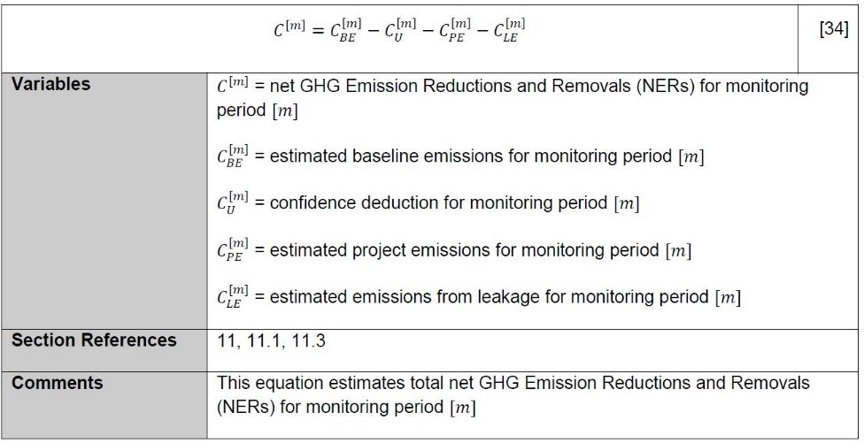

Net VCUs to which the project is eligible after deduction of the buffer credits are shown in the table below.
Table 2: Eligible VCUs

Total net VCUs to project proponent in  tCO2e | 10,870,864
Net VCUs to project proponent in tCO2e,  vintage 2016 | 1,811,810
Net VCUs to project proponent in tCO2e,  vintage 2017 | 3,623,622
Net VCUs to project proponent in tCO2e,  vintage 2018 | 3,623,622
Net VCUs to project proponent in tCO2e,  vintage 2019 | 1,811,810

Optional Criterion: Climate Change Adaptation Benefits
For Climate Change Adaptation Benefits and how the project will provide the means to adapt to the impacts of climate change, please refer to the CCB PDD, page 80, 81 and 82.
As lined out in the CCB PDD, section GL1.2, page 80, risks emerging from ongoing climate change are covered in the project’s adaptive management process. The only new risk identified in the adaptive management meetings is related to lack of interest on tree nurseries and illegal settlements and mitigation is secured as explained in section 2.2.5. The full minutes of the meetings are provided in the Supporting Documents, Adaptive Management Plan, Adaptive Management Meeting.
As pointed out in the CCB PDD, section GL1.3, page 81, the productivity of main crops such as maize and wheat is predicted to decrease in the project area due to increasing temperatures and reduced rainfall. During the project’s activities, the communities are given assistance to adapt to these impacts of climate change, particularly reduced productivity of crops. The introduction of beekeeping using local wild bees, direct employment, training for farmers on more drought-adapted and yield-increasing conservation farming techniques and technical support on irrigation schemes help communities to adapt a changing climate. These activities increase the income of local communities, diversify income sources make communities less dependent on crops susceptible to climate-­‐change, and increase the yield of field crops, thereby counteracting the effects of climate change.

Activities and/or Processes Implemented for Adaptation (GL1.4)
According to CCB PDD, most common adaptation strategies include diversification of income beyond agriculture, different crops and varieties, irrigation and water conservation and conservational agriculture.
The Kariba REDD+ Project is promoting all of these adaptation strategies on a large scale in the project area.
Honey production systems provide new income opportunities to large parts of the local population, beyond traditional farming activities. This helps to alleviate the impact of climate extremes on the locals’ livelihoods and adds real value to standing forests. Honeybees can live in very different climatic zones. There are subspecies of Apis mellifera occurring in northern Europe and sub-Saharan Africa. Our beekeeping activity uses exclusively local wild bee species, caught using catcher boxes. This promotes local bee species diversity, as well as reduces the risk of negative effects from climate change on our beekeeping activities. Our beekeeping is therefore likely to be possible despite a changing climate.
Many locals also benefit from direct employment or additional income sources as a result of the project activities, thus providing income diversification.
As part of its agricultural improvement activities, the project enhances drought‐resistant species and varieties as well as conservational agriculture. Certain agricultural species such as groundnut, cassava and sorghum are likely to be relatively unaffected by climate change in Southern Africa. Meanwhile, conservational agriculture activities have a proven potential to mitigate the effects of drought that must be expected as a result of climate change.
Irrigation in Zimbabwe’s northern region is a sustainable means of climate change adaptation. The irrigation potential within the basin of the Zambezi River is relatively high. Zimbabwe uses only 53% of the area suitable for irrigation. Establishment, recovery and maintenance of the boreholes area by the Kariba REDD+ Project also contribute significantly to the climate change adaptation in the project area.
The project’s adaptive management approach helps to continuously address issues of adaptation that emerge with a changing climate. Refer to section 4.3.2 of this document for a more detailed description of the current status of the mentioned project activities.

Community

Net Positive Community Impacts

Community Impacts (CM1.1)
The Kariba REDD+ Project’s direct and indirect impacts on the local communities have been monitored according to the project’s monitoring plan and Standard Operation Procedure available under the Supporting documents, SOPs, Social monitoring SOP.
With regards to the project’s direct effects, 174 workshops have been conducted on improved agriculture and community gardens, reaching a total of 8,258 participants. There have been 24 community gardens supported, and 18 are still active. A total of 4,567 participants benefited from our 107 beekeeping workshops. Also, schools and clinics have been supported. The results of all indicators for the project’s direct effects are provided separately in the Supporting Documents, CCB Monitoring, Social Monitoring, Direct Effects, file “Social monitoring direct effects”. There are 22 permanent staff working on the project. In addition, more detailed information on the net positive community impacts for each project activity are provided under section 4.3.2.

Net Positive Community Well-Being Impacts (CM1.1)
The Kariba REDD+ Project’s direct and indirect impacts on the local communities have been monitored according to the project’s monitoring plan and Standard Operation Procedure available under the Supporting Documents, SOPs, Social Monitoring SOP. The main project activities described in more detail in section 4.3.2 were designed to have net positive impacts on communities’ well-being because they were not carried out in the project area before the project start. Therefore, without the project activities, the net positive impact in well-being cause by the project activities would not occur. For further details on the net positive impacts, refer to the project activities listed under section 4.3.2.
To monitor the project’s indirect social effects, an extensive survey campaign was implemented in February and March 2019. All results are provided in the Supporting Documents, CCB monitoring, Social Monitoring, Indirect Effects, file “Kariba_social Survey”. A total of 392 local community members, direct project beneficiaries and employees have been reached. Interviews where necessary were conducted in the local language Shona and participants were selected randomly.
Most interview partners expressed their satisfaction with the project, as shown Table 3. Direct beneficiaries and employees reported consistently positive impacts of the Kariba REDD+ Project on their livelihoods, food security, children’s access to education and healthcare, as shown in Table 4, Table 5, Table 6, and Table 8: . This shows the project’s positive impacts in community aspects.

Table 3: Satisfaction with the Kariba REDD+ Project
 | Community Members (%) | Beneficiaries (%) | Employees (%)
Very unsatisfied | 0.0 | 0.0 | 0.0
Unsatisfied | 0.7 | 0.0 | 4.0
Indifferent | 10.0 | 0.0 | 0.0
Satisfied | 60.1 | 51.2 | 40.0
Very satisfied | 25.3 | 48.8 | 56.0
N/A | 3.9 | 0.0 | 0.0

Table 4: Reported project impact on livelihoods by beneficiaries and employees
 | Beneficiaries (%) | Employees (%)
Very negatively | 0.0 | 0.0
Negatively | 0.0 | 0.0
No impact | 0.0 | 4.0
Positively | 51.2 | 56.0
Very positively | 48.8 | 40.0

Table 5: Reported project impact on food security by beneficiaries and employees
 | Beneficiaries (%) | Employees (%)
Very negatively | 0.0 | 0.0
Negatively | 0.0 | 0.0
No impact | 3.5 | 0.0
Positively | 60.5 | 68.0
Very positively | 36.0 | 32.0

Table 6: Reported project impact on children’s access to education by beneficiaries and employees
 | Beneficiaries (%) | Employees (%)
Very negatively | 0.0 | 0.0
Negatively | 0.0 | 0.0
No impact | 3.5 | 0.0
Positively | 59.3 | 64.0
Very positively | 37.2 | 36.0

Table 7: Reported project impact on healthcare by beneficiaries and employees
 | Beneficiaries (%) | Employees (%)
Very negatively | 0.0 | 0.0
Negatively | 0.0 | 0.0
No impact | 3.5 | 0.0
Positively | 53.5 | 56.0
Very positively | 43.0 | 44.0

Protection of High Conservation Values (CM1.2)
The project area is identified as being of the community-related High Conservation Values (HCVs) 5 (fundamental basic needs) and 6 (cultural identity).
In order to assess the project’s impact on these HCVs, four specific questions have been included in the project’s social impact survey.
In order to assess projects impacts on HCV 5, the following questions have been asked:
- “Through the project, are you, or members of your household, restricted in collecting the following forest products?” (for building materials, firewood, fruits and other products separately).
- “If yes, did the project provide you with alternative sources to collecting these products in natural forests?”
- “If yes, are the alternative provided by the project attractive to you?”
The answer to the first question was “not restricted” in 100% of the cases, which left the following two questions not answered.
With regards to HCV 6, the following question was included in the survey:
- “Through the project, are you or members of your household restricted in using the forest to fulfill your cultural needs?”
Also here, the answer was “not restricted” in 100% of the cases.
According to the social impact survey, the project High Conservation Values related to community well being were not negatively affected. Please refer to the results of the social impact survey provided separately for further reference (Supporting Documents, CCB monitoring, Social Monitoring, Indirect Effects, file ‘Kariba_Social Survey’).

Offsite Stakeholder Impacts
The Kariba REDD+ Project focuses on providing to communities attractive alternative livelihoods, which reduce the pressure on local forests. Since the project relies on providing positive incentives, negative impacts on stakeholders are not expected. On the contrary, the project is expected to have positive offsite impacts. In addition, the large project size and the limited mobility of local communities further reduce potential negative impacts.
The only potentially affected stakeholders identified include the population of wards within participating RDCs, which do not form part of the project. In order to identify and mitigate any potentially negative impacts on these communities, there is an ongoing dialogue with these stakeholders through the RDCs councils. The RDC councils have a full council meeting at minimum of four times per year. These meetings include every ward councilor, as well as the councilors from wards, which are not part of the project. The councilors update the council on all activities and issues within their wards. If there are any negative impacts by the project these will be reported to the council during these meetings and reported to CGA through the councils. To date, no negative reports have been made, and only requests to extend the project so that offsite stakeholders can also benefit directly from the project, have been received.

Mitigation of Negative Impacts on Other Stakeholders (CM2.2)
CM2.2 is not applicable as no other stakeholders were identified. Please, refer to the CCB PDD, page 69. However, negative impacts can be identified and mitigated through the adaptive management process.

Net Impacts on Other Stakeholders (CM2.3)
CM2.3 is not applicable as no other stakeholders were identified. Please, refer to the CCB PDD, page 69.

Community Impact Monitoring

Community Monitoring Plan Development (CM3.3)
Not applicable.

Community Monitoring Plan Results (CM3.1, CM3.2, GL2.5)
For community impact monitoring, please refer to the sections of CCB PDD CM3.1 and CM3.2 from pages 69 to 73. For information on community groups and HCVs related to community well-being, community variables selected in the validated project description, frequency, sampling methods used and dates, please refer to the Supporting Documents, SOPs, Social monitoring SOP.
The results and evaluation of this monitoring period are presented below.
This section serves as a qualitative and quantitative description of the project activities for the period from July 1, 2016 to June 30, 2019. The project activities will be summarized for all four project areas namely Binga, Nyaminyami, Hurungwe and Mbire. It should also be noted that the intention at the core of every project activity implemented is to ultimately impart knowledge to the beneficiaries through training and provisional support to help make all community members more independent and to reduce deforestation.

IMPROVED AGRICULTURE
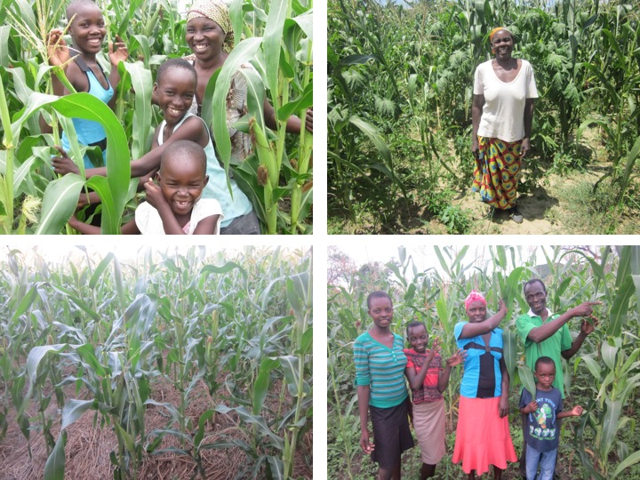
Figure 2: Maize farming in the project area

Conservation Farming (CF) continues to be a major activity in the Kariba REDD+ project and has continued to be implemented successfully during the monitoring period with three cropping seasons being implemented during this monitoring period, the 1st ran from November 2016 to April 2017, the 2nd cropping season ran from November 2017 to April 2018 and the 3rd cropping season ran from November 2018 to April 2019. The Kariba REDD+ Project has noted with interest the number of farmers who continue to do CF without inputs. This is encouraging because it supports our goal to empower people with knowledge so that they can better solve their own problems and needs.
The Kariba REDD+ project also continues to focus on trainings for CF by ensuring that all community members at ward level have a fair and equal opportunity to attend these trainings if they wish to do so. The demonstration plots have proven valuable as a visual impact on the communities who can see the success following the trainings, and also as a meeting point for the communities to discuss points related to CF. We intend to consider increasing the number of demonstration plots at ward level overtime.
As mentioned in previous monitoring reports, in regard to our intention to stop monitoring traditional yields as compared with CF yields and our justified reasons for doing so, this season we have done this once again and so the information below is for CF only.
- Binga
  - 1st cropping season (From November 2016 to April 2017): 307 people were recorded to have implemented CF. Maize 82,030 kg, sorghum 79,510 kg, legumes 72,890 kg. Yield difference increase is 109% for CF over traditional farming.
  - 2nd cropping season (From November 2017 to April 2018): 232 people were recorded to have implemented CF. The recorded harvest totals in Kg are as follows; Maize 18,150 kg, Sorghum 24,180 kg, other crops or legumes 5,912 kg.
  - 3rd cropping season (From November 2018 to April 2019): 326 people were recorded to have implemented CF. The recorded harvest totals in Kg are as follows; Maize 4,184 kg, Sorghum 2,436 kg, other crops or legumes 799 kg.

- Nyaminyami
  - 1st cropping season (From November 2016 to April 2017): 158 people were recorded to have implemented CF. Maize 74,770 kg, sorghum, 165,60 kg, legumes 7,680 kg. Yield difference increase is 43% for CF over traditional farming.
  - 2nd cropping season (From November 2017 to April 2018): 187 people recorded to have implemented CF. The recorded harvest totals in Kg are as follows; Maize 57,253 kg, Soya Beans 19,665 kg, Cow Peas 12,107 kg, Groundnuts 9,767 kg.
  - 3rd cropping season (From November 2018 to April 2019): 237 people recorded to have implemented CF. The recorded harvest totals in Kg are as follows; Maize 23,780 kg, Sorghum 3,020 kg, legumes or other crops 2,350 kg.

- Hurungwe
  - 1st cropping season (From November 2016 to April 2017): 394 people were recorded to have implemented CF. Maize 134,800kg. Yield difference increase is 14.5% for CF over traditional farming.
  - 2nd cropping season (From November 2017 to April 2018): 394 people were recorded to have implemented CF. The recorded maize harvest for this period is 369,080 kg.
  - 3rd cropping season (From November 2018 to April 2019): 1,268 people were recorded to have implemented CF. The recorded maize harvest for this period is 99,060 kg.

- Mbire
  - 1st cropping season (From November 2016 to April 2017): 451 people were recorded to have implemented CF. Maize 240,019 kg, sorghum 202,397 kg. Yield difference increase is 194% for CF over traditional farming.
  - 2nd cropping season (From November 2017 to April 2018): 314 people were conservatively recorded to have implemented CF. The recorded harvest totals in Kg are as follows; Maize 95,720 kg, Sorghum 90,920 kg; Legumes 47,460 kg.
  - 3rd cropping season (From November 2018 to April 2019): 542 people were conservatively recorded to have implemented CF. The recorded harvest totals in Kgs are as follows; Maize 203,940 kg, Sorghum 238,020 kg; other crops or legumes 76,550 kg.

The 1st cropping season (From November 2016 to April 2017) was another great success with an average 90% increase in yield for maize as compared with traditional farming practices, across the board. What is important to note is that the CF yield information in most cases was compared with a far larger portion of cropped land under traditional farming and not equal in size to CF, otherwise we have no doubt that the increase would have been far more. Also, after three previous seasons of proven data, we will be phasing out the comparison on yield and focus more on trying to increase the number of CF farmers. The Kariba REDD+ Project viewed this as yet more evidence to support the positive impact CF has over traditional cropping methods and its potential for making people more food secure. The impact is further increased by seeing how many community members who were not beneficiaries have adopted the farming method of their own accord upon seeing the difference in quality of the crops grown by the previously registered farmers.
The 2nd cropping season (From November 2017 to April 2018) continues to positively impact the food security of all those who choose to adopt and implement this farming practice. With the above-recorded yields it is very clear that every family practicing CF has produced enough food to last an average family of 4.3 people for a year. The excess is sold as profit which can be used for other household or family needs. The Kariba REDD+ Project will continue to provide the necessary support to see increased numbers of people adopting CF and strive to find ways to continue improving yields and food security. Our method to achieve this through ToT (Training of Trainers) gives people a sense of ownership. We believe this will result in increased health and well-being and reduced deforestation.
The 3rd cropping season (From November 2018 to April 2019) proved to be exceptionally tough due to the drought experienced in Zimbabwe that season. Rainfall was well below average and during these times even the most innovative farming methods were strained. The farmers that preformed CF techniques during the cropping season were the only people that managed to at least harvest a crop. This is an indication that the CF techniques are extremely efficient, and we believe this will be an encouragement for many people to adopt the CF principles.
CGA continues to receive welcome letters from community members expressing their gratitude to CGA and the Kariba REDD+ Project for the training they received either directly or indirectly through the ToT, and telling how they have achieved food security through the CF farming method and are able to sell their surplus to buy other domestic needs.
It is the intention of the project to continue expanding this activity to more and more members of the communities with more ward level training workshops, and increased extension work by engaging the communities directly. It will also increase support to farmers implementing the CF method which has the potential to impact individual households, improve food security, increase wealth and reduce deforestation through reducing the need to clear more land in search of more fertile soils (shifting agriculture). The project also will reduce the need to monitor traditional yields for comparative purposes, because the many years of evidence support CF as the undoubtedly preferable farming method, which should be promoted as much as possible going forward.
Please, see Map 4 below with the distribution of beneficiaries of conservation farming activities implemented per ward and Map 5 and Map 6 below for location of conservation farming demo plots.

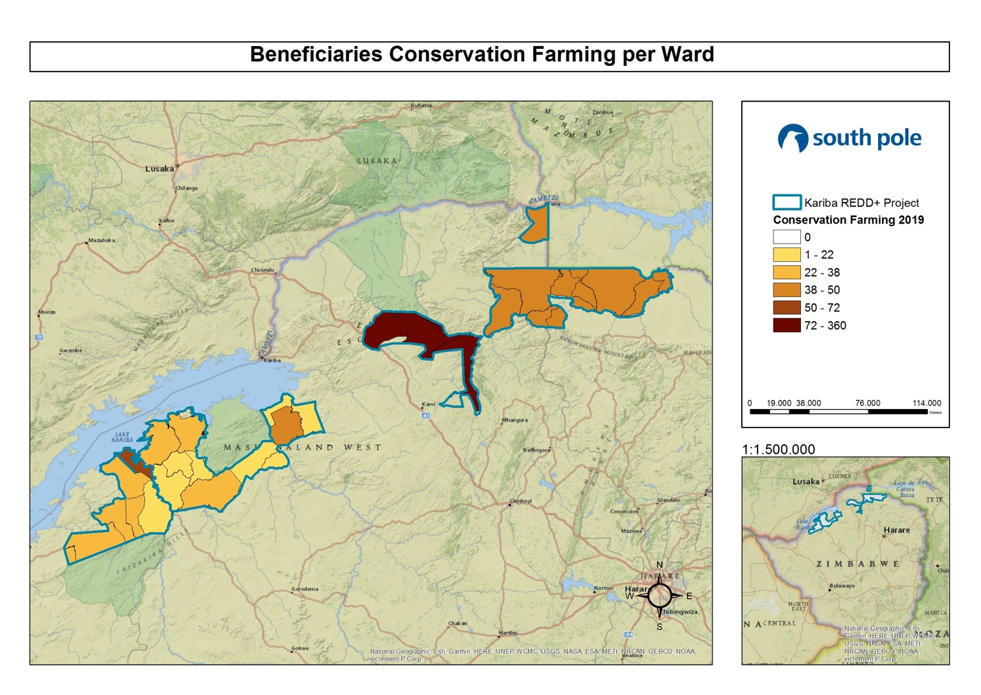
Map 4: Distribution of beneficiaries of conservation farming activities implemented per ward

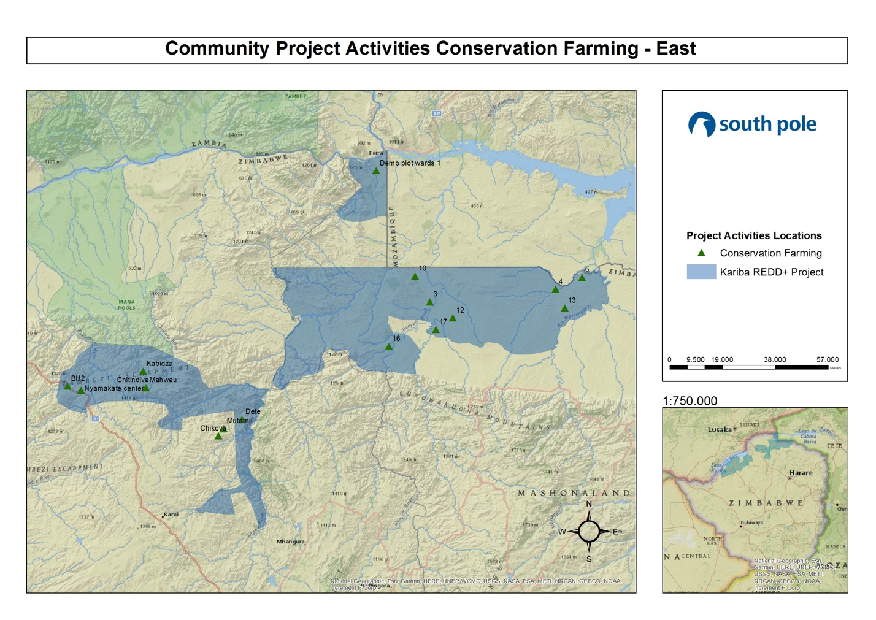
Map 5: Location of conservation farming in the Eastern part of the project

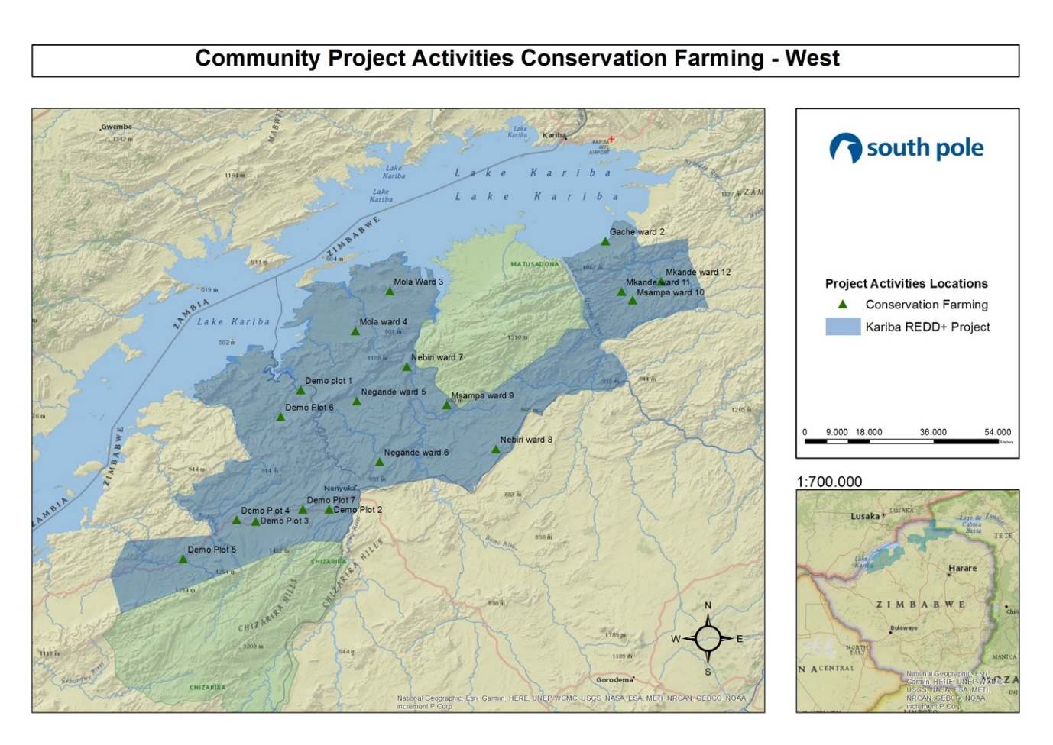
Map 6: Location of conservation farming in the Western part of the project

Trainings were conducted by the organization named “Foundations for Farming” who provided the trainers and training material. Training was done at district level where a central location was used as a training center or base. In September 2016 and 2017 for CF, there were 3 separate one-day trainings for each activity across the project area including ToT (Training of Trainers). In November 2016 and 2017 trainings on conservation farming consisted of a three-day event for each activity and were recorded as one single training event per activity, covering theory and field work as well as ToT and demonstration plot establishment at ward level which was done by Agritex. In 2018 and 2019, refresher training for ToT was conducted by “Foundations for Farming” who provided the trainers and training material. ToT training was performed using the same method as in 2016 and 2017.
A breakdown of the trainings per district as follows:
- Binga
  - 1st period (From 01 July 2016 to 30 June 2017): 9 trainings and 250 people were recorded to have attended the trainings.
  - 2nd period (From 01 July 2017 to 30 June 2018): 7 trainings and 306 people were recorded to have attended the training.
  - 3rd period (From 01 July 2018 to 30 June 2019): 9 trainings and 365 people were recorded to have attended the training.

- Nyaminyami
  - 1st period (From 01 July 2016 to 30 June 2017): 3 trainings and 92 people were recorded to have attended the trainings.
  - 2nd period (From 01 July 2017 to 30 June 2018): 2 trainings and 42 people were recorded to have attended the trainings.
  - 3rd period (From 01 July 2018 to 30 June 2019): 8 trainings and 652 people were recorded to have attended the trainings.

- Hurungwe
  - 1st period (From 01 July 2016 to 30 June 2017): 5 trainings and 207 people were recorded to have attended the trainings.
  - 2nd period (From 01 July 2017 to 30 June 2018): 10 trainings and 642 people were recorded to have attended the trainings.
  - 3rd period (From 01 July 2018 to 30 June 2019): 3 trainings and 116 people were recorded to have attended the trainings.

- Mbire
  - 1st period (From 01 July 2016 to 30 June 2017): 16 trainings and 887 people were recorded to have attended the trainings.
  - 2nd period (From 01 July 2017 to 30 June 2018): trainings in Mbire were done outside this monitoring period and are recorded in the 2018-2019 period.
  - 3rd period (From 01 July 2018 to 30 June 2019): 10 trainings and 572 people were recorded to have attended the trainings.
In the first period, this gives us a total of 33 trainings. In the second period, this gives us a total of 19 trainings. In the third period, this gives us a total of 30 trainings. This approach significantly increased the number of people who have had access to training and thus increases the footprint in the project area and empowers more people with knowledge to do conservation farming (CF) and improve their food security and lives. Evidence of training on conservation farming (CF) is provided in the Supporting Documents, Training, Attendance Registers, CF Training. Additional evidence on trainings can be provided upon request.
Community gardens have long been recognized as a means to enhance food security and improve general nutrition during times of the year when field crops are not grown. Moreover, community gardens have been established as a means of providing knowledge to children in school as well. Therefore, gardening tends to be seasonal from a cultural perspective, whereby field crops of maize, sorghum, groundnuts etc. are the focus during the rainy season and gardening during the winter and dry months. However, since very little rain was received during the 2018-2019 season and the field crops struggled, gardening will be the main source of food most people will resort to until the next rains.
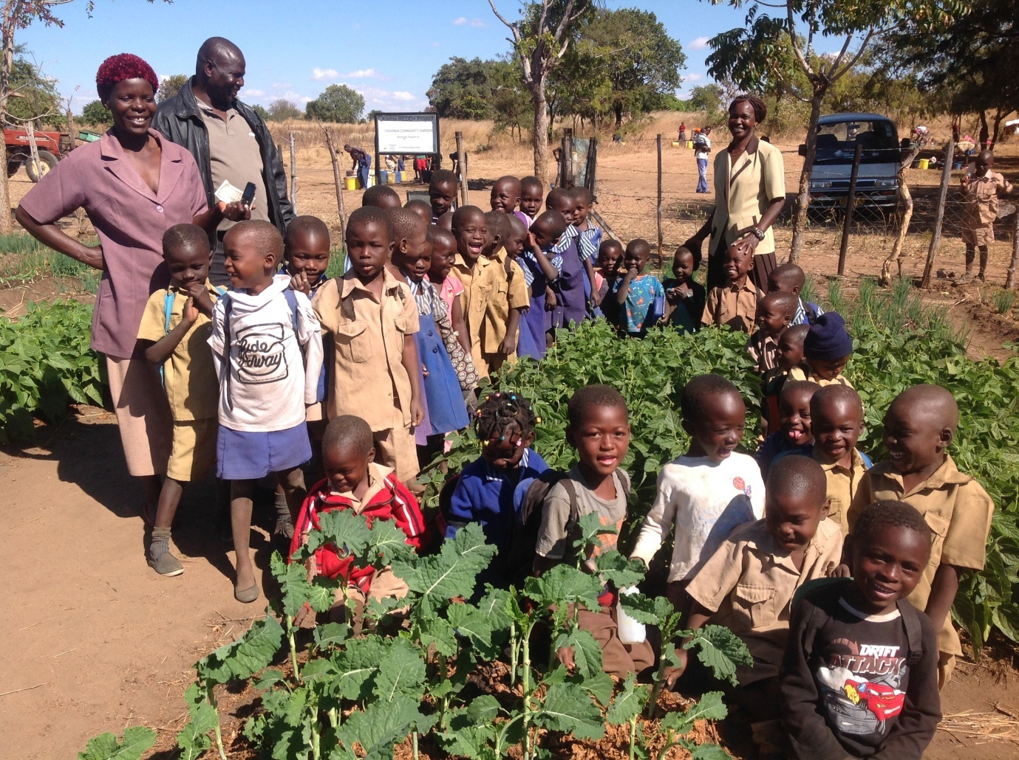
Figure 3: School field visit at community garden

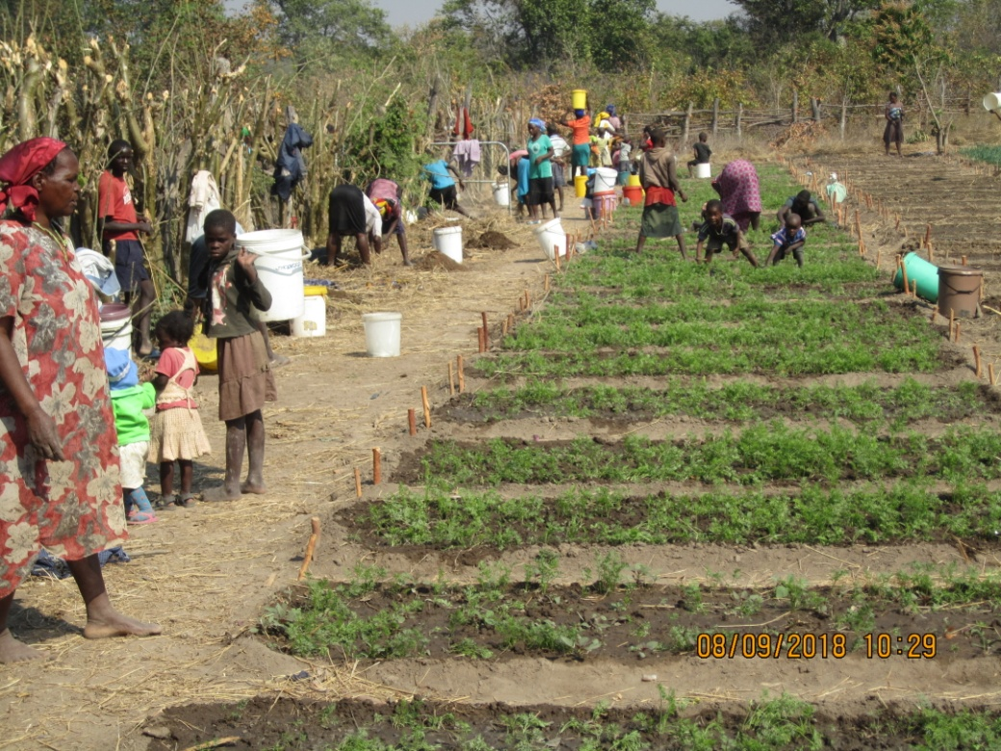
Figure 4: Introducing the carrot plant to the community garden

The Kariba REDD+ Project gardens continue to benefit during the monitoring period under review including some school gardens. The support has mostly been in the form of training that promotes independence for the long term. Tashinga garden in Hurungwe continues to lead by example by paying for the school fees of ten orphans using the sale of their produce. However, there is also an individual garden, called Chikodyo Investment garden in Binga that has produced considerable crops and has generated the greatest amount of income recorded for the area. Below is a breakdown of the garden beneficiaries per district.
- Binga
  - 1st period (From 01 July 2016 to 30 June 2017): 478 beneficiaries including students from two schools. Recorded income generated from sale of produce $3,586.00.
  - 2nd period (From 01 July 2017 to 30 June 2018): 659 beneficiaries including students from schools and individual gardens from community members who received training. Recorded income generated from sale of produce $18,622.15.
  - 3rd period (From 01 July 2018 to 30 June 2019): 601 beneficiaries from community gardens including students from 2 schools and individual gardens from community members who received training. Recorded income generated from sale of produce $36,352.93

- Nyaminyami
  - 1st period (From 01 July 2016 to 30 June 2017): 104 beneficiaries from three community gardens continue to benefit from their gardens. Recorded income generated from sale of produce $376.00.
  - 2nd period (From 01 July 2017 to 30 June 2018): 104 beneficiaries from four community gardens continue to benefit from their gardens. Recorded income generated from sale of produce $524.00.
  - 3rd period (From 01 July 2018 to 30 June 2019): 109 beneficiaries from community gardens recorded an income of $1,554.5 from the sale of produce.

- Hurungwe
  - 1st period (From 01 July 2016 to 30 June 2017): 1,825 Beneficiaries including students from 2 schools. Recorded income generated from sale of produce $11,965.00.
  - 2nd period (From 01 July 2017 to 30 June 2018): 1,390 Beneficiaries including students from 2 schools. Recorded income generated from sale of produce $14,296.00.
  - 3rd period (From 01 July 2018 to 30 June 2019): 2,604 beneficiaries from community gardens including students from 3 schools. Recorded income generated from sale of produce $18,399.00

- Mbire
  - 1st period (From 01 July 2016 to 30 June 2017): 446 beneficiaries including students from one school. Recorded income generated from sale of produce $1,614.00.
  - 2nd period (From 01 July 2017 to 30 June 2018): 446 beneficiaries including students from one school. Recorded income generated from sale of produce $3,829.30.
  - 3rd period (From 01 July 2018 to 30 June 2019): 440 beneficiaries from community gardens and 1 school recorded an income from sales of produce $6,214.00.
From July 2016 to June 2017, a total recorded income is $17,541.00 and this gives an excess of 3,000 lives being positively impacted both directly and indirectly. During July 2017 to June 2018, this gives a total recorded income of $37,271.45 and an excess of 10,500 lives being positively impacted both directly and indirectly. From July 2018 to June 2019, a total recorded income of $62,520.43 and an estimated excess of 16,000 lives being positively impacted both directly and indirectly. This includes school students and the families they represent as well as the community garden members and their families they also represent.
Please, see Map 7 for distribution of beneficiaries on community gardens activities per ward and Map 8 and Map 9 below for location of community gardens.
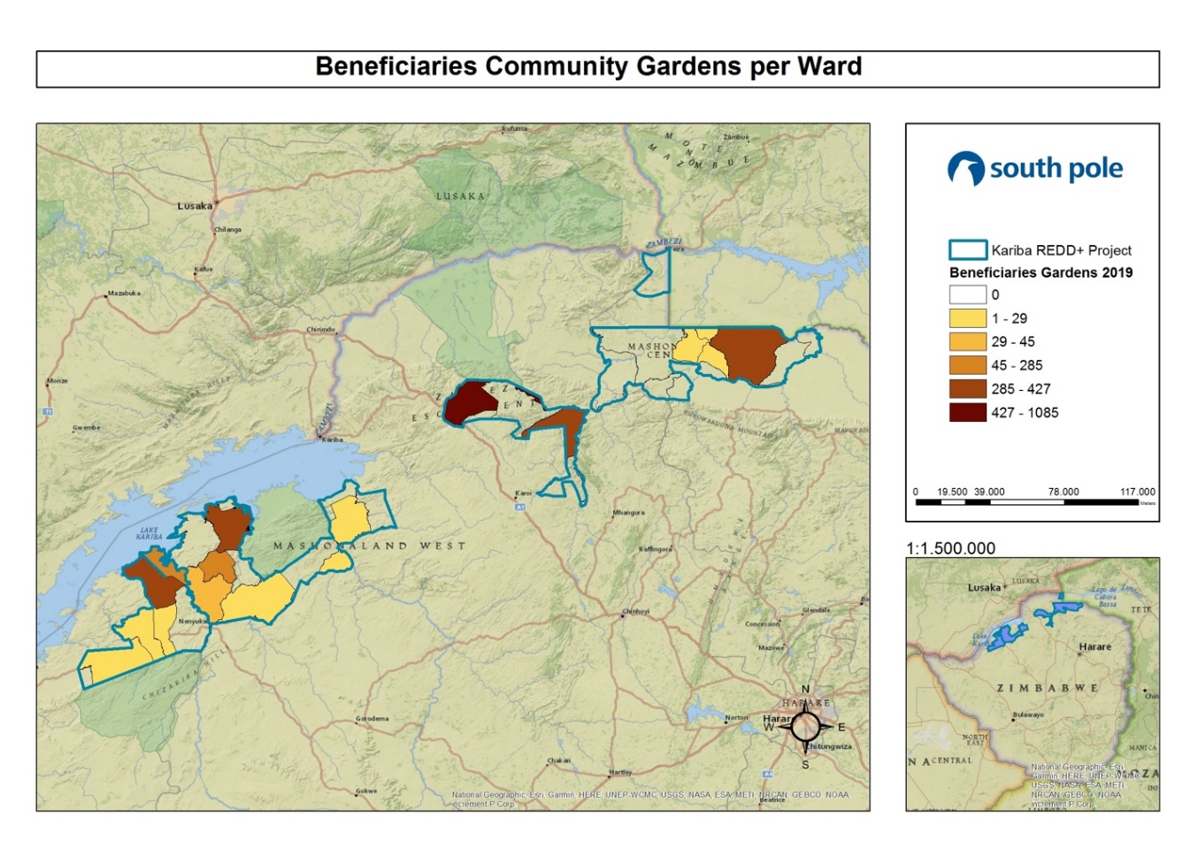
Map 7: Distribution of beneficiaries of community gardens activities implemented per ward

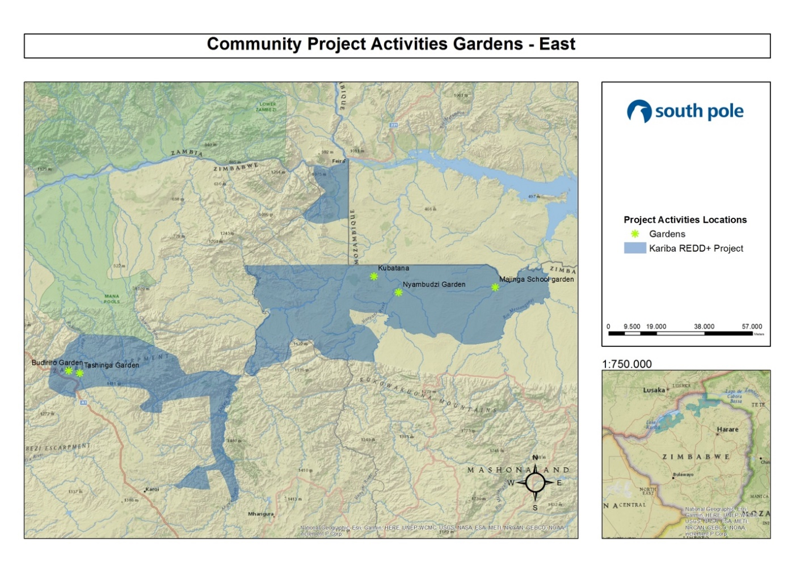
Map 8: Location of community gardens in the Eastern part of the project

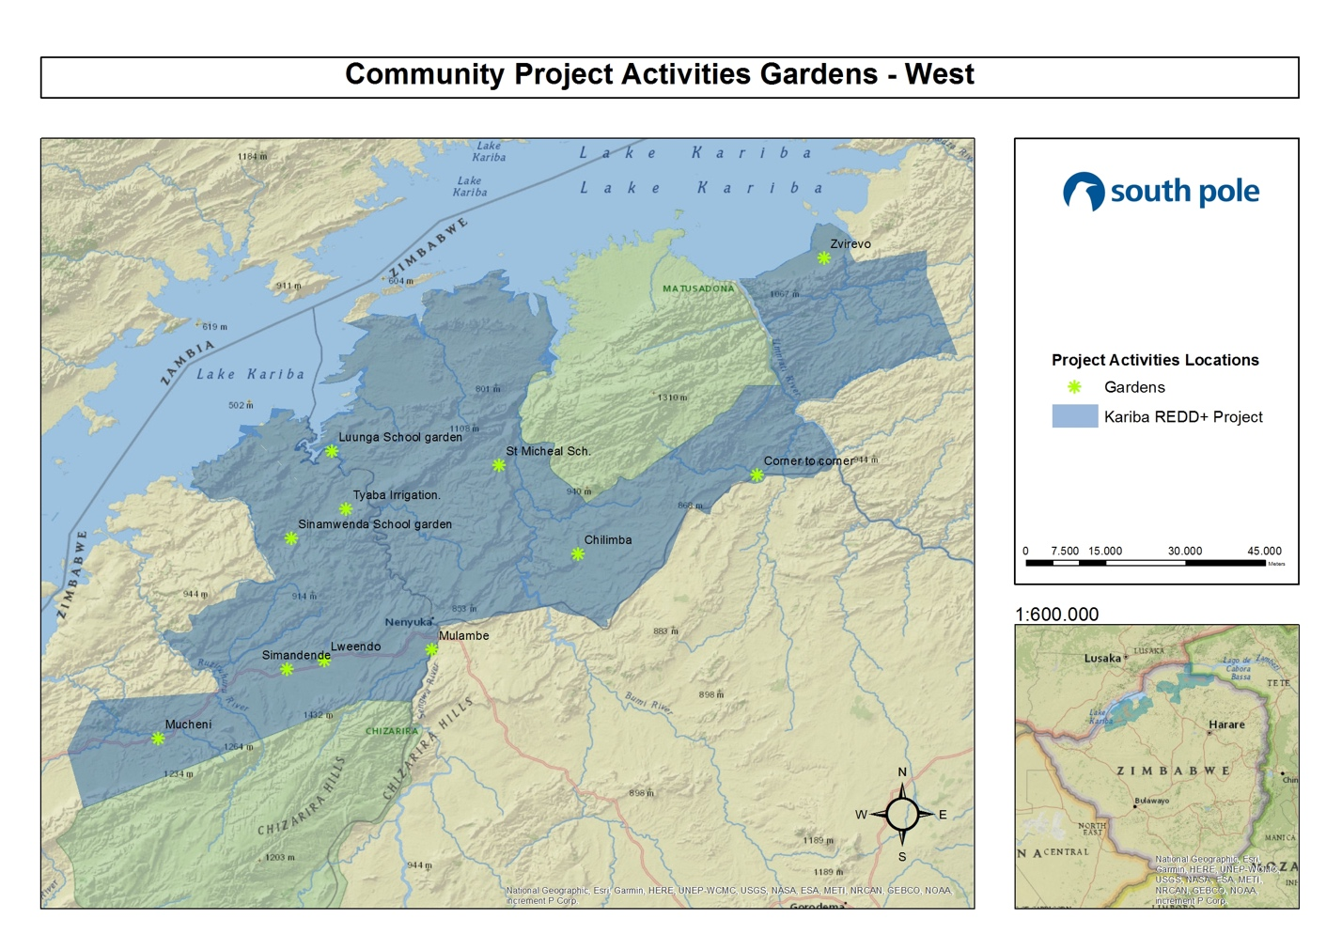
Map 9: Location of community gardens in the Western part of the project

Trainings (Figure 5) during the first period were conducted by an organization called “Foundations for Farming” who provided the trainers and training material. Training was done at district level where a central location was used as a training center or base. In September 2016, three separates one-day trainings were carried out including ToT (training of trainers). Then in November 2016 and April-May 2017, trainings consisted of a three-day event per ward and recorded as a single training event, covering theory and fieldwork.

For the second period, trainings were conducted by an organization called “Sustainable Agricultural Technologies (SAT)” who provided the trainers and training material. Training was done at district level where a central location was used as a training center or base. In May 2018, four separate 1.5-day trainings were carried out, including ToT (training of trainers). Then in May-June 2018, trainings consisted of a three-day event per ward and recorded as 1 single training event, covering theory and fieldwork.

During the third period, trainings were conducted by the community’s own ToT. After recognizing the number of ToT trainings and refresher trainings done since the project start, the KRP decided to give the communities an opportunity to show how far they have come in regards to independence. KRP provided the training material. Training was done at ward level where a central location was used as a training center or base. In May 2019, combined gardening and beekeeping trainings were done for a full 3 days, where 1.5 days were spent training gardening and 1.5 days were spent training beekeeping at ward level for the general community members. These trainings covered theory and fieldwork and were assisted and supported by our OGM.

A breakdown of the trainings per district as follows:
- Binga
  - 1st period (From 01 July 2016 to 30 June 2017): 6 trainings for 220 people
  - 2nd period (From 01 July 2017 to 30 June 2018): 7 trainings for 207 people
  - 3rd period (From 01 July 2018 to 30 June 2019): 7 trainings with 106 people

- Nyaminyami
  - 1st period (From 01 July 2016 to 30 June 2017): 2 training for 77 people
  - 2nd period (From 01 July 2017 to 30 June 2018): 5 trainings 210 people
  - 3rd period (From 01 July 2018 to 30 June 2019): 17 trainings with 861 people

- Hurungwe
  - 1st period (From 01 July 2016 to 30 June 2017): 9 trainings for 254 people
  - 2nd period (From 01 July 2017 to 30 June 2018): 1 training for 1 person for the ward. This was ToT. Ward level trainings were done after this monitoring period and thus recorded in the following monitoring period.
  - 3rd period (From 01 July 2018 to 30 June 2019): 11 trainings with 896 people

- Mbire
  - 1st period (From 01 July 2016 to 30 June 2017): 3 trainings for 65 people
  - 2nd period (From 01 July 2017 to 30 June 2018): 9 trainings for 345 people
  - 3rd period (From 01 July 2018 to 30 June 2019): 15 trainings with 886 people
The total training of first, second, and third period were 20, 22, and 50 trainings, respectively. Evidence of training on community garden is provided in the Supporting Documents, Training, Attendance Registers, Gardening Training. Additional evidence on trainings can be provided upon request.
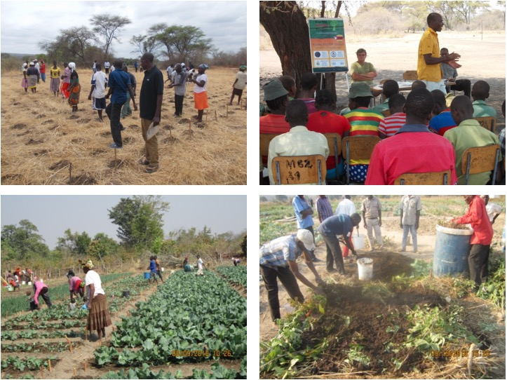
Figure 5: Training on improved agriculture in community garden

BEEKEEPING
Beekeeping has been continuously implemented successfully during this monitoring period under review. The most noticeable part has been the number of occupied hives, which stands at approximately 50% of a total of 730 KTB which have been distributed to 287 beneficiaries across the project area since the project start. This activity has been shown to improve livelihoods in general but especially during lean times when other crops have faltered or as an additional income source.
A total of 2,847 kg of honey was produced during the first period (From July 1, 2016 to June 30, 2017), which was a respectable decrease from the 3,442 kg recorded during the year 2015 to 2016. During the second period (From July 1, 2017 to June 30, 2018), there were 4,803 kg of honey recorded. For the third period (From July 1, 2018 to June 30, 2019), a total of 7,754 kg of honey were produced. Below is the breakdown of honey harvest recorded and income generated per district during the monitoring period under review:
- Binga
  - 1st period (From 01 July 2016 to 30 June 2017)
    - Total number of beneficiaries = 55
    - Total recorded honey harvested = 644 kg
    - Total recorded income = $530.00
  - 2nd period (From 01 July 2017 to 30 June 2018)
    - Total number of beneficiaries = 55
    - Total recorded honey harvested = 1,347 kg
    - Total recorded income = $1,343.00
  - 3rd period (From 01 July 2018 to 30 June 2019)
    - Total number of beneficiaries = 22
    - Total recorded honey harvested = 1,181 kg
    - Total recorded income = $1,953.00

- Nyaminyami
  - 1st period (From 01 July 2016 to 30 June 2017)
    - Total number of beneficiaries = 58
    - Total recorded honey harvested = 516 kg
    - Total recorded income = $445.00
  - 2nd period (From 01 July 2017 to 30 June 2018)
    - Total number of beneficiaries = 58
    - Total recorded honey harvested = 897 kg
    - Total recorded income = $1,223.00
  - 3rd period (From 01 July 2018 to 30 June 2019)
    - Total number of beneficiaries = 32
    - Total recorded honey harvested = 787 kg
    - Total recorded income = $885.00

- Hurungwe
  - 1st period (From 01 July 2016 to 30 June 2017)
    - Total number of beneficiaries = 84
    - Total recorded honey harvested = 1,125 kg
    - Total recorded income = $1,390.00
  - 2nd period (From 01 July 2017 to 30 June 2018)
    - Total number of beneficiaries = 62
    - Total recorded honey harvested = 1,147 kg
    - Total recorded income = $977.50
  - 3rd period (From 01 July 2018 to 30 June 2019)
    - Total number of beneficiaries = 159
    - Total recorded honey harvested = 3,128 kg
    - Total recorded income = $20,420.00

- Mbire
  - 1st period (From 01 July 2016 to 30 June 2017)
    - Total number of beneficiaries = 124
    - Total recorded honey harvested = 562 kg
    - Total recorded income = $374.00
  - 2nd period (From 01 July 2017 to 30 June 2018)
    - Total number of beneficiaries = 132
    - Total recorded honey harvested = 1,412 kg
    - Total recorded income = $2,231.00
  - 3rd period (From 01 July 2018 to 30 June 2019)
    - Total number of beneficiaries = 149
    - Total recorded honey harvested = 2,658 kg
    - Total recorded income = $7,278.62
This gives a total recorded income of $39,050. It should be noted that not all the honey harvested was sold. Some of it was consumed at household level and some of it was also barter-traded which, if assigned a monetary value, would significantly increase the recorded income. The Kariba REDD+ Project views this as a very positive impact in the lives of the beneficiaries. The 2018-2019 period was one of the best seasons since the project start date and can be attributed to the increased training and ongoing support and awareness. An average household of 4.4 members per household equates to a total of 1,254, 1,044 and 1,593 direct and indirect beneficiaries during the first, second and third harvest year, respectively.
The Kariba REDD+ Project aims to continue enhancing this activity through additional trainings, support of materials and assistance in establishing markets for the honey.
Please, see Map 10 below for the distribution of beneficiaries of beekeeping activities implemented per ward.
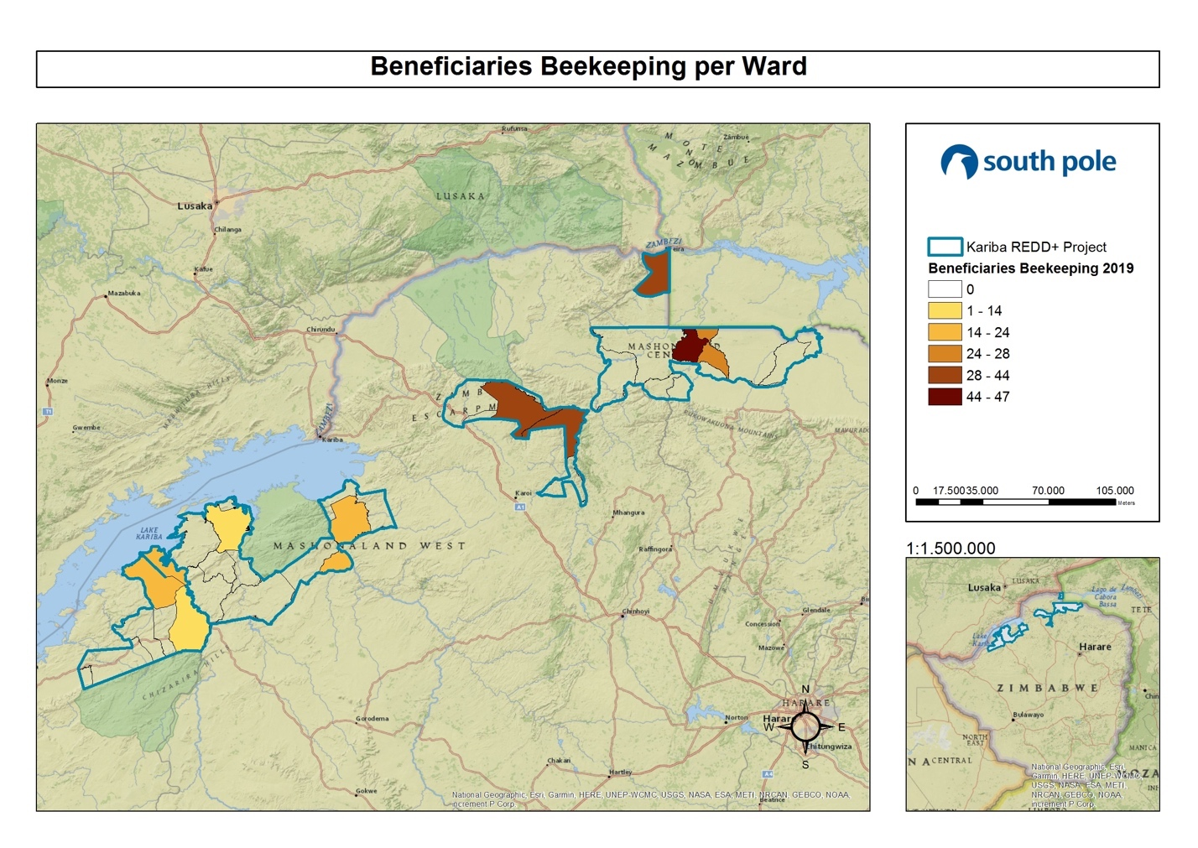
Map 10: Distribution of beneficiaries of beekeeping activities implemented per ward

Trainings (Figure 6) for the first period were conducted by “Foundations for Farming” who provided the trainers and training material. Training was done at district level where a central location was used as a training center or base. In September 2016, three separate one-day trainings were carried out. From March to May 2017, beekeeping training consisted of three-day events per ward and was recorded as one single training event per activity, covering theory and fieldwork as well as ToT.
For the second period, Trainings were conducted by an organization called “Sustainable Agricultural Technologies (SAT)” who provided the trainers and training material. Training was done at district level where a central location was used as a training center or base. In May 2018, four separate 1.5-day trainings were carried out including ToT (training of trainers). Then from May to June 2018, trainings consisted of a three-day event per ward and recorded as a single training event, covering theory and fieldwork.
During the third period, trainings were conducted by the community’s own ToT. After recognizing the number of ToT trainings and refresher trainings done since the project start, the KRP decided to give the communities an opportunity to show how far they have come in regard to independence. KRP provided the training material. Training was done at ward level where a central location was used as a training center or base. In May 2019, combined Gardening and beekeeping trainings were done for a full 3 days, where 1.5 days were spent training gardening and 1.5 days were spent training beekeeping at ward level for the general community members. These trainings covered theory and fieldwork and were assisted and supported by our OGM.
A breakdown of the trainings per district as follows:
- Binga
  - 1st period (From 01 July 2016 to 30 June 2017): 6 trainings for 237 people
  - 2nd period (From 01 July 2017 to 30 June 2018): 11 trainings for 137 people
  - 3rd period (From 01 July 2018 to 30 June 2019): 9 trainings with 113 people

- Nyaminyami
  - 1st period (From 01 July 2016 to 30 June 2017): 2 trainings for 17 people
  - 2nd period (From 01 July 2017 to 30 June 2018): 9 trainings for 184 people
  - 3rd period (From 01 July 2018 to 30 June 2019): 17 trainings with 961 people

- Hurungwe
  - 1st period (From 01 July 2016 to 30 June 2017): 6 trainings for 313 people
  - 2nd period (From 01 July 2017 to 30 June 2018): 1 training for 1 person. This was a ToT training and the ward level trainings were done after the monitoring period thus recorded under the next monitoring period
  - 3rd period (From 01 July 2018 to 30 June 2019): 14 trainings 963 people

- Mbire
  - 1st period (From 01 July 2016 to 30 June 2017): 8 trainings for 349 people
  - 2nd period (From 01 July 2017 to 30 June 2018): 11 trainings for 502 people
  - 3rd period (From 01 July 2018 to 30 June 2019): 13 trainings 790 people
The total training of the first, second, and third period were 22, 32, and 53 trainings, respectively. Evidence of training on beekeeping is provided in the Supporting Documents, Training, Attendance Register, Beekeeping Training. Additional evidence on trainings can be provided upon request.
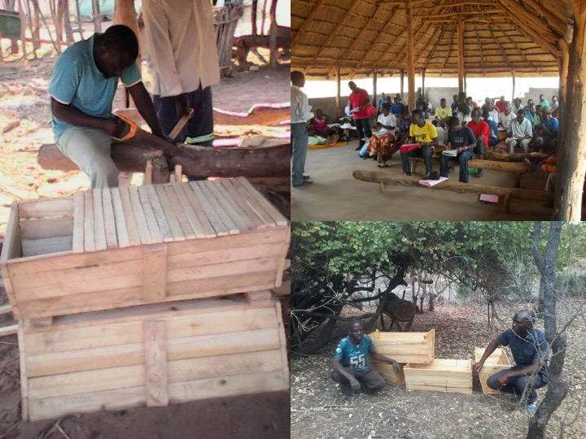
Figure 6: Training on beekeeping
FUELWOOD PLANTATION
This activity is a 2nd phase project activity with the goal of providing an alternative to curing tobacco, as well as for construction, cooking and fencing and other domestic use. The Kariba REDD+ Project embarked on the initial steps to implement these plantations during the early part 2016. The “Forestry Commission”, who has the technical expertise, will assist with training. During the first period (July 1, 2016 to June 30, 2017) under review there have been 18 additional trainings done, all between September and December at the end of the 2016 season. Also, instead of just focusing on planting eucalyptus trees, the project has decided to incorporate additional multi-purpose trees such as fruit trees and Moringa oleifera which would be of value to the communities. The location of these nurseries would also serve as a meeting point for trainings and awareness. A total of 28,700 planting pockets have been distributed up to July 2017, primarily between September 2016 and December 2016. The seeds for the multi-purpose trees were sourced locally by the beneficiaries.
During the second period (July 1, 2017 to June 30, 2018) under review there have been 39,510 seedlings redirected to the general communities, some through sales and some as donations from school nurseries. This excludes any income generated from the sale of Moringa oleifera that have added value to the communities. The fuel wood plantations project is still at the nursery stage at this time.
For the third period between July 1, 2018 and June 30, 2019, there have been 80 seedlings redirected as donations and 36 seedlings sold to the general communities. In addition, 200 planting pockets were given to a new group of community members in Binga as an incentive to start a nursery. The fuel wood plantations project is still at nursery stage for this time.
The breakdown of the planting pockets received is as follows:
- Binga
  - 1st period (From 01 July 2016 to 30 June 2017): 10,000 planting pockets.
  - 2nd period (From 01 July 2017 to 30 June 2018): 7,000 seedlings sold to surrounding community, earning $3,500.
  - 3rd period (From 01 July 2018 to 30 June 2019): The nurseries in Binga did not make any sales or donations during this monitoring period. However, 200 planting pockets were distributed to a new group of community members who intent to start a new nursery next rainy season.

- Nyaminyami
  - 1st period (From 01 July 2016 to 30 June 2017): 3,700 planting pockets.
  - 2nd period (From 01 July 2017 to 30 June 2018): From the planting pockets, which were distributed previously, 3 schools have managed to make a combined small income of $42.20 from moringa leaves sold.
  - 3rd period (From 01 July 2018 to 30 June 2019): There is 1 small plantation and 4 small nurseries that have continued to be active during this monitoring period, however they have not sold any trees.

- Hurungwe
  - 1st period (From 01 July 2016 to 30 June 2017): 10,000 planting pockets.
  - 2nd period (From 01 July 2017 to 30 June 2018): 32,510 assorted seedlings were redistributed as a donation to the general community by the school nurseries.
  - 3rd period (From 01 July 2018 to 30 June 2019): There has been no change since the figures reported for the previous monitored year. Many of the distributed seedlings are now growing.

- Mbire
  - 1st period (From 01 July 2016 to 30 June 2017): 5,000 planting pockets.
  - 2nd period (From 01 July 2017 to 30 June 2018): The planting pockets previously distributed were for a eucalyptus plantation and is still in the growing phase.
  - 3rd period (From 01 July 2018 to 30 June 2019): There is 1 small eucalyptus nursery/plantation and they also donated 80 trees to the general community and sold 36 seedlings for $9.00.
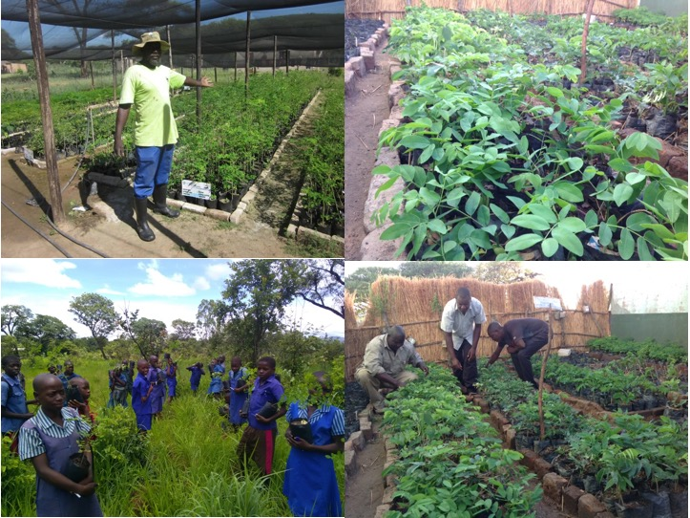
Figure 7: School supporting on indigenous trees and fuel wood seeding
SOCIAL FORESTRY
This activity continues to be implemented and explored. Moringa oleifera is still being readily harvested for a small local market. Baobab powder and other indigenous trees are on the radar and recently we have had an increase in market interest. We are hoping that a more positive break through will be realized soon.
Moringa oleifera tree has naturalized in the project area as a local tree with amazing benefits both physically for general health and well-being and financially for the community members. The tree is highly nutritious and is also valued internationally in cosmetics and health products. During the first period from July 2016 to June 2017, six schools benefitted in varying ways and four schools continued to benefit in varying ways between July 2017 and June 2018, mostly from income earned from the sale of the dried leaves. Between July 2018 and June 2019, three schools (two in Binga and one in Mbire) continued to benefit from income earned from the sale of the dried moringa leaves and four schools in Hurungwe had propagated tree seedlings that were all donated back to the general communities. This activity is not restricted to schools only, and general community members are also encouraged to harness resources from natural trees. This shows the potential to impact individual households in the project area. It is anticipated that the use of moringa trees will hopefully become a valuable source of cash income for the communities in the near future.

The breakdowns of the beneficiaries that have participated and benefitted from this activity are as follow:
- Binga
  - 1st period (From 01 July 2016 to 30 June 2017): 4 schools and general community members generated a combined total of $3,317.00.
  - 2nd period (From 01 July 2017 to 30 June 2018): 3 schools and general community members generated a combined total of $8,938.57.
  - 3rd period (From 01 July 2018 to 30 June 2019): 2 schools and general community members generated a combined total of $4,746.92.

- Nyaminyami
  - 1st period (From 01 July 2016 to 30 June 2017): 1 school and general community generated a combined total of $1,029.00.
  - 2nd period (From 01 July 2017 to 30 June 2018): General community generated a combined total of $2,000.04.
  - 3rd period (From 01 July 2018 to 30 June 2019): General community generated a combined total of $363.56.

- Hurungwe
  - 1st period (From 01 July 2016 to 30 June 2017): This area has not yet harvested anything as the trees are still growing.
  - 2nd period (From 01 July 2017 to 30 June 2018): This area has not yet harvested anything yet.
  - 3rd period (From 01 July 2018 to 30 June 2019): This area has not harvested any moringa yet and tree seedlings propagated were donated to the general communities.

- Mbire
  - 1st period (From 01 July 2016 to 30 June 2017): 2 schools and general community generated a combined total of $2,515.00.
  - 2nd period (From 01 July 2017 to 30 June 2018): 1 school and general community generated a combined total of $9,896.08
  - 3rd period (From 01 July 2018 to 30 June 2019): 1 school and general community generated a combined total of $2,252.03.

For the first period of July 2016 to June 2017, a total of 7 schools and over 150 community members benefitted from the use of moringa trees with a combined total income of $6,861.00 recorded. During July 2017 to June 2018, a total of 3 schools and over 500 community members benefitted from the use of moringa trees with a combined total income of $20,834.69 generated. From July 2018 to June 2019, a total of 3 schools and over 500 community members benefitted from the use of moringa trees with a combined total income of $7,362.51 generated.

BIOGAS DIGESTER
During this monitoring period going from 01 July 2016 to 30 June 2019, the project focused on the installation of a biogas digester that is more conservative than using fuel wood for cooking. Chitsungo hospital in Mbire district is the only referral hospital for the district, catering for 13 clinics and has been having serious power challenges due to erratic electricity supplies and power cuts. The hospital has been using over 90 tons of fuel wood annually, with costs as high as $24,000.
In response to the challenge mentioned, the Kariba REDD+ project decided to construct 20 cubic biogas at Chitsungo hospital. This biogas digester was commissioned by HON. D. Karoro, Deputy Minister of Lands, Agriculture, Water, Climate and Rural Resettlement on October 18, 2018. The biogas digester lights up 4 stoves, which is adequate for the hospital’s daily needs. The biogas digester produces approximately 5,000 kg of methane gas by using 50 kg of cow dung, which is enough for two weeks energy needs in the hospital. The biogas digester has saved the hospital roughly $12,000 in expenses annually.
The biogas digester has provided an alternative to the hospital basic energy needs, and the hospital has since stopped using firewood, thereby saving a lot on deforestation. Moreover, the slurry that comes out of the biogas digester as waste is a very good form of organic manure that can be used in gardens.
This activity has been promoted to other institutes such as schools and clinics to start looking into setting up biogas digesters as well. This project activity is not only adapted in Mbire district but right across the country of Zimbabwe. This is a big step forward to combating deforestation and global warming.
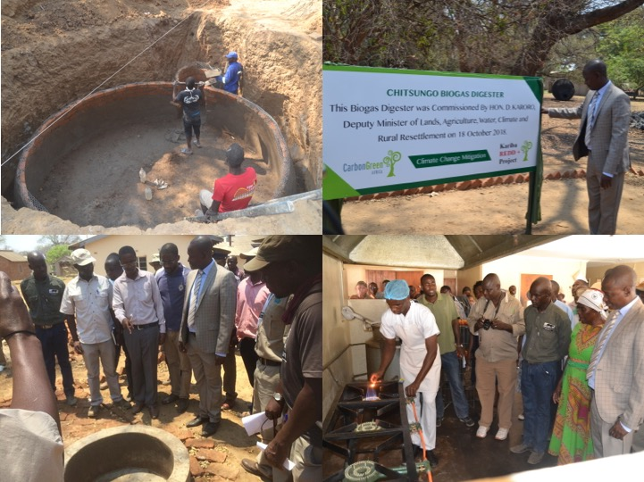
Figure 8: Implementing biogas digester for cooking at Chitsungo hospital
FIRE MANAGEMENT
The 1st period (From 01 July 2016 to 30 June 2017)
This has been an important activity since the project start date. 168 man-days were recorded as
spent on fire management and roads. There are 67 recorded community firefighting teams and they have all been supported with an assortment of firefighting equipment including knapsack sprayers, sickles, hoes and shovels. A total of 17 community-based fireguards covering a distance of approximately 1,500 km were recorded, primarily in the Hurungwe district that has historically been viewed as an area very susceptible to wild fires.
In addition to this, between July 2016 and June 2017, CGA has also repaired and maintained approximately 467 km of bush roads that assist as fireguards across the project area. Along these same roads early burning (controlled fire burns) was carried out for approximately 350 km.
The 2nd period (From 01 July 2017 to 30 June 2018)
There were 77 man-days recorded as spent on fire management and roads. There are 67 recorded community firefighting teams and they have all been supported with an assortment of firefighting equipment including knapsack sprayers, sickles, hoes and shovels. A total of 16 community-based fireguards covering a distance of approximately 525 km have been recorded across the project area.
In addition to this, CGA has also repaired and maintained approximately 693.5 km of bush roads
between July 2017 and June 2018 across the project area, which assist as fireguards. It was also along these same roads and other areas in the bush, which were identified as vulnerable to fire where early burning was done. Approximately 649.5 km of early burning (controlled fire burns) was carried out by OGM.

The 3rd period (From 01 July 2018 to 30 June 2019)
There were 179 man-days recorded as spent on fire management and roads between OGM and communities. There are 102 recorded community fire awareness meetings and the firefighting committees are still using an assortment of firefighting equipment such as knapsack sprayers, sickles, hoes and shovels distributed during previous seasons. A total of 423 fireguards between OGM and communities covering a distance of approximately 1,143 km were recorded across the project area. A total of 216 of these community-based fireguards are in Hurungwe, a district historically known for bad dry season fires.
In addition to this, CGA has also repaired and maintained approximately 177 km of bush roads between July 2018 and June 2019 across the project area, which assist as fireguards. However, it should be noted that this exercise had not yet been completed as of the end of this monitoring period which is ongoing through July, and the balance of roads will be submitted in the next report. It was also along these same roads and other areas in the bush identified as vulnerable to fire where early burning was done. Approximately 1,143 km of early burning (controlled fire burns) was jointly carried out by OGM and communities. The positive impact early burning is having is supported by the increase in visual numbers of small tree seedlings which have been seen to survive in some areas. It is mostly these small seedlings, which are burned during the late season hot fires.

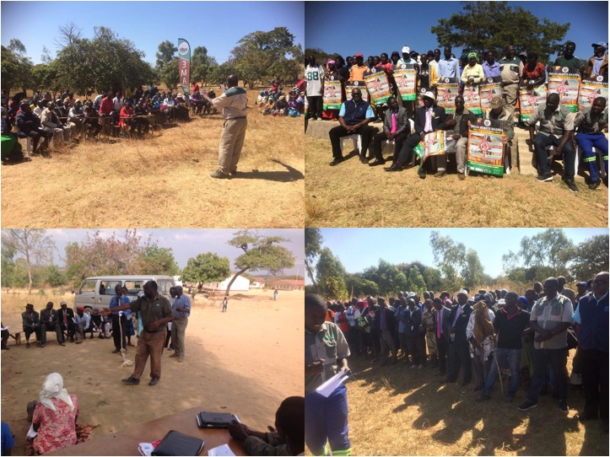
Figure 9: Fire-fighting training workshops in the project area

This protection of habitat together with good anti-poaching has also seen an increase in numbers of wildlife particularly in the Nyaminyami district.
A breakdown of the fire management activity per district during this monitoring period from July 1, 2016 to June 30, 2019 is as follows:

- Binga
  - 1st period (From 01 July 2016 to 30 June 2017):
20 Firefighting committees, approximately 130 km of roads were maintained and approximately 650 km of early burning done across all the wards in the project area.
  - 2nd period (From 01 July 2017 to 30 June 2018):
20 Firefighting committees, approximately 15 km roads and early burning was done in the
project area.
  - 3rd period (From 01 July 2018 to 30 June 2019):
7 Firefighting committees, approximately 183 km early burning was done along roads in the project area, doubling as fireguards.

- Nyaminyami
  - 1st period (From 01 July 2016 to 30 June 2017):
18 Firefighting committees, 4 village fireguards extending approximately 40 km around the communities, approximately 70 km of roads maintained, approximately 80 km of early burning done.
  - 2nd period (From 01 July 2017 to 30 June 2018):
18 Firefighting committees, 13 village fireguards including schools, gardens, beekeepers did approximately 8,4 km early burning around the communities, approximately 312 km of roads were maintained, approximately 426 km of early burning done was done by OGM.
  - 3rd period (From 01 July 2018 to 30 June 2019):
18 Firefighting committees, 16 village fireguards including schools, gardens, beekeepers and OGM did approximately 253 km early burning around the communities, approximately 15 km of roads were maintained, approximately 124 km of early burning was done.

- Hurungwe
  - 1st period (From 01 July 2016 to 30 June 2017):
13 Firefighting committees, 5 ward-based fire guards extending an approximate total distance of 833 km around communities, approximately 155 km of roads maintained and approximately 75 km of early burning done.
  - 2nd period (From 01 July 2017 to 30 June 2018):
13 Firefighting committees, 5 ward-based fireguards extending an approximate total
of 75 km of early burning and approximately 155 km of roads maintained.
  - 3rd period (From 01 July 2018 to 30 June 2019):
20 Firefighting committees, 216 ward-based fireguards extending an approximate total of 370 km of early burning and approximately 145 km of roads maintained.

- Mbire
  - 1st period (From 01 July 2016 to 30 June 2017):
16 Firefighting committees, approximately 300 km of roads maintained, approximately 313 km of early burning done.
  - 2nd period (From 01 July 2017 to 30 June 2018):
16 Firefighting committees, approximately 211.5 km of roads maintained, approximately
133.5 km of early burning done.
  - 3rd period (From 01 July 2018 to 30 June 2019):
16 Firefighting committees, approximately 18.5 km of roads maintained, approximately 56.4 km of early burning done.
The project aims to continue enhancing this activity through continued road maintenance and early burning, continued fire awareness and firefighting training.
ALTERNATIVE AND SUSTAINABLE CONSTRUCTION (BRICK MAKING)
During this monitoring period of July 1, 2016 to June 30, 2019, this activity has not yet been implemented. A competitively priced alternative compared to cost of local bricks has not been found yet.

ON THE GROUND MANAGEMENT TEAMS (OGM)
The project has four OGM Teams covering the four project areas. Each team has successfully managed to fulfill its obligations as per supplied reports to the CGA head office on a regular basis. These obligations include the following:
- Maintenance and resuscitation of boreholes and water pumps provided.
- Prevention of fire.
- Maintaining roads for accessibility.
- Constantly facilitating the relations to the local authorities through meetings and general interaction.
- Receiving feedback and grievances from the local communities through meetings and general interaction.
- Carrying out the proper monitoring requirements according to the applied standards.
Borehole resuscitation and maintenance
The aim of this project activity is to secure and access clean water for public utility. Before the Kariba REDD+ project started, communities have been suffering from water challenges because the water system was down. Local Authorities and CGA were engaged to install boreholes for local people in the project area. Safe potable drinking water can be considered as the very essence of life itself, and borehole resuscitation and maintenance has been an immense benefit to the communities because each borehole impacts more than 250 people. During the first, second and third period of this monitoring period, the Kariba REDD+ Project has managed to maintain 119, 138 and 147 boreholes as part of the ongoing maintenance of the previously reported boreholes which were resuscitated. This activity has had a profound impact on the lives of the communities in these areas and saves many family members the very challenging task of walking many kilometers to fetch water from long distances. The total number of people estimated to have been positively impacted by this activity is over 37,000 people.
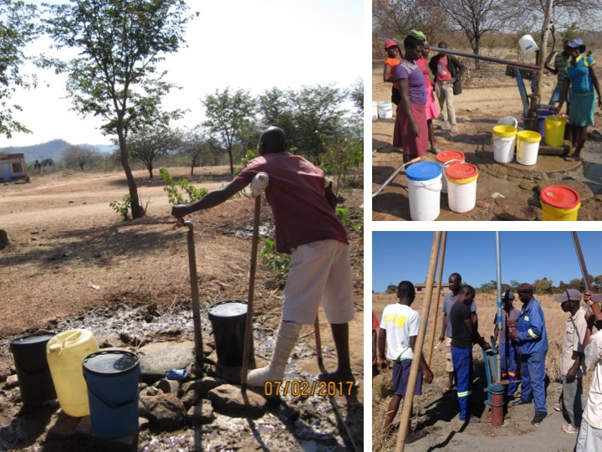
Figure 10: Community mobilization for boreholes resuscitation

The breakdown of boreholes per district is summarized below:
- Binga
  - 1st period (From 01 July 2016 to 30 June 2017): 3 boreholes.
  - 2nd period (From 01 July 2017 to 30 June 2018): 12 boreholes.
  - 3rd period (From 01 July 2018 to 30 June 2019): 13 boreholes.

- Nyaminyami
  - 1st period (From 01 July 2016 to 30 June 2017): 15 boreholes.
  - 2nd period (From 01 July 2017 to 30 June 2018): 15 boreholes.
  - 3rd period (From 01 July 2018 to 30 June 2019): 13 boreholes.

- Hurungwe
  - 1st period (From 01 July 2016 to 30 June 2017): 16 boreholes.
  - 2nd period (From 01 July 2017 to 30 June 2018): 19 boreholes.
  - 3rd period (From 01 July 2018 to 30 June 2019): 20 boreholes.

- Mbire
  - 1st period (From 01 July 2016 to 30 June 2017): 85 boreholes.
  - 2nd period (From 01 July 2017 to 30 June 2018): 92 boreholes.
  - 3rd period (From 01 July 2018 to 30 June 2019): 101 boreholes.
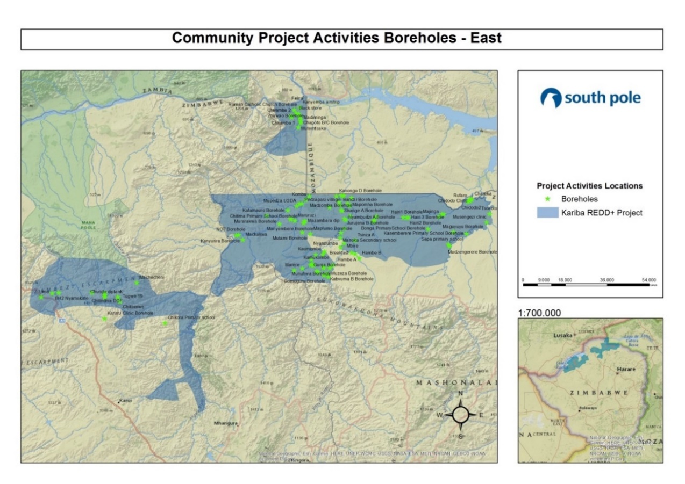
Please, see Map 11 and Map 12 below for boreholes location.

Map 11: Location of boreholes in the Eastern part of the project

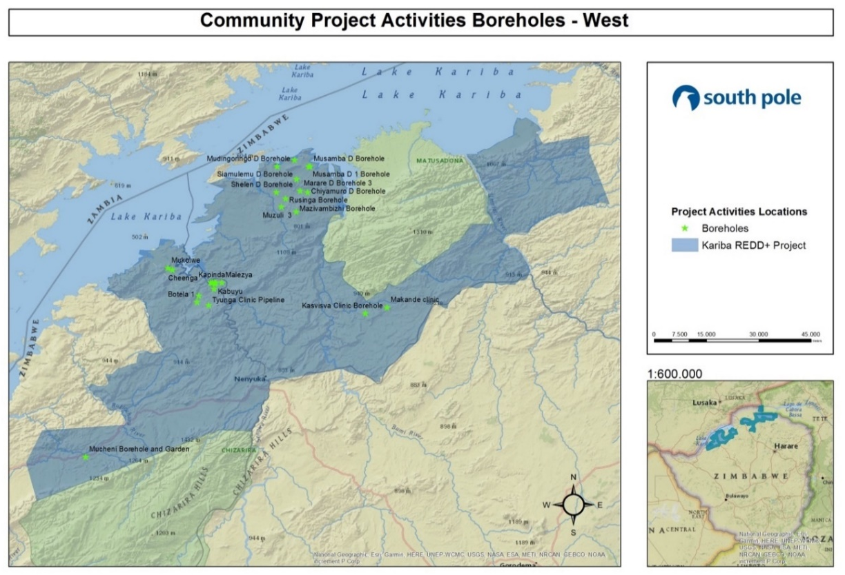
Map 12: Location of boreholes in the Western part of the project

Community meetings are ongoing all the time. It is an important way to build and maintain the relationship with community members, local authorities and CGA. Project related issues, project activity implementation and any new potential activities that would improve livelihoods and at the same time reduce deforestation are discussed during these meetings (for evidence of community meeting, please refer to the Supporting Documents, Community Meetings). It is also the time that any grievances are addressed. However, to date, no grievances have ever been received as a result of the project. Only continual requests for more support have been made. This is of course not considered a grievance, but rather a positive response where the project is concerned.
The following shows the number of community meetings held per district during this monitoring period of July 1, 2016 to June 30, 2019. These meetings cover CF, gardening, beekeeping, fire awareness, environmental awareness related to climate change and the Kariba REDD+ Project and general community meetings.
- Binga
  - 1st period (From 01 July 2016 to 30 June 2017): 15 community meetings
  - 2nd period (From 01 July 2017 to 30 June 2018): 6 community meetings
  - 3rd period (From 01 July 2018 to 30 June 2019): 76 community meetings

- Nyaminyami
  - 1st period (From 01 July 2016 to 30 June 2017): 4 community meetings
  - 2nd period (From 01 July 2017 to 30 June 2018): 3 community meetings
  - 3rd period (From 01 July 2018 to 30 June 2019): 87 community meetings

- Hurungwe
  - 1st period (From 01 July 2016 to 30 June 2017): 10 community meetings
  - 2nd period (From 01 July 2017 to 30 June 2018): 2 community meetings
  - 3rd period (From 01 July 2018 to 30 June 2019): 26 community meetings

- Mbire
  - 1st period (From 01 July 2016 to 30 June 2017): 18 community meetings
  - 2nd period (From 01 July 2017 to 30 June 2018): 6 community meetings
  - 3rd period (From 01 July 2018 to 30 June 2019): 24 community meetings
This gives a total of 277 meetings in the project during this monitoring period of July 1, 2016 to June 30, 2019. Having these community meetings has increased the general communities’ understanding of the project, the aims and objectives of the Kariba REDD+ Project and also their roles and responsibilities to communities within the project, thus continuously bridging the gap of understanding all round.
Monitoring on biodiversity has been validated and verified for double gold standard based on high value biodiversity, which occurs in the area. Biodiversity monitoring is being implemented to monitor wildlife and tree species. Wildlife monitoring is done every month using two principle methods: “walking-based” monitoring and “vehicle-based” monitoring. Walking-based monitoring is restricted to council and CGA game scouts who record animal sightings and tracks whilst on foot patrol, and vehicle-based monitoring is done by OGM who record animal sightings and tracks whilst driving between communities. The recordings also include total number of man days spent monitoring, number of snares collected, number and species of animals poached, and number of poachers arrested. This is all compared with the number of man days spent monitoring over time to assess what the impact is. It should be noted that the total number of animals recorded does not reflect the actual population, but are sightings, so in some cases the same animal could have been recorded more than once on different days. This data is available under the Supporting Documents, CCB Monitoring, Biodiversity Monitoring, ‘Kariba biodiversity wildlife datasheet’ document. Tree species are monitored using the 235 permanent forest inventory plots inside the project area (data is available under the Supporting Documents, CCB Monitoring, Biodiversity Monitoring, Tree Biodiversity). Further information is also presented under section 5.3.2.
COMMUNITY AND PROJECT SUSTAINABILITY FUND
The following additional inputs have been provided to general community members, local leaders and authorities and schools etc. and the following summary is a general list of the variety of inputs provided:
The 1st period (From 01 July 2016 to 30 June 2017)
- Fuel – 345 liters of fuel was provided to local leaders, local law enforcement officers, Agritex field officers, garden water pumps and local football clubs.
- Education – 29 schools have benefitted. 7 schools in Hurungwe, 3 schools in Binga, 2 schools in Nyaminyami and 17 schools in Mbire have received benefits from the projects, primarily through boreholes that have been maintained, thus providing safe drinking water.
- Training – Thirty-five flip charts and stands were handed to Agritex extension workers to aid and assist with training and teaching in CF, gardening and beekeeping. In addition, 35 KTB hives, bee suites and smokers were handed to out to 1 Agritex trainer per ward for community training purposes.
- Agriculture – Inputs for 35 demonstration plots, 1 per ward, were handed to the communities along with 11 flexi hand pumps which were given as prizes at agricultural field days, 298 bamboo seedlings, wire for gardens and $119.00 worth of compost was purchased.
- Health – 9 Clinics have benefitted. Clean water sources have been provided to one clinic in Binga, two in Nyaminyami, one in Hurungwe and five in Mbire.
- General – Four bags of cement were provided for gardening support.
- Employment – Additional $285.00 was spent on employment of community members to undertake various tasks in the communities such as digging wells for water.
The 2nd period (From 01 July 2017 to 30 June 2018)

- Fuel – 230 liters of fuel was provided to local leaders, local law enforcement officers, Agritex field officers, garden water pumps and local football clubs.
- Education – A total of 20 schools across the project area have received benefits from the Kariba REDD+ Project in a variety of different ways ranging from resuscitated boreholes, moringa, seedlings provided or sale of moringa and cement for building classroom blocks, roof repairs or toilets and the construction of a strong room and safe for one school to keep important documents for exams and other development needs. A separate list is available upon request.
- Training – The following stationery was handed to the communities for training purposes for CF, gardening and beekeeping: 80 flip charts, 5,250 pens, 5,250 note books and 114 marker pens. In addition, 60 KTB hives, 12 bees suites and smokers were handed out to 60 new beekeeping beneficiaries.
- Agriculture – Inputs for 40 demonstration plots were handed to the communities and 1 new school garden was established, 10 flexi hand pumps were given as prizes at agricultural field days and 20 grams of eucalypts seed. There were also handout materials, stationery, notebooks etc. provided for the attendees of the trainings.
- Health – 14 clinics across the project area have benefited from support through the Kariba REDD+ Project either as ongoing access to clean water from borehole maintenance or from cement for development of structural needs at some clinics. A specific list of the clinics and their benefit is available separately upon request.
- General – 1,050 bags Cement were provided to the communities across the project area for infrastructural development such as new classroom blocks, foundations for a new clinic, mother shelters in waiting areas at clinics, school toilets, community dip tank etc. Some of these developments have not been completed and are ongoing. In addition, basic gardening support material has been provided for a new school garden. A 20 km long water pipeline has been resuscitated with new piping, storage tanks, taps and related hardware for a community of approximately 5,000 people, which includes providing water for two schools, one clinic and the community members’ gardens and domestic use. This same community also had their footbridge restored, which is their only way to reach the outside world during the rainy season when the rivers are in flood. Two submersible borehole pumps with solar modules were also installed.
- Employment – Additional $1,285.00 was spent on employment of community members to undertake various tasks in the communities.
The 3rd period (From 01 July 2018 to 30 June 2019)

- Fuel – 525 liters of fuel was provided to local leaders, local law enforcement officers and Environmental Management Agency.
- Education – A total of 43 schools across the project area received benefits from the Kariba REDD+ Project in a variety of different ways ranging from resuscitated boreholes, like in the Makande school in Nyaminyami where a solar borehole was installed and the Negande primary and secondary schools, also in Nyaminyami, who benefitted from a 20 km pipeline which was resuscitated by the KRP. They also received water storage tanks. In addition, 3 schools in Hurungwe received assorted stationary. There are also a good number of schools that continue to benefit from boreholes that were previously maintained and are still functioning, as well as ongoing moringa production and sales.
The Kariba REDD+ Project also introduced the “Pan African Conservation Education” (PACE) educational material to 14 schools and a few general community members in Nyaminyami as a pilot project. The PACE material can be used as a teaching aid for all subjects and has practical experiments which can help communities and children to come up with their own ways to better solve problems in their livelihoods. A submersible pump with water storage tank, cement and piping was also purchased for Madzomba primary school in Mbire.
Cement that was purchased in the previous year has now been used where in Mbire some new classroom blocks were built to various levels ranging from foundations only to roof level and will be completed with next funds allocation.
It is also important to know that Nyamakate primary school in Hurungwe received tanks and piping and a well-organized water storage system was put in place in previous years and is presently producing very good crops and the school is positively benefitting from its sales. One of the main reasons this was set up at this school was they could conduct experiments on different crops as part of the agricultural curriculum. A large percentage of the income figures recorded under gardening section 4.3.2 above has come from this garden.
- Training – The following stationery was handed to the communities for training purposes for CF, gardening and beekeeping: 185 flip charts, 10,500 pens, 10,500 note books and 344 marker pens and food that was provided during the trainings.
Members of the Nyambudzi garden in Mbire were also assisted with training for fish farming as an extension of the gardening project.
- Agriculture – Inputs for 37 demonstration plots and 89 planting strings were handed to the communities along with flexi hand pumps that were given as prizes at agricultural field days. There were also multiple assorted seed packs for gardens such as Nyamakate school (Hurungwe), Chikova school (Hurungwe), Chitindiva school (Hurungwe), Tashinga garden (Hurungwe), Majinga school (Mbire) and Kubatana garden (Mbire).
Multiple gardens in Nagande community (Nyaminyami) also benefitted from a 20 km long pipeline that was resuscitated and cement was purchased for repairs to the Tyaba irrigation scheme water outlet in Binga.
A water pump was purchased for the Nyambudzi garden and fencing for the Nyambudzi garden fish project was also purchased along with 1,000 fingerlings to kick-start the project.
For beekeeping, 10 new KTB hives were purchased for distribution to the Mbire community being 5 hives for ward 3 and 5 hives for ward 17 beekeepers. The 60 KTB hives distributed to the new beekeepers in the previous monitoring period in Mbire. Ward 1 is almost at 100% occupancy and they have started harvesting honey and their yield is included under section 4.3.2 above.
- Health – 14 clinics across the project area have benefited from support through the Kariba REDD+ Project either as ongoing access to clean water from borehole maintenance or from cement for development of structural needs at some clinics, such as waiting areas in Mbire. Two pipelines were installed: one new pipeline purchased to repair the water system at Siabuwa clinic in Binga, which is the main clinic in the Binga project area; and a 2nd pipeline maintained for the Chunga clinic water system, also in Binga.
A biogas digester was also built for the Chitsungo mission hospital in Mbire. This is the main district hospital that formerly used 9 to 12 tons of wood monthly for their domestic needs, but now has access to biogas. Then the Makande clinic in Nyaminyami also received a submersible borehole pump and water storage tank stand that serves the clinic and general community.
- General – 1,277 bags of cement was provided to the communities across the project area for infrastructural development, like the new dam being built in Binga, repairs to the Tyaba irrigation outlet, new classroom blocks in Mbire, foundations for a new clinic in ward 23 of Binga, sheltered waiting areas for mothers at clinics in Mbire, school toilets in Binga, community dip tank in Mbire, window and door frames for a school in Binga. Some of these developments have not been completed but are at different levels of progress and are on-going. In addition, basic gardening support materials have been provided for a new school garden called Chikova school garden. A 20 km long water pipeline has been resuscitated in Nyaminyami with new piping, storage tanks, taps and related hardware for a community of approximately 5,000 people, which includes providing water for 2 schools, 1 clinic and the community member’s gardens and domestic use. This same community also had their footbridge restored, which is their only way to reach the outside world during the rainy season when the rivers are in flood. One solar borehole pump was also installed at Makande School in Nyaminyami ,and is also used by the general community.
- Employment – Additional $18,341.00 was spent on employment of community members to undertake various tasks in the communities ranging from early burning and road maintenance to payment for community-based trainers to train at ward level for CF, gardening and beekeeping.
Please, see Map 13 and Map 14 below for location of schools benefited from the project and Map 15 and Map 16 below for location of clinics benefited from the project.
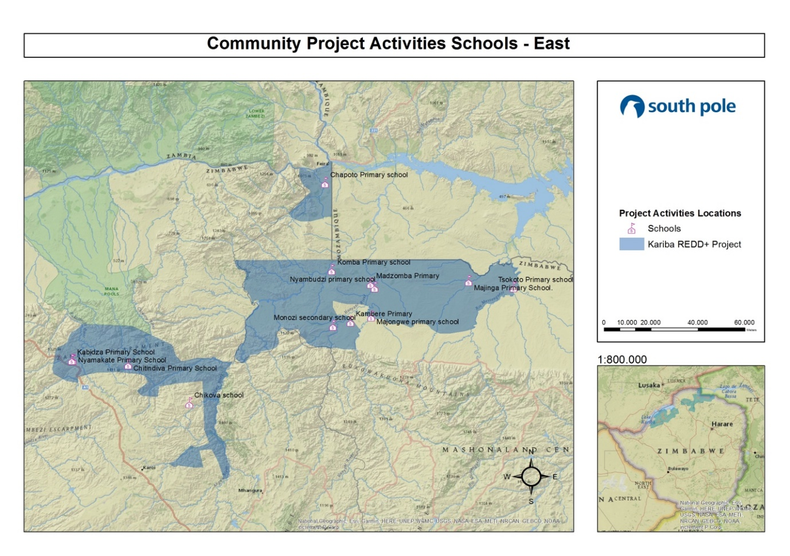
Map 13: Location of schools supported in the Eastern part of the project

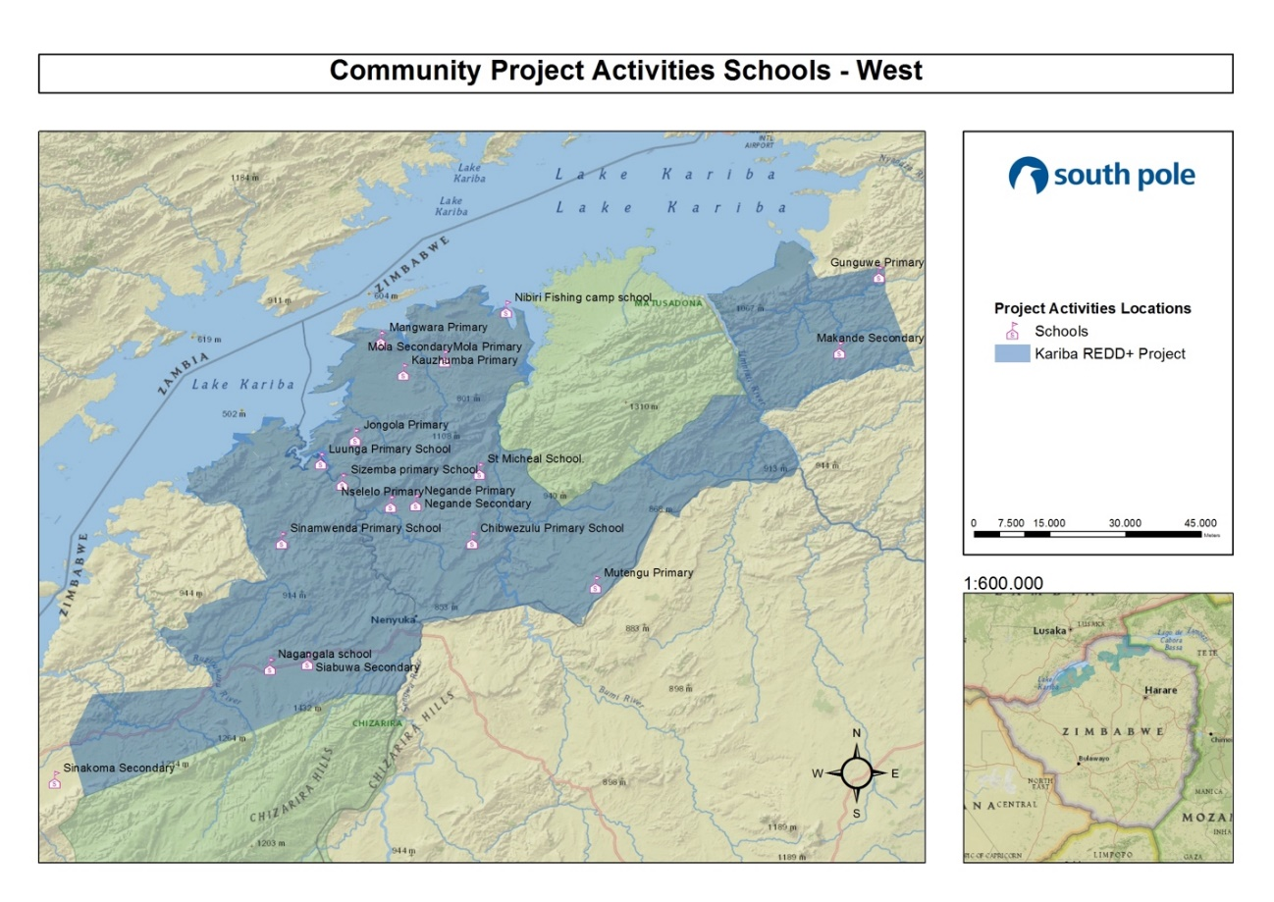
Map 14: Location of schools supported in the Western part of the project

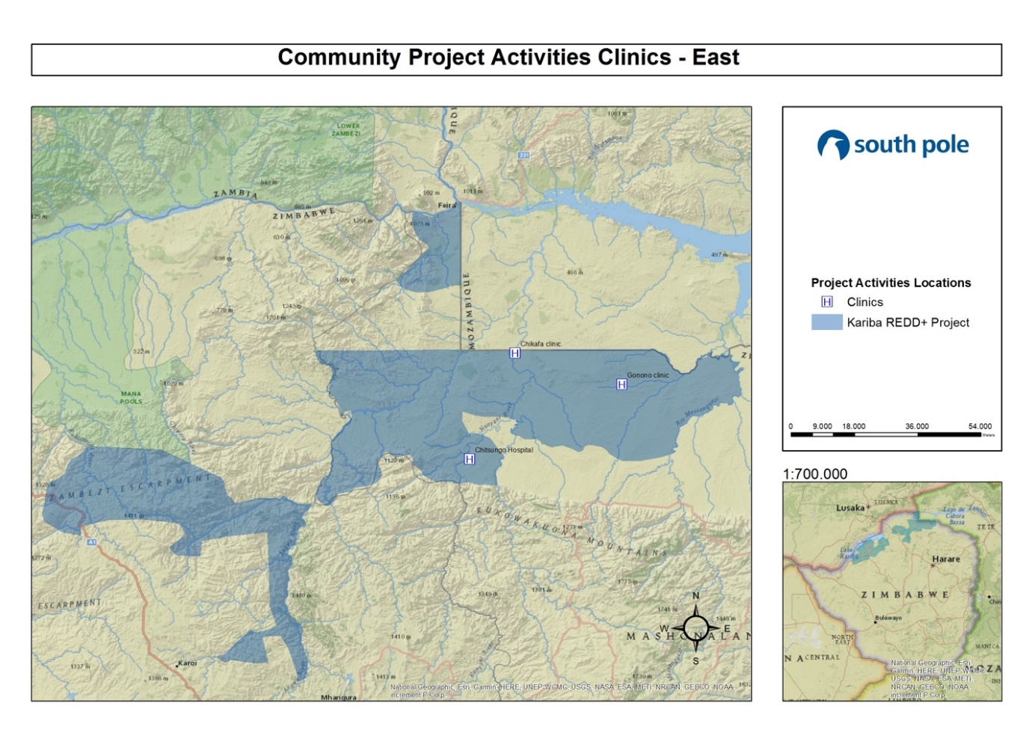
Map 15: Location of clinics supported in Eastern part of the project

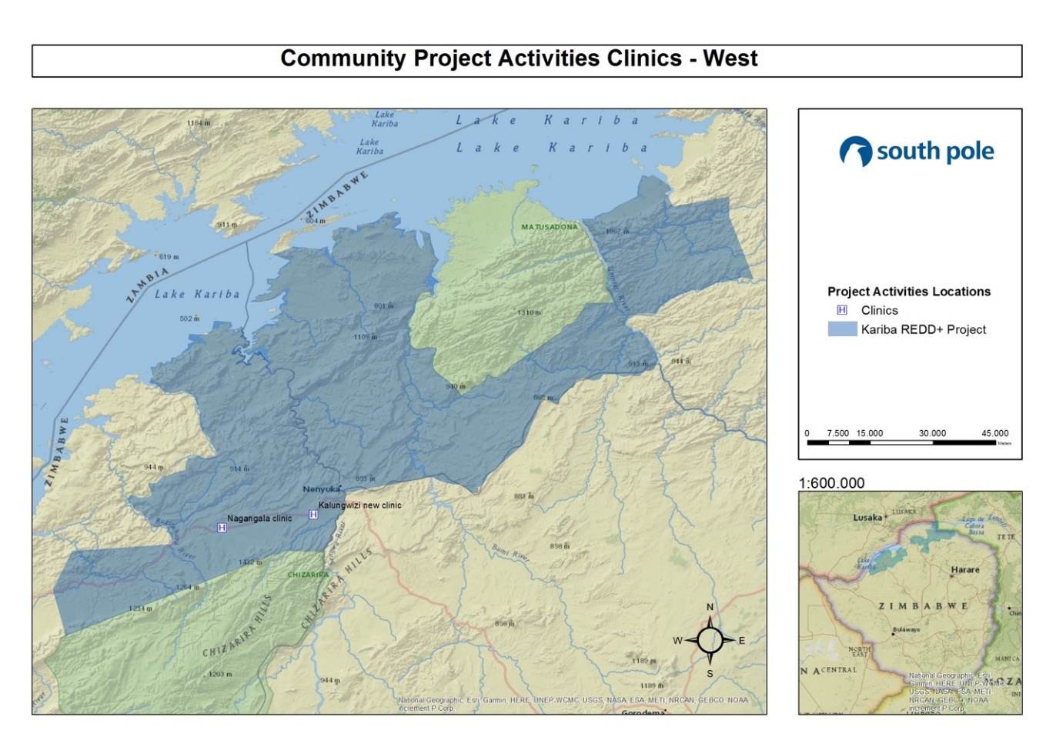
Map 16: Location of clinics supported in Western part of the project

NEWSLETTER
During this monitoring period the project has been publishing a monthly letter for distribution to the RDC’s and local communities, with a total of 33 newsletters. To date one newsletter per project area per month has been published. Sometimes more than one month is covered in one newsletter. These newsletters have covered topics such as general project progress, environmental awareness, grievances if any, vacancies if any and general topics. These newsletters have been published in English, Shona and Tonga and have been distributed to the RDC’s and local communities by the CGA OGM teams. Copies of these newsletters are available in the Supporting documents, Newsletter.
The project aims to enhance the above obligations through increased communications, workshops and awareness to the local authorities and local communities.

Dissemination of Monitoring Plan and Results (CM3.3)
According to the already validated information from the CCB PDD, page 62, a full monitoring plan was submitted to the CCBS for publication on its website and remains available.
The results of the monitoring are disseminated and made public in the project area. The results of the monitoring are published in the monitoring reports, which is not only published online for public consultation, but was also distributed locally through summaries, which have been translated to Tonga and Shona and distributed in the project area. Community members have also been invited to comment on the Monitoring Report and its Summary (refer to section 2.3).

Optional Criterion: Exceptional Community Benefits
This section has not been subject to validation, therefore is not applicable. However, for a description of the project’s impact on the poorest segments of the local communities, please refer to the CCB PDD.

Barriers to Benefits (GL2.3)
Not applicable.

Protections for Poorer and More Vulnerable Households and Individuals (GL2.4)
Not applicable.

Biodiversity

Net Positive Biodiversity Impacts

Biodiversity Changes (B1.1)
As described in the CCB PDD, section B1.1, page 74, in the without project case, the wildlife populations would continue to decline sharply due to undamped deforestation and poaching. The Kariba REDD+ Project not only reduces the deforestation rate in the project area significantly, it also reduces the poaching pressure on wildlife through patrolling and further anti‐poaching measures.
The Kariba REDD+ Project’s changes and impacts on the biodiversity have been monitored according to the project’s monitoring plan and Standard Operation Procedure available under the Supporting Documents, SOPs, Biodiversity Monitoring SOP.

High Conservation Value Protection (B1.2)
The identified HCV1 is a major focus of the project. Through reduced forest loss and poaching pressure, the project significantly improves the habitat conditions for threatened wildlife in the area, resulting in affecting positively HCV 1.
The project will use different plant species during its agricultural activities and woodlot establishments. Invasive species are not used. Species used in the Kariba REDD+ Project include the following:
Garlic (Allium sativum)
Peanuts (Arachis hypogaea)
Chilli Peppers (Capsicum spp.)
Eucalyptus (Eucalyptus robusta and E. tereticornis for fire wood and tobacco curing)
Soy Bean (Glycine max)
Jatropha (Jatropha curcas; for oil and life fences)
Cassava (Manihotes culenta)
Moringa (Moringa oleifera is used as vegetable and fodder)
Sugar Bean (Phaseolus lunatus)
Sorghum (Sorghum bicolor)
Cowpea (Vigna unguiculata)
Maize (Zea mays)

Invasive Species (B1.3)
As stated in the PDD, no invasive or exotic species were used in the project activities. In addition to that, as the project evolves, new species could be introduced, taking into account their invasive potential. No species that are likely to have a negative effect will be used. The population of any invasive species does not increase as a result of the project.

Impacts of Non-native Species (B1.4)
Refer to CCB PDD, section B1.4, page 76, for possible effects of non-native species used in the project.

GMO Exclusion (B1.5)
As stated in the CCB PDD, no GMOs are used in the project activities.

Offsite Biodiversity Impacts

Negative Offsite Biodiversity Impact Mitigation (B2.2)
No negative offsite biodiversity impacts have been identified. Rather, by providing a corridor for wildlife in three adjacent national parks, the project has had a positive impact on biodiversity outside the project area. This positive impact could also include improvement of the habitat conditions for the species. Leakage of poaching activities is not possible as there is hardly any wildlife left outside the project area, except for in the well‐guarded national parks. Furthermore, the poachers mostly live within the project area where they benefit from the project activities. The poachers have a low level of mobility and cannot easily displace themselves to faraway locations.
Although no negative impacts are envisioned, any negative impact will be addressed by active adaptive management. In addition to that, biodiversity is monitored and the effect of the project on biodiversity is positive.

Net Offsite Biodiversity Benefits (B2.3)
The project activities do not cause negative offsite biodiversity impacts. On the contrary, the project activities only enhance biodiversity benefits for the areas outside the project area. The project area hosts painted dogs (Lycaon pictus), which are an endangered (EN) species according to the IUCN. Furthermore, the project area contains many individuals of vulnerable (VU) species, such as the African elephant (Loxodonta africana), lion (Panthera leo),and cheetah (Acinonyx jubatus), as well as critically endangered (CR) species such as leopard (Panthera pardus) and white‐headed vulture (Trigonoceps occipitalis).
Endangered species are at the focus of the project’s biodiversity impact monitoring. A significant population of different threatened species has been recorded since the project start in 2011, showing the positive effect of the project, especially with regard to anti-poaching activities. For detailed information on the positive impacts the project activities have had on biodiversity, please refer to section 5.3.2 of this document.

Biodiversity Impact Monitoring

Biodiversity Monitoring Plan Development (B3.3)
Not applicable.

Biodiversity Monitoring Results (B3.1, B3.2)
For biodiversity impact monitoring, please refer to the project’s monitoring plan and Standard Operation Procedure available under the Supporting Documents, SOPs, Biodiversity Monitoring SOP.
The results of the project’s biodiversity impact monitoring are given in Table 8. It shows a significant presence of wildlife in the area, including 16 threatened and endangered species. Namely elephants, hippopotamus and pangolin are very commonly seen in the project area (Figure 11). The number of sightings of threatened species per team-day shows a higher value in 2019 when comparing to previous years, which means the effectiveness to enhance HCV is increasing. Evidence of biodiversity monitoring and anti-poaching activities are presented under the Supporting Documents, CCB Monitoring, Biodiversity Monitoring, Supporting Documents.
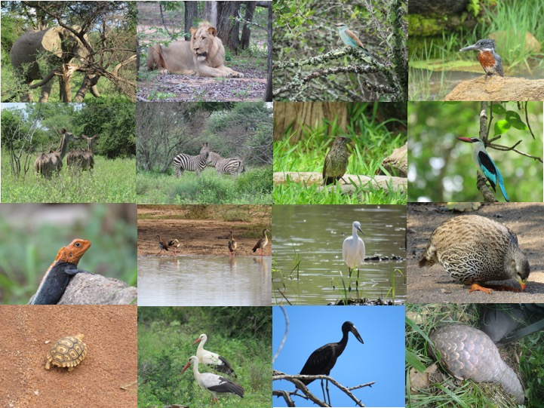

Figure 11: Fauna spotted in the project area during patrols

Table 8: Sightings and tracks of wildlife in the project from 1st July 2016 until 30th June 2019

Year |  | 2016 | 2017 | 2018 | 2019
Team-days spent monitoring |  | 536 | 1,027 | 1,003 | 420
Species | Status
Lion | VU | 38 | 122 | 58 | 55
Elephant | VU | 1,194 | 2,763 | 2,396 | 2,084
Black Rhino | CR | 0 | 0 | 0 | 0
Common Hippo | VU | 689 | 3,865 | 3,942 | 2,412
Cheetah | VU | 0 | 0 | 0 | 0
Southern Ground hornbill | VU | 27 | 72 | 68 | 106
Hooded Vulture | CR | 69 | 34 | 29 | 82
Egyptian Vulture | EN | 0 | 0 | 0 | 0
Cape Vulture | EN | 0 | 0 | 0 | 0
Lappet‐faced vulture | EN | 0 | 6 | 4 | 7
White‐headed vulture | CR | 0 | 47 | 62 | 58
White-backed Vulture | CR | 254 | 202 | 200 | 74
Martial Eagle | VU | 8 | 30 | 19 | 24
Crowned Eagle | NT | 6 | 30 | 23 | 10
Bateleur | NT | 4 | 37 | 27 | 19
Lilian's Lovebird | NT | 97 | 1,847 | 2,342 | 959
Painted Dog | EN | 0 | 2 | 50 | 31
Leopard | CR | 30 | 46 | 52 | 43
Buffalo |  | 591 | 728 | 547 | 251
Zebra |  | 53 | 133 | 140 | 106
Other spp. |  | 1,815 | 7,724 | 12,704 | 10,410
Total threatened spp. |  | 2,424 | 9,069 | 9,232 | 5,943
Total all spp. |  | 4,783 | 17,700 | 22,675 | 14,040
Threatened spp. / team day |  | 4.52 | 8.83 | 9.20 | 11.74
All spp. / team day |  | 8.92 | 17.23 | 22.61 | 33.43

Tree diversity was assessed during the forest inventory monitoring campaign throughout the monitoring period. The monitoring campaign was fully integrated into the carbon stock assessment implemented on 235 Permanent Sampling Plots (PSPs) of 254 m² each. During the campaign, a total of 165 tree species were identified. Of the about 11,083 living trees measured, the ten most common identify species are shown below in Table 9. The complete analysis is provided in the Supporting Documents, CCB Monitoring, Tree Biodiversity.
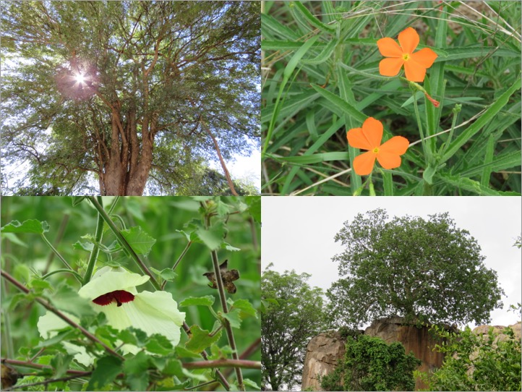
Figure 12: Flora species in the project area

Table 9: Ten most common tree species during field campaign
Tree species | Abundance (%)
Colophospermum mopane | 11.52
Combretum celastroides | 6.79
Combretum apiculatum | 6.23
Diospyros quiloensis | 5.89
Julbernardia globiflora | 5.78
Combretum eleagnoides | 4.35
Brachystegia boehmii | 3.77
Combretum mossambicense | 2.89
Croton longipedicellatus | 2.66
Freisoldelsia obovata | 2.40
Total | 52.29

The project’s positive impact on biodiversity is particularly visible in its anti-poaching measures, e.g. through snares which are removed from the forest habitats. Anti‐poaching patrols are implemented in close cooperation with the local RDCs. Patrols monitor wildlife, remove snares and other traps from the forest, inform local communities and, where necessary, enforce the existing anti‐poaching regulations. Table 10: below gives an overview over the project’s anti‐poaching activities for this monitoring period. During a total of over 3,876 team-days spent patrolling, over 3,400 snares were removed from the field and over 120 poachers were arrested, which means a substantial relief of pressure on the local wildlife. Nevertheless, poached wildlife was still recorded, including the poaching of threatened species, especially elephants. Elephants are typically poached by commercial poachers, which partly come from outside the project area. Poaching of other animals such as Impala is typically done by locals for subsistence. Poaching is illegal in the project area and would be illegal even without the project.
The project is working on further reducing the pressure of poaching on the local wildlife, as a necessary complementary activity to habitat conversation, in order to further increase the project’s positive impact on the local biodiversity. For further information on wildlife monitoring and anti-poaching, please refer to the Supporting documents, CCB monitoring, Biodiversity monitoring, file “Kariba_biodiversity_wildlife_datasheet”.
Table 10: Overview of project’s anti-poaching activities from 1st January 2016 until 30th June 2019
Year |  |  | 2016 | 2017 | 2018 |  |  | 2019
Team-days spent patrolling |  |  | 768 | 1,275 | 1,235 |  |  | 598
No of snares removed |  |  | 496 | 968 | 1,323 |  |  | 712
No of poachers arrested |  |  | 25 | 41 | 29 |  |  | 31
Poached species |  | Status
Lion |  | VU | 0 | 0 | 0 |  | 0
Elephant |  | VU | 2 | 7 | 2 |  | 2
Black Rhino |  | CR | 0 | 0 | 0 |  | 0
Common Hippo |  | VU | 0 | 0 | 1 |  | 0
Cheetah |  | VU | 0 | 0 | 0 |  | 0
Southern Ground hornbill |  | VU | 0 | 0 | 0 |  | 0
Lappet‐faced vulture |  | EN | 0 | 0 | 0 |  | 0
White‐headed vulture |  | CR | 0 | 0 | 0 |  | 0
Painted Dog |  | EN | 0 | 0 | 0 |  | 0
Buffalo |  |  | 0 | 1 | 4 |  | 2
Leopard |  | CR | 0 | 0 | 0 |  | 0
Impala |  |  | 1 | 5 | 7 |  | 3
Other spp. |  |  | 15 | 33 | 41 |  | 14
Total threatened spp. |  |  | 2 | 7 |  | 3 |  |  | 2
Total all spp. |  |  | 18 | 46 |  | 55 |  |  | 21

Monitoring Plan and Results Dissemination (B3.3)
According to the already validated information from the CCB PDD, page 62, a full monitoring plan was submitted to the CCBS for dissemination on its website and remains available.
The results of the monitoring are disseminated and made public in the project area. The results of the monitoring are published in the monitoring reports, which is not only published online for public consultation, but was also distributed locally through summaries, which have been translated to Tonga and Shona and distributed in the project area. Community members have also been invited to comment on the Monitoring Report and its summary (refer to section 2.3).

Additional Project Implementation Information
There is no additional information related to the implementation of the project.

Additional Project Impact Information
There is not additional project impact information.

Land with woody vegetation that meets an internationally accepted definition (e.g., UNFCCC, FAO or IPCC) of what constitutes a forest, which includes threshold parameters, such as minimum forest area, tree height and level of crown cover, and may include mature, secondary, degraded and wetland forests (VCS Program Definitions)
Reduced emissions from deforestation and forest degradation (REDD) - Activities that reduce GHG emissions by slowing or stopping conversion of forests to non-forest land and/or reduce the degradation of forest land where forest biomass is lost (VCS Program Definitions)
Afforestation, reforestation and revegetation (ARR) - Activities that increase carbon stocks in woody biomass (and in some cases soils) by establishing, increasing and/or restoring vegetative cover through the planting, sowing and/or human-assisted natural regeneration of woody vegetation (VCS Program Definitions)
Improved forest management (IFM) - Activities that change forest management practices and increase carbon stock on forest lands managed for wood products such as saw timber, pulpwood and fuelwood (VCS Program Definitions)
Although this figure is not monitored directly, it is estimated that around each person implementing conservation farming techniques implement the techniques in 1 ha of land, summing to 4,810 ha of improved land management.
This data is not included in the report because it is not a requirement, but the project team have supporting documents to support this figure.
Although the data is not monitored directly, an estimation of 10,178 female community members were trained. This includes women who have benefitted from trainings, as well as direct beneficiaries of project activities
Employed in project activities means people directly working on project activities in return for compensation (financial or otherwise), including employees, contracted workers, sub-contracted workers and community members that are paid to carry out project-related work.
Full time equivalency is calculated as the total number of hours worked (by full-time, part-time, temporary and/or seasonal staff) divided by the average number of hours worked in full-time jobs within the country, region or economic territory (adapted from UN System of National Accounts (1993) paragraphs 17.14[15.102];[17.28])
Livelihoods are the capabilities, assets (including material and social resources) and activities required for a means of living (Krantz, Lasse, 2001. The Sustainable Livelihood Approach to Poverty Reduction. SIDA). Livelihood benefits may include benefits reported in the Employment metrics of this table.
Although this data is not represented in the Monitoring Report because this was only monitored for the last year of the monitoring report, 123,751 people have improved livelihoods during the period from July 2018 to June 2019. This includes direct and indirect beneficiaries form project activities and includes health, education, borehole resuscitation, trainings etc. For boreholes, a conservative number of 250 people impacted by each borehole was considered. For schools that have received support through educational material, community garden and borehole establishment, the total number of students enrolled are accounted for.
Although this data is not presented in the Monitoring Report, the livelihoods of an estimated 450,784 people were improved since the project started. This is a cumulative figure and includes the general population that have continued to benefit cumulatively.
Although this data is not monitored directly, an estimated 52,125 women have improved livelihoods. This includes women involved in direct project activities, training received and also from resuscitated boreholes. Where boreholes have been included, the total female gender group is used, which includes infants and girls. It should be noted that the figure used for boreholes was 51% of the total recorded number people impacted.
Although this data is not monitored directly, an estimated 164,687 women have improved livelihoods. This is a cumulative figure since project start and so includes women from the same general population. It includes all project activities, trainings and benefits from resuscitated boreholes.
Although this data is not monitored directly, an estimated 89,662 people had access to improved health services for the period from July 2018 to June 2019. This figure is based on the total number of people in the wards where the clinics are located, according to the 2012 population census.
Although this data is not monitored directly, an estimated 104,901 people had access to improved health services. This is the estimated total number of people impacted from boreholes repaired for clinics since the project started. The figures are based on ward level population records from last census in 2012.
Although this data is not monitored directly, an estimated 35,543 women had access to improved health services for the time period from July 2018 to June 2019. It includes the entire female gender group, including infants and girls, who have benefitted as a result of water restoration at clinics or cement provided for renovation or construction.
Although this data is not monitored directly, an estimated 53,500 women had access to improved health services, based on 51% of total population at ward level where the clinics are located. This also includes the entire female gender group, including infants and girls.
Although this data is not presented in the Monitoring Report, education improves for an estimated 14,832 people. The number of students and gender ratio was not always monitored as it was not a requirement under the present methodology. Therefore, an average is used for the estimation.
Although this data is not presented in the Monitoring Report, an estimated 25,136 people had improved education. The number of students and gender ratio was not always monitored as it was not a requirement under the present methodology. Therefore, an average is used for the calculation. A total of 61 schools were recorded to have received support since the project started, either in the form of stationery, or materials for income generating projects such as planting pockets for tree nurseries, from the sale of moringa leaf, or gardening, which is also part of the agriculture-learning curriculum. These are direct benefits, and do not include indirect benefits that may have the potential to improve learning, such as borehole repairs giving children access to clean water.
Although this data is not presented in the Monitoring Report, education improves for an estimated of 7,564 women. The 2012 population census was used for this estimation, in which 51% of the total population is female.
Although this data is not presented in the Monitoring Report, education improved for an estimated 12,819 women. The 2012 population census was used for this estimation, in which 51% of the total population is female.
Although this data is not presented in the Monitoring Report, an estimated 18,743 women experienced improved water quality and/or increased access to drinking water. The 2012 population census was used for this estimation, in which 51% of the total population is female, including infants and girls.
Although this data is not monitored directly, an estimated 22,695 women experienced improved water quality and/or increased access to drinking water. The 2012 population census was used for this estimation, in which 51% of the total population is female, including infants and girls.
Well-being is people’s experience of the quality of their lives. Well-being benefits may include benefits reported in other metrics of this table (e.g. Training, Employment, Health, Education, Water, etc.), but could also include other benefits such as empowerment of community groups, strengthened legal rights to resources, conservation of access to areas of cultural significance, etc.
Although this data is not monitored directly, well-being was improved for an estimated 123,752 people. The impact on the total population, covering all forms of project related activities for both direct and indirect beneficiaries, was estimated using an average of 4.3 members per household.
Although this data is not monitored directly, the wellbeing of an estimated 450,784 people was improved. Cumulative impact since the project start from the same general population for both direct and indirect beneficiaries was estimated based on a 4.3 average per household.
Although this data is not monitored directly, well-being was improved for an estimated 63,114 women. Estimated as 51% of total population.
Although this data is not monitored directly, well-being was improved for an estimated 229,900 women. Estimated as 51% of total population, cumulative from the same general population since the project started.
Biodiversity conservation in this context means areas where specific management measures are being implemented as a part of project activities with an objective of enhancing biodiversity conservation.
Per IUCN’s Red List of Threatened Species
In the absence of direct population or occupancy measures, measurement of reduced threats may be used as evidence of benefit
Timberlake, J. (2000), Biodiversity of the Zambezi basin. Occasional Publications in Biodiversity No. 9, Biodiversity Foundation for Africa, Bulawayo, Zimbabwe. Available online at: http://bit.ly/1Xjsa77
See PD, section 2.4.6.4.
For more information: www.southpole.com
Clarification note: “Project area” definition under VCS is different from CCB second edition.
Sustainable Development Goals Knowledge Platform. Available at: https://sustainabledevelopment.un.org/memberstates/zimbabwe
Zimbabwe Voluntary National Review (VNR) of SDGs For the High Level Political Forum. Available at: https://sustainabledevelopment.un.org/content/documents/15866Zimbabwe.pdf
Additional parameters available at validation are presented under the Supporting documents, ER calculation, Supporting Documents, file ‘Annex3_Parameters at Validation’ as submitted during the project validation.
BIOTROPICA 43(4): 423–432 2011. Available at: http://onlinelibrary.wiley.com/doi/10.1111/j.1744-7429.2010.00713.x/abstract
BIOTROPICA 43(4): 423–432 2011. Available at: http://onlinelibrary.wiley.com/doi/10.1111/j.1744-7429.2010.00713.x/abstract
Available at: http://www.climate-standards.org/?s=kariba
The updated SOPs are provided on Supporting documents, SOPs, Tree and soil SOPs under the title “150812_SOP Tree and soil data collection_2015 version.docx”
IPCC GPG for LULUCF; Chapter 5.5 Quality assurance and quality control
IPCC GPG and Uncertainty management in National GHG Inventories; Ch. 8 QA and QC
IPCC GPG for LULUCF; Chapter 3.2 Forest land
IPCC GPG for LULUCF; Chapter 5.5 Quality assurance and quality control
IPCC GPG and Uncertainty management in National GHG Inventories; Ch. 8 QA and QC
Available at: https://www.vcsprojectdatabase.org/#/ccb-all-project-details/902
Available at: https://www.vcsprojectdatabase.org/#/ccb-all-project-details/902
Available at: https://www.vcsprojectdatabase.org/#/ccb-all-project-details/902

