

MONITORING REPORT

KEPEZKAYA

HYDROELECTRIC POWER PLANT

Document Prepared by Sekans Danışmanlık
Project Title | Kepezkaya Hydroelectric Power Plant Project
Version | 4
Report ID | KPZMONITORING1
Date of Issue | 17 December 2020
Project ID | 954
Monitoring Period | 01-September 2012 to 28-February-2018
Prepared By | SEKANS DANIŞMANLIK
Contact | Konaklar Mah.34330, Yeni Levent-İstanbul  E-mail: sila@sekansdanismanlik.com  Phone: +90 532 438 30 29
Contents
1 Project Details 3
1.1 Summary Description of the Implementation Status of the Project 3
1.2 Sectoral Scope and Project Type 6
1.3 Project Proponent 6
1.4 Other Entities Involved in the Project 7
1.5 Project Start Date 7
1.6 Project Crediting Period 7
1.7 Project Location 7
1.8 Title and Reference of Methodology 8
1.9 Participation under other GHG Programs 8
1.10 Other Forms of Credit 9
1.11 Sustainable Development 9
2 Safeguards 9
2.3 AFOLU-Specific Safeguards 14
3 Implementation Status 14
3.1 Implementation Status of the Project Activity 14
3.2 Deviations 14
3.3 Grouped Projects 15
4 Data and Parameters 15
4.1 Data and Parameters Available at Validation 15
4.2 Data and Parameters Monitored 19
4.3 Monitoring Plan 28
5 Quantification of GHG Emission Reductions and Removals 31
5.1 Baseline Emissions 31
5.2 Project Emissions 34
5.3 Leakage 35
5.4 Net GHG Emission Reductions and Removals 35
APPENDIX I: VOLUME VS AREA CURVE 36

Project Details

Summary Description of the Implementation Status of the Project
Kepezkaya Hydroelectric Power Plant, Karaman is located on the Göksu River in the Eastern Mediterranean region of Turkey. The project is being used only for energy generation purpose and has an Energy Generation License for 48 years and 2 and half months obtained from Energy Market Regulatory Authority (EMRA) in 2007.
The Project Activity is planned as a run-of-river type which is composed of a weir, water intake structures, 3 610 m long conveyance tunnel, a head pond, penstocks and powerhouse equipped with 28.00 MWe installed capacity turbines and other facilities.
As was also explained in the DSI approved project feasibility study report, the Project Activity is a part of the Konya-Çumra 3rd Stage Irrigation Plan of DSI. At the upstream basin of the Kepezkaya HPP, a large-scale irrigation project was conducted by General Directorate of State Hydraulic Works (DSİ). Within the scope of this irrigation project at the upper elevation of 1,000 m of Göksu basin 3 dams: Namely Bağbaşı, Afşar and Bozkır dams.
The purpose of the Kepezkaya HPP is to utilize the hydropower potential of the Göksu river to generate electricity based on a renewable resource and thus to generate Verified Emission Reductions (VERs) by displacing electricity generation from grid connected fossil fuel- fired power plants.
The expected annual energy generation is 107,587 MWh and the estimated amount of GHG emission reduction is 61,443 tonnes CO2e per year in the registered PDD. During its operation during this monitoring period, the actualized net electricity generation is 435,265.15 MWh. By displacing equivalent amount of electricity consumed from the national grid which is mostly comprised of fossil fired power plants, the actual emission reduction has been calculated as 248,579 tonnes CO2 for this monitoring period.
The project has produced positive environmental benefits as displacing the electricity generated by fossil fuel fired power plants by utilising the renewable resources so as to avoid environmental pollution and GHG emissions.

Please see the vintage based comparison of expected and achieved emission reductions for this monitoring period:

Table 1- Expected vs achieved emission reductions

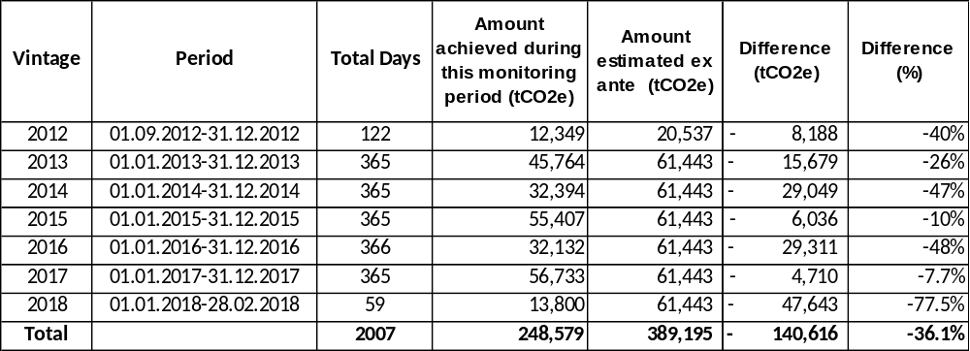

Project timeline is presented in Table 2:

Table 2-Project timeline

Date | Milestone | Reference
12-Sep-06 | Correspondences starts to seek consultancy to develop Carbon asset of the project | Proposal
15-Nov-06 | A proposal was taken from E&C Services GMbH Germany to develop the projects in the pipeline of the mother company | Correspondences
5-Jul-07 | EMRA granted Electricity Production License to Selen Elektrik Üretim A.Ş. | License (see Annex-5in the validated PD)
13-Jul-07 | EIA not Needed Certificate Issued by MoEF Karaman Province Representation | Certificate in Annex 3 of the PDD
28-Jan-08 | Turnkey Engineering Procurement and Construction Contract Signed between Selen Elektrik Uretim A.S. and IC İçtaş İnşaat | Agreement
6-Feb-08 | Loan Agreement Signed | Agreement
18.Mar.08 | Construction start Date | NHS record for the opening of the Work site
2-Apr-08 | Project Owner Was Granted the Ultimate Forestry Permit to operate within the jurisdictions of the forestry authorities’ lands | The ultimate permit proclamation
15-Apr-08 | Electromechanical equipment procurement agreement was signed between IC Içtaş (as the Turnkey EPC Contractor) and Harbin electric Co. | Agreement
1-Jun-08 | Feasibility study Report Finalized | FSR Report
22-Sep-08 | DSI Approval for the Feasibility Study | DSI Approval letter
23-Jan-09 | Water Usage Agreement Signed between Selen and DSI | Agreement
7-Oct-09 | TEIAS Connection Agreement Signed | Agreement
6-Sep-10 | Government officials approved the project to be suitable to be connected to the grid | Ministry of Energy and Natural Resources approval committee report
1-Oct-10 | First Date Electricity is supplied to the grid | October 2010 PMUM Screen Printout
1-Oct-2010/31-Aug-2012 | 1st Monitoring Period | -
01-Sep 2012/28-Feb-2018 | 2nd Monitoring Period | -

The Project Activity is a run-of-river type hydro power plant with a total installed capacity of 28 MW (2 x 14.00 MW). A concrete gravity weir diverts water into the conveyance tunnel with 40 m3/s flow rate capacity. A net water head of 81.57 m (gross head 87.88 m) is formed, and water is discharged into two vertical Francis turbines. A 30 km 33 kV transmission line interconnects to the national grid at the Kepezkaya Basin Transformer Substation. Figure 1 summarizes how the project activity will be operating and what needs to be considered within the physical project boundary.

The project boundary may be seen through Figure 1.

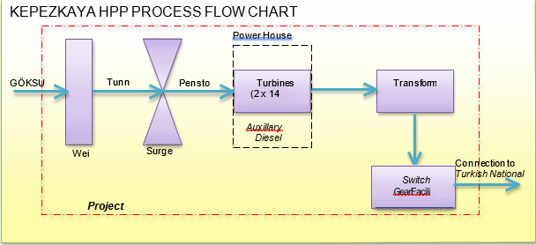

Figure 1. The project boundary of Kepezkaya Hydroelectric Power Plant

Sectoral Scope and Project Type
According to UNFCCC sectoral scopes definition for CDM projects, the Project Activity is included in the Sectoral Scope 1, category “Energy industries (renewable - / nonrenewable sources)”. The project is a single green field investment and is not part of a project group or bundle.

Project Proponent

Organization name | Entek Elektrik Üretim A.Ş.
Contact person | Serkan Dündar
Title | Trade Manager
Address | Köseköy Mah. Yeni Demiryolu Cad. No:70 41250 Kartepe/Kocaeli
Telephone | +90 216 217 11 90
Email | serkan.dundar@entekelektrik.com.tr

Other Entities Involved in the Project

Organization name | Sekans Danışmanlık
Role in the Project | Consultant
Contact person | Sıla Duran
Title | Consultant
Address | Konaklar Mah. 34330,4. Levent - Istanbul
Telephone | -
Email | sila@sekansdanismanlik.com

Project Start Date
The project start date is 01/10/2010.

Project Crediting Period
The Project’s total crediting period is ten years renewable twice: 01/10/2010 – 30/09/2020 (both days are included).

Project Location
The Project Activity is located on the Göksu River in the Eastern Mediterranean region of Turkey, within the Karaman city borders. The power-house is located between the elevations of 682 m and 483 between 36°57’14.99” north and 33°00’28.34” eastlatitudes.

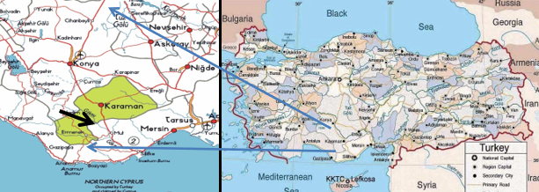
.
Figure 2. Map showing the location of Kepezkaya HEPP on the Göksu River, Karaman,Turkey

Title and Reference of Methodology
The following UNFFCC methodology and its related tools are used:
Approved consolidated baseline and monitoring methodology ACM0002 “Consolidated baseline methodology for grid-connected electricity generation from renewable sources.” Version 13.0.0.
The Approved Methodology refers to the following tools:

“Tool for the demonstration and assessment of additionality” (Version 06) “Tool to calculate the emission factor for an electricity system” (Version 02.2.1),
"Tool to calculate project or leakage CO2 emissions from fossil fuel combustion" (Version 02).

Participation under other GHG Programs
The project has never been included in an emissions trading program or any other binding limits. It has neither received any kind of environmental credits nor been registered under any other GHG programs.

Other Forms of Credit
The project has never been included in an emissions trading program or any other binding limits. It has neither received any kind of environmental credits nor been registered under any other GHG programs.

Sustainable Development

The project produces electricity from renewable energy sources using hydro as the power source and to contribute to Turkey’s growing electricity demand through a sustainable and low carbon technology. The project displaces the same amount of electricity generated by the grid dominated with fossil fired power plants. During its operation in this monitoring period, the actualized net electricity generation is 435,265.15 MWh The project contributes to the Sustainable Development Goal, Affordable and Clean Energy.
The actual emission reduction has been calculated as 248,579 tonnes CO2 for this monitoring period. While this amount of emissions is mitigated, technology transfer is also realized as benefitting from hydropower.
The project contributes to improve the environmental situation in the region and in the country as avoiding fossil fuel-based electricity will enhance the air quality and help to reduce the negative effects on the climate. Through renewable technologies and hydro-based electricity sustainable and climate friendly development is promoted. The project contributes to the Sustainable Development Goal, Climate Action.
During construction and operational period, the project has created employment opportunities for the local community. The project contributes the economic development of the region by providing sustainable energy resources. The project provides workers with a safe and healthy work environment and is not complicit in exposing workers to unsafe or unhealthy work environments. Thus, the project contributes to the Sustainable Development Goal, Decent Work and Economic Growth.

Safeguards

No Net Harm
There isn’t any negative environmental or socio-economic impact.
Noise

The noise levels on Kepezkaya Regulator site, tunneling system and HES site, were could have a negative impact on residentials. The day and night time modelled noise levels around the nearest residential areas are within the standards of the “Day and night noise limits for Rural Areas and Settlement Areas" in accordance with the Article 25 of the Regulations for Evaluation and Management of Environmental Noise announced in the Official Gazette No. 25862 on 01.07.2005.

Waste Management
Wastewater produced by employees is collected in an impermeable septic tank and later they are periodically transferred to wastewater treatment plant.
Regarding the hazardous waste, the lubricant oil is transferred and disposed in line with the regulations.

Water flow
The Project does not have a negative impact on water quality. The regulator is a small reservoir which is enough to retain water for only a few hours. In addition, all vegetation was cleared prior to flooding the area. Therefore, anaerobic conditions and decomposition are not expected to form and will not affect water quality and composition or encourage methane production. A fish passage for fish species has been as the project design and the photo of the passage may be seen in Figure 3. A specially designed fish ladder allows fish to swim upstream and over the dam. Thus, the project will not produce any air or water pollution to the surrounding environment.

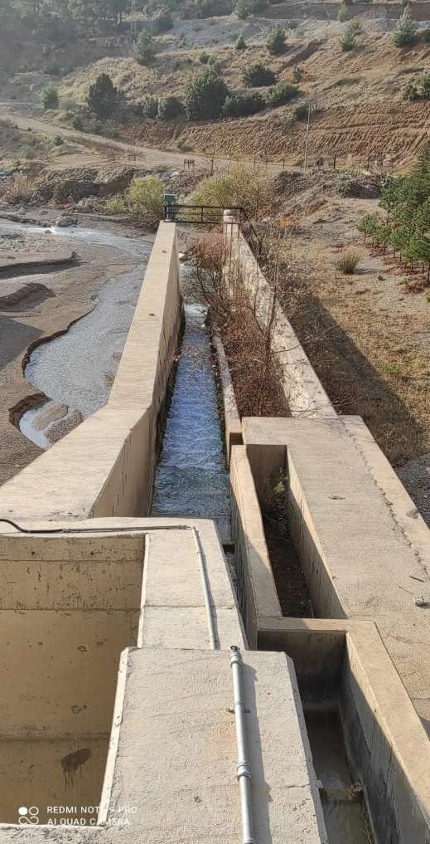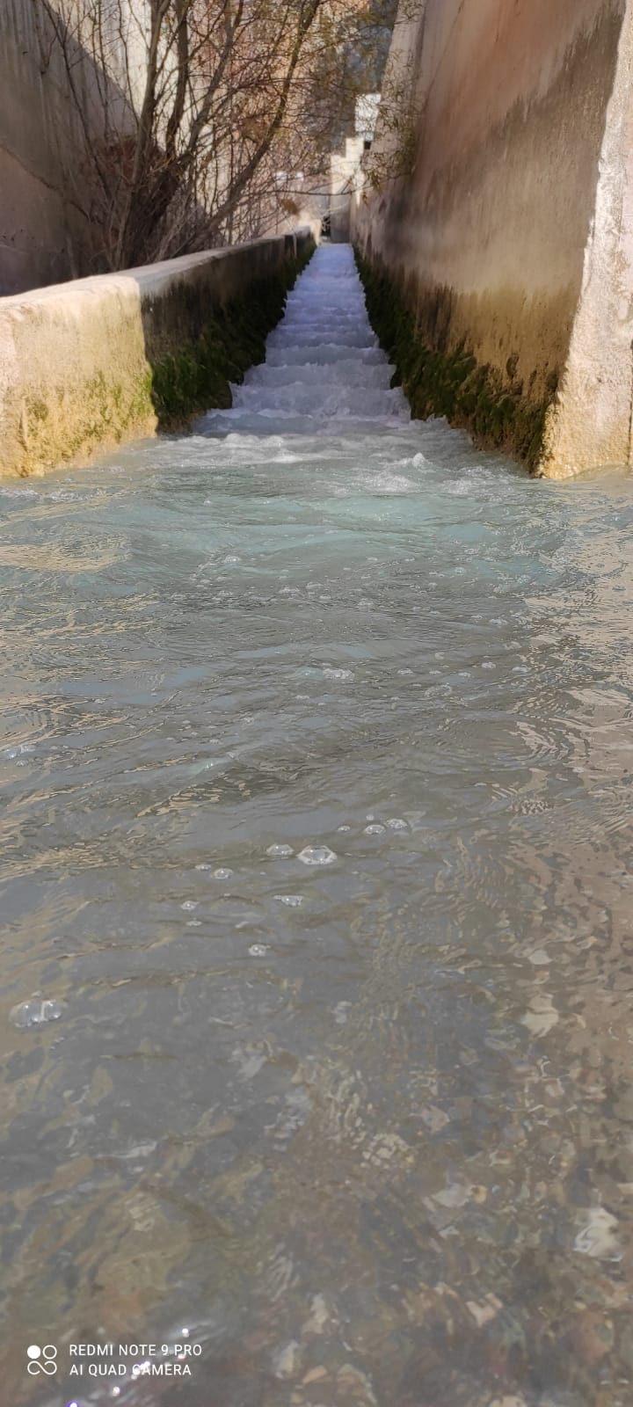
Figure 3.Fish Passage
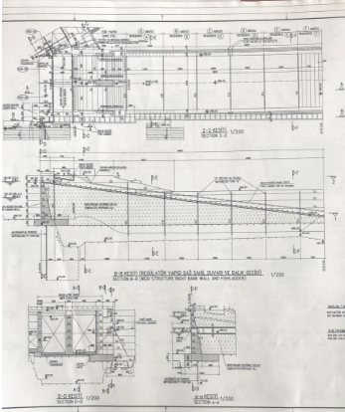
Figure 4.Design of the Fish Passage
Ecology
The project area is not designated as an area for preservation. According to the available literature, there are no rare, endemic, endangered or protected species by national and/or international laws. Fauna and flora species which are included in the Bern Convention or Red Data Book categories were not found in the project area.

It is therefore concluded that the implementation of the project is expected to have only a minor impact on the surrounding environment and regional ecology.
As there was no settlement in the reservoir area, resettlement was not needed for the Project Activity.

Local Stakeholder Consultation

The meeting was organized and conducted by Çınar Mühendislik Müşavirlik ve Proje Hizmetleri Ltd. Şti. This meeting was the first dialogue ever conducted with stakeholders by this large company (the largest in Turkey) which was unfamiliar with the concept and its importance. By doing so, the project contributed to the idea of establishing a dialogue with stakeholders as a common practice in other projects. To prepare for the meeting, key stakeholders were identified and notified about the event. For the participation of officials, phone calls were made to the Karaman Governorship, Provincial Environment and Forestry Directorship (of which 2 persons attended), and the Karaman Mayoralty (The mayor himself could not attend the meeting. However, a separate meeting with him was conducted after the stakeholders meeting). For the participation of the locals, a fax notification and personal invitations were sent to the Mukhtar's (village mayor) offices of Damlapınar, Güzer, Çukurköy and Buçakkışla villages inviting them and the residents of their villages. In addition, the event was advertised in both a regional and a national newspaper, calling for stakeholders to attend the meeting. The ads were published in the Anadolu Manşet Gazette (regional), and the Türkiye Gazette (national).

42 people attended (participant information is available), and the meeting included a presentation, a dialog session, and a personal questionnaire. An informational brochure (can be provided) summarizing all the information presented was handed to all participants with contact information of a representative for any further questions and clarifications. The presentation included:

1. General principals of run-of-river type hydro plants.
2. The specific technical details of the proposed project, including information and location of each component, shown on a topographic map.
3. Environmental impact assessment of the project.

The local villagers asked about employment possibilities. The Owner promised that when hiring unskilled workers during the construction and operation of the project activity, priority was given to the local villagers. Five employees have been employed from the local region.
There was no specific environmental problem that concerned the locals more than others, and environmental issues need to be solved by the government. All people considered clear signs of climate change in the region in recent years.
The contact information of the plant responsible exist at the Mukhtar, the project owner and local community are always in touch. The project owner regularly checks with the Mukhtar if any complaint or a request exists. Any complaint or need from the local community could directly be received by the project owner and appropriate contributions or improvements are made to the local community. The signed letter (dated on 13.01.2020) by Mukhtar, which indicates that contact information of the plant responsible is available to them has been provided to the DOE. During the monitoring period, there hasn’t been any complaint.
There is no update or any change to the project design after the registration of the project.

AFOLU-Specific Safeguards
N/A

Implementation Status

Implementation Status of the Project Activity

The project became operational on 01.10.2010. So far, there have been no events that may impact the GHG emission reductions or removals and monitoring. The description of the implementation and operational status of the project and the installed technology(ies), technical process and equipment are detailed in Section 1.1.
The shareholder structure was changed on 10.04.2015 and the Project has been transferred to Entek Elektrik Üretim A.Ş. The sole Project Proponent is Entek Elektrik Üretim A.Ş.
Other entity involved in the Project was Ekobil Çevre Hizmetleri Danışmanlık Eğt.Tar. Hayv.Mad. İnş. İth. İhr.Tur. ve Tic. Ltd. Şti. in the project description. However, it’s been changed as Sekans Danışmanlık after the first periodic monitoring period.

Deviations

3.2.1. Methodology Deviations
There are no methodology deviations applied during this monitoring period.

3.2.2. Project Description Deviations
The shareholder structure was changed on 10.04.2015 and the Project has been transferred to Entek Elektrik Üretim A.Ş. The sole Project Proponent is Entek Elektrik Üretim A.Ş.
Other entity involved in the Project was Ekobil Çevre Hizmetleri Danışmanlık Eğt.Tar. Hayv.Mad. İnş. İth. İhr.Tur. ve Tic. Ltd. Şti. in the project description. However, it’s been changed as Sekans Danışmanlık after the first periodic monitoring period.

Grouped Projects
There is not a grouped project.

Data and Parameters

Data and Parameters Available at Validation

Data / Parameter | FCi,y
Data unit | Volume Unit (cubic meter)
Description | Amount of fuel i consumed by relevant power plants in Turkey in years, 2008, 2009, 2010.
Source of data | Official publications at the Turkish Electricity Transmission Company (TEIAŞ) Web Site  https://www.teias.gov.tr/tr/turkiye-elektrik-uretim-iletim-istatistikleri
Value applied | Detailed in Annex 2 in the PDD
Justification of choice of data or description of measurement methods and procedures applied | Data used is taken from the TEİAŞ website, which is the website of the Turkish Electricity Distribution Company. The data published on the TEİAŞ website is the most up-to date and reliable data available for the Turkish grid
Purpose of Data | Calculation of baseline emissions
Comments | -

Data / Parameter | NCVi,y
Data unit | GJ/Mass or Volume Unit
Description | Net Calorific Values for fossil fuel type i in year, for the years 2008,  2009 and 2010
Source of data | Regional or national average default values that are reliable and documented in national energy statistics of the Turkish Electricity Transmission Company Web Site  https://www.teias.gov.tr/tr/turkiye-elektrik-uretim-iletim-istatistikleri
Value applied | Detailed in Annex 2 in the PDD
Justification of choice of data or description of measurement methods and procedures applied | Data used is taken from the TEİAŞ website, which is the website of the Turkish Electricity Distribution Company. The data published on the TEİAŞ website is the most up-to date and reliable data available for the Turkish grid.
Purpose of Data | Calculation of baseline emissions
Comments | -

Data / Parameter | EFCO_{2,i,y}
Data unit | tCO2/GJ
Description | CO2 emission factor of fossil fuel type i in year y
Source of data | IPCC default values at the lower limit of the uncertainty at a 95% confidence interval as provided in table 1.4 of Chapter1 of Vol. 2 (Energy) of the 2006 IPCC Guidelines on National GHG Inventories
Value applied | Detailed in Annex 2 in the PDD
Justification of choice of data or description of measurement methods and procedures applied | According to the “Tool to calculate the emission factor for an electricity system” version 02.2.1, if values provided by the fuel supplier of the power plants in invoices or regional or national average defaults values are not available the IPCC default values at the lower limit of uncertainty must be used
Purpose of Data | Calculation of baseline emissions
Comments

Data / Parameter | EGy
Data unit | MWh
Description | Net electricity generated in the project electricity system in other words, net electricity generated and delivered to the grid by all power sources serving the system, not including low-cost / must-run power plants /units, in year y
Source of data | Turkish Electricity Transmission Company Web Site  https://www.teias.gov.tr/tr/turkiye-elektrik-uretim-iletim-istatistikleri
Value applied | Detailed in Annex 2 in the PDD
Justification of choice of data or description of measurement methods and procedures applied | Data used is taken from the TEİAŞ website, which is the website of the Turkish Electricity Distribution Company. The data published on the TEİAŞ website is the most up-to-date and reliable data available for the Turkish grid.
Purpose of Data | Calculation of baseline emissions
Comments | -

Data / Parameter | EG_{m,y}
Data unit | MWh
Description | Net electricity generated and delivered to the grid by power unit m in
Source of data | Turkish Electricity Transmission Company Web Site (www.teias.gov.tr).  Data is extracted from the relevant annexes of the capacity projection reports for the years 2009 and 2010.  The reports are now available through the website of EPDK:  https://www.epdk.org.tr/Detay/Icerik/3-0-66/elektrikuretim-kapasite-projeksiyonlari  The projects that are listed in Gold Standard Registry, VCS project Database, and Blue Registry (VER+ Standard) are deducted.
Value applied | Detailed in Annex 2 in the PDD
Justification of choice of data or description of measurement methods and procedures applied | Data used is taken from the TEİAŞ website, which is the website of the Turkish Electricity Distribution Company. The data published on the TEİAŞ website is the most up-to-date and reliable data available for the Turkish grid.
Purpose of Data | Calculation of baseline emissions
Comments | -

Data / Parameter | n_{m,y}
Data unit | -
Description | Specific electrical efficiency for all relevant energy sources (natural gas, lignite, coal/anthracite, fuel/motor oil
Source of data | 1. Turkish Electricity Transmission Company (TEIAS), http://www.teias.gov.tr  2. European Commission Report (July 2006): Integrated Pollution Prevention and Control (IPPC) - Best Available Techniques for Large Combustion Plants.  3. German Federal Environmental Agency (UBA).
Value applied | Please see Table 14 in the PDD.
Justification of choice of data or description of measurement methods and procedures applied | As no plant specific efficiency data is available, average numbers were calculated with the help of statistical data from TEIAS.
Purpose of Data | Calculation of baseline emissions
Comments | -

Data / Parameter | NCV_{i,y}
Data unit | GJ/Mass or Volume Unit
Description | Weighted average net calorific value of fuel type i in year y
Source of data | IPCC default values at the upper limit of the uncertainty at a 95% confidence interval as provided in Table 1.2 of Chapter 1 of Vol. 2 (Energy) of the 2006 IPCC Guidelines on National GHG Inventories
Value applied | 43.3 GJ/ton
Justification of choice of data or description of measurement methods and procedures applied | Default IPCC value is used. Any future revision of the IPCC Guidelines will be taken into account.
Purpose of Data | Data will be used for potential Project Emission Calculations. The project emissions are those that are related to the burning of the diesel (fossil fuel) in the auxiliary power generators that produce electricity in the absence of the electricity obtained from the grid for self-consumption.
Comments | -

Data and Parameters Monitored

Data / Parameter | EG_{PP-self consumption, y}
Data unit | MWh
Description | Quantity of electricity imported by the power plant from the grid for self-consumption, in year y
Source of data | The primary source is the Meter Reading Forms. The data is crosschecked with EPIAS records.  However, the shareholder structure was changed on 10.04.2015 and the Project has been transferred to Entek Elektrik Üretim A.Ş. So, the EPIAS records are only available since August 2014.  EPİAS is the financial settlement center of TEIAS (the national grid operator).  The Meter Reading Forms are filled by the project owner and approved by the governmental officers. Additionally, the remote reading by the governmental body is also available.
Description of measurement methods and procedures to be applied | Measurements are to be made by electricity meters that belong to the grid operator TEIAŞ. The meters are in compliance with the collected data. Data will be used to calculate the net electricity supplied to the grid.
Frequency of monitoring/recording | Recorded continuously, reported monthly on TEIAS Meter Reading Protocols, Reported annually on the VCS Monitoring Report
Value monitored | 76.40 MWh for 2012  190.40 MWh for 2013  248.36 MWh for 2014  221.38 MWh for 2015  277.02 MWh for 2016  225.89 MWh for 2017  20.51 MWh for 2018
Monitoring equipment | Power meters:  Unit 1:  Unit 2:  The below power meters were changed on 23.07.2019.  Unit 1:  Unit 2:
   | Main Meter | Spare Meter
  Description | Bi-directional electricity meter in compliance with TS-620 EN 60044-1 and TS718 IEC60044.2 standards
  Location | TEIAS Meters located at Kepezkaya Basin Transformer Station
  Brand | ITRON | ITRON
  Serial Number | 84260262 | 84260263
   | Main Meter | Spare Meter
  Description | Bi-directional electricity meter in compliance with TS-620 EN 60044-1 and TS718 IEC60044.2 standards
  Location | TEIAS Meters located at Kepezkaya Basin Transformer Station
  Brand | ITRON | ITRON
  Serial Number | 84260264 | 84260265
   | Main Meter | Spare Meter
  Description | Bi-directional electricity meter in compliance with TS-620 EN 60044-1 and TS718 IEC60044.2 standards
  Location | TEIAS Meters located at Kepezkaya Basin Transformer Station
  Brand | ELSTER | ELSTER
  Serial Number | 401726 | 484319
   | Main Meter | Spare Meter
  Description | Bi-directional electricity meter in compliance with TS-620 EN 60044-1 and TS718 IEC60044.2 standards
  Location | TEIAS Meters located at Kepezkaya Basin Transformer Station
  Brand | ELSTER | ELSTER
  Serial Number | 401723 | 401724
QA/QC procedures to be applied | - A spare meter is used for crosschecking the accuracy and both meters are calibrated if required.  - The Meter Reading Forms are considered as the main source for the net electricity and the values are crosschecked with the EPIAS records.  - TEIAS is responsible for calibration and maintenance of the devices. The periodic calibration or maintenance is under the responsibility of TEIAS and has been fixed as once in 10 years. Since TEİAŞ meters are sealed by TEİAŞ, the project proponent cannot intervene with the devices. The periodic tests are executed on annual basis.  - The power meters were changed on 23.07.2019.. Therefore, the last meter test date is 23.07.2019. Before this change, the last test dates are14.08.2017 and 06.08.2018.
Purpose of the data | Calculation of net electricity supplied to the grid and thus baseline emissions
Calculation method | Direct continuous measurement  Please check Section 4.1
Comments | -

Data / Parameter | EGPP-gross, y
Data unit | MWh
Description | Quantity of electricity produced by the power plant, in y
Source of data | The primary source is the Meter Reading Forms.  Net electricity exported is crosschecked with EPIAS records.  EPİAS is the financial settlement center of TEIAS (the national grid operator).  The Meter Reading Forms are filled by the project owner and approved by the governmental officers. Additionally, the remote reading by the governmental body is also available
Description of measurement methods and procedures to be applied | Measurements are to be made by electricity meters that belong to the grid operator TEIAŞ. The meters are in compliance with the collected data. Data will be used to calculate the net electricity supplied to the grid.
Frequency of monitoring/recording | Recorded continuously, reported monthly on TEIAS Meter Reading Protocols, Reported annually on the VCS Monitoring Report.
Value monitored | 21,623.20 MWh for 2012  80,133.01 MWh for 2013  56,723.11 MWh for 2014  97,017.84 MWh for 2015  56,263.33 MWh for 2016  99,339.47 MWh for 2017  24,165.19 MWh for 2018
Monitoring equipment | Power meters as detailed in EG_{PP-selfconsumption, y} parameter
QA/QC procedures to be applied | - A spare meter is used for crosschecking the accuracy and both meters are calibrated if required.  - EPİAS records are considered as the main source for the net electricity and the values are crosschecked with the data measured by meters.  - TEIAS is responsible for calibration and maintenance of the devices. The periodical calibration or maintenance is under the responsibility of TEIAS and has been fixed as once in 10 years. Since TEİAŞ meters are sealed by TEİAŞ, the project proponent cannot intervene with the devices. The periodic tests are executed on annual basis.
Purpose of the data | Calculation of baseline emissions
Calculation method | Direct continuous measurement  Please check Section 4.1
Comments | -

Data / Parameter | Cap_{PJ}
Data unit | W
Description | Installed capacity of the hydropower plant after the the  implementation of the Project Activity
Source of data | Project site computers with SCADA system and the turbine name plates.
Description of measurement methods and procedures to be applied | Observation via the SCADA system of the Project Activity
Frequency of monitoring/recording | Once for each monitoring period
Value monitored | 28,000,000
Monitoring equipment | SCADA system of the Project Activity
QA/QC procedures to be applied | Can be confirmed also by the parameter readings on the design plates of each turbine and by summing up the two units.
Purpose of the data | Calculation of project emissions
Calculation method | N/A
Comments | -

Data / Parameter | APJ
Data unit | m2
Description | Area of the reservoir measured in the surface of the water, after the implementation of the Project Activity, when the reservoir is full.
Source of data | Scada System of the project
Description of measurement methods and procedures to be applied | The reservoir area corresponding to maximum operational level has been determined as a certain value according to the topographical maps. And a correlation graphic that exhibits the relationship between the water depth, reservoir area and the volume of the reservoir is plotted against a graphic. In order to make verification of the reservoir area, the monthly maximum water depth recordings will be taken and the corresponding reservoir area will be determined using the same graphic, presented in Annex 1.
Frequency of monitoring/recording | Once during each monitoring period
Value monitored | 166,258.40 m2  (The maximum recorded water level for the project activity is 501.80 m)
Monitoring equipment | Scada system water level readings
QA/QC procedures to be applied | Can be checked and compared to satellite imagery available by Google Earth.
Purpose of the data | Calculation of project emissions
Calculation method | Please check Annex 1 and Section 4.2
Comments | Since there is no capacity increase, the same installed capacity during the registration is valid. Therefore, no annual electronic spreadsheet has been recorded for the area of the reservoir and the reservoir area corresponding to maximum operational level has been taken into consideration.

Data / Parameter | PE_{FC,j,y}
Data unit | tCO2/yr
Description | CO2 emissions from fossil fuel combustion in process j during the year y
Source of data | As per the “Tool to calculate project or leakage CO2 emissions from fossil fuel combustion” (Version 2.00 EB 41 Report Annex 11)
Description of measurement methods and procedures to be applied | As per the “Tool to calculate project or leakage CO2 emissions from fossil fuel combustion” (Version 2.00 EB 41 Report Annex 11)
Frequency of monitoring/recording | Once at every monitoring period
Value monitored | 132.5
Monitoring equipment | As per the “Tool to calculate project or leakage CO2 emissions from fossil fuel combustion” (Version 2.00 EB 41 Report Annex 11)
QA/QC procedures to be applied | As per the “Tool to calculate project or leakage CO2 emissions from fossil fuel combustion” (Version 2.00 EB 41 Report Annex 11)
Purpose of the data | Calculation of project emissions
Calculation method | As per the “Tool to calculate project or leakage CO2 emissions from fossil fuel combustion” (Version 2.00 EB 41 Report Annex 11)
Comments | Used to determine Project Emissions related to use of auxiliary diesel generator at the power-house of the project activity.

Data / Parameter | FC,j,y
Data unit | Mass or volume unit per year (tonne/yr)
Description | Quantity of fuel type i combusted in process j during the year y
Source of data | Onsite logs and measurements
Description of measurement methods and procedures to be applied | N/A as option A is chosen
Frequency of monitoring/recording | Once at every monitoring period
Value monitored | 40.92
Monitoring equipment | Site Manager’s logbook
QA/QC procedures to be applied | Continuous
Purpose of the data | Used for the calculation of Project Emissions related to use of auxiliary diesel generator
Calculation method | - The auxiliary diesel generator work hours are recorded precisely and the annual work hours are summed and conservatively round up to the nearest whole hour.  - The total hours multiplied by the diesel fuel consumption of 69.9 L and 6 L 100% load factor for the powerhouse and the regulator, respectively. The facts sheet of Volvo TAD94 1GE model BCV 360-50 E2 diesel generator and MI-33 ISUZU NK diesel generator are available to the DOE.  - The Mass is calculated based on the following formula:  • M=dXV where:  • M = Mass in kg,  • d = the average density of diesel fuel (0.845 kg/L34) and  • V is the Volume in litres  • The Mass in kg is converted to Tonnes by dividing into 1000.
Comments | Used to determine Project Emissions related to use of auxiliary diesel generator at the power-house of the project activity.

Data / Parameter | NCV_{i,y}
Data unit | GJ per mass or volume unit (GJ/ton)
Description | Weighted average net calorific value of fuel type i in year y
Source of data | IPCC default values at the upper limit of the uncertainty at a 95% confidence interval as provided in Table 1.2 of Chapter 1 of Vol. 2 (Energy) of the 2006 IPCC Guidelines on National GHG Inventories
Description of measurement methods and procedures to be applied | Not Applicable as default value of the IPCC guidelines is utilized
Frequency of monitoring/recording | Not Applicable as default value of the IPCC guidelines is utilized
Value monitored | 43.3 GJ/ton (default value used for calculations-does not change throughout the crediting period)
Monitoring equipment | Default IPCC value is used. Any future revision of the IPCC Guidelines will be taken into account
QA/QC procedures to be applied | Not Applicable as default value of the IPCC guidelines is utilized
Purpose of the data | To calculate project or leakage CO2 emissions from fossil fuel combustion.
Calculation method | Not Applicable as default value of the IPCC guidelines is utilized
Comments | Applicable as option B of the Methodological tool “Tool to calculate project or leakage CO2 emissions from fossil fuel combustion” (Version 02) is chosen.

Data / Parameter | EFCO_{2,i,y}
Data unit | tCO2/GJ
Description | Weighted average CO2 emission factor of fuel type i in year y
Source of data | IPCC default values at the upper limit of the uncertainty at a 95% confidence interval as provided in table 1.4 of Chapter1 of Vol. 2 (Energy) of the 2006 IPCC Guidelines on National GHG Inventories
Description of measurement methods and procedures to be applied | Not Applicable as default value of the IPCC guidelines is utilized
Frequency of monitoring/recording | Not Applicable as default value of the IPCC guidelines is utilized
Value monitored | 74.80 tCO2/GJ (default value used for calculations-does not change throughout the monitoring period)
Monitoring equipment | Default IPCC value is used. Any future revision of the IPCC Guidelines will be taken into account
QA/QC procedures to be applied | Not Applicable as default value of the IPCC guidelines is utilized
Purpose of the data | To calculate project or leakage CO2 emissions from fossil fuel combustion.
Calculation method | Not Applicable as default value of the IPCC guidelines is utilized
Comments | Applicable as option B of the Methodological tool “Tool to calculate project or leakage CO2 emissions from fossil fuel combustion” (Version 02) is chosen.

Monitoring Plan

The objective of the monitoring plan is to ensure the complete, consistent, clear, and accurate monitoring and calculation of the emission reductions during the whole crediting period. The Project proponent is responsible for the implementation of the monitoring plan.
According to the methodology applied, ACM0002 version 13.0.0, the electricity supplied to the national grid by the proposed project and the electricity consumed by the project activity are monitored. The net electricity is the difference of the electricity supplied from electricity consumed by the project and are taken into account for emission reduction calculations.
The Project Proponent is responsible for the overall management of the monitoring procedures including recording, data collection, calculating emission reductions and project emissions.
Please see below the management structure for the plant operation:

Figure 5. The management structure for the plant operation

The plant manager is responsible for the whole management of the Project Activity and the technicians are responsible for the implementation of the Project Activity. In total, ten employees are working for the Project Activity.
Four power meters are installed at the grid interface of the project. There are two main meters and two spare meters of the main meters for cross-checking. All meters are jointly inspected and sealed in order to be protected from interference by any of the parties. Both the main and secondary meters are owned and installed by the grid operator (TEIAS). The grid operator's is the only one authorized to deal with fixing, calibrating, or changing the meters, which will be done either by the grid operator or by a company authorized by the grid operator. During this monitoring period, there were no records of meter failure. In case of any urgent case TEIAS contacts the Plant Manager. Since the meters are within TEIAS’ province, TEIAS executes all the procedures for handling non-conformities. Therefore, the Project Participant does not have any internal auditing for this purpose
TEIAS is performing remote reading of the meters and monthly power meter readings are the basis for monitoring net electricity fed into the grid. A measuring protocol is prepared including day, peak and night hour electricity generation by the project owner and approved by governmental officers at the end of each month.
The primary source is the Meter Reading Forms. Net electricity exported is crosschecked with EPIAS records. EPİAS is the financial settlement centre of TEIAS. The Meter Reading Forms are filled by the project owner and approved by the governmental officers. Additionally, the remote reading by the governmental body is also available. The website of EPİAS is accessible to Project Proponent with their unique user ID and password. Once accessed, the Project Proponent is able to call electricity generation and consumption reports of their own projects. The same reports are used by the Project Proponent for invoicing TEIAS. The electricity generation data is reported monthly basis.
The installed capacity is measured through the SCADA system. By means of the SCADA system established in the plant all kinds of technical parameters related with turbines and generators including installed capacity is measured and stored in the system on real time basis.
The third data to be monitored is the reservoir area of the Project Activity. The reservoir area corresponding to maximum operational level has been determined as a certain value according to the topographical maps. In order to make verification of the reservoir area, the coordinates may be measured by GPS around the border of the reservoir area.
The fourth data is project emissions related to diesel generator usage. The project activity is forced to use an auxiliary diesel generator in cases when there may be a power outage. The technicians are keeping a track record of the diesel consumed by the diesel generators located at the powerhouse and at the weir and the hours of diesel generator usage is recorded by the generator’s computers on a day-to-day basis.

Quality Control and Assurance (QC/QA)
Both the main and spare (control) meters are owned and installed by the grid company. Both meters are jointly inspected and sealed in order to be protected from interference by any of the parties.
The grid operator's Metering Officer should be notified of any failure of one of the meters. He is the only one authorized to deal with fixing, calibrating, or changing the meters, which will be done either by the grid operator or by a company authorized by the grid operator. During this monitoring period, there were no records of meter failure. The data is hourly recorded by the personnel on the plant. TEIAS Load Dispatching Center also executes remote reading during 24-hour period. At the end of the month, the readings are taken to the center to be compared and approved. The data could be remotely accessed by TEIAS.
The capacity of the transmission line connected is 33 kV, the accuracy class for main power meter has been defined in the Communiqué for Power Meters as 0.2S class. The spare meter has the same accuracy class of 0.2S. The calibration will be implemented in accordance with the related standard procedures (TS-620 EN 60044-1 and TS718 IEC60044-2) by either TEIAS or the provider company in the name of TEIAS. When the main meter has a breakdown, the readings of the spare meter will be used. All power meters are ITRON , 0.2S class.

The electricity produced will be sold to TEİAŞ. Therefore, TEİAŞ measures the electricity produced by two main meters and two spare meters:
1. The serial number for main power meter is 84260262 and the spare power meter is 84260263.
2. The serial number for main power meter is 84260264 and the spare power meter is 84260265.
All data collected as part of monitoring will be archived electronically by the Project Proponent and be kept at least for 2 years after the end of the last crediting period.

Quantification of GHG Emission Reductions and Removals

Baseline Emissions
The baseline emission BEy (tCO2e) during the monitoring period results from:
BEy = EGPJ,y* EFgrid,CM,y

Where:
BE_{y} | Baseline emissions in year y (tCO₂e/y)
EG_{PJ,y} | Quantity of net electricity supplied to the grid as a result of the implementation of the CDM project activity in year y (MWh)
EF_{grid,CM,y} | Combined margin CO₂ emission factor for grid connected power generation in year y calculated by using the latest version of the “Tool to calculate the emission factor for an electricity system” (tCO₂/MWh)

EF_{grid,CM,y} value is fixed as 0.5711 tCO2/MWh for during the crediting period. Table 3 shows the baseline emissions for the verification period:

Table 3- Baseline emissions
Month | (A)  Electricity  supplied to  the grid  [MWh] | (B)  Electricity  consumption  from the grid  [MWh] | (C) = (A) - (B)  EG (ID 8)  Net electricity  supplied to the grid  [MWh] | EF [tCO₂/MWh] | Baseline  emission:  ER = EG * EF  [t CO₂-eq]
Sep-12 | 2,903.11 | 25.31 | 2,877.80 | 0.571103 | 1,644
Oct-12 | 3,545.08 | 22.61 | 3,522.47 | 0.571103 | 2,012
Nov-12 | 4,920.40 | 18.32 | 4,902.09 | 0.571103 | 2,800
Dec-12 | 10,331.01 | 10.16 | 10,320.84 | 0.571103 | 5,894
Jan-13 | 10,596.20 | 9.14 | 10,587.06 | 0.571103 | 6,046
Feb-13 | 12,227.14 | 1.40 | 12,225.74 | 0.571103 | 6,982
Mar-13 | 14,307.62 | 2.69 | 14,304.94 | 0.571103 | 8,170
Apr-13 | 13,545.54 | 2.95 | 13,542.59 | 0.571103 | 7,734
May-13 | 6,583.08 | 15.02 | 6,568.06 | 0.571103 | 3,751
Jun-13 | 3,463.24 | 20.88 | 3,442.36 | 0.571103 | 1,966
Jul-13 | 2,873.80 | 24.83 | 2,848.98 | 0.571103 | 1,627
Aug-13 | 2,384.68 | 27.69 | 2,356.99 | 0.571103 | 1,346
Sep-13 | 2,950.21 | 24.81 | 2,925.40 | 0.571103 | 1,671
Oct-13 | 2,778.41 | 29.02 | 2,749.39 | 0.571103 | 1,570
Nov-13 | 3,090.78 | 10.74 | 3,080.04 | 0.571103 | 1,759
Dec-13 | 5,522.719 | 21.249 | 5,501.47 | 0.571103 | 3,142
Jan-14 | 6,947.907 | 17.529 | 6,930.38 | 0.571103 | 3,958
Feb-14 | 6,308.050 | 13.105 | 6,294.94 | 0.571103 | 3,595
Mar-14 | 9,052.430 | 10.657 | 9,041.77 | 0.571103 | 5,164
Apr-14 | 4,233.880 | 18.614 | 4,215.27 | 0.571103 | 2,407
May-14 | 3,680.887 | 23.682 | 3,657.20 | 0.571103 | 2,089
Jun-14 | 3,725.305 | 22.777 | 3,702.53 | 0.571103 | 2,115
Jul-14 | 3,133.754 | 25.140 | 3,108.61 | 0.571103 | 1,775
Aug-14 | 1,415.850 | 21.630 | 1,394.22 | 0.571103 | 796
Sep-14 | 2,860.469 | 27.281 | 2,833.19 | 0.571103 | 1,618
Oct-14 | 3,512.813 | 27.592 | 3,485.22 | 0.571103 | 1,990
Nov-14 | 3,378.875 | 26.008 | 3,352.87 | 0.571103 | 1,915
Dec-14 | 8,721.251 | 14.341 | 8,706.91 | 0.571103 | 4,973
Jan-15 | 10,526.96 | 14.75 | 10,512.21 | 0.571103 | 6,004
Feb-15 | 11,531.96 | 4.91 | 11,527.05 | 0.571103 | 6,583
Mar-15 | 19972.191 | 0.308 | 19,971.88 | 0.571103 | 11,406
Apr-15 | 18,561.37 | 1.08 | 18,560.29 | 0.571103 | 10,600
May-15 | 7,304.85 | 16.41 | 7,288.44 | 0.571103 | 4,162
Jun-15 | 5,806.39 | 20.27 | 5,786.12 | 0.571103 | 3,304
Jul-15 | 5,540.32 | 19.19 | 5,521.12 | 0.571103 | 3,153
Aug-15 | 3,683.48 | 23.38 | 3,660.11 | 0.571103 | 2,090
Sep-15 | 3,368.34 | 26.17 | 3,342.17 | 0.571103 | 1,909
Oct-15 | 4,837.11 | 28.91 | 4,808.20 | 0.571103 | 2,746
Nov-15 | 3,100.11 | 28.68 | 3,071.43 | 0.571103 | 1,754
Dec-15 | 3,006.13 | 37.32 | 2,968.80 | 0.571103 | 1,695
Jan-16 | 5,805.25 | 25.48 | 5,779.77 | 0.571103 | 3,301
Feb-16 | 9,148.64 | 12.30 | 9,136.34 | 0.571103 | 5,218
Mar-16 | 9,909.78 | 11.68 | 9,898.10 | 0.571103 | 5,653
Apr-16 | 5,468.76 | 16.58 | 5,452.18 | 0.571103 | 3,114
May-16 | 3,581.96 | 25.76 | 3,556.20 | 0.571103 | 2,031
Jun-16 | 3,485.44 | 21.83 | 3,463.61 | 0.571103 | 1,978
Jul-16 | 3,370.81 | 23.33 | 3,347.48 | 0.571103 | 1,912
Aug-16 | 3,252.49 | 25.23 | 3,227.26 | 0.571103 | 1,843
Sep-16 | 2,800.08 | 32.28 | 2,767.80 | 0.571103 | 1,581
Oct-16 | 3,015.04 | 26.16 | 2,988.88 | 0.571103 | 1,707
Nov-16 | 2,866.08 | 26.67 | 2,839.42 | 0.571103 | 1,622
Dec-16 | 3,836.02 | 29.72 | 3,806.30 | 0.571103 | 2,174
Jan-17 | 7,477.07 | 21.05 | 7,456.01 | 0.571103 | 4,258
Feb-17 | 8,747.48 | 12.66 | 8,734.82 | 0.571103 | 4,988
Mar-17 | 19,920.91 | 1.44 | 19,919.47 | 0.571103 | 11,376
Apr-17 | 20,269.11 | 0.01 | 20,269.10 | 0.571103 | 11,576
May-17 | 15,396.99 | 2.61 | 15,394.38 | 0.571103 | 8,792
Jun-17 | 5,643.19 | 16.59 | 5,626.60 | 0.571103 | 3,213
Jul-17 | 3,504.36 | 24.53 | 3,479.84 | 0.571103 | 1,987
Aug-17 | 3,241.37 | 28.44 | 3,212.93 | 0.571103 | 1,835
Sep-17 | 2,949.50 | 23.93 | 2,925.57 | 0.571103 | 1,671
Oct-17 | 2,639.68 | 33.04 | 2,606.64 | 0.571103 | 1,489
Nov-17 | 4,639.05 | 30.67 | 4,608.38 | 0.571103 | 2,632
Dec-17 | 5,136.67 | 30.93 | 5,105.74 | 0.571103 | 2,916
Jan-18 | 10,645.36 | 16.69 | 10,628.66 | 0.571103 | 6,070
Feb-18 | 13,540.34 | 3.82 | 13,536.53 | 0.571103 | 7,731
2012 Vintage  (01.09.2012-31.12.2012) | 21,699.60 | 76.40 | 21,623.20 | 0.571103 | 12,349
2013 Vintage  (01.01.2013-31.12.2013) | 80,323.41 | 190.40 | 80,133.01 | 0.571103 | 45,764
2014 Vintage  (01.01.2014-31.12.2014) | 56,971.47 | 248.36 | 56,723.11 | 0.571103 | 32,394
2015 Vintage  (01.01.2015-31.12.2015) | 97,239.21 | 221.38 | 97,017.84 | 0.571103 | 55,407
2016 Vintage  (01.01.2016-31.12.2016) | 56,540.35 | 277.02 | 56,263.33 | 0.571103 | 32,132
2017 Vintage  (01.01.2017-31.12.2017) | 99,565.36 | 225.89 | 99,339.47 | 0.571103 | 56,733
2018 Vintage  (01.01.2018-28.02.2018) | 24,185.70 | 20.51 | 24,165.19 | 0.571103 | 13,800
Total | 436,525.10 | 1,259.95 | 435,265.15 | 0.571103 | 248,579

Project Emissions

There is no project emission resulting from the reservoir area of the Project Activity as the power density of the project is greater than 10W/m2. The aerial extent of the reservoir is calculated based on the Volume Area curve presented in Appendix-1, during this verification period, the maximum water level was 501.80m.

Water levels are recorded by the scada system and the meter gauge located at the weir and tail water canals. The maximum recorded water level of 501.80 m value gives an aerial extend of 166,258.40 m². The Project Activity’s power density was calculated as below:

= 28,000,000 W/ 166,258.40 m²
= 168.41 W/m²

In addition to this, there are 2 auxiliary diesel generators in the project area: One that produce electricity for the operation of the gate over the weir, and one more is installed in the powerhouse. These generators are logged to work for 591 hours and 642 hours respectively. During power outages, and this accounts to a diesel consumption of maximum 27,417.90 Liters (assuming that both generators have worked at 100% load).

Therefore, PE= 0

Leakage
No leakage is to be accounted by the Project Activity. This is in line with the registered PDD and applicable methodology ACM0002 version 13.0.0. Therefore, the leakage from the Project Activity is zero.

Net GHG Emission Reductions and Removals

Table 4– Net GHG Emission Reductions and Removals:
Year | Baseline emissions or removals  (tCO₂e) | Project emissions or removals (tCO₂e) | Leakage emissions (tCO₂e) | Net GHG emission reductions or removals  (tCO₂e)
2012 | 12,349 | 0 | 0 | 12,349
2013 | 45,764 | 0 | 0 | 45,764
2014 | 32,394 | 0 | 0 | 32,394
2015 | 55,407 | 0 | 0 | 55,407
2016 | 32,132 | 0 | 0 | 32,132
2017 | 56,733 | 0 | 0 | 56,733
2018 | 13,800 | 0 | 0 | 13,800
Total | 248,579 |  |  | 248,579

APPENDIX I: VOLUME VS AREA CURVE
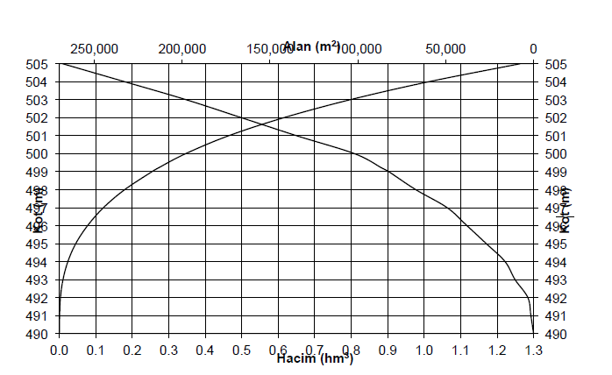

Googlearth Screenshot of the location is available to the DOE.
Official records are available to the DOE.
Official records are available to the DOE.
Social Security System records are available to the DOE.
http://www.mevzuat.gov.tr/Metin.Aspx?MevzuatKod=7.5.6381&MevzuatIliski=0&sourceXmlSearch
The Meter Change Protocol is available to the DOE.
Tests belonging to the previous years are available to the DOE.
The calculation is available to the DOE through ER calculations file.
The calculation is available to the DOE through ER calculations file.

